# **DevOps Assignment No : 10**

# **Create a Jenkins pipeline to build and push Docker Image. Dockerfile, Jenkinsfile and the application(for which image will be built) shall be stored in a GitHub Repository.**

Signed to GitHub as below: -

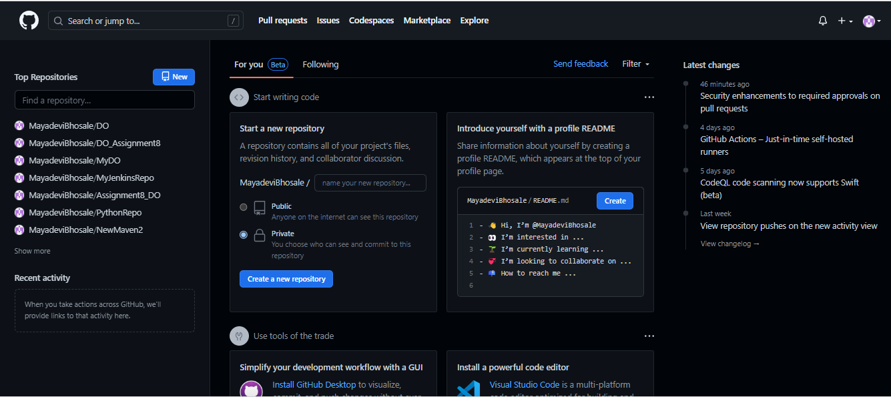

Login to Jenkins as below: -

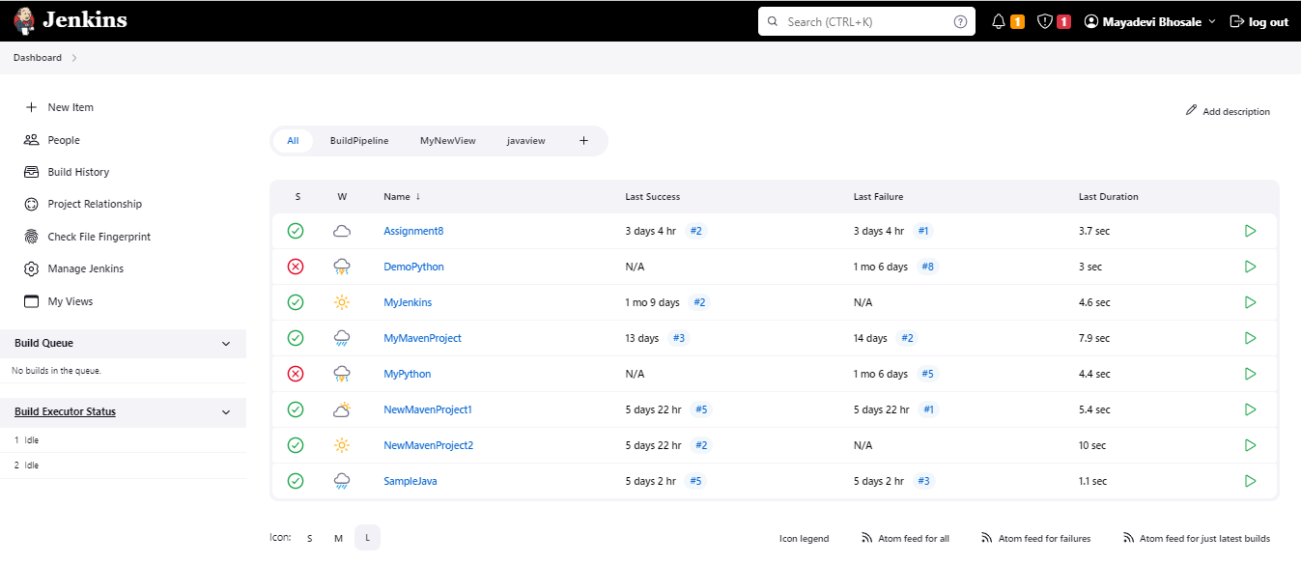

Starting the Docker as below: -

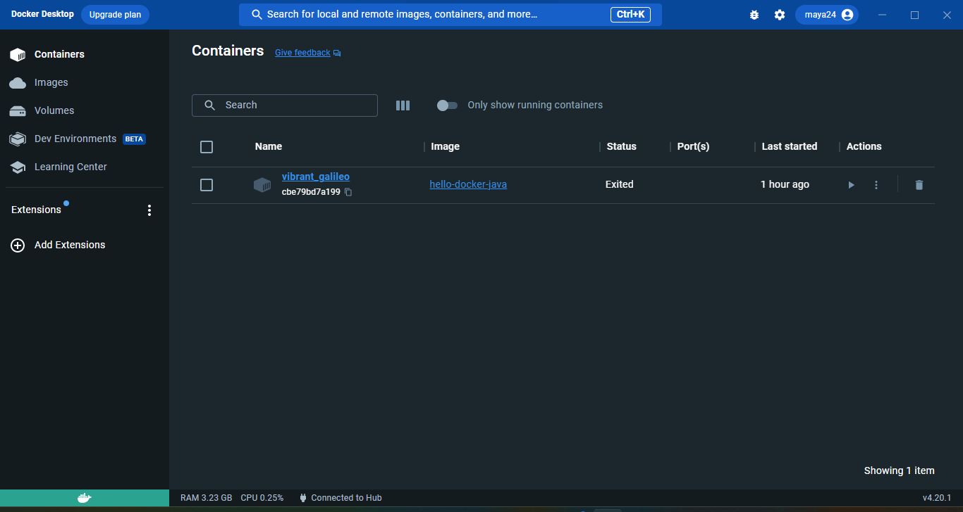

Creating a New Repository on GitHub as below: -

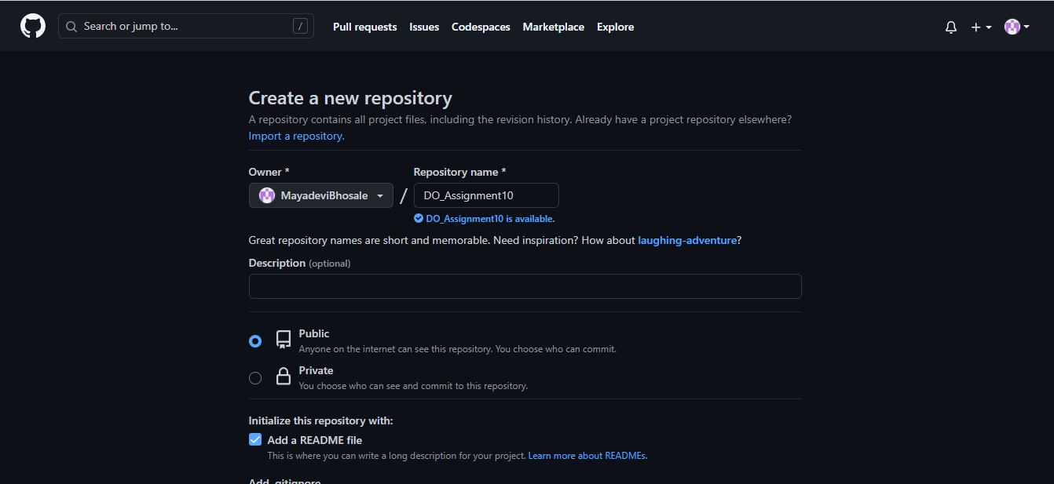

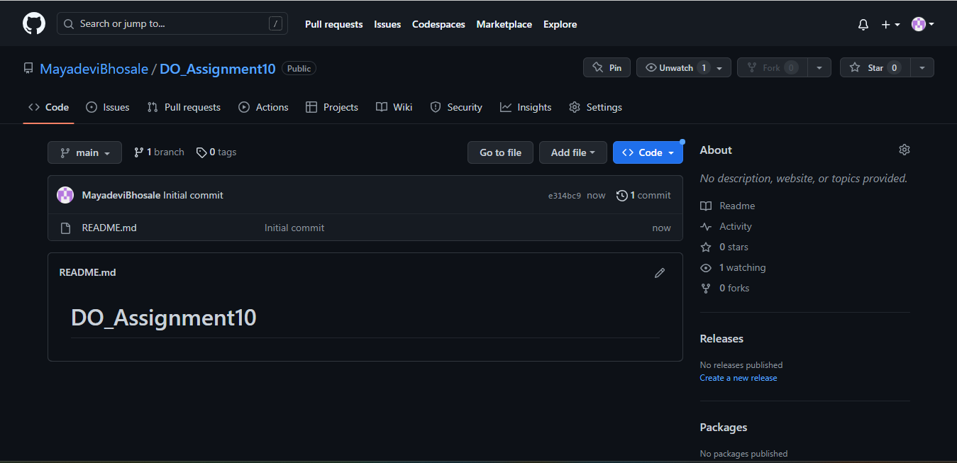

Adding “HelloWorld.java” as below on GitHub Repository as below : -

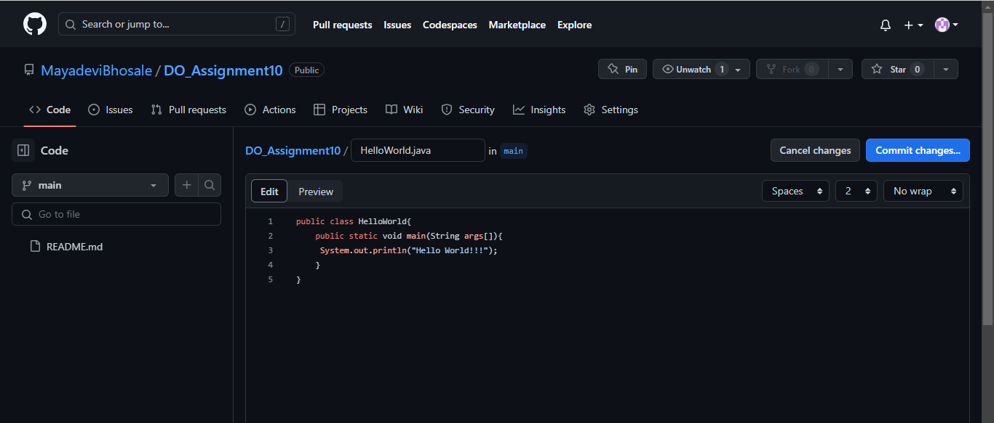

Committed file as below: -

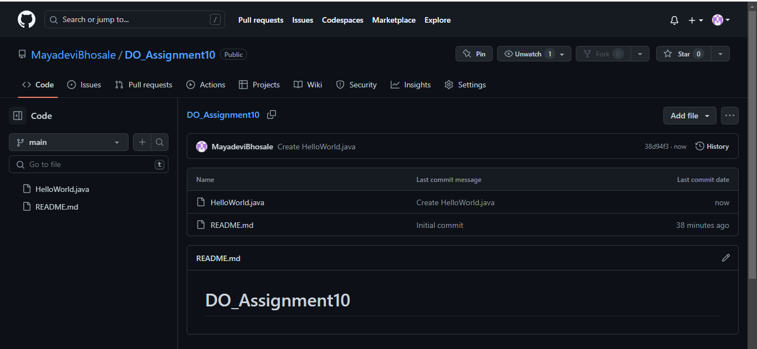

**Now we will Create a Jenkins Pipeline Job as below: -**

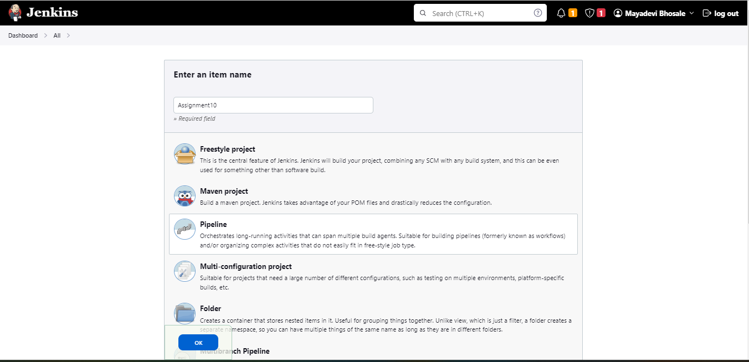

**We will select Poll SCM, and enter “* * * * *” as below: -**

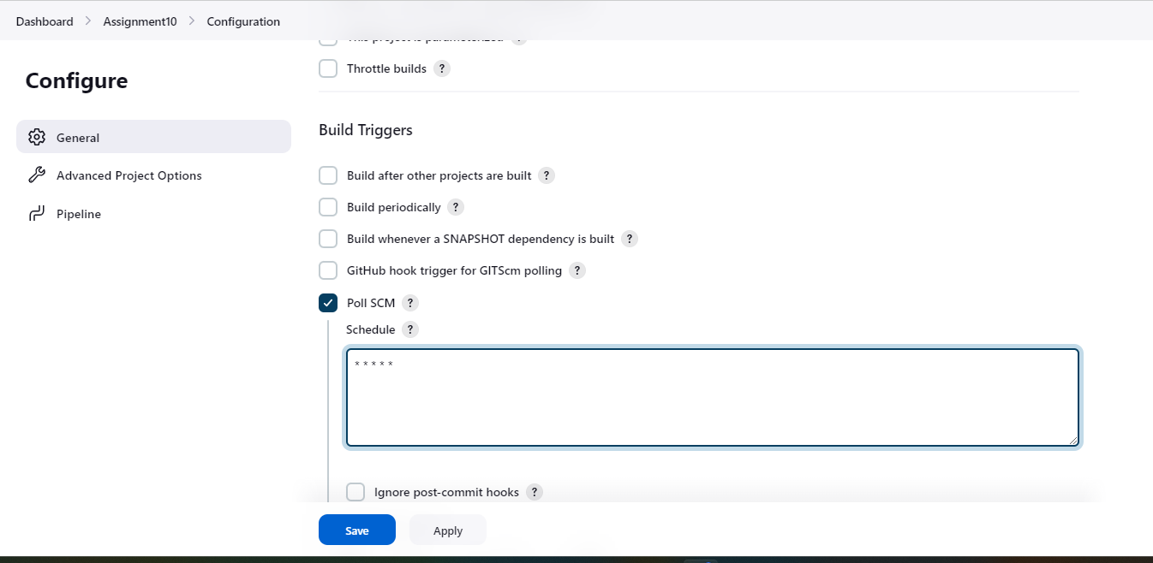

**Then we will select “Pipeline Script from SCM” from below options: -**

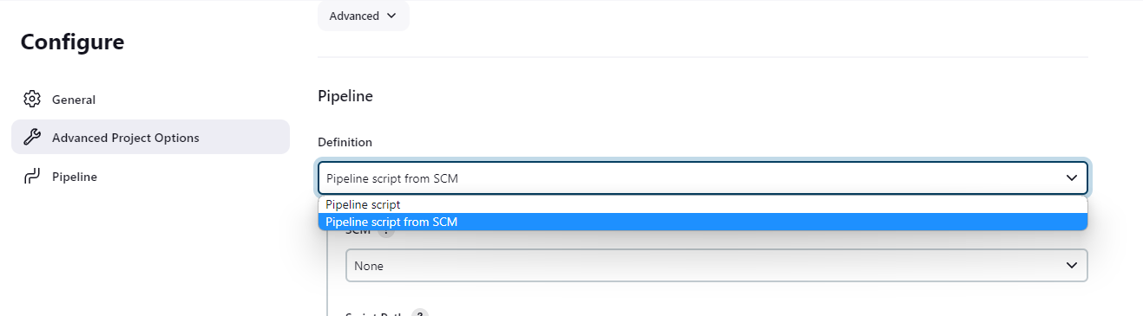

**Then we will select Git option and add Repository URL ,credentials and change branch name as “main” : -**

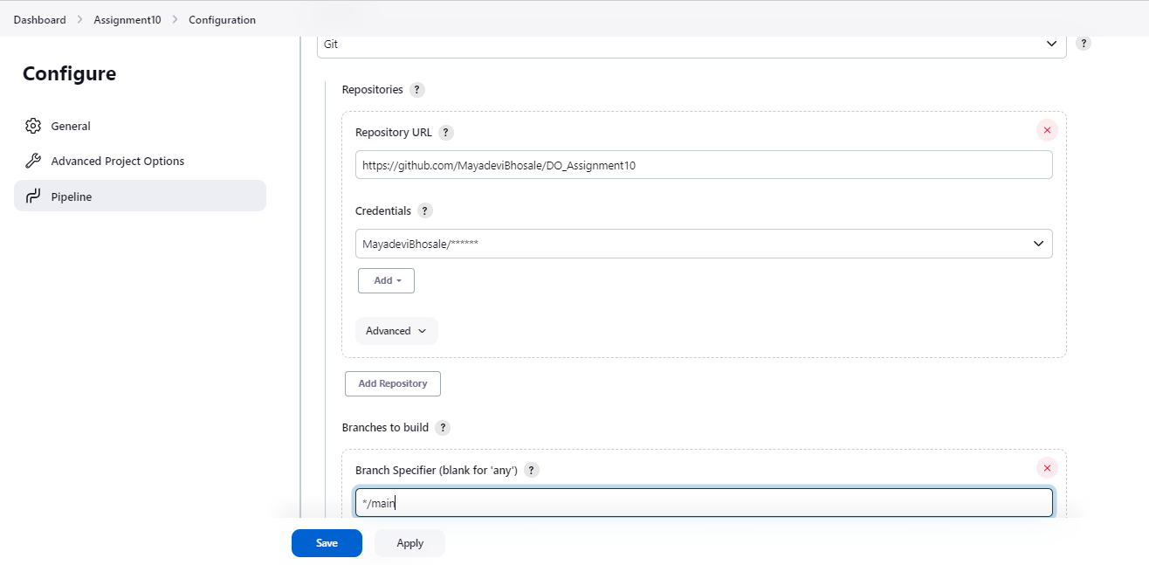

**Click on Apply and save:-**

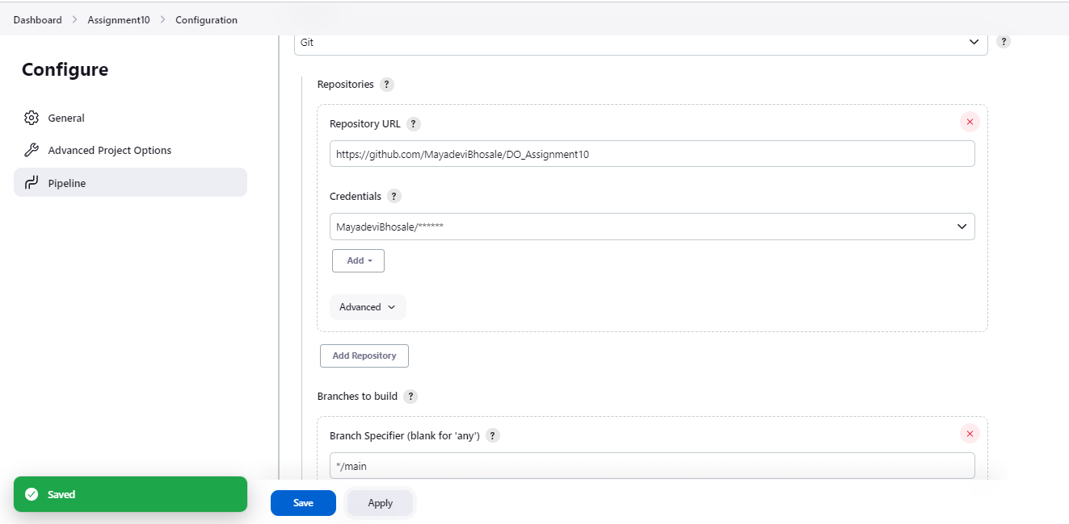

**Now we will create Personal Access Token on Docker Hub as below: -**

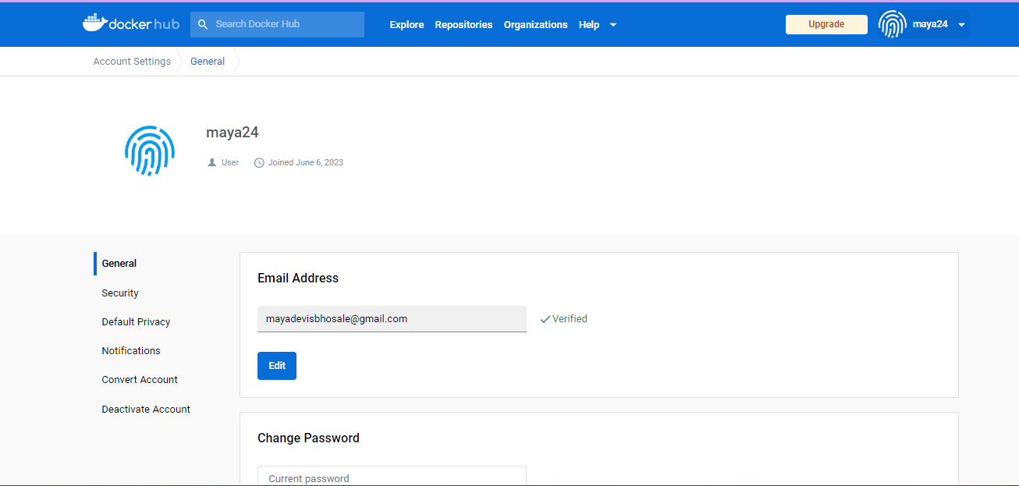

**We will click on “New Access Token” as below: -**

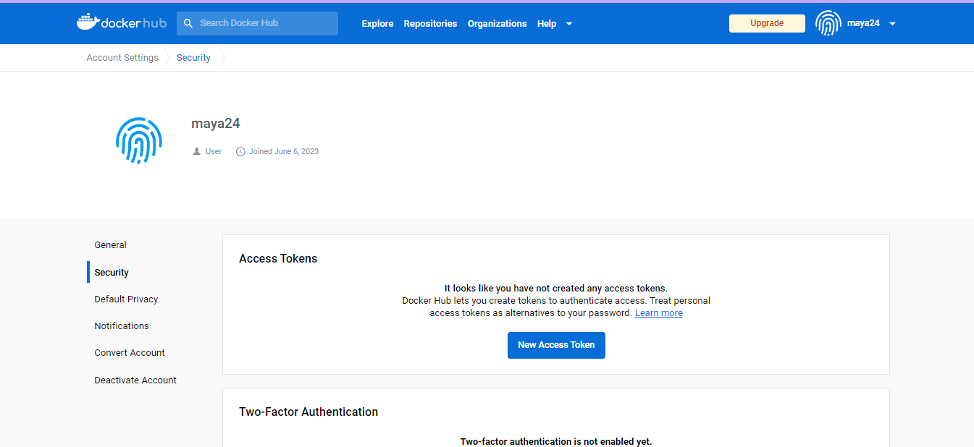

**We will give token description and click on Generate as below:-**

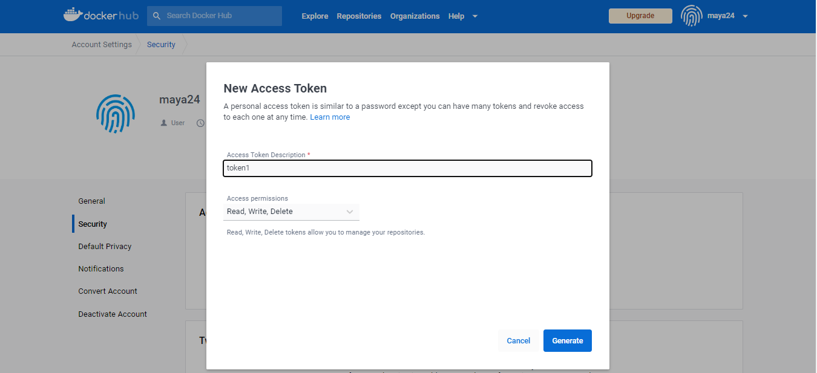

**Access Token is Generated as below: -**

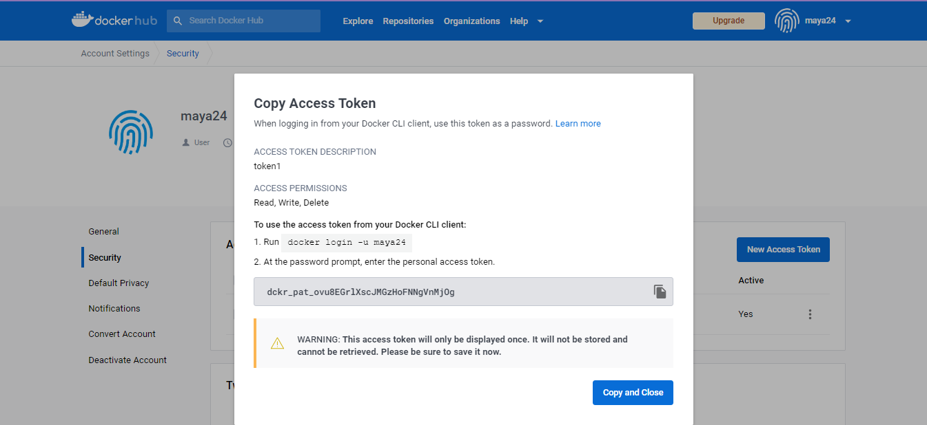

**Then click on Manage Jenkins→ Manage Credentials: -**

**Then click on System in Credentials as below: -**

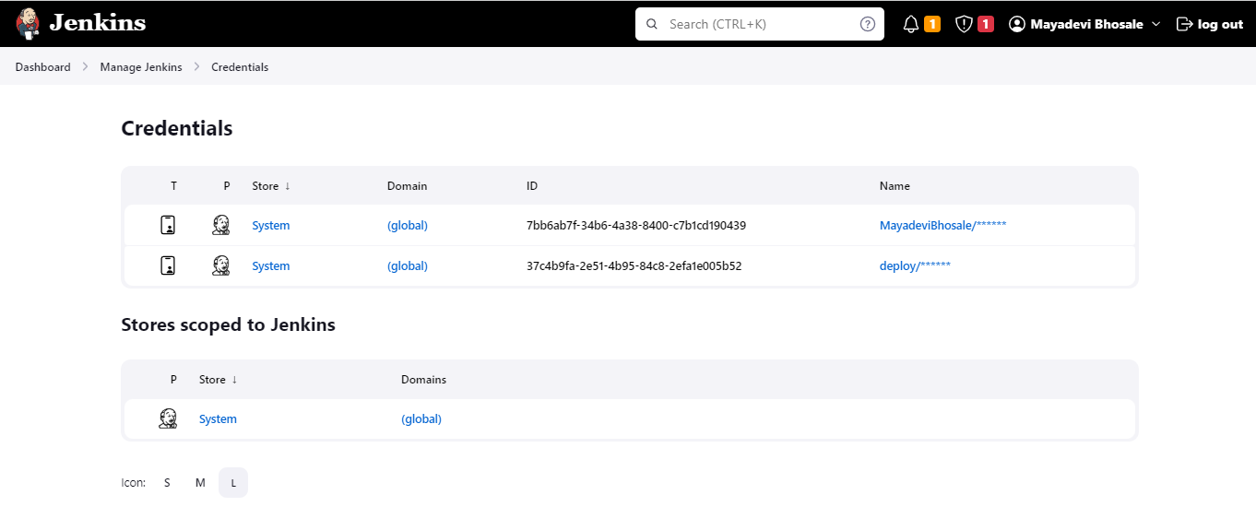

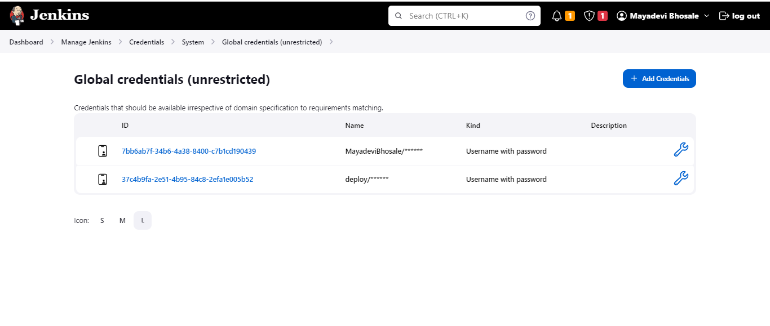

**Then we will enter the Username of docker Hub and Generated Access Token in Password field as below: -**

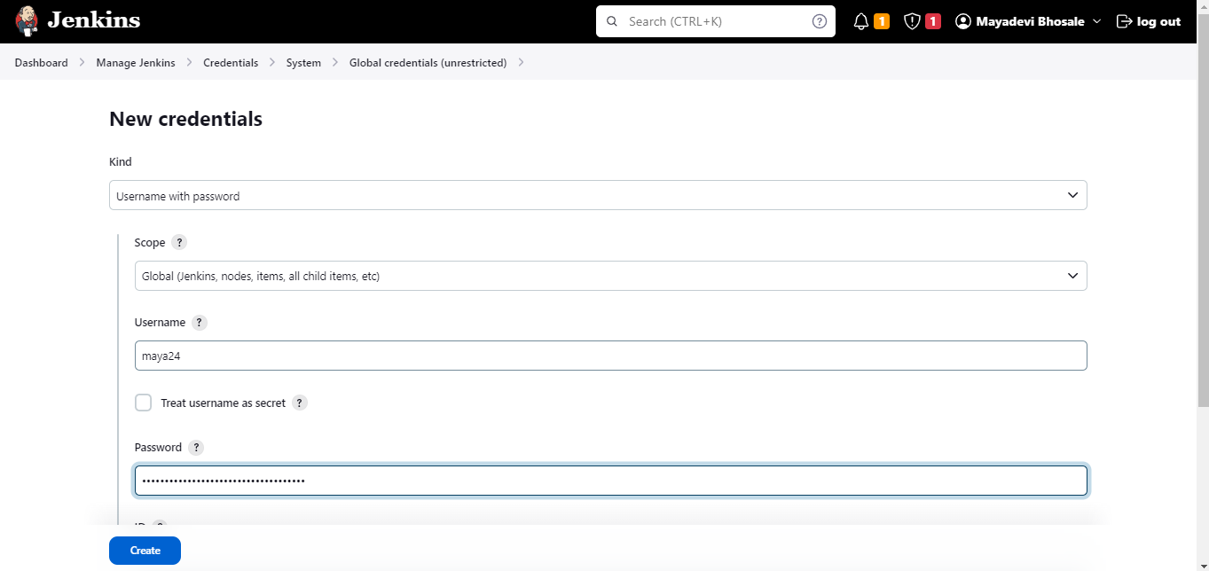

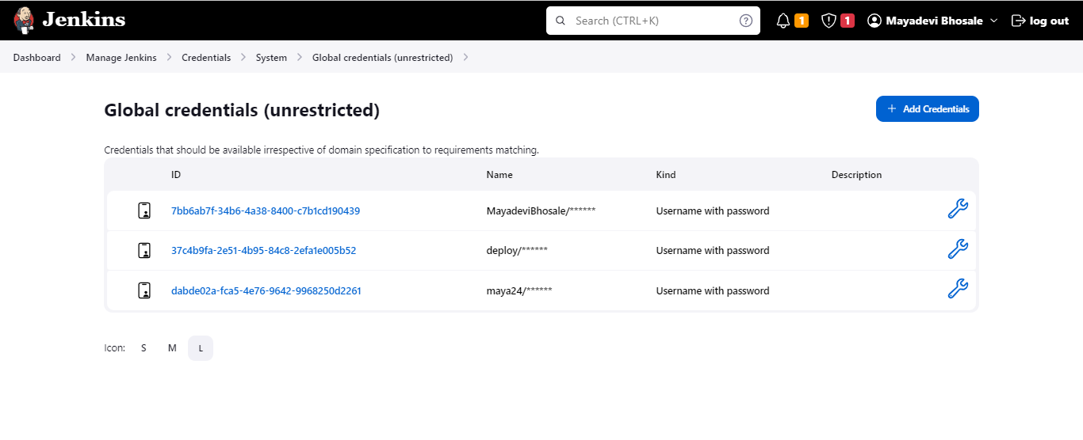

**Now we will configure our Docker Hub User Id in Pipeline Job:-**

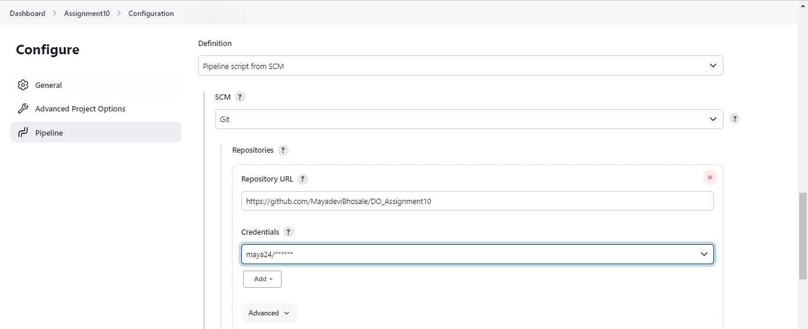

**click on Apply and save and then click on build now :**

**Our First build is failed because we have not added Jenkinsfile Yet as shown below: -**

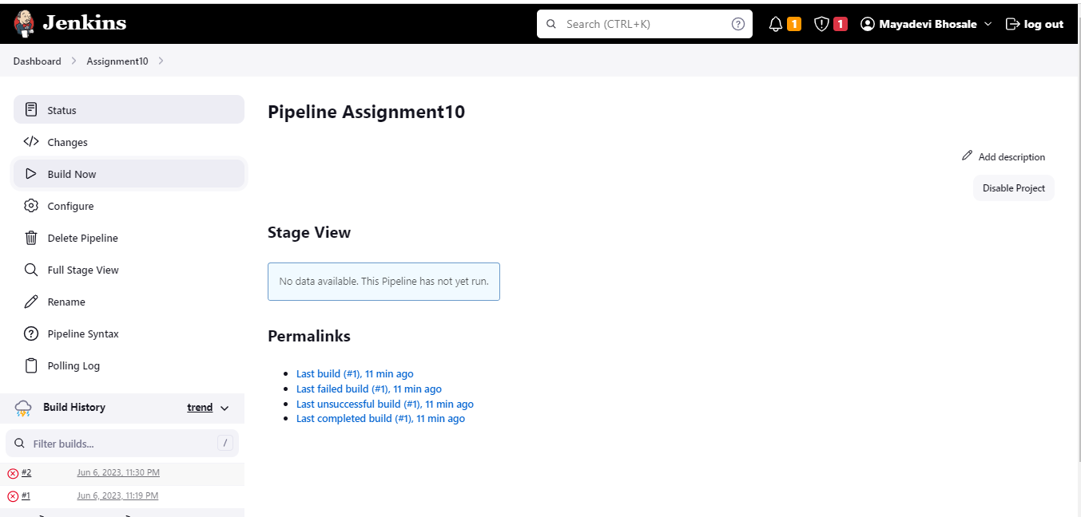

**Now on git we will add file as below: -**

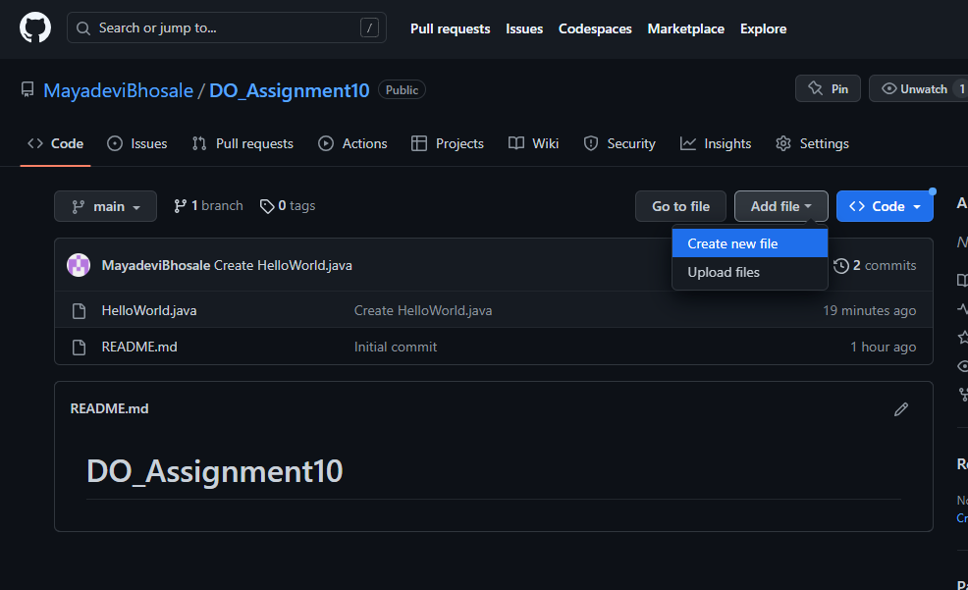

**First we need to add dockerfile to our Repository as below:-**

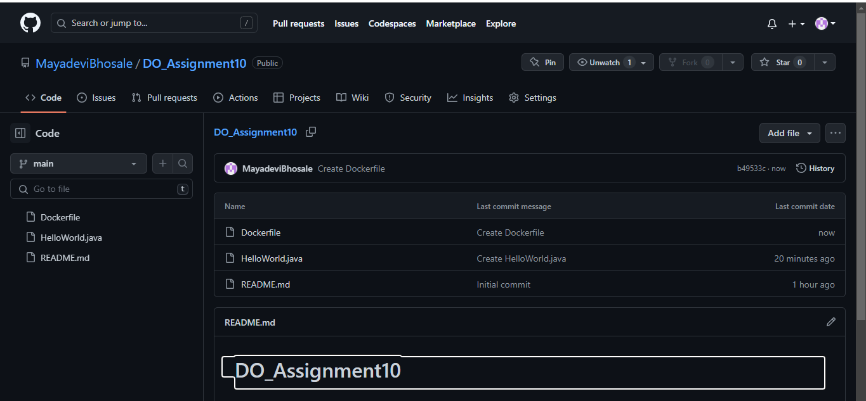

**Committed file as below:**

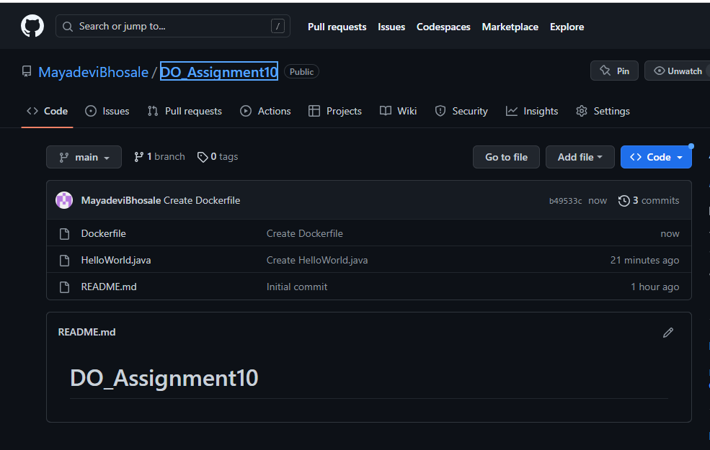

**Then we need to install few plugins as below for docker: -**

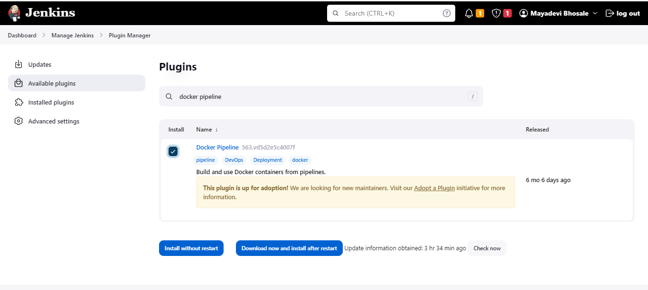

**Installation of Plugin is Successful as below:**

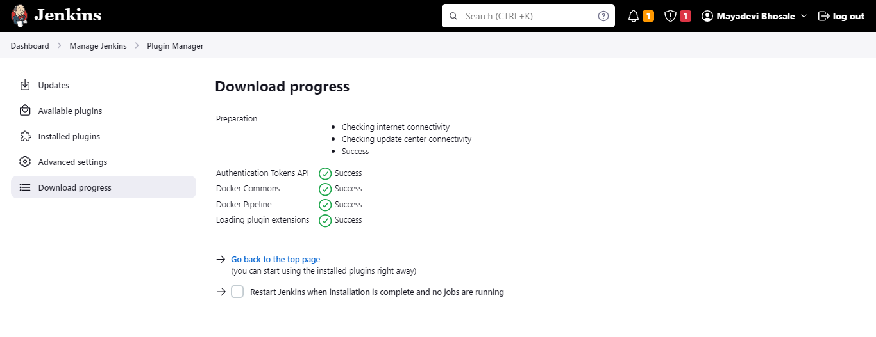

**Required Plugins to install are :**

* **Cloudbees docker Build and publish**
* **Docker**
* **Docker Build-Step**

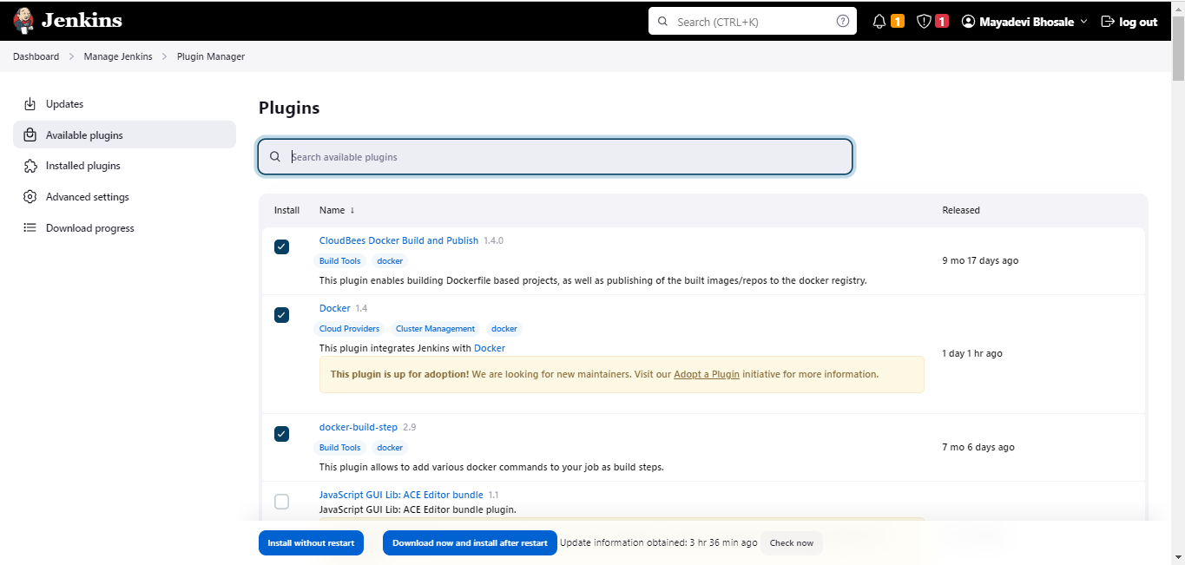

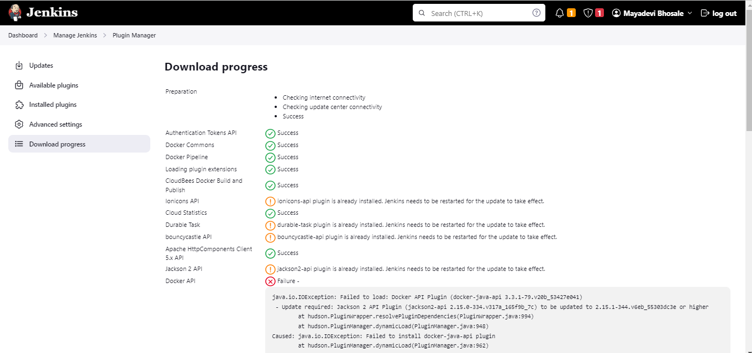

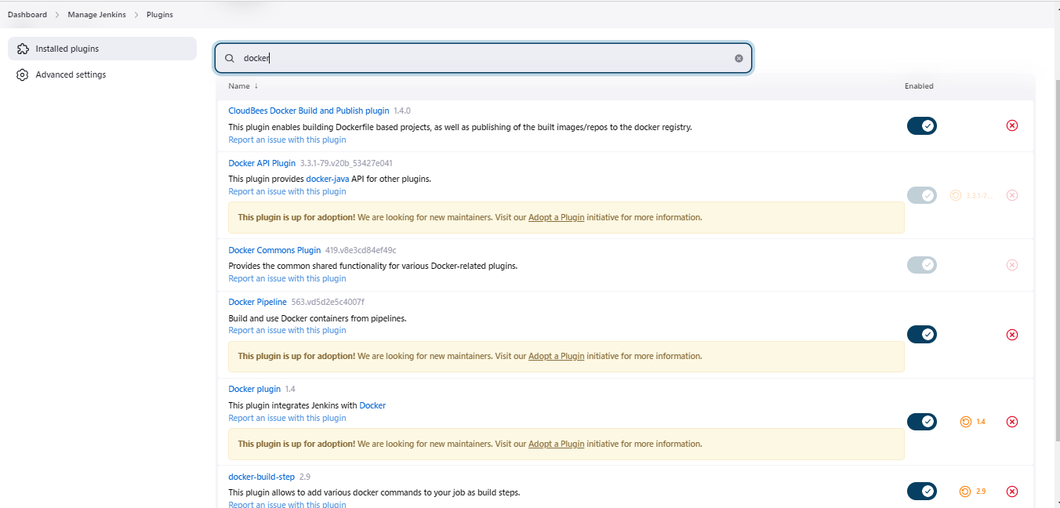

**Now we will add the “Jenkinsfile” as below: -**

