# **DevOps Assignment No. 3**

**Create a blank project : “DevOpsDemo”**

Create a .gitlab-ci.yml file at the root of our repository and choose the template for a file as bash.

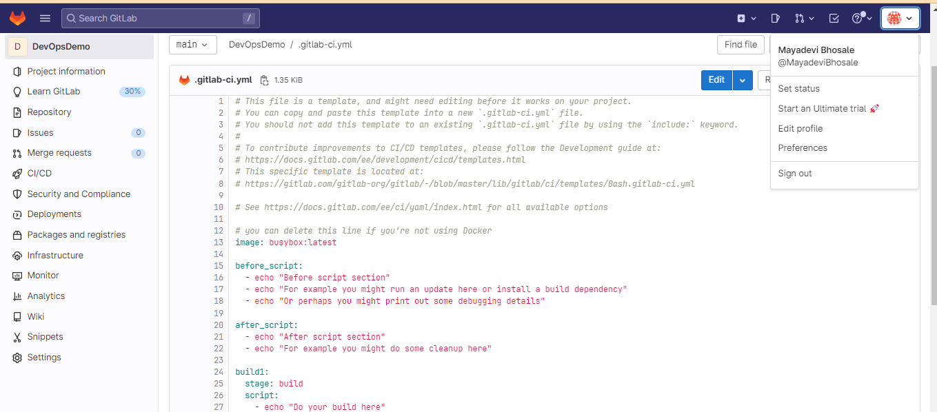

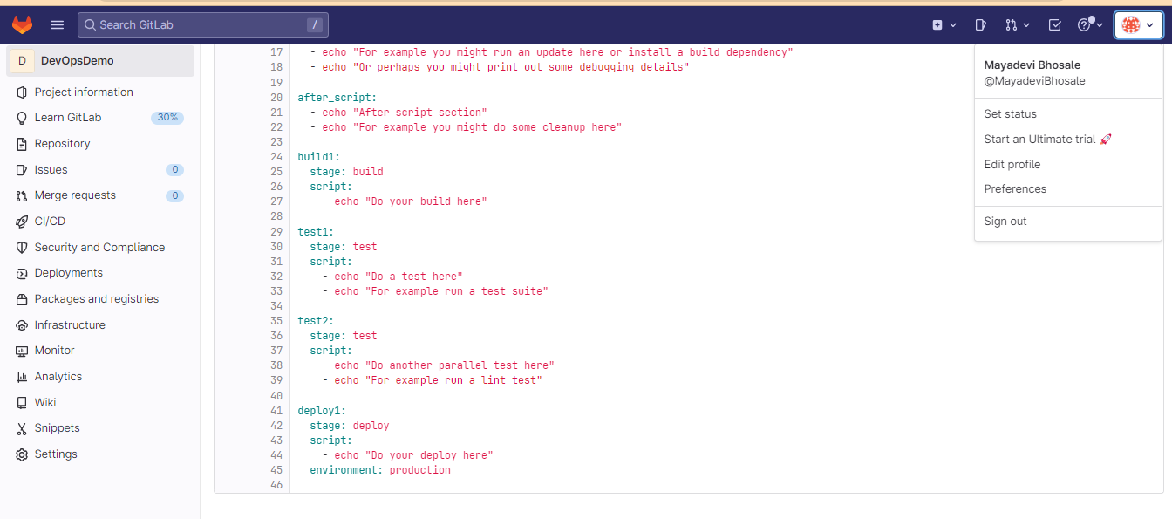

**Register and Start Runner:** After installing the runner, register for the runner execution file. Once the registration is successful, start the runner.

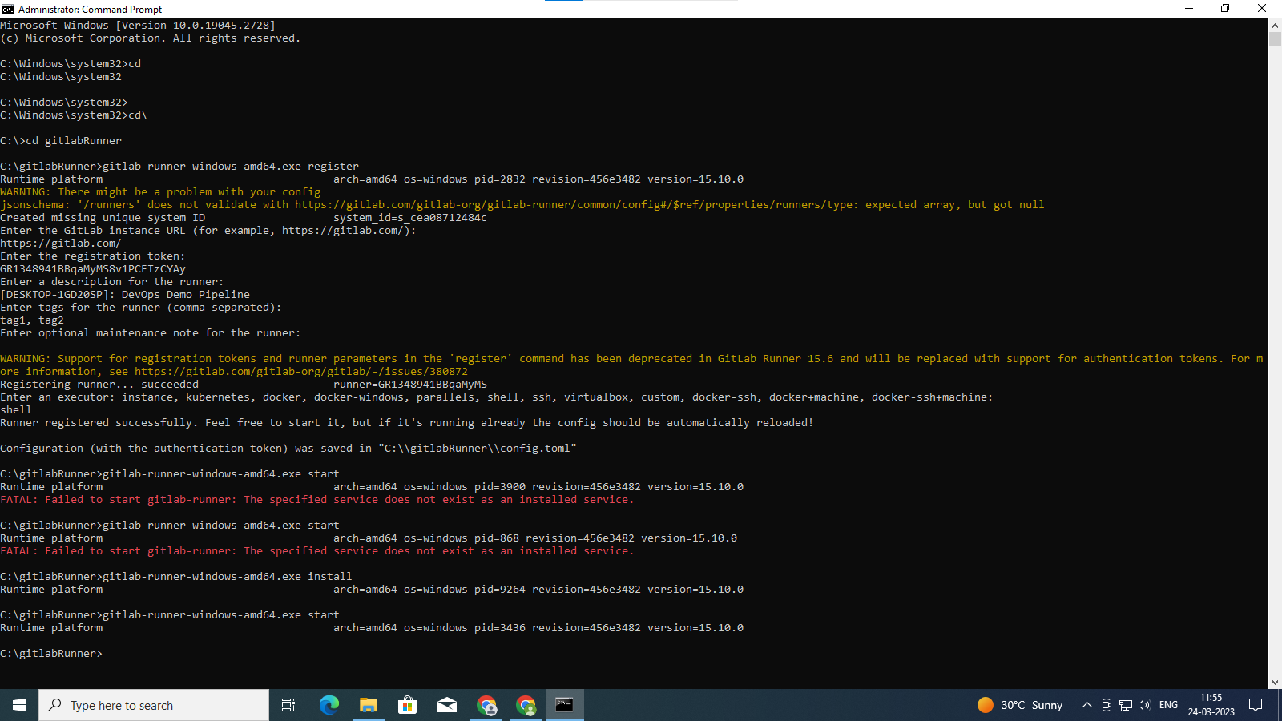

**To run pipeline:**

Go to settings→Runner→disable the shared runners. And Edit the project runner, click on checkbox run untagged jobs. It will start executing the pipeline in build, test, and deploy phase one by one.

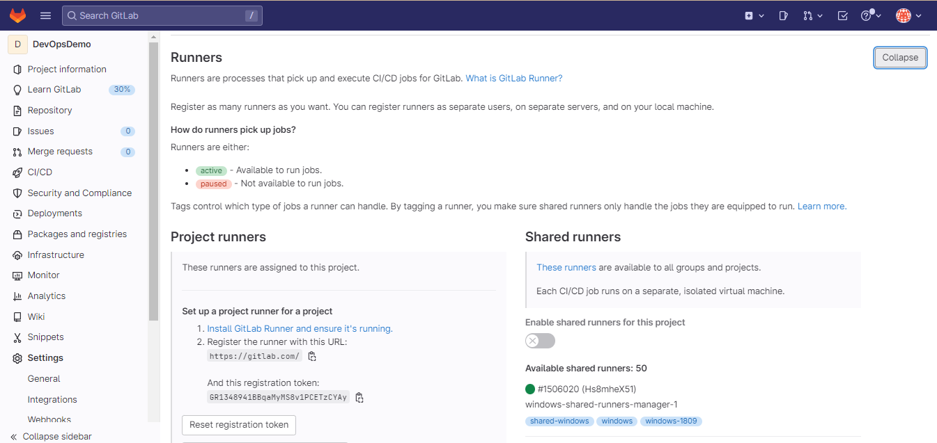

**Add New File and Check the CICD Pipeline Status :**

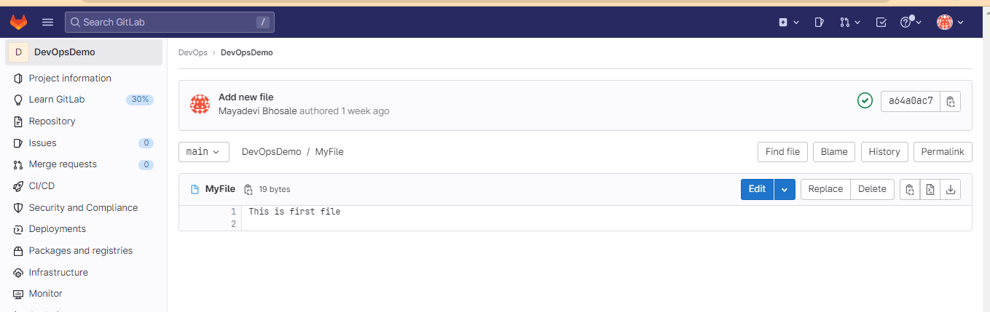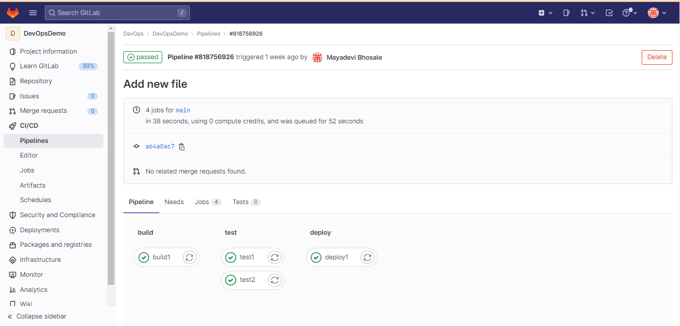

**Check the status of more than one files in pipeline stages :**

