**DevOps Assignment No. 4**

### **Git Server**

**Create a new folder as “git-server” and Set up the git server as follows :**

**Go to git-server properties → Sharing → Share → Click “Everyone” from dropdown and ADD it → Choose Read/Write option**

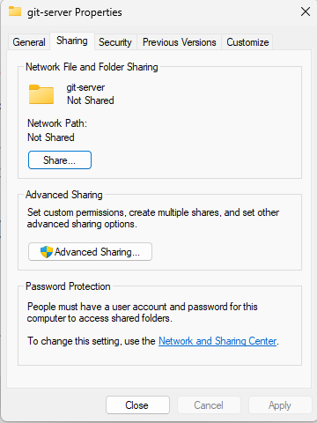

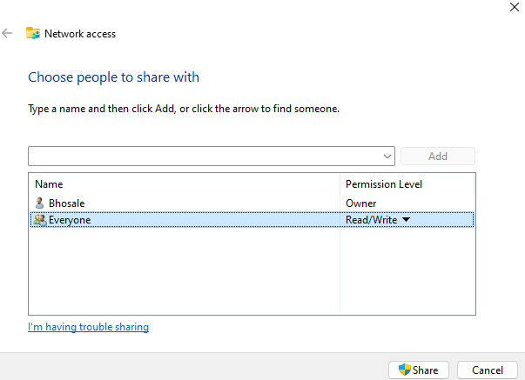

**Initialize Git on this folder and Add Files :**

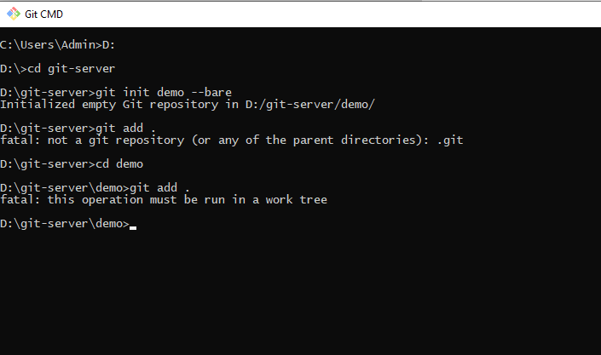

**Create new folder as “test” and Clone it to git server :**

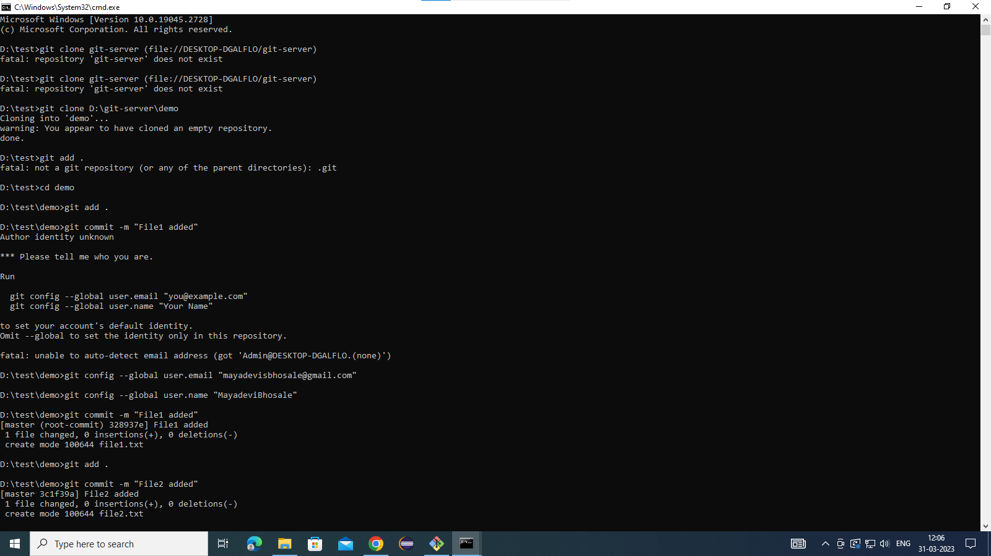

**Add Files to test folder and push the files in git server :**

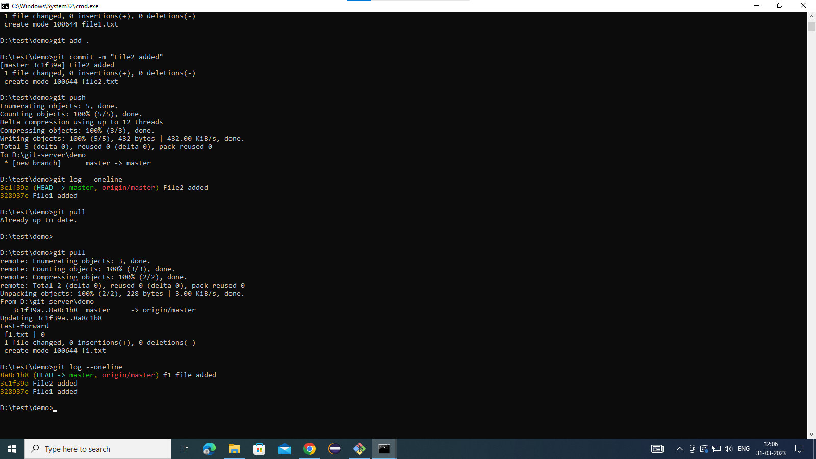

**Create one more new folder as test1 to check the status of server :**

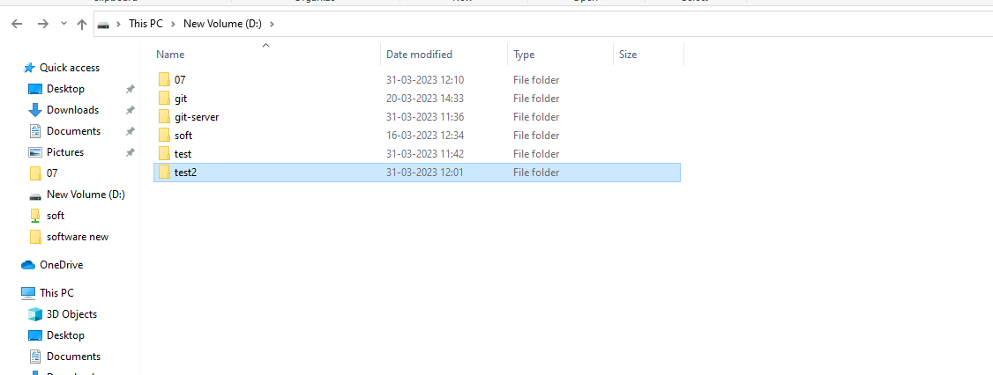

**Add new files:** 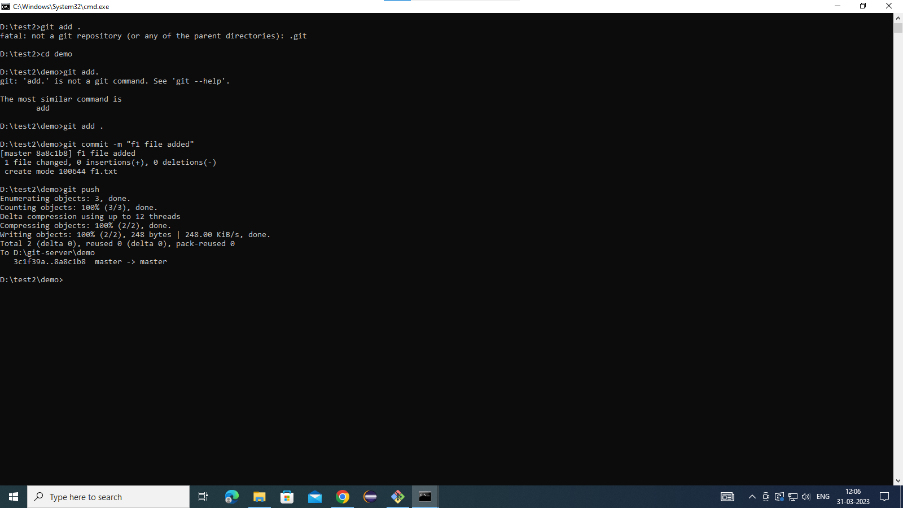

**Pull the changes in test folder from the git server:**

