**DevOps Assignment No. 5 - Jenkins**

1. **Set up a Jenkins job that picks up a Java application from a GitHub repository, builds it, and runs it.**
2. **Create Repository in GitHub and clone it to local repository**

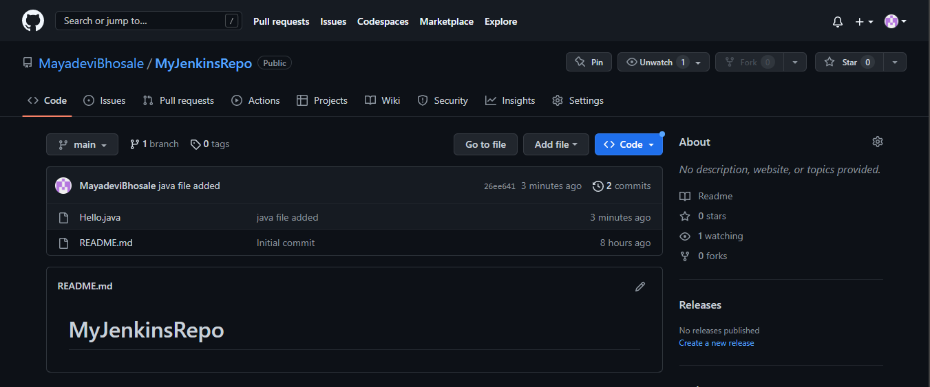

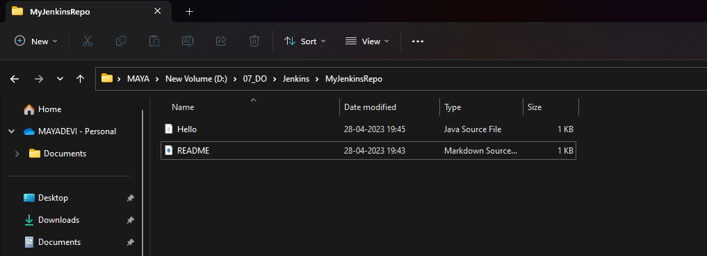

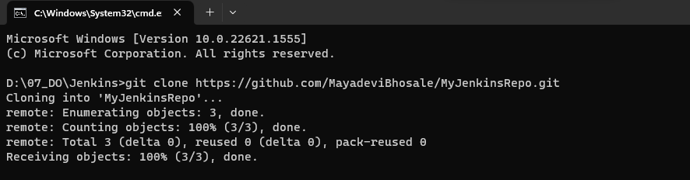

1. **Add Java source file And push it to GitHub**

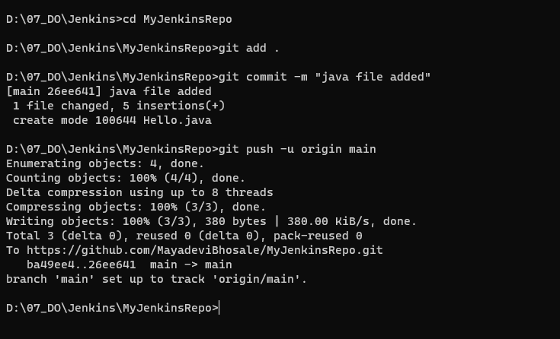

1. **Login to Jenkins**

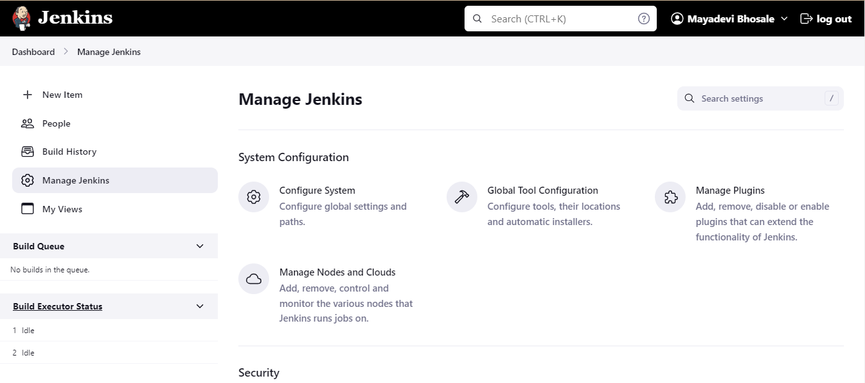

1. **Go to Manage Jenkins → Global Tool Configuration→ Add JDK→ Apply & Save**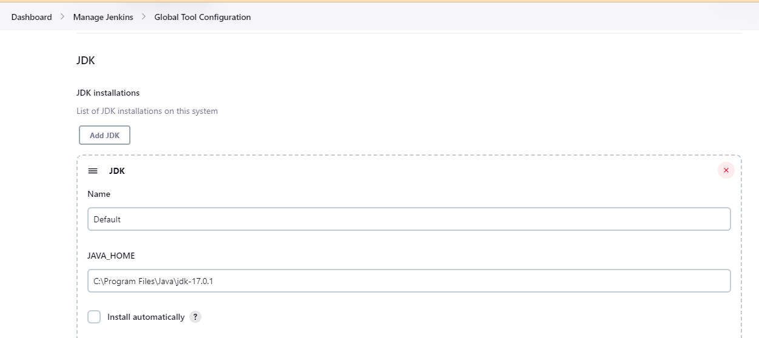
2. **Go to New Item → enter an Item name → select freestyle project → click on OK**

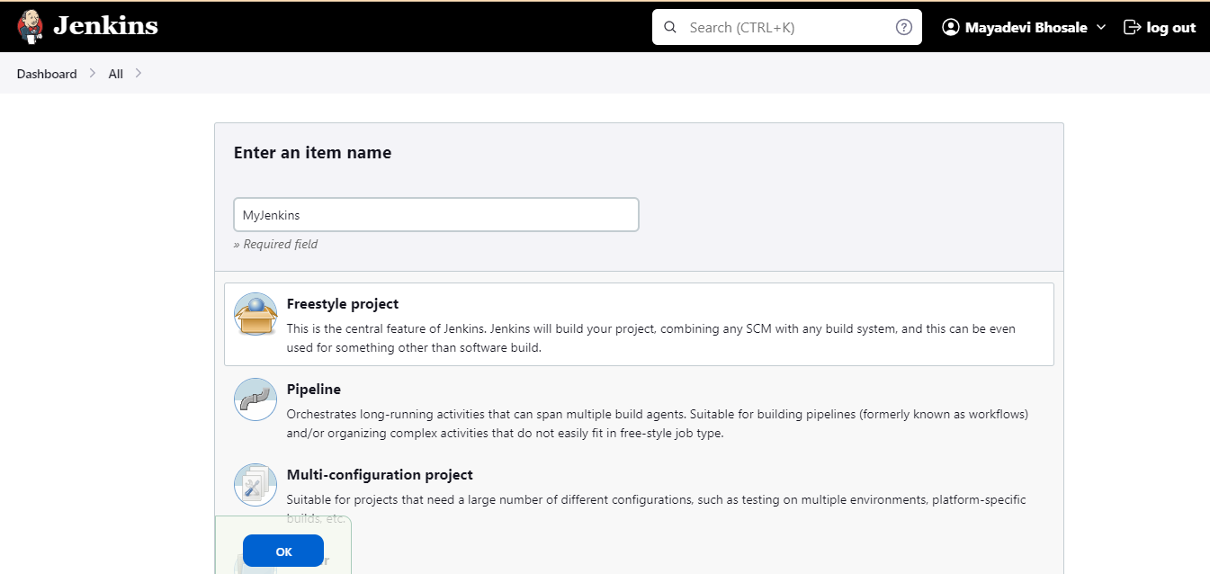

1. **Go to Configure → SCM → select Git → add GitHub repo URL**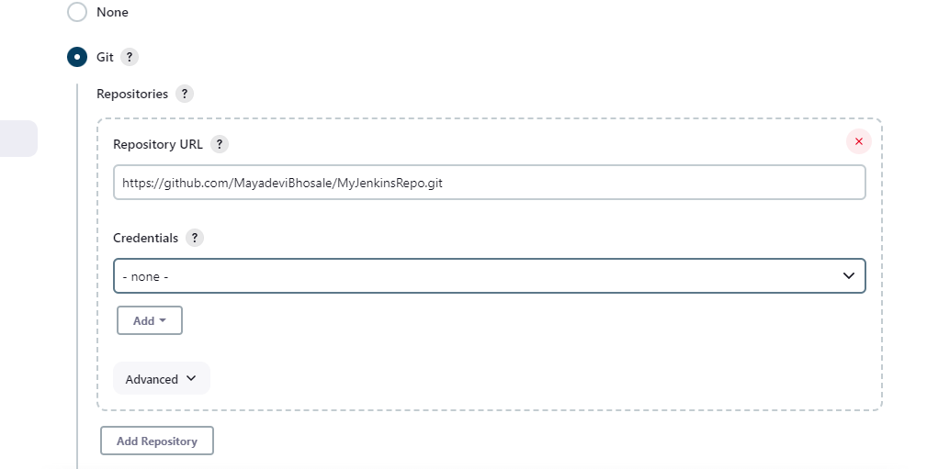
2. **Change branch name master to main**

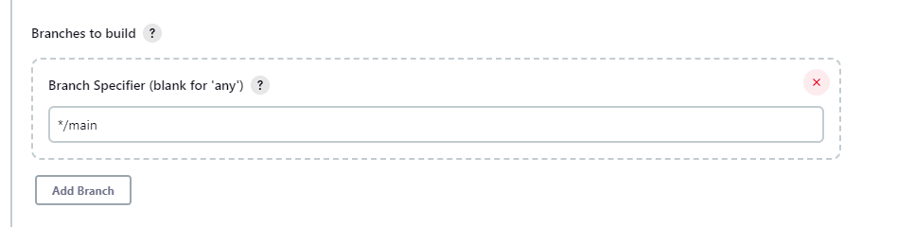

1. **Select Poll SCM**

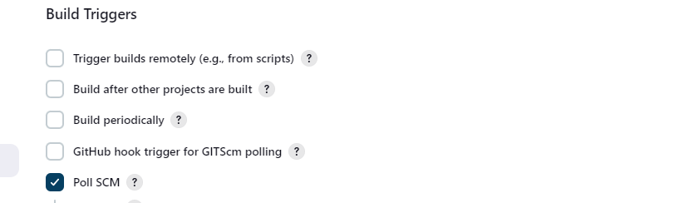

1. **Select Execute Windows batch command from dropdown and enter commands require to compile & execute the java code**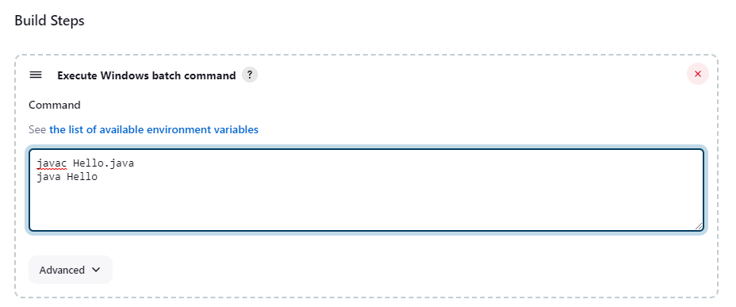
2. **Click on Build Now → after successfully build click on #1**

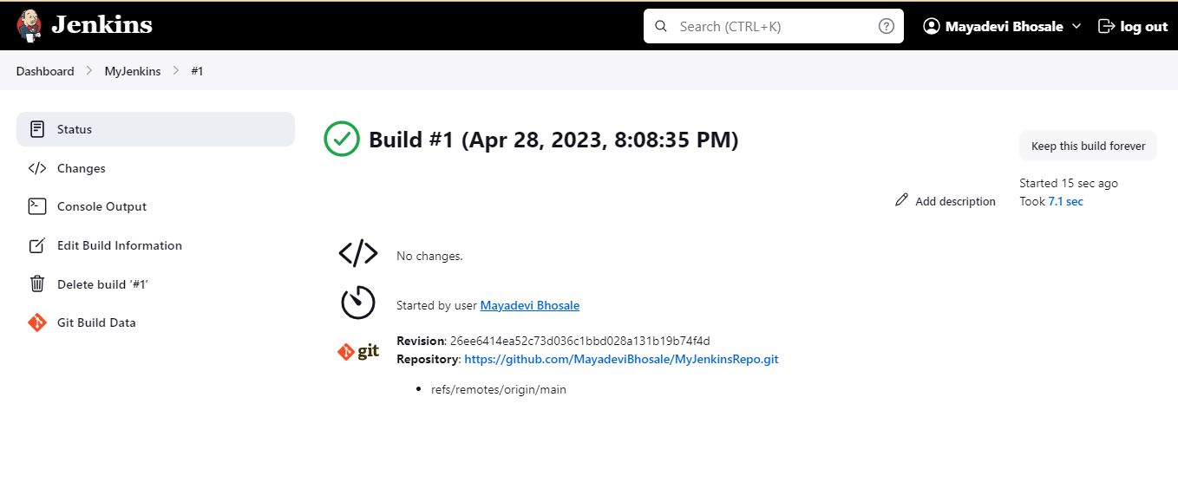

1. **Click on Console Output** 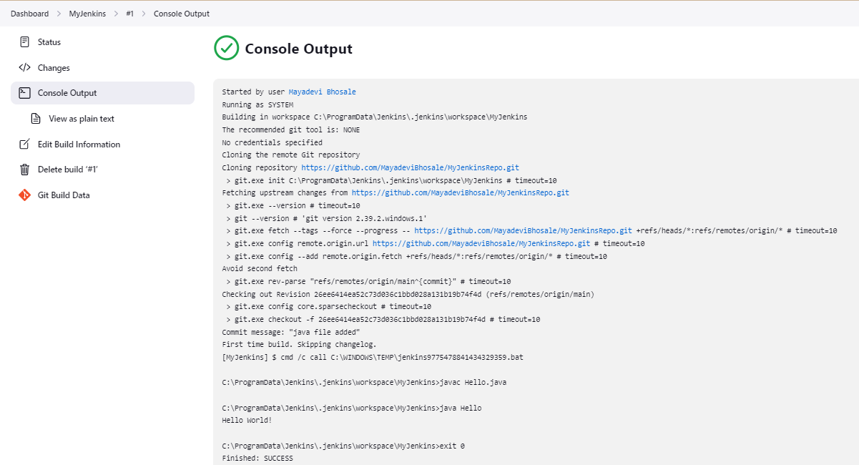
2. **Do some changes in java file in GitHub and commit the it**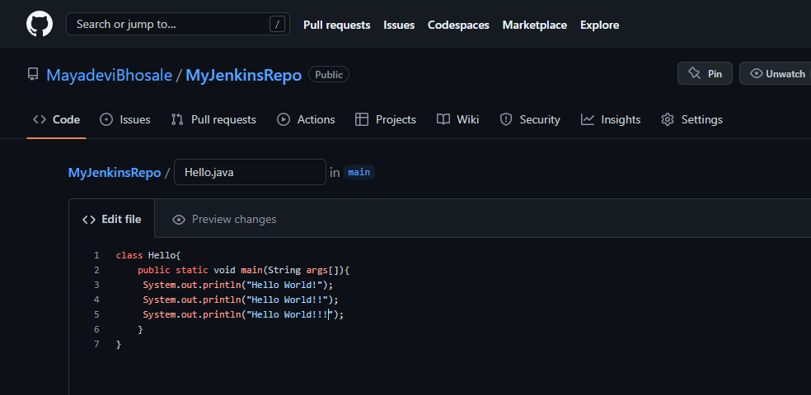
3. **Go to Jenkins and click on Build Now → Build History → #2**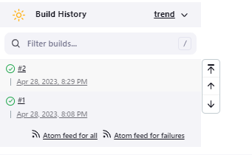

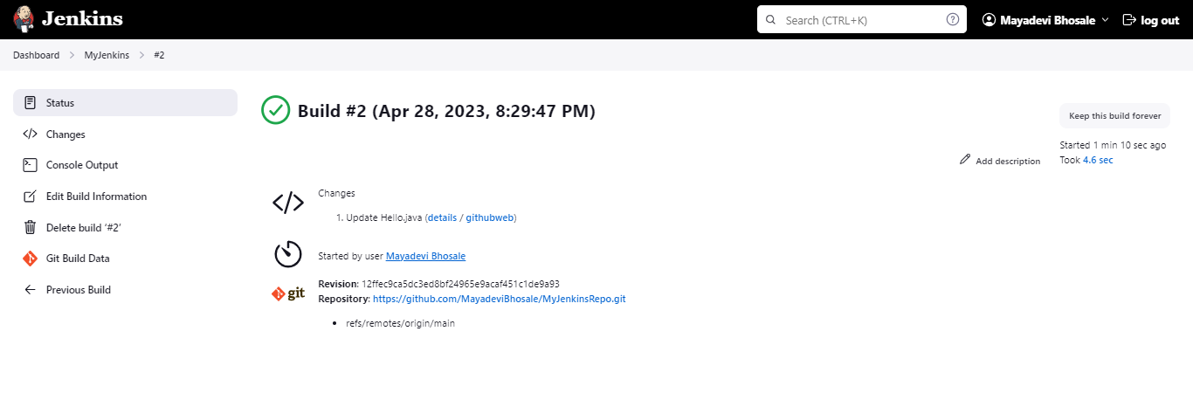

1. **Go to Console Output**

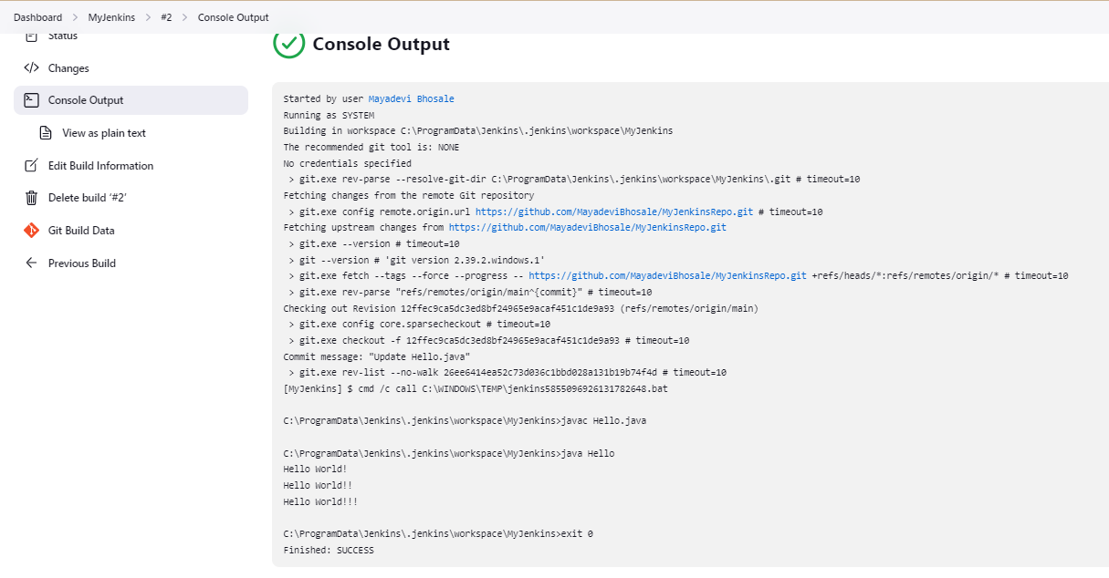

1. **Set up a Jenkins job that picks up a Python application from a GitHub repository, builds it, and runs it.**
2. **Add python source file in local repo and it on staging area**

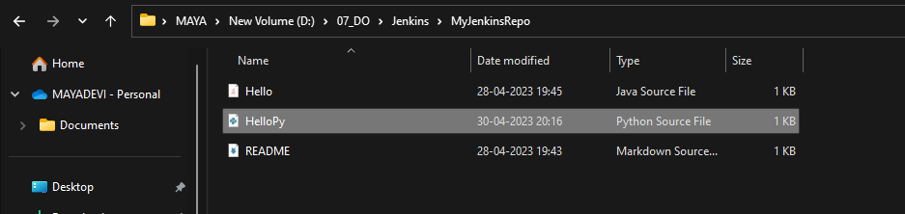

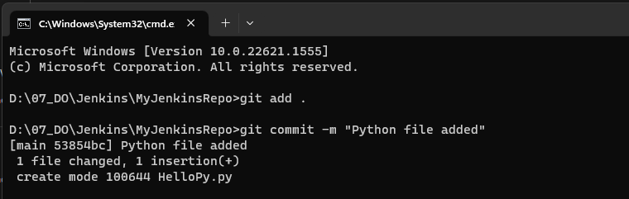

1. **Push python source file to GitHub**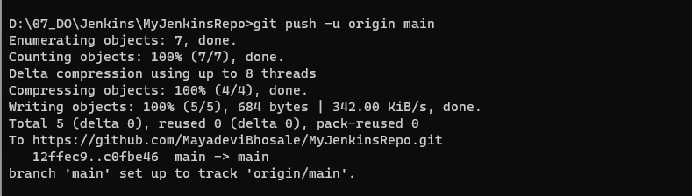
2. **Go to Manage Jenkins → Global Tool Configuration→ Add JDK→ Apply & Save**

