**DevOps Assignment No. 7**

**Use Jenkins “Deploy to container” plugin and "Build pipeline" plugin to implement continuous deployment and delivery of a project.**

**In Eclipse IDE :**

**Create a New Maven Project 1 in Eclipse :**

**Click on File → New → Maven Project → Next → Click on Next : select “maven-archetype-webapp” as Artifact ID → Next → Enter Group Id and Artifact Id → click on Finish :**

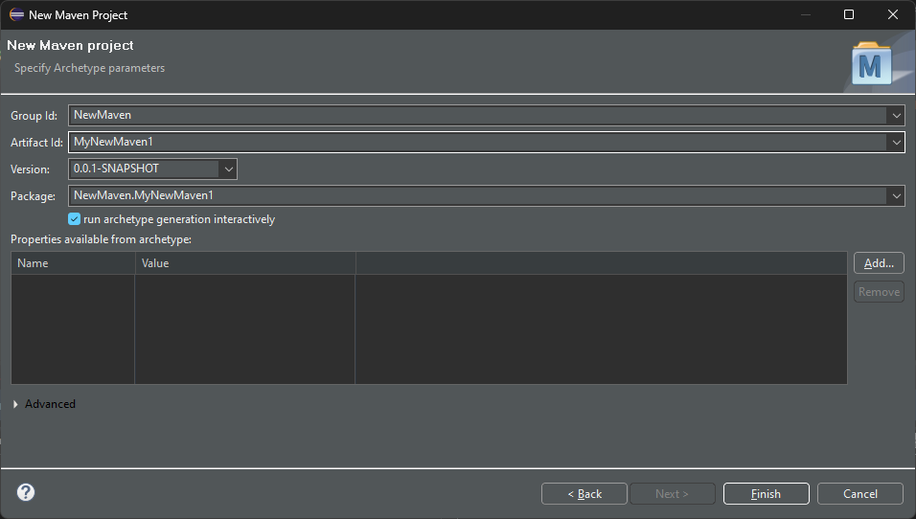

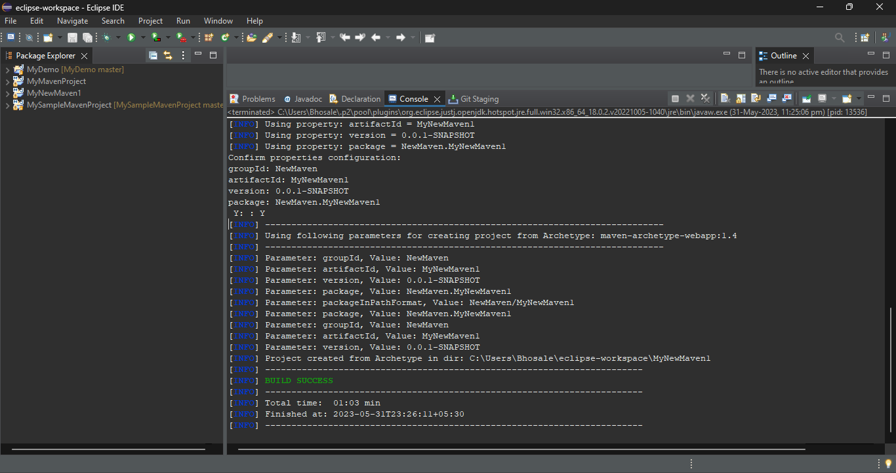

**Right Click on Project name → Team → Share Project → Select “*Use or create repository in parent folder of project*” → select checkbox of project name →Click on Finish**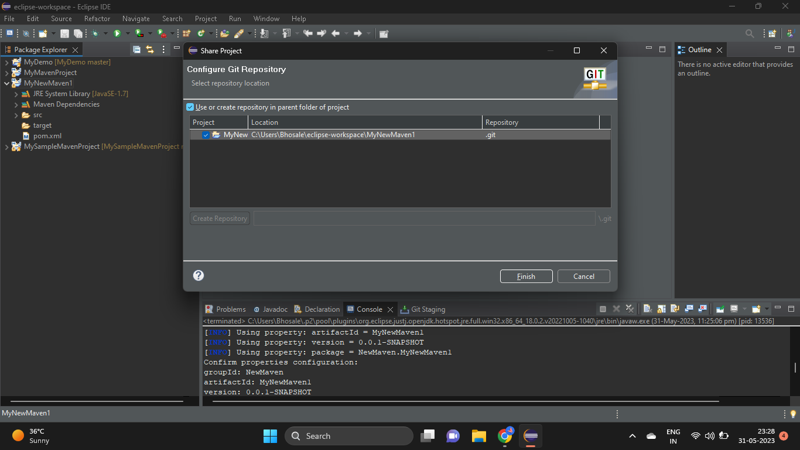

**Check The Preview :**

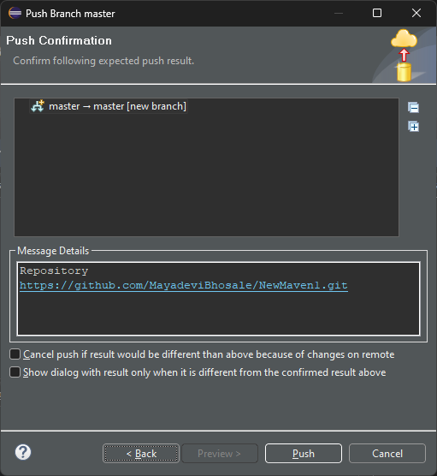

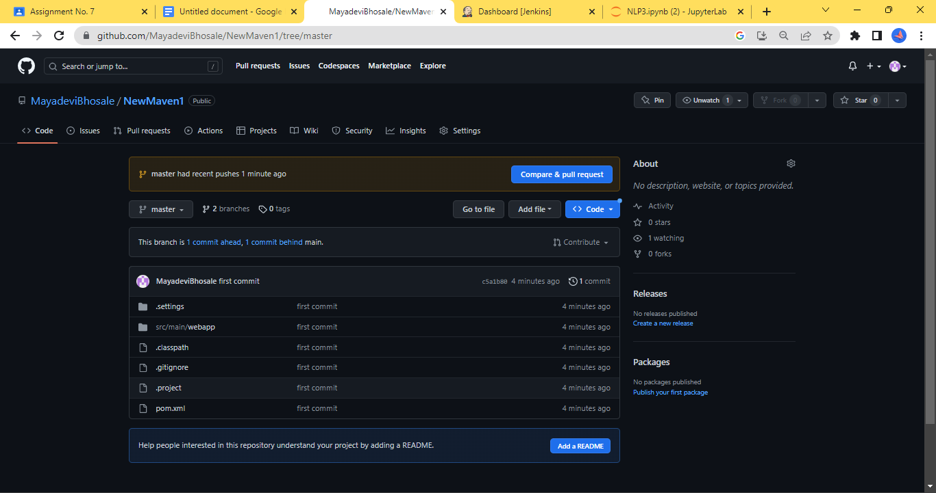

**In Jenkins :**

**Click on New Item → Enter Item Name → Select freestyle Project → OK**

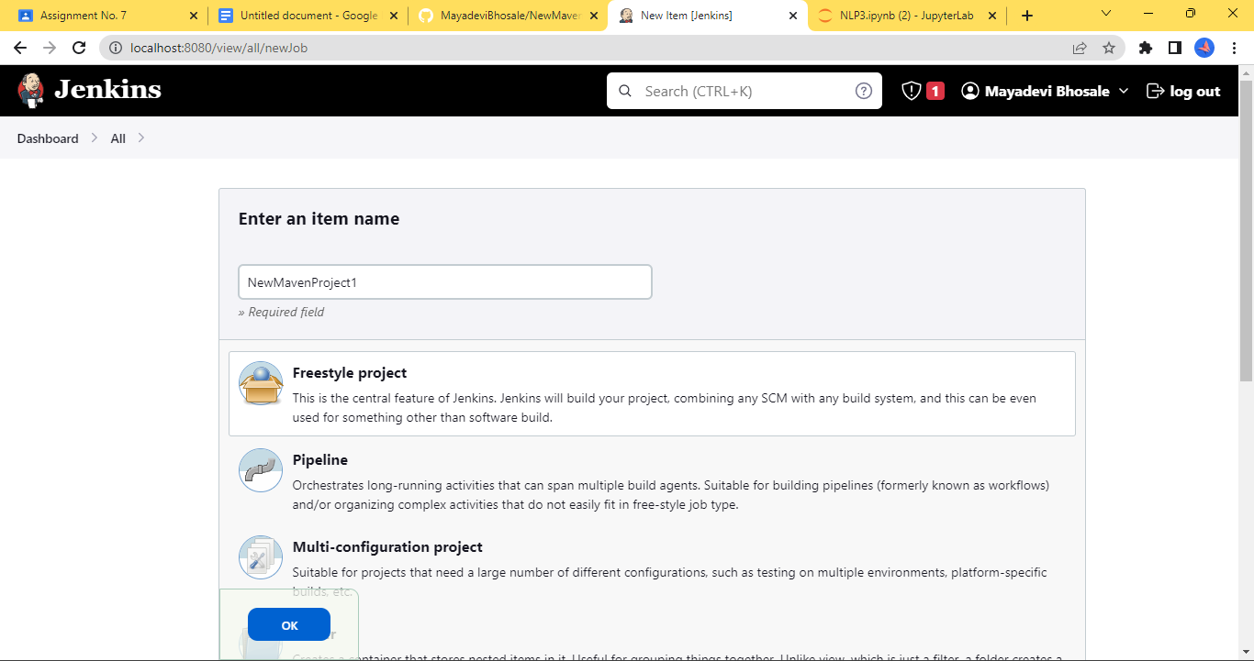

**Go to Configure → Source Code Management → Enter Git Repo URL**

**In Build Triggers → Choose Poll SCM → Enter * 5 times with space**

**In Build Steps → Select Invoke top level Maven Targets → select *maven version* → Enter Goals → *clean install***

**Now Click on Build Now :**

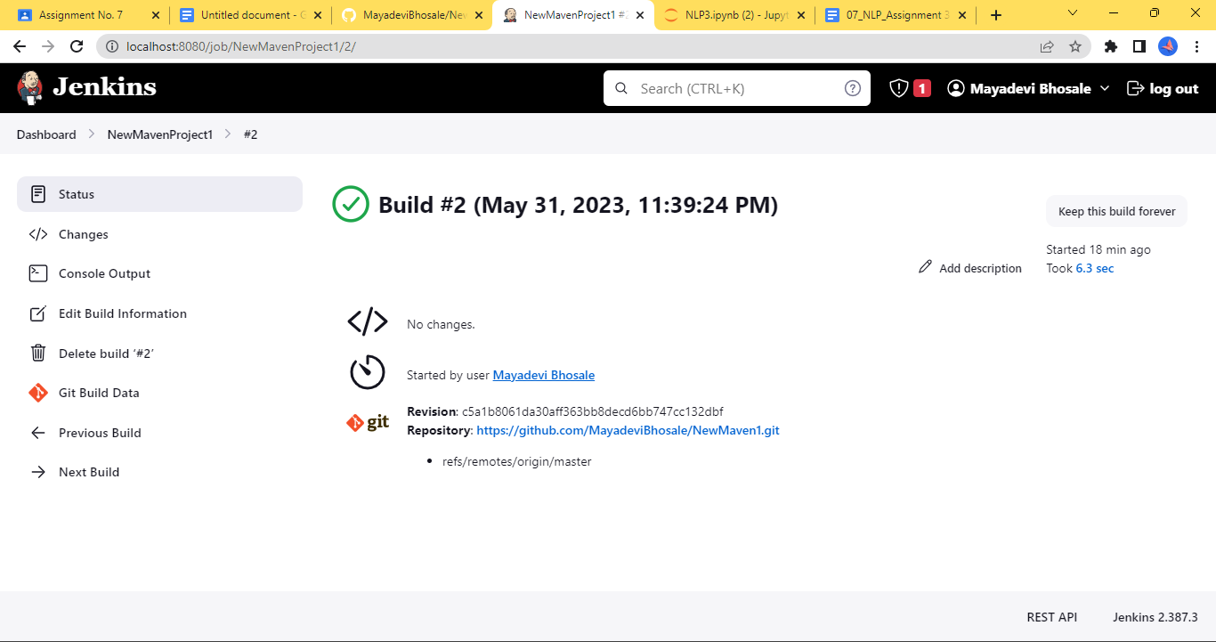

**In Eclipse IDE :**

**Create a New Maven Project 1 in Eclipse :**

**Click on File → New → Maven Project → Next → Click on Next : select “maven-archetype-webapp” as Artifact ID → Next → Enter Group Id and Artifact Id → click on Finish :**

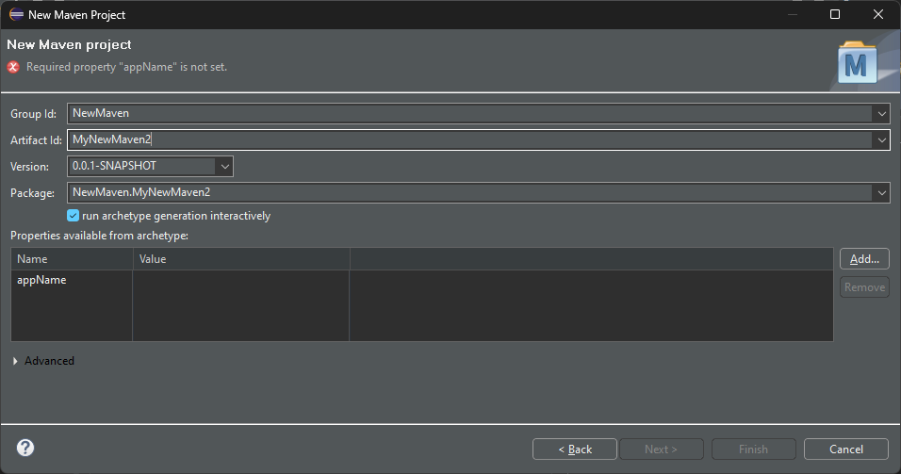

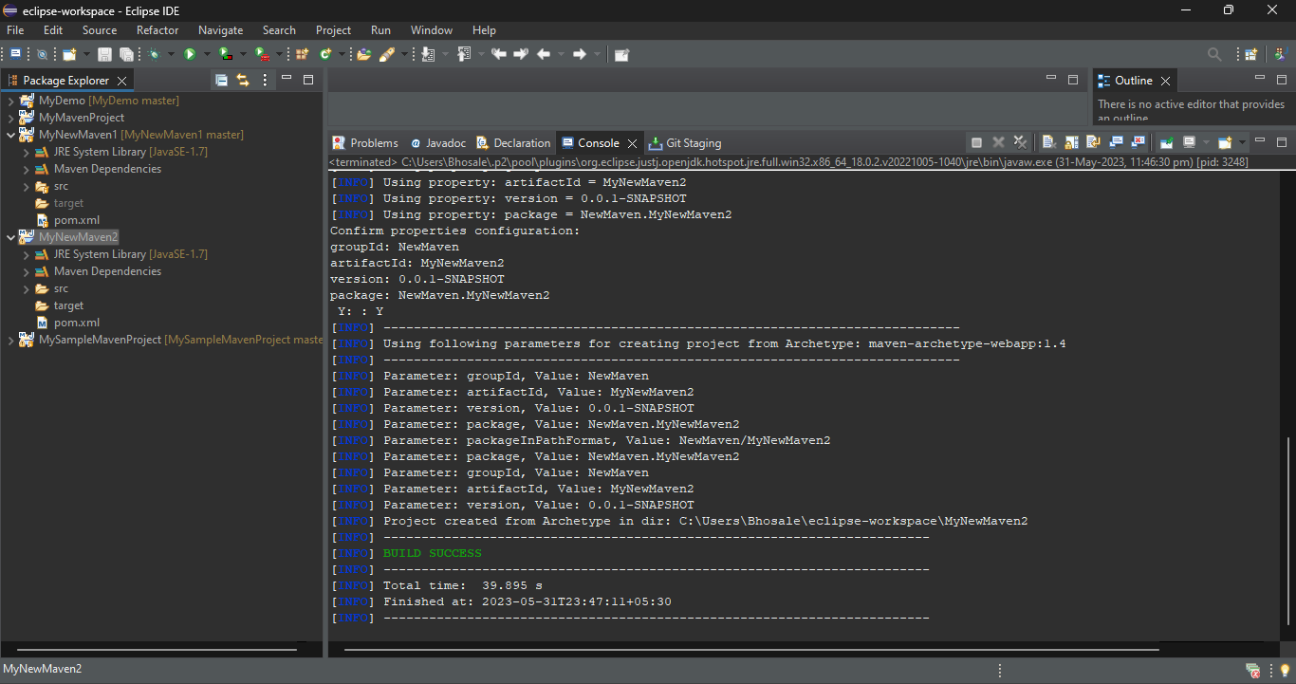

**Right Click on Project name → Team → Share Project → Select “*Use or create repository in parent folder of project*” → select checkbox of project name →Click on Finish and Check the preview :**

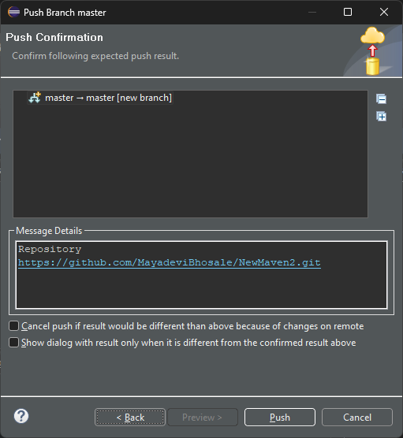

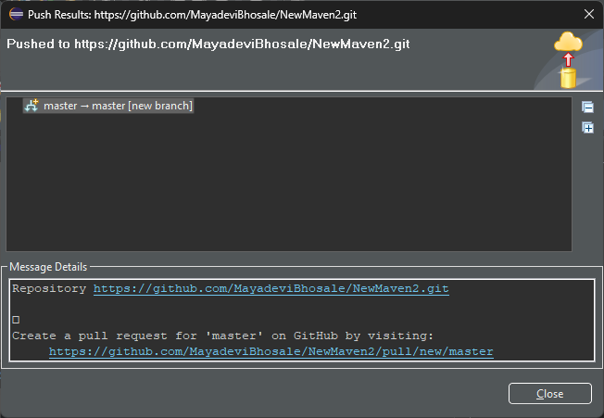

**In Jenkins :**

**Click on New Item → Enter Item Name → Select freestyle Project → OK**

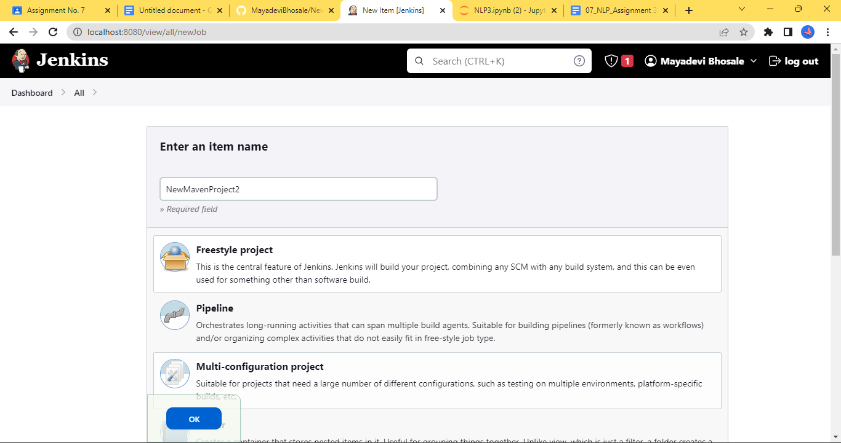

**Go to Configure → Source Code Management → Enter Git Repo URL**

**In Build Triggers → Choose Poll SCM → Enter * 5 times with space**

**In Build Steps → Select Invoke top level Maven Targets → select *maven version* → Enter Goals → *clean install***

**Now Click on Build Now :**

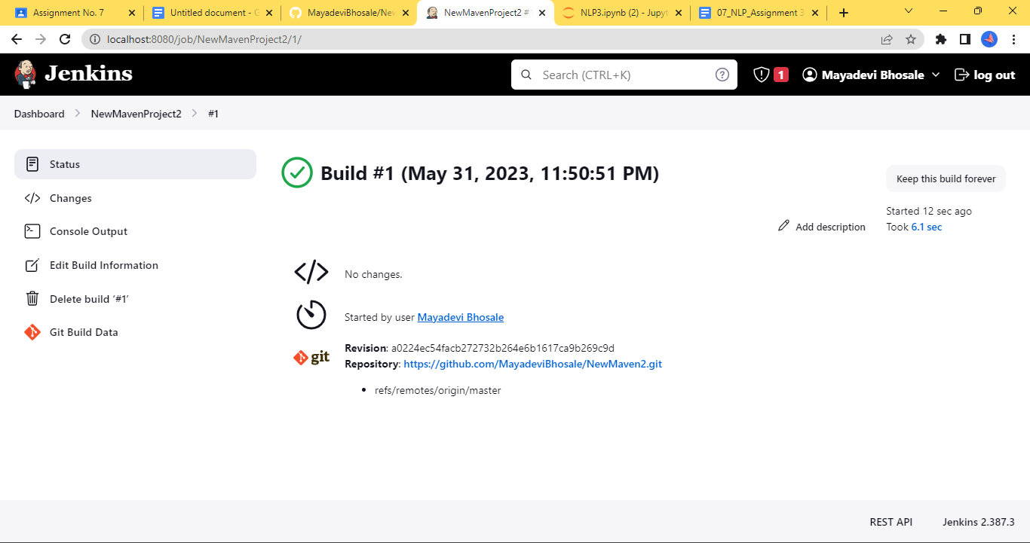

**Go to Manage Jenkins → Plugin Manager → Available Plugins → Search *Build Pipeline*  plugin → Click on *Install without restart***

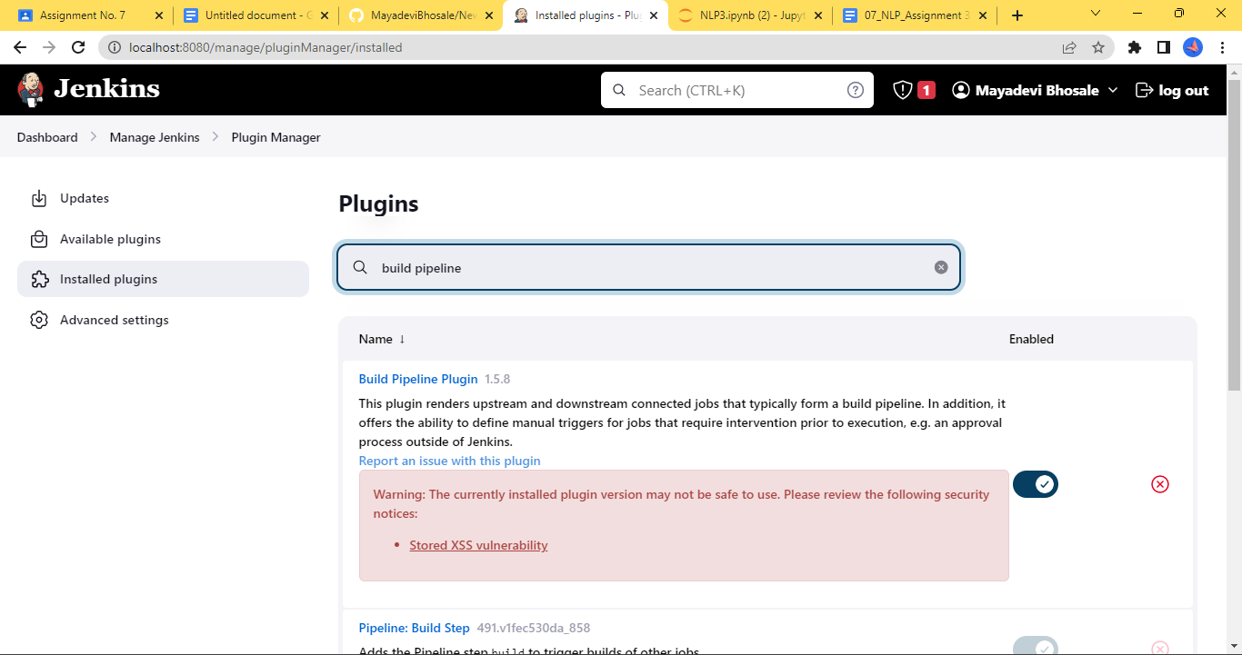

**Go to NewMavenProject2 → Configure → Post Build Actions → select *Build Other Projects* → Select *NewMavenProject1* for Projects to build**

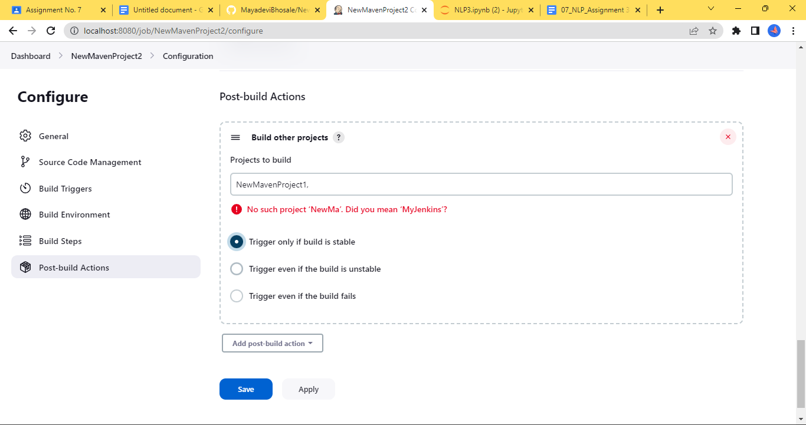

**Click on build now :**

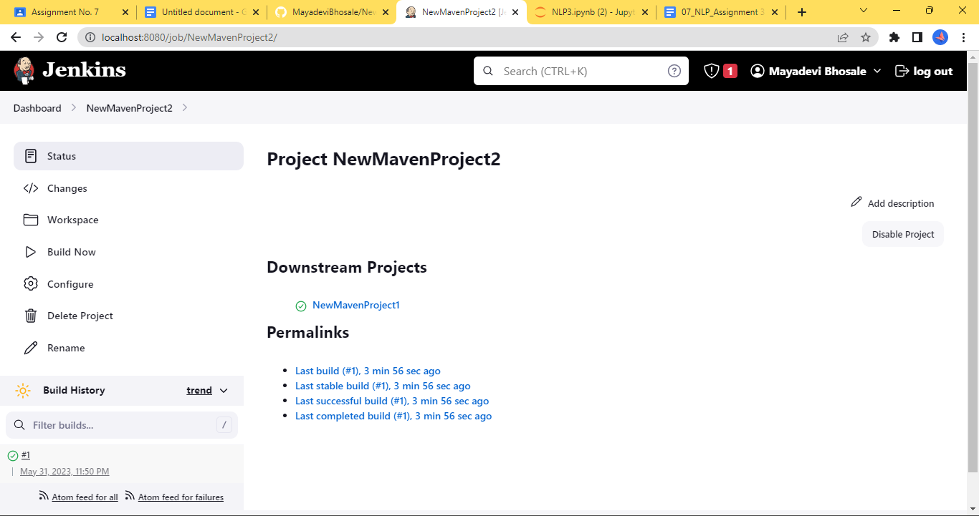

**Check the status :**

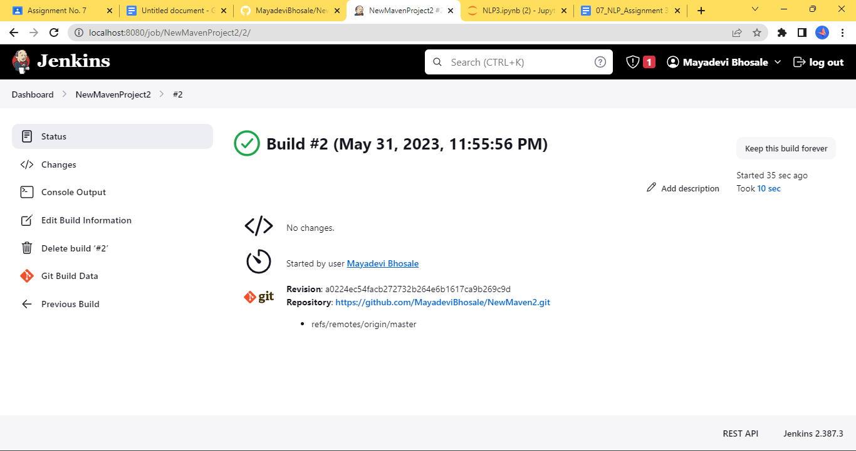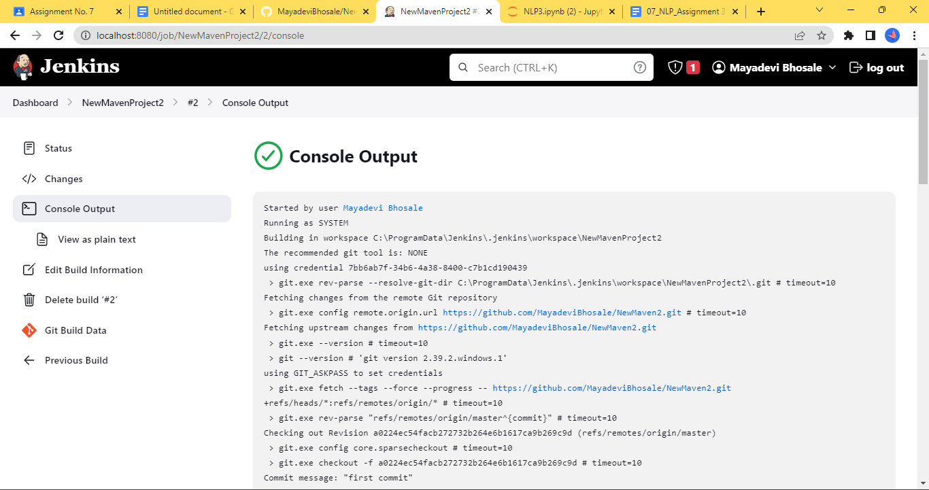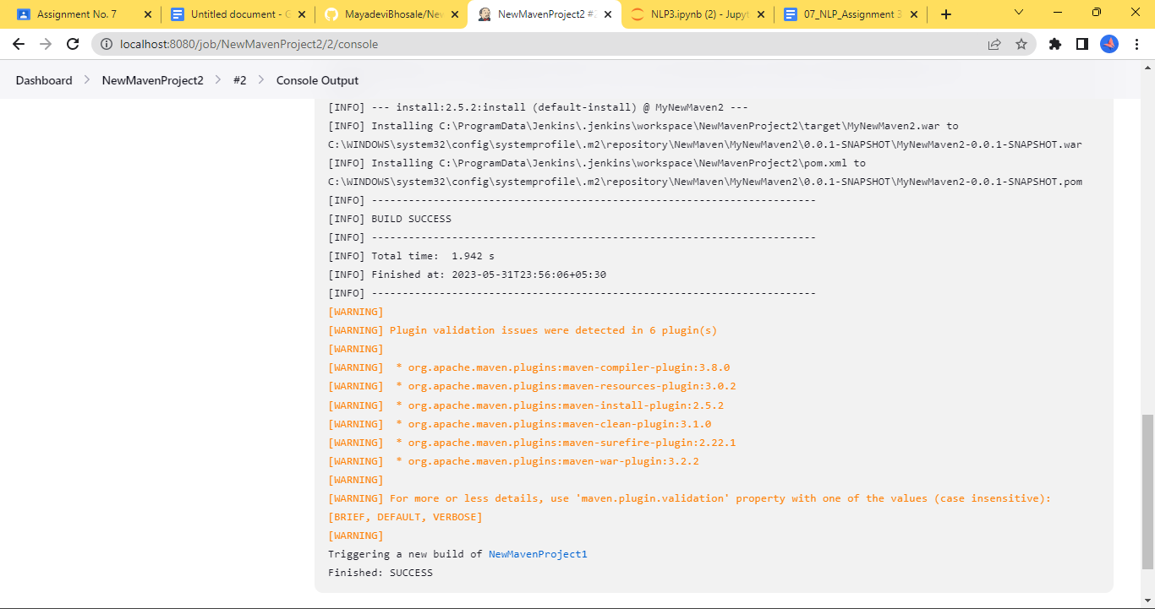

**Now Go to ‘NewMavenProject1’ and click on build now :**

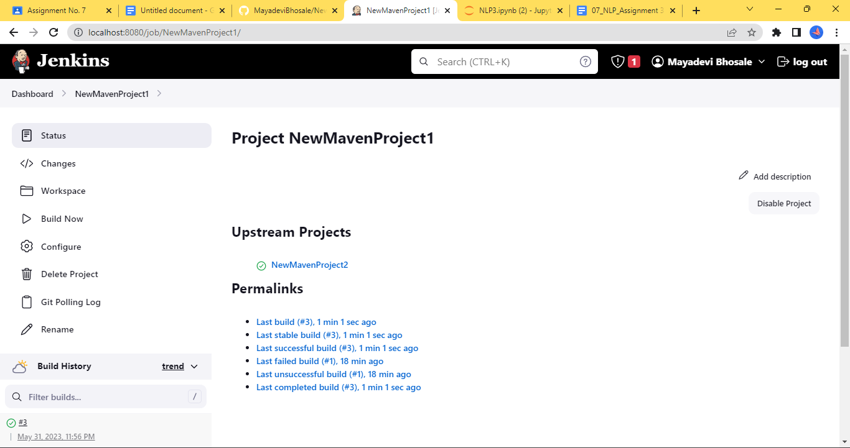

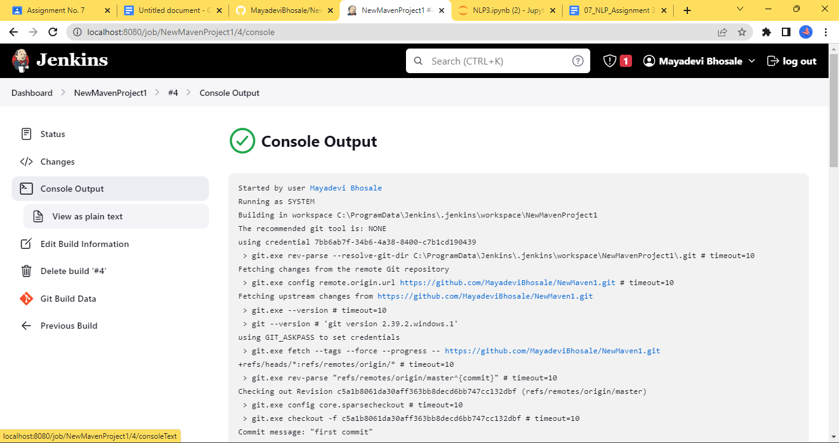

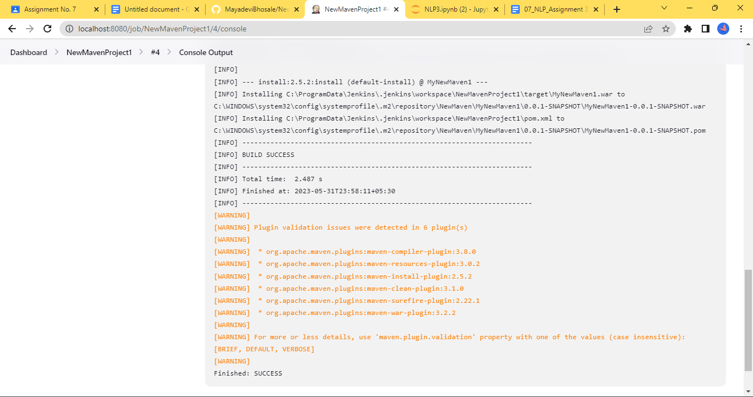

**Go to Dashboard → Create New View :**

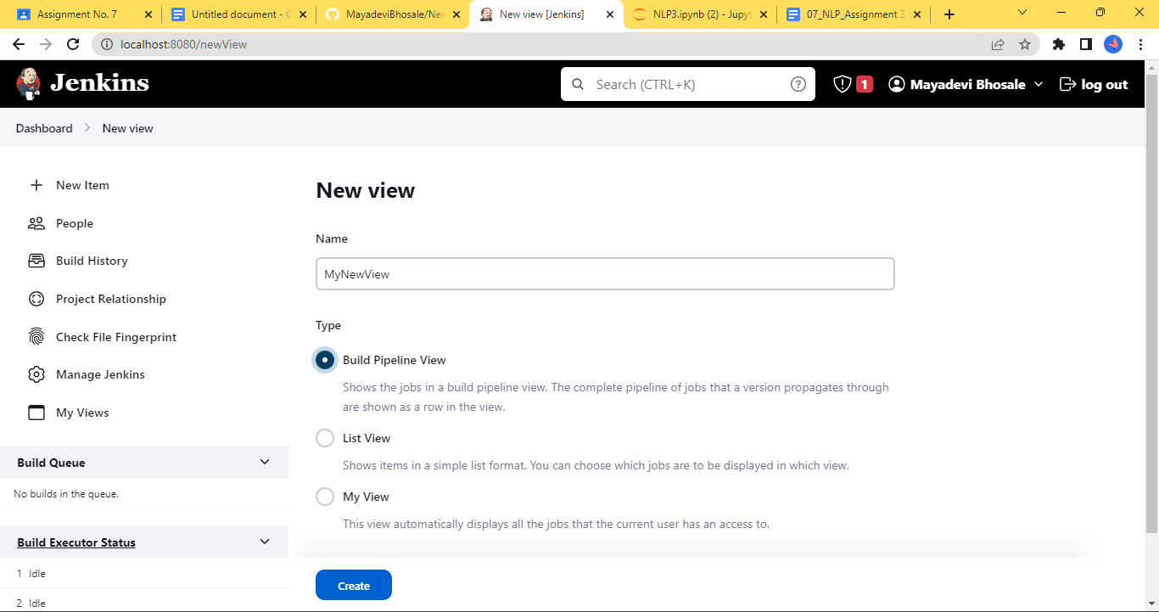

**Go to New View → Configure → Select Initial Job : NewMavenProject2**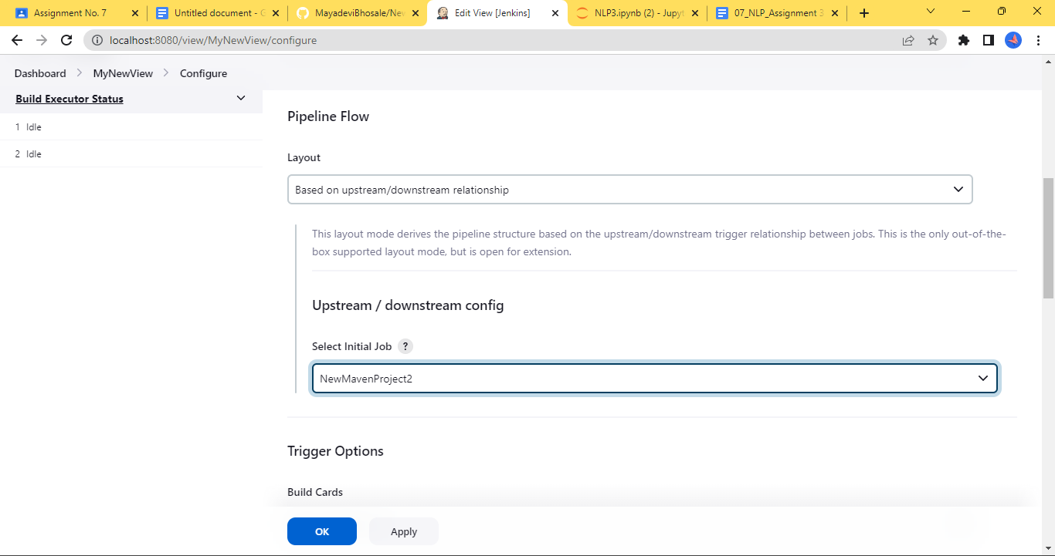

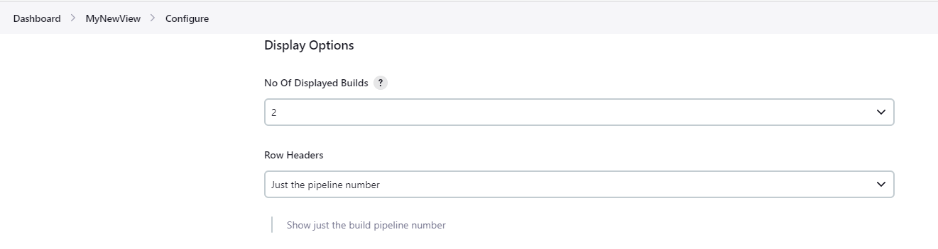

**Click on Apply and OK :**

