# **DevOps Assignment 8**

# **Create a Jenkins pipeline to execute any Java Application**

**Create New GitHub Repository and Add any source code of java application**

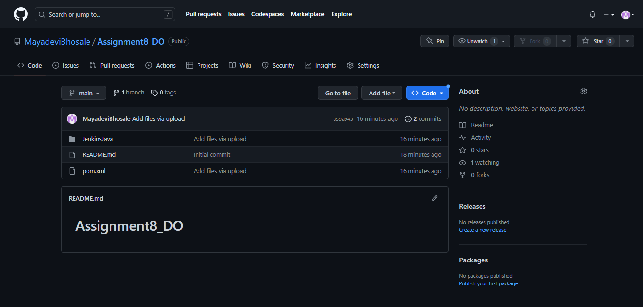

**To create a jenkins pipeline, we require 4 plugins as follows :**

* **Maven Integration**
* **Pipeline Maven Integration**
* **Pipeline Utility steps**
* **Junit Attachments**

**For this, Go to Manage Jenkins → Manage Plugins → Available Plugins → search all above plugins → click on install without restart :** 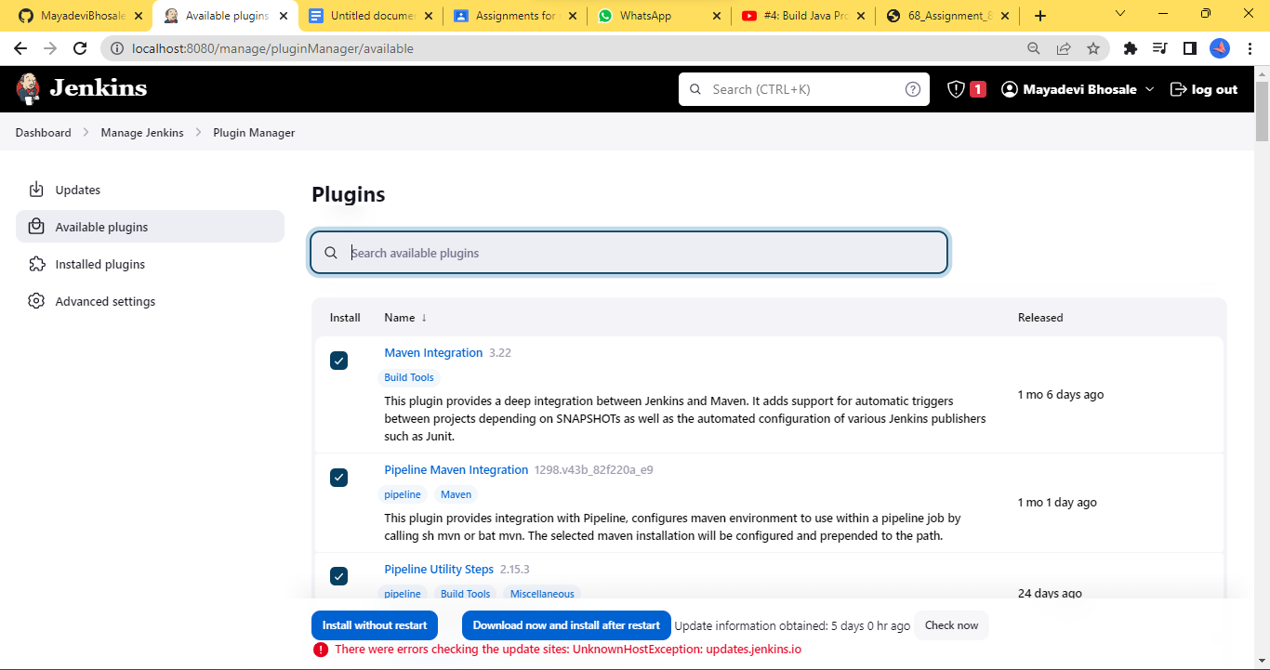

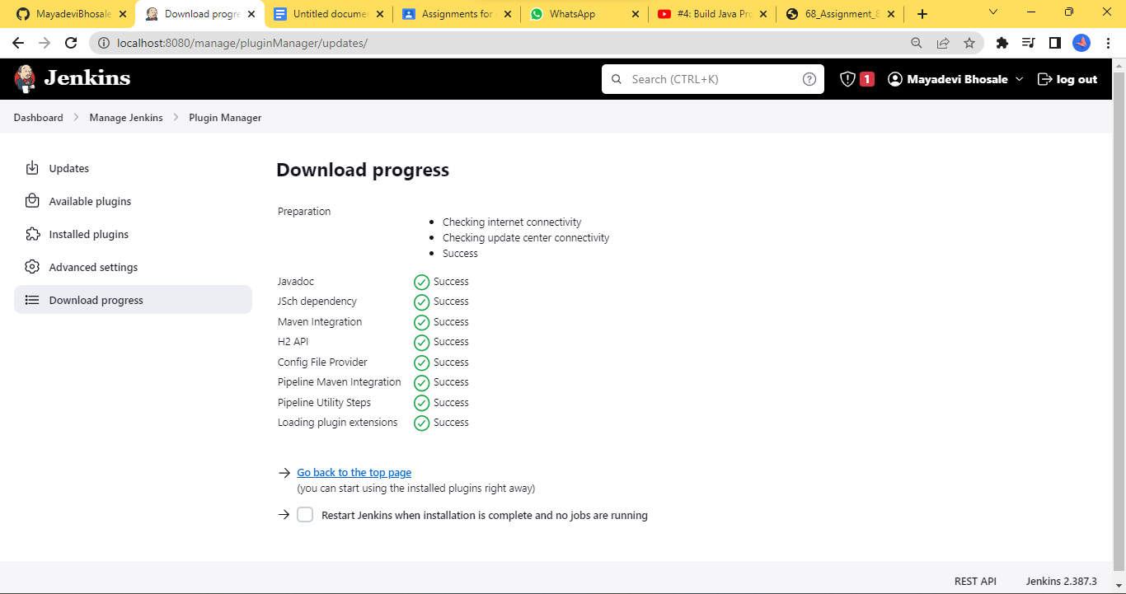

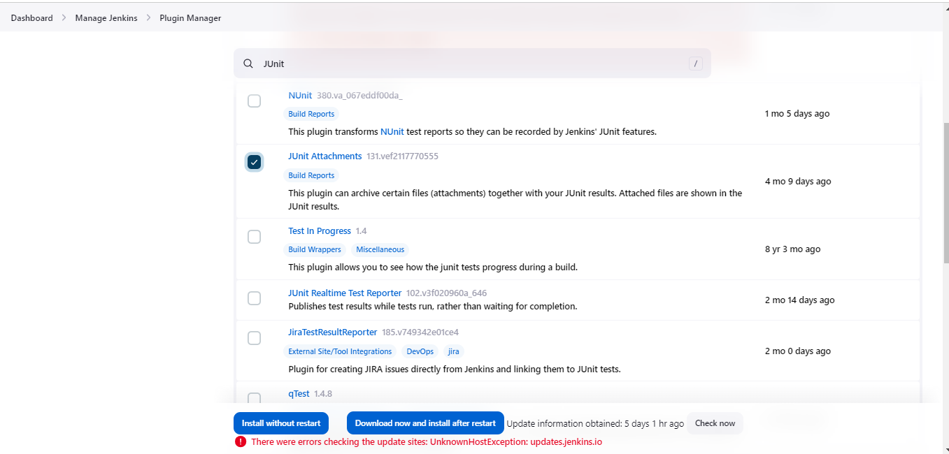

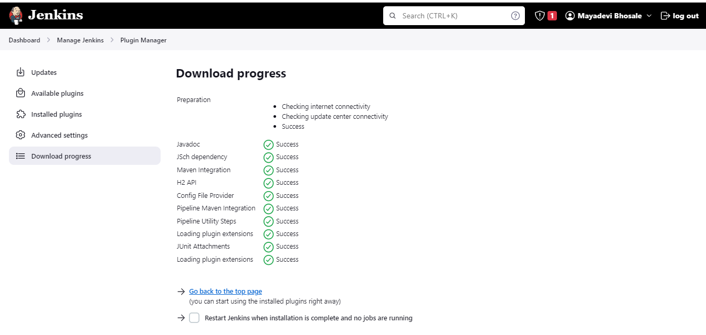

**Click on New Item → Enter new item name → select Pipeline Project :** 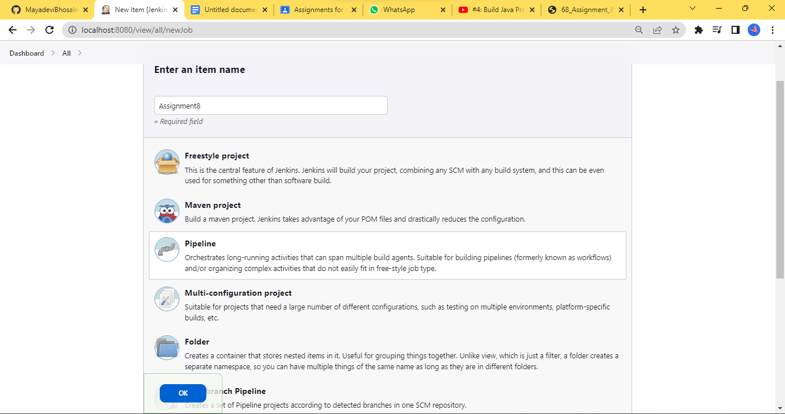

**In General → Click on GitHub Project → Enter GitHub Project link :**

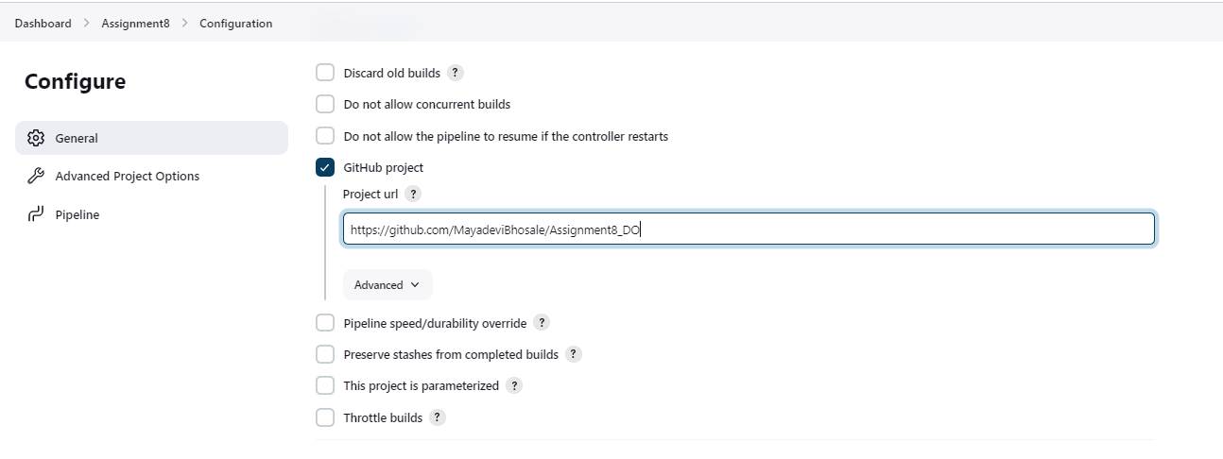

**In Build Triggers → select Build whenever a SNAPSHOT dependency is built and Github hook trigger for GITscm polling**

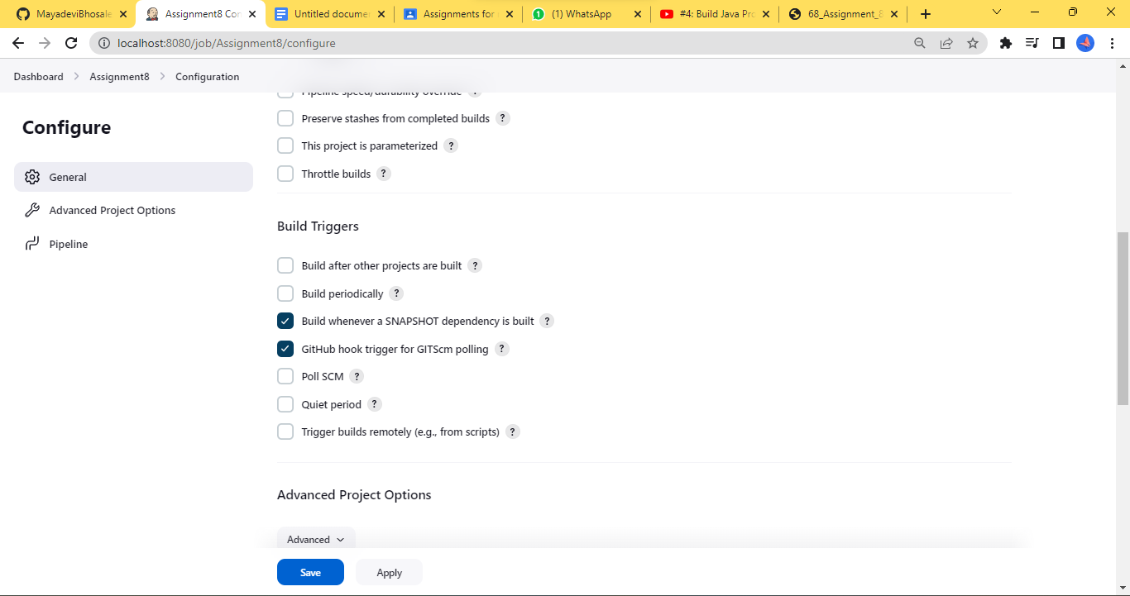

**In Pipeline → Select Pipeline Script → Add Script**

**My Script is :**

**pipeline {**

**agent any**

**tools{**

**maven 'Maven'**

**}**

**stages {**

**stage('Build') {**

**steps {**

**echo 'Hello World!!!'**

**checkout scmGit(branches: [[name: '*/main']], extensions: [], userRemoteConfigs: [[credentialsId: '7bb6ab7f-34b6-4a38-8400-c7b1cd190439', url: 'https://github.com/MayadeviBhosale/Assignment8_DO.git']])**

**}**

**}**

**}**

**post {**

**always{**

**junit(**

**allowEmptyResults: true,**

**testResults: '*/test-reports/.xml'**

**)**

**} }}**

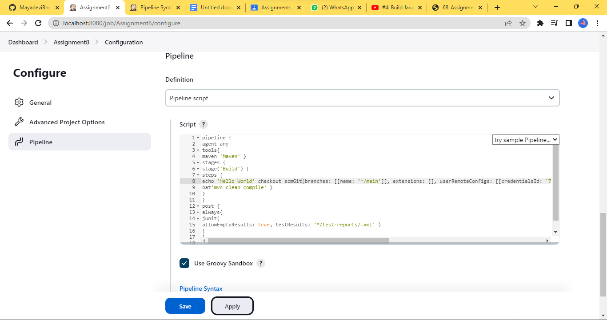

**To generate the pipeline script for you github repository click on pipeline syntax below**

**Check the Use Groovy Sandbox checkbox**

**In Sample steps click on checkout: Check out from version control**

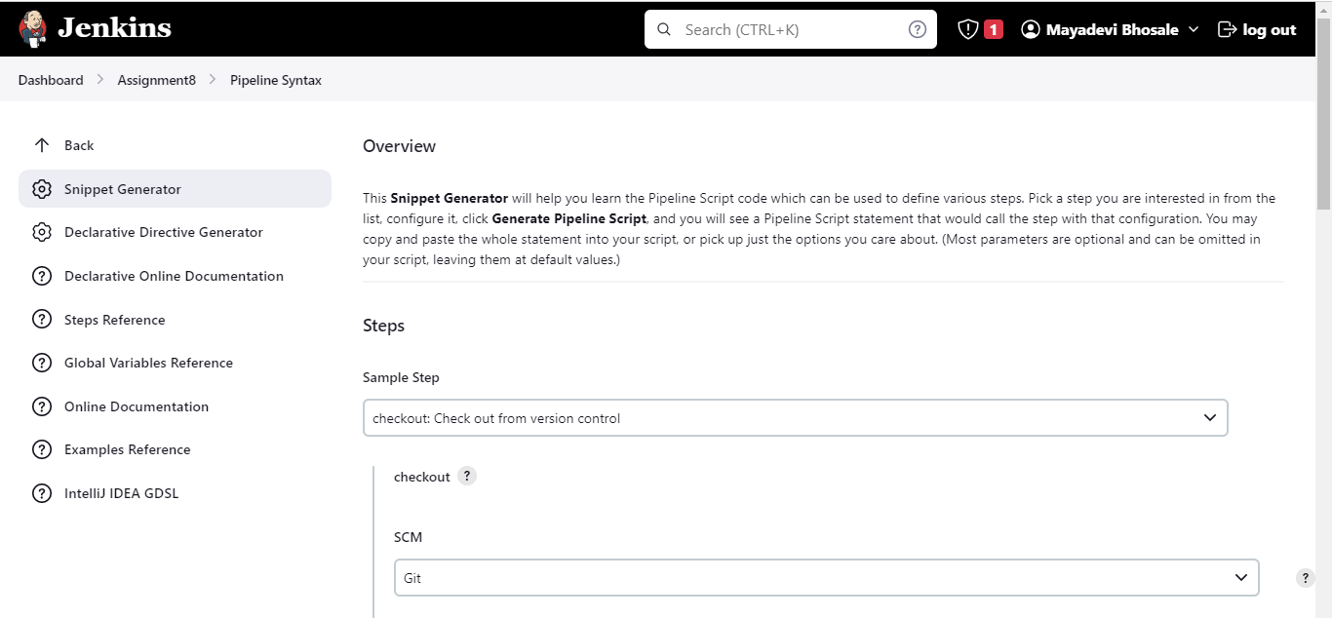

**Enter Repo URL and Credentials :**

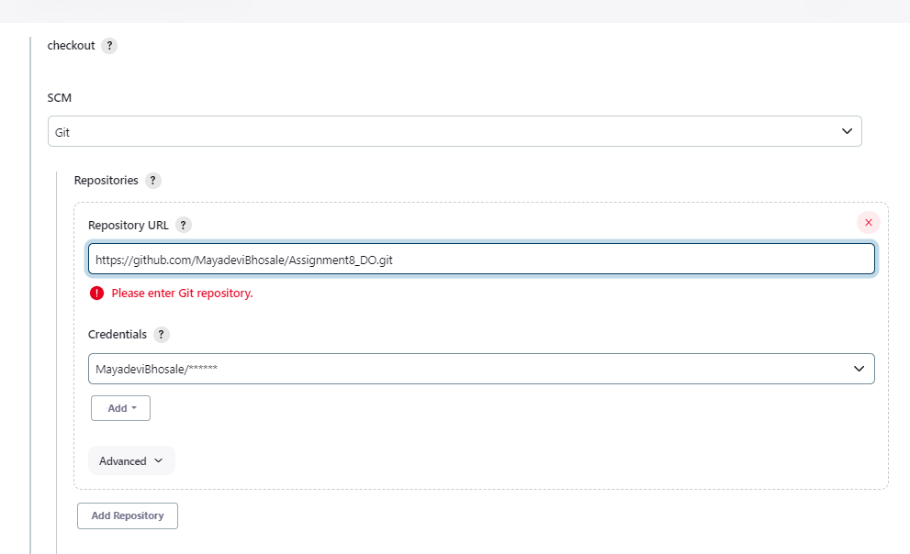

**Change the branch → Click on Generate Pipeline Script :**

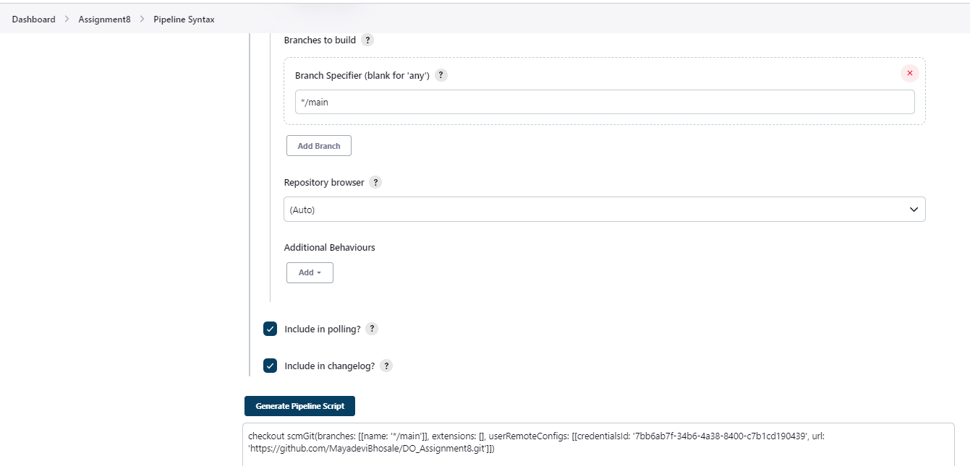

**Click on Apply and Save → click on Build Now :**

