# **DevOps Assignment No : 9**

**Build a Docker image and push it to Docker Hub. Pull it on another system. Create and run a new container from an image.**

**Install Docker Desktop for your system :**

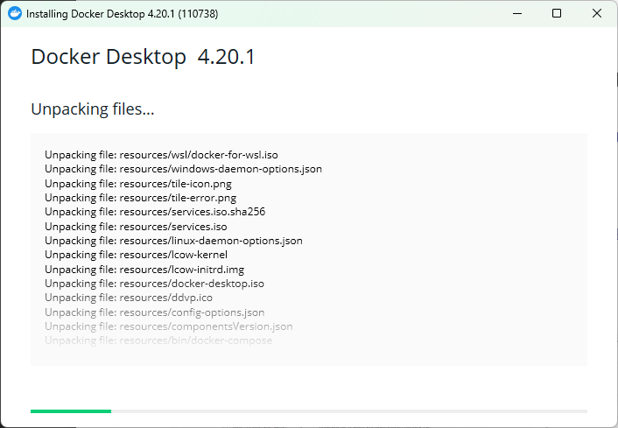

**Accept Service Agreement :**

**Signed In to Docker Account as below: -**

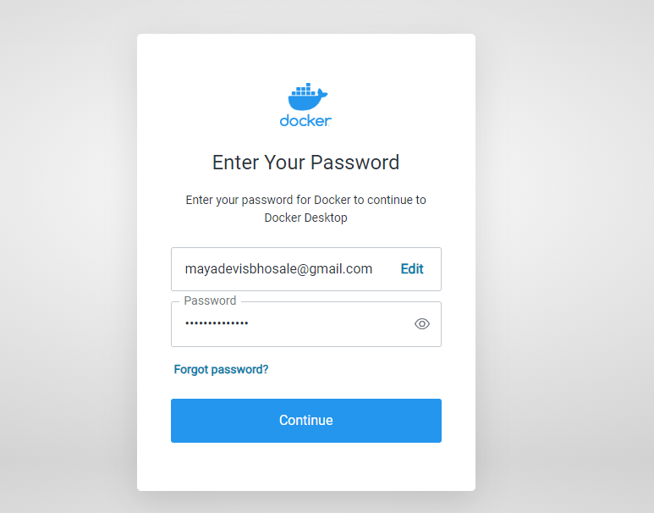

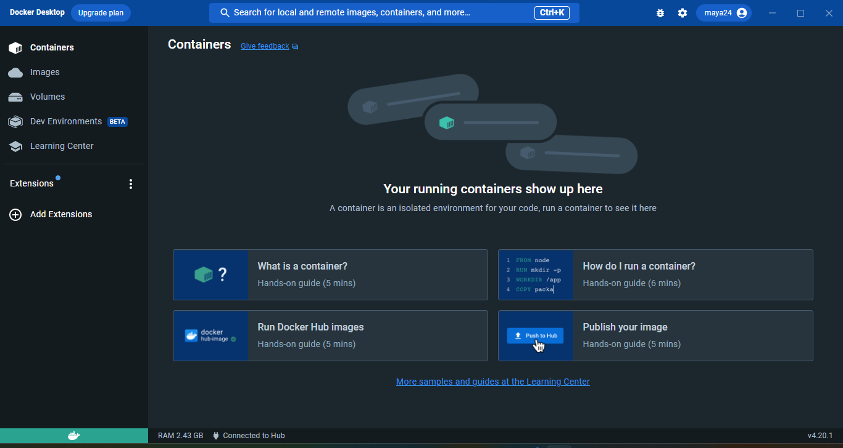

**Now we will install WSL2 file: -**

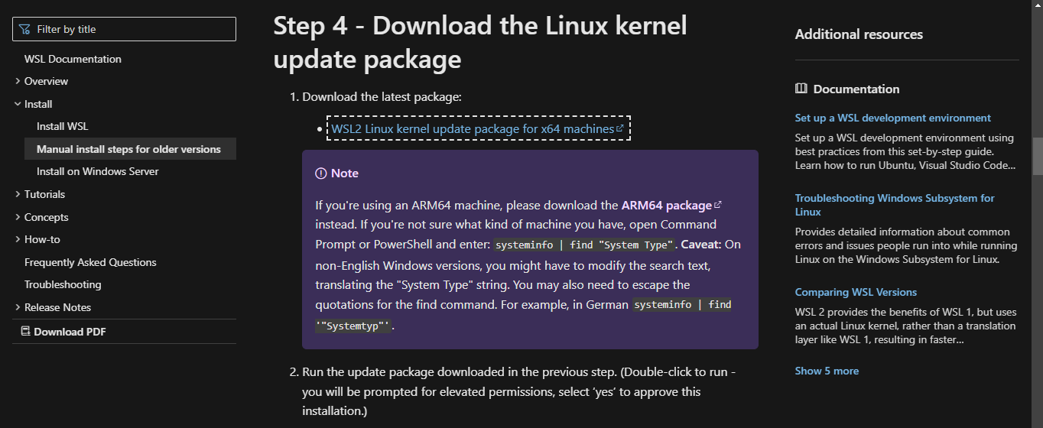

**Then we will create folder named “hello-docker-java”: -**

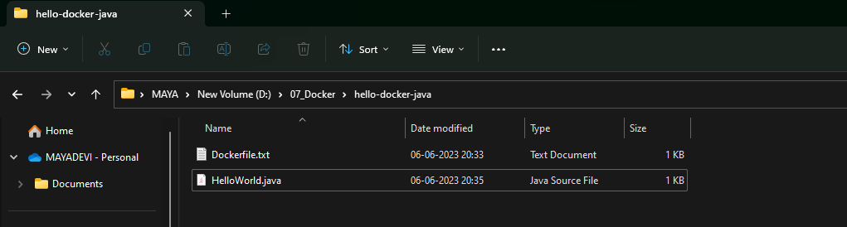

**In that folder, we will create two files as below and third file will be getting after running the java file: - “Dockerfile” as below : -**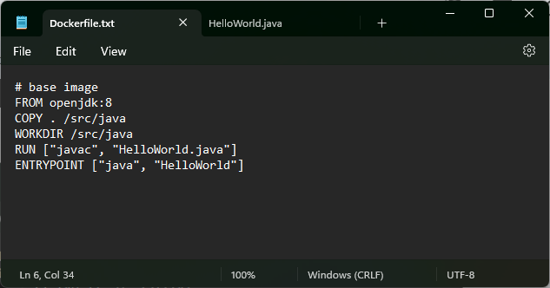

**“HelloWorld.java” file as below :-**

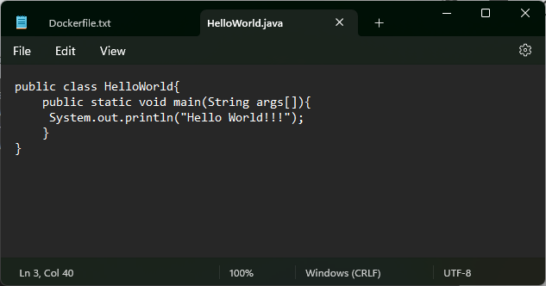

**Run Java file then only class file will be created as follow: -**

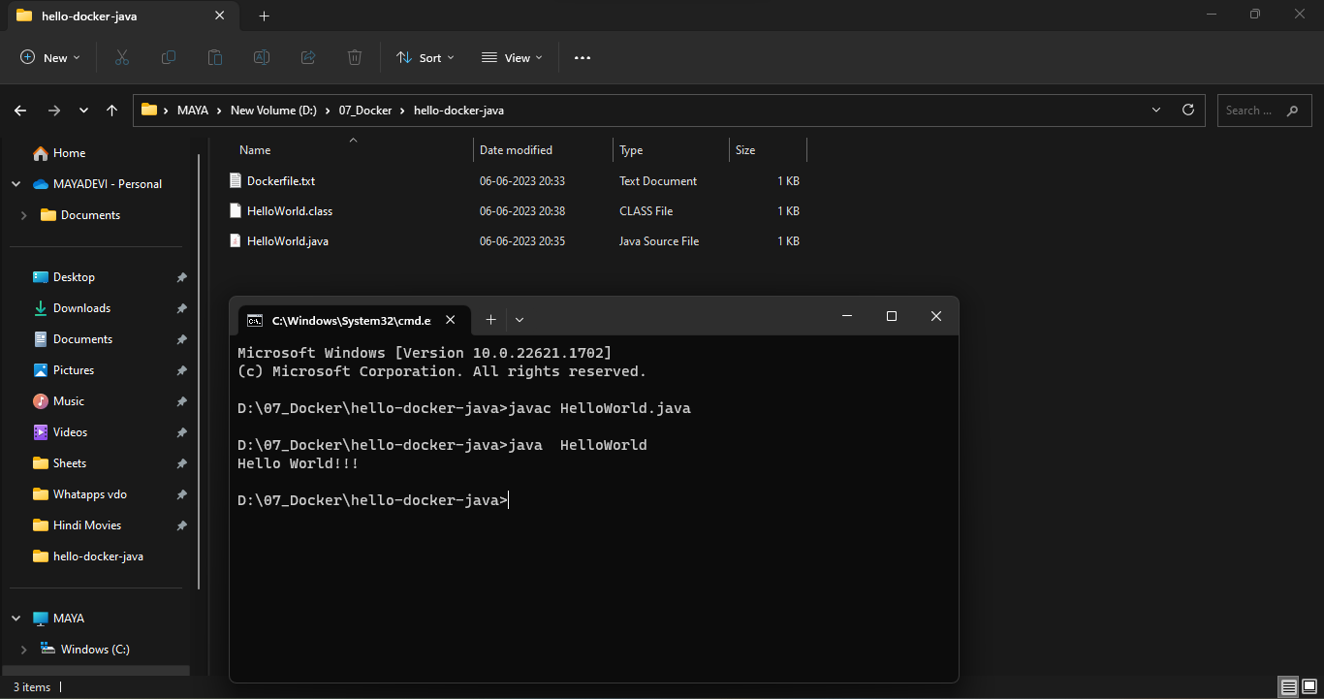

**Sign in Docker Hub as follow:-**

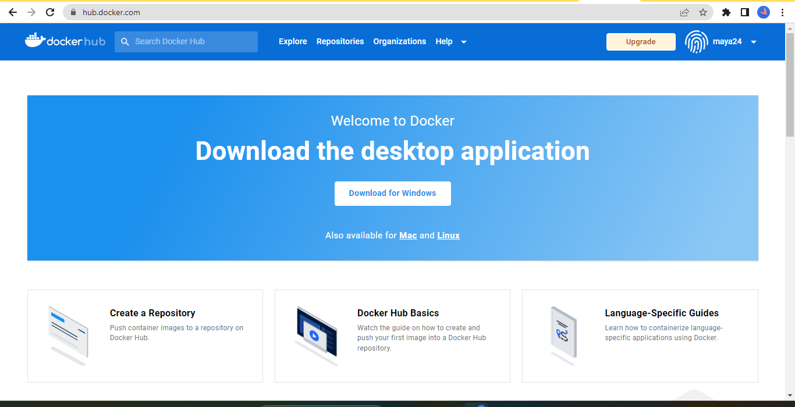

**Save the Dockerfile name in “” without any extension :**

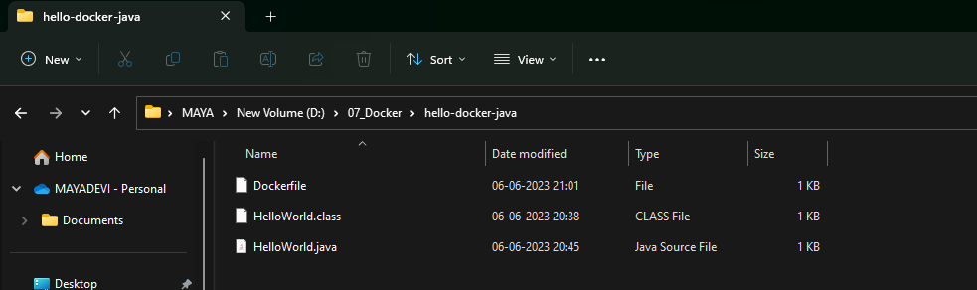

**Give the command as below to build our Java file and build will get started :-**

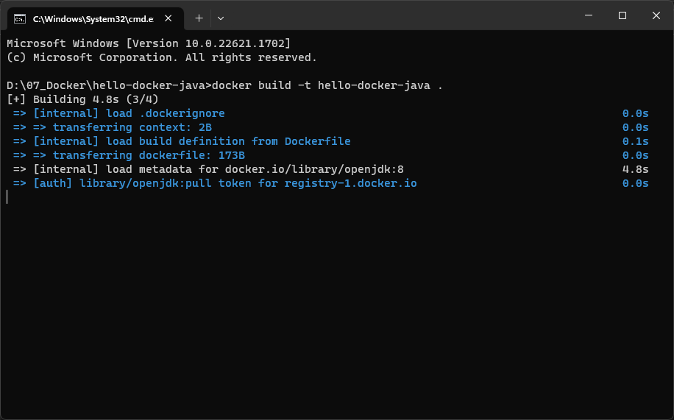

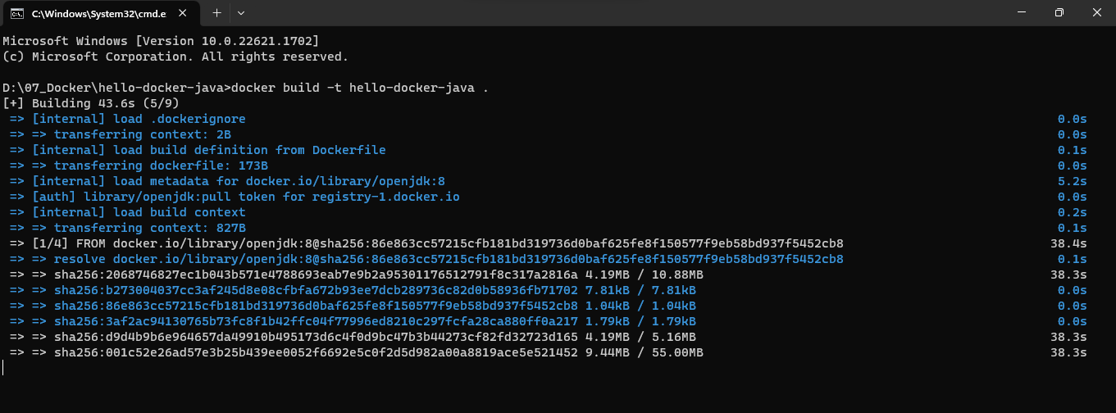

**Building is finished as below: -**

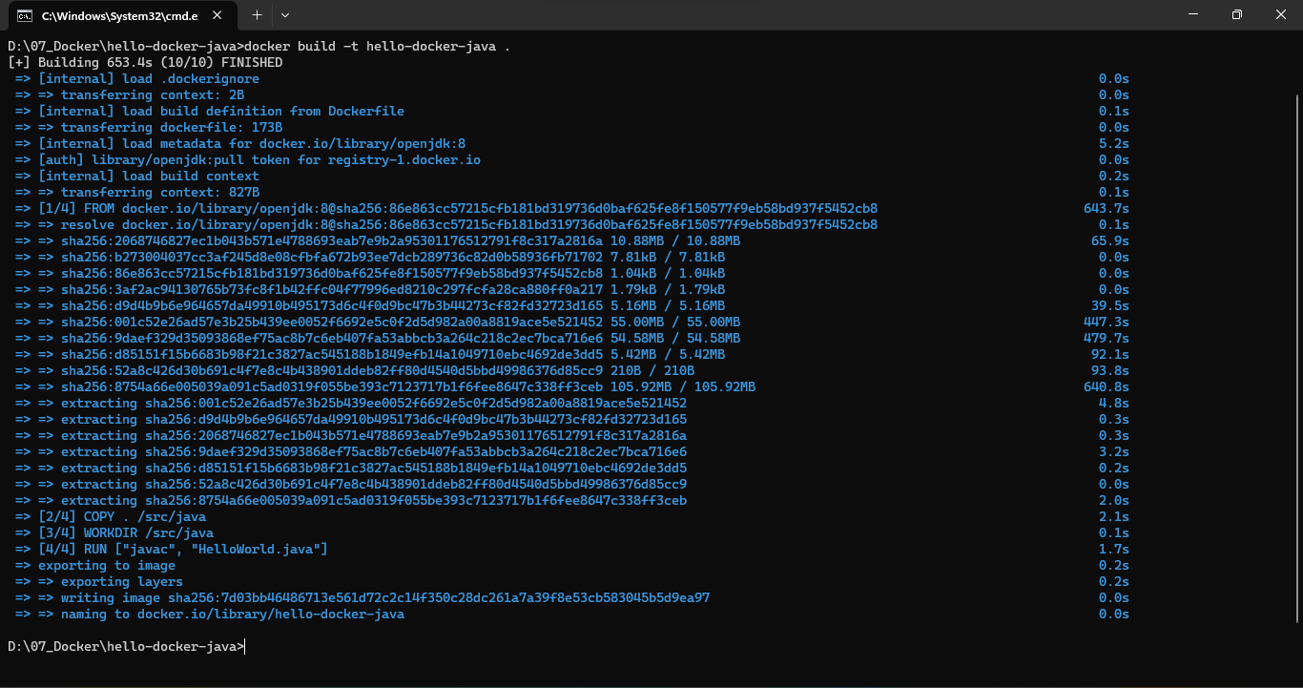

**Then we will check whether our docker image is present or not by giving the following command.**

**Here we can see Image generated as follow and run our docker image and will get o/p as follow: -**

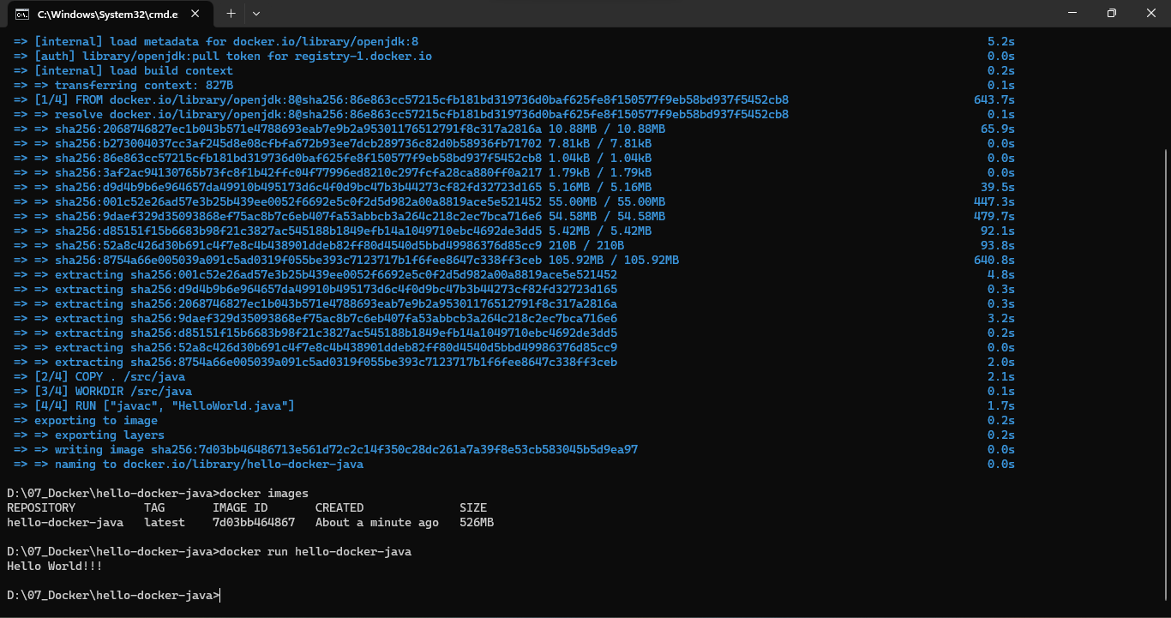

**We will add tag as below: -**

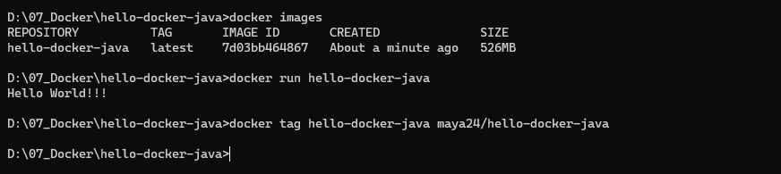

**Then we will login to the Docker Hub account as below.**

**Login is Succeeded as below: -**

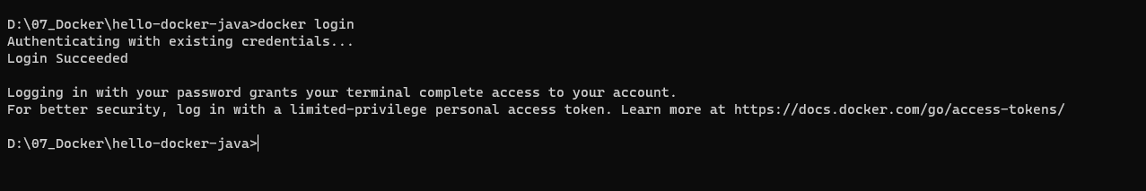

**Currently no Repository is present as below: -**

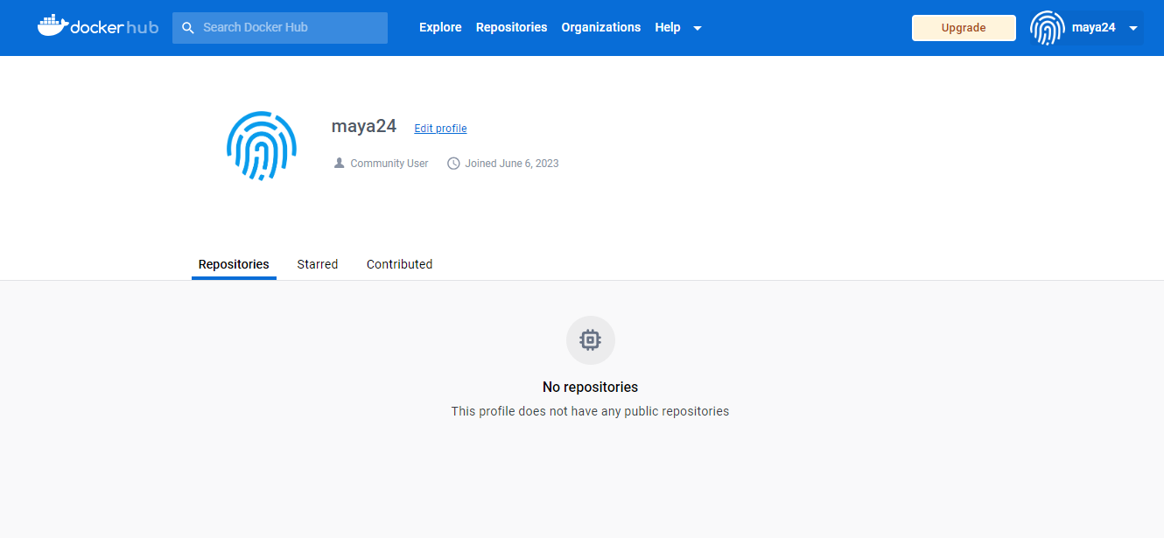

**Then we will push our Docker Image as follow: -**

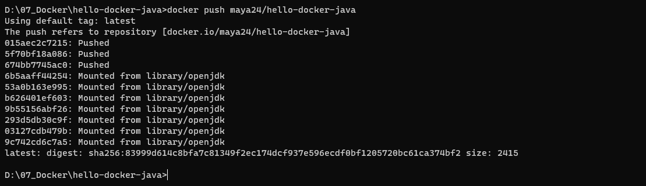

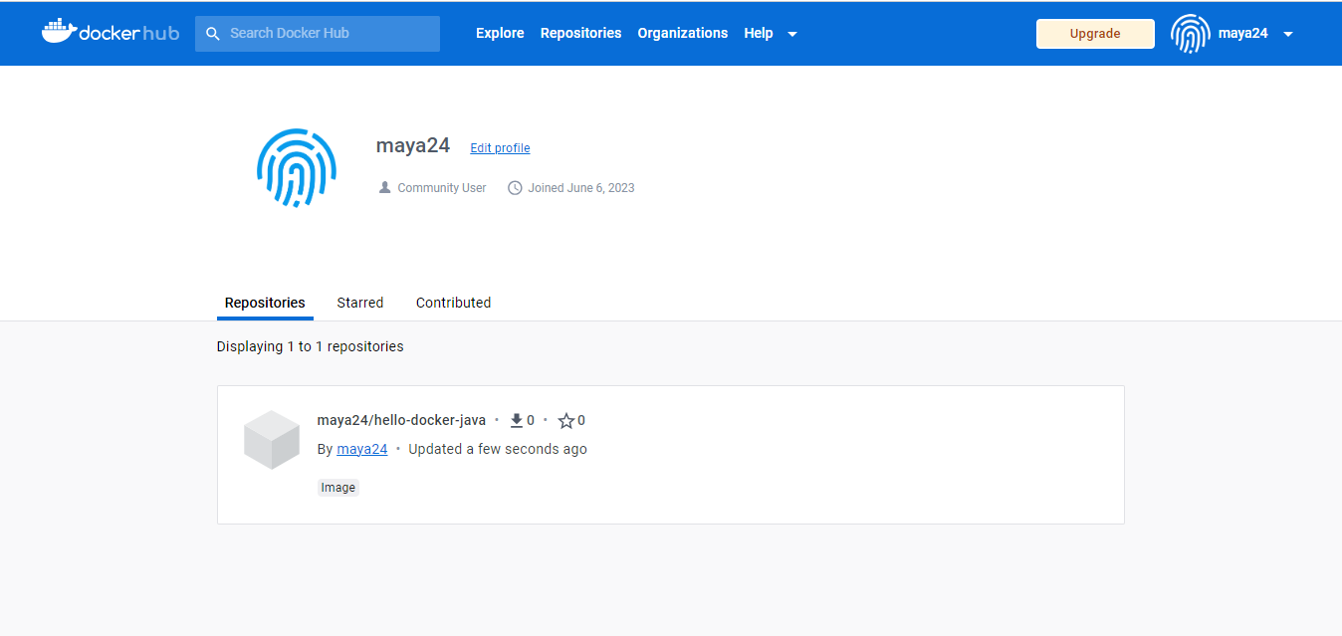

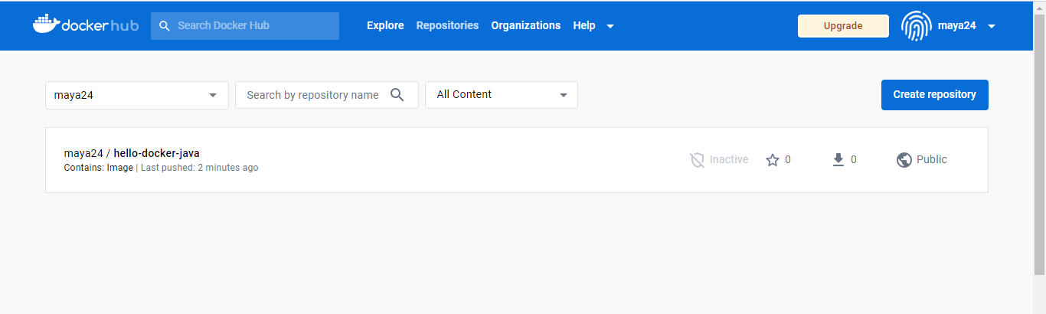

**Pushed Docker Image as below: -**

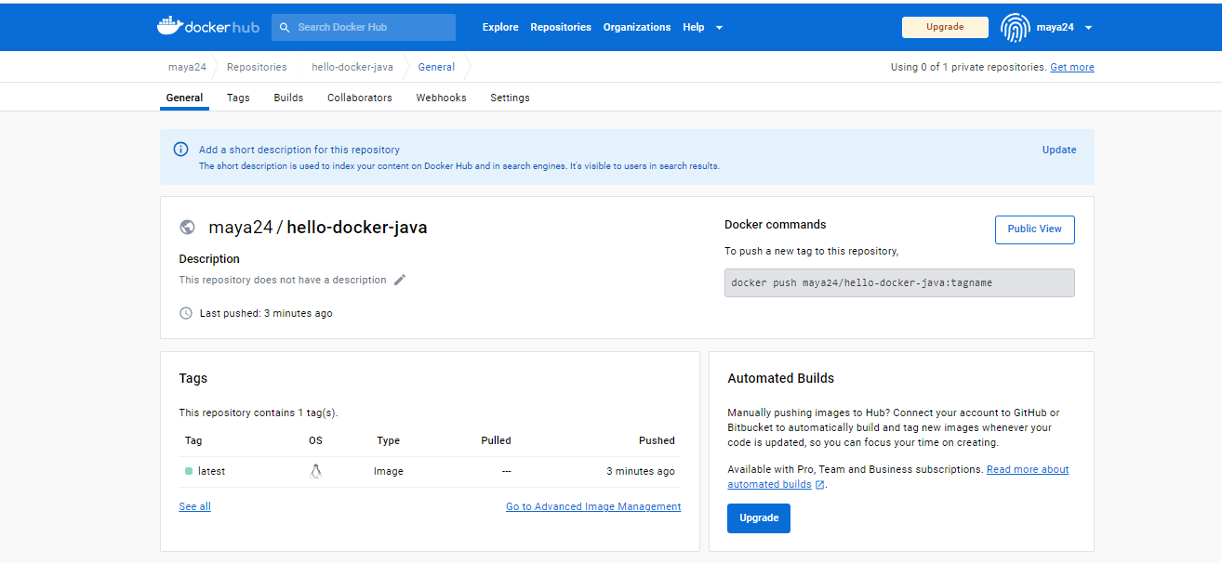

**Our Public URL of docker image is as below: -**

[**https://hub.docker.com/r/maya24/hello-docker-java**](https://hub.docker.com/r/maya24/hello-docker-java)

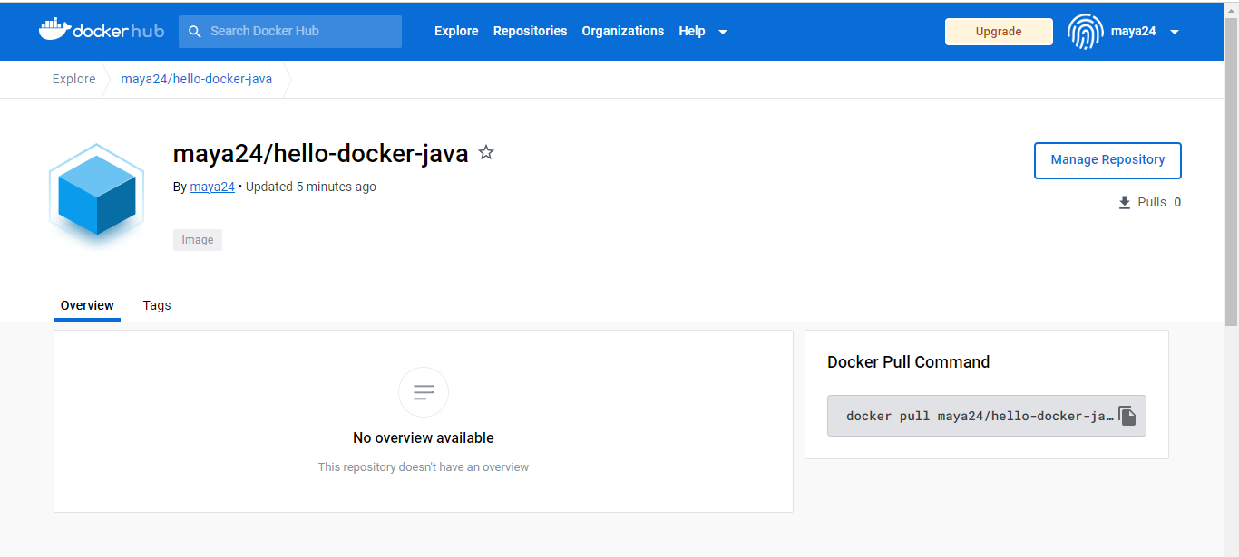

**Command for Pulling docker image as : docker pull maya24/hello-docker-java**

**Current Docker Images as below: -**

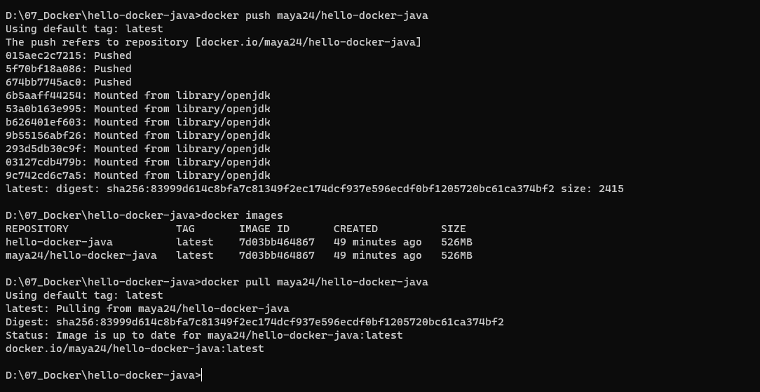

**When we click on Images tab in our Docker Application: -**

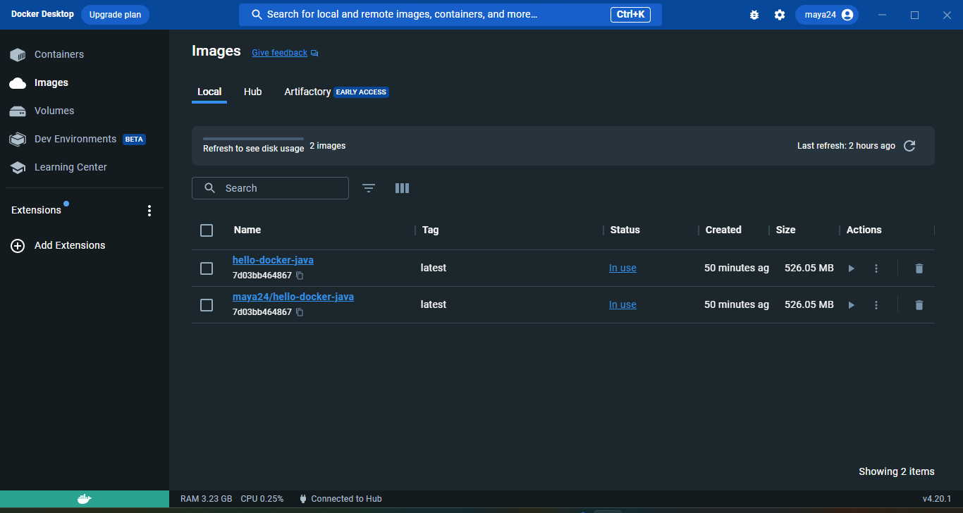

**Remote Repositories as below: -**

