LK WELLNESS · DOCTOR–PATIENT APP
Proof of Concept
Demo guide
A walkthrough of the working app: the patient portal, the doctor portal for Dr. Padmanaban, Integrative Expert Practitioner, and the admin area, with screenshots of every main screen.
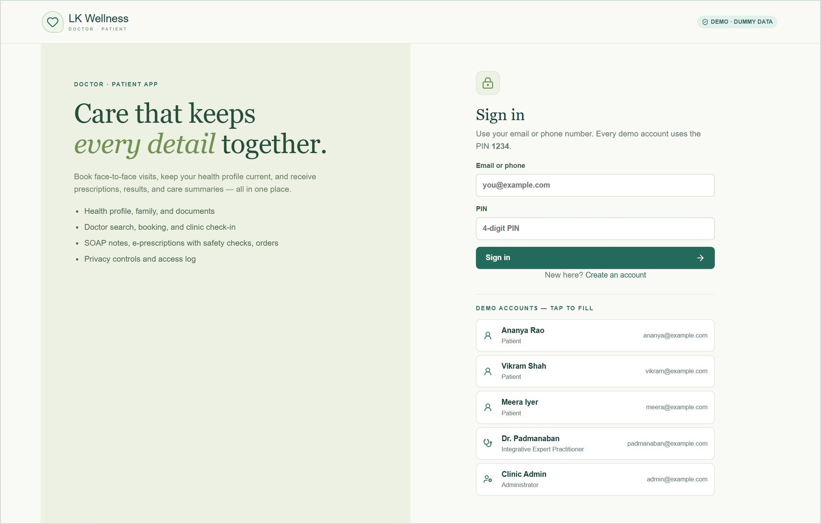
Version | POC build of 2 October 2026
Data | Dummy data only, stored in one JSON file (no database)
Sign-in | Any demo account with PIN 1234
Screens shown | Captured from the running app on 2 October 2026

Contents
- About this proof of concept
- Before the demo: running the app and demo accounts
- Patient portal
- Doctor portal
- Admin area
- On a phone
- Suggested 15-minute demo script
- Coverage against the components document
- Known limits and next steps

1. About this proof of concept
The proof of concept (POC) turns the components listed in Doctor_Patient_App_Components.docx into one working web app with three areas:
- Patient portal: registration, health profile, family members, booking face-to-face visits, results, e-prescriptions, messages, and privacy controls.
- Doctor portal: the day's clinic queue, schedule and fees, a single-screen patient record, the consultation workspace with safety-checked e-prescriptions, follow-up, and earnings.
- Admin area: doctor verification, user management, and platform analytics. Admins cannot open clinical records.
Every record type (patients, allergies, medications, appointments, notes, prescriptions, orders, messages and so on) can be created, viewed, edited and deleted. All data is fictional.

Decisions applied from the document
Topic | How the POC handles it
Login | Every account signs in with the PIN 1234. OTP, email verification and biometrics are not part of the POC.
Consultations | Always face-to-face at the clinic. Patients check in on arrival, which replaces the video "waiting room". There are no video, audio or chat calls.
Payments | To be decided. Fees are shown, and the app states that payment is collected at the clinic.
Doctors | The clinic has one doctor: Dr. Padmanaban, Integrative Expert Practitioner. More doctors can register and be verified by the admin.
Storage | No database. All data lives in one JSON file that can be reset to the dummy data at any time.

Placeholders to confirm: Dr. Padmanaban's registration and licence numbers (DEMO-REG-0001, DEMO-LIC-0001), qualifications and clinic address are placeholders. They print on e-prescriptions. They can be updated under Profile when signed in as the doctor.

Quality checks
Before this guide was written, the app passed a type check and a production build, 32 automated API tests, and 14 browser tests. The browser tests open every page for each role on desktop and phone widths and run the main journeys end to end.

2. Before the demo

Start the app
From the codebase folder in PowerShell (Node.js 22 or newer):
Step | Command
First time only | npm.cmd ci
Create the dummy data | npm.cmd run data:seed
Build and start | npm.cmd run build, then npm.cmd run start
Open | http://127.0.0.1:3000
Fresh data before each demo | npm.cmd run data:reset

Dummy-data dates are relative to the moment the data is reset, so today always has a clinic queue. Resetting also signs everyone out and removes uploads. Dates in this guide are from 2 October 2026.

Demo accounts
Every account uses the PIN 1234. The sign-in page lists all accounts; click one to fill it in.
Account | Role | Good for showing
ananya@example.com | Patient | Rich history, a dependent son (Aarav), a visit today at 10:30, a further booking request
vikram@example.com | Patient | Diabetes; already checked in for today's 10:00 visit
meera@example.com | Patient | New patient with a booking request waiting for the doctor
padmanaban@example.com | Doctor | Dr. Padmanaban: today's queue, booking requests, alerts, messages
admin@example.com | Admin | Doctor verification, users, analytics
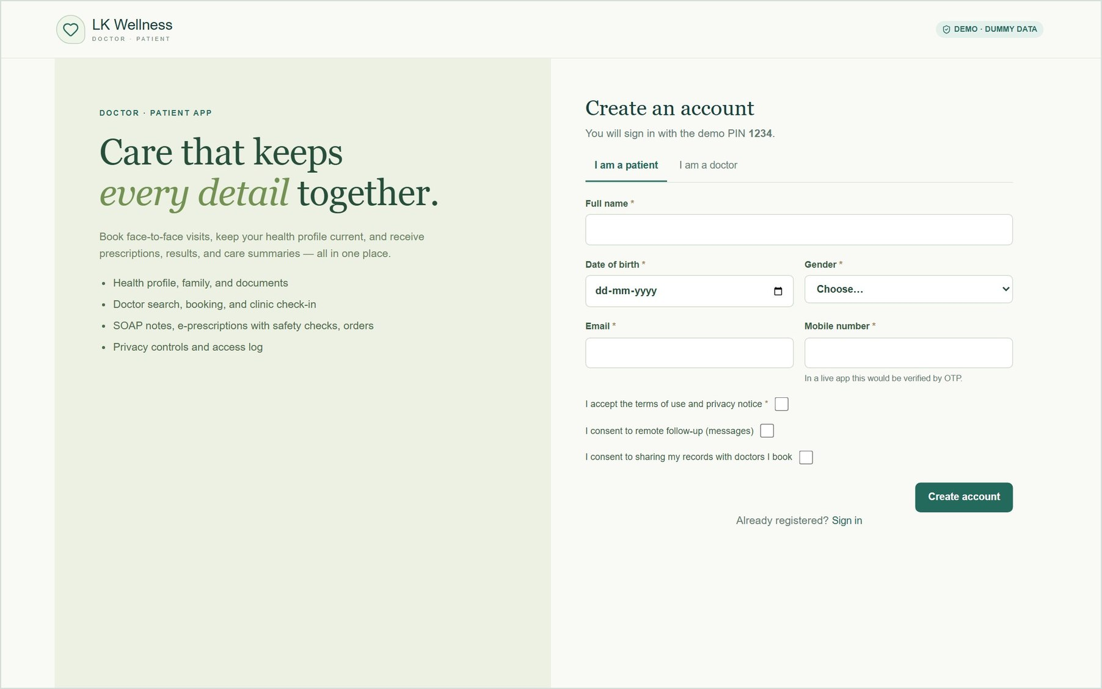
Figure 1. New patients register themselves: name, date of birth, contact details, and consent. Doctors use the "I am a doctor" tab.

3. Patient portal
Sign in as ananya@example.com. The bar under the menu switches between Ananya and her son Aarav, so a parent can manage a child's records from the same account.

3.1 Home
The home page shows upcoming appointments, refill reminders and recent results, with an out-of-range result flagged. A permanent notice tells patients the app is not for emergencies and offers a one-tap call to 112.
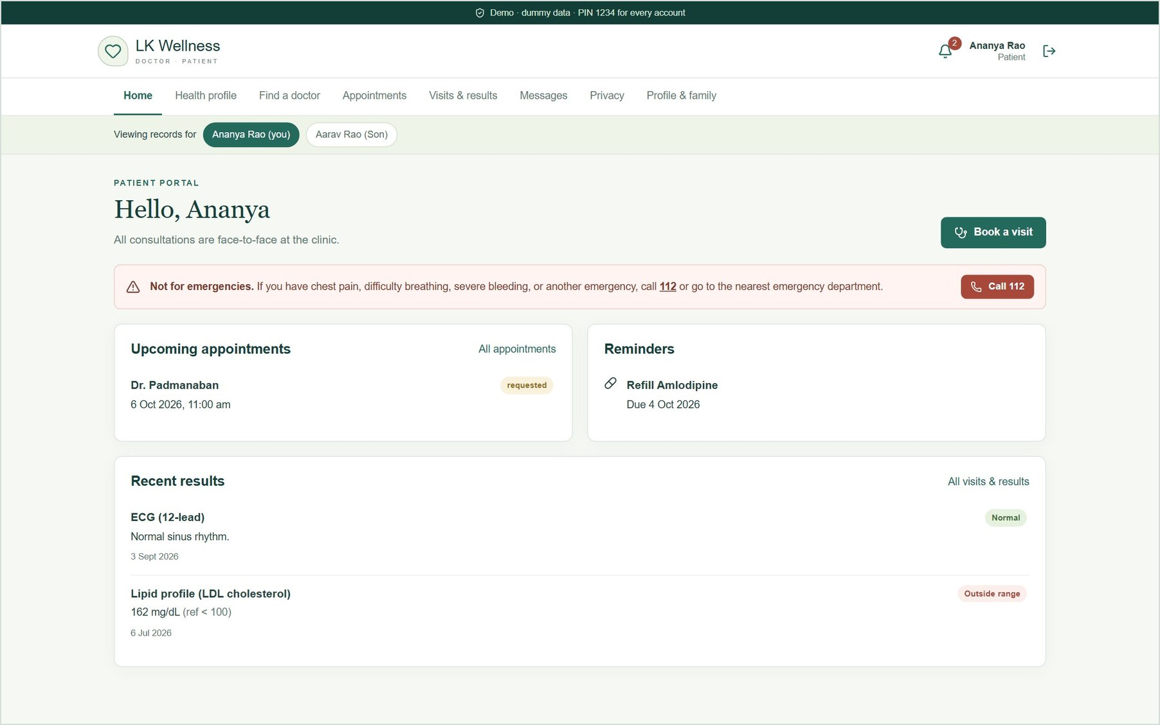
Figure 2. Patient home: upcoming visits, reminders, recent results, and the emergency notice.

3.2 Health profile
Five tabs keep the patient's profile current before a visit: Medical history, Allergies, Medications, Vitals and Documents. Every entry can be added, edited and deleted.
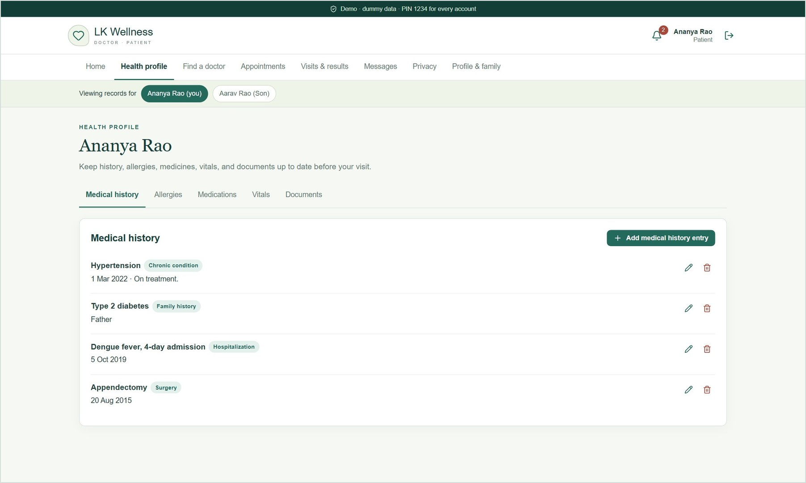
Figure 3. Medical history: chronic conditions, family history, hospitalisations and surgeries.
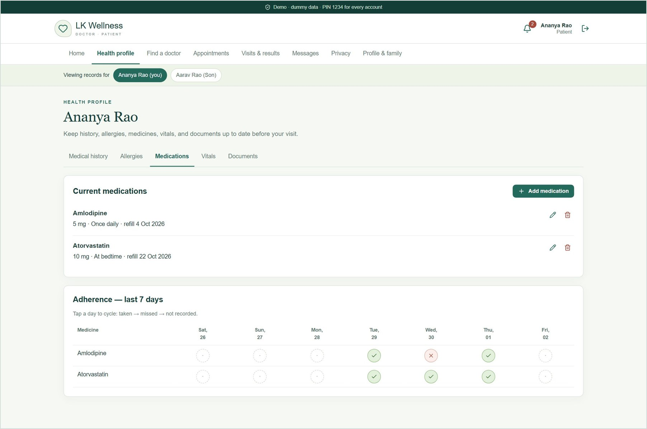
Figure 4. Medications with refill dates, plus a 7-day adherence tracker. Tapping a day cycles taken → missed → not recorded.
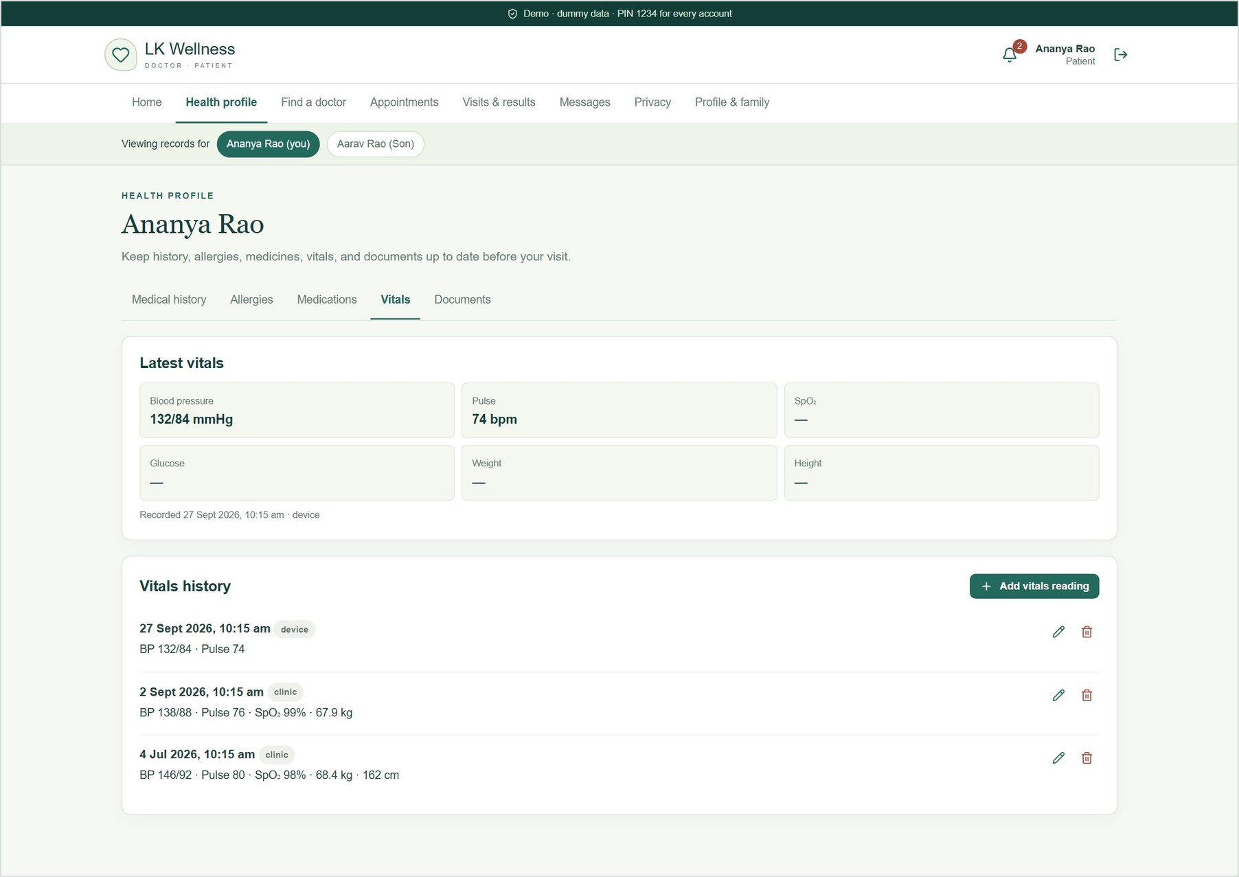
Figure 5. Vitals: blood pressure, pulse, SpO₂, glucose, weight and height. "Device" readings are simulated.
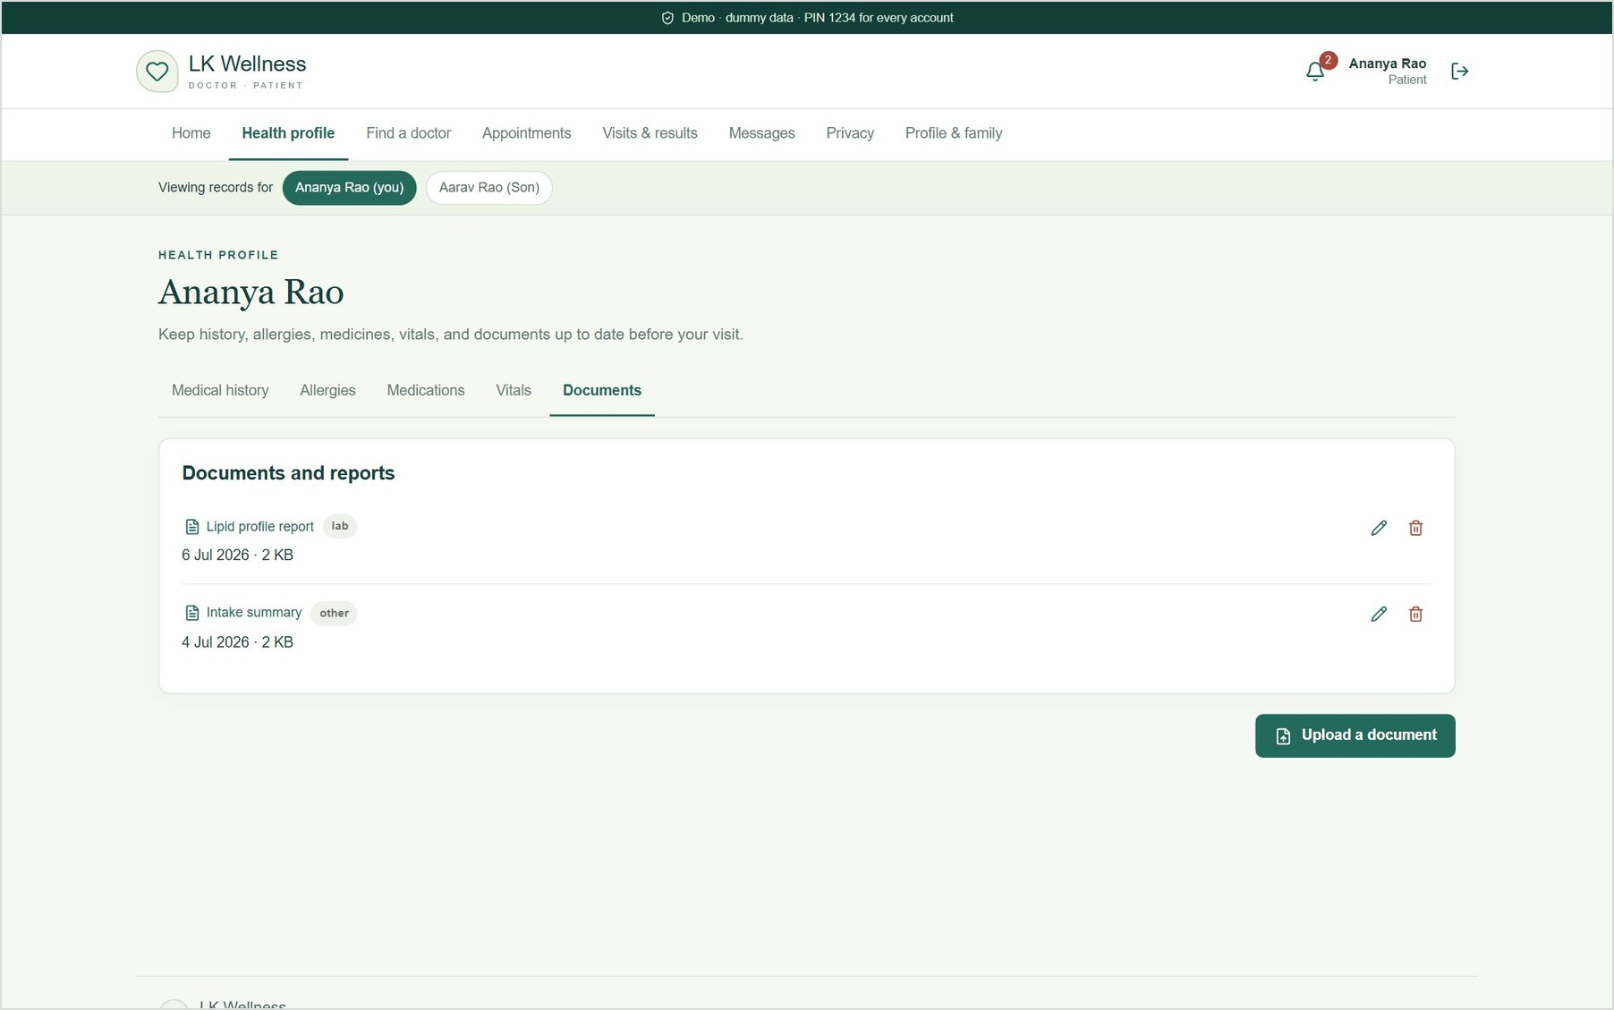
Figure 6. Documents: upload and view reports (PDF, PNG or JPEG up to 5 MB).

3.3 Find a doctor and book
Sign in as meera@example.com. Patients filter by specialty, language, fee, availability and rating, then pick a real free slot from the doctor's working hours. Breaks, buffers, leave and existing bookings are taken into account.
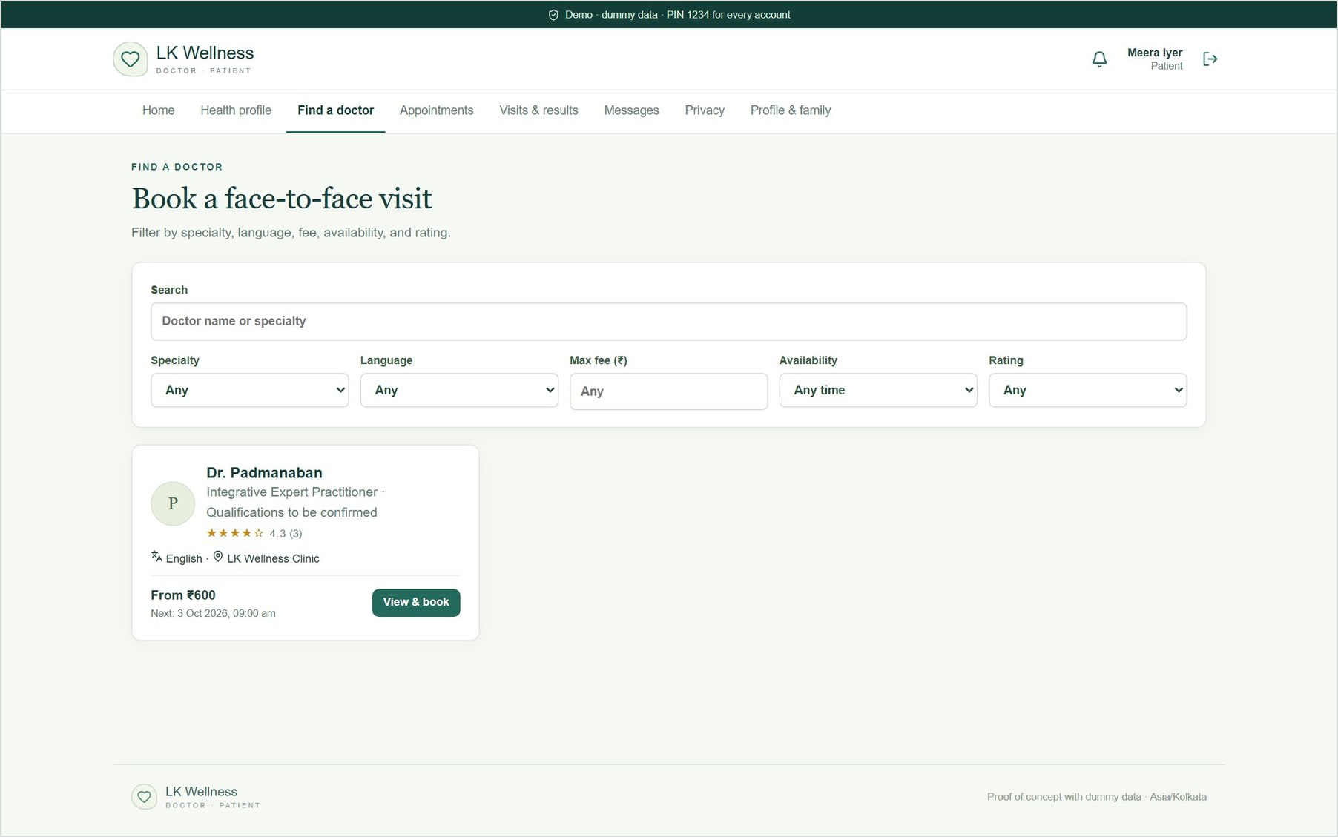
Figure 7. Find a doctor, with search and filters.
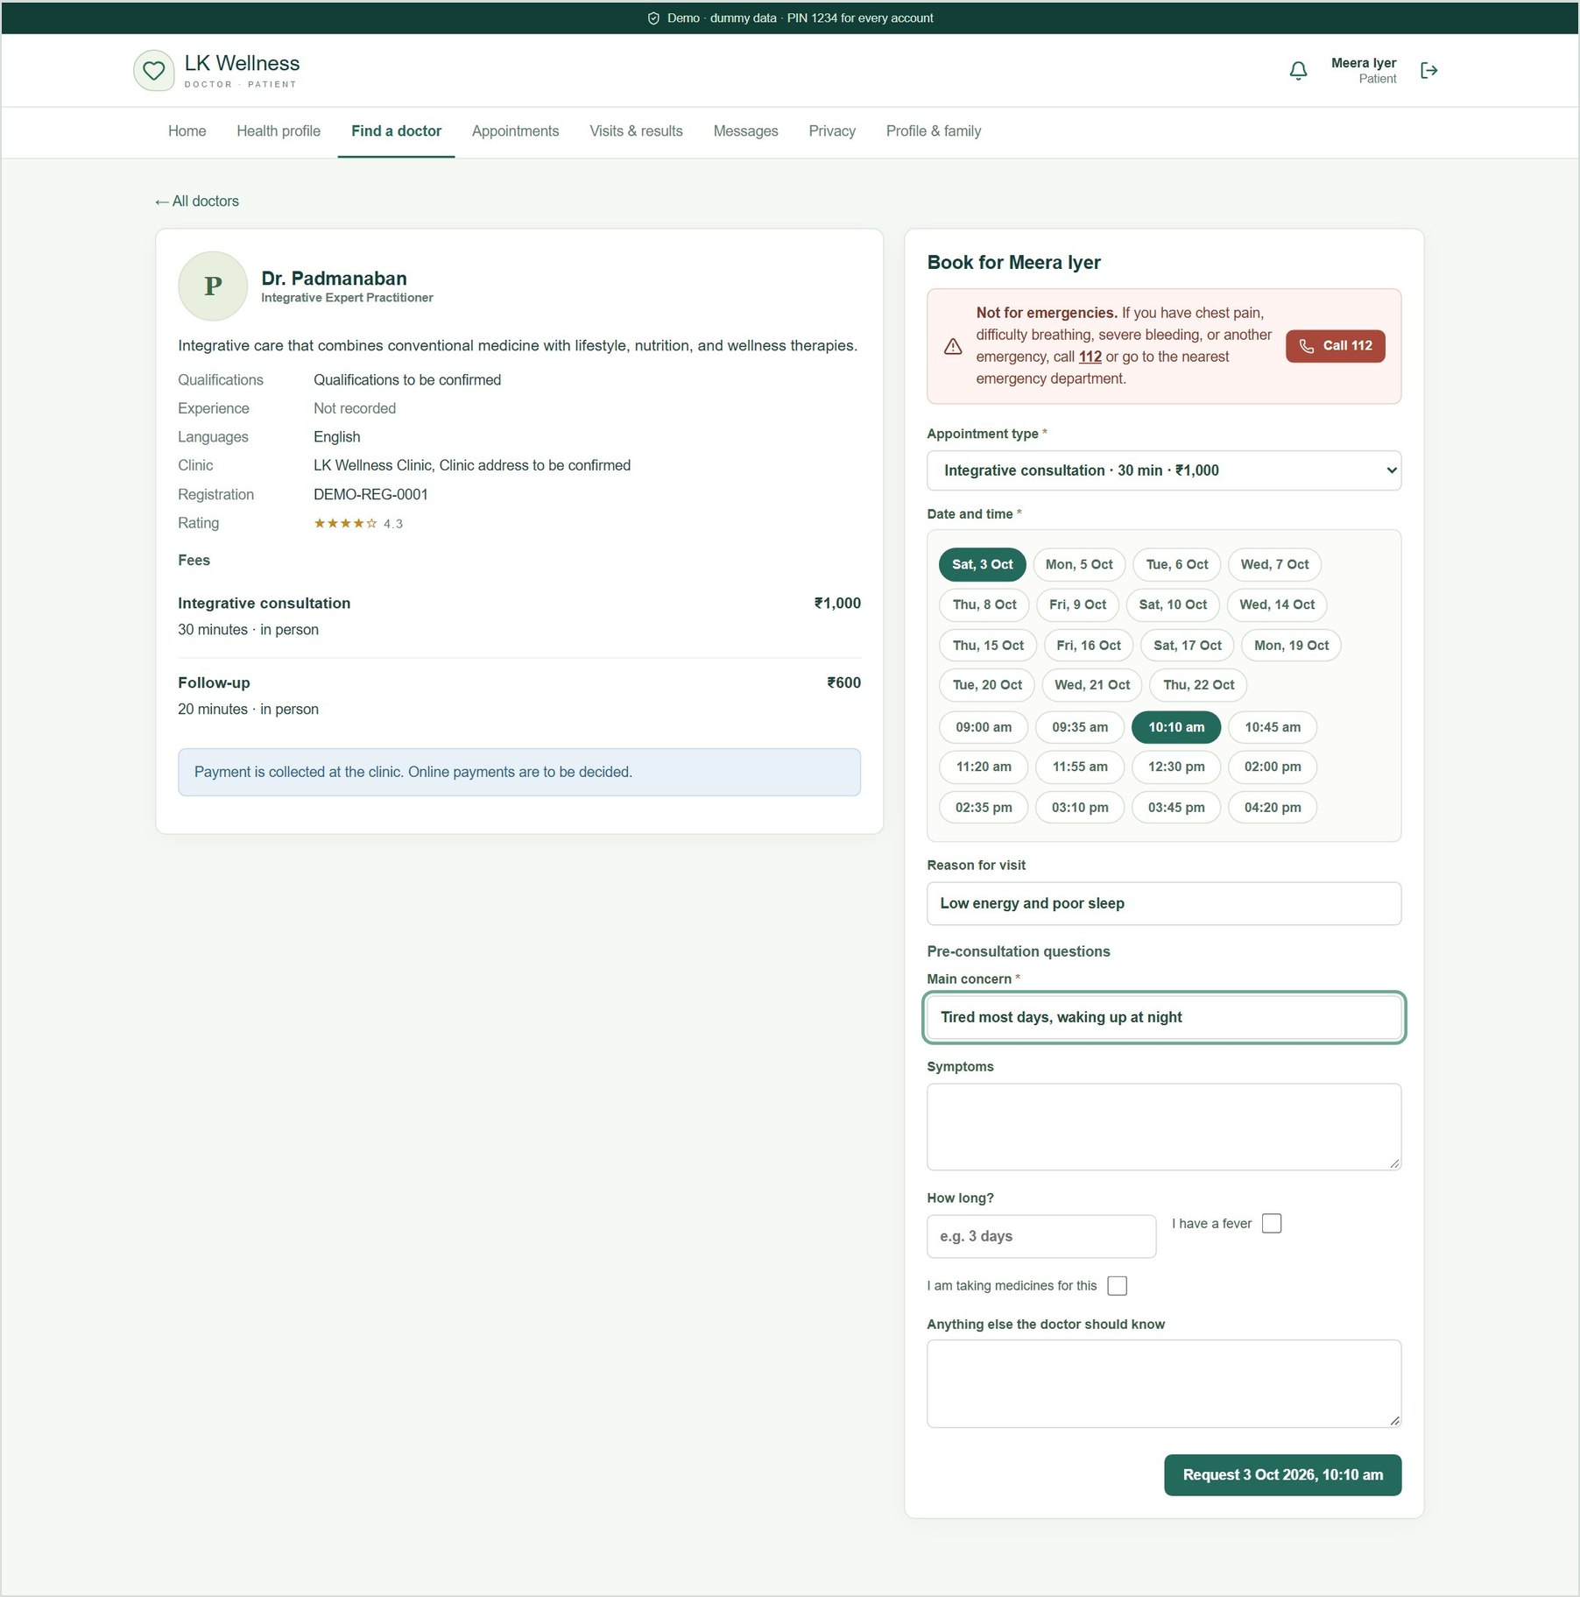
Figure 8. Booking: appointment type and fee, date and time slots, reason for the visit, and pre-consultation questions.
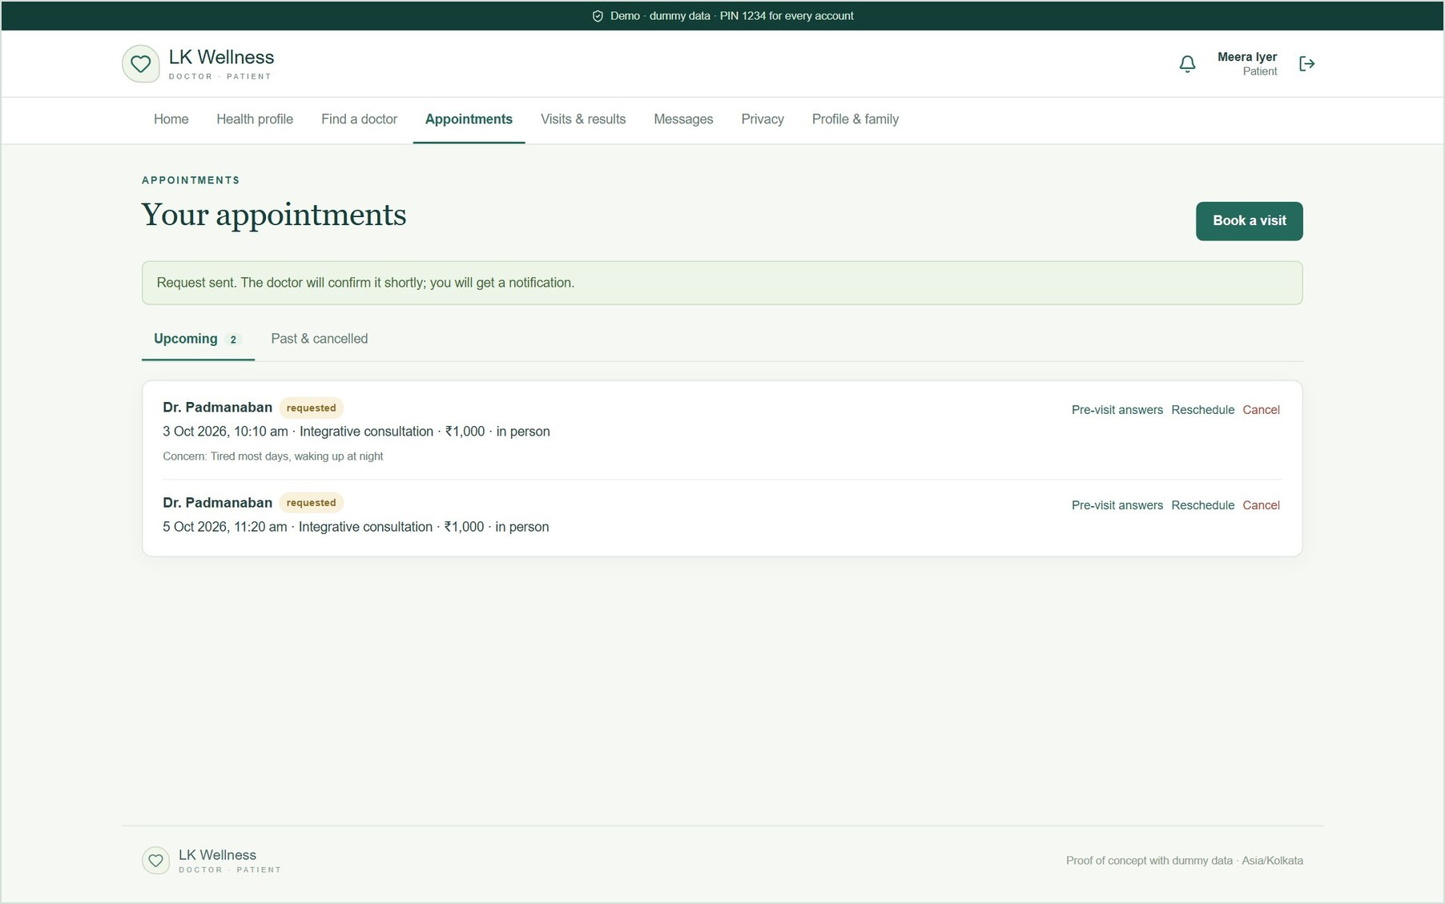
Figure 9. The request appears under Appointments as "requested" until the doctor accepts it. The patient can reschedule or cancel.

3.4 Appointments and check-in
On the day of the visit the patient taps Check in on arrival. The doctor sees them move to "waiting" in the day queue. Pre-visit answers can be edited until the consultation starts.
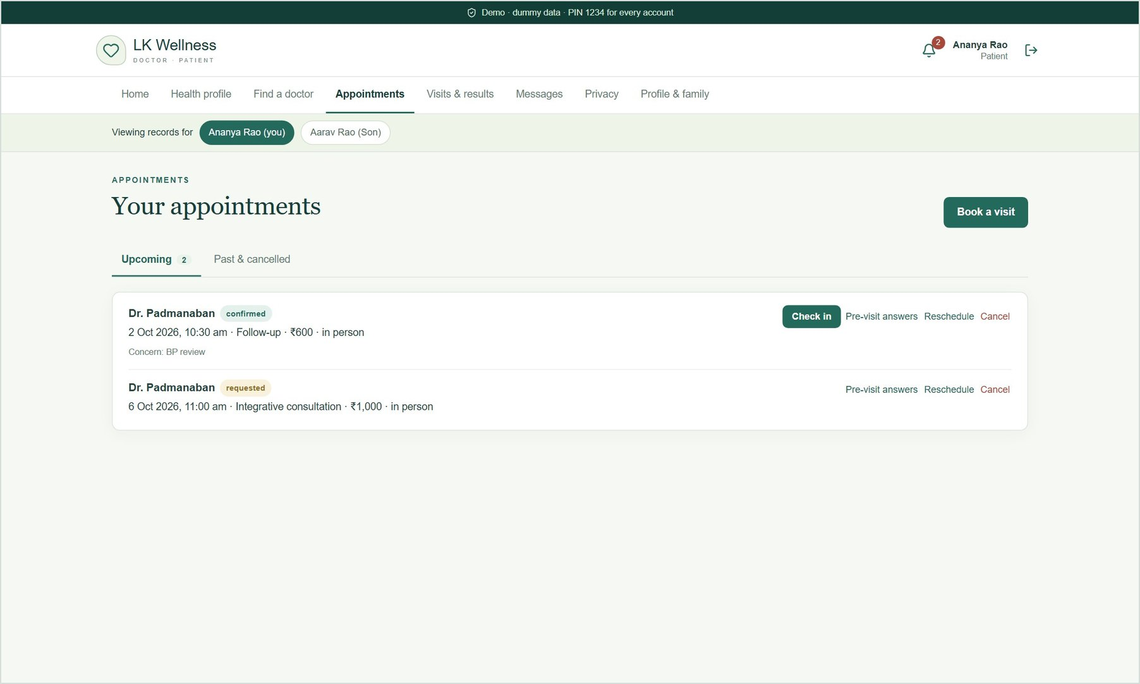
Figure 10. Ananya's appointments: today's confirmed visit with Check in, and a pending request.

3.5 Visits, results and e-prescriptions
After each visit the patient sees the doctor's plain-language care summary, diagnoses, signed e-prescriptions, and lab or imaging results with out-of-range flags.
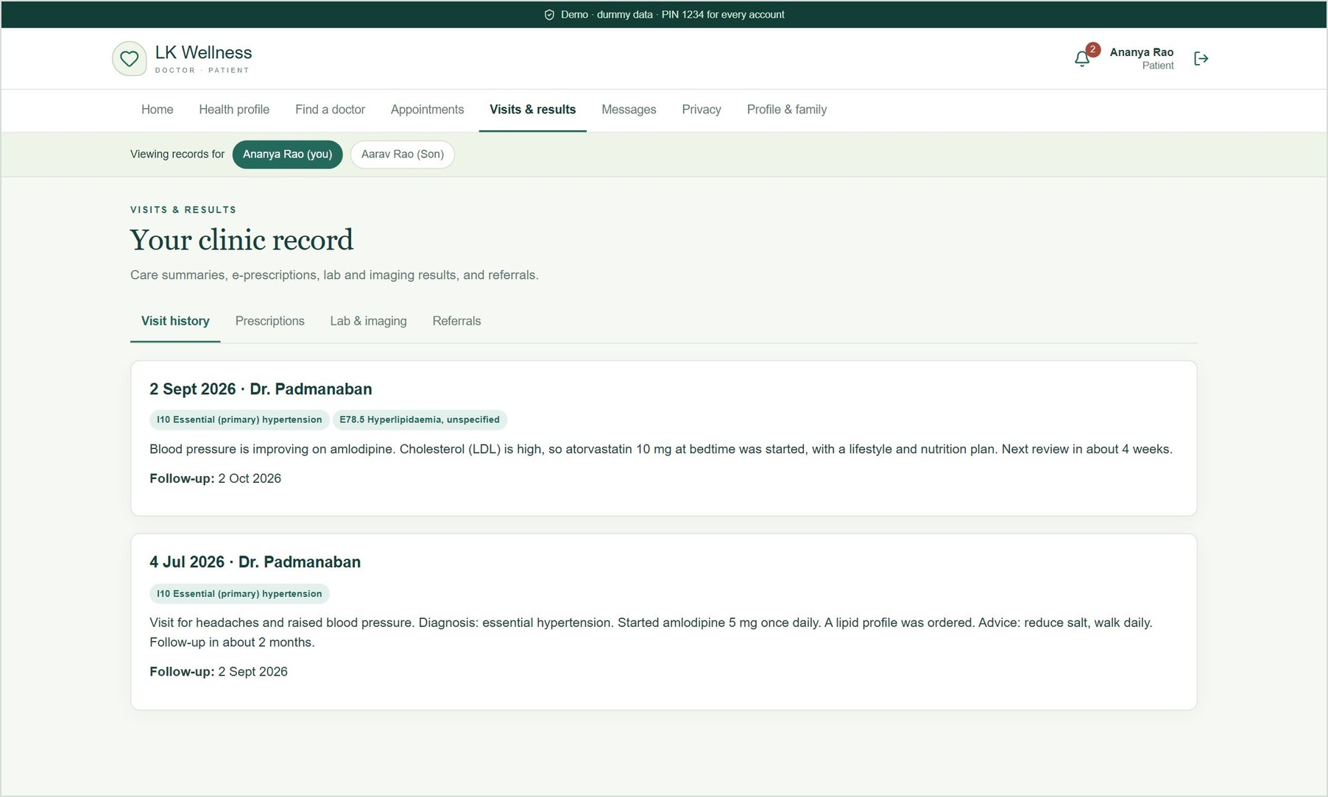
Figure 11. Visit history with care summaries and ICD-10 diagnoses.
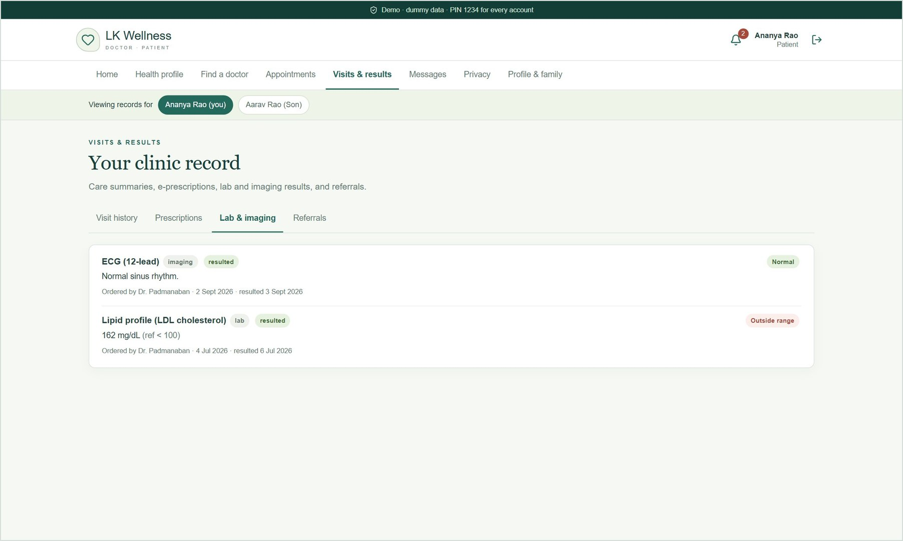
Figure 12. Lab and imaging results; out-of-range values are flagged.
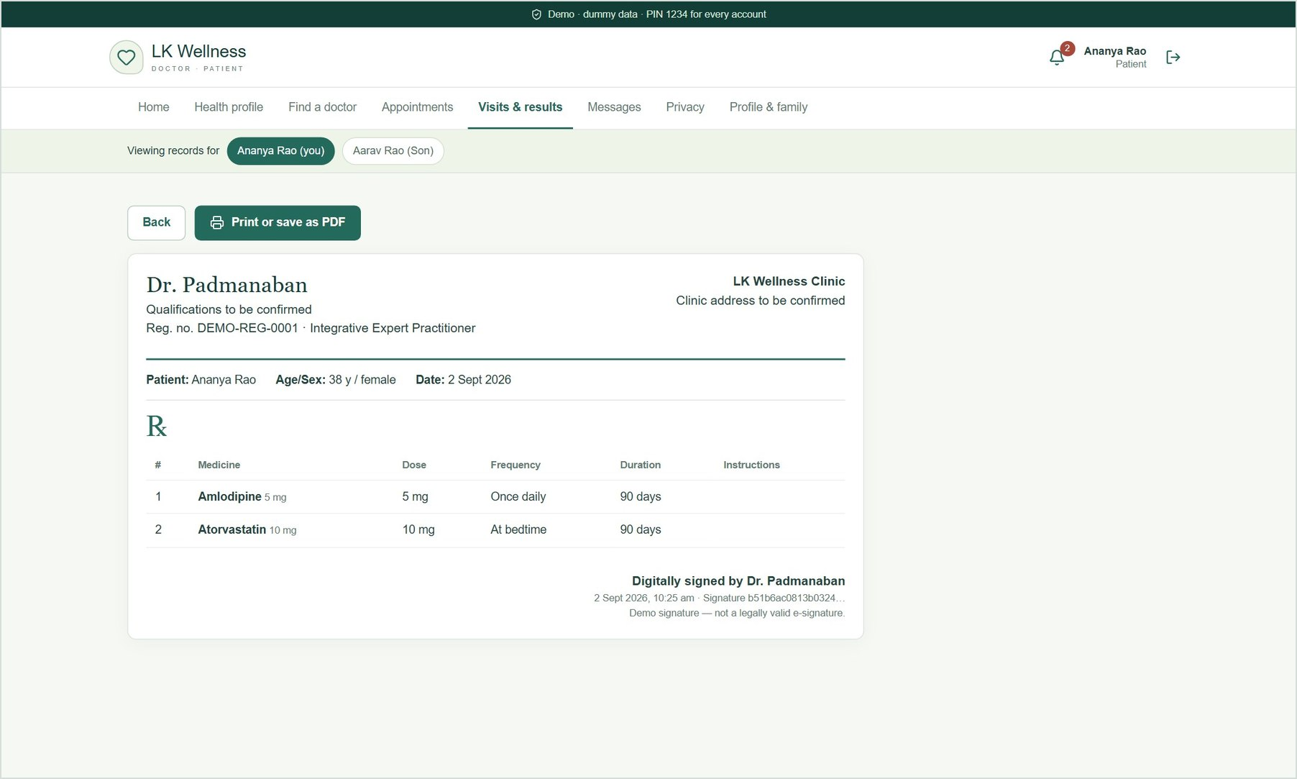
Figure 13. E-prescription with the doctor's registration number and a simulated digital signature. It can be printed or saved as PDF.

3.6 Messages and notifications
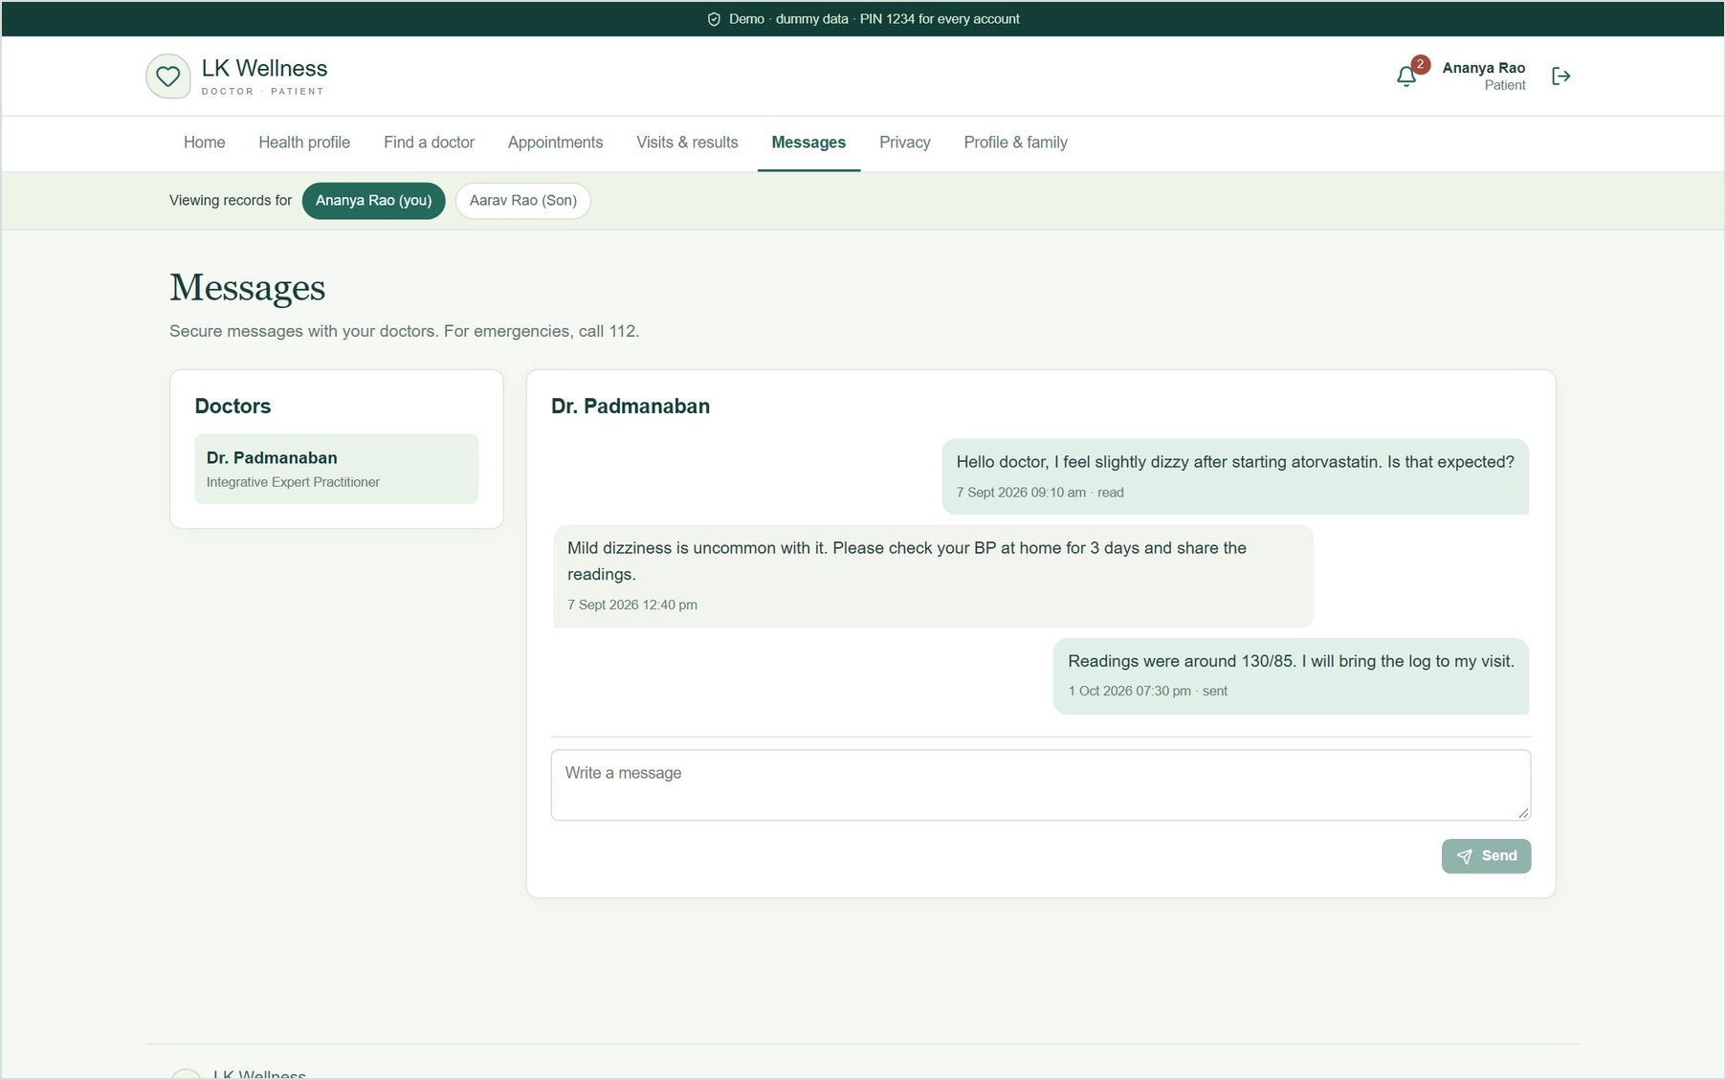
Figure 14. Secure messages with the doctor for follow-up questions, with read receipts.
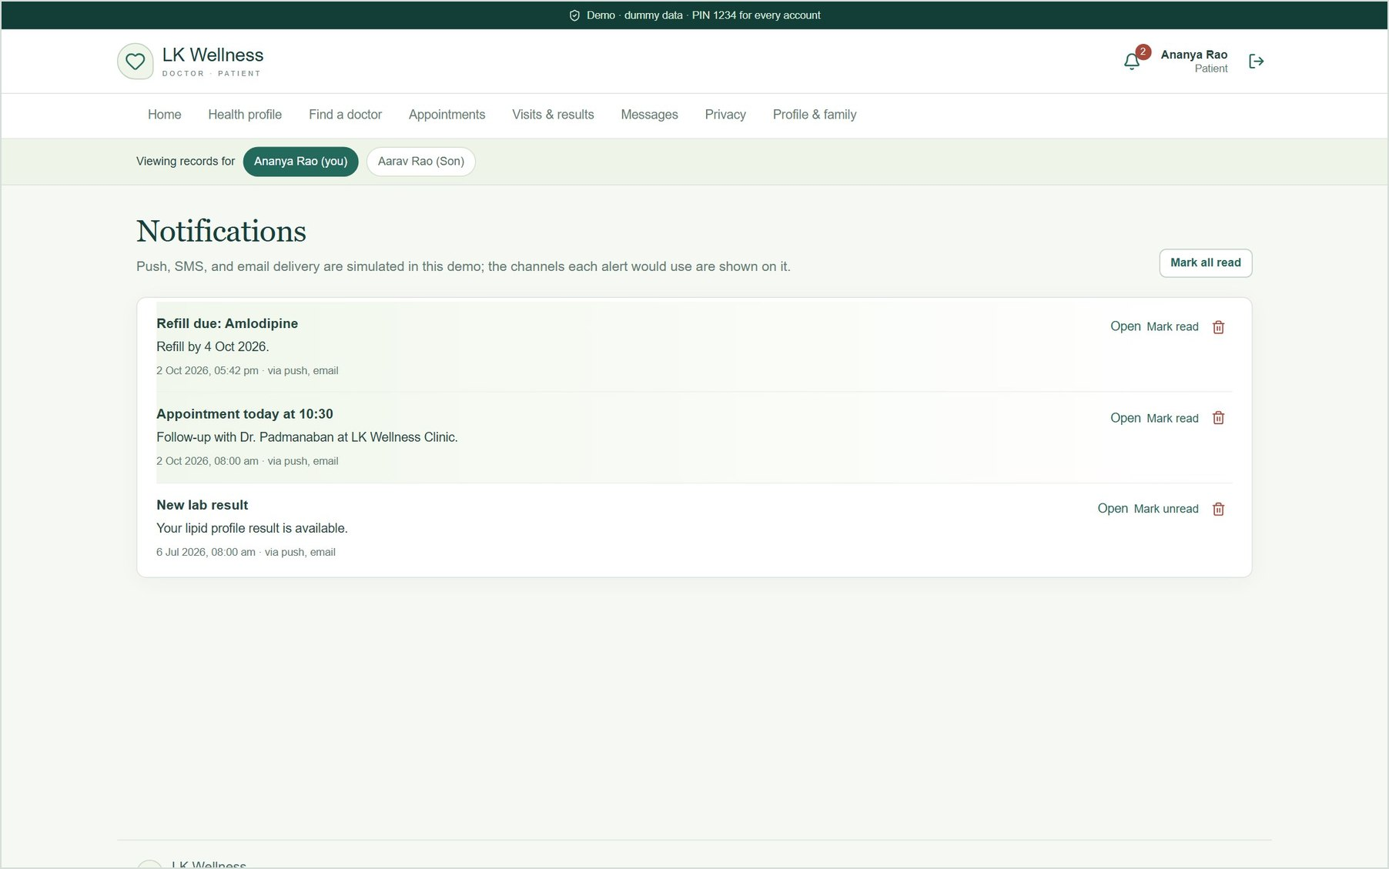
Figure 15. Notification centre. Each alert shows the channels it would use (push, SMS, email); delivery is simulated.

3.7 Privacy
Patients control their consent, can block a specific doctor from their record, see an access log of who viewed or changed it, download all their data as JSON, and delete their account and data.
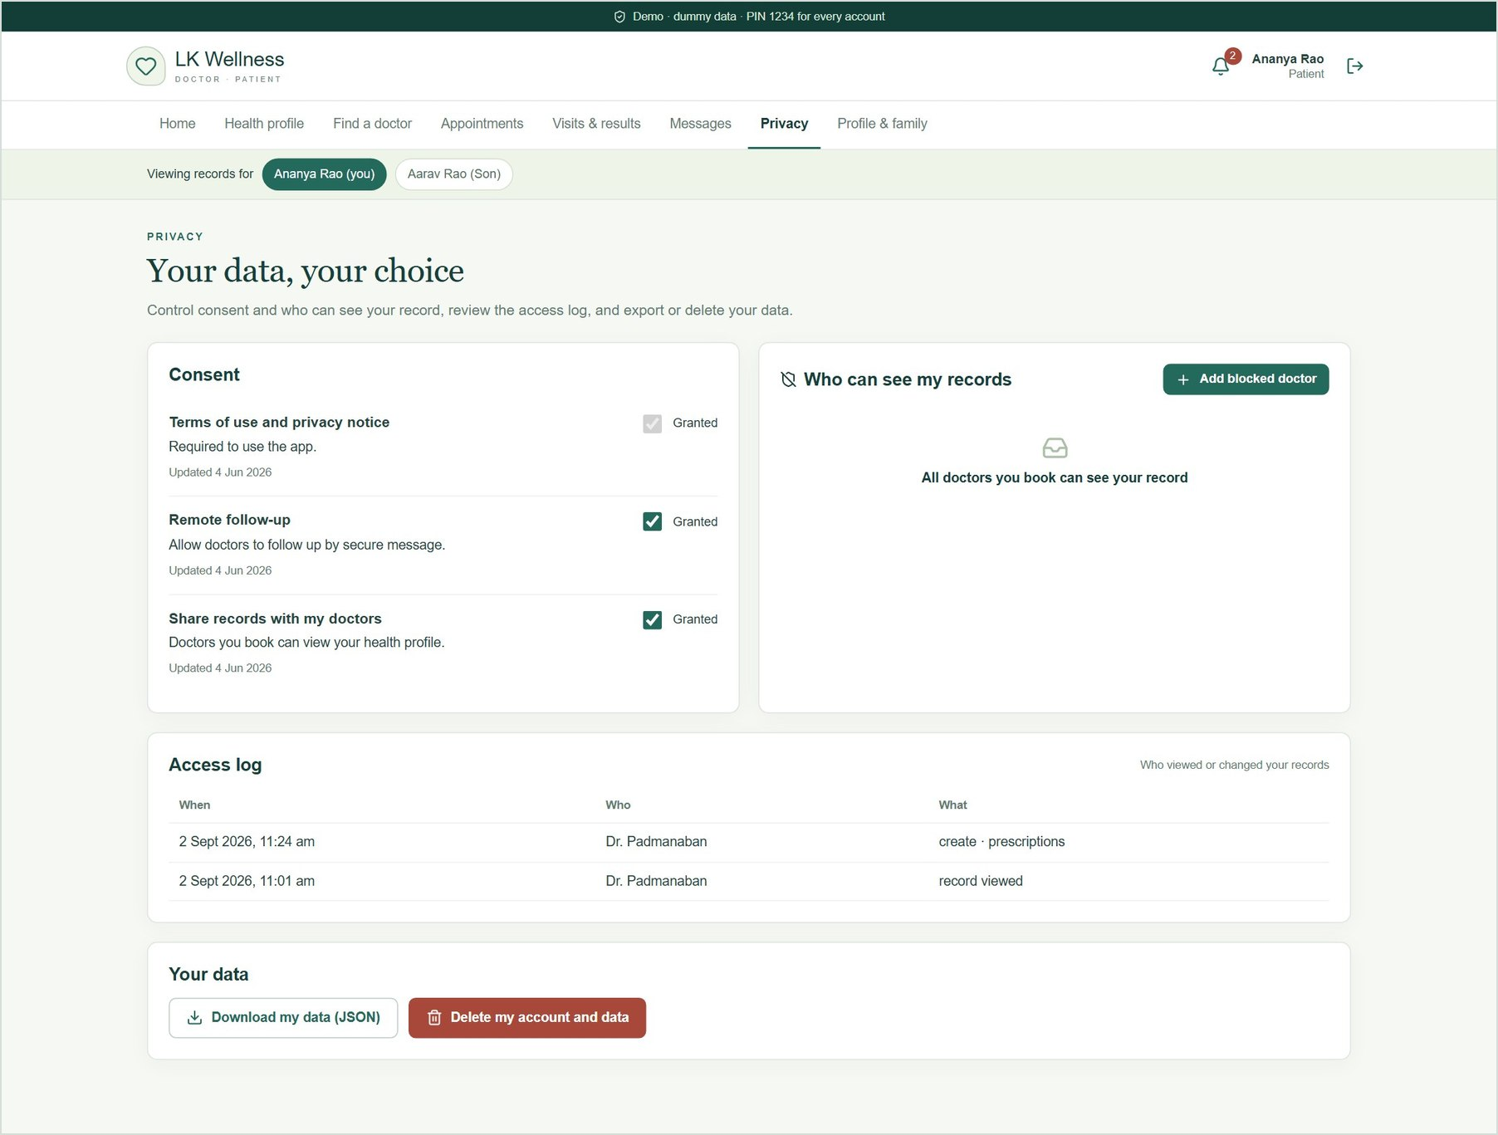
Figure 16. Privacy controls: consent, blocked doctors, access log, export and deletion.

3.8 Profile and family
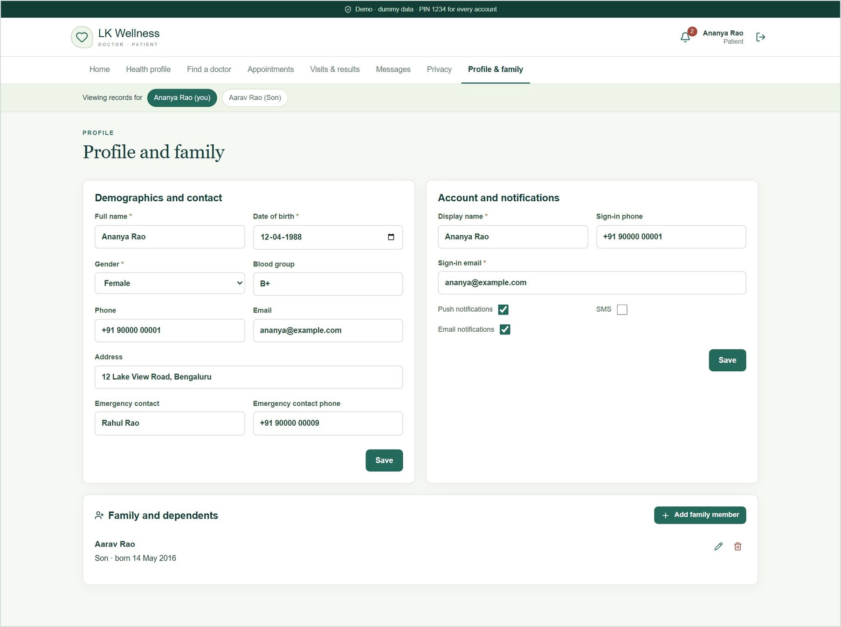
Figure 17. Profile, notification preferences, and family members (dependents).

4. Doctor portal
Sign in as padmanaban@example.com.

4.1 Today's clinic
The doctor's home page shows today's numbers, the day queue in time order, booking requests to accept or reject, and alerts such as abnormal results. Patients who have checked in are highlighted as waiting.
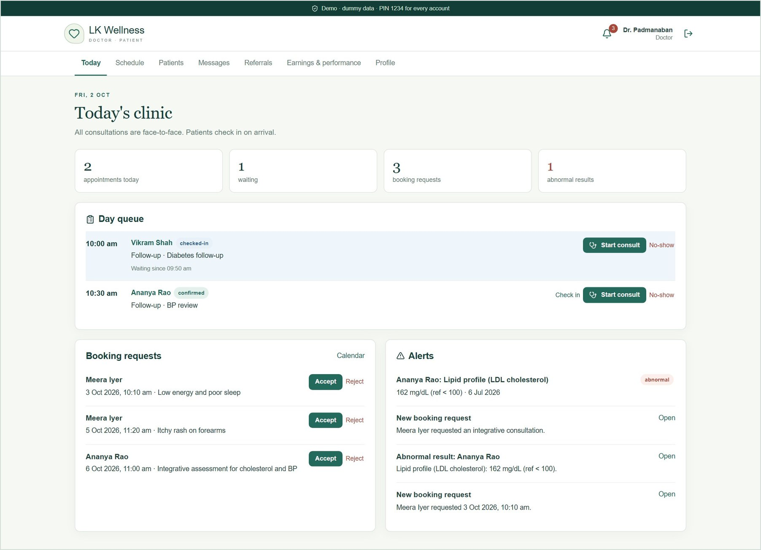
Figure 18. Today's clinic: day queue with check-in, booking requests, and alerts.

4.2 Schedule management
Four tabs manage availability: the calendar of bookings (accept, reject, reschedule, cancel), working hours with breaks and buffer time, leave, and appointment types and fees. Patient booking slots are calculated from these settings.
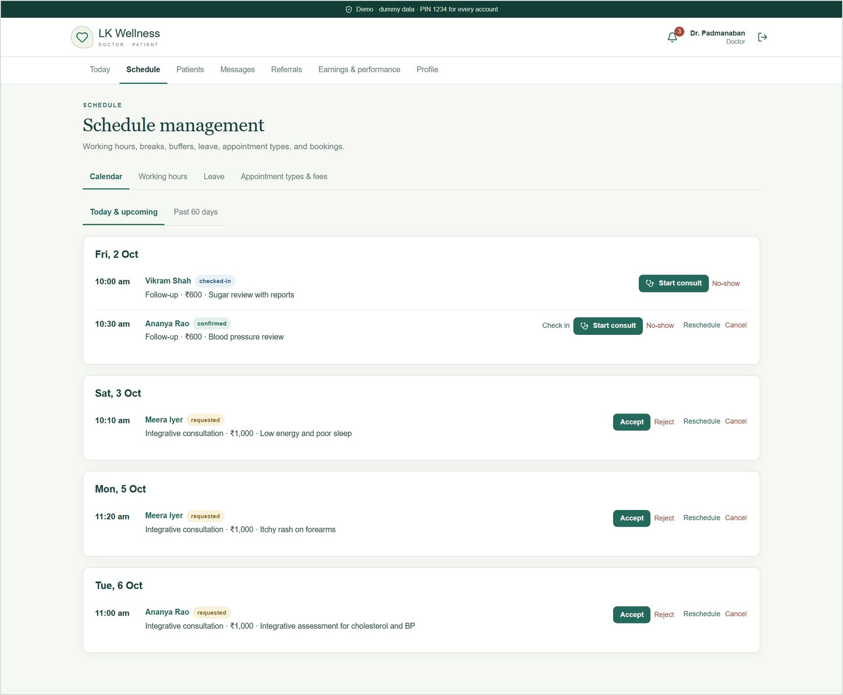
Figure 19. Calendar of today's and upcoming bookings, with actions on each.
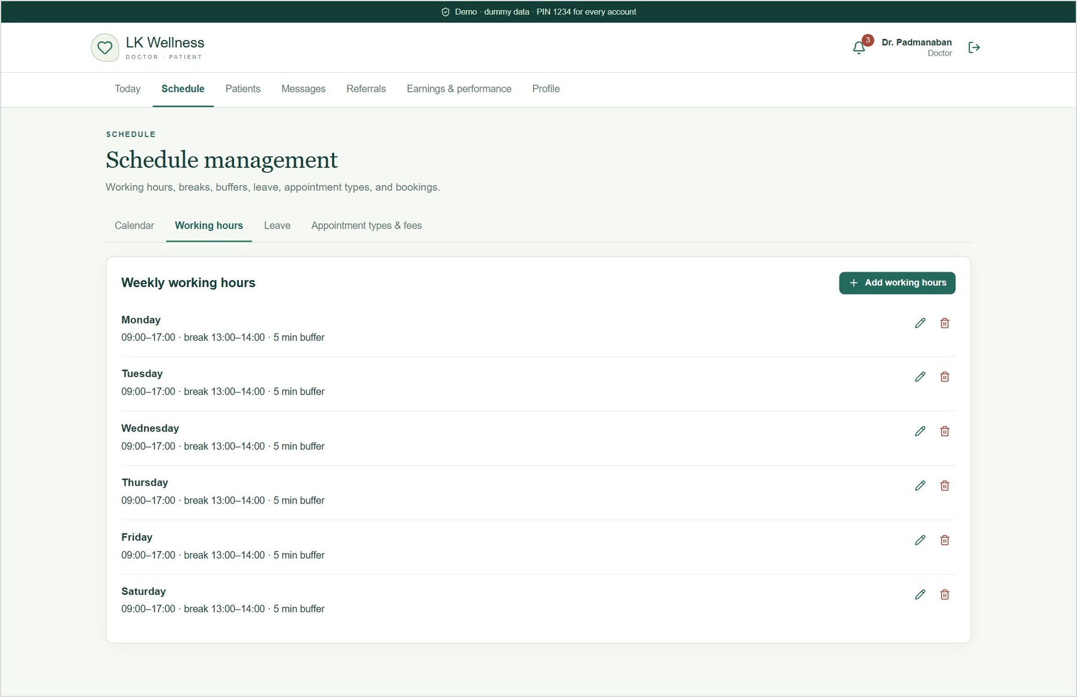
Figure 20. Weekly working hours: Monday to Saturday 09:00–17:00, lunch break 13:00–14:00, 5-minute buffer.
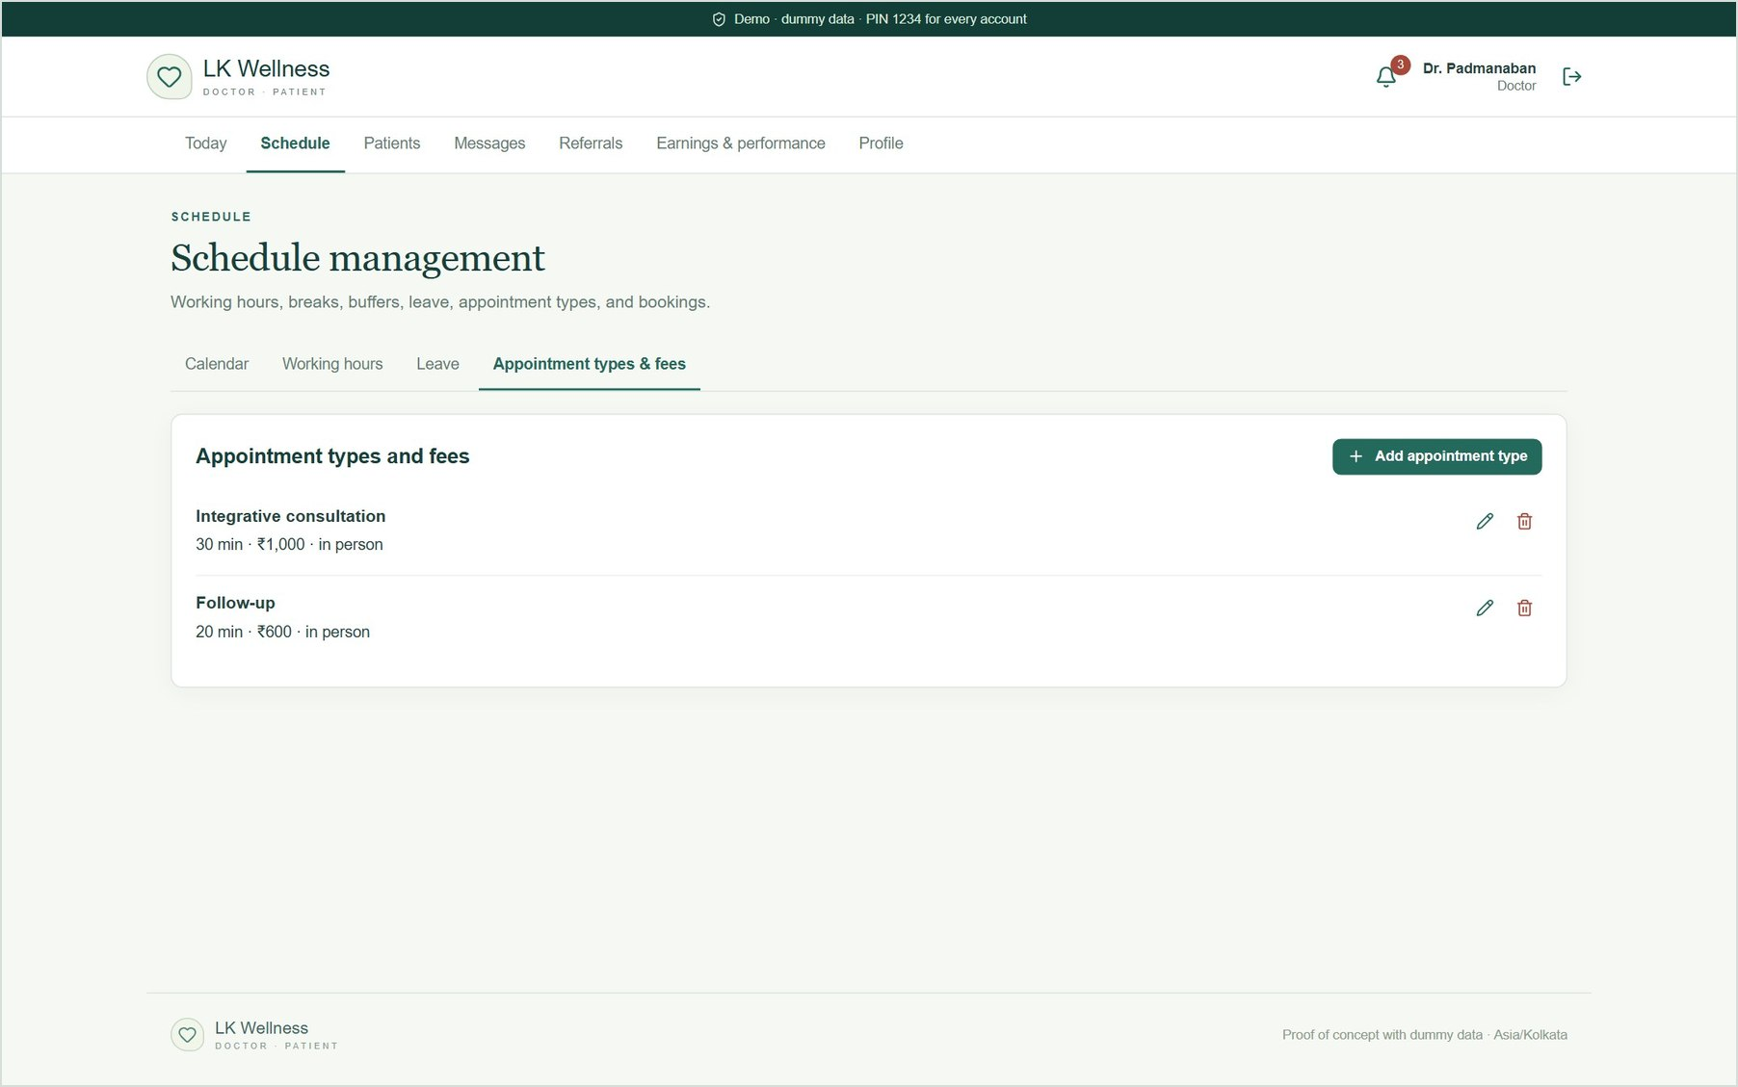
Figure 21. Appointment types and fees: integrative consultation (30 min, ₹1,000) and follow-up (20 min, ₹600). These fees are demo values.

4.3 Patients and the single-screen record
Patients lists everyone with a booking, visit or referral with the doctor, with search by name, phone or date of birth. Opening a patient shows the whole record on one screen.
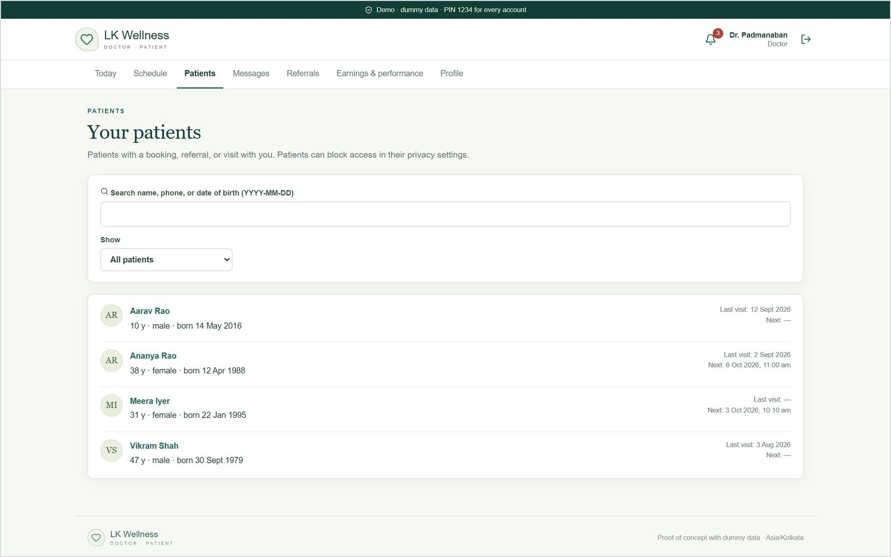
Figure 22. Patient list with search and filter.
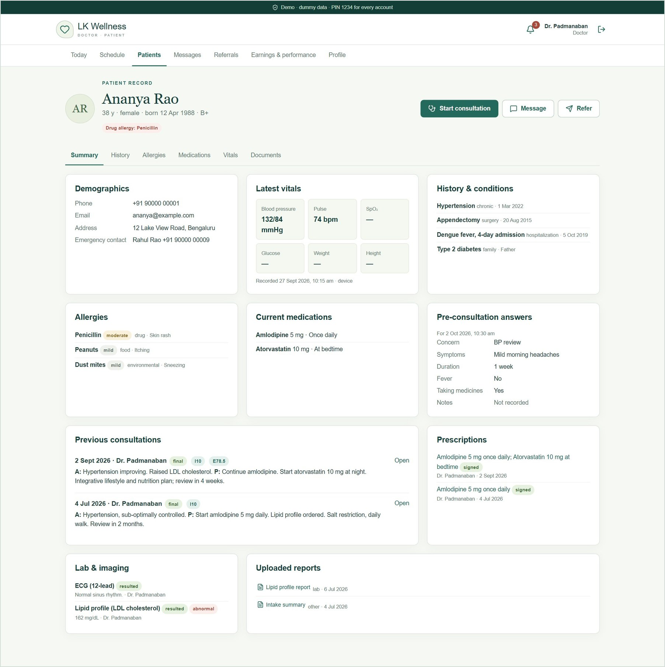
Figure 23. Single-screen record: demographics, vitals, history, allergies, medications, pre-visit answers, past consultations, prescriptions, results and uploaded reports.

4.4 Consultation workspace
From the day queue the doctor checks the patient in and clicks Start consult. The workspace has SOAP notes (prefilled from the patient's pre-visit answers), templates, quick text, voice dictation in Chrome or Edge, ICD-10 coding, and follow-up booking. The patient snapshot stays beside the notes.
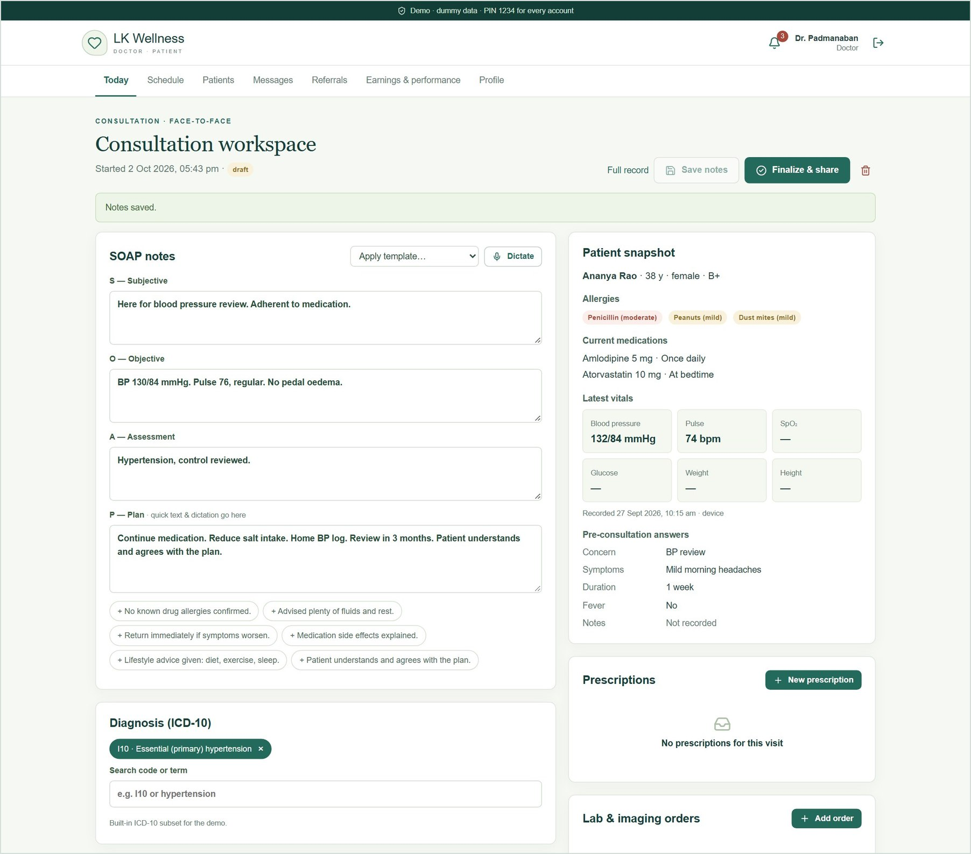
Figure 24. Consultation workspace: SOAP notes with a template applied, ICD-10 diagnosis, and the patient snapshot with allergies and current medicines.

4.5 E-prescriptions with safety checks
Choosing a medicine fills in its usual strength, dose and frequency. The prescription is checked as it is written for allergy conflicts, interactions with current medicines, duplicate therapy and dose limits. The doctor must tick a box to acknowledge any warning before signing.
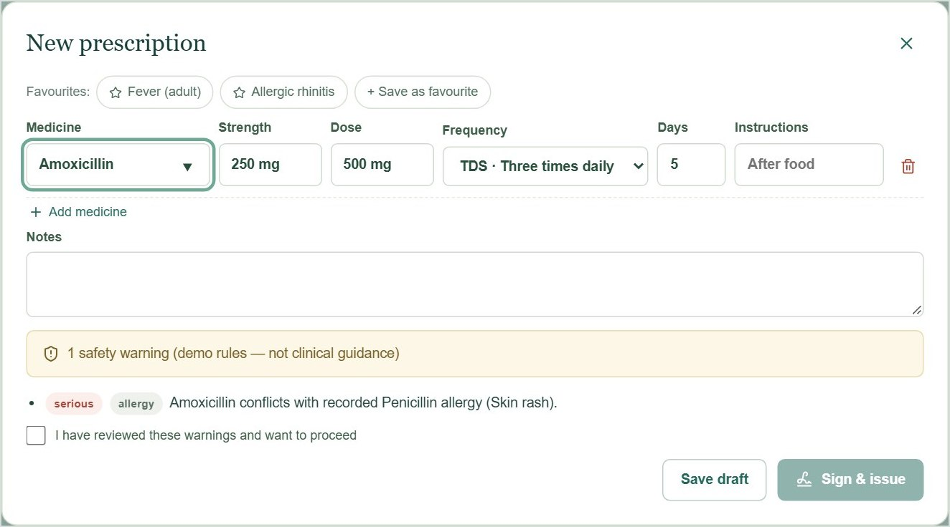
Figure 25. Amoxicillin for a patient with a recorded penicillin allergy: a serious warning, and "Sign & issue" stays disabled.
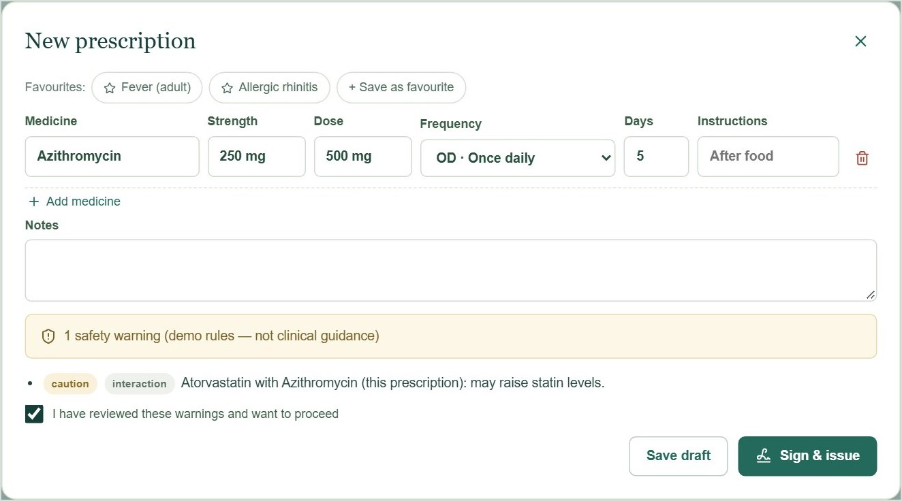
Figure 26. Azithromycin with the patient's current atorvastatin: an interaction caution, acknowledged so the prescription can be signed.
The drug list, interaction rules and ICD-10 codes are small demo datasets. They are not clinical guidance.

4.6 Orders, care summary and finalising
Lab and imaging orders are added in the same workspace, and their results return to the patient's record. Generate from notes drafts a plain-language care summary from the notes, diagnosis, medicines and orders. It is template-based (no AI) and editable. Finalize & share sends it to the patient.
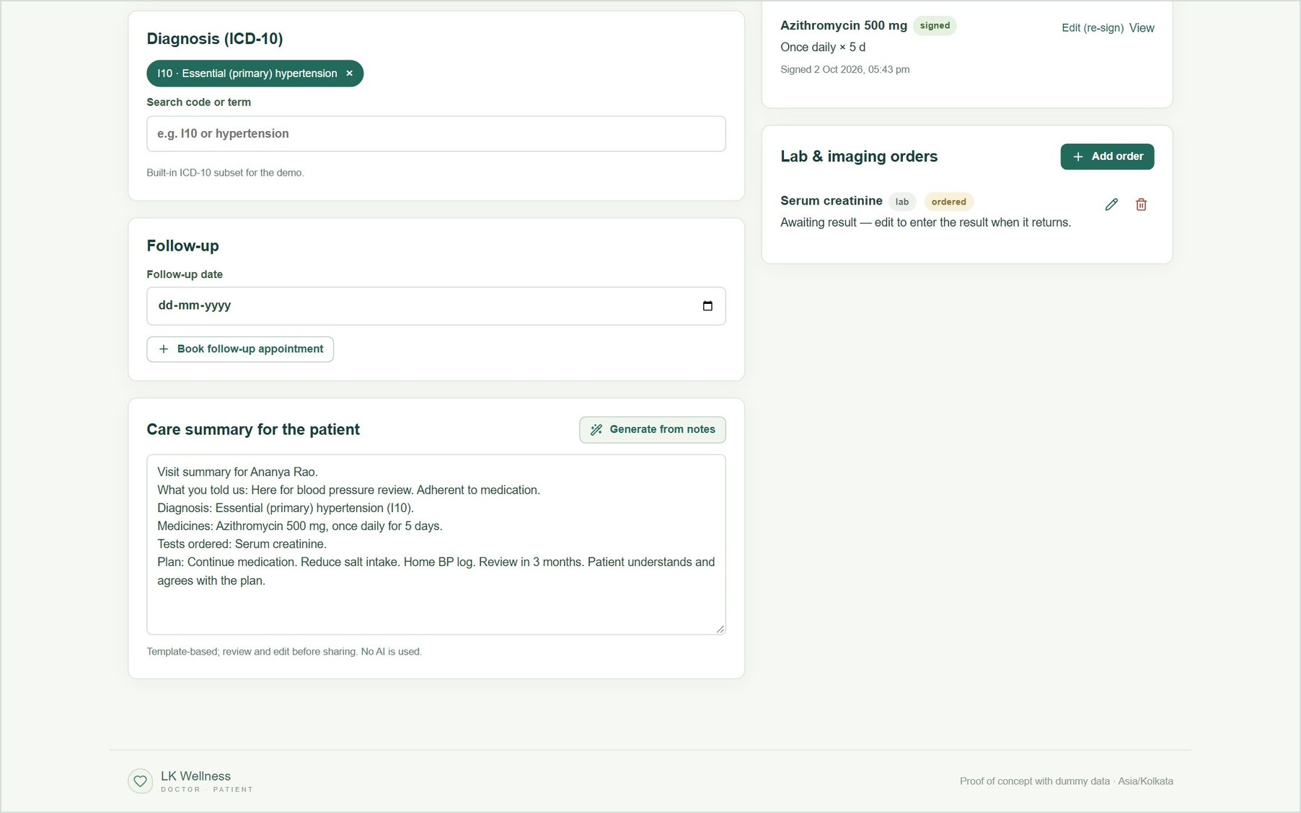
Figure 27. Signed prescription, a lab order, and the generated care summary ready to share.

4.7 Messages
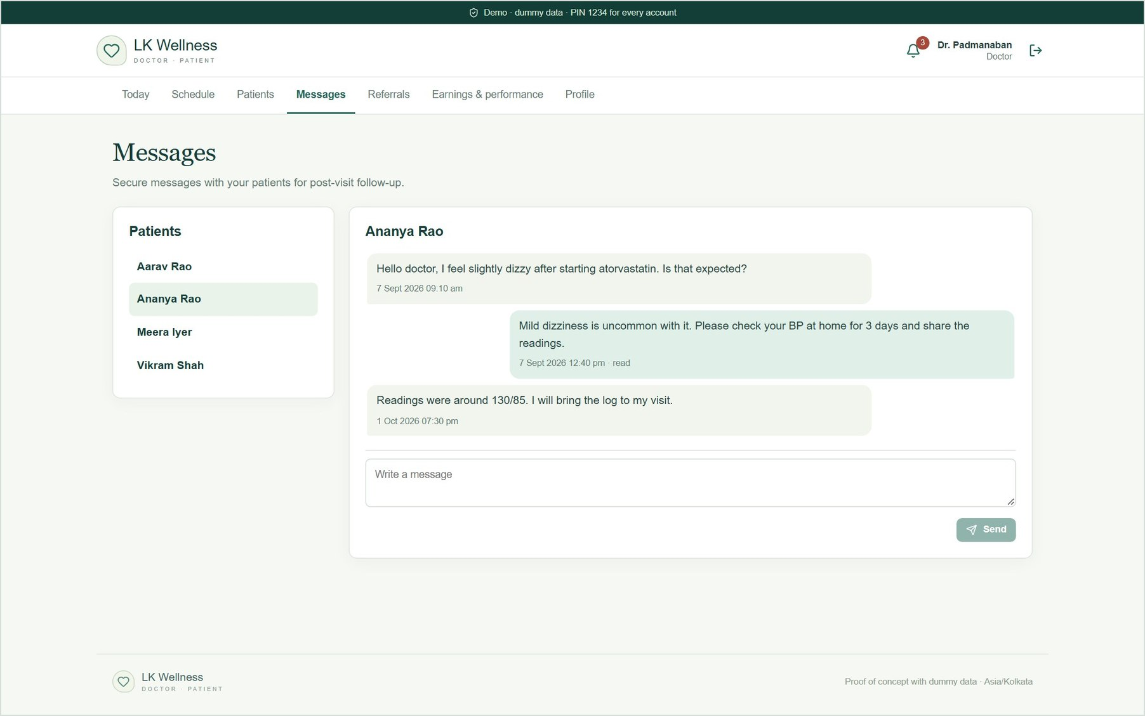
Figure 28. Secure messaging with patients for follow-up.

4.8 Earnings and performance
Earnings come from the fees of completed visits. The page also shows consultation count, average duration, no-shows, ratings, and patient feedback. Payouts and invoices wait for the payments decision.
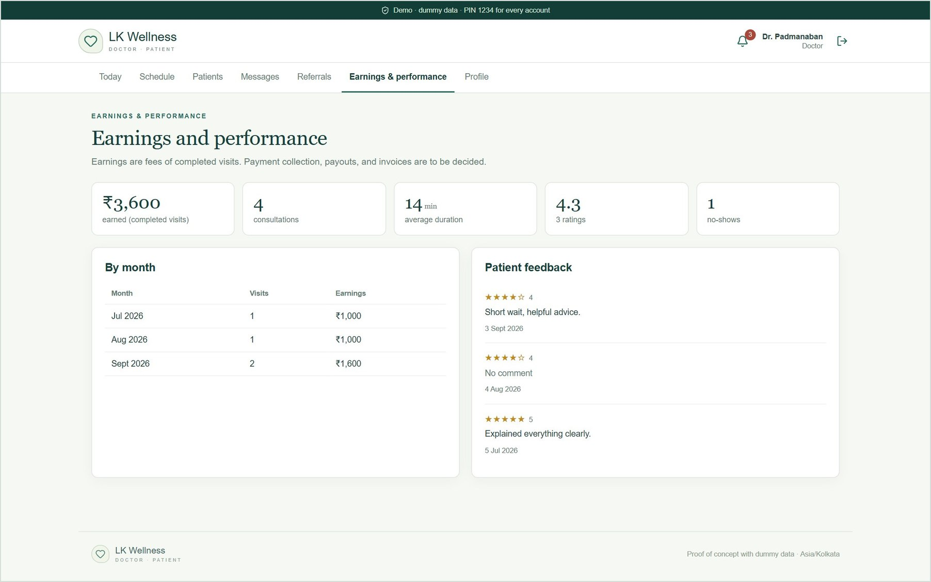
Figure 29. Earnings and performance, by month, with patient feedback.

4.9 Profile
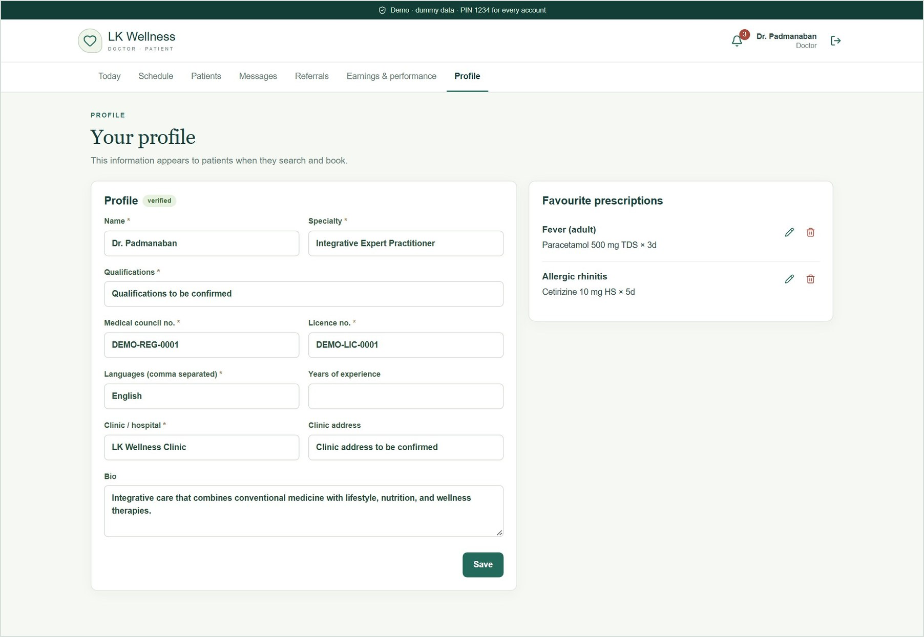
Figure 30. The doctor's public profile and favourite prescriptions. The placeholder registration details are edited here.

5. Admin area
Sign in as admin@example.com. Administrators manage accounts and doctor verification. They cannot open clinical records.
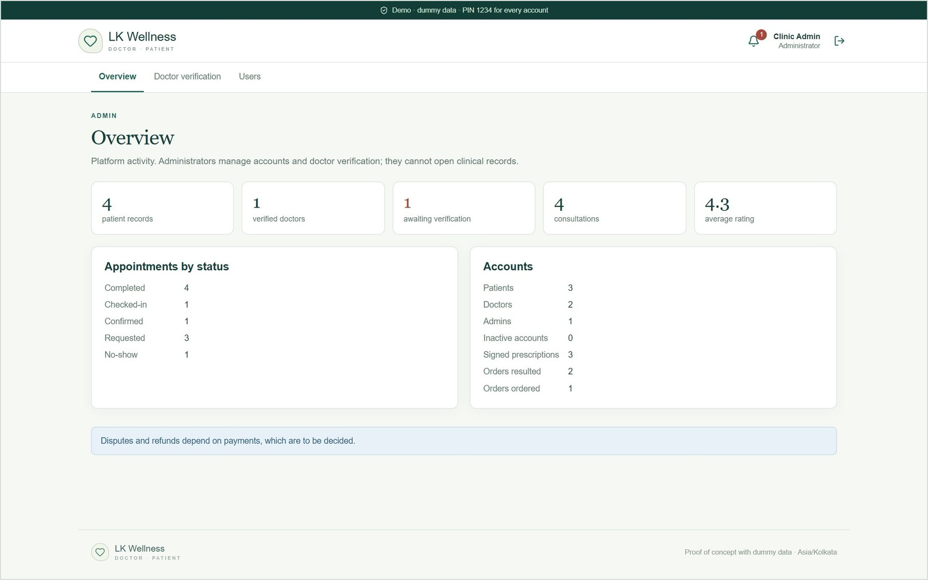
Figure 31. Overview: patient records, verified and pending doctors, consultations, ratings, appointments by status, and accounts.
A doctor who registers stays pending and does not appear in patient search until an admin checks their council registration and licence and clicks Verify. In the screenshot below, a sample doctor registered for the demo is waiting.
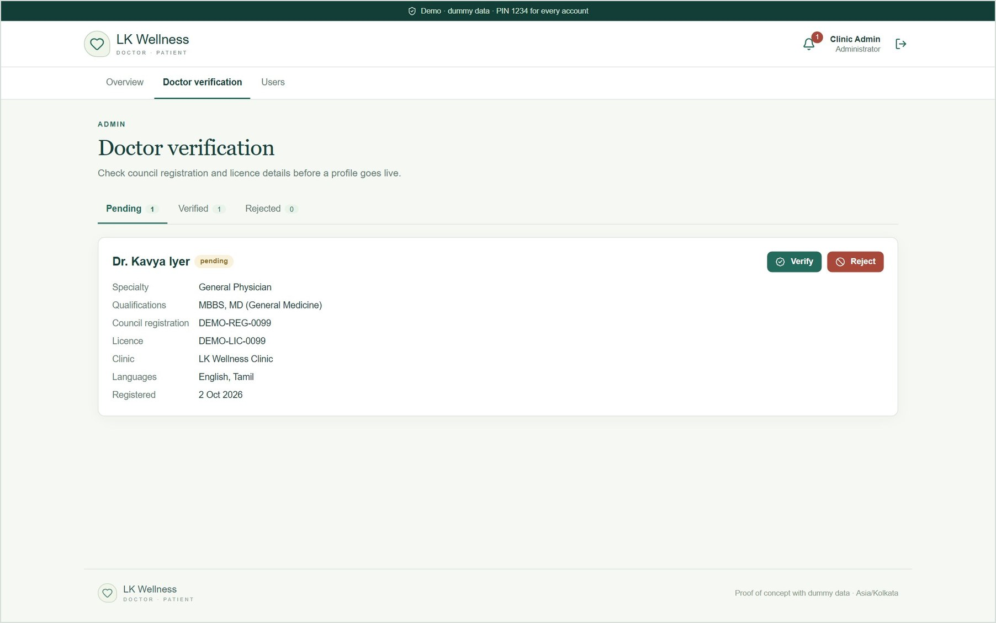
Figure 32. Doctor verification: a pending registration with Verify and Reject.
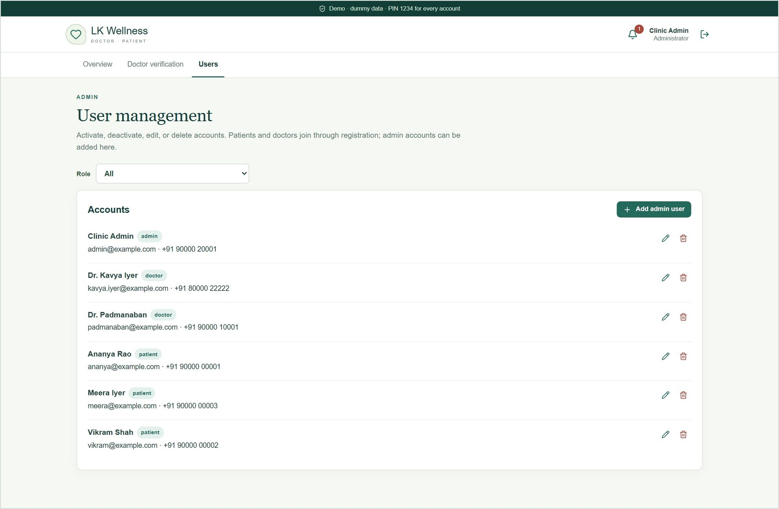
Figure 33. User management: edit, deactivate or delete accounts, and add admin users.

6. On a phone
The same app adapts to phone screens: the menu scrolls sideways, cards stack, and tables scroll inside their card. Browser tests check every page at 390 px wide for errors and sideways scrolling.
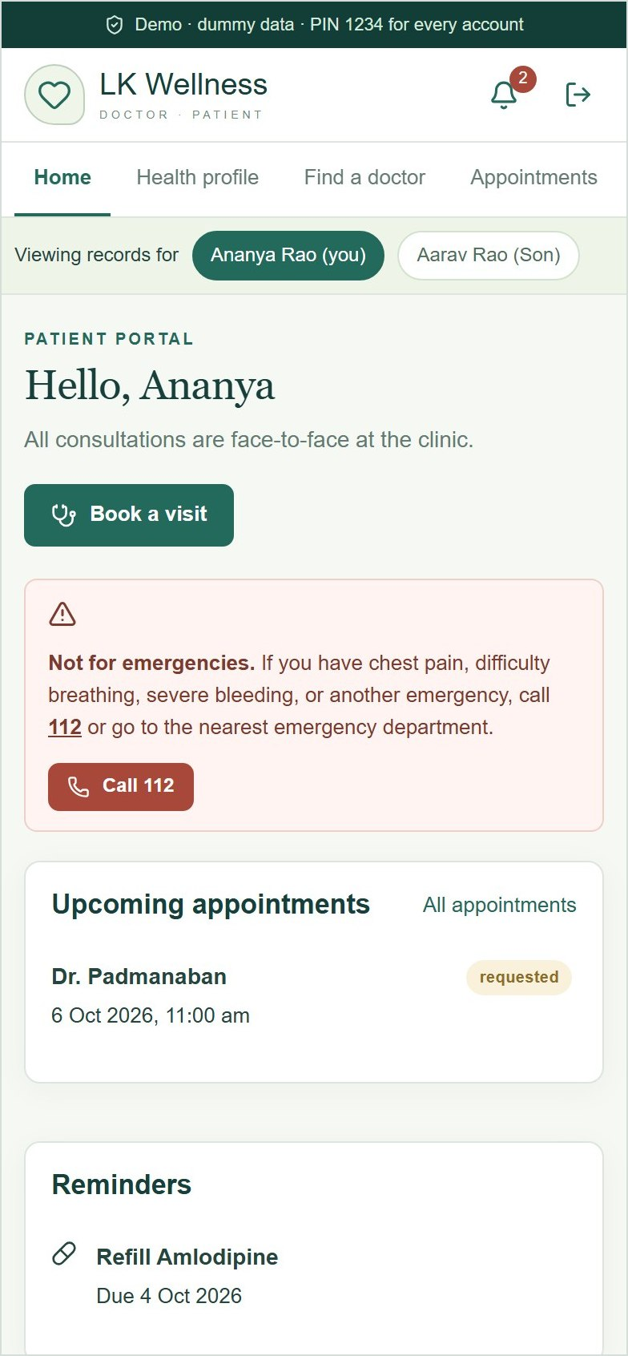 | 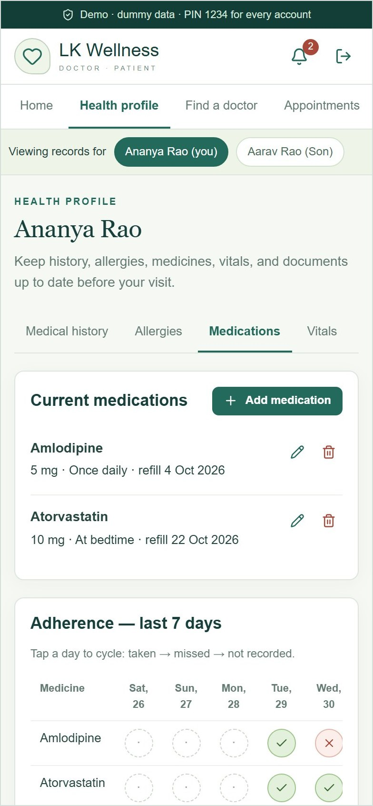 | 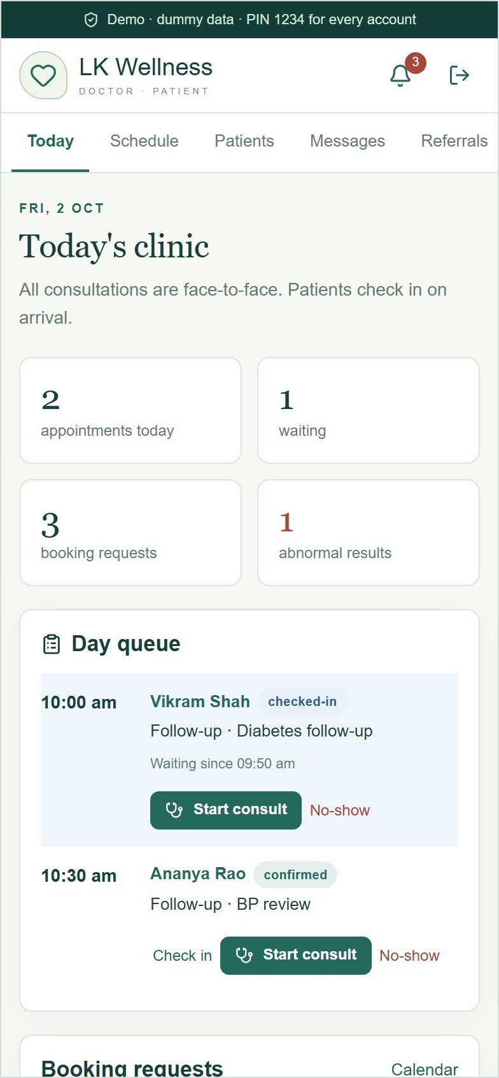
Patient home | Medications and adherence | Doctor's day queue

7. Suggested 15-minute demo script
Reset the data first (npm.cmd run data:reset), then open the sign-in page. Using two browser windows (one normal, one private) lets you keep a patient and the doctor signed in side by side.
# | Signed in as | What to show | Time
1 | — | Sign-in page: demo accounts and PIN 1234. On the Register page, show the "I am a doctor" tab and register a sample doctor for step 7. | 1 min
2 | Meera (patient) | Find a doctor → filter → View & book. Pick a slot, answer the pre-visit questions, send the request. | 2 min
3 | Dr. Padmanaban | Today: accept Meera's request. Check in Ananya and click Start consult. | 1 min
4 | Dr. Padmanaban | Consultation: apply the "Hypertension review" template, add quick text, code I10. New prescription: Amoxicillin (allergy warning), then Azithromycin (interaction, acknowledge, sign). Add a lab order. Generate the care summary, Finalize & share, Complete visit. | 5 min
5 | Ananya (patient) | Visits & results: the new care summary and e-prescription (print or save as PDF). Appointments → Past: rate the visit. | 2 min
6 | Ananya (patient) | Privacy: access log, block a doctor, download my data. Switch to Aarav to show family profiles. | 2 min
7 | Admin | Doctor verification: verify the doctor registered in step 1. Overview analytics. | 2 min

8. Coverage against the components document
Status key: Built works in the app; Simulated behaves correctly in the app but is not connected to a real external service; Partly means some items are built; To be decided waits on a business decision; Not in POC is not implemented.

Patient portal
Component | In the POC | Status
Registration and login | Self-registration; sign-in by email or phone with PIN 1234. OTP, email verification and biometrics are not implemented. | Partly
Consent | Terms, remote follow-up and data sharing; captured at registration and editable under Privacy. | Built
Family and dependent profiles | Add, edit and delete dependents; switch whose records are shown. | Built
Health profile | History, allergies, medications, vitals and document upload. Device readings are simulated. | Built
Finding and booking | Search with filters; slots from real schedules; reschedule and cancel. | Built
Reminders | In-app notification centre. Push, SMS and email delivery is simulated. | Simulated
Consultation | Pre-visit questions, check-in on arrival, and an emergency notice. Video, audio and chat are omitted because visits are face-to-face. | Built
After the visit | E-prescriptions, results, follow-up booking, adherence tracker, refill reminders, visit history and ratings. | Built
Payments | Fees shown; payment is collected at the clinic. | To be decided
Privacy controls | Block doctors, access log, data export and account deletion. | Built

Doctor portal
Component | In the POC | Status
Onboarding and verification | Registration with council number, licence and specialty; pending until an admin verifies. | Built
Schedule management | Working hours, breaks, buffers, leave, appointment types and fees, calendar and day queue. | Built
Patient record view | Single-screen summary of the whole record. | Built
Consultation workspace | SOAP notes, templates, quick text, voice dictation (Chrome or Edge), ICD-10, follow-up, care summary (template-based). | Built
Prescriptions and orders | E-prescriptions with safety checks and favourites; lab and imaging orders. The digital signature is simulated; pharmacy routing (optional) is not included. | Partly
Continuity of care | Messaging, referrals, care summaries, abnormal-result alerts. | Built
Earnings and performance | Earnings, consultations, durations, no-shows, ratings. Payouts and invoices wait on payments. | Partly

Shared and backend
Component | In the POC | Status
Security | Role-based access on every request, audit log, session timeouts, sign-in rate limiting. No encryption at rest. | Partly
Compliance (DPDP, HIPAA, GDPR, ABDM) | Consent, access log, export and deletion exist as building blocks only. | Not in POC
Interoperability (FHIR, ICD, SNOMED, LOINC) | A built-in ICD-10 subset only. | Partly
Notifications engine | In-app notifications; external channels simulated. | Simulated
Admin panel | Doctor verification, user management and analytics. Disputes depend on payments. | Built

9. Known limits and next steps

Limits of the POC
- Demo sign-in: every account shares the PIN 1234. Replace it with real authentication (OTP, passwords or biometrics) before anyone outside the demo uses the app.
- Storage: one JSON file on one server. It suits a demo, not real patient data or several servers.
- Clinical content: the drug list, interaction rules and ICD-10 codes are small demo datasets, not clinical guidance.
- External services: SMS, email and push delivery, device readings and the digital signature are simulated.
- Doctor details: Dr. Padmanaban's registration and licence numbers, qualifications and clinic address are placeholders.

Decisions and work for the next phase
- Confirm Dr. Padmanaban's registration details, qualifications, clinic address, fees and working hours.
- Decide the payments approach (online or at the clinic, invoices, refunds, payouts). This unlocks payment screens and admin disputes.
- Choose the production sign-in method and notification providers (SMS, email, push).
- Move from the JSON file to a managed database with encryption at rest and backups.
- Plan compliance work (DPDP, and ABDM if required), and agree on clinical content sources for drugs, interactions and coding.

All names, records and reports in this guide are fictional dummy data.

