QuicKlip

What does it do?

Keeps last 10 things you copy and allows for quick pastes of any previous clip.

How to use:

With QuicKlip running, it actively watches your clipboard and keeps old copies for recall.

Pressing Alt + # Will paste that clipping where # is the number key of the clip you would like to paste. For example: Pressing ALT+2 will paste the immediate previous item you had in your clipboard before your current clipboard contents.

Pressing CTRL+ALT+# will send all clippings up to #, where # is the clip you want it to compile up to - will take the contents out of each clip and paste them all at once with line breaks between items.

Clip Ticker:

This is a gui that will keep on top of your other windows and display the contents of each previous clipping, allowing for quick recall of old pastes.

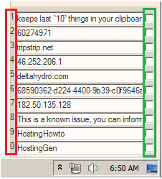

The numbers outlined in RED correspond to the clip # that text is kept in. Pressing ALT and one of these numbers will paste that text.

The checkboxes outlined in GREEN are for locking individual clips. This will cause pressing that hotkey to always send the information you have locked into the field.

\*NOTE\* The fields are editable however you cannot type directly into them. If you would like to put text into one you can right click on the field, select all to delete the old text and then right click again and paste to replace it with your text you would like.

\*NOTE 2\* If this is not showing over top of your other windows you can press CTRL + \ to display again

Clipping Manager:

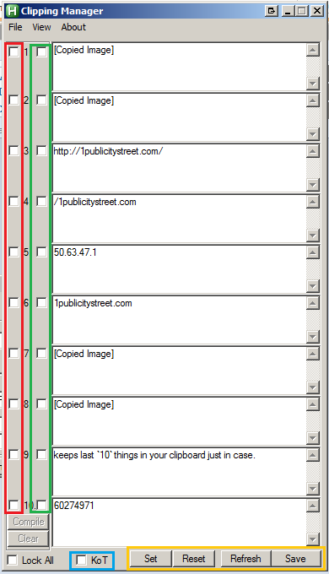

Checkboxes outlined in RED allow you to selectively compile any previous clip into a new one. For example: checking these next to 3, 7, and 9 then clicking the “COMPILE” button below, will update your most recent clipping with the compiled text from the selected clippings for you to paste.

Checkboxes outlined in GREEN are for locking and function the same as the Clip Ticker lock boxes.

\*NOTE\* If the manager is open and a field is LOCKED, this will take priority over the clip-ticker if it also has that same field locked. This allows them to have different information saved, however your locked fields are lost immediately upon closing the manager.

KoT, outlined in BLUE - if checked, will keep this window on top of all others and apply a transparency effect if it is not active.

The buttons outlined in YELLOW:

Set: This will take the contents of all fields and save them internally.

Reset: Sets each field back to contents saved when “SET” was pressed. If set was not pressed. Restores to content of fields when the manager was first opened.

Refresh: Updates all fields to what they should currently be according to your clipboard history.

Save: Updates internal clipboard history with the current content of all 10 fields.

Options:

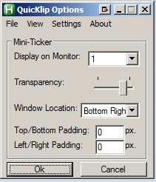

These are pretty self-explanatory. Choose which monitor you would like the clip ticker to display on and set the transparency level via the slider.

If would like your window to be free-movable and not attach itself to a corner of your monitor, select “FREE MOVE” under the Window Location drop down.

Each padding field adds the number of pixels you input to that side of the window, if attached to a corner.

Under the “Settings” menu you will find options for automatically loading the program upon startup and showing the ticker automatically once QuicKlip starts.

\*NOTE\* Your settings are saved into ‘settings.ini’ in the same location as the program itself. If the directory is set to read-only you may have issues saving settings. You can manually edit this file to set these.