MUNICIPAL CONNECT
Municipal Services Application for South Africa
PART 2 | README & USER GUIDE

Document information | Details
Project | Municipal Connect — MunicipalServicesApp
Assessment | Portfolio of Evidence, Part 2
Student | Dumisani Ernest Jnr Mvelase
Student number | ST10539769
Platform | C# Windows Forms; .NET Framework 4.8
GitHub Repository | https://github.com/Smurphie47/MunicipalServicesApp

1. Application Overview
Municipal Connect is a desktop application designed as a prototype for citizen participation in South African municipal services. Residents can submit service issues, view previously submitted reports, browse local events and announcements, search for relevant information, and receive event recommendations based on their searches.
Part 2 expands the Part 1 Report Issues functionality with Local Events and Announcements, event filtering, advanced data structures, and a search-based recommendation feature. Service Request Status remains visible on the main menu but is disabled for a later part of the project.

2. System Requirements
- Windows operating system capable of running .NET Framework 4.8 Windows Forms applications.
- Visual Studio with the .NET desktop development workload and .NET Framework 4.8 targeting/developer tools (to compile from source).
- Access to the complete solution folder, including the .slnx solution file, .csproj project file, source code and form resources.
- No external database or online service is required for the demonstration.

3. Compile and Run
- Extract the complete MunicipalServicesApp ZIP to a folder on a Windows computer.
- Open MunicipalServicesApp.slnx in Visual Studio.
- Ensure the MunicipalServicesApp project is loaded and its target framework is .NET Framework 4.8.
- Choose Build > Rebuild Solution, and check that the build succeeds.
- Press F5 (Start Debugging) to launch the application, or use Ctrl+F5 to start without debugging.
- The Municipal Connect main menu appears.
If compilation fails, confirm that the .NET Framework 4.8 developer/targeting pack is installed and that all project source files are included.

4. Main Menu and Key Features
Menu option | Behaviour
Report an Issue | Opens the report form to capture municipal issues and optional supporting evidence.
Local Events & Announcements | Opens upcoming sample events, filtering, recommendations and the announcement queue.
Service Request Status | Displayed but disabled; reserved for a later project part.
View Submitted Reports | Displays reports already saved to the local JSON report repository.

Main Menu
Home screen showing all four options, with Service Request Status disabled.
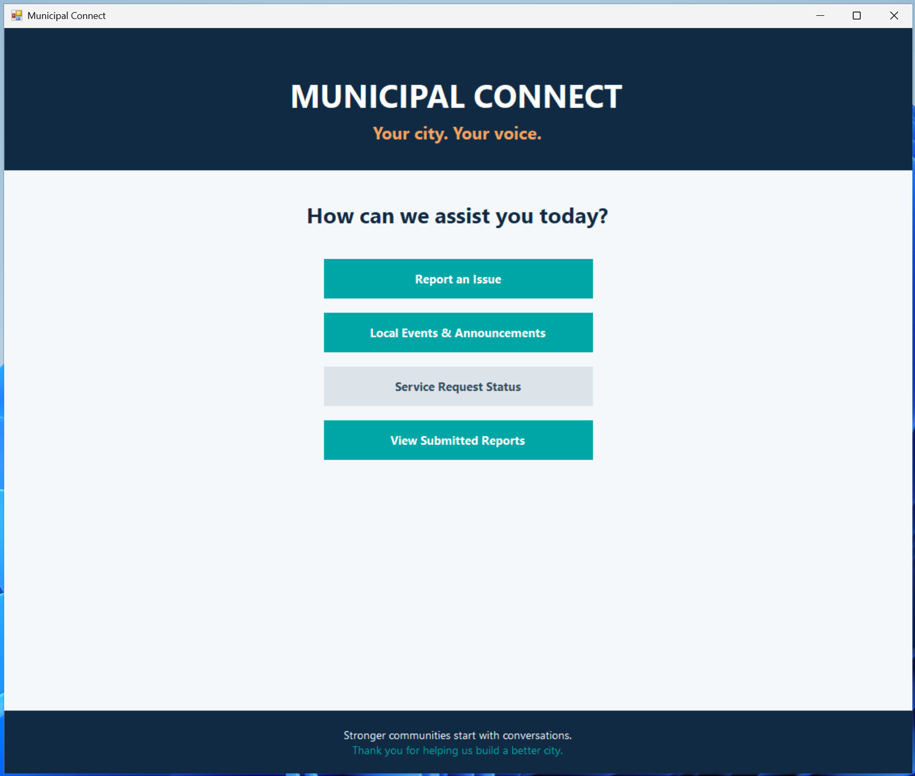

5. Reporting a Municipal Issue
Select Report an Issue. Enter the issue location, choose a category from the dropdown list, and type a detailed description. Attach File is optional and uses a Windows OpenFileDialog to select a supporting image or document. The progress bar updates as the three required fields are completed and the form displays guidance messages.
Select Submit Report. The form validates the required fields, creates an IssueReport record, assigns the next available report ID, and saves the data. A success message displays the report number and Submitted status. If the save fails, the form displays an error rather than confirming success.

Report Issue Form
Completed issue form with its location, category, description, optional attachment field and 100% progress bar.
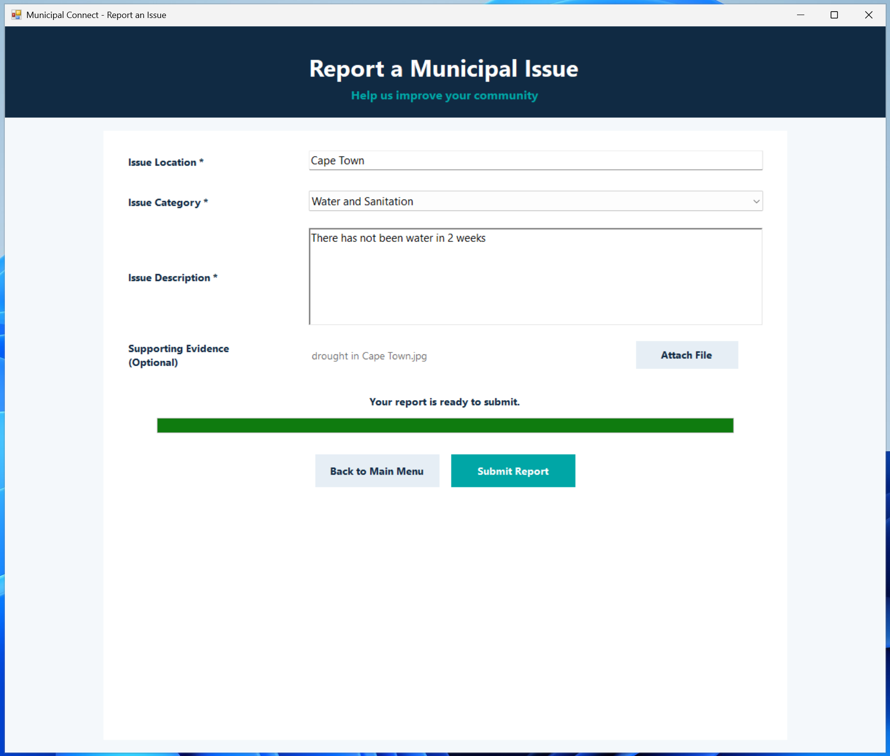

Submission Confirmation
Confirmation message showing a newly assigned report number and Submitted status
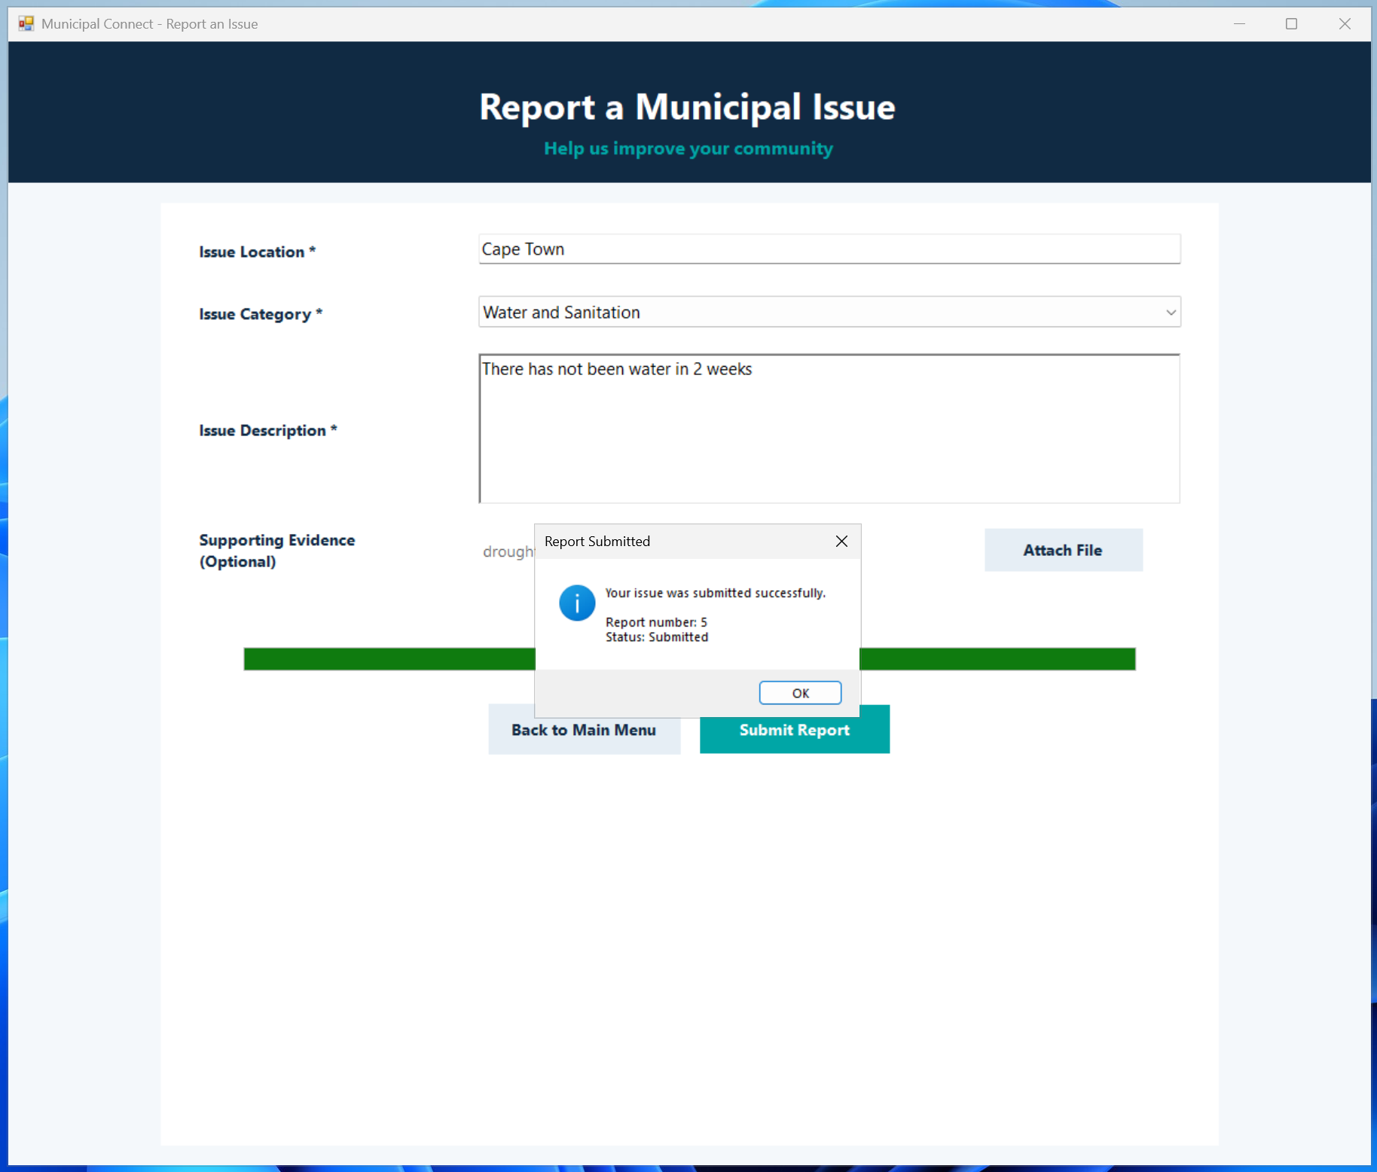

6. Saved Reports and Permanent Storage
Select View Submitted Reports from the main menu. A table displays the report ID, location, category, description, submission date, status and attachment path. Selecting a row shows fuller report details underneath. Refresh Reports reloads the current repository data.
Reports are serialized to JSON under the current Windows user profile at:
%LOCALAPPDATA%\MunicipalConnect\reports.json
The application loads the file when the repository is first used. Data remains available after the program closes and reopens. A new report ID is calculated from the highest stored report ID.
Attachment limitation: the saved report stores the selected file path, not a copy of the file. Moving or deleting the original attachment can make the path unusable.

Submitted Reports
Report table displaying previously submitted municipal reports and the selected report’s details.

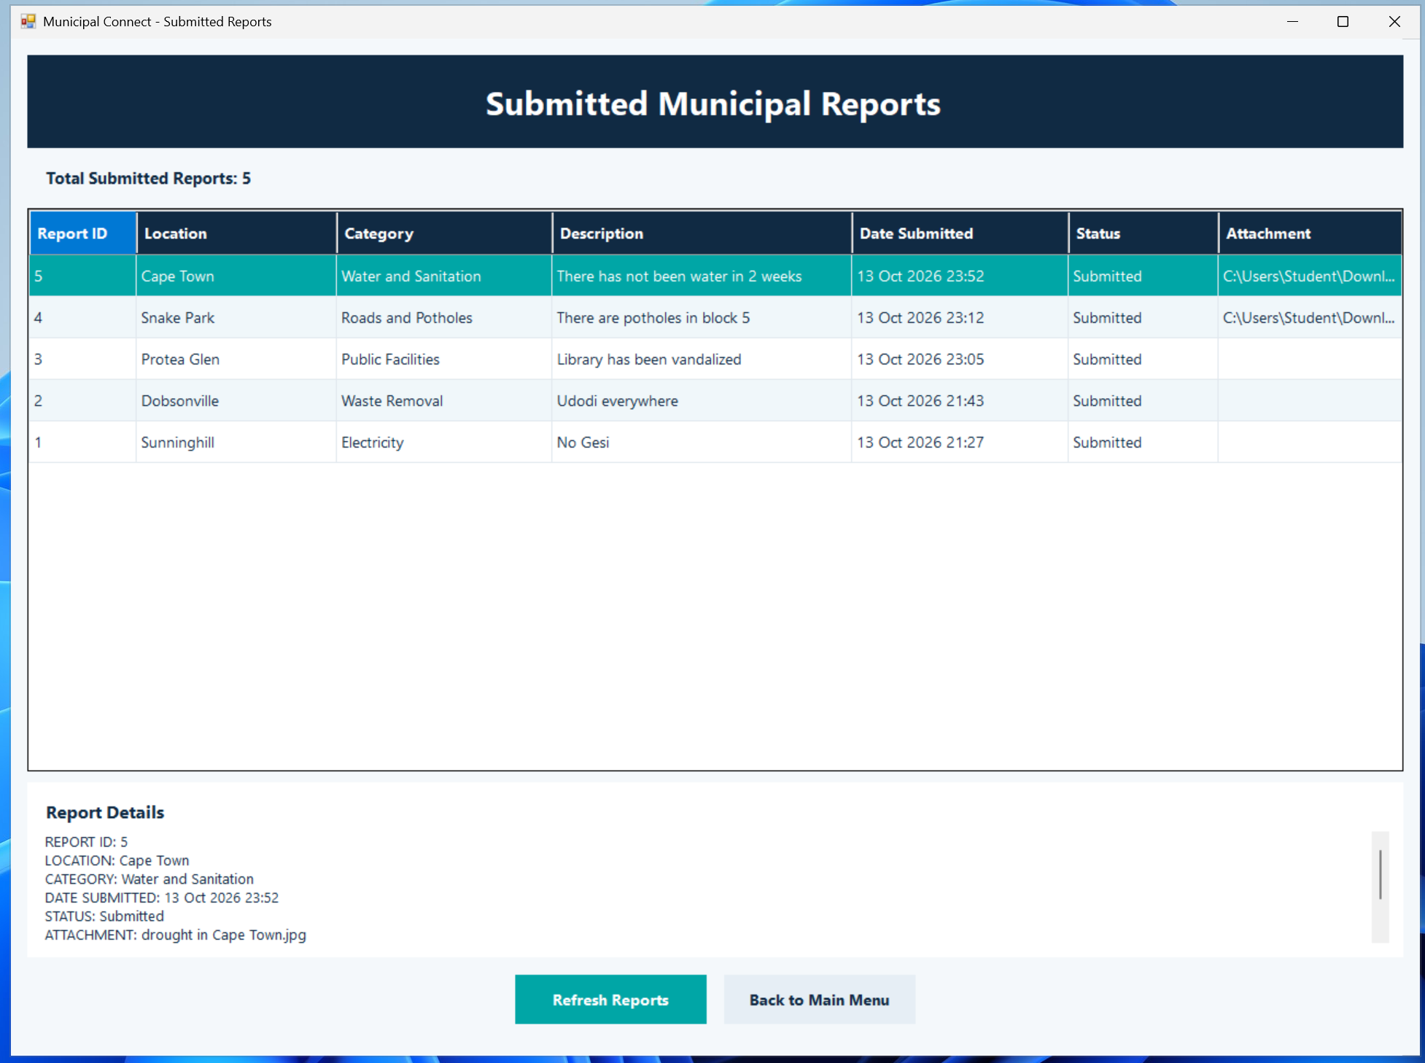

7. Local Events and Announcements
Open Local Events & Announcements to view the sample events and municipal notices. The events table shows ID, title, category, location, date and type. Selecting a row opens the corresponding description in Event Details.
The repository contains six fictional demonstration records with dates set relative to the day the application starts. They are not real municipal event listings.

7.1 Searching and Filtering
- Enter a keyword in Search Events and press Enter or select Search. Matching checks title, description, location and category without case sensitivity.
- Choose a category to limit the results to that category. The category list is generated from unique values in a HashSet.
- Tick Filter by Date and select a date to display matching records for that day.
- Select Clear Filters to restore the complete list. This does not erase the search preference history.

Local Events and Search Filters
The events table, category dropdown, keyword search field and date-filter control.
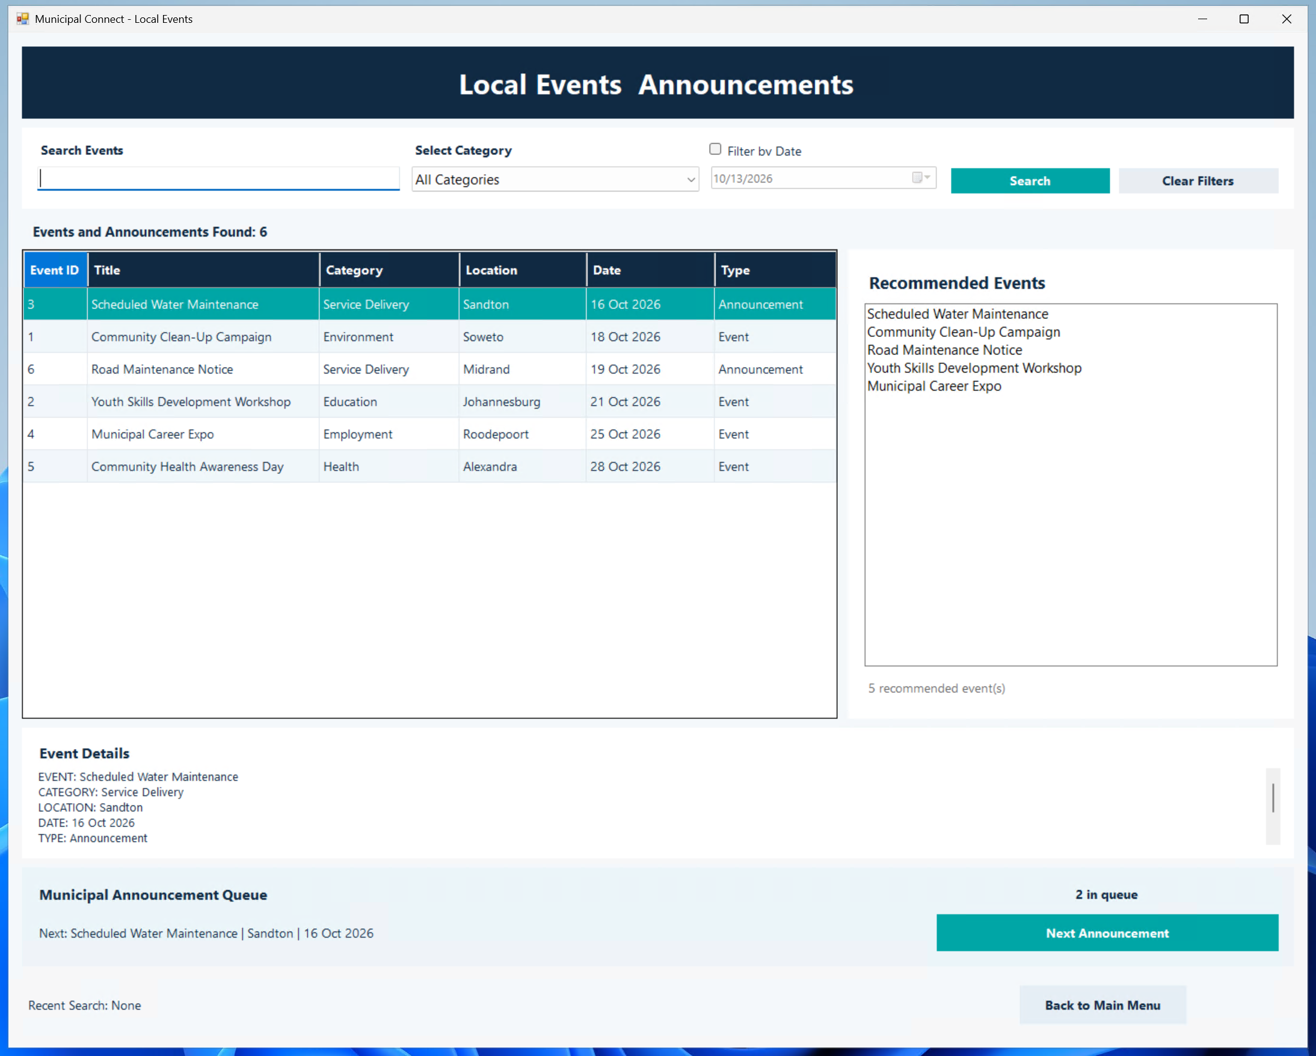

7.2 Recommendations
The recommendation feature uses recent keyword searches and category search frequency to rank upcoming events. A Stack stores recent keywords and a Dictionary counts selected-category searches. RecommendationEngine calculates scores using title, category, description and location matches, category frequency, and proximity of the event date. The top five results appear in Recommended Events. Selecting one displays its details.
The recommendation score is a deterministic rule-based algorithm, not machine learning. Search preferences are kept in memory for the current application session and are not currently saved to disk.

Recommended Events
The recommended events list after performing several keyword and category searches, displays suggestions based on previous searches and category preferences.

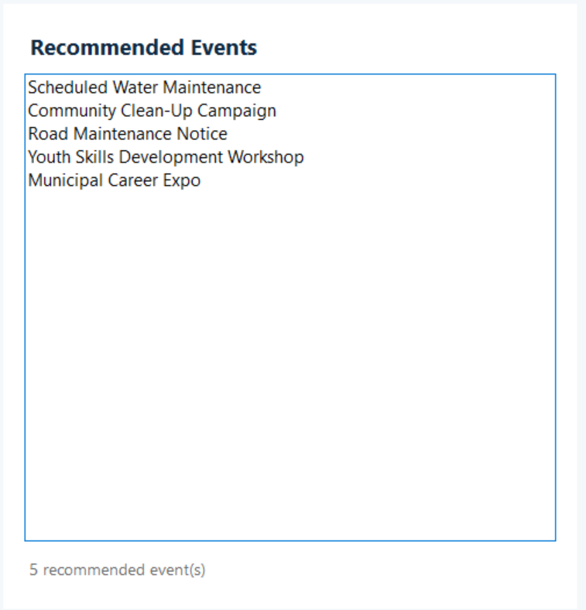

7.3 Announcement Queue
The announcement viewer uses Queue<MunicipalEvent>. Select Next Announcement to remove the first item from the queue (Dequeue), display it, and add it to the end (Enqueue). This demonstrates FIFO processing while allowing repeated browsing. The queue counter shows the number of loaded announcements.

Municipal Announcement Queue
The announcement panel showing “2 in queue”, the Next Announcement button, and an announcement displayed in Event Details.

8. Advanced Data Structures and Algorithms
Structure | Used in | Purpose
List<IssueReport> | ReportRepository | Holds submitted issue reports for display and JSON serialization.
Dictionary<int, MunicipalEvent> | EventRepository | Finds events by their unique IDs.
SortedDictionary<DateTime, List<MunicipalEvent>> | EventRepository | Groups and orders event records by date.
HashSet<string> | EventRepository | Keeps category values unique.
Queue<MunicipalEvent> | EventRepository | Processes announcements in first-in, first-out order.
Stack<string> | LocalEventsForm | Stores recent searches for the recommendation system.
Dictionary<string, int> | LocalEventsForm | Counts searches by category for preference ranking.

9. Functional Testing Checklist
Test | Expected outcome
Submit a complete issue | Confirmation shows a unique report ID and Submitted status.
Submit missing fields | Validation warning; incomplete report is not submitted.
Close/reopen the app | Previously saved reports remain visible.
Search “water” | Matching water-maintenance announcement appears.
Filter by category/date | Only corresponding event records appear.
Clear Filters | The full sample event list returns.
Repeat category searches | Recommendation ordering responds to search preferences.
Cycle announcements three times | Announcement rotation demonstrates FIFO and remains browseable.
Navigate back | Each screen returns to the main menu.

10. Project File Guide
File | Responsibility
MainMenuForm.cs | Home screen and navigation.
ReportIssueForm.cs | Issue entry, validation, attachments and progress feedback.
ViewReportsForm.cs | Report table and selected report details.
IssueReport.cs / ReportRepository.cs | Issue model and JSON report storage.
MunicipalEvent.cs / EventRepository.cs | Event model and event indexes, categories and queue.
LocalEventsForm.cs | Event browsing, search, filtering, recommendations and queue UI.
RecommendationEngine.cs | Ranks events using user search preferences.
Program.cs | Application entry point.

11. Current Scope and Limitations
- Service Request Status is not implemented in Part 2 and remains disabled.
- Six municipal event records are fictional sample data; no live municipal API is connected.
- Event data and recommendation preferences are loaded/managed in memory; only submitted issue reports have JSON persistence.
- Report attachments are stored by original file path rather than copied into a managed folder.
- The application is a local Windows desktop prototype; it does not synchronize reports across different devices.

