* **Linear Regression**

Accuracy: 100%

R^2 value ~ 0.7

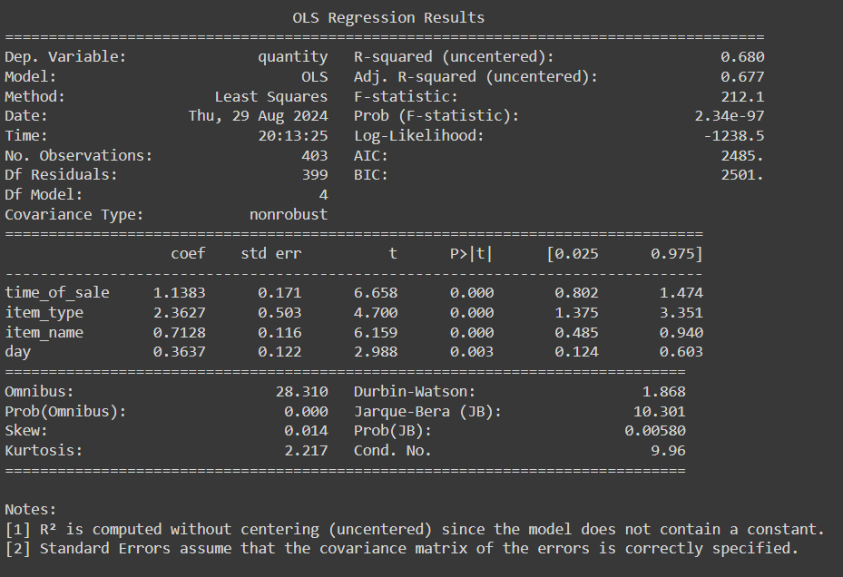

*Correlation matrix :*

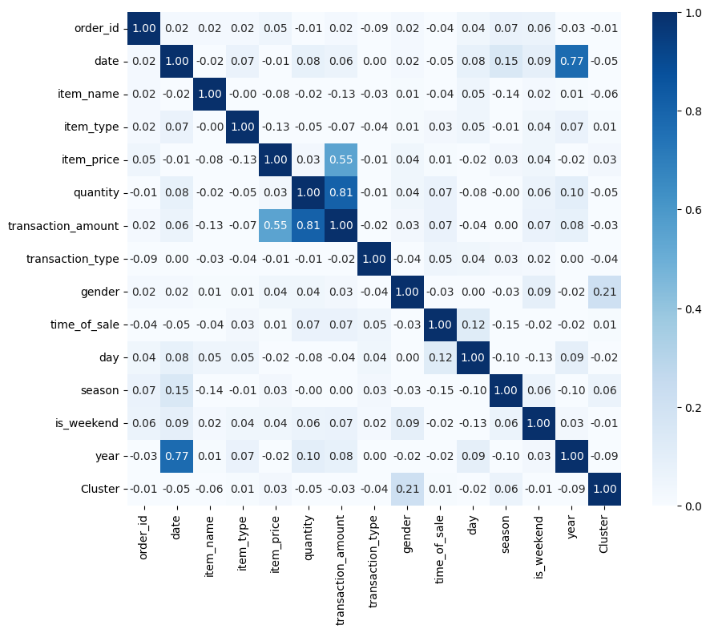

* **RandomForestRegression**  
  R^2 value=-0.15  
  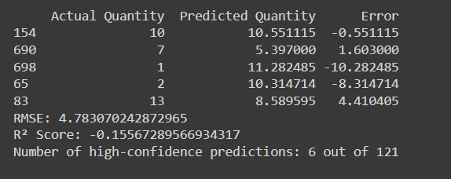

Accuracy ~ 5%

* **Decision Making**

