**Space shooter**

***Intended Systems***

PC

***Target Ages***

All Ages 10 and up

**Rating**

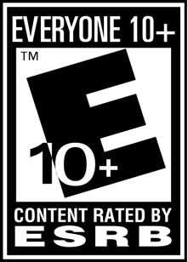

***Game Overview***

The player will control a spaceship flying through space hunting down alien thieves. You must fight your way through hordes of space thieves and destroy the mothership or be defeated and scavenged.

***Game Controls***

The Spaceship will be able to be controlled with the WASD keys to move up,down,right, or left

***Core Gameplay***

Travelling through space you must avoid enemy ships as well as their attacks. The ship you will control will be automatically shooting and you will be able to retrieve special power-ups adding onto your arsenal of weapons. Destroying enemy ships will give you added score. Destroying the enemy mothership will win you the game and losing all 3 of your lives will make you lose the game.

***Environment***

The space background will be infinitely moving with asteroids and stars.