PROJECT REPORT
ON
HOME AUTOMATION SYSTEM
For the partial fulfilment of Software Engineering lab
Semester IV



Submitted By :- Submitted To :-

Muskaan Talat (8184) Mr. Suyash Kumar
Haripriya (8210) Department of Computer Science
Damini Patel (8189) Hansraj College
Saumya Gangwar (8187)

Department of Computer Science
Hansraj College
University of Delhi
April – 2021

CERTIFICATE

It is hereby certified that the Project Report of Software Engineering entitled “HOME AUTOMATION SYSTEM” is submitted by Saumya Gangwar, Haripriya, Damini Patel, Muskaan Talat, the students of B.Sc. (H) Computer Science, Hansraj College (University of Delhi). It has been found satisfactory and hereby approved for submission.

Mr. Suyash Kumar Date:
(Assistant Professor
Department of CS, HRC)

Acknowledgement

We wish to express our sincere gratitude to our Professor Mr. Suyash Kumar for providing his invaluable guidance, comments and suggestions throughout the course of the project. We also wish to express our gratitude to the officials and other staff members of IOT academy who rendered their help in requirement gathering in the Project. We also thank the Principal Ms. Rama and H.O.D. of Computer Science Dr. Baljeet Kaur for providing us the opportunity to embark on this Project.

DECLARATION

It is hereby declared that the Software Engineering Report entitled “HOME AUTOMATION SYSTEM” is submitted by Haripriya, Damini Patel, Muskaan Talat, Saumya Gangwar, the students of B.Sc. (H) Computer Science, Hansraj College (University of Delhi). The Project Report submitted is our own piece of work and it is an authentic record in accordance with the guidelines and requirements of Software Engineering during the period from 1st February 2021 to 30th April 2021 under the guidance of Mr. Suyash Kumar.

INDEX
- Introduction.....................................................................................................................................7
  - Problem Statement...........................................................................................................7
  - Purpose.............................................................................................................................7
  - Scope................................................................................................................................7
  - Definitions, Acronyms, Abbreviations...........................................................................8
  - References........................................................................................................................9
  - Overview........................................................................................................................10
  - Use-Case Diagram.........................................................................................................10
  - Requirement Elicitation based on Use-Case Diagram...................................................10
    - Actors.....................................................................................................10
    - Use-Cases...............................................................................................11
    - Relationships..........................................................................................11
  - Data Flow Diagrams......................................................................................................11
    - Context level Diagram...........................................................................11
    - 1-level Diagram.....................................................................................12

- Overall Description........................................................................................................................13
  - Product Perspective........................................................................................................13
    - System Interfaces...................................................................................13
    - User Interfaces.......................................................................................13
    - Hardware Interfaces...............................................................................14
    - Software Interfaces................................................................................14
    - Communications Interfaces....................................................................14
    - Memory Constraints...............................................................................14
    - Operations..............................................................................................15
    - Site Adaptation Requirements...............................................................15
  - System Functions...........................................................................................................15
  - User Characteristics.......................................................................................................15
  - Constraints.....................................................................................................................15
  - Assumptions and Dependencies....................................................................................15
  - Apportioning of Requirements......................................................................................15

- Specific Requirements...................................................................................................................16
  - External Interface Requirements..................................................................................16
    - User Interfaces......................................................................................16
    - Hardware Interfaces..............................................................................17
    - Software Interfaces...............................................................................17
    - Communication Interfaces....................................................................19
  - System Features.............................................................................................................20
  - Performance Requirements............................................................................................20
  - Design Constraints.........................................................................................................20
  - Software System Attributes...........................................................................................21
    - Security..................................................................................................21
    - Maintainability.......................................................................................21
    - Portability...............................................................................................21
  - Other Requirements.......................................................................................................21

- Testing.............................................................................................................................................21
  - Pseuodcode...................................................................................................................21
  - Test Cases.....................................................................................................................27
- Scheduling......................................................................................................................................29
- Estimations.....................................................................................................................................29
  - Function Points.............................................................................................................29
  - Efforts...........................................................................................................................30
- Appendix.........................................................................................................................................32
  - Circuit Diagram.............................................................................................................32
  - Implementation at large-scale........................................................................................32

- INTRODUCTION
In this age of technology, the Internet of Things refers to the individual identifiable objects and their virtual representation in cyberspace. IoT is a pristine information processing and accretion method encompassing smart technology, nanotechnology, and other technological advancements. IoT is not alone noble technology; instead, it circumvents considerable complementary technical development and provides capabilities that are appropriated together and aid to bridge the gap between the virtual and physical world. Everyone is living a very busy life, and they want to get ease in every aspect of life. The Internet of Things (IoT) is a very vast field, and this research cannot cover up the whole thing to automate. But, the ease of people Home Automation is the first domain that comes in mind. Home Automation is a term used to describe the working of all home appliances together, and we are controlling things by using an Android Smartphone, tablet, or computer having internet connectivity. The popularity of home automation is increased rapidly during the recent years. People like the comfort of maintaining and changing the status of appliances from any part of the world using remote access. It is eventually becoming the need of every person.

  - Problem Statement
This project aims at the automation and control of household appliances from a single point remotely. It will also help in measuring the temperature and humidity of the surroundings.​

  - Purpose
This automation system with high range of connectivity allows users to control their homes easily and efficiently via a user-friendly interface using smart phones and/or laptops regardless of time and location. This will use Wi-Fi facility to integrate the appliances and sensors for additional information about the temperature and humidity. For this project we will be focusing on lights in the house. This can be further elaborated and applied to other appliances as well.​

  - Scope
Our proposed system is an Arduino based home automation system done with NodeMCU as the main board. It will also have a DHT-11 sensor that will measure the temperature and humidity of the surroundings of the system. This system has two main modules: The hardware interface module and the software interface module. At the core of this system is the NodeMCU board. All communication in this system passes through this board. It offers switching functionalities to control lighting, fans and other home appliances connected to the relay system. With this in mind, an internet based home automation system is designed with an addition of measurement of physical quantities temperature and humidity using a sensor.​

  - Definitions, Acronyms, Abbreviations
Relay Module
This is relay interface board that can be controlled directly by a wide range of microcontrollers such as Arduino. It connects multiple AC powered devices that needs to be controlled and uses low-level triggered control signals (3.3-5 V DC) for controlling purpose. Every relay module consist of channels for each particular connected device. And, each channel has 2 parts:-​

- INPUT PART​
This part consist of 3 pins: INP (signal trigger port), VCC (acts as DC +ve), GND (acts as DC –ve)​

- OUTPUT PART​
It consist of 3 points: Normally Open Port (NOP), Common, Normally Closed Port (NCP). And, triggering relay operates NOP or NCP.​

Whenever INP pin reads a HIGH voltage then common port gets in touch with NOP (because flowing current through coil of relay generates magnetic field that attracts Common lever and change switch contacts) & circuit gets completed. When it reads a LOW voltage, common port touches with NCP & circuit remains incomplete. In this way, when Arduino provides a +ve voltage then relay of particular device completes circuit and device gets powered on.​

DHT11 Sensor
DHT11 is a low-cost digital sensor for sensing temperature and humidity. This sensor can be easily interfaced with any micro-controller such as Arduino, Raspberry Pi etc… to measure humidity and temperature instantaneously. DHT11 sensor consists of a capacitive humidity sensing element and a thermistor for sensing temperature. The humidity sensing capacitor has two electrodes with a moisture holding substrate as a dielectric between them. Change in the capacitance value occurs with the change in humidity levels. The IC measure, process this changed resistance values and change them into digital form.

For measuring temperature this sensor uses a Negative Temperature coefficient thermistor, which causes a decrease in its resistance value with increase in temperature. To get larger resistance value even for the smallest change in temperature, this sensor is usually made up of semiconductor ceramics or polymers.

The temperature range of DHT11 is from 0 to 50 degree Celsius with a 2-degree accuracy. Humidity range of this sensor is from 20 to 80% with 5% accuracy. The sampling rate of this sensor is 1Hz .i.e. it gives one reading for every second. DHT11 is small in size with operating voltage from 3 to 5 volts. The maximum current used while measuring is 2.5mA.

DHT11 sensor has four pins- VCC, GND, Data Pin and a not connected pin. A pull-up resistor of 5k to 10k ohms is provided for communication between sensor and micro-controller.

NodeMCU Board
NodeMCU is an open-source LUA based firmware developed for the ESP8266 wifi chip. By exploring functionality with the ESP8266 chip, NodeMCU firmware comes with the ESP8266 Development board/kit i.e. NodeMCU Development board.
Some of the features of the board include;
- Arduino-like (software defined) GPIO
- Can be programmed using the Esplorer IDE or the Arduino IDE.
- Onboard USB-TTL converter for easy programming10
- onboard digital I/O pins, an analog pin along with pins for SPI, IIC, and 1-Wire communication protocols.
- Extensive WiFi capabilities (Can create an access point and/or join an existing one). It is used to connect devices to the internet to fetch/ upload data and can serve as a mini web server for simple pages.
- Onboard PCB antenna.
- 3.3V logic level

Originally when the ESP8266 modules were released, to work in standalone mode, they had to be programmed using the ESplorer IDE which required a knowledge of the LUA programming language, but as things progressed, the board type was created for the Arduino IDE and someone can now easily program several ESP based boards, using the Arduino IDE.

Breadboard
A breadboard is a solderless device for temporary prototype with electronics and test circuit designs. Most electronic components in electronic circuits can be interconnected by inserting their leads or terminals into the holes and then making connections through wires where appropriate. The breadboard has strips of metal underneath the board and connects the holes on the top of the board. The metal strips are laid out as shown below. Note that the top and bottom rows of holes are connected horizontally and split in the middle while the remaining holes are connected vertically.

Node-Red
- Flow based Programming which realizes quick development.
- Node-RED is a programming tool for wiring together hardware devices, APIs and online services in new and interesting ways.
- It provides a browser-based editor that makes it easy to wire together flows using the wide range of nodes in the palette that can be deployed to its runtime in a single-click.
- Various connectors(Node-RED nodes) to add functionalities
- Open source software under Linux foundation

  - References
- IOT Academy : For the information about all IOT Components
- https://www.link-labs.com/blog/applications-of-home-automation : For the applications of this system
- http://ieeeprojectsmadurai.com/IEEE%202019%20IOT%20BASEPAPERS/36_ IOT%20BASED%20HOME%20AUTOMATION.pdf : Research Paper
- https://www.researchgate.net/publication/342327250_IoT_based_Smart_Environment_Using_Node-Red_and_MQTT : Research Paper

  - Overview
In this research paper, the complete design scheme and working methodology of a home automation project are explained. The reason behind the paper is to get enhancement ideas to make it better and user friendly. This proposed system comprises two nodes, the admin side in which the user able to design the complete prototype of the home with an easy GUI-based interface. The proposed system also has decision-making ability about the status of each device of the home. Moreover, this project is user acceptance tested verified and operational in many homes. It provides simplicity, flexibility, reliability and a low-cost system that is affordable to middle-class families too.

  - Use-Case Diagram
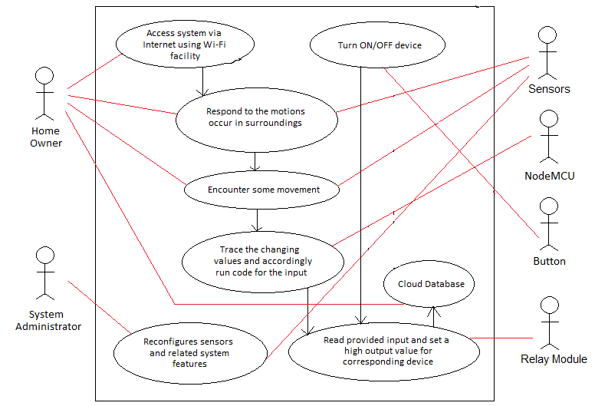
  - Requirement Elicitation based on use-case diagram
The components of our use case diagram are as follows:
    - Actors
- Home Owner
- System Administrator
- Relay Module
- Button
- Sensors
- NodeMCU
    - Use-Cases
- Access system via Internet using Wi-Fi facility
– by Home Owner
- Respond to motions occur in surroundings
– by home owner and sensors
- Encounter some movement
- by home owner and sensors
- Trace changes and accordingly run code for input
- by NodeMCU
- Reconfigure sensors and related system features
- by System Administrators and sensors
- Read provided input and set high output value for corresponding device
- by Relay Module
- Turn ON/OFF device
- by Button
- Cloud database
- by Home Owner

    - Relationships
They are represented by straight lines in the use case diagram among different entities and use-cases.

  - Data-Flow Diagrams
    - Context level Diagram
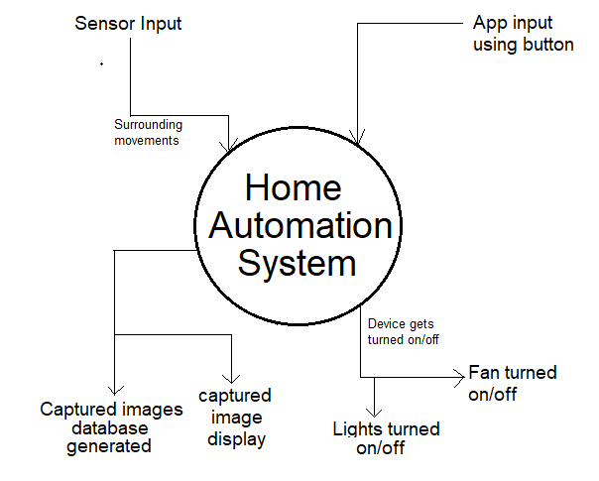
    - 1-Level Diagram
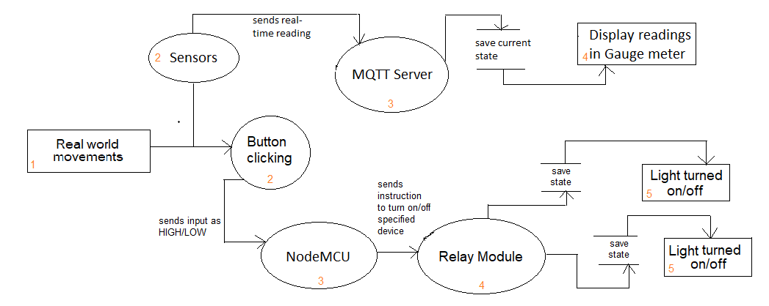

- OVERALL DESCRIPTION
The requirements of this system deals with the situations like when a person wants a kind of comfort or peace of mind. Hence, this system will provide them with the following benefits: save energy, save money, safety, convenience and control. Also, it will provide you with some additional data about your surrounding environment like room temperature, humidity.
The system will have a user interface that will provide you with necessary data and allows controlling devices. This user interface can be utilized either in form of a mobile application or online as a website. This provides user with an option to choose their preferred way for operating the system.
Also, this whole system has been setup on a cloud server with the help of Wi-Fi facility that will allow the user to operate their devices from sitting anywhere around, not needed to be specifically in that particular room/home where it has been set up.

  - Product Perspective
The system will be an application-based. It will be dependent on the MQTT server & Wi-Fi connection in the setup area.

    - System Interfaces
User-friendly GUI screens.

    - User Interfaces
The system will have a user-friendly interface in 2 forms:
- Web Screen on Node-Red Dashboard
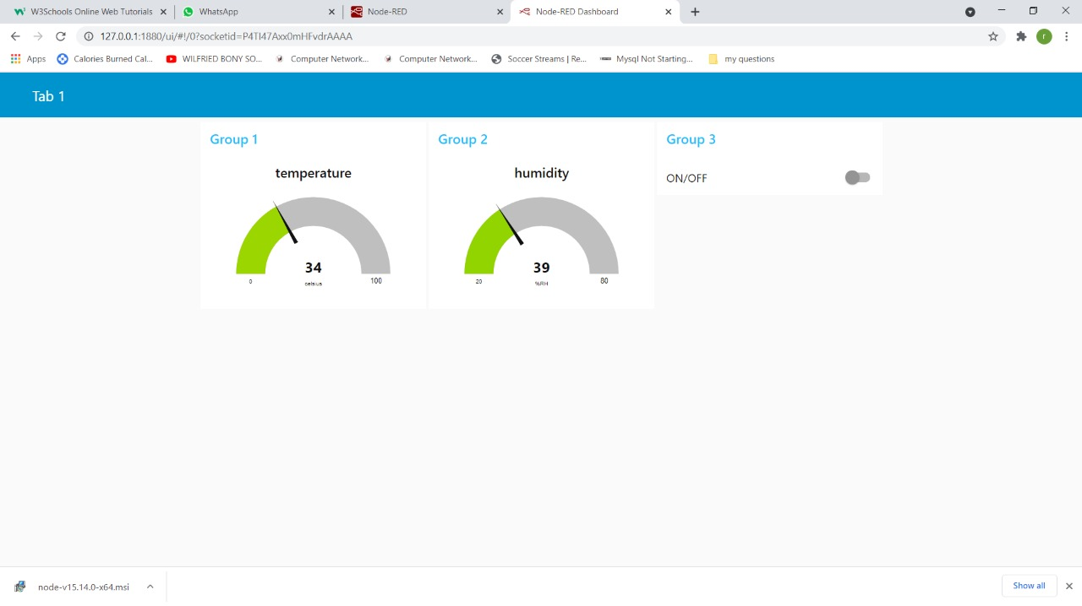

- Mobile Application screen on MQTT Dash Application
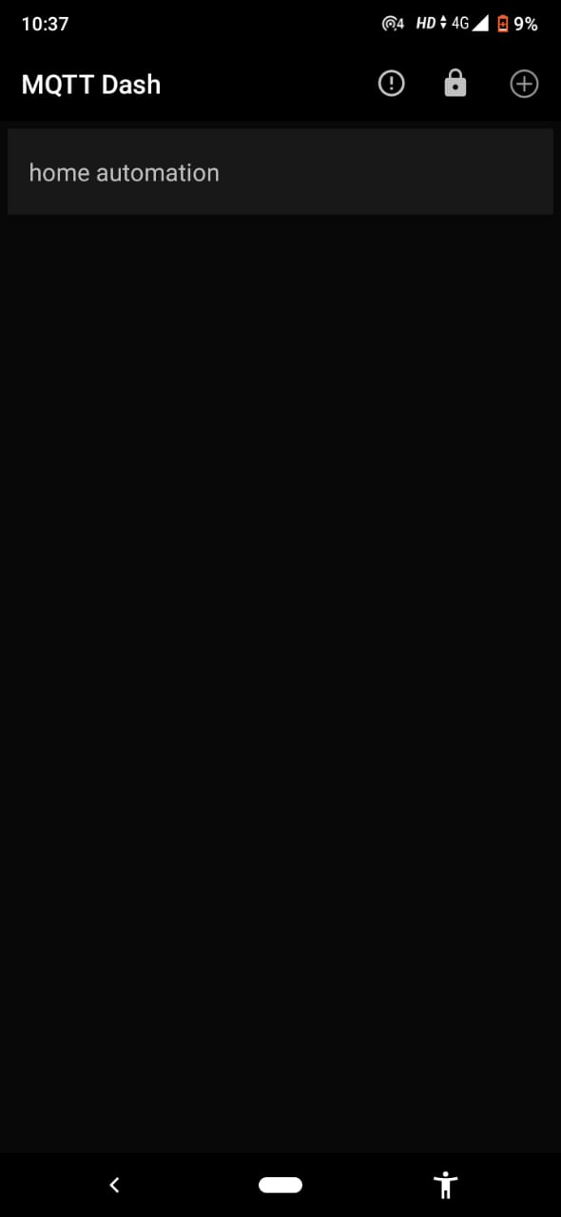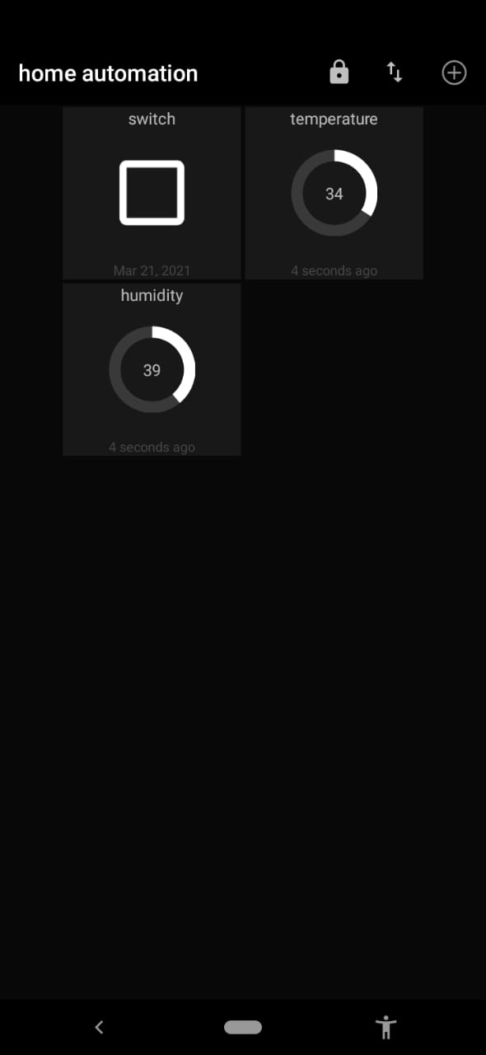

    - Hardware Interfaces
A network-based system to use the system online.

    - Software Interfaces
- Arduino IDE for uploading code on NodeMCU board
- Node-Red application for making connections and data delivery on a wi-fi connection.

    - Communication Interfaces
Wi-Fi will be used for the communication between hardware system and Software interface.

    - Memory Constraints
None

    - Operations
This system can be reconfigured to a higher level during the working mode but that might need a lot of efforts & components replacement.

    - Site Adaptation Requirements
The terminals at client site will have to support the hardware and software interfaces specified in above sections.

  - System Functions
The system will allow access to users who had been connected to it while the setup process of whole project.
- A summary of the major functions that the system will perform:
- User will be able to keep a record of its surrounding.
- User can check room temperature anytime in form of a gauge meter.
- User can check humidity in the air in gauge meter.
- User has access to the system all time, once gets connected.
- User can access the system by connecting through Wi-Fi from anywhere.
- User can control devices with the help of toggle buttons.

  - User Characteristics
Educational Level: Not specific educational requirements are needed to use this system.
Experience: None
Technical Expertise: User should be comfortable using general-purpose applications on a computer or mobile phone.

  - Constraints
None

  - Assumptions and Dependencies
We assume that a single user phone is accessible to him/her only. This system will require 24*7 Wi-Fi connections for it to work continuously.

  - Apportioning of Requirements
None

- SPECIFIC REQUIREMENTS
This section contains the system requirements to a level of detail sufficient to enable designers to design the system, and testers to test that system.

  - External Interface Requirements

    - User Interfaces
In order to operate this home automation system, we are going to use prebuilt applications on computer as well as phone. The following screens will be provided:

- To operate on computer system

For this, we will use Node-Red which is a programming tool for wiring together hardware devices, APIs and online services in new and interesting ways. It provides a browser-based editor.
Our node-red dashboard contains 2 gauge meters - 1 for temperature & other one for humidity, for determining the values measured using sensor. And, a toggle button to control the device. These components need to be added in workspace area of node-red before deploying to the dashboard screen.

Node-Red Dashboard Screen:


- To operate on mobile phone
For this, we will use MQTT Dash application that is software basically for controlling systems connected to the MQTT server. To add any system, credentials that will be required are Client ID, Username, UserPassword. This will contain 2 gauge meters - 1 for temperature & other one for humidity, for determining the values measured using sensor. And, a toggle button to control the device.

MQTT dash Screen:

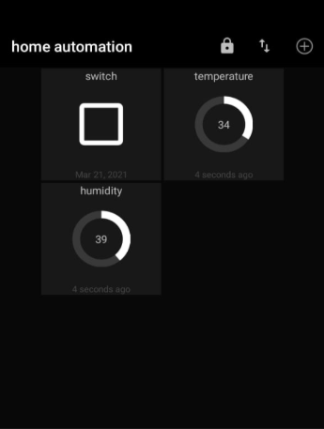

    - Hardware Interfaces
None

    - Software Interfaces
This system has been connected to the Wi-Fi with the help of Node-Red software/programming tool where we need to define connections and the flow of data delivery between components. Also, with the help of this software we decide the final interface.
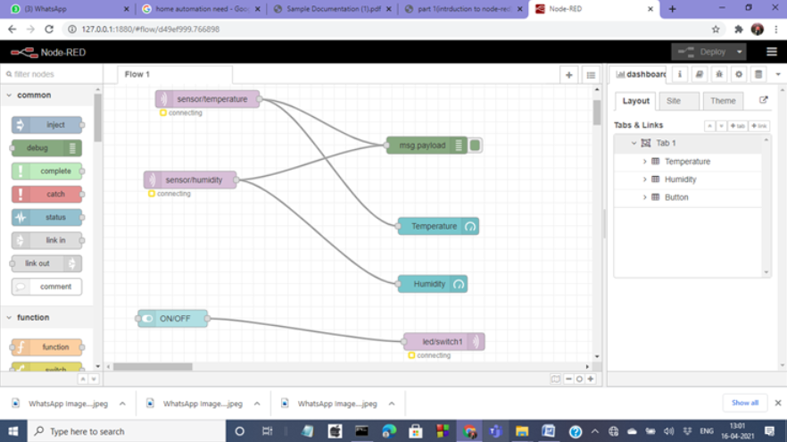
To add these all components, follow preceding steps:
- Select 2 mqtt in nodes and drag them into workspace
- Double click on first mqtt in node
- Add new mqtt broker(server) here
- Now click on edit button mentioned in slide
- Fill the details as shown in figure
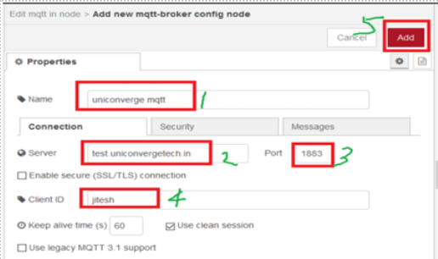

- Fill the details and select topic sensor/temperature
- Double click 2nd mqtt in node
- Select uniconverge mqtt as a server
- Fill the details and select topic sensor/humidity
- Drag debug node from node palette
- Drag 2 gauge node(dashboard) from node palette into workspace
- Double click on one of gauge
- Fill the details(Label-Temperature) & click on done
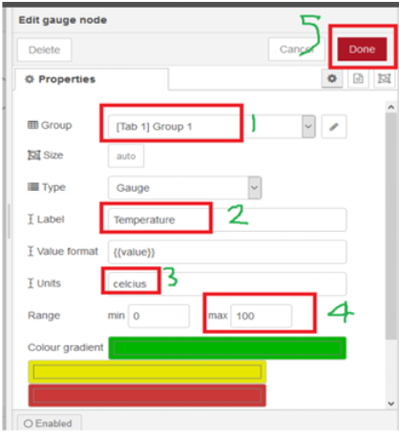

- For second gauge, Fill the details (Label-Humidity) & click on done
- Connect Nodes & Deploy
- Click on dashboard tab in output pane
- Drag a switch node(dashboard in node palette) into workspace
- Double click on switch node & fill details
- Select same group which is selected in gauge nodes & click on done
- Drag mqtt out node (from node palette) into workspace
- Double click on mqtt out node
- Fill the details & write topic led/switch1
- Connect switch node and mqtt out node & deploy
- Now, dashboard is ready.

    - Communication Interfaces
None

  - System Features

    - ANYWHERE ACCESS USING WI-FI

Description: The user will be able to keep a record of the surroundings of the house. The devices in the house can be remotely controlled through Wi-Fi like lights.

Validity Checks:
- Good internet connectivity is required.
- Internet connectivity should be stable.
Sequencing Information: Firstly, in Arduino IDE, while uploading the code, put the Wi-Fi username and password so that NodeMCU gets connected to the network and we can operate the circuit. Finally, Wi-Fi needs to be connected to the computer.
Error Handling/Response to Abnormal Situations: If any of the above validations/sequencing flow does not hold true, appropriate error messages will be prompted on serial monitor to the user for doing the needful.
    - GET MEASUREMENT OF TEMPERATURE & HUMIDITY OF THE SURROUNDING ENVIRONMENT
Description: The surrounding temperature and humidity will be displayed on the Node-Red dashboard on being deployed.

Validity Checks: NONE

Sequencing Information: Firstly, define flow on Node-RED dashboard. Second step is to Deploy the whole circuit. Finally, we can operate the system.

Error Handling/Response to Abnormal Situations: If any of the above validations/sequencing flow does not hold true, appropriate error messages will be prompted on serial monitor to the user for doing the needful.
    - DEVICE CONTROLLING
Description: Node-RED Dashboard provides one button for controlling LED lights in home and two gauge meters for temperature and humidity.

Validity Checks: (i) Good internet connectivity is required.

Sequencing Information: Firstly, define flow on Node-RED dashboard. Second step is to Deploy the whole circuit. Finally, we can operate the system.

Error Handling/Response to Abnormal Situations: If any of the above validations/sequencing flow does not hold true, appropriate error messages will be prompted on serial monitor to the user for doing the needful.

  - Performance Requirements
It requires a high-speed internet connection for the system to run smoothly without any interruption.

  - Design Constraints
None

  - Software system Attributes
    - Security
The system will be protected with Wi-Fi password. Users will have to enter correct username, password and role in order to access, control the system.

    - Maintainability
The system will be designed in a maintainable manner.

    - Portability
The system would not be easily portable once it has been setup.

  - Other Requirements
None

- TESTING
Now we find out the complexity of the module to determine the possible independent paths and hence develop test cases.

  - Pseuodcode
(NodeMCU-MQTT)
START
SET wifi_ssid to "Ravi188"(WiFi connection Name) [1]
SET wifi_password to "115204416"(WiFi Password) [2]
SET mqtt_server to "test.uniconvergetech.in" [3]
SET mqtt_user to "guest" [4]
SET mqtt_password to "guest" [5]

SET temperature_topic to "sensor/temperature" [6]
SET humidity_topic to "sensor/humidity" [7]

declare a 100 characters array [8]
initialize lastMsg to 0 [9]
initialize lastRecu to 0 [10]
initialize debug to FALSE [11]
SET DHTPIN to D4 [12]
SET DHTTYPE to DHT11 [13]

declare dht and configure DHTPIN of DHTTYPE [14]
declare a WiFiClient espClient [15]
declare a PubSubClient client with a WiFiClient [16]

Function setup
Pass In:nothing
Start a serial communication from nodeMCU at a baud rate of 9600 [17]
configure D2 pin as OUTPUT pin [18]
call setup_wifi() to setup WiFi connection [19]
configure a MQTT connection with mqtt_server on port 1883 [20]
set a handling function callback() to be executed when a MQTT message is received[21]
Pass Out:nothing
Endfunction

Function setup_wifi
Pass In:nothing
take a delay of 10ms [22]
print "Connecting to (wifi_ssid)" [23]
establish a WiFi connection using wifi_ssid & wifi_password [24]
REPEAT
take a delay of 500ms [25]
print "." [26]
UNTIL WiFi connection doesn't get established [27]
print "WiFi OK => ESP8266 IP Address: " [28]
print local IP address [29]
Pass Out:nothing
Endfunction

Function reconnect
Pass In:nothing
REPEAT
print "connecting to mqtt broker..." [30]
IF MQTT connection get established [31]
THEN print "OK" [32]
ELSE
print Client's state as error [33]
print "Wait 5 seconds before to retry" [34]
take a delay of 5000ms [35]
ENDIF
UNTIL client connection with server doesn't get established [36]
Pass Out:nothing
Endfunction

Function loop
Pass In:nothing
IF client's MQTT connection hasn't been established [37]
THEN call reconnect() [38]
ENDIF
initialize 'now' with the milliseconds passed up till now [39]
IF lastMsg timing was a minute ago THEN [40]
SET lastMsg to now [41]
read Humidity from DHT sensor to h [42]
read temperature from DHT sensor to t [43]
IF read values are not numerical THEN [44]
print "Please change DHT sensor!" [45]
return out of function [46]
ENDIF
IF debug sets TRUE THEN [47]
print "Temperature : t" [48]
print "Humidity : h" [49]
ENDIF
publish temperature & humidity on their respective topics created on node-red [50]
ENDIF
IF lastRecu timing was more than a minute ago THEN [51]
SET lastRecu to now [52]
subscribe to the topic led/switch1 for controlling device [53]
ENDIF
Pass Out:nothing
Endfunction

Function callback
Pass In: Topic, payload in bytes, length of msg
initialize counter i to 0 [54]
IF debug is true THEN [55]
print "Message recu=> topic: " + topic [56]
print "| lonueur: " + length in string form [57]
ENDIF
FOR every character of msg [58]
copy from payload into message_buff [59]
ENDFOR
add a null character at end of message_buff [60]
convert message_buff into a string to msgString [61]
IF debug is true THEN [62]
print "Payload: " + msgString [63]
ENDIF
IF msgString is 'ON' THEN [64]
set D2 Pin at LOW state [65]
ELSE
set D2 pin at HIGH state [66]
ENDIF
Pass Out:nothing
Endfunction

It’s cyclomatic complexity is:
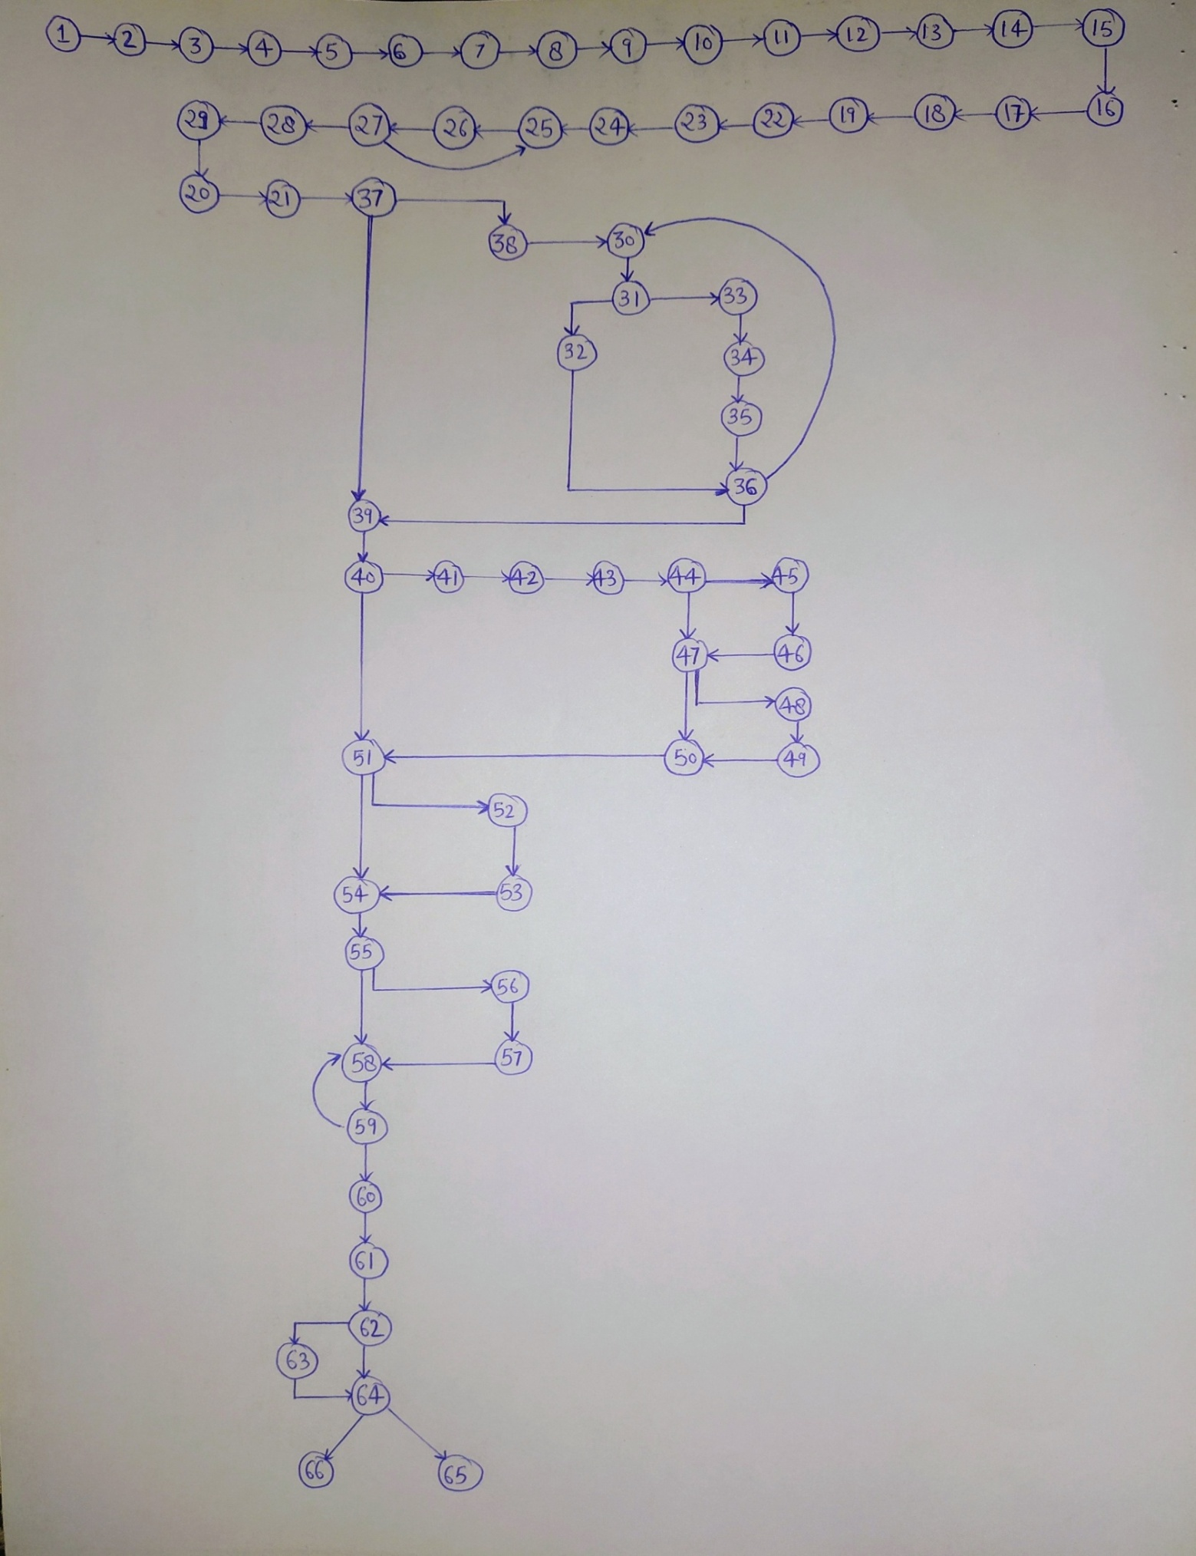

Regions = 11
Predicate Nodes+1: 10+1 = 11
Edges-Vertices+2: 75-66+2 = 11
Independent Paths:
- 1-37-39-40-51-54-55-58-62-64
- 1-37-39-40-51-54-55-58-62-63-64
- 1-37-39-40-51-54-55-56-57-58-64
- 1-37-39-40-51-52-53-54-55-58-64
- 1-37-39-40-44-47-50-51-54-55-58-64
- 1-37-39-40-44-47-48-49-50-51-54-55-58-64
- 1-37-39-40-44-45-46-47-48-49-50-51-54-55-58-64
- 1-37-38-30-31-32-36-39-40-51-54-55-58-64
- 1-37-38-30-31-33-34-35-36-39-40-51-54-55-58-64

  - Test Cases

TEST CASE ID-01
SECTION-I (Before Execution) | SECTION-II (After Execution)
PURPOSE: Checking the functionality of system | EXECUTION HISTORY:-
PRE-CONDITIONS: Person going to operate must be member of that home where system is installed | RESULT: Fails, No connected message displayed
INPUTS: Passing power to the circuit using USB cable | IF FAILS, ANY POSSIBLE REASON(OPTIONAL): We must have tried to connect PC and NodeMCU device on different Wi-Fi networks
EXPECTED OUTPUTS: Wi-Fi connection setup message on Serial Monitor | ANY OTHER OBSERVATION: None
POST-CONDITIONS: None | ANY SUGGESTION: Always Connect both devices on same network
WRITTEN BY: Saumya | RUN BY: Haripriya
DATE: 19 April 2021 | DATE: 19 April 2021

TEST CASE ID-02
SECTION-I (Before Execution) | SECTION-II (After Execution)
PURPOSE: Checking the functionality of system | EXECUTION HISTORY:-
PRE-CONDITIONS: Person going to operate must be member of that home where system is installed | RESULT: Wi-Fi connection setup successfully
INPUTS: Passing power to the circuit using USB cable | IF FAILS, ANY POSSIBLE REASON(OPTIONAL):
EXPECTED OUTPUTS: Wi-Fi connection setup message on Serial Monitor | ANY OTHER OBSERVATION:
POST-CONDITIONS: None | ANY SUGGESTION:
WRITTEN BY: Saumya | RUN BY: Muskaan Talat
DATE: 20 April 2021 | DATE: 20 April 2021

TEST CASE ID-03
SECTION-I (Before Execution) | SECTION-II (After Execution)
PURPOSE: Checking the functionality of system | EXECUTION HISTORY:-
PRE-CONDITIONS: Person going to operate must be member of that home where system is installed | RESULT: Connected to MQTT broker after getting setup with W-Fi connection successfully
INPUTS: Passing power to the circuit using USB cable | IF FAILS, ANY POSSIBLE REASON(OPTIONAL):
EXPECTED OUTPUTS: Client Connection to MQTT broker on port 1883 and display message on Serial Monitor | ANY OTHER OBSERVATION: Node-Red MQTT nodes represents setup connection
POST-CONDITIONS: None | ANY SUGGESTION:
WRITTEN BY: Saumya | RUN BY: Muskaan Talat
DATE: 20 April 2021 | DATE: 20 April 2021

TEST CASE ID-04
SECTION-I (Before Execution) | SECTION-II (After Execution)
PURPOSE: Checking the functionality of system | EXECUTION HISTORY:-
PRE-CONDITIONS: Person going to operate must be member of that home where system is installed | RESULT: Dashboard Screen with expected items
INPUTS: Deploy the circuit on Node-Red & open Dashboard | IF FAILS, ANY POSSIBLE REASON(OPTIONAL): Circuit may not be successfully deployed
EXPECTED OUTPUTS: 2 Gauge meters (of temperature and Humidity) + a toggle button displayed on dashboard | ANY OTHER OBSERVATION:
POST-CONDITIONS: None | ANY SUGGESTION: None
WRITTEN BY: Haripriya | RUN BY: Damini Patel
DATE: 21 April 2021 | DATE: 21 April 2021

TEST CASE ID-05
SECTION-I (Before Execution) | SECTION-II (After Execution)
PURPOSE: Checking the functionality of system | EXECUTION HISTORY:-
PRE-CONDITIONS: Person going to operate must be member of that home where system is installed | RESULT: LED turned ON
INPUTS: Turn ON toggle button dashboard | IF FAILS, ANY POSSIBLE REASON(OPTIONAL): Loose Connections in circuit may result in failure
EXPECTED OUTPUTS: Home LED gets turned on | ANY OTHER OBSERVATION: Circuit gets heated up after some time. So, it’s recommended not to keep lights on for a very long duration.
POST-CONDITIONS: None | ANY SUGGESTION:
WRITTEN BY: Haripriya | RUN BY: Muskaan Talat
DATE: 22 April 2021 | DATE: 22 April 2021

TEST CASE ID-06
SECTION-I (Before Execution) | SECTION-II (After Execution)
PURPOSE: Checking the functionality of system | EXECUTION HISTORY:-
PRE-CONDITIONS: Person going to operate must be member of that home where system is installed | RESULT: LED turned OFF
INPUTS: Turn OFF toggle button dashboard | IF FAILS, ANY POSSIBLE REASON(OPTIONAL): Wrong connections
EXPECTED OUTPUTS: Home LED gets turned off | ANY OTHER OBSERVATION:
POST-CONDITIONS: None | ANY SUGGESTION:
WRITTEN BY: Haripriya | RUN BY: Damini Patel
DATE: 22 April 2021 | DATE: 22 April 2021

- SCHEDULING
WORK TASKS | Week 1 | Week 2 | Week 3 | Week 4 | Week 5 | Week 6 | Week 7 | Week 8 | Week 9 | Week 10 | Week 11 | Week 12
Initial Idea/ Introduction/ Overview/ Description/ Problem Statement
Requirements Gathering/ Feasibility Study
Requirement Analysis
Use-Case Diagram
Data Flow Diagrams
Implementation
Software Requirement Specification (SRS)
Pseuodcode and Test Cases
Function Point and Effort Estimation

- ESTIMATIONS
  - Function Points
FACTOR | VALUE
BACKUP AND RECOVERY | 1
DATA COMMUNICATION | 5
DISTRIBUTED PROCESSING FUNCTIONS | 0
CRITICAL PERFORMANCE | 4
PERFORMANCE IN EXISTING AND HEAVILY UTILISED ENVIRONMENT | 5
REQUIRE ONLINE DATA ENTRY | 3
INPUT TRANSACTION BUILT OVER MULTIPLE SCREENS | 0
ILFs UPDATED ONLINE | 2
INPUTS, OUTPUTS, FILES COMPLEXITY | 4
INTERNAL PROCESSING COMPLEX | 3
REUSABLE CODE | 4
CONVERSIONS AND INSTALLATIONS INCLUDED IN DESIGN | 3
MULTIPLE INSTALLATIONS | 1
CHANGE AND EASE OF USE | 5
Scale: 0 (not important and applicable) to 5 (absolutely essential)
TOTAL = 40
PARAMETERS | COUNT | SIMPLE | AVERAGE | DIFFICULT | TOTAL
External Input | 3 | 3 * 3 | 4 * 0 | 6 * 0 | 9+0+0 = 9
External Output | 2 | 4 * 2 | 5 * 0 | 7 * 0 | 8+0+0 = 8
External Enquiry | 1 | 3 * 1 | 4 * 0 | 6 * 0 | 3+0+0 = 3
Internal Logical Files | 0 | 7 * 0 | 10 * 0 | 15 * 0 | 0
External Interface Files | 0 | 5 * 0 | 7 * 0 | - * 0 | 0

COUNT TOTAL = 9 + 8 +3 = 20
FP = (COUNT TOTAL)*[0.65 + 0.01 * (TOTAL)]
= 20 * [0.65 + 0.01 * 40]
= 20 * 1.05
= 21

  - Efforts
Using COCOMO II Model
Object Type | Complexity weight
 | Simple | Medium | Difficult | Total
Screen | 1 * 1 | 2 * 2 | 3 * 0 | 1+4+0 = 5
Report | 2 * 0 | 5 * 1 | 8 * 0 | 0+5+0 = 5
3GL Component | N/A | N/A | 10 * 2 | 20

Object Points, OP = 5+5+20 = 30

%REUSE = 35%

Productivity, PROD = 14 (NOMINAL)

Newly calculated Object Points, NOP = OP * [100 - %REUSE] / 100
= 30 * [100 - 35] / 100 = 19.5

Efforts = NOP/PROD = 19.5/14 = 1.39 = 2 pm

Referenced tables for above calculations:
Object Type | Complexity weight
 | Simple | Medium | Difficult
Screen | 1 | 2 | 3
Report | 2 | 5 | 8
3GL Component | - | - | 10

Parameters | Simple | Average | Difficult
External Input | 3 | 4 | 6
External Output | 4 | 5 | 7
External Enquiry | 3 | 4 | 6
Internal Logical Files | 7 | 10 | 15
External Interface Files | 5 | 7 | 10

- APPENDIX
  - Circuit Diagram
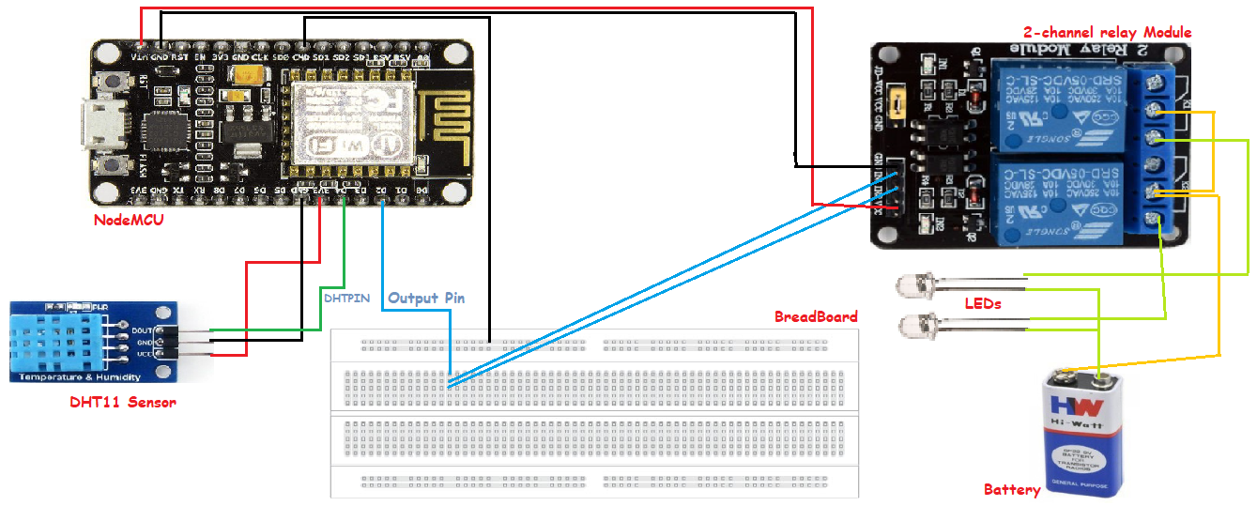

  - Implementation at Large-Scale
We don’t think that this project could be implemented at a large-scale with these same components because NodeMCU ESP8266 component that we are using has current and voltage limitations that are very low. But, we can replace those components with the ones which have higher specifications but same workings like Arduino UNO with Arduino Mega and similar like this along with separate Wi-Fi module.​
So, the conclusion is - this project is modifiable and possible to be implemented at large-scale.

