3.SPECIFIC REQUIREMENTS:
This section contains the system requirements to a level of detail sufficient to enable designers to design the system, and testers to test that system.
3.1 External Interface Requirements
3.1.1 User Interfaces
In order to operate this home automation system, we are going to use prebuilt applications on computer as well as phone. The following screens will be provided:
- To operate on computer system
For this, we will use Node-Red which is a programming tool for wiring together hardware devices, APIs and online services in new and interesting ways. It provides a browser-based editor.
Our node-red dashboard contains 2 gauge meters - 1 for temperature & other one for humidity, for determining the values measured using sensor. And, a toggle button to control the device.
These components need to be added in workspace area of node-red before deploying to the dashboard screen.

Node-Red Dashboard Screen:
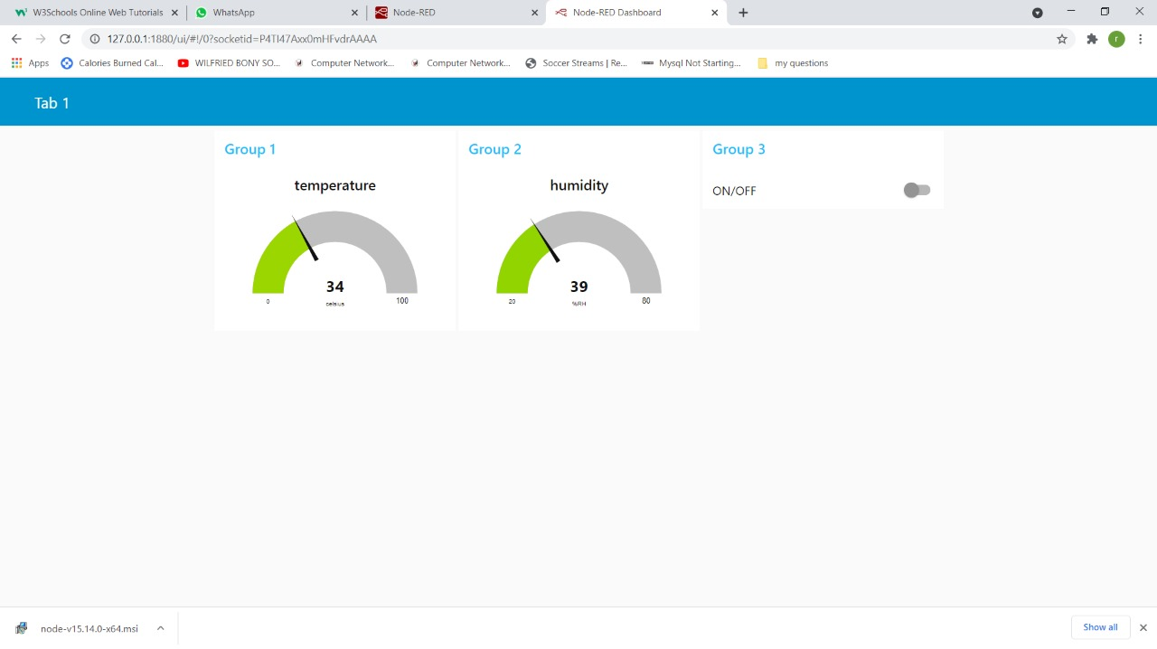

- To operate on mobile phone
For this, we will use MQTT Dash application that is software basically for controlling systems connected to the MQTT server. To add any system, credentials that will be required are Client ID, Username, UserPassword.
This will contain 2 gauge meters - 1 for temperature & other one for humidity, for determining the values measured using sensor. And, a toggle button to control the device.

MQTT dash Screen:
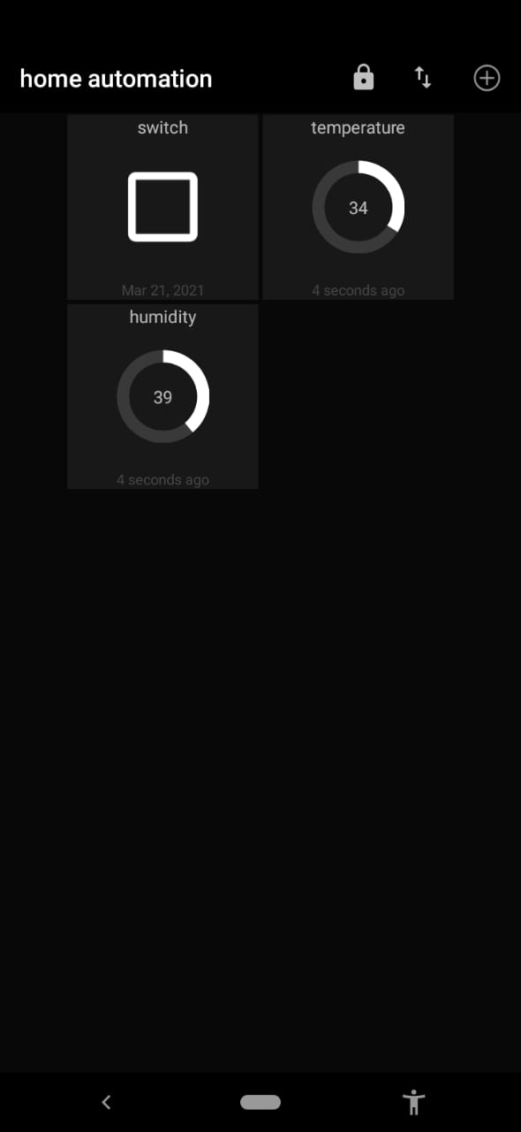
3.1.2 Hardware Interfaces
None
3.1.3 Software Interfaces
This system has been connected to the Wi-Fi with the help of Node-Red software/programming tool where we need to define connections and the flow of data delivery between components. Also, with the help of this software we decide the final interface.
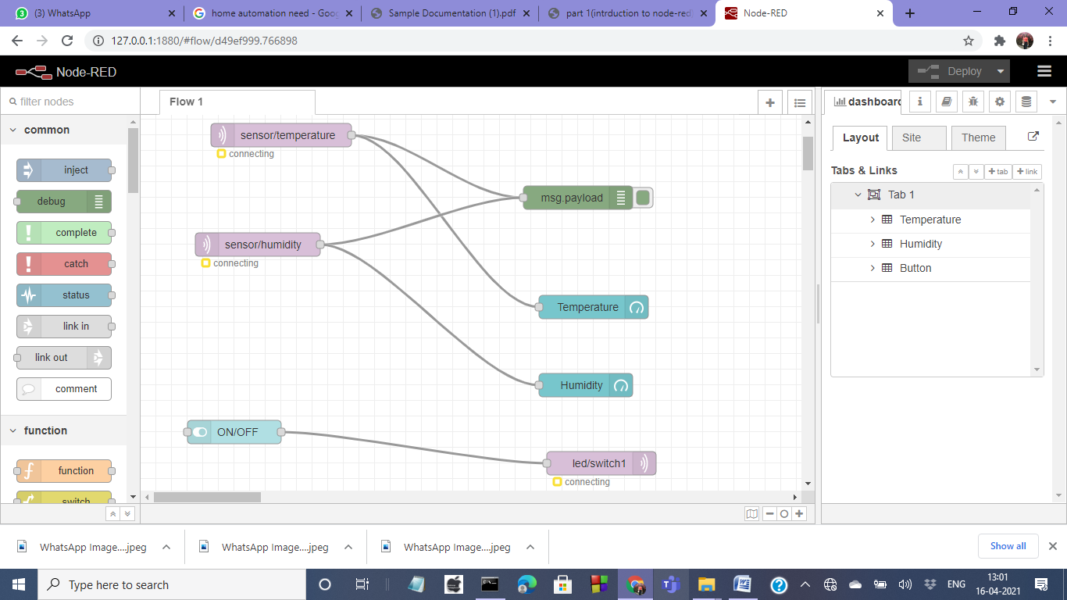
To add these all components, follow preceding steps:
- Select 2 mqtt in nodes and drag them into workspace
- Double click on first mqtt in node
- Add new mqtt broker(server) here
- Now click on edit button mentioned in slide
- Fill the details as shown in figure
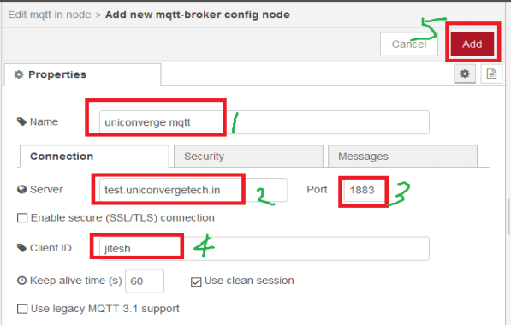
- Fill the details and select topic sensor/temperature
- Double click 2nd mqtt in node
- Select uniconverge mqtt as a server
- Fill the details and select topic sensor/humidity
- Drag debug node from node palette
- Drag 2 gauge node(dashboard) from node palette into workspace
- Double click on one of gauge
- Fill the details(Label-Temperature) & click on done
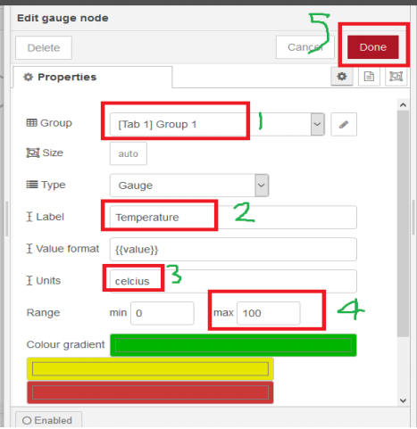
- For second gauge, Fill the details (Label-Humidity) & click on done
- Connect Nodes & Deploy
- Click on dashboard tab in output pane
- Drag a switch node(dashboard in node palette) into workspace
- Double click on switch node & fill details
- Select same group which is selected in gauge nodes & click on done
- Drag mqtt out node (from node palette) into workspace
- Double click on mqtt out node
- Fill the details & write topic led/switch1
- Connect switch node and mqtt out node & deploy
- Now, dashboard is ready.
3.1.4 Communication Interfaces
None

3.2 System Features
3.2.1 ANYWHERE ACCESS USING WI-FI
Description: The user will be able to keep a record of the surroundings of the house. The devices in the house can be remotely controlled through Wi-Fi like lights.
Validity Checks:
(i) Good internet connectivity is required.
(ii) Internet connectivity should be stable.
Sequencing Information: Firstly, in Arduino IDE, while uploading the code, put the Wi-Fi username and password so that NodeMCU gets connected to the network and we can operate the circuit. Finally, Wi-Fi needs to be connected to the computer.
Error Handling/Response to Abnormal Situations: If any of the above validations/sequencing flow does not hold true, appropriate error messages will be prompted on serial monitor to the user for doing the needful.
3.2.2 GET MEASUREMENT OF TEMPERATURE & HUMIDITY OF THE SURROUNDING ENVIRONMENT
Description: The surrounding temperature and humidity will be displayed on the Node-Red dashboard on being deployed.
Validity Checks: NONE
Sequencing Information: Firstly, define flow on Node-RED dashboard. Second step is to Deploy the whole circuit. Finally, we can operate the system.
Error Handling/Response to Abnormal Situations: If any of the above validations/sequencing flow does not hold true, appropriate error messages will be prompted on serial monitor to the user for doing the needful.
3.2.3 DEVICE CONTROLLING
Description: Node-RED Dashboard provides one button for controlling LED lights in home and two gauge meters for temperature and humidity.
Validity Checks: (i) Good internet connectivity is required.
Sequencing Information: Firstly, define flow on Node-RED dashboard. Second step is to Deploy the whole circuit. Finally, we can operate the system.
Error Handling/Response to Abnormal Situations: If any of the above validations/sequencing flow does not hold true, appropriate error messages will be prompted on serial monitor to the user for doing the needful.

3.3 Performance Requirements
It requires a high-speed internet connection for the system to run smoothly without any interruption.
3.4 Design Constraints
NONE
3.5 System Attributes
3.5.1 Security
The system will be protected with Wi-Fi password. Users will have to enter correct username, password and role in order to access, control the system.
3.5.2 Maintainability
The system will be designed in a maintainable manner.
3.5.3 Portability
The system would not be easily portable once it has been setup.
3.6 Other Requirements
NONE

