4. TESTING
Now we find out the complexity of the module to determine the possible independent paths and hence develop test cases.
PSEUDOCODES
4.1 NodeMCU-MQTT
START
SET wifi_ssid to "Ravi188"(WiFi connection Name) [1]
SET wifi_password to "115204416"(WiFi Password) [2]
SET mqtt_server to "test.uniconvergetech.in" [3]
SET mqtt_user to "guest" [4]
SET mqtt_password to "guest" [5]

SET temperature_topic to "sensor/temperature" [6]
SET humidity_topic to "sensor/humidity" [7]

declare a 100 characters array [8]
initialize lastMsg to 0 [9]
initialize lastRecu to 0 [10]
initialize debug to FALSE [11]

SET DHTPIN to D4 [12]
SET DHTTYPE to DHT11 [13]

declare dht and configure DHTPIN of DHTTYPE [14]
declare a WiFiClient espClient [15]
declare a PubSubClient client with a WiFiClient [16]

Function setup
Pass In:nothing
Start a serial communication from nodeMCU at a baud rate of 9600 [17]
configure D2 pin as OUTPUT pin [18]
call setup_wifi() to setup WiFi connection [19]
configure a MQTT connection with mqtt_server on port 1883 [20]
set a handling function callback() to be executed when a MQTT message is received[21]
Pass Out:nothing
Endfunction

Function setup_wifi
Pass In:nothing
take a delay of 10ms [22]
print "Connecting to (wifi_ssid)" [23]
establish a WiFi connection using wifi_ssid & wifi_password [24]
REPEAT
take a delay of 500ms [25]
print "." [26]
UNTIL WiFi connection doesn't get established [27]
print "WiFi OK => ESP8266 IP Address: " [28]
print local IP address [29]
Pass Out:nothing
Endfunction

Function reconnect
Pass In:nothing
REPEAT
print "connecting to mqtt broker..." [30]
IF MQTT connection get established [31]
THEN print "OK" [32]
ELSE
print Client's state as error [33]
print "Wait 5 seconds before to retry" [34]
take a delay of 5000ms [35]
ENDIF
UNTIL client connection with server doesn't get established [36]
Pass Out:nothing
Endfunction

Function loop
Pass In:nothing
IF client's MQTT connection hasn't been established [37]
THEN call reconnect() [38]
ENDIF
initialize 'now' with the milliseconds passed up till now [39]
IF lastMsg timing was a minute ago THEN [40]
SET lastMsg to now [41]
read Humidity from DHT sensor to h [42]
read temperature from DHT sensor to t [43]
IF read values are not numerical THEN [44]
print "Please change DHT sensor!" [45]
return out of function [46]
ENDIF
IF debug sets TRUE THEN [47]
print "Temperature : t" [48]
print "Humidity : h" [49]
ENDIF
publish temperature & humidity on their respective topics created on node-red[50]
ENDIF
IF lastRecu timing was more than a minute ago THEN [51]
SET lastRecu to now [52]
subscribe to the topic led/switch1 for controlling device [53]
ENDIF
Pass Out:nothing
Endfunction

Function callback
Pass In: Topic, payload in bytes, length of msg
initialize counter i to 0 [54]
IF debug is true THEN [55]
print "Message recu=> topic: " + topic [56]
print "| lonueur: " + length in string form [57]
ENDIF
FOR every character of msg [58]
copy from payload into message_buff [59]
ENDFOR
add a null character at end of message_buff [60]
convert message_buff into a string to msgString [61]
IF debug is true THEN [62]
print "Payload: " + msgString [63]
ENDIF
IF msgString is 'ON' THEN [64]
set D2 Pin at LOW state [65]
ELSE
set D2 pin at HIGH state [66]
ENDIF
Pass Out:nothing
Endfunction

It’s cyclomatic complexity is:
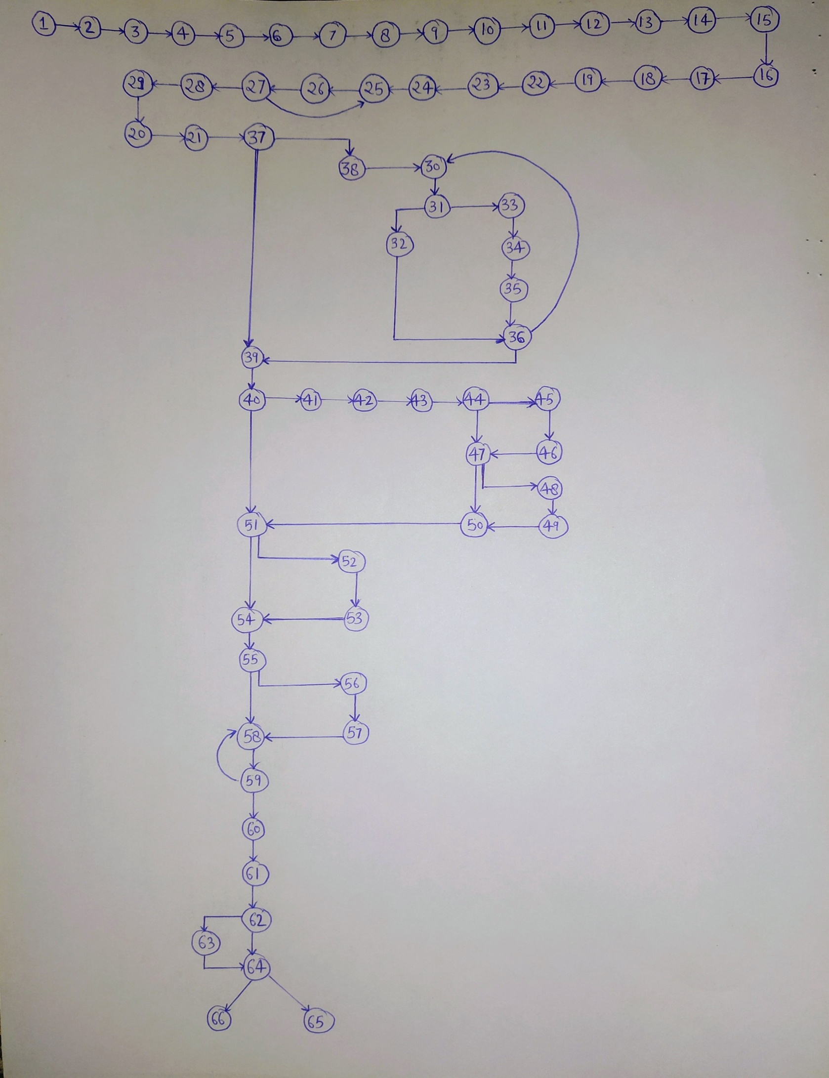

Regions = 11
Predicate Nodes+1: 10+1 = 11
Edges-Vertices+2: 75-66+2 = 11
Independent Paths:
- 1-37-39-40-51-54-55-58-62-64
- 1-37-39-40-51-54-55-58-62-63-64
- 1-37-39-40-51-54-55-56-57-58-64
- 1-37-39-40-51-52-53-54-55-58-64
- 1-37-39-40-44-47-50-51-54-55-58-64
- 1-37-39-40-44-47-48-49-50-51-54-55-58-64
- 1-37-39-40-44-45-46-47-48-49-50-51-54-55-58-64
- 1-37-38-30-31-32-36-39-40-51-54-55-58-64
- 1-37-38-30-31-33-34-35-36-39-40-51-54-55-58-64

4.2 TEST CASES
TEST CASE ID-01
SECTION-I (Before Execution) | SECTION-II (After Execution)
PURPOSE: Checking the functionality of system | EXECUTION HISTORY:-
PRE-CONDITIONS: Person going to operate must be member of that home where system is installed | RESULT: Fails, No connected message displayed
INPUTS: Passing power to the circuit using USB cable | IF FAILS, ANY POSSIBLE REASON(OPTIONAL): We must have tried to connect PC and NodeMCU device on different Wi-Fi networks
EXPECTED OUTPUTS: Wi-Fi connection setup message on Serial Monitor | ANY OTHER OBSERVATION: None
POST-CONDITIONS: None | ANY SUGGESTION: Always Connect both devices on same network
WRITTEN BY: Saumya | RUN BY: Haripriya
DATE: 19 April 2021 | DATE: 19 April 2021

TEST CASE ID-02
SECTION-I (Before Execution) | SECTION-II (After Execution)
PURPOSE: Checking the functionality of system | EXECUTION HISTORY:-
PRE-CONDITIONS: Person going to operate must be member of that home where system is installed | RESULT: Wi-Fi connection setup successfully
INPUTS: Passing power to the circuit using USB cable | IF FAILS, ANY POSSIBLE REASON(OPTIONAL):
EXPECTED OUTPUTS: Wi-Fi connection setup message on Serial Monitor | ANY OTHER OBSERVATION:
POST-CONDITIONS: None | ANY SUGGESTION:
WRITTEN BY: Saumya | RUN BY: Muskaan Talat
DATE: 20 April 2021 | DATE: 20 April 2021

TEST CASE ID-03
SECTION-I (Before Execution) | SECTION-II (After Execution)
PURPOSE: Checking the functionality of system | EXECUTION HISTORY:-
PRE-CONDITIONS: Person going to operate must be member of that home where system is installed | RESULT: Connected to MQTT broker after getting setup with W-Fi connection successfully
INPUTS: Passing power to the circuit using USB cable | IF FAILS, ANY POSSIBLE REASON(OPTIONAL):
EXPECTED OUTPUTS: Client Connection to MQTT broker on port 1883 and display message on Serial Monitor | ANY OTHER OBSERVATION: Node-Red MQTT nodes represents setup connection
POST-CONDITIONS: None | ANY SUGGESTION:
WRITTEN BY: Saumya | RUN BY: Muskaan Talat
DATE: 20 April 2021 | DATE: 20 April 2021

TEST CASE ID-04
SECTION-I (Before Execution) | SECTION-II (After Execution)
PURPOSE: Checking the functionality of system | EXECUTION HISTORY:-
PRE-CONDITIONS: Person going to operate must be member of that home where system is installed | RESULT: Dashboard Screen with expected items
INPUTS: Deploy the circuit on Node-Red & open Dashboard | IF FAILS, ANY POSSIBLE REASON(OPTIONAL): Circuit may not be successfully deployed
EXPECTED OUTPUTS: 2 Gauge meters (of temperature and Humidity) + a toggle button displayed on dashboard | ANY OTHER OBSERVATION:
POST-CONDITIONS: None | ANY SUGGESTION: None
WRITTEN BY: Haripriya | RUN BY: Damini Patel
DATE: 21 April 2021 | DATE: 21 April 2021

TEST CASE ID-05
SECTION-I (Before Execution) | SECTION-II (After Execution)
PURPOSE: Checking the functionality of system | EXECUTION HISTORY:-
PRE-CONDITIONS: Person going to operate must be member of that home where system is installed | RESULT: LED turned ON
INPUTS: Turn ON toggle button dashboard | IF FAILS, ANY POSSIBLE REASON(OPTIONAL): Loose Connections in circuit may result in failure
EXPECTED OUTPUTS: Home LED gets turned on | ANY OTHER OBSERVATION: Circuit gets heated up after some time. So, it’s recommended not to keep lights on for a very long duration.
POST-CONDITIONS: None | ANY SUGGESTION:
WRITTEN BY: Haripriya | RUN BY: Muskaan Talat
DATE: 22 April 2021 | DATE: 22 April 2021

TEST CASE ID-06
SECTION-I (Before Execution) | SECTION-II (After Execution)
PURPOSE: Checking the functionality of system | EXECUTION HISTORY:-
PRE-CONDITIONS: Person going to operate must be member of that home where system is installed | RESULT: LED turned OFF
INPUTS: Turn OFF toggle button dashboard | IF FAILS, ANY POSSIBLE REASON(OPTIONAL): Wrong connections
EXPECTED OUTPUTS: Home LED gets turned off | ANY OTHER OBSERVATION:
POST-CONDITIONS: None | ANY SUGGESTION:
WRITTEN BY: Haripriya | RUN BY: Damini Patel
DATE: 22 April 2021 | DATE: 22 April 2021

