The figure below shows a marble-rolling toy. A marble is dropped at A or B. levers x1, x2, and x3 cause the marble to fall either to the left or to the right. Whenever a marble encounters a lever, it causes the lever to reverse after the marble passes, so the next marble will take the opposite branch.

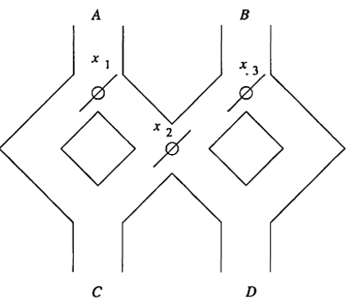

**Required**

1. Model this toy by a finite automaton. Let the inputs A and B represent the input into which the marble is dropped. Let acceptance correspond to the marble exiting at D, non-acceptance represents a marble exiting at C (10 marks)
2. Informally describe the language of the automaton (6 marks)
3. Suppose that instead the levers switched before allowing the marble to pass. How would your answers to parts (a) and (b) change? (4marks)