



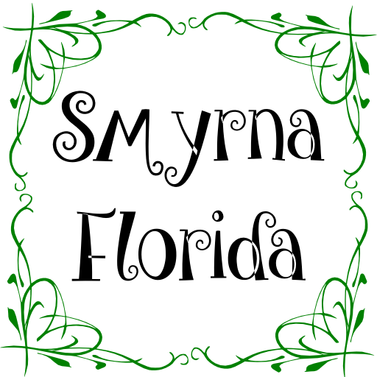

Breakfast Menu
Weekdays, 07:00 AM to 12:00 PM
Kızarmış Yumurta $ 4.⁰⁰ Fried Egg
Menemen $ 5.⁵⁰ Scrambled Egg & Vegetables
Kızarmış Sucuk $ 6.⁰⁰ Fried Turkish Sausages
Sucuklu Yumurta $ 7.⁰⁰ Egg & Turkish Sausages
Sosili Yumurta $ 7.⁰⁰ Egg & Beef Franks
Pastırmalı Yumurta $ 8.⁰⁰ Egg & Turkish Pastrami
Kahvaltı Tabağı $ 6.⁰⁰ Breakfast Plate
Tost Ekmek $ 2.⁰⁰ Toasted Bread
Yumurtalı Ekmek $ 3.⁰⁰ Turkish Style French Toast
Türk Kahvesi $ 2.⁰⁰ Turkish Coffee
Filitre Kahve $ 1.⁵⁰ Filter Coffee
Bitki & Normal Çay $ 2.⁰⁰ Black & Herbal Tea

call us for daily lunch menu
525 Northwood Rd, West Palm Beach, FL 33407
+1 (347) 903-8773 - SmyrnaFlorida@gmail.com
http://SmyrnaFL.com

