For this project, using the todo-list project, transfer it to your running EC2 instance. Then, add the deploy scripts to automate deployment with a one-line command. Complete and provide screenshots

1. Sign into the EC2 Server through your command line

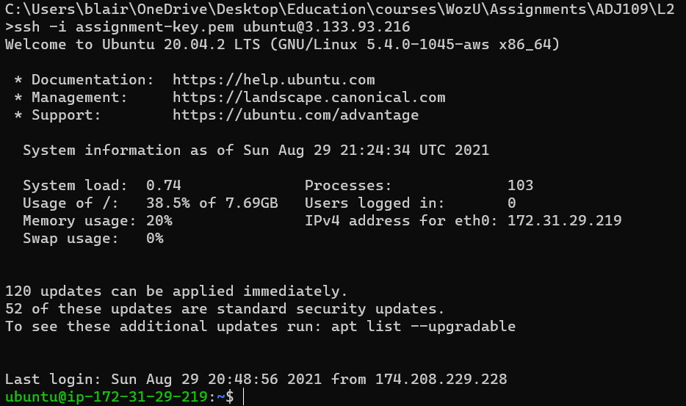

1. Transfer the todo-list files to the EC2 Instance using SCP



1. Run the application that lives on your EC2 Instance

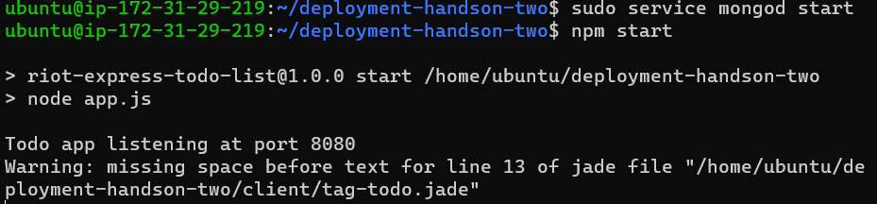

1. Add Automation to the todo-list using a deploy.js file

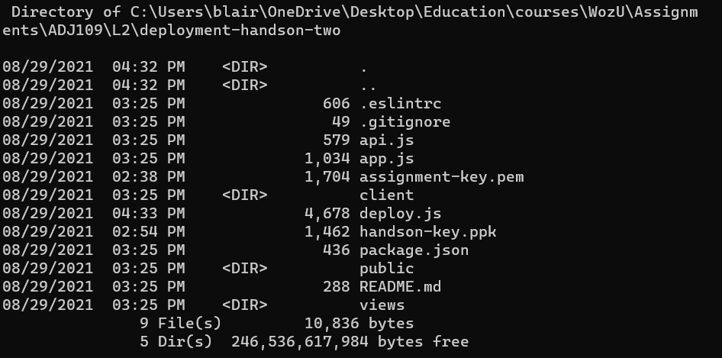

Note: node-sass needed to be installed / updated independently

Change all occurrences of “hackathon-starter” to “deployment-handson-two”



Change the host and privateKey

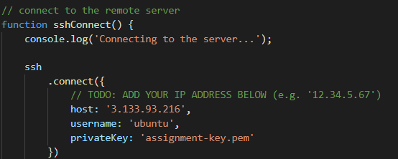

Change the package information:

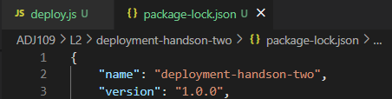

1. Rerun the application to ensure the deploy.js works correctly

