**Report2**

**Protein:** Glycine--tRNA ligase

For reviewed, human proteins, **there is only one item.**

**Uniprot ID**: P41250

**Status:** Reviewed. It indicates the entry has been manually annotated and reviewed by UniProtKB curators

**Binding site:** 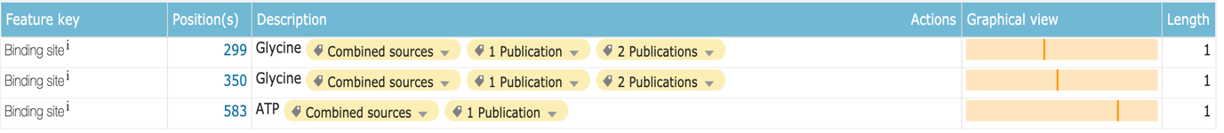

**Regions for nucleotide binding:**

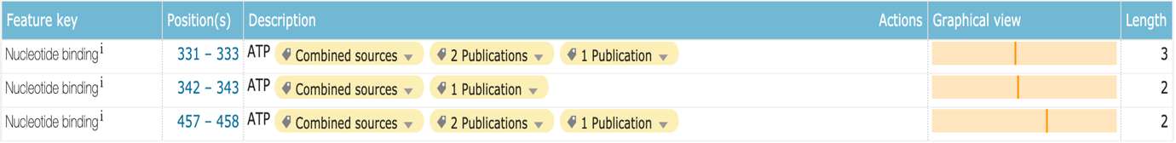

**Variants**

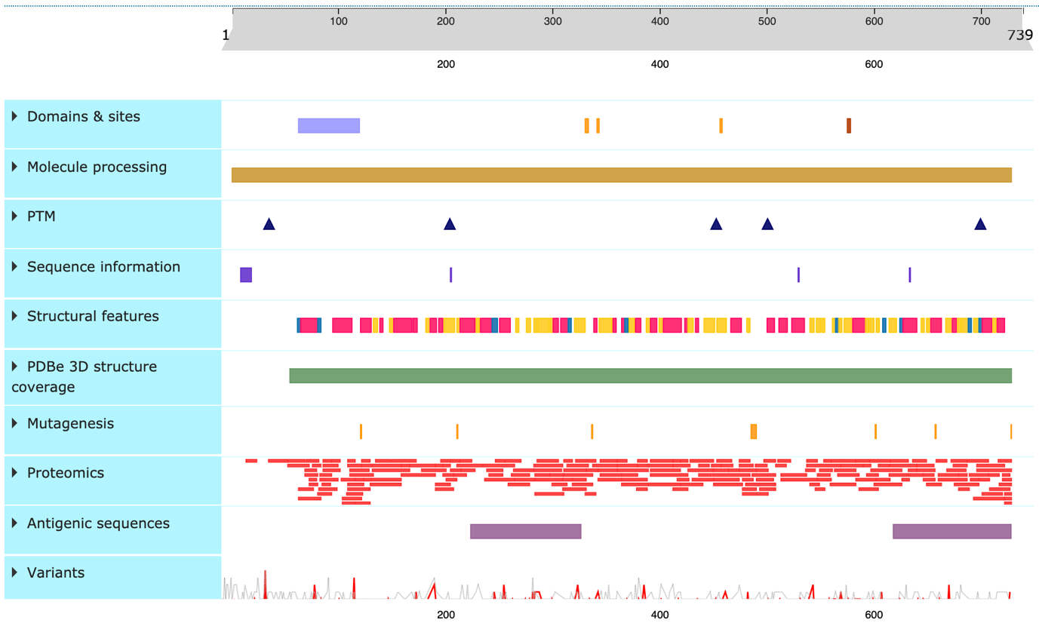

**Are these natural variants close to the active site in sequence?**

There is no active site for this protein. But I find there are disease-associated variations close to the nucleotide binding site. (Details see the picture below)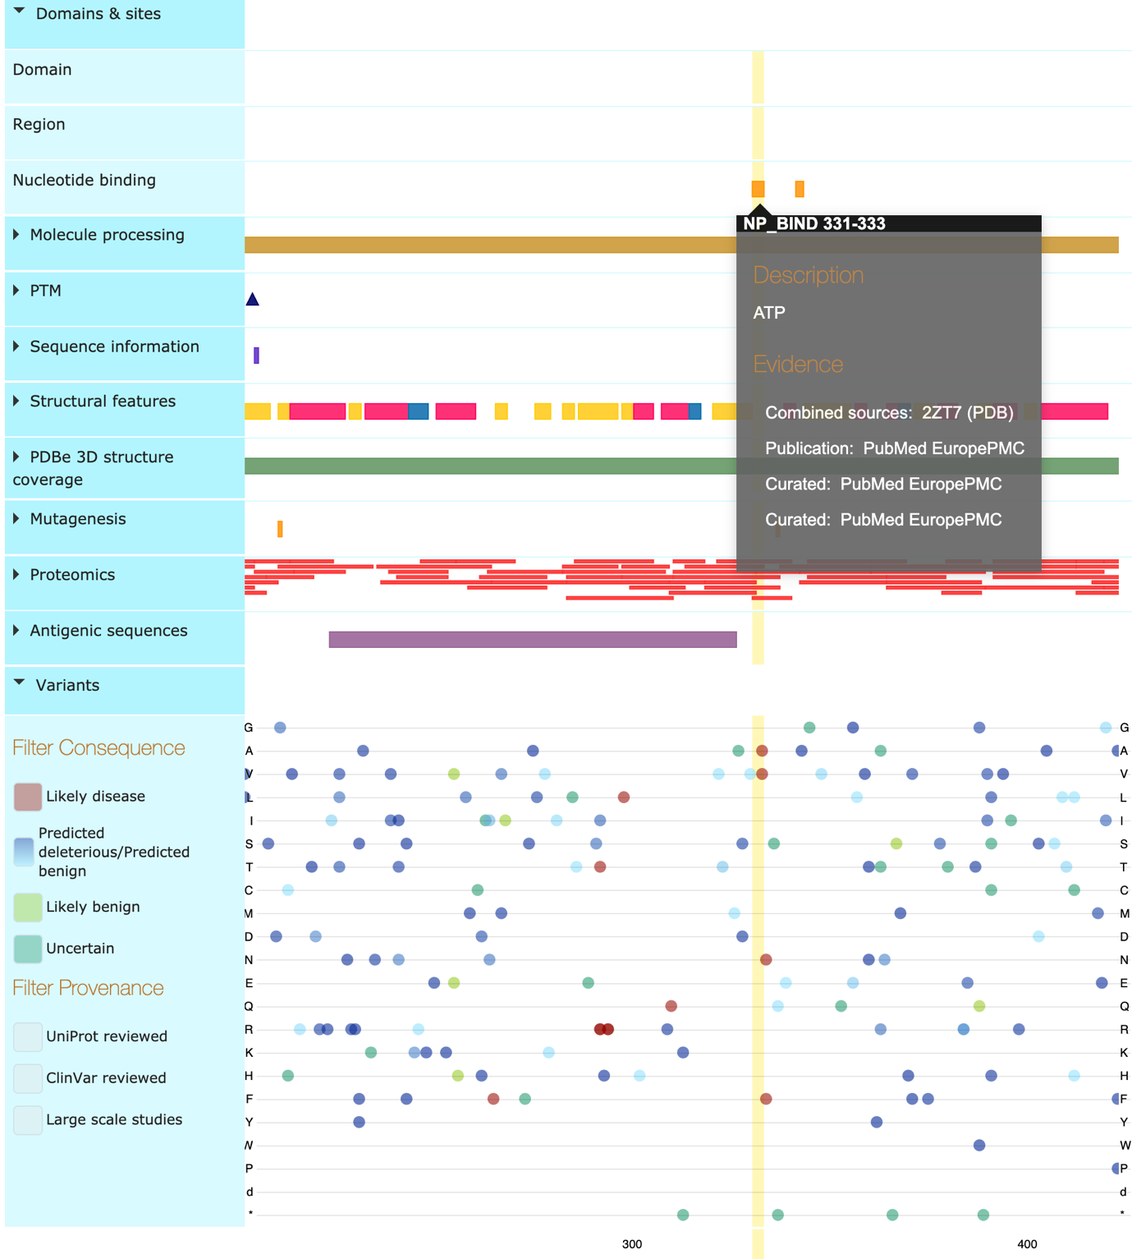

**Biological function**

* Catalyzes the ATP-dependent ligation of glycine to the 3'-end of its cognate tRNA, via the formation of an aminoacyl-adenylate intermediate (Gly-AMP) (PubMed:17544401, PubMed:28675565, PubMed:24898252).
* Produces diadenosine tetraphosphate (Ap4A), a universal pleiotropic signaling molecule needed for cell regulation pathways, by direct condensation of 2 ATPs. Thereby, may play a special role in Ap4A homeostasis (PubMed:19710017).

**GO terms:**

Molecular Function:

ATP-binding (GO:0005524)

bis(5'-nucleosyl)-tetraphosphatase (asymmetrical) activity (GO:0004081)

glycine-tRNA ligase activity (GO:0004820)

identical protein binding (GO:0042802)

transferase activity (GO:0016740)

protein dimerization activity (GO:0046983)

Biological process:

diadenosine tetraphosphate biosynthetic process (GO:0015966)

glycyl-tRNA aminoacylation (GO:0006426)

mitochondrial glycyl-tRNA aminoacylation (GO:0070150)

tRNA aminoacylation for protein translation (GO:0006418)