**Report 3**

**Protein of interest**: Human Glycine--tRNA ligase

**Gene:** GARS

**Ensembl gene accession**: ENSG00000106105

**Search in EVA variant browser**

Identify 2816 variants from 16 studies

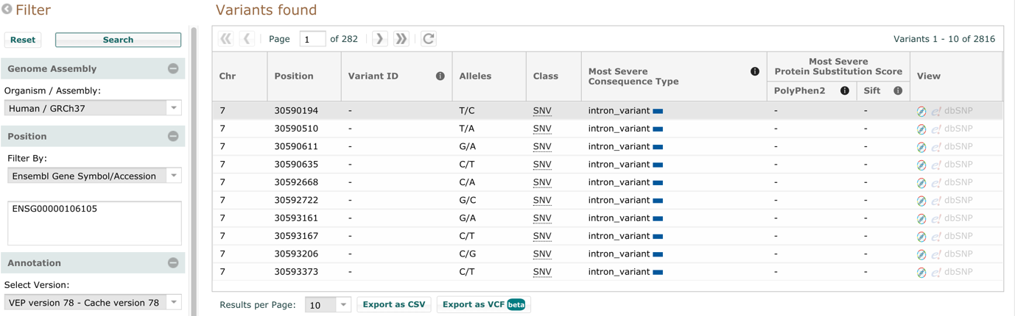

**Search in Ensembl**

**Variants**

Filtered for pathogenic variants (no MAF data in these variants)

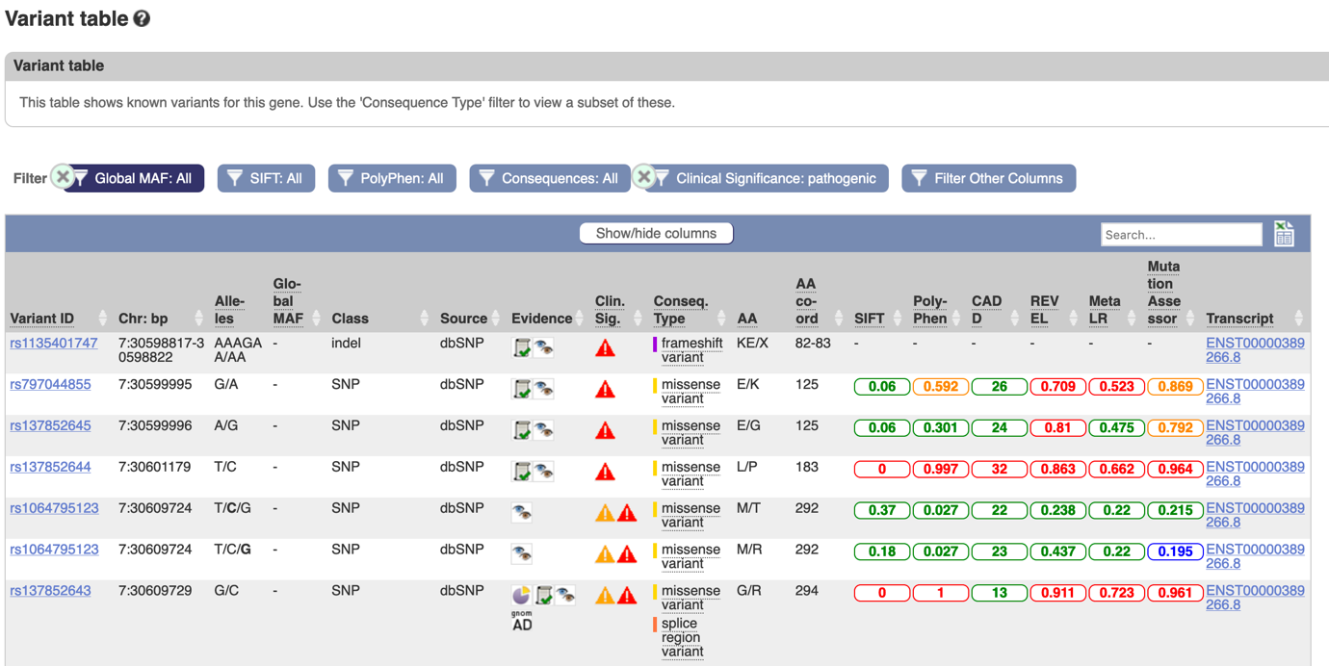

**Phenotype**

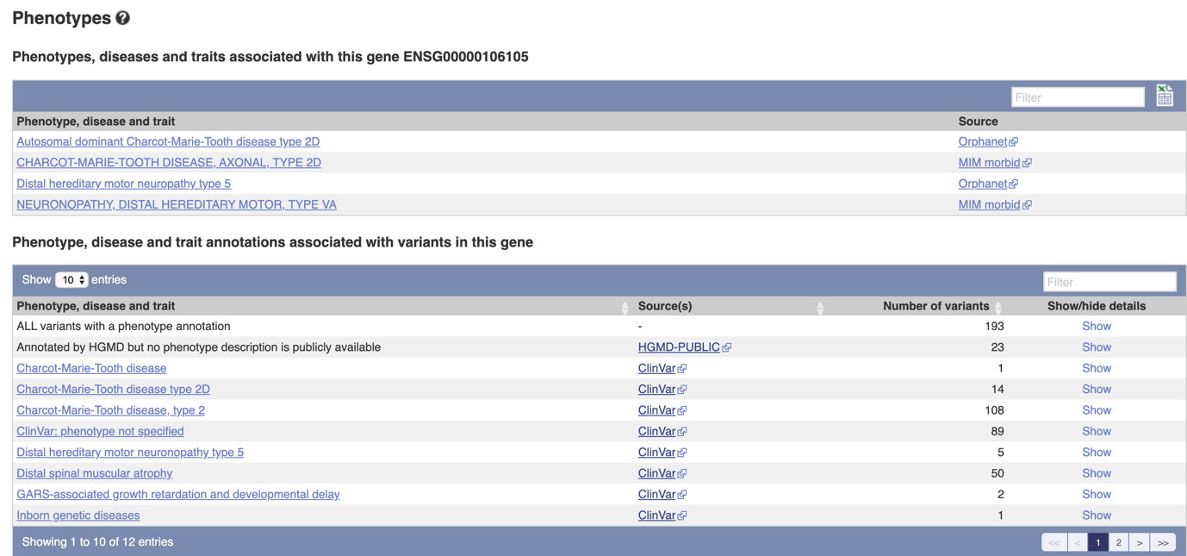

The majority of traits associated with variants in the human GARS gene are held privately at ClinVar. The publicly available associations are mostly to Charcot-Marie-Tooth disease, type 2.

**Search in Uniprot (exclude the uncertain variation)**

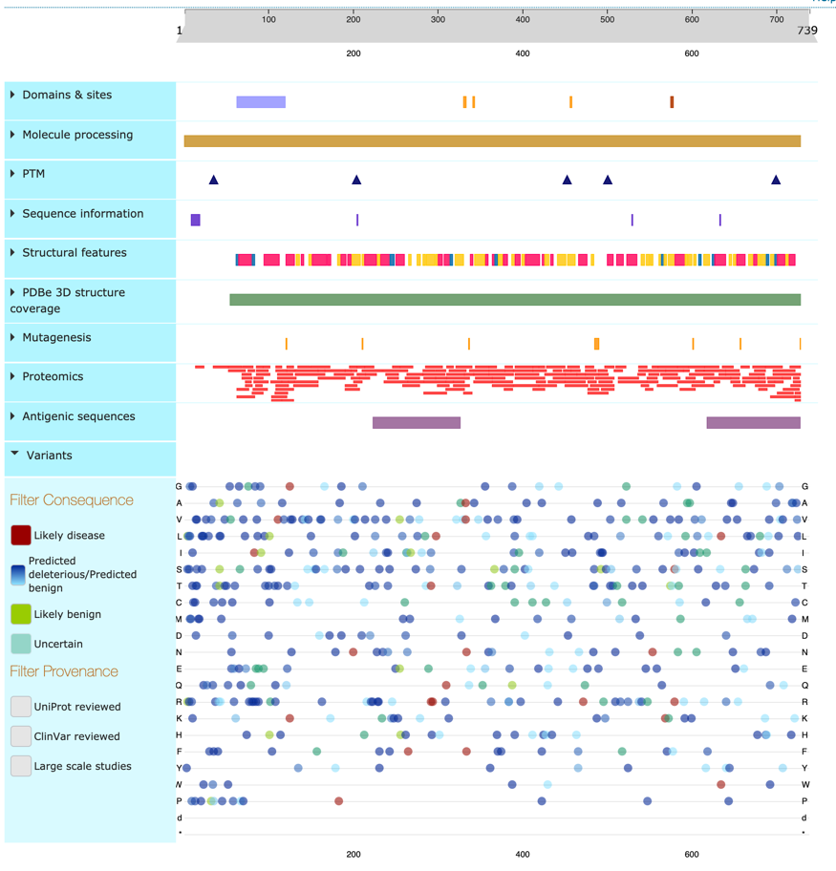

The majority of variants is predicted deleterious/predicted benign. We cannot see the complete overlap between known variants and specific protein features. But there exist disease-associated variants close to nucleotide binding site.