**Report 4**

**The questions based on the article**

* What is the function of Src tyrosine kinases?

Src tyrosine kinase specializes in messages that control the growth of cells. More specifically, it adds phosphate groups to special tyrosine amino acids of a wide variety of proteins that control cellular structure, cell communication, and cellular growth. It turns these proteins "on" and release them to perform their individual tasks.

* Is there only one Src tyrosine kinase? What are some others?

No.  There are hundreds of protein tyrosine kinases, several of which are nearly identical to Src. For example, the Hck protein and the Abl protein are similar with Src.

* What is special about v-Src? How does it differ from c-Src?

v-Src is always active. It continually adds phosphate groups to the many proteins serviced by Src, sending a constant, unwavering signal to grow. This leads to cancer, as cells grow without control into tumors. While c-Src is under control and not constitutively active.

* What is the purpose of most drug design studies against Src?

Block the action of mutated proteins which are constitutively active, and restore the normal limits on growth.

**The name of primary citation for Abl kinase structure in PUBMED**

Structural basis for the autoinhibition of c-Abl tyrosine kinase.

**The search for reviewed, human Src kinases with Src as the protein family filter in Uniprot database**

1. **There are totally 13 proteins.**
2. UniRef 90 is built by clustering UniRef100 sequences such that each cluster is composed of sequences that have at least 90% sequence identity to, and 80% overlap with, the longest sequence.

UniRef 100 combines identical sequences and sub-fragments with 11 or more residues from any organism into a single UniRef entry.

**The result of query filtered by UniRef 90 and UniRef 100**

|  |  |  |  |  |  |  |  |  |  |
| --- | --- | --- | --- | --- | --- | --- | --- | --- | --- |
| Size | P06239 | P06241 | P07947 | P07948 | P08631 | P09769 | P12931 | P42685 | P51451 |
| UniRef100 | 6 | 18 | 3 | 5 | 4 | 6 | 4 | 1 | 2 |
| UniRef90 | 194 | 244 | 15 | 252 | 30 | 109 | 18 | 19 | 27 |

|  |  |  |  |
| --- | --- | --- | --- |
| Q15596 | Q15788 | Q9H3Y6 | Q9Y6Q9 |
| 3 | 1 | 1 | 1 |
| 11 | 92 | 22 | 260 |

1. **Alignment of these 13 sequences**

Highly conserved residues/regions (highlight the **motif**)

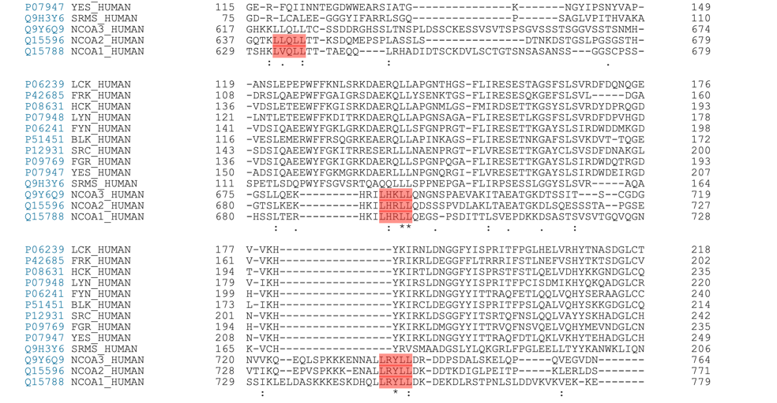

Conserved active site residue (highlight the **active site**)

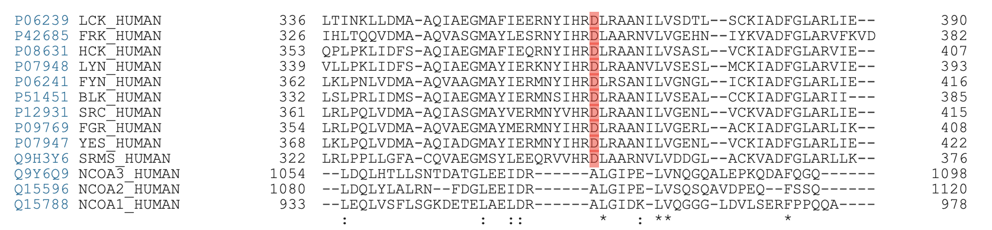

1. **Choose one protein SRC_HUMAN (P12931) from these 13 proteins**

* There are some variants around the active site residue (Position 389)

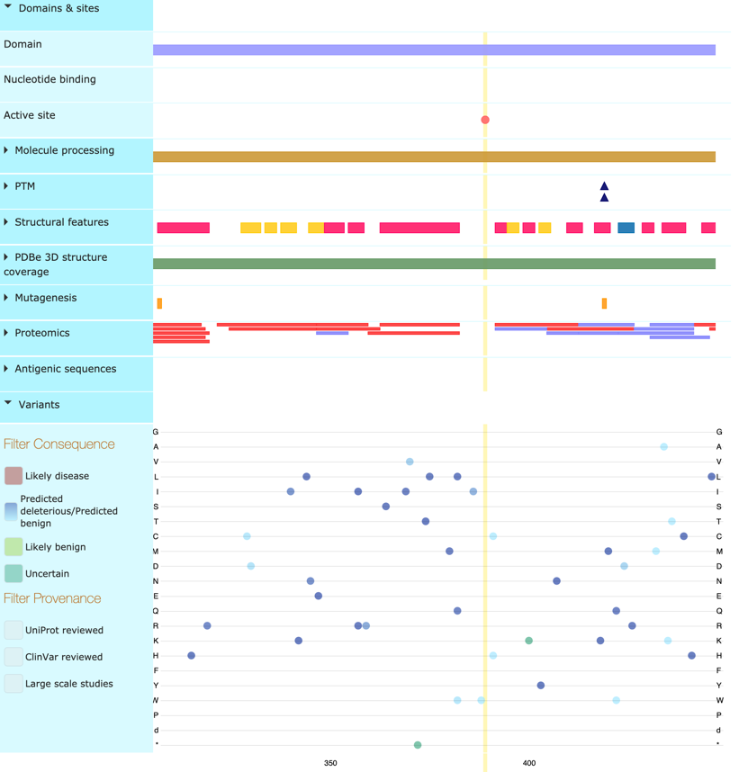

* There are many PDB structures associated with it, among which **the entry 2H8H** has the maximum coverage (Residues: 2-536; Coverage: 100%)

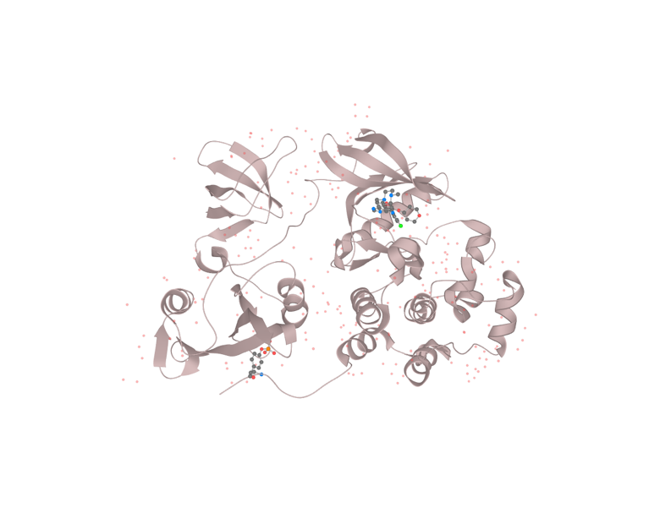 The red dots in the 3D structure view represent water molecules

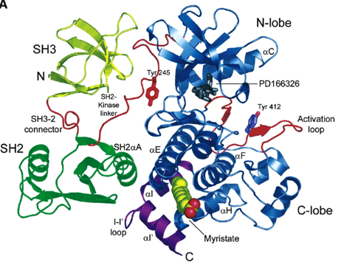

3D structure view of SRC_HUMAN protein (2H8H) Figure of c-Abl kinase structure in the primary citation