


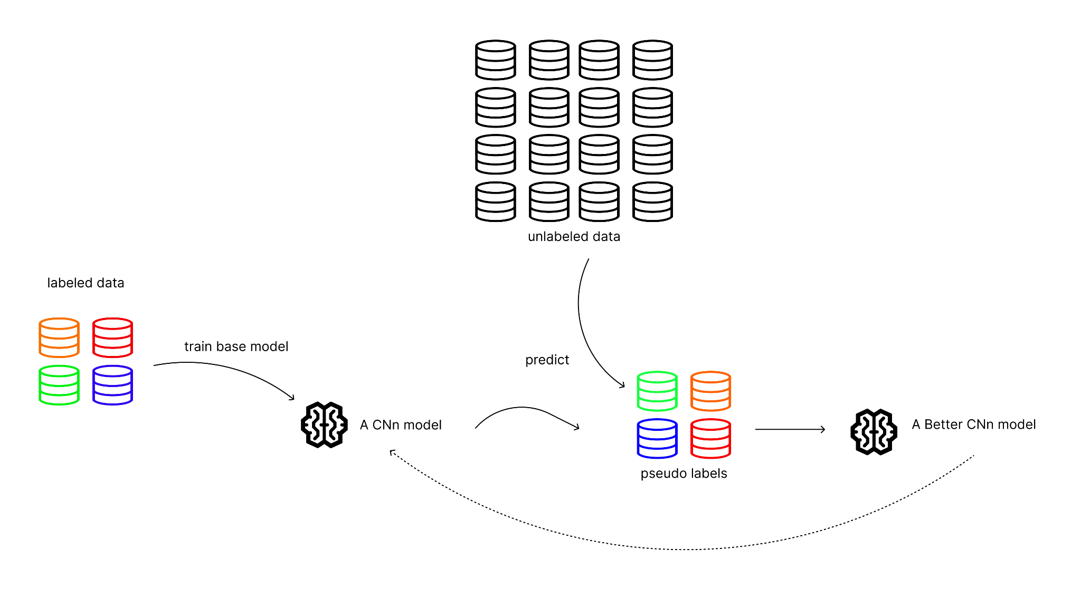

How Can a Semi-Supervised Neural Network Be Efficiently Implemented In Rust For The Automatic Labeling of Partially Labeled Datasets On an Edge Device?
internal promotor: Gilles Depypere
external promotor: Sandro Queirós

Research question carried out by
Warre Snaet
FOR OBTAINING THE BACHELOR'S DEGREE IN THE
Multimedia & Creative Technologies
Howest | 2025-2026

