**ICEHAMMER GT II   
2022**

Location Pack : Reykjavik, Iceland

**INTRODUCTION**

WELCOME TO WARHAMMER-TOURNAMENTS.COM’s LOCATION PACK : LDN OPEN

This document provides all the practical information on the venue . For any gaming related information please check out the Ice Hammer Website and download the Gaming pack.

GENERAL ENQUIRIES AND FEEDBACK

Please note that this document is a work in progress, and feedback is appreciated. If you have any questions, please get in touch at [IcehammerGT@gmail.com](mailto:IcehammerGT@gmail.com)

OPENING HOURS

The venue will be open at the following times, please do not arrive earlier than this. 30min has been allotted for arrival and you will not be allowed into the venue before 9:

**Saturday**

Doors open 09:30

Gaming 10:00 – 20:30

Venue Closes 21:00

**Sunday**

Doors open 09:30

Gaming 10:00 – 17:00

Venue closes to public 18:00

FOOD

The event is right in the middle of Downtown Reykjavik. Numerous restaurants, fast food restaurants and super markets are within walking distance of the venue.

LOST & FOUND

During the event, lost and found items will be collected at the Tournament Organiser desk. Please see the Tournament Organiser if you have lost anything.

Address: Iðnó, Vonarstræti 3, 101 Reykjavík, Iceland

Venue

The Venue is located in the middle of downtown Reykjavik within walking distance of downtown hotels.

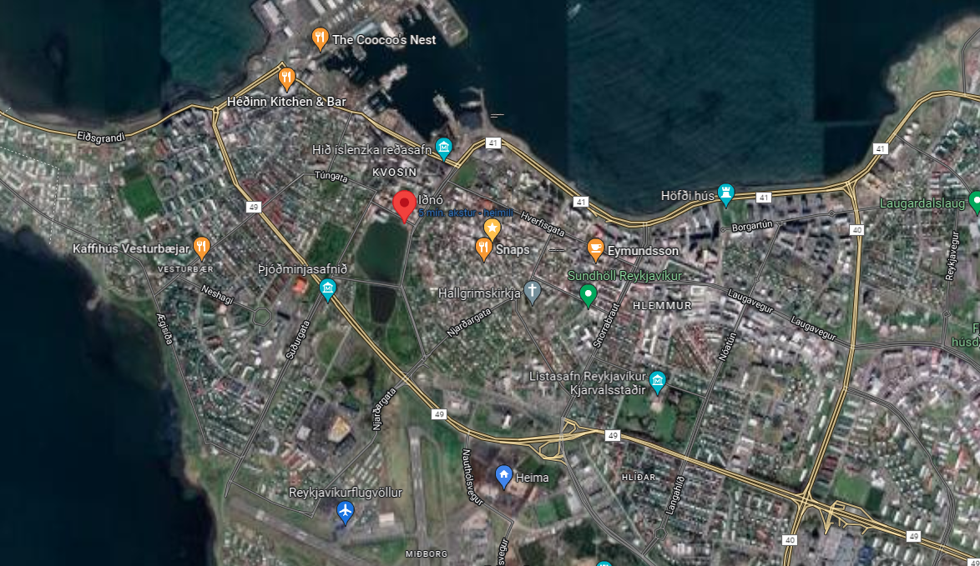

Parking

There is no on-site parking, but street parking is available throughout the downtown area paid by the meter. Free Parking is available West of the Icelandair Hotel Reykjavik Marina (Circled in red in the following picture). The Free Parking is a 5 minute walk away from the venue.

