**TERRAIN AND MISSION PACK**

**INTRODUCTION**

This document provides all the information you need on the terrain and missions used at our events.

This pack covers the information on our mission selection and terrain maps only; for all the practical information on the venue, please see the Location Pack for the event.. For the information on format, round times and other tournament specific information, see the Tournament Pack.

# GENERAL ENQUIRIES AND FEEDBACK

If you have any questions, please get in touch at [IcehammerGT@gmail.com](mailto:IcehammerGT@gmail.com)

TERRAIN

The terrain for your games will be on each table for you to arrange in accordance with the maps below. Each game will use the deployment map below and a terrain map for each deployment has been drafted to create the most balanced, competitive 40k experience possible for attendees of all levels and across multiple games. Please note that no model or player may abuse terrain to gain an unsportsmanlike advantage.

**All terrain rules must be played as per the rules for terrain in the matched play section of the rule book**.

These maps have been designed to allow for the most common army builds and cannot simultaneously cater to very unusual lists while still being balanced for the vast majority of common tournament army archetypes.

**HOW TO SET UP TERRAIN**

Each round uses a different mission and deployment map and has a unique terrain layout to match. When you arrive at the table please set up the objectives for your mission and then set up the terrain according to these maps. The maps list dimensions where placement of the terrain is not obvious by making reference to the deployment zone or objectives. As an additional aid the maps are on a 1” by 1” grid and objective control zones are marked out to make the intent of the terrain placement clear.

**A NOTE ON MOVING AND TERRAIN**

Please familiarize yourself with the rules as they relate to moving and terrain and bear in mind that non-infantry/beasts/swarms can still move up/over ruins and ruined walls using the normal rules for movement and ignore terrain less than 1” in height for movement purposes.

**TYPES OF TERRAIN**

**‘Large L Shape’** This terrain piece has a base size of 20 x 20 cm and two line of sight blocking wall faces also of 20cm x 20cm. It has three levels: 5cm, 10cm and 20cm. **Played using the rules for Ruins from the rule book, therefore the base is considered part of the model when determining line of sight / obscuring.**



**‘Medium L Shape’** This terrain piece has a base size 4 cm wide. The wall is 3mm wide and is centered down the middle of the base. The wall is 15cm high and has apertures throughout so it does not naturally block line of sight. There is a single level 10cm high. The small side is 15cm wide and the long side is 20cm long. **Played using the rules for Ruins from the rule book, as such if you are standing behind the ruin not on the base, you will benefit from obscuring but if you go onto the base you will be able to see through the open windows on this feature.**



**‘Small L Shape’** This terrain piece has a base size of 10 x 20 cm and two line of sight blocking wall faces also of 10cm x 20cm and 10cm x 10cm respectively. It has one level at 10cm. **Played using the rules for Ruins from the rule book. Note that as ‘ruins’ these pieces have the obscuring keyword. Also note that they are not over 5” tall.**



**‘Ruined Wall’** This wall is an L shape with approximately 8cm x 8xm walls, no base and is 3 inches high. **Played using the rules for Ruined walls from the rule book, as it is 3” high, it gains the Dense rules** Please note that these ruined walls are often placed together to form staggered or ‘U’ shapes. **Please make sure you place these correctly, as they have been positioned deliberately to provide the benefit of dense cover through specific firing positions.**

**ROUNDS AND MISSIONS**

Each round has an associated mission and map to be played. If you are playing in a 3 round event, disregard rounds 4 onwards etc.

* Round 1: Mission - 11 Recover the Relics
* Round 2: Mission - 13 Data Scry-salvage
* Round 3: Mission - 33 Secure Missing Artifacts
* Round 4: Mission - 22 Conversion
* Round 5: Mission- 32 Death and Zeal

**MISSIONS AND MAPS**

Round 1: Mission - 11 Recover the Relics

Round 2: Mission - 13 Data Scry-salvage

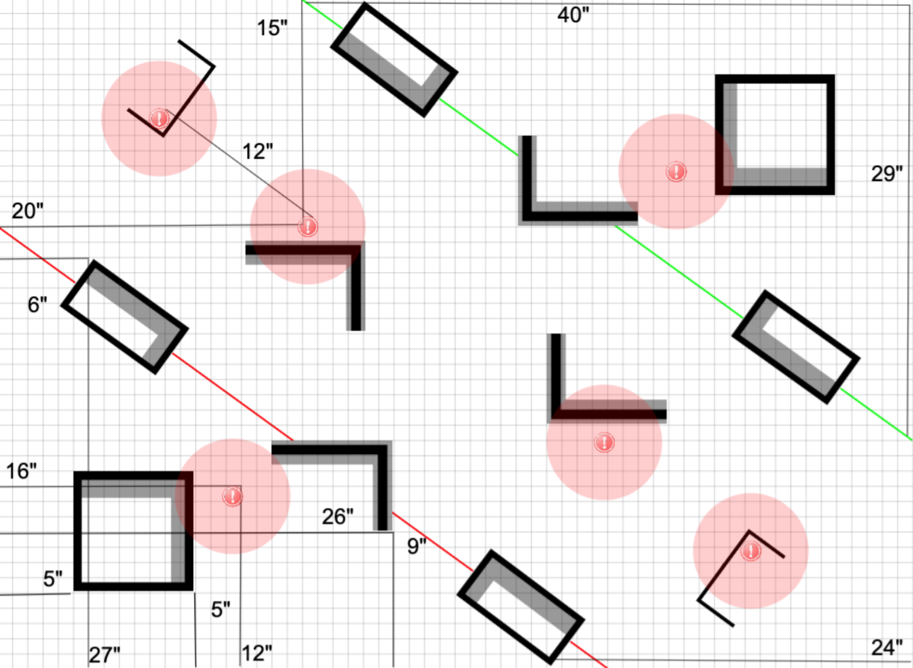

Round 3: Mission- 33 Secure Missing Artifacts

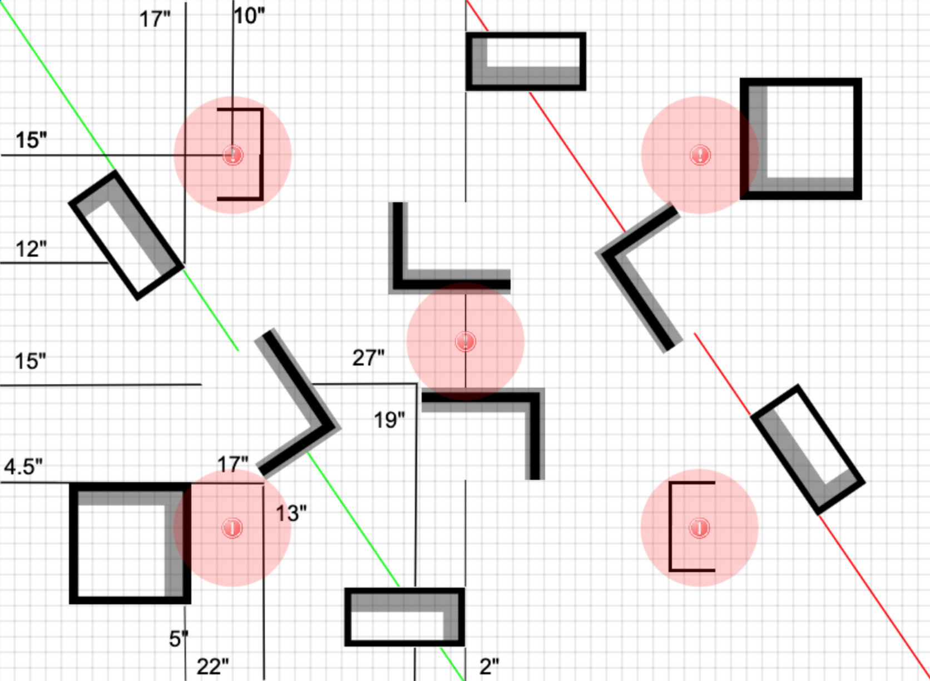

Round 4: Mission - 22 Conversion

Round 5: Mission - 32 Death and Zeal

