SETUP WWISE IN ACCORDANCE WITH THE MOD EDITOR GUIDE  
  
  
Gather all your WAV files (MUST BE WAVE AND A BITRATE OF 1411 KPS) for each dialog and place them in the following directory. MAKE SURE THEY HAVE NO ‘.’ IN THEM:  
  
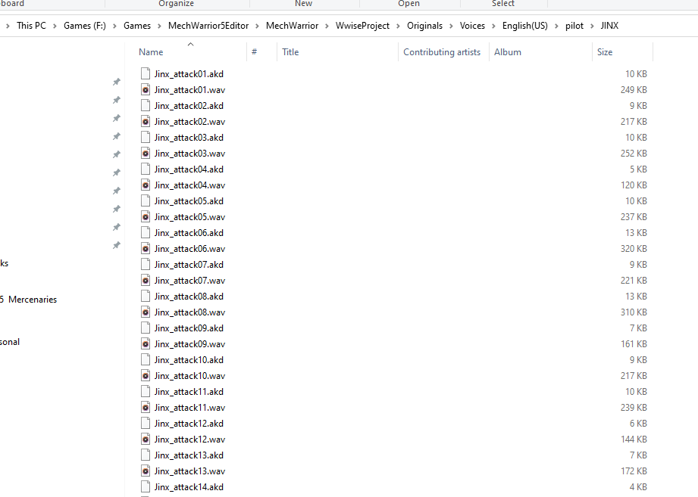  
  
The JINX folder will not be in your directory, create a new folder with the pilot name. With WWise AND the MW5Editor open, past the WAVE files into this directory. The AKD files will automatically be created.  
  
Go to the following directory and make a NEW copy of an existing CSV file, if you are doing a pilot, I suggest one of the ###Ally01.csv files:  
  
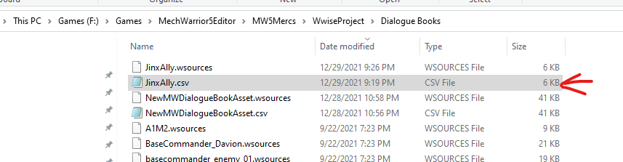

Open the CSV file in EXCEL or any other editor you wish.   
  
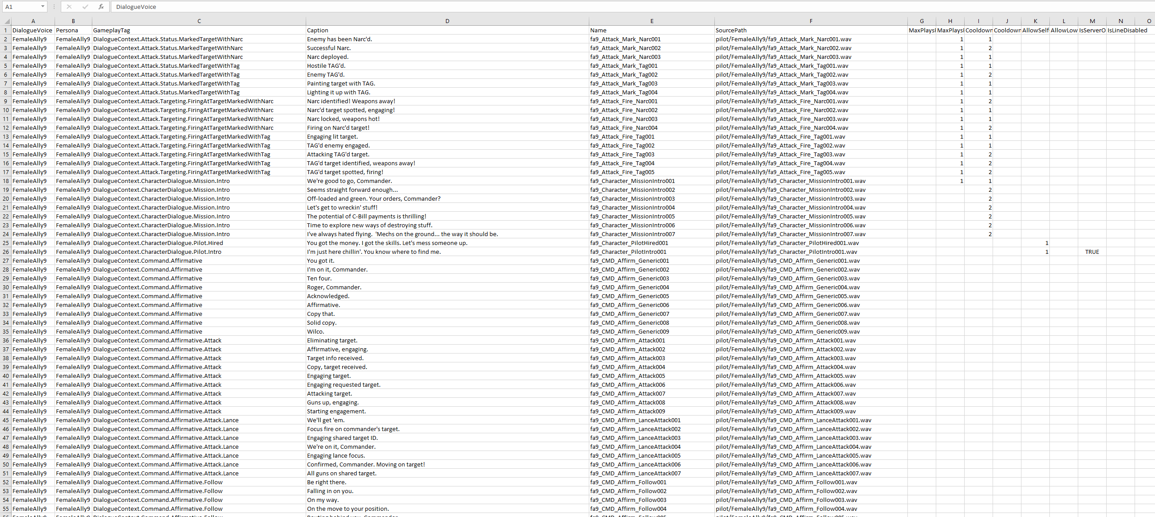

What you will be doing in this file, match the WAVE files you have for what current condition is going on. Also put in the caption that will appear when the pilot is talking.  
  
For the NAME column, use the FILENAME in the SourcePath:  
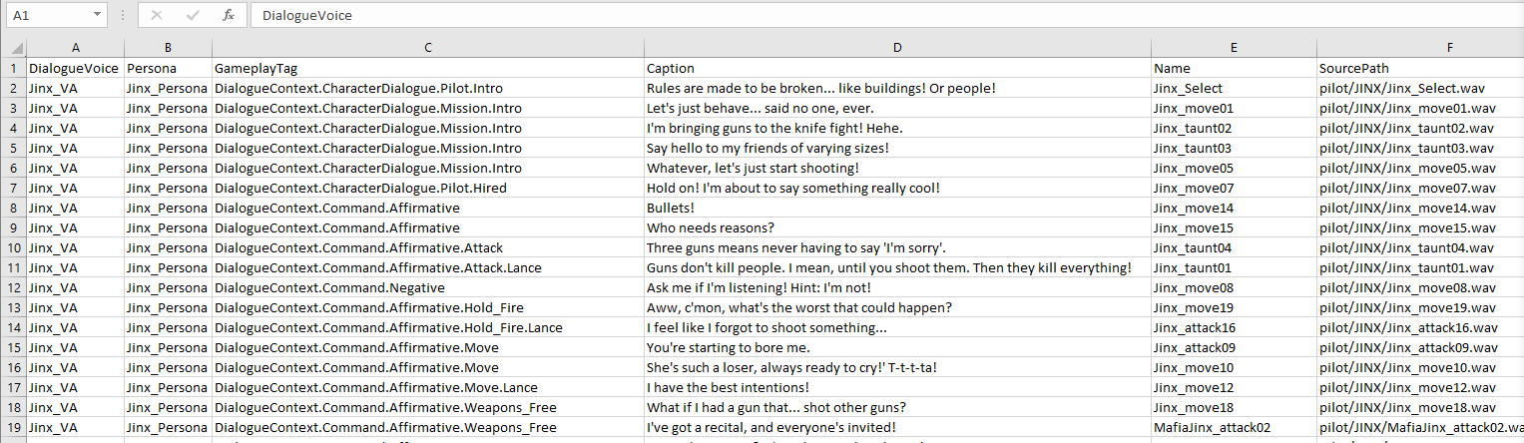

You can see how I did it in my JINX one. For the DialogVoice and Persona, use the FileName you will have for the ASSET in the editor. My DIALOG_VOICE asset is called Jinx_VA, and the Persona is Jinx_Persona.  
  
Save and close the CSV file. Make sure it is in the directory that all the other ones are in.

In the editor, create the Persona, Pilot Persona, Portrait, Texture, and DialogVoice asset.   
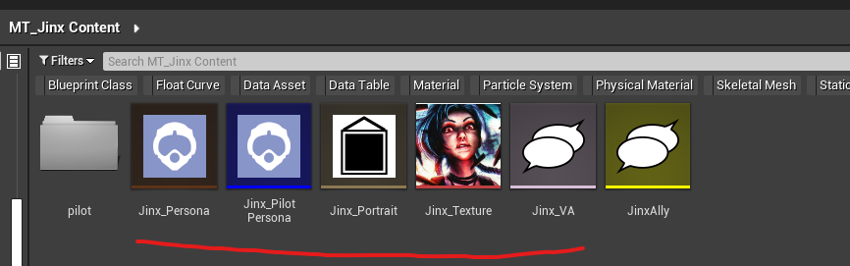

Now create a new DialogBook asset and name it exactly as you have the CSV file (minus the CSV). You can see mine was called JinxAlly  
  
Right click this new asset and click the “Generate Dialogue Book – UE4 Asset & External Audio”  
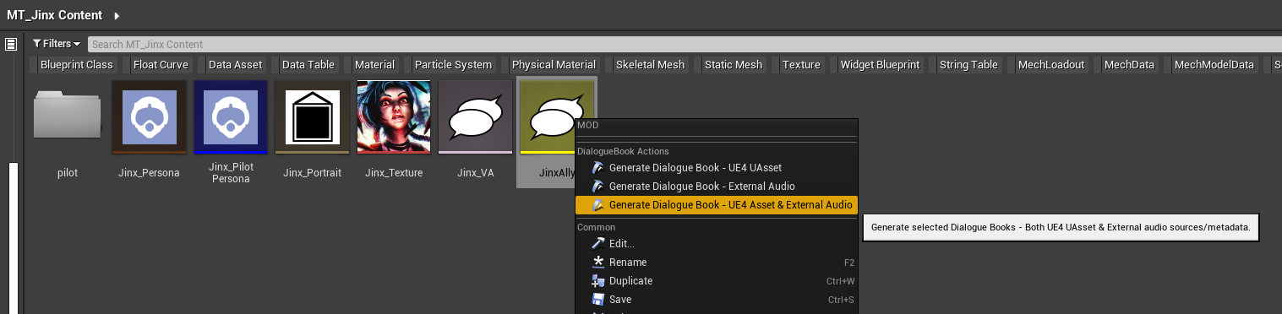  
  
A command prompt should open up and close, and you should not have errors. If you get errors, look at the output log, most times it’s an issue with the file names.  
  
Save the file and open it up, then expand one of the lines and press ”Play Audio” in one of them, you should hear your audio line.  
  
Now go to the following directory:  
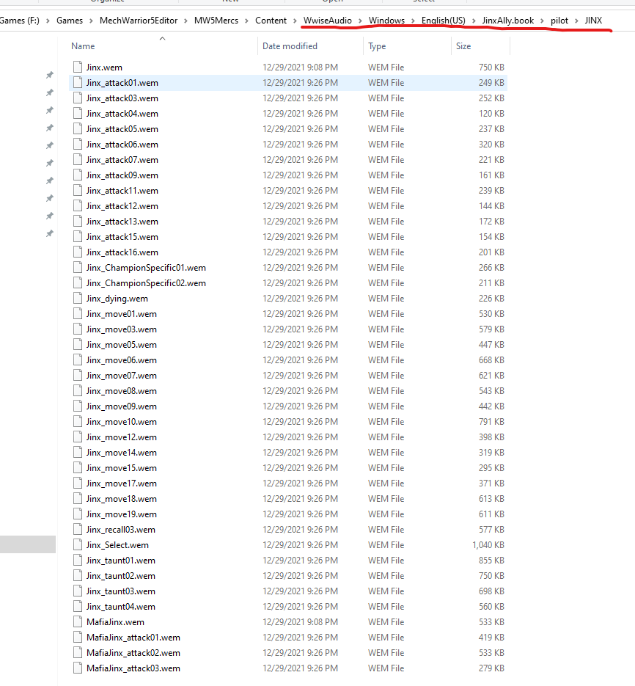

These are the sound assets that need to be packaged as well. In your ModOveride Folder, copy and paste it in the exact folder structure as it appears in the root content directory, as such:  
  
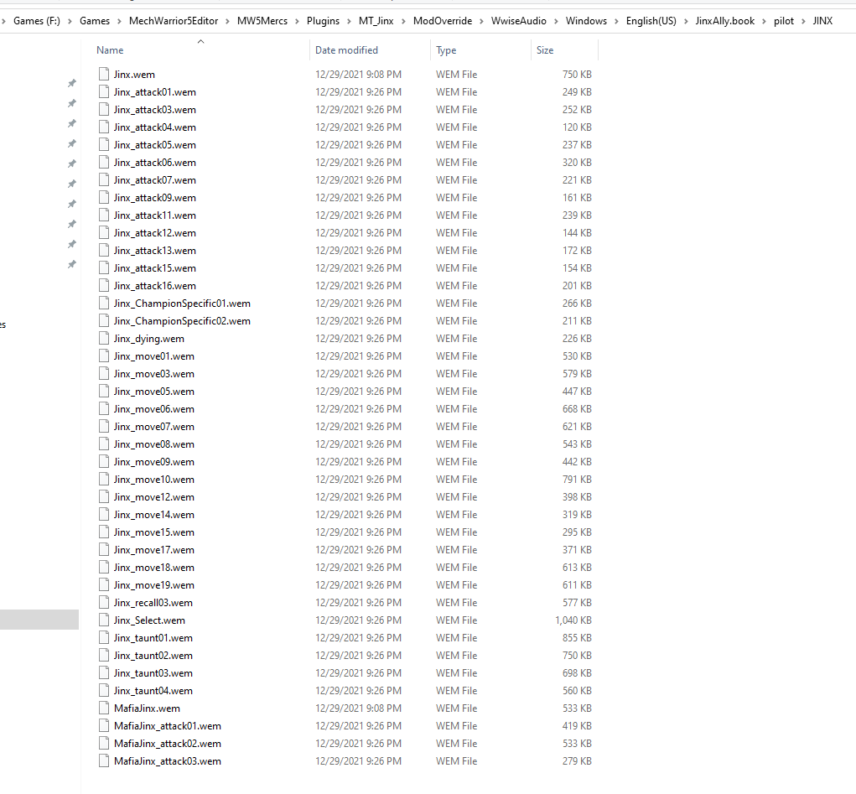  
  
Package the mod, it should work.