算法设计与分析第二次作业

2019202243 郭炜

题目描述：

该题目可抽象为从二维矩阵中某一点开始向四周（上下左右以及斜对角线）遍历附近相邻的1，并用+号标记出来。

Code：

main.cpp以及grid.h未修改

以下为grip.cpp:

#include <iostream>  
#include <fstream>  
  
#include "grid.h"  
// 行号列号确定vector的索引值  
int grid::indexof(int row, int col) const  
{  
 return row * cols + col;  
}  
// 判断该位置是否感染  
bool grid::infected(int row, int col) const  
{  
 return area->operator[](indexof(row, col)) == INFECTED;  
}  
// 未使用  
bool grid::visited(int row, int col) const  
{  
 return true;  
}  
// 构造  
grid::grid(string file)  
{  
 ifstream gridFile;  
 gridFile.open(file);  
  
 gridFile >> rows;  
 gridFile >> cols;  
  
 area = new vector<bool>(rows * cols, NOT_INFECTED);  
 marks = new vector<bool>(rows * cols, NOT_INFECTED);  
  
 while (!gridFile.eof())  
 {  
 int row, col;  
 gridFile >> row >> col;  
 area->operator[](indexof(row, col)) = INFECTED;  
 }  
 gridFile.close();  
}  
// 析构  
grid::~grid()  
{  
 delete area;  
 delete marks;  
}  
// 统计感染子区域大小  
int grid::count(int row, int col)  
{  
 // 参数错误  
 if (row < 0 || row >= rows || col < 0 || col >= cols)  
 {  
 return 0;  
 }  
 // 未感染  
 if (grid::area->operator[](indexof(row, col)) == NOT_INFECTED)  
 {  
 return 0;  
 }  
 // 感染已标记  
 if (grid::marks->operator[](indexof(row, col)) == INFECTED)  
 {  
 return 0;  
 }  
 // 感染未标记  
 grid::marks->operator[](indexof(row, col)) = INFECTED;  
 // 走到当前步，表明当前为感染未标记，因此加一，然后搜索周围九宫格  
 return 1 + grid::count(row - 1, col - 1) + grid::count(row - 1, col) + grid::count(row - 1, col + 1) + grid::count(row, col - 1) + grid::count(row, col + 1) + grid::count(row + 1, col - 1) + grid::count(row + 1, col) + grid::count(row + 1, col + 1);  
}  
// 输出流  
ostream& operator<<(ostream& stream, const grid& ob)  
{  
 for (size_t i = 0; i < ob.rows; ++i)  
 {  
 for (size_t j = 0; j < ob.cols; ++j)  
 {  
 stream << ob.area->operator[](ob.indexof(i, j));  
 // 目标子区域感染+号标记  
 if (ob.marks->operator[](ob.indexof(i, j)))  
 {  
 stream << "+";  
 }  
 else  
 {  
 stream << " ";  
 }  
 if (j < ob.cols - 1)  
 {  
 stream << " ";  
 }  
 }  
 stream << endl;  
 }  
 stream << endl;  
 return stream;  
}

Result:

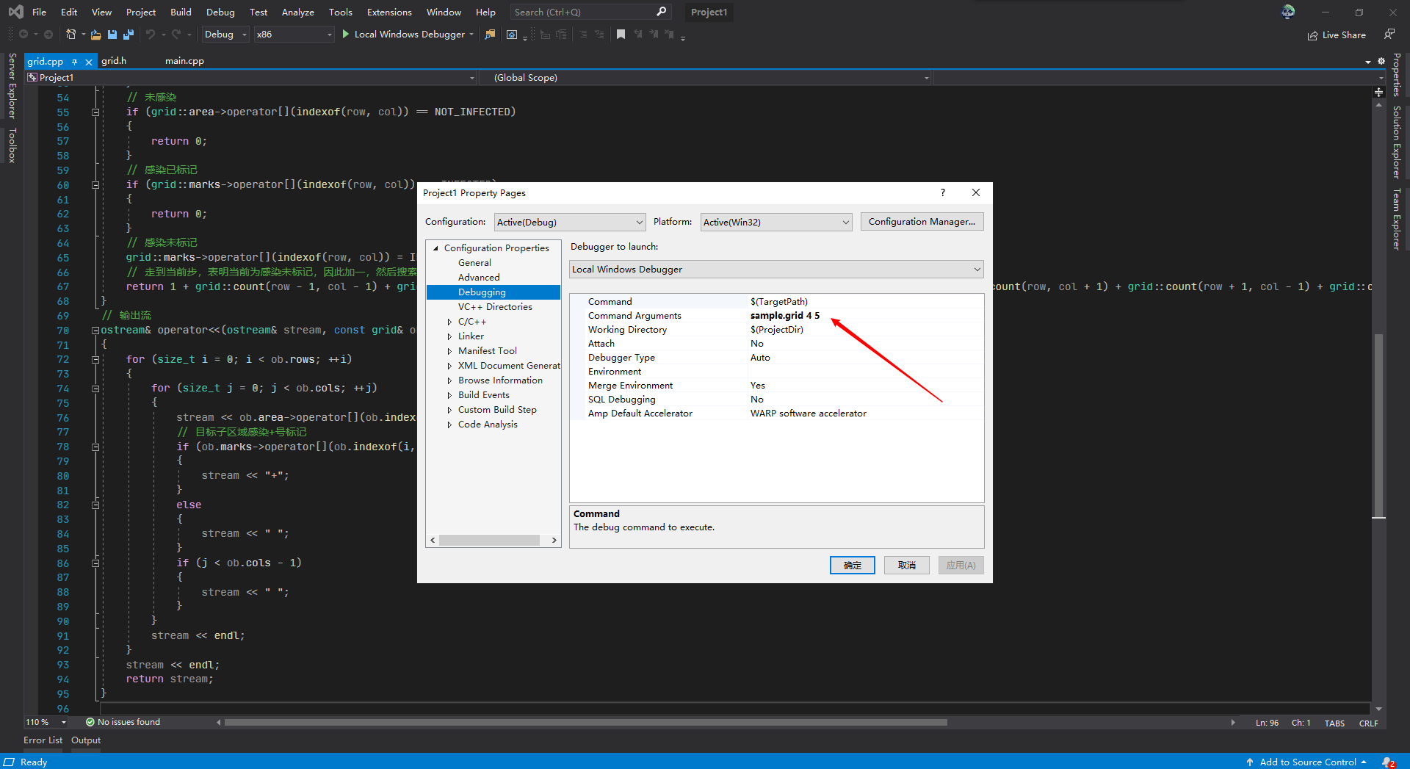

Pic 1 Visual Studio 2019在如图所示位置设置命令行参数

Sample.grid 4 5

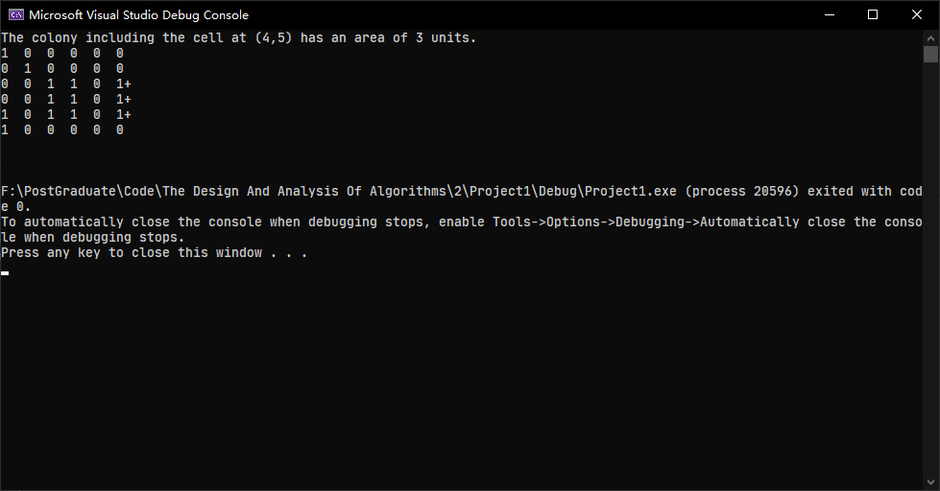

Sample.grid 3 2

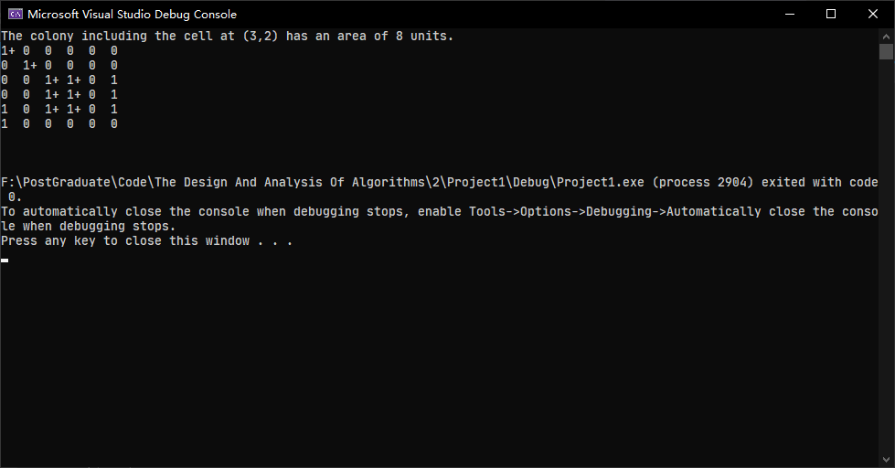

Sample.grid 5 0

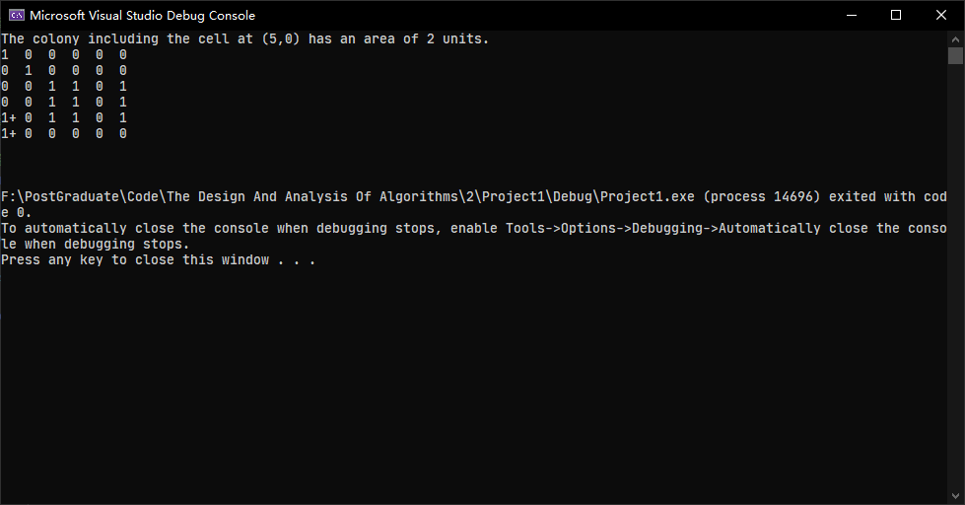

Sample.grid 5 1（5 1处属于未感染区域故没有+号标记）

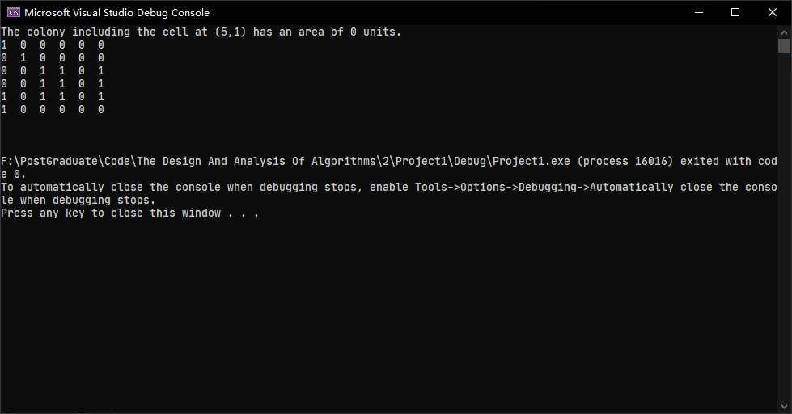

Sample.grid 1 1

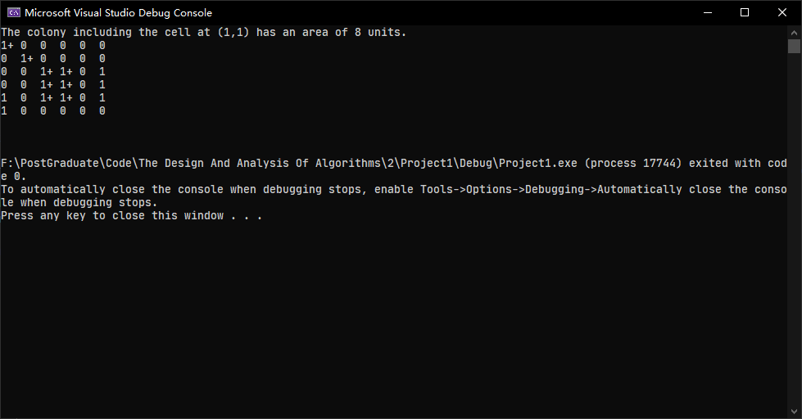

Sample.grid 4 2

