# Overview

XXXX

This project is a video player based on VLC. Project is contained by server part and client part. Server provide video title list ,and send video file. Client get video list from Server, then choose a video to play it. The player has PLAY,PAUSE,STOP functions can to control the playing process.

Develop environment:

* Ubuntu 14.04 64-bit.
* Eclipse Neon 4.6.0
* VLC 2.2.4 for Ubuntu

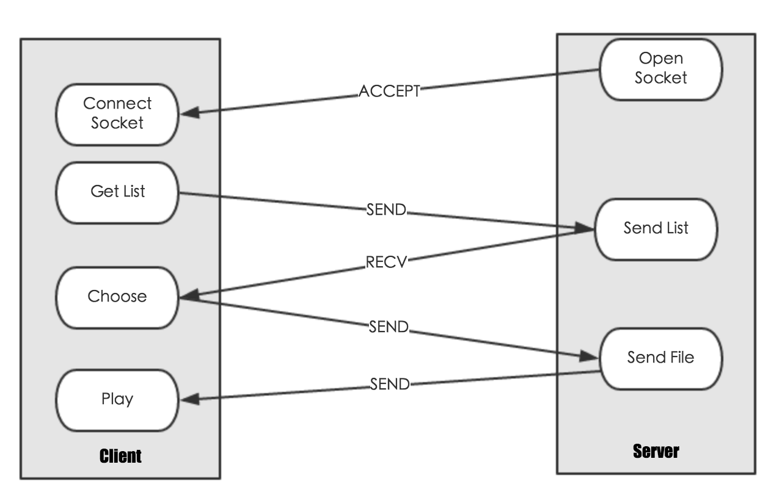

## Client

Client is video player. The whole UI is actualized through JSwing. Main class is MainFrame(src/main/java/client/MainFrame.java)

**Develop steps:**

1.Install VLC client

install VLC media player client for Ubuntu from <http://www.videolan.org/vlc/download-ubuntu.html>.

2.Actualize UI

The main panel is a JFrame, which consisted by JButton, JList,JScrollPane.

3.Play local file

By call EmbeddedMediaPlayer.playMedia can play local video.

4.Play video from Server

1. Get video List

When click the button named “Get List”, client will connect to server by socket. That’s mean s the server must be available before clicking. If connection failed , an error notice panel will be shown.If connection success, then client will receive a video list object. Read video title and show in list panel.

2. Select and get video

After list is shown, client need select a video , and click PLAY button. When click PLAY button, client will send selected title to server.

3. Play video

Server receive a title, then check whether the video file is existed. If not, Server will send “Nothing” to Client, otherwise the video will send to Client and play at Client as local.

**Test:**

testGetVideoList: Verify whether video list can be received.

testRecvFile: Verify whether video can be received

**2. Server**

Server is socket server. Main class is Server(src/main/java/server/Server.java)

Server need to be opened before Client want to get video list.When Server is opening, it will keep waiting request from Client by serversocket.accept(). If there has a client connection, Server wills read command by socket.readline(). If command is “Get List”, Server will read XML file ,pack titles, send to Client by socket output stream. Otherwise, Server will send video file to Client which name is equal to received string.

Send video object from Server to Client by socket need using Java serialization, which means that Video bean class need implements Serializable interface.

**Test:**

testXMLReader:Verify whether XML file can be read.

**3. Kits**

Kits module include some Server and Client functions.

1.Socket tool

File is SocketUtil.java(src/main/java/client/SocketUtil.java). Separating interface and function is good for maintain. Client can call the function “getVideoList” and “recvFile” to get video title list and video.

2.XMLReader tool

File is XMLReader.java(src/main/java/server/XMLReader.java). Server can using this tool to read video object information from XML file.

**4.Summary**

The function of this player is quit easy, but learning how to use VLC library taken me a lot of time. VLC is an excellent open source project, it can make player to order easier.

The most difficult part of this project is about socket. There are so much things about socket transmission need to be notice, such like that when you close the input stream or output stream, the socket connection will be both closed, and if you want to send any information to each other, an exception “Connection refused” is shown. So you need be careful to close data stream.

By this project, I learn a lot about JSwing, Socket, VLC, and Java coding. There has a lot of enhancement left. I would like to improve the efficiency of development and robustness in the code reuse and procedures when I am free.