Software Architecture and Design Specification
for
Snake Game
Version 1.0
Prepared by:
Nisarg Ravi (PES1UG25CS901)
Ramya H RS (PES1UG25CS835)
Vinayaka (PES1UG25CS855)
PES UNIVERSITY: SOFTWARE ENGINEERING (UE23CS341A)
Based on Snake Game SRS, Version 1.0
Created: 28/09/2026

Table of Contents
Revision History
1. Introduction
1.1 Purpose
1.2 Scope
1.3 Document Conventions
1.4 Intended Audience and Reading Suggestions
1.5 References
2. Software Architecture
2.1 Architecture Overview
2.2 Component Diagram and Description
2.3 Architectural Pattern
2.4 Traceability to Requirements
2.5 Security Architecture
2.6 Design Constraints and Assumptions
2.7 Important Design Decisions
3. Software Design
3.1 Design Overview
3.2 UML Sequence Diagrams
3.3 API Design
3.4 Error Handling
3.5 Other Design Details
Appendix A: Glossary
Appendix B: Open Issues

Revision History
Date | Reason for Changes | Version
28/09/2026 | Initial Software Architecture and Design Specification release, based on Snake Game SRS v1.0 and the layered component diagram. | 1.0

1. Introduction

1.1 Purpose
This Software Architecture and Design Specification (SADS) describes the software architecture and the design of Version 1.0 of the Snake Game. It explains how the requirements in the Software Requirements Specification (SRS) are realised as software components, interfaces and interactions. Section 2 covers the architecture: the component diagram, the architectural pattern, traceability to requirements and the security architecture. Section 3 covers the design: UML sequence diagrams, API design, error handling and other supporting design details.

1.2 Scope
This document covers the complete Snake Game system, the same scope as the SRS. The system is a single-process desktop application with no network communication. Multiplayer, mobile deployment and any GUI toolkit other than SFML remain out of scope, as stated in the SRS.

1.3 Document Conventions
The requirement identifiers defined in the SRS are reused: FR- for functional requirements, NFR- for non-functional requirements, SO- for security objectives and SEC- for security requirements. Component names (for example GameEngine) and operation names (for example tick()) are written exactly as they appear in the design and in the diagrams. Diagrams follow UML 2.x notation. Figures are numbered from Figure 1 in this document and are referred to in the text as “Figure X”. The editable draw.io source of every figure is supplied with this document.

1.4 Intended Audience and Reading Suggestions
This document is meant for the project team members who implement and test the system, and for the course instructor and evaluators. Readers who want a quick overview should read Section 2.2 and Section 2.3. Developers should read Section 3.3 (API Design) and Section 3.4 (Error Handling) before implementing a component.

1.5 References
- Software Requirements Specification for Snake Game, Version 1.0, PES University, 27/09/2026.
- Software Test Plan for Snake Game, Version 1.0, PES University, 27/09/2026.
- IEEE Std. 1016-2009, IEEE Standard for Information Technology — Systems Design — Software Design Descriptions, Institute of Electrical and Electronics Engineers, 2009.
- OMG Unified Modeling Language (OMG UML), Version 2.5.1, Object Management Group, 2017.
- SFML 2.6 Official API Documentation — Graphics, Window, and System modules (sf::RenderWindow, sf::Event, sf::Keyboard, sf::Clock).
- Software Engineering course material and templates (UE23CS341A), Department of CSE, PES University.

2. Software Architecture

2.1 Architecture Overview
The Snake Game is a standalone desktop application that runs as one process. It uses SFML for the window, keyboard input and drawing, and the standard C++ file library for the high score file. The application code is split into five software components arranged in four layers. The program entry point, main(), creates the sf::RenderWindow and the components and runs the main loop. It is not a design component and is therefore not shown in the diagram.

2.2 Component Diagram and Description
Figure 1 shows the UML component diagram of the system. Each layer is drawn as a subsystem. A ball on a layer boundary is a provided interface, and the open arrow that points to it shows the component that requires that interface. The dashed arrow shows that HighScoreManager uses the High Score File.
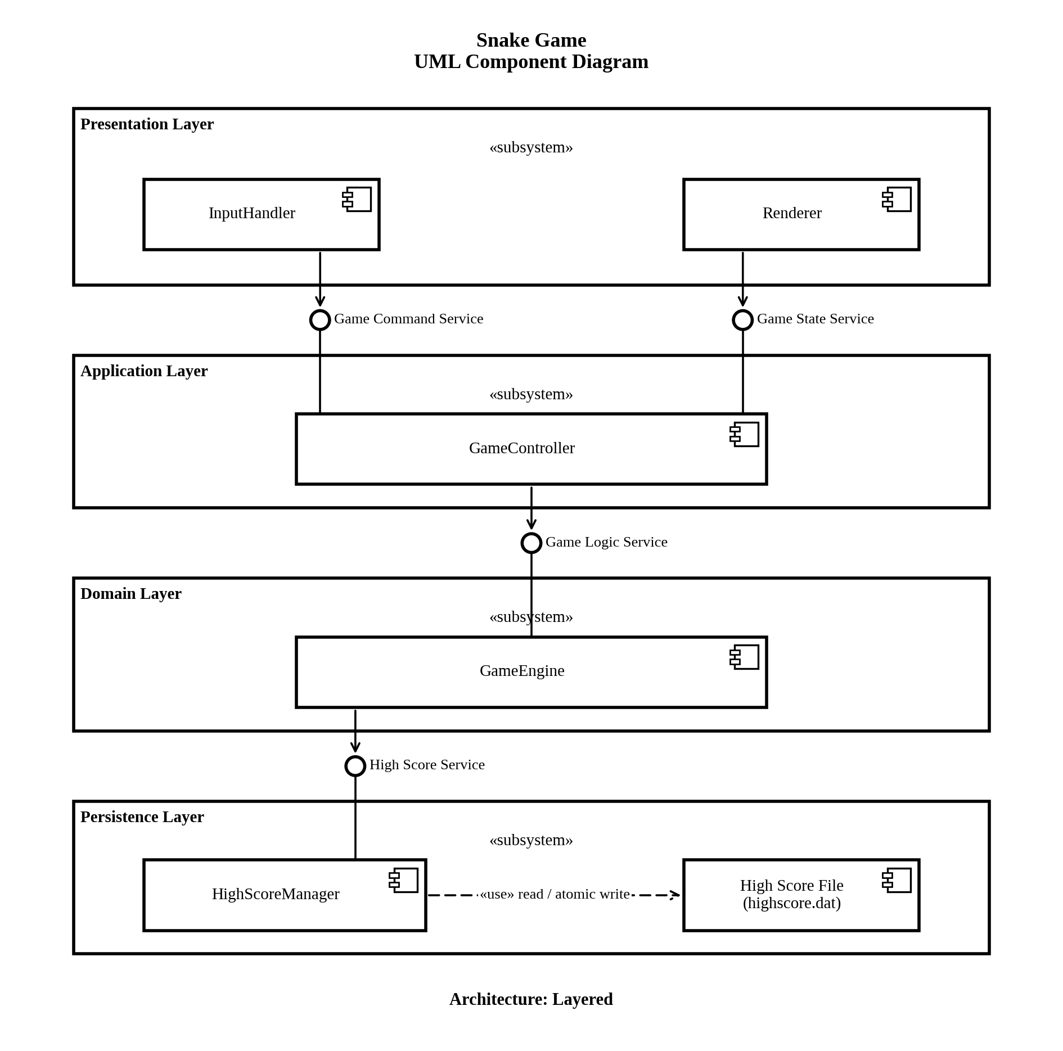
Figure 1: Snake Game UML Component Diagram (Layered Architecture)
The table below lists the components and their responsibilities.
Component | Layer | Responsibility | Interfaces
InputHandler | Presentation | Reads keyboard input through sf::Event and sf::Keyboard, converts the keys (arrow keys, W/A/S/D, pause, restart, exit) into commands and sends them to GameController. Keys that are not mapped are ignored. | Requires: Game Command Service
Renderer | Presentation | Draws the grid, snake, food, score, high score, the control instructions and the Game Over screen on the sf::RenderWindow, using sf::RectangleShape and sf::Text. It only reads a GameSnapshot and never changes game state. | Requires: Game State Service
GameController | Application | Owns the session state (RUNNING, PAUSED, GAME_OVER) and the tick timing (sf::Clock). Accepts commands from InputHandler, checks them against the session state, calls GameEngine, and builds the GameSnapshot for Renderer. | Provides: Game Command Service, Game State Service. Requires: Game Logic Service
GameEngine | Domain | Holds the game rules and game state: grid, snake, food, heading and score. Performs movement, food detection, growth, scoring and collision detection, bound-checks every grid index, and decides at the end of a session whether the high score must be updated. | Provides: Game Logic Service. Requires: High Score Service
HighScoreManager | Persistence | The only component that touches the high score file. Reads and validates the stored value, and writes a new value using a temporary file and an atomic rename. | Provides: High Score Service. Uses: High Score File
High Score File (highscore.dat) | Persistence | Local file that stores the high score between sessions. | Used by HighScoreManager (read / atomic write)

The next table lists the four interfaces shown in Figure 1. Their operations are defined in Section 3.3.
Interface | Provided by | Required by | Purpose
Game Command Service | GameController | InputHandler | Passes player commands (direction, pause, restart, exit) to the application layer.
Game State Service | GameController | Renderer | Gives Renderer a read-only snapshot of the current game state.
Game Logic Service | GameEngine | GameController | Runs the game rules: reset, heading change, one tick, end of session.
High Score Service | HighScoreManager | GameEngine | Loads and saves the high score.

2.3 Architectural Pattern
The system follows the Layered architectural pattern. Each layer has one job and uses only the layer directly below it:
- Presentation Layer: everything the player sees or touches. InputHandler collects keyboard input and Renderer draws the screen.
- Application Layer: GameController controls the session (pause, restart, game over) and the timing of the game tick, and connects the presentation layer to the game rules.
- Domain Layer: GameEngine contains the game rules and game state. It has no knowledge of the keyboard, the window or the file system.
- Persistence Layer: HighScoreManager and the High Score File store the high score across sessions.
The layered pattern was chosen for three reasons. First, NFR-7 asks for game logic, rendering and input handling to be separate so that each can be modified independently. Second, the Domain Layer can be tested alone, which supports the unit and integration testing in the Software Test Plan. Third, the system is small and runs in one process, so a strict layered structure is enough and no further infrastructure is needed. Inside this structure the game runs as a fixed-interval loop: on each frame the main loop reads input, lets GameController advance the game when a tick is due, and lets Renderer draw the current state.

2.4 Traceability to Requirements
The table below shows which components and design elements realise each functional and non-functional requirement of the SRS, so that every requirement can be followed to the design and back.
ID | Requirement | Component(s) | Design Element
FR-1 | Initialise grid (default 20×20) | GameEngine | reset() – Figure 2
FR-2 | Snake at centre, length 3, heading right | GameEngine | reset() – Figure 2
FR-3 | One food item at a random free cell | GameEngine | reset(), spawnFood() – Figures 2, 3
FR-4 | Read direction keys; reject reversal | InputHandler, GameController, GameEngine | submitDirection(), setHeading() – Figure 3
FR-5 | Move one cell per tick (150 ms default) | GameController, GameEngine | Tick timing, tick() – Figure 3
FR-6 | Detect food, grow +1, score +10 | GameEngine | tick() – Figure 3
FR-7 | Display score, updated in same tick | GameController, Renderer | getSnapshot() – Figure 3
FR-8 | Detect wall and self collision | GameEngine | tick() – Figure 4
FR-9 | Stop movement; Game Over screen | GameController, GameEngine, Renderer | GAME_OVER state – Figure 4
FR-10 | Pause and resume | InputHandler, GameController | togglePause(); Section 3.5.1
FR-11 | Restart from Game Over screen | InputHandler, GameController, GameEngine | requestRestart(), reset() – Figure 4
FR-12 | Exit from Game Over screen or menu | InputHandler, GameController | requestExit()
FR-13 | Read stored high score at start | GameEngine, HighScoreManager | loadHighScore(), load() – Figure 2
FR-14 | Compare and overwrite high score | GameEngine, HighScoreManager | finalizeSession(), save() – Figure 4
FR-15 | Show high score with live score | GameController, Renderer | GameSnapshot.highScore
NFR-1 | Frame redraw ≤ 33 ms | Renderer | Draws only simple SFML shapes and text from a snapshot
NFR-2 | Full tick ≤ 50 ms | GameController, GameEngine, Renderer | No file access inside a normal tick; file I/O only at start and at Game Over
NFR-3 | No crash on invalid input | InputHandler, GameController | Unmapped keys and out-of-state commands are ignored; Section 3.4
NFR-4 | High score persists over 100 sessions | HighScoreManager | Atomic write and validation on read
NFR-5 | On-screen instructions ≥ 3 s | Renderer | First frame – Figure 2
NFR-6 | Runs on Windows, Linux, macOS | All components | Only standard C++ and SFML are used; no OS-specific calls
NFR-7 | Separate logic, rendering, input | All components | Layered structure – Figure 1
SEC-1 | Temporary file and atomic rename | HighScoreManager | save(); Section 2.5
SEC-2 | Validate stored high score | HighScoreManager | load(); Section 2.5
SEC-3 | Length-checked buffers | InputHandler, HighScoreManager | Bounded reads; Section 2.5
SEC-4 | Bound-check grid indices | GameEngine | tick(), spawnFood(); Section 2.5

2.5 Security Architecture
The system has no network interface and no user accounts, so its security concerns are limited to two places where data enters from outside the game logic: the keyboard and the high score file. The security objectives SO-1 to SO-3 and the requirements SEC-1 to SEC-4 of the SRS are enforced by the components shown in Figure 1.

2.5.1 Entry Points and Controls
Entry Point | Threat | Control | Component(s)
Keyboard input | Very fast, repeated or unexpected key presses could lead to undefined behaviour or an invalid state (SO-2). | Only a fixed set of keys is mapped; everything else is dropped in InputHandler. GameController then checks the command against the session state, and GameEngine rejects reversal. | InputHandler, GameController, GameEngine
High score file | The file may be missing, half-written after a crash, or edited by hand (SO-1, SO-3). | Value is validated on read and replaced by 0 if invalid. Writes go to a temporary file first and are renamed over the old file. | HighScoreManager
Snake and food coordinates | A wrong coordinate could be used as an array index (SO-2). | Every index is bound-checked before the grid is accessed. | GameEngine
Network | None. The system does not use any network (SRS Section 3.4). | No network code is included, so there is no remote attack surface. | –

2.5.2 Allocation of Security Requirements
Objective | Requirement | Component(s) | Design Mechanism
SO-1 | SEC-1 | HighScoreManager | save() writes the new value to a temporary file in the same directory and renames it over highscore.dat. The old file stays intact until the rename succeeds.
SO-3 | SEC-2 | HighScoreManager | load() accepts only a non-negative integer of at most 999,999. Anything else is discarded, a warning is logged and 0 is returned.
SO-2 | SEC-3 | InputHandler, HighScoreManager | Key input is read as key states, not as free text. The high score file is read into a std::string with a fixed maximum length. No unbounded C string functions are used.
SO-2 | SEC-4 | GameEngine | Grid access goes through one checked function that rejects any index outside the grid array.

Three design principles support these controls. All access to the high score file goes through HighScoreManager, so the protection cannot be bypassed. Renderer receives only a copy of the state, so the presentation layer cannot change game data. On any failure the system falls back to a safe value (high score 0, or the previous file content) instead of continuing with unchecked data.

2.6 Design Constraints and Assumptions
The following constraints come from the SRS and shape the architecture:
- The implementation language is C or C++ (C++17 or later) with SFML; rendering is limited to SFML’s Graphics and Window modules.
- The application runs on one desktop machine with no network, so there is no client-server or messaging layer.
- The high score store is a local file, not a database or cloud service.
- Development time is limited to one academic term, which favours a small number of components.
The following assumptions are made in this design:
- A keyboard is the only input device, and the window is large enough for a 20×20 grid without scrolling (SRS Section 2.7).
- The game runs on a single thread, so no locking or synchronisation between components is needed.
- highscore.dat is stored in the application’s working directory, and warnings are written to the standard error stream.

2.7 Important Design Decisions
1. A layered architecture with four layers (Presentation, Application, Domain, Persistence) is used, as shown in Figure 1. It matches NFR-7 and keeps each concern in one place.
2. Layers only talk to each other through named service interfaces (Game Command Service, Game State Service, Game Logic Service, High Score Service). A component can therefore be changed or replaced without changing the ones above it.
3. Dependencies point downwards only. Renderer reads a snapshot from GameController instead of being called by it, so no lower layer depends on a higher one.
4. GameController owns the tick timing with sf::Clock (default 150 ms, adjustable in code from 80 ms to 300 ms, FR-5). GameEngine does not depend on SFML windowing, input or drawing classes, so its rules can be unit tested without opening a window.
5. The snake is stored as an ordered sequence of grid positions with the head first, so growth (FR-6) only adds one new head position.
6. Reversal is checked against the direction of the last completed move, not the last key pressed. This stops two quick key presses inside one tick from turning the snake back onto itself (FR-4).
7. HighScoreManager is the only component that accesses the high score file, so SEC-1 and SEC-2 are enforced in a single place. The value is stored as one plain-text integer, which the SRS allows.

3. Software Design

3.1 Design Overview
The main loop in main() runs once per frame in a fixed order: it lets InputHandler read the keyboard, calls GameController.update(), and lets Renderer draw the current GameSnapshot. GameController starts a game tick only when the tick interval has elapsed (150 ms by default). A full tick, including input, movement, collision check and drawing, must finish in 50 ms (NFR-2) and a frame must be redrawn in 33 ms (NFR-1). File access happens only at start-up and at Game Over, so it never delays a normal tick.

3.2 UML Sequence Diagrams
Three sequence diagrams show how the components work together. They cover the start of the application, the normal game tick, and the end of a game. Pausing and resuming needs no separate diagram because it only changes the session state in GameController (Section 3.5.1).

3.2.1 Application Launch and Initialization
Figure 2 shows what happens when the player launches the application. GameController asks GameEngine to load the high score, and GameEngine gets the value from HighScoreManager, which reads and validates highscore.dat (FR-13, SEC-2). GameEngine then resets the game to its starting state (FR-1 to FR-3). Renderer reads the first snapshot and draws the first frame together with the control instructions for at least 3 seconds (NFR-5).
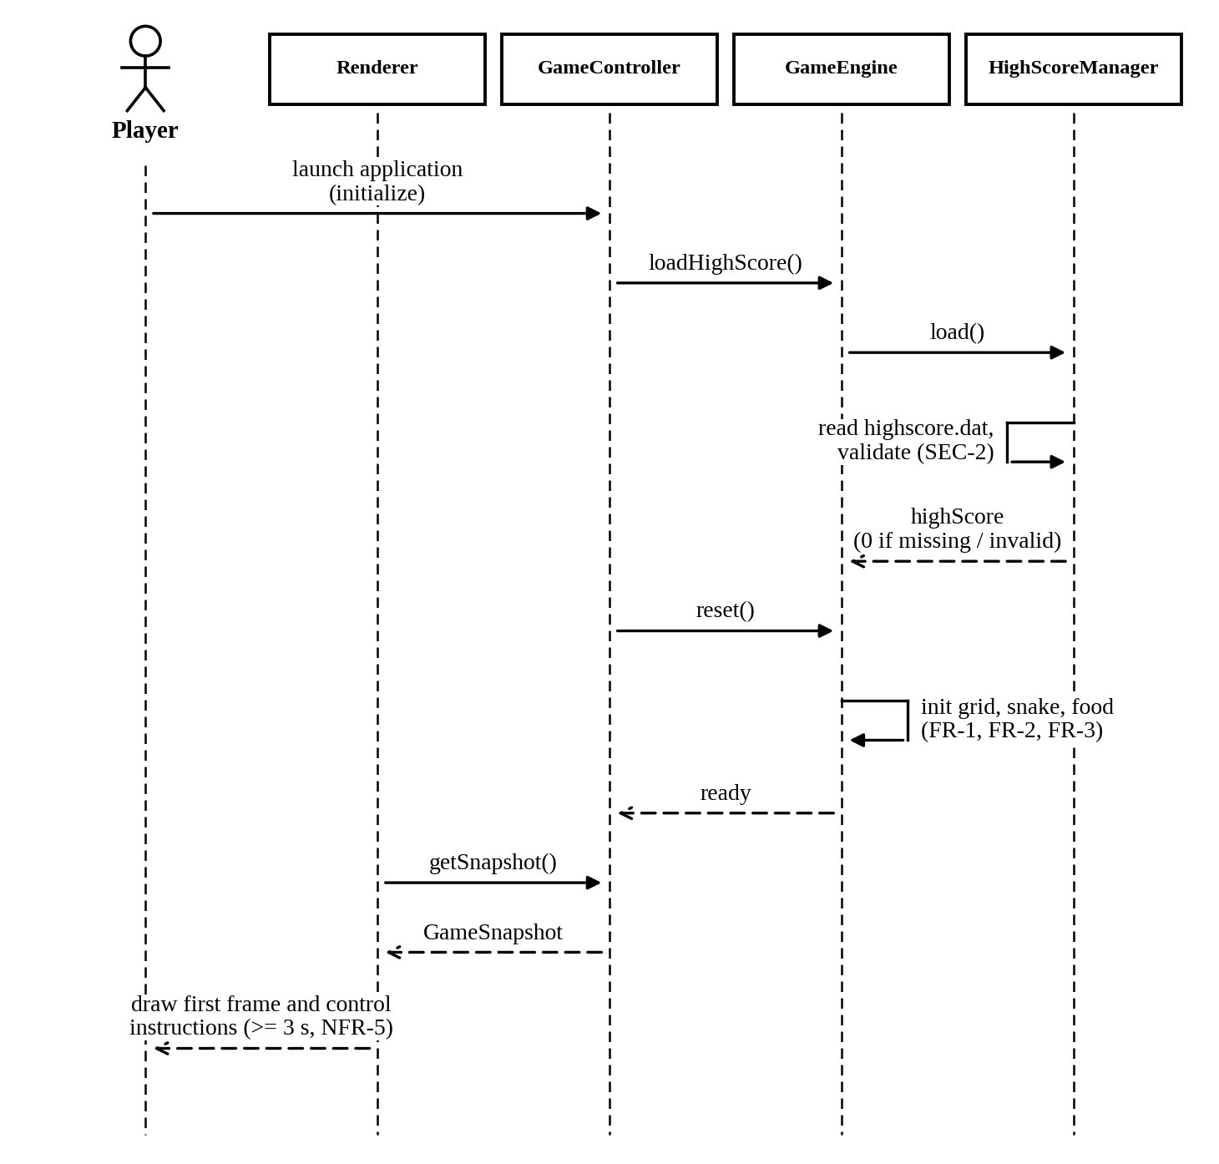
Figure 2: Sequence Diagram – Application Launch and Initialization

3.2.2 Gameplay Tick: Movement, Food and Score
Figure 3 shows a normal game tick. A key press is passed from InputHandler through GameController to GameEngine, which rejects a reversal (FR-4). When the tick interval has elapsed, GameController calls tick(). GameEngine moves the snake one cell, checks the grid bounds and the collision conditions, and, if the head is on the food cell, grows the snake, adds 10 points and places a new food item (FR-6, FR-3). Renderer then reads the snapshot and draws the frame with the score and the high score (FR-7, FR-15).
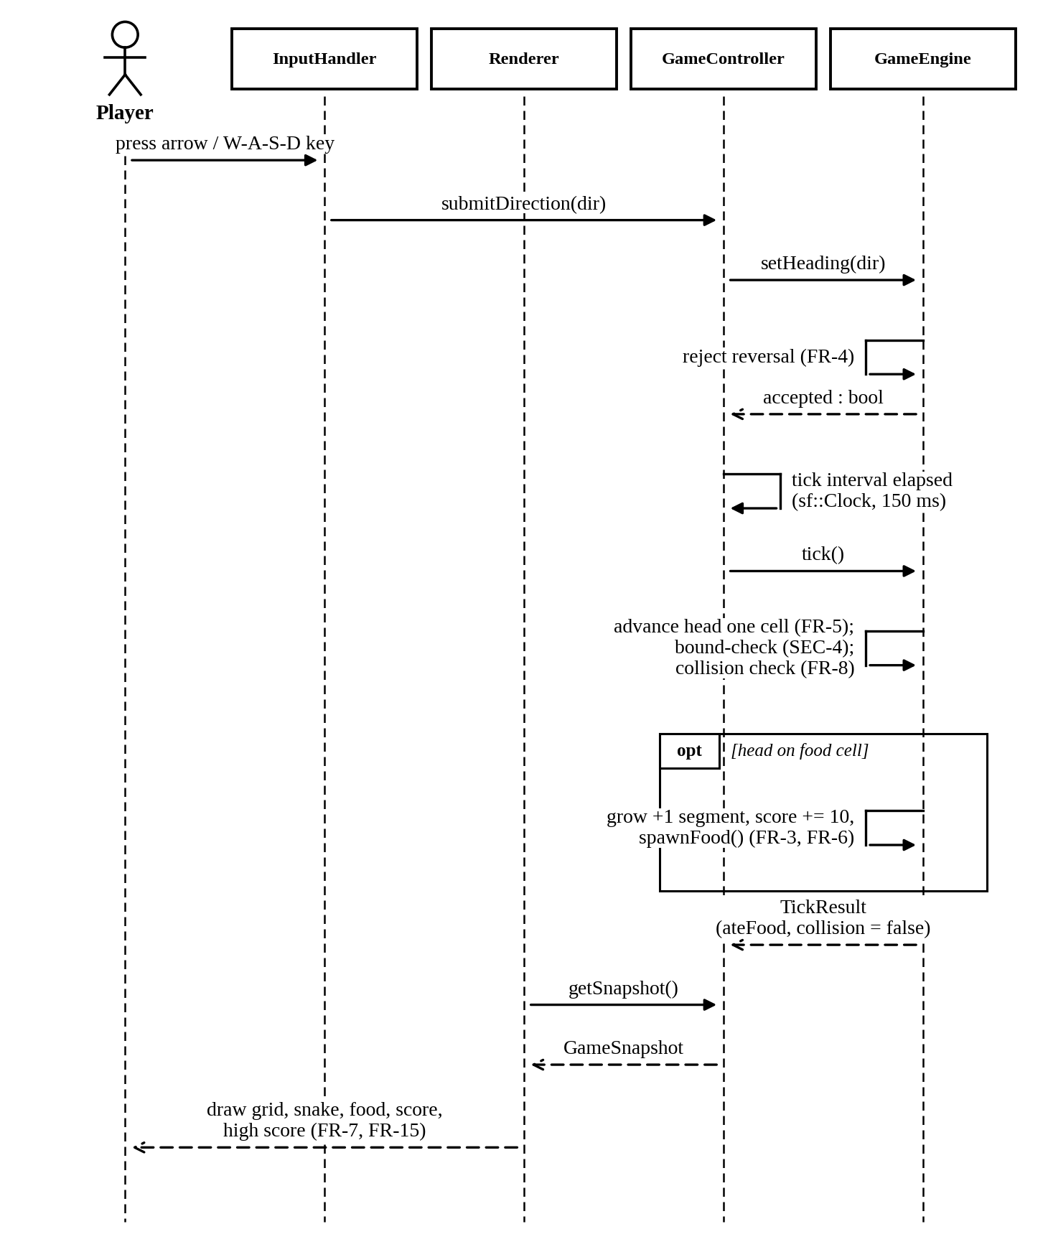
Figure 3: Sequence Diagram – Gameplay Tick

3.2.3 Collision, Game Over and Restart
Figure 4 shows the end of a game. When tick() reports a collision, GameController sets the state to GAME_OVER and movement stops (FR-8, FR-9). It then calls finalizeSession(). Only if the final score is greater than the stored high score does GameEngine call save(), and HighScoreManager writes the value with a temporary file and an atomic rename (FR-14, SEC-1). Renderer shows the Game Over screen with the final score and the high score. When the player presses the restart key, GameController resets the game, and the stored high score is not changed (FR-11).
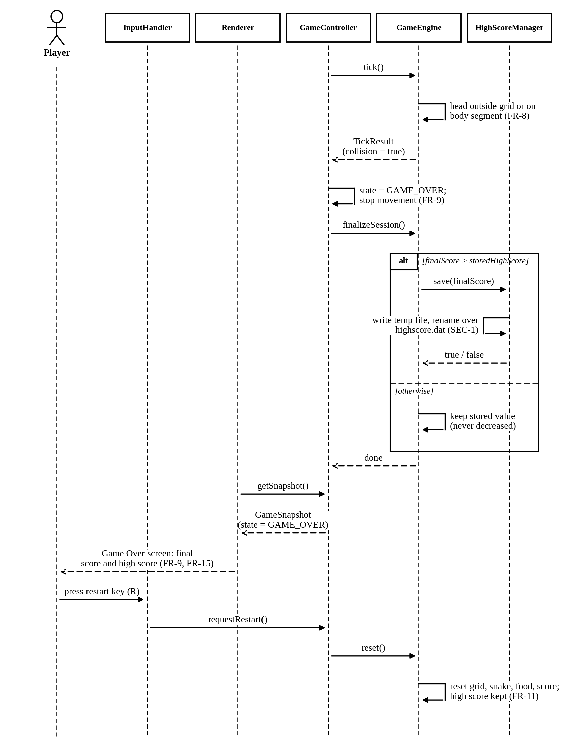
Figure 4: Sequence Diagram – Collision, Game Over and Restart

3.3 API Design
The system has no network or external API (SRS Section 3.4). The APIs in this section are the internal interfaces between components, which correspond to the four interfaces in Figure 1. They are described as C++-style operations. The exact parameter types may change during implementation, but the behaviour described here must stay the same.

3.3.1 Shared Data Types
Type | Definition | Used By
Direction | Enumeration: UP, DOWN, LEFT, RIGHT. | InputHandler, GameController, GameEngine
Position | Pair of integers (column, row) identifying one grid cell. | GameEngine, GameSnapshot
SessionState | Enumeration: RUNNING, PAUSED, GAME_OVER. | GameController, GameSnapshot
TickResult | Result of one tick: ateFood (bool) and collision (bool). | GameEngine, GameController
GameSnapshot | Read-only copy of the state for drawing: grid width and height, snake (list of Position, head first), food (Position), score, highScore and sessionState. | GameController, Renderer

3.3.2 Game Command Service
Provided by GameController and used by InputHandler.
Operation | Description | Error Behaviour | Req.
void submitDirection(Direction d) | Requests a heading change. Passed on to GameEngine.setHeading() only while the state is RUNNING. | Ignored in PAUSED and GAME_OVER. A reversal is rejected by GameEngine and ignored. | FR-4
void togglePause() | Switches between RUNNING and PAUSED. The tick and all other input are suspended while PAUSED. | Ignored in GAME_OVER. | FR-10
void requestRestart() | Calls GameEngine.reset() and sets the state to RUNNING. The stored high score is kept. | Ignored unless the state is GAME_OVER. | FR-11
void requestExit() | Marks the application for exit. The main loop then closes the window. | Accepted in GAME_OVER only; ignored otherwise. | FR-12

3.3.3 Game State Service
Provided by GameController and used by Renderer.
Operation | Description | Error Behaviour | Req.
GameSnapshot getSnapshot() const | Returns a copy of the current game state and session state. Does not change any state. | None. Always returns a valid snapshot. | FR-7, FR-15

GameController also has three lifecycle operations that are used only by main(), not by the other components:
Operation | Description | Error Behaviour | Req.
void initialize() | Called once by main() at start-up. Calls GameEngine.loadHighScore() and GameEngine.reset(). | A failed high score load results in high score 0. | FR-1–FR-3, FR-13
void update() | Called once per frame by main(). If the state is RUNNING and the tick interval has elapsed, calls GameEngine.tick(). On a collision, sets GAME_OVER and calls finalizeSession(). | Does nothing when PAUSED or GAME_OVER. | FR-5, FR-9
bool isExitRequested() const | Tells main() whether the application should close. | None. | FR-12

3.3.4 Game Logic Service
Provided by GameEngine and used by GameController.
Operation | Description | Error Behaviour | Req.
void loadHighScore() | Calls HighScoreService.load() and keeps the returned value as the stored high score. | Invalid or missing data gives 0. | FR-13
void reset() | Creates an empty grid, places the snake at the centre with 3 segments and heading right, sets the score to 0 and places one food item. The stored high score is kept. | None. | FR-1–FR-3, FR-11
bool setHeading(Direction d) | Sets the next heading. Returns false and keeps the old heading if d is the reverse of the last completed move. | Returns false on reversal. | FR-4
TickResult tick() | Moves the snake one cell, checks for food (grow +1, score +10, new food) and for collision with the wall or the body. After a collision no further movement or scoring happens. | Head outside the grid counts as a collision. | FR-5–FR-8, SEC-4
void finalizeSession() | Compares the final score with the stored high score. If it is greater, calls HighScoreService.save() and updates the stored value. | If save() fails, the stored value stays unchanged and a warning is logged. | FR-14
const GameState& getState() const | Read access to grid size, snake, food, score and high score. | None. | FR-7, FR-15

3.3.5 High Score Service
Provided by HighScoreManager and used by GameEngine.
Operation | Description | Error Behaviour | Req.
int load() | Reads highscore.dat, validates the content and returns the value. Returns 0 if the file is missing or the content is invalid. | Never fails to the caller. Invalid content: warning logged, 0 returned. | FR-13, SEC-2, SEC-3
bool save(int score) | Writes the score to a temporary file and renames it over highscore.dat. Returns true on success. | Returns false on any failure; the old file stays unchanged. | FR-14, SEC-1

3.4 Error Handling
The error handling follows three rules. Invalid player input is ignored silently and never shown as an error, as required by NFR-3. Problems with the high score file never stop the game: the system uses a safe default, logs a warning and carries on. Operations report their outcome through return values (bool, TickResult, or a safe default value) and not by letting failures pass between layers. The table below lists the error cases and how each one is handled.
Error Case | Detected By | Handling | Req.
Key that is not mapped to a command | InputHandler | Ignored. No command is sent. | NFR-3, SO-2
Several key presses inside one tick | GameController, GameEngine | Each direction is checked against the last completed move. Only valid directions change the heading. | FR-4, SO-2
Direction, pause or restart command in a state that does not allow it | GameController | Ignored. The state does not change. | FR-10, NFR-3
Direction that reverses the snake | GameEngine | setHeading() returns false and the heading is unchanged. | FR-4
Grid index outside the grid array | GameEngine | Rejected before the array is accessed. A head position outside the grid is treated as a collision. | SEC-4, FR-8
highscore.dat does not exist | HighScoreManager | load() returns 0. This is the normal case on the first run. | FR-13
highscore.dat has invalid content (empty, not a number, negative, above 999,999 or too long) | HighScoreManager | Value discarded, warning logged, 0 returned. The file is replaced the next time a higher score is saved. | SEC-2, SO-3
highscore.dat exists but cannot be opened or read | HighScoreManager | Warning logged and 0 returned. The game continues. | NFR-3, SO-3
Temporary file cannot be created or written, or the rename fails | HighScoreManager | save() returns false, the temporary file is removed if it exists, the old file stays unchanged, and a warning is logged. The game continues. | SEC-1, SO-1
Crash or power loss while saving | Design of save() | highscore.dat still holds either the old or the new complete value. | SEC-1, SO-1
No free cell left for a new food item | GameEngine | Not defined in the SRS. Provisionally the session ends as at a collision (see Appendix B). | Open issue
Font for sf::Text cannot be loaded | Renderer | Error message written to the standard error stream and the application exits. | NFR-3

3.5 Other Design Details

3.5.1 Session State Model
GameController keeps one session state at a time. The table below lists the states and what changes them. This is also where the pause behaviour of FR-10 is defined.
State | Entered When | Behaviour | Leaves When
RUNNING | After initialization, or after a restart. | Ticks are processed and direction commands are accepted. | Pause key → PAUSED. Collision → GAME_OVER.
PAUSED | Pause key pressed in RUNNING. | The tick is suspended. Only the pause toggle is accepted. | Pause key → RUNNING.
GAME_OVER | Collision detected. | Movement and scoring stop. Final score and high score are shown. Restart and exit are accepted. | Restart key → RUNNING. Exit key → application exits.

3.5.2 High Score File Format
The SRS allows either a plain text or a binary file. This design stores the high score as a single non-negative integer written as plain text in highscore.dat. This keeps the file easy to check and validate. load() reads at most a small fixed number of characters, which is more than the six digits of the upper limit, and accepts the content only if it consists of digits and its value is not more than 999,999. save() writes the new value to a temporary file in the same directory and then renames that file over highscore.dat, so the file always holds one complete value.

Appendix A: Glossary
Term | Description
SADS | Software Architecture and Design Specification
GameController | Application layer component that controls the session state and the tick timing and connects the presentation layer to GameEngine.
GameEngine | Domain layer component that holds the game rules and game state.
HighScoreManager | Persistence layer component that reads, validates and writes the high score file.
InputHandler | Presentation layer component that reads the keyboard and sends commands to GameController.
Renderer | Presentation layer component that draws the game on the sf::RenderWindow.
GameSnapshot | Read-only copy of the game state that Renderer uses to draw one frame.
TickResult | Result returned by GameEngine.tick(): whether food was eaten and whether a collision happened.
Session State | Current mode of the game: RUNNING, PAUSED or GAME_OVER.
Main Loop | The loop in main() that reads input, updates the game when a tick is due, and draws each frame.

Appendix B: Open Issues
The following points are not defined in the SRS. The second column shows how this design handles each of them for now.
No. | Issue | Current Design Position
1 | Main menu: FR-12 and FR-14 refer to a main menu, but the SRS does not describe it. It is not designed here. | Team to decide whether a main menu is needed. If yes, add a requirement and a session state.
2 | Start-up: the SRS says the grid is initialised at launch and that instructions are shown for at least 3 seconds, but not whether the snake moves during that time. | This design shows the instructions on the first frames of the running game. Team to confirm.
3 | Exit: FR-12 allows exit only from the Game Over screen or the main menu. Behaviour of the window close button and of exit during play or pause is not specified. | This design accepts requestExit() only in GAME_OVER. Team to confirm.
4 | Grid full: the SRS does not say what happens when no free cell is left for food. | Provisional: the session ends like a collision. Team to confirm.
5 | High score file: format (plain text or binary), location and warning log destination are not fixed in the SRS. | This design uses a plain-text integer in highscore.dat in the working directory, and warnings go to the standard error stream.
6 | Key bindings: the SRS gives only examples (P, R, Esc or Q). | Final keys to be fixed during implementation.

