Лабораторная работа №4
Батурин Георгий РТ-21

Задание 1
RC – цепь.
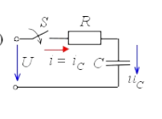
N = 3;
U = 4;
L = (10 * round(100 / N)) * 10^-3
C = (round(100 / N)) * 10^-6
R = 2 * sqrt(L / C)

tau = R * C
a = 1 / tau
t = 0 : 0.001 : 10 * tau;
uc = U*(1 - exp(-t/tau));
ic = U/R * exp(-t/tau);

uc_t = @(time) U*(1 - exp(-time/tau));
ic_t = @(time) U/R * exp(-time/tau);
[ic_t(0.00001), uc_t(0,00001)]
[ic_t(tau), uc_t(tau)]
[ic_t(2*tau), uc_t(2*tau)]
[ic_t(3*tau), uc_t(3*tau)]

hold on, grid on
plot(t, uc/U, 'b')
plot(t, ic/(U/R), 'r')
L = 0.3300
C = 3.3000e-05
R = 200.00
tau = 6.6000e-03
ans =
0.019699 0

ans =
7.3576e-03 2.5285e+00

ans =
2.7067e-03 3.4587e+00

ans =
9.9574e-04 3.8009e+00
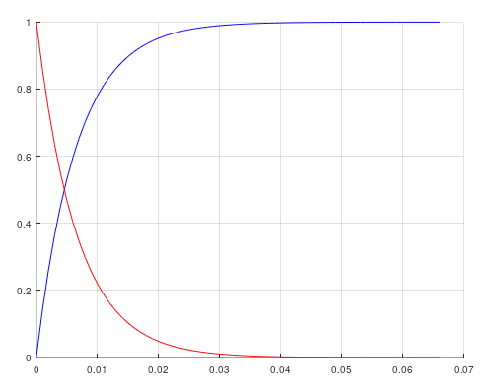
Номиналы схемы
U, В | 4
C, мкФ | 33
L, мГн | 330
R_{кр,} Ом | 200

Схема | Момент времени |  | Измерено | Посчитано
RC-цепь | 0+ | Ic, А |  | 0.01997
RC-цепь | 0+ | Uc, В |  | 0
RC-цепь | tau | Ic, А |  | 0.0074
RC-цепь | tau | Uc, В |  | 2.53
RC-цепь | 2*tau | Ic, А |  | 0.0027
RC-цепь | 2*tau | Uc, В |  | 3.46
RC-цепь | 3*tau | Ic, А |  | 0.000996
RC-цепь | 3*tau | Uc, В |  | 3.8
RC-цепь | а |  |  | 151.5
RC-цепь | Tau |  |  | 0.0066
RLC-цепь | Tсв |  |  | 0.021
RLC-цепь | a |  |  | 30-60
RLC-цепь | wc |  |  | 301.5-296.9

Задание 2
N = 3;
U = 4;
L = (10 * round(100 / N)) * 10^-3;
C = (round(100 / N)) * 10^-6;
Rcr = 2 * sqrt(L / C);
R = ([0.1 0.125 0.15 0.175 0.2])*Rcr

a = R / (2 * L)
w0 = 1 / sqrt(L * C);
wc = sqrt(w0^2 - alfa.^2)
Tsv = (2 * pi)./ wc
i = @(t, ri) (U / (wc(ri) * L)) * e.^(-a(ri) * t) .* sin(wc(ri) * t)

hold on, grid on
t = 0:0.001:0.1;
for k = 1:length(R)
plot(t, i(t,k), 'DisplayName', strcat('R=', num2str(R(k)), ' Ом.'))
Im = [max(i(t,k)) max(i(1/a(k):0.001:0.1,k))]
end
legend show
title('Ток после коммутации в RLC-контуре')
a =

30.303 37.879 45.455 53.030 60.606

wc =

301.51 300.65 299.60 298.35 296.91

Tsv =

0.020839 0.020898 0.020972 0.021059 0.021162

Im =

3.4480e-02 9.6706e-03

Im =

0.033284 0.014780

Im =

0.032147 0.012384

Im =

0.031067 0.010211

Im =

3.0040e-02 8.3586e-03
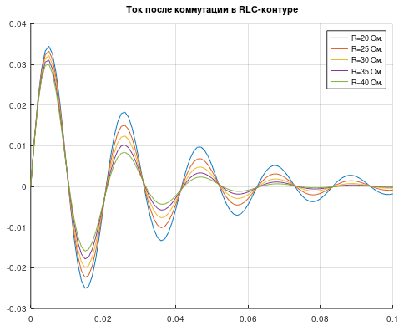

Задание 3
