**Name: Swaraj Pawar**

**Roll no:** 282072

**Batch:** B3

**ASSIGNMENT 4**

**Problem Statement:**

Apply appropriate ML algorithm on a dataset collected in a cosmetics shop showing details of customers to predict customer response for special offer. The cosmetics shop aims to optimize its marketing strategies by predicting customer responses to special offers.

**Objective:**

The objective of this project is to analyze customer behavior in a cosmetics shop and predict whether a customer will respond to a special offer. Using machine learning techniques, we will process and clean the dataset, extract meaningful features, and train an appropriate classification model. The model's performance will be evaluated using a confusion matrix, accuracy, precision, recall, and F1-score. The insights gained from this analysis will help in optimizing marketing strategies and improving customer engagement.

**Libraries-used**

1] import pandas as pd

For data loading, processing, and manipulation

2] from sklearn.model_selection import train_test_split

For splitting data into training and testing sets

3] from sklearn.ensemble import RandomForestClassifier

Machine Learning model for classification

4] from sklearn.metrics import confusion_matrix, accuracy_score, precision_score, recall_score f1_score

Performance evaluation metrics

**1. Confusion Matrix**

This matrix shows how well the model classifies responses. The structure is:

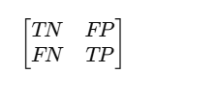

**TN (True Negative):** Customers correctly predicted as not responding to the offer.

**FP (False Positive):** Customers incorrectly predicted as responding when they did not.

**FN (False Negative):** Customers incorrectly predicted as not responding when they actually did.

**TP (True Positive):** Customers correctly predicted as responding to the offer.

**2. Accuracy**

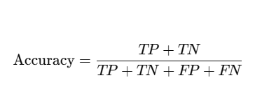

**3. Precision**

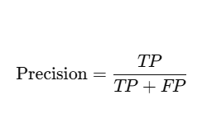

**4. Recall**

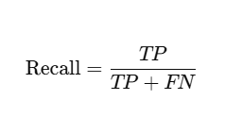

**5. F1 score**

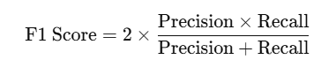

**Output :**

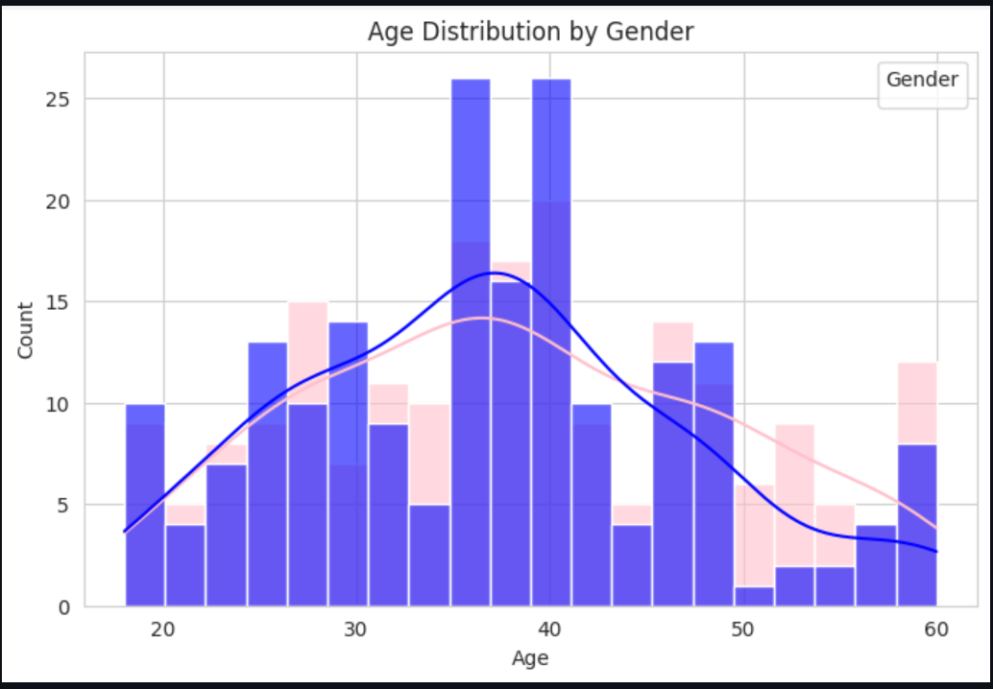

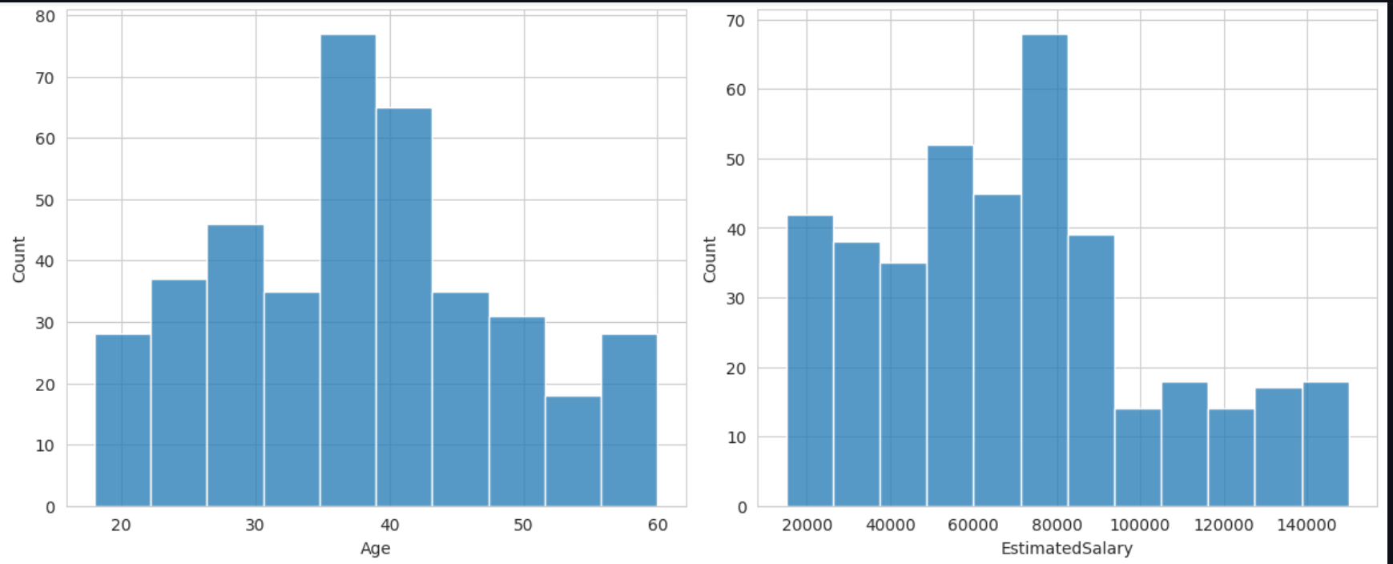

**Conclusion**

In above assignment we performed Dataset selection, Confusion Matrix and Metrics and calculated Accuracy ,Precision ,Recall , F-1 score. By applying machine learning algorithms to customer data, we can effectively predict responses to special offers, enabling targeted marketing strategies and improved customer engagement.