**eRostering User Guide**

**Contents:**

|  |  |
| --- | --- |
| Home | Page 2 |
| Admin | Page 4 |
| Admin – Special Dates | Page 6 |
| Admin – Roles | Page 7 |
| Admin – Templates | Page 8 |
| Admin – Skills | Page 10 |
| Admin - Sites | Page 11 |
| Admin – Absence Types | Page 12 |
| Employees | Page 13 |
| Absences | Page 16 |
| Teams | Page 18 |
| Sessions | Page 20 |
| Roster | Page 25 |
| Table Features | Page 27 |
| Printing | Page 29 |
| Mobile Design | Page 32 |

**Home**

Upon opening the eRostering App, the user is presented with the Home screen. This is simply a placeholder screen whereby the WBS logo is presented along with the App’s name and relevant information. From here, the user is able to use the buttons on the Toolbar (the red bar at the top) to perform various functionalities. Pressing upon the paint drop icon will toggle the App between the light and dark themes:

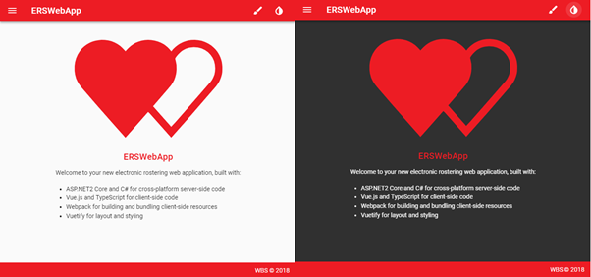

Pressing upon the paint brush icon will open up a pop up menu whereby the user is able to change the colour theme of the App. For example, here is the App as shown when selecting the blue colour:

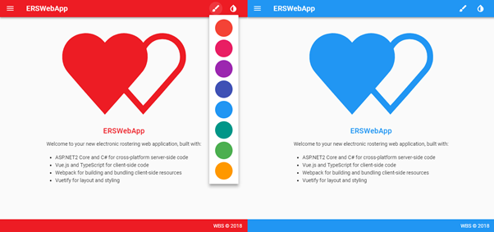

Finally, the user is able to navigate to the different screens of the App by clicking on the three line icon on the top left:

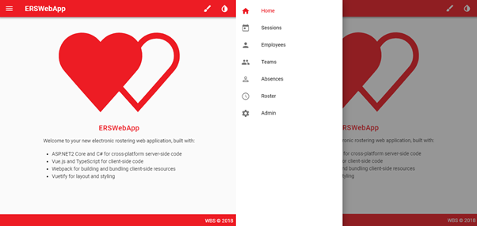

**Admin**

If the App is opened for the first time, the user is required to input various data to which the App depends upon within the Admin screen. This screen consists of various tables for the various data types the Admin is able to control. For example, below is how this screen looks with the Special Dates and top of the Roles table:

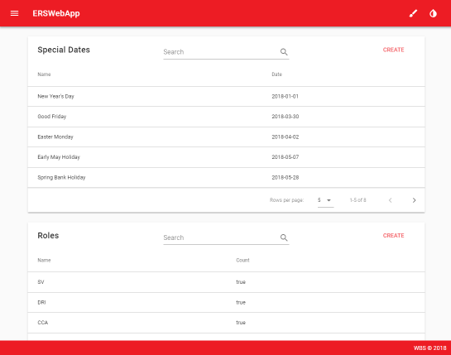

The user is able to use each table for various functionalities such as searching for a specific item, sorting the columns by item properties and also choose how many rows for each table to display. Most of the tables within the App allow to show further information/options when pressing onto a table row. For instance, pressing onto a row in the Special Dates table causes the EDIT and DELETE buttons for each item to be displayed:

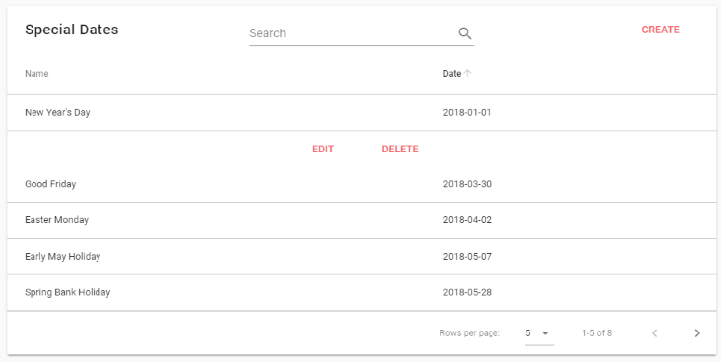

The CREATE button on these tables allows you to input the relevant items the App depends upon.

**Admin - Special Dates**

Special Dates are any dates to which will count as “High Rate Unsocial” when any employees are rostered on these dates. These dates will mainly consists of Bank Holidays but also any other dates the Admin wishes to include and so the Admin will be required to input at least the Bank Holidays for that year before creating any sessions. Below is how the CREATE and EDIT screen looks for a Special Date time:

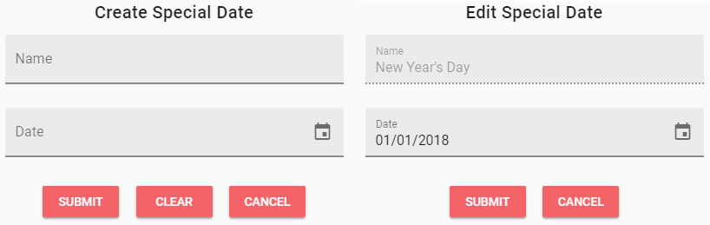

As shown, the Special Date requires a Name and Date property. The App is programmed so that a unique Name is required for each Special Date just to act as a means of preventing possible confusion if multiple Special Dates have the same name. Therefore, editing a Name once a Special Date has been created is not allowed. If you’ve made a mistake when naming a Special Date, the Admin is able to delete and recreate the Special Date using the DELETE button on the expanded table row. Upon selecting this, a pop up is shown just to confirm if you wish to delete this Special Date or not with ACCEPT deleting the Special Date:

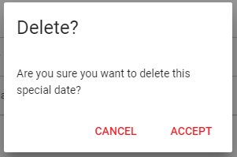

**Admin – Roles**

These are the Roles which are used for assigning Roles to employees and also for creating Session Templates and Teams. Below is how the Roles table looks with some dummy Roles created:

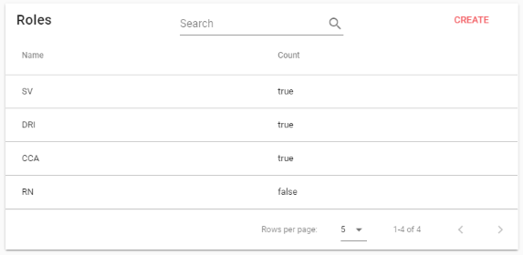

Upon creating a Role, the “Staff count” property is automatically assigned to “true”. This property decides whether or not this Role will count towards the Staff Count when rostering a session. This property can be changed to “true” or “false” at any time but it should be made note of that the Staff Count of a session **will not be changed for any previous sessions rostered if a change has been made**. The user is able to simply resubmit the roster of a session if they wish to update the Staff Count for that session after a Role Staff Count property has been changed.

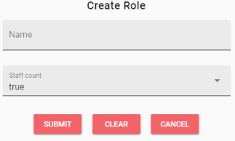

**Admin – Templates**

With Roles created, the Admin is able to create Templates which can be used to outline what Roles a Session should consist of. Below is how the Templates table looks with two dummy Templates input using the dummy Roles displayed above. As shown, the Roles within the Template are displayed as a comma separated string:

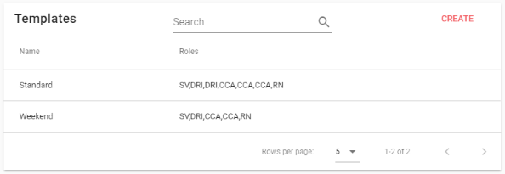

Upon creating a Template, the Admin is presented with the following screen:

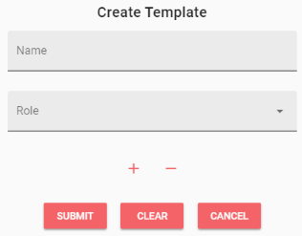

From there, the Admin is able to enter a Name for the Template and use the Role drop down menu to select a Role from the created Roles for the first Role that Template will consist of. Use of the + and – buttons will allow the Admin to add or remove a Role for the Template. IT should be made note of that there is currently a limit on Templates whereby there must be **at least 1 and no more than 30 Roles per Template**. This value can be easily changed by a developer if requested. Also, the name is a unique identifier for Templates to avoid confusion with multiple Templates being created with the same name. Below is an example of how creating a Template looks with a number of Roles selected:

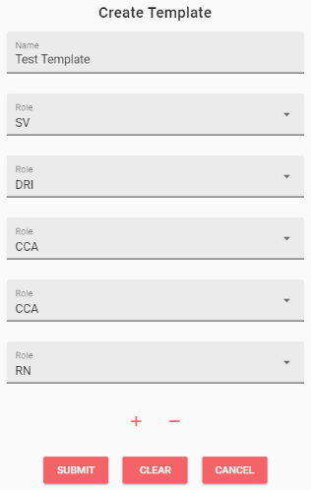

**Admin – Skills**

This table allows the Admin is able to assign various Skills to each Role which can be assigned to an Employee. Here is some dummy Skills provided for the dummy Roles:

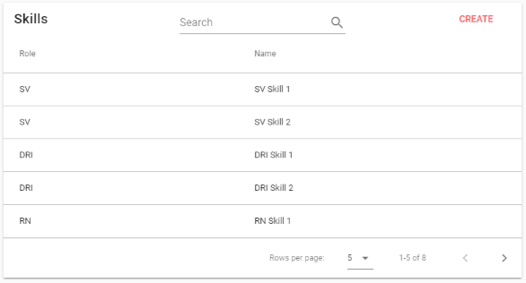

When creating/editing a Skill, the Admin is required to first select a Role from the drop down menu for which Role the Skill will be assigned too along with the Name of the Skill:

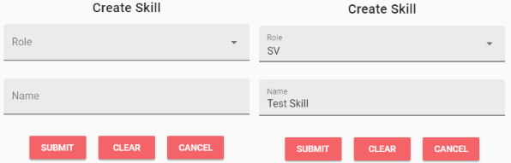

**Admin – Sites**

This is where the Admin is able to create the Sites to which sessions are assigned to. The Sites are currently programmed to have either a Type of “Community” or “MDC”. Also, the list of different times are separated by a forward slash (“/”):

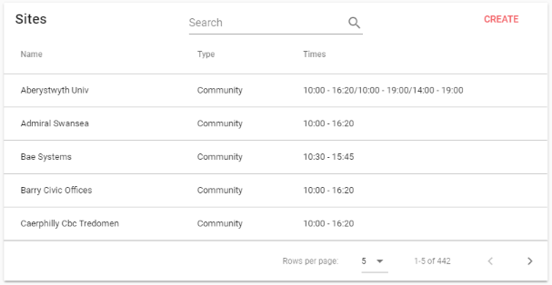

When creating a Site, the Admin is required to enter a Site Name, select a Type from the drop down to select either “Community” or “MDC” and enter the Times. The Times should be entered in the format of “HH:MM – HH:MM” (with HH meaning 24 hour and MM meaning minute) and any additional times separated by a forward slash. For example, the following Test Site has two different Times to select from as shown by the “09:00 - 17:00/10:00 - 18:00” entry within the Times field. If the times aren’t separated by a forward slash then the App will not properly separate these times when creating a Session with this Site:

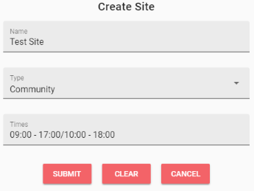

**Admin – Absence Types**

This is where the Admin is able to create any Absence Types which can be assigned to an employee along with which text colour to use for easily indicating these Absence Types in tables:

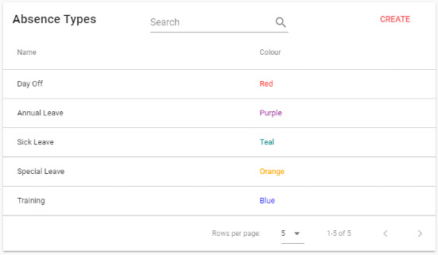

When creating an Absence Type, the Admin is able to select which colour used by selecting one from the drop down menu. For the time being, there are 15 colours to choose from. If it is required to increase this amount, this can be easily performed by a developer upon request:

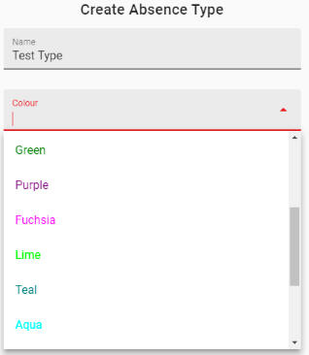

**Employees**

The Employees screen allows the user to view various information on the employees created within the App similar to the functionalities seen with the tables within the Admin screen:

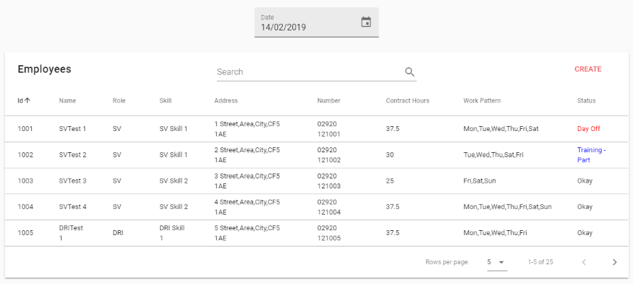

One difference here is the ability to use the Date Picker to change the selected date for the screen. This allows the user to see what the Status is for each employee displayed. As shown, the Status for the employee SVTest 1 is “Day Off” indicating that employee has an Absence Type of Day Off on that day, SVTest 2 is “Training – Part” indicating that employee has a part Absence Type of Training on that day, with the rest being “Okay” indicating they have no Absences on that day. Upon pressing the CREATE button, the user is presented with this screen:

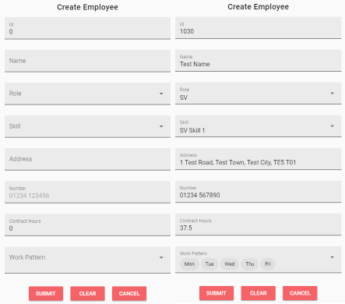

From here, the user is required to input various required information for the employee:

* Id – This is the unique identifier for the employee
* Name – The full name of the employee
* Role – The role to which the employee is assigned too
* Skill – The specified skill the employee has for that role. If they have none, the user must select the blank option from the drop down.
* Address – The address of the employee to allow easier allocation of employees to sessions by location
* Number – contact number for the employee if required
* Contract Hours – the amount of hours the employee is required to work per work by contract
* Work Pattern – the days of the week which the employee is required to work

The fields have various validation rules on them. For example, the Contract Hours must be of a whole or decimal number e.g. 30 or 37.5. If not, the App will inform the inputted value doesn’t match this validation rule and the employee will not be able to be created:

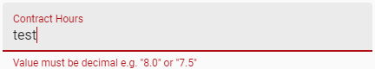

It is also worth noting that if there is an error when creating an employee, a pop up error message will be displayed. This can occur from either the employee being created has an entered Id that is already taken or there is a connection issue with the App’s database:



As well as editing and deleting an employee using the EDIT and DELETE buttons when pressing onto an employee row, the user is able to VIEW an employee:



Pressing on this button will bring the user to the ViewEmployee screen:

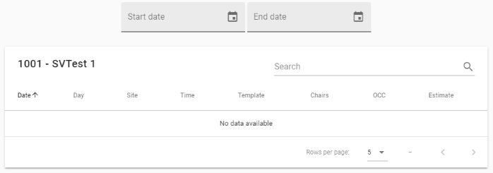

This screen allows the user to view which sessions the selected employee is rostered to between two given dates. Upon entering in dates, the table is then populated with any matching sessions found. For example:

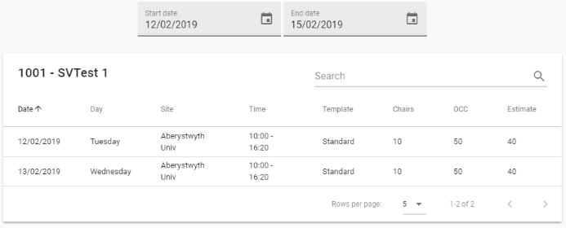

If the user tries entering invalid dates, such as an end date which is before a start date, they are presented with an error pop up indicating this:



**Absences**

As seen within the employees screen, the user is able to assign Absences to employees. For example, below is the Absences screen with some dummy data:

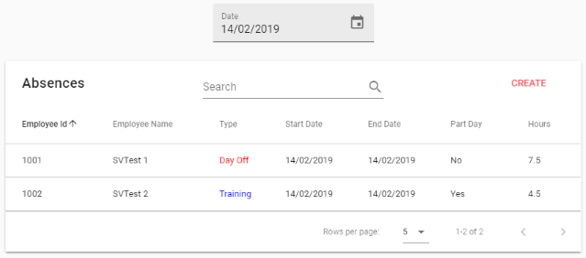

The Date Picker is used to view any Absences that are assigned within that date. The Type column is also programmed so that the colour matches that to the Absence Type. Upon creating an Absence, the user is presented with a similar create screen whereby they can input the various required Absence information:

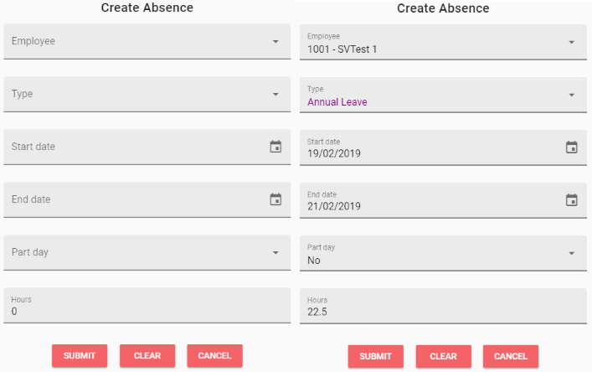

This screen uses a useful functionality of the App whereby the user is able to select an employee either from a drop down or they are able to search either the employee’s name or Id in order to filter the drop down menu options:

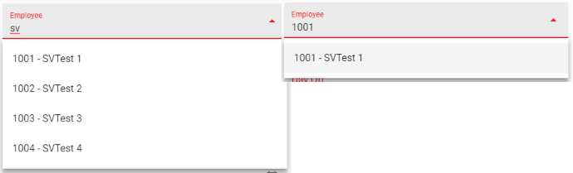

It is worth nothing that if the user wishes to create an Absence for an employee but they **don’t wish for the hours to be counted towards that employee’s weekly rostered hours, the hours field should be input at 0. The user will have to re-input the value of 0 into the Hours field to pass validation as a means to confirm the Absence is as 0 hours.** If the user wishes to extend an Absence as the length has changed, they are able to do so by simply using the EDIT button and changing the end date picker to the later date as well as increasing the amount of hours if necessary.

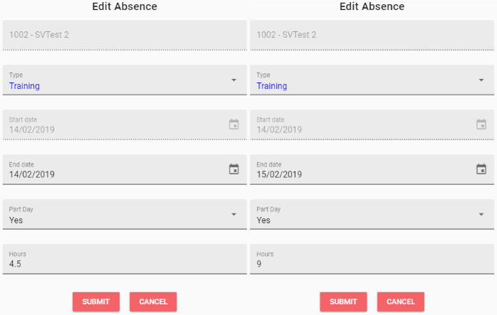

**Teams**

The user is able to create Teams to allow easy rostering to sessions. The Team screen is very much like the Employee screens. Below is the Team table with one Team created as an example:

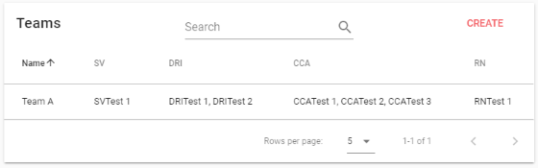

Creating/editing a Team follows a similar structure to creating a Session Template except that each Role is assigned an employee along with it using the same employee autocomplete system described when assigning an absence to an employee. **It is recommended that a Team or Template should match the same role layout as it’s respective other to allow easy allocation of that Team to a Session of that matching Template.** However, this is only a recommendation as the user is still able to manually roster employees in within a session.

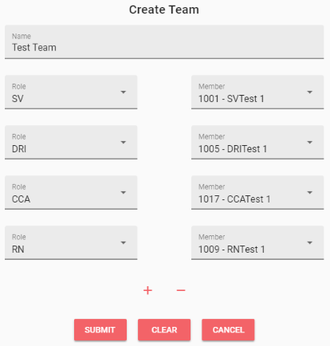

Similar to that of the Employee screen, the user is able to view the Team between two given dates when pressing onto the VIEW button:

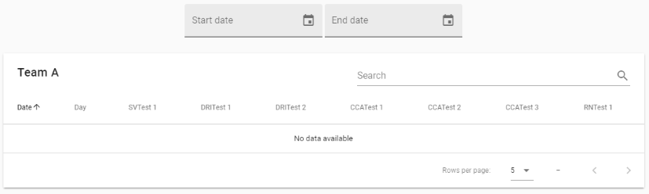

One main difference here with the ViewTeam screen though is that not only are the Sites of each Session which a Team Member is rostered are displayed but also any Absences and gaps between the two given dates. The Absences are also displayed with the corresponding text colour assigned to that Absence Type. It is worth nothing that for each Team Member, a list of each Session they are rostered too on that day is displayed with a comma separated string in case they are rostered to multiple sessions or have a part absence.

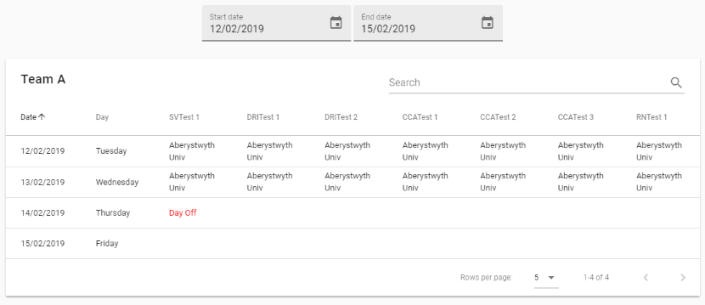

**Sessions**

The Session screen is similar to that previously seen except with the Sessions created on the selected date from the Date Picker. However, the colour of the Session Site is programmed to be displayed as grey if that Session’s Staff Count is less than that defined by the Template Role count:

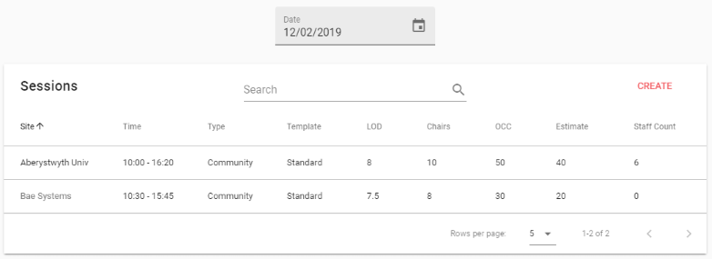

When creating a session, the follow screen is displayed to the user. This performs in a similar format as previous creation screens with the follow data format for the session:

* Date – the date of the session
* Type – whether the session is of a “Community” or “MDC” type
* Site – which site the session is at. This is populated based upon which Type is selected
* Clinic Time – the start and end time of the session. This is taken from the Site and so is populated when a Site is selected
* Template – which Role Template the session will follow
* LOD – the Length of Day hours the session consists of
* Chairs – the amount of chairs present at the session
* OCC – the optimal clinical capacity of the session (amount of donations)
* Estimate – the estimated amount of donations given at the session

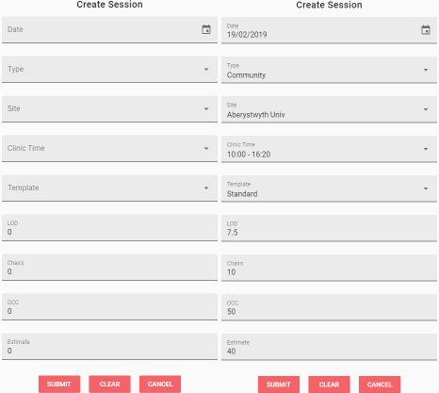

Once a session is created, pressing onto it from the table will expand it and review some additional options: NOTE and ROSTER:



Pressing on the NOTE button will display a pop up displaying the note that session has been assigned to which is done within the RosterSession screen:

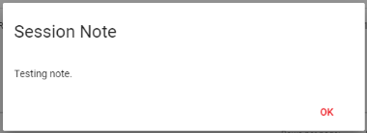

Pressing on the ROSTER button will open the RosterSession screen:

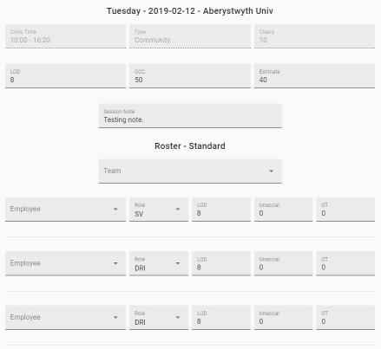

This screen allows the user to assign employees to a session along with their respective hours for that session along with editing some session information such as the Note, overall LOD, OCC and Estimate if necessary. The Role layout is matched to that provided by the Template with each employee Role being filled out to match that of the Template. The user is then able to select an employee either from the drop down or use the autocomplete feature to search for an employee by their Id or Name along with their Skill which is a unique addition to this screen:

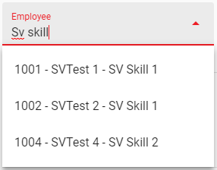

Apparent from the above image, the “SVTest 3” employee is not selectable from the drop down. This is this drop down only displays employees whose Work Pattern means they are able to work on the day of the week of that Session. Also, they aren’t displayed if they have a non-part absence on that day indicating they are unavailable for the entire day. They are also not displayed if they are already rostered to a different session on that same day. The user is also able to assign employees via using the Team drop down to which all members of that team which are available for that day are applied to that session. **It should be made not of that applying a Team will override the Template layout and so this is why it is recommended for Teams to match a corresponding Template:**

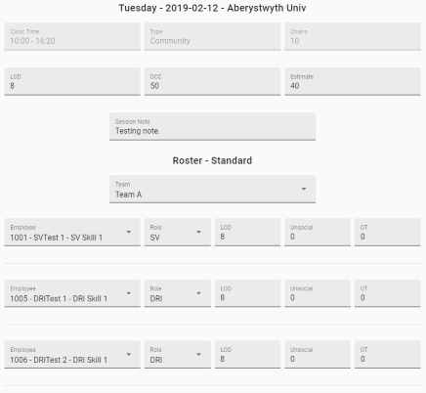

That being said, the user is fully able to manually change the Role layout or add/remove any roles from the layout using the + and – buttons seen at the bottom of the screen:

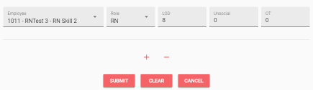

As mentioned, the user is able to allocate different hour types to the employee within this screen. If the session is within a weekday and not on a Special Date (such as a Bank Holiday), the user is able to assign the employee their Length of Day (LOD), Unsocial and Overtime (OT) hours for that session. **It is important to note that the amount of unsocial and overtime times are part of the LOD hours meaning. Therefore, if an employee worked 7 hours normal but 1 hour Overtime then their LOD should be 8 to reflect their entire Length of Day.** If the session is based on a weekend or Special Date, the Unsocial hours field is not present as all hours on these sessions are counted as unsocial:

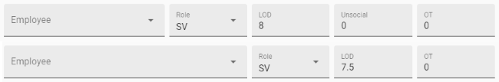

Any unsocial hours assigned during the week and not on a Special Date are counted as “Low Rate Unsocial” as well as any LOD hours rostered on a Saturday. Any LOD hours rostered on a Sunday or Special Date are counted as “High Rate Unsocial”. Finally, the RosterSession screen is programmed so that the user is alerted if any duplicate employees are selected which produces an alert pop up indicating this.

Once a session’s roster has been accepted, a preview of the employees rostered is now displayed when the user pressed onto a session row within the table:

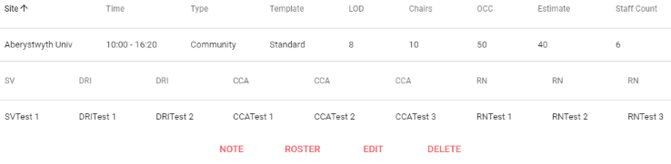

This can be used to easily see which employees are rostered where when looking through the sessions on a given day. **The user is now unable to edit or delete a session unless they unroster the employees from that session as a means to avoid any possible data issues when changing this session. They are able to go back onto the RosterSession screen and make any changes at any time but they are required to unroster all employees from the session (which can be easily performed by using the CLEAR button) before they can edit/delete the session from the table.**

**Roster**

The Roster Screen allows the user to view all of the rostered hours employees have. As required, the hours are separated by the weeks of the year with the week being the first number followed by the year e.g. 7.2019 meaning week 7 of 2019. For example:

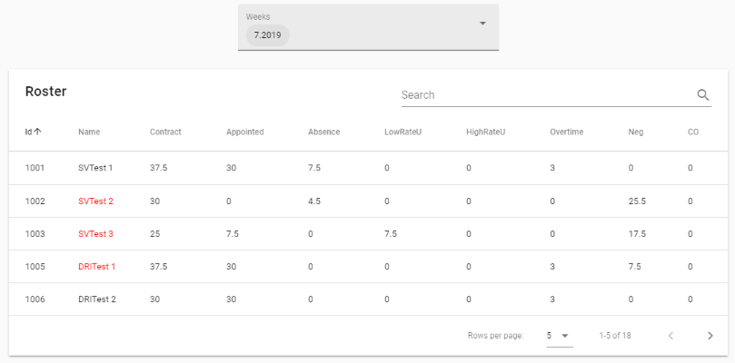

The type of hours displayed for each employee is as followed:

* Contract – that employees weekly contracted hours
* Appointed – hours appointed to sessions for that employee
* Absence – any absence hours which are counted towards the contract hours (some absence types won’t count towards this and so should be left at 0 hours as mentioned earlier)
* LowRateU – the amount of appointed hours which are assigned as low rate unsocial hours from that employee (low rate being any unsocial hours appointed on a weekday which isn’t a Special Date and any appointed hours on a Saturday)
* HighRateU – the amount of appointed hours which are assigned as high rate unsocial hours from that employee (high rate being any appointed hours on a Sunday or a Special Date)
* Overtime – the amount of appointed hours which are assigned as overtime
* Neg – the negative difference between the employee’s appointed and absence hours vs their contract hours (indicating they are missing hours for that week)
* CO – the carry over difference between the employee’s appointed and absence hours vs their contract hours (indicating they are over their contract for that week)

The drop down menu for the weeks allows for multi-select support meaning that the user is able to load in multiple weeks at a time to which the hours of the employees are added together e.g. two weeks of an employee’s contract hours of 37.5 resulting in 75:

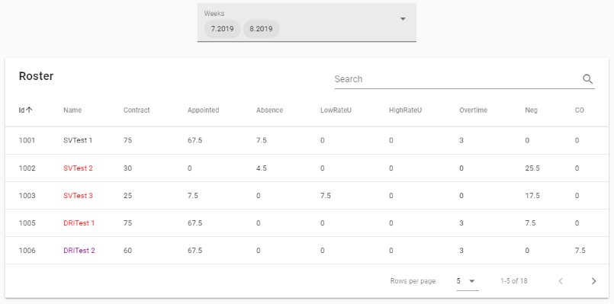

As shown, this table also provides coloured text on the employee’s name depending on if the employee has any negative or carry over hours as means to highlight this to the user. If the employee has any negative hours their name is displayed in red and if they have any carry over hours their name is displayed in purple. This is currently programmed by the App and can be changed to different colours by a developer if requested.

**Table Features**

The tables within the App provide various functionality which enable the user to filter and sort the data within that data if they so desire to. Using the above Roster table as an example, the user can use the Search field to filter the data to only show those whose names match that containing “SV”:

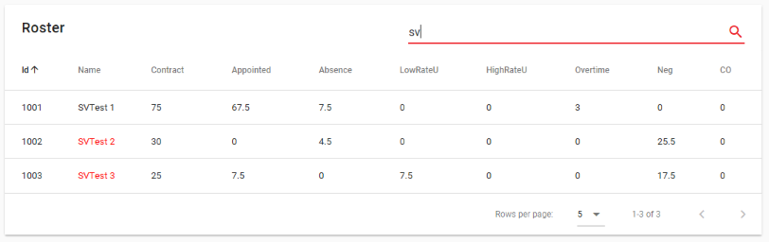

Within the same Search field, they are able to search the data from any of the columns present in the table. For example, below is the same Search field being used to search for an employee with the Id of “1006”:

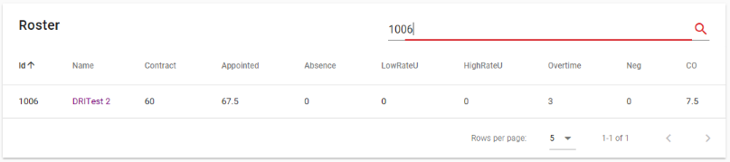

As another example, here are all of the employees within the table which have a contract hours of 75 over the two weeks selected:

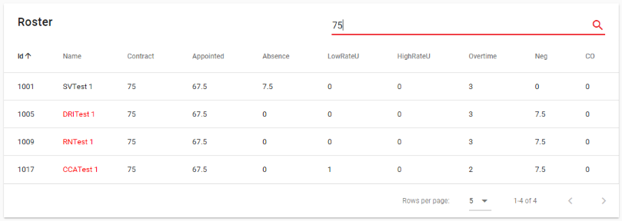

This demonstrates how the single Search field is able to filter the data presented in any table in respective to the columns of that table.

The user is also able to press on a column header in order to sort the data of that table by that column. For example, pressing onto the “Neg” column will change the sorting of that column between ascending (smallest first):

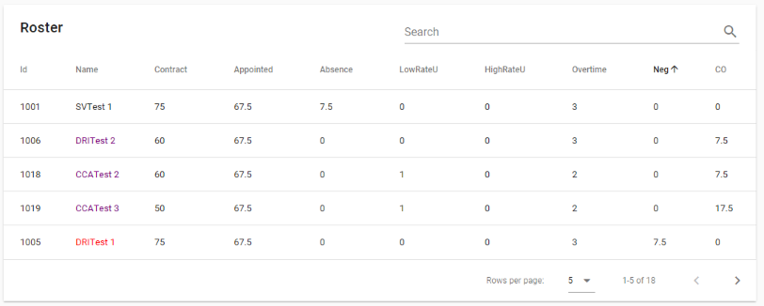

Pressing it again will sort that column be descending (largest first):

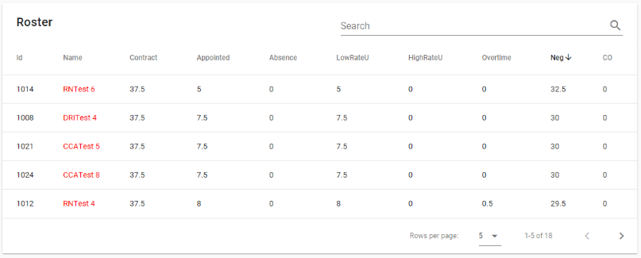

Pressing it again will return to the default sort of that column. The user can even combine both the Search and Sort functions of the table in order to further choose how they wish to display the data. For example, below are all of the employees which contain “sv” in their name sorted by their absence hours in descending order:

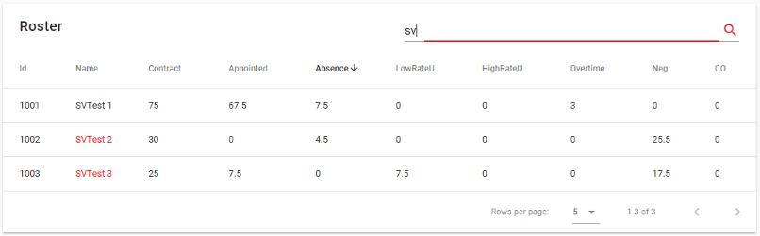

**Printing**

Considering that the App is a web based application and is displayed within a web browser, all of the screens can be used for printing purposes using the browsers printing functionality. **Please note that the App cannot be opened within Internet Explorer. This is because the App uses newer forms of web based programming languages which Internet Explorer does not support. It is recommended to use the App with Microsoft Edge or Google Chrome.** To access the print function on Edge, click on the triple dot “…” options icon in the top right which will open a menu of options:

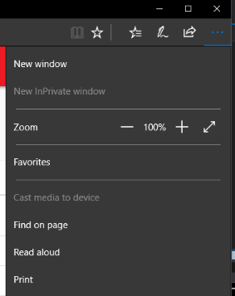

Pressing on the “Print” option will bring up the printing screen:

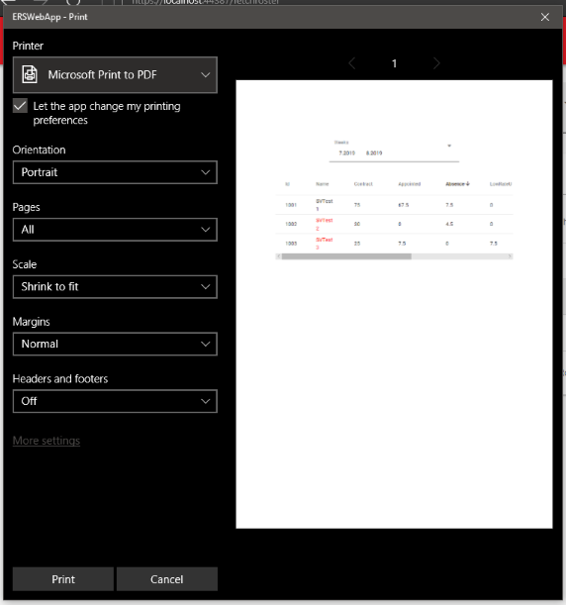

The app is programmed so only relevant information from whichever table the user is viewing will be printed onto the page as a means to avoid clutter (if you notice, the App’s toolbar, footer and sidebar are not included for example). As you can see, the user is able to alter various options within the browser’s print feature as a means to further improve how the information on the page will be displayed when printing. It is required to alter these until all of the relevant information on the printing page is displayed as some of the tables within the App display quite a lot of info. With the example given, these settings were found to yield the best results for displaying all of the information:

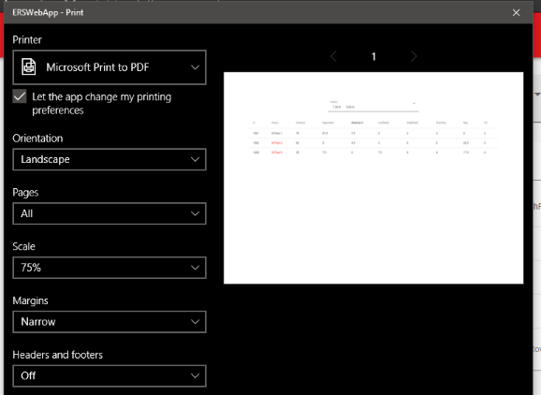

As shown, setting the orientation to “landscape”, scale to “75%” and margins to “narrow” allowed all of the information to be displayed fully. **The user can then either print out this page or use the inbuilt “Microsoft Print to PDF” option to convert the page into a PDF. Utilising the table’s Search and Sort features will enable the user to create pages/PDFs of any possible data they so wish.**

**Mobile Design**

Being that the App is a web application, it is required to change its layout and design in order to allow use of the App on a variety of screen sizes including mobile devices. This is already supported by the App and as an example, below is how the home screen and navigation menu looks when viewing the App on a mobile device:

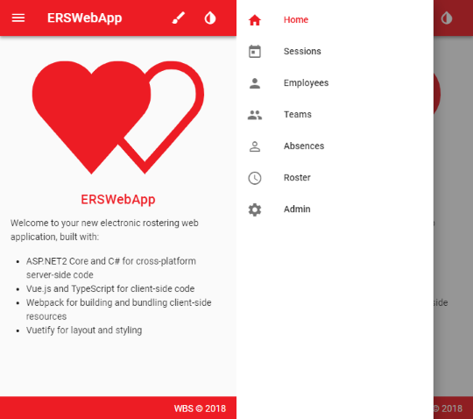

One major design change is how the data within the tables from the various sections are displayed. Being that a table with lots of information isn’t the best method of viewing lots of data, the layout for these screens are changed so that each row within that table is displayed as “cards” which the user can view by scrolling down the page. For example, below is the Sessions Screen but viewed through a mobile with the image on the left being the top of the view and the image on the right being the view being scrolled down to view the second Session on that day:

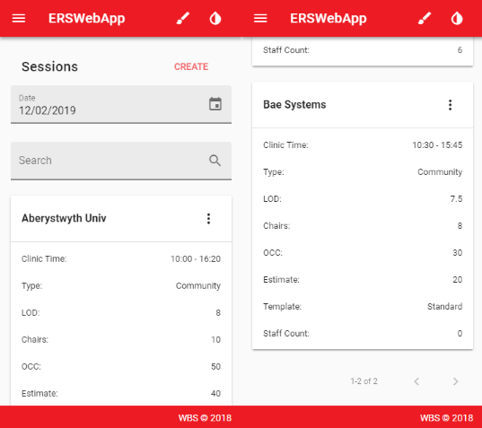

Considering now the data rows are cards rather than rows, the “expand” functionality is not apparent. To overcome this, the user is able to tap onto the “options” Icon (the three vertical dots) to open more options for each card within a pop up menu:

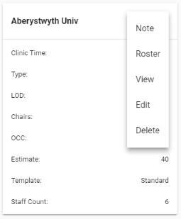

In this example, these show the same options as to when a session row is expanded except an additional “View” option is present. Tapping on this will bring up a dialog which displays all of the employees rostered to that session like that shown earlier in the user guide when expanding a session table row:

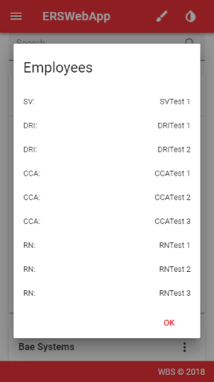

As like most dialogs within mobile Apps, the user is able to close this dialog either but tapping onto the “OK” button or by tapping outside of the dialog. As displayed, the user is still able to filter the data by inputting a search query into the Search field at the top of the screen:

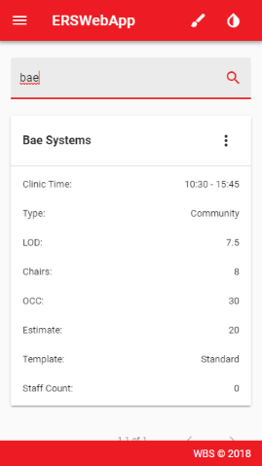

That being said, the user is unable to sort the data within the cards like they are able to sort the data within a table by column simply because the data is no long being displayed by columns any more. **This highlights that although most of the functionality within the App is still present when using a mobile device, some of the more advanced features are not present and so the App should be viewed from a non-mobile device in order to access these features.**