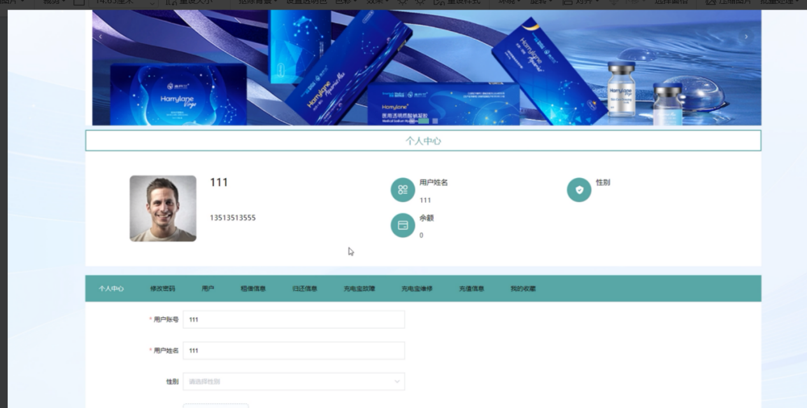
核心代码：
/**
* 前端列表
*/
@IgnoreAuth
@RequestMapping("/list")
public R list(@RequestParam Map<String, Object> params,YonghuEntity yonghu,
HttpServletRequest request){
EntityWrapper<YonghuEntity> ew = new EntityWrapper<YonghuEntity>();
PageUtils page = yonghuService.queryPage(params, MPUtil.sort(MPUtil.between(MPUtil.likeOrEq(ew, yonghu), params), params));
return R.ok().put("data", page);
}
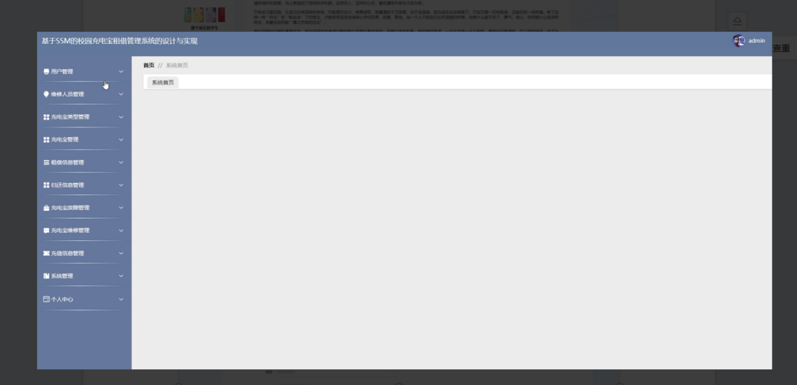
回复：你这系统首页是空的，无代码。
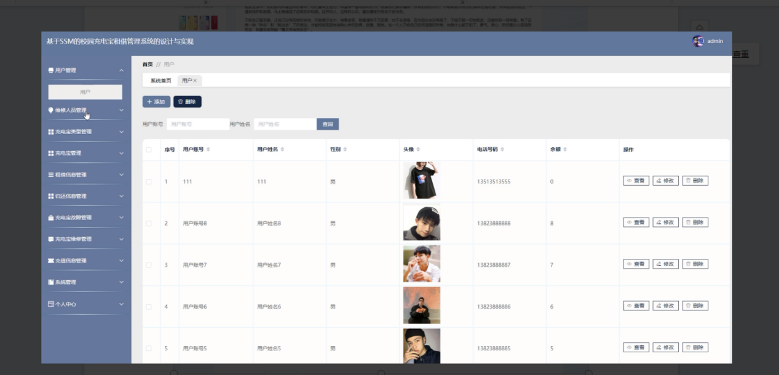
核心代码：
/**
* 后端列表
*/
@RequestMapping("/page")
public R page(@RequestParam Map<String, Object> params,YonghuEntity yonghu,
HttpServletRequest request){
String tableName = request.getSession().getAttribute("tableName").toString();
if(tableName.equals("yonghu")) {
yonghu.setYonghuzhanghao((String)request.getSession().getAttribute("username"));
}
EntityWrapper<YonghuEntity> ew = new EntityWrapper<YonghuEntity>();
PageUtils page = yonghuService.queryPage(params, MPUtil.sort(MPUtil.between(MPUtil.likeOrEq(ew, yonghu), params), params));
return R.ok().put("data", page);
}
/**
* 前端列表
*/
@IgnoreAuth
@RequestMapping("/list")
public R list(@RequestParam Map<String, Object> params,YonghuEntity yonghu,
HttpServletRequest request){
EntityWrapper<YonghuEntity> ew = new EntityWrapper<YonghuEntity>();
PageUtils page = yonghuService.queryPage(params, MPUtil.sort(MPUtil.between(MPUtil.likeOrEq(ew, yonghu), params), params));
return R.ok().put("data", page);
}

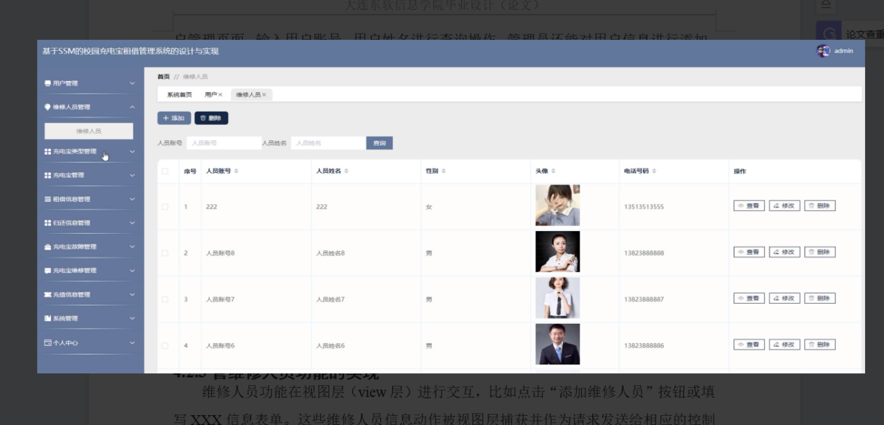
核心代码：
/**
* 后端列表
*/
@RequestMapping("/page")
public R page(@RequestParam Map<String, Object> params,WeixiurenyuanEntity weixiurenyuan,
HttpServletRequest request){
EntityWrapper<WeixiurenyuanEntity> ew = new EntityWrapper<WeixiurenyuanEntity>();
PageUtils page = weixiurenyuanService.queryPage(params, MPUtil.sort(MPUtil.between(MPUtil.likeOrEq(ew, weixiurenyuan), params), params));
return R.ok().put("data", page);
}
/**
* 前端列表
*/
@IgnoreAuth
@RequestMapping("/list")
public R list(@RequestParam Map<String, Object> params,WeixiurenyuanEntity weixiurenyuan,
HttpServletRequest request){
EntityWrapper<WeixiurenyuanEntity> ew = new EntityWrapper<WeixiurenyuanEntity>();
PageUtils page = weixiurenyuanService.queryPage(params, MPUtil.sort(MPUtil.between(MPUtil.likeOrEq(ew, weixiurenyuan), params), params));
return R.ok().put("data", page);
}

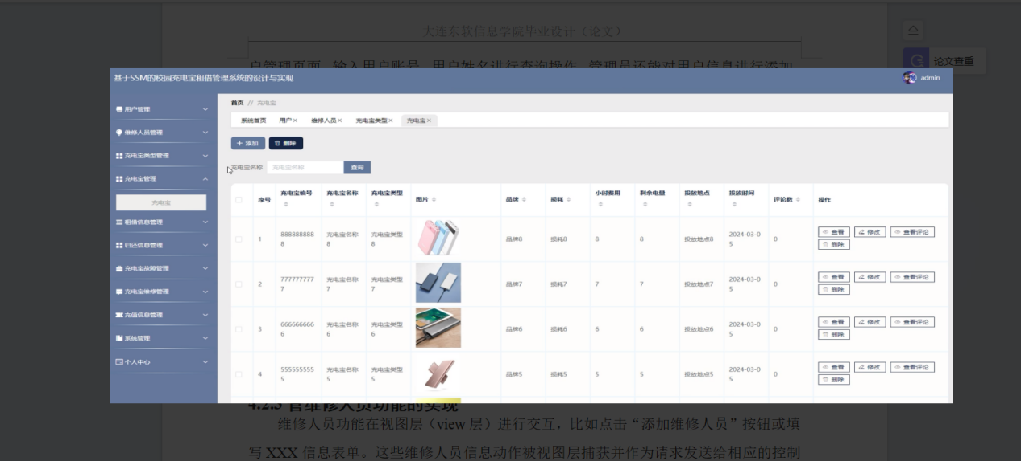
核心代码：
/**
* 后端列表
*/
@RequestMapping("/page")
public R page(@RequestParam Map<String, Object> params,ChongdianbaoEntity chongdianbao,
HttpServletRequest request){
EntityWrapper<ChongdianbaoEntity> ew = new EntityWrapper<ChongdianbaoEntity>();
PageUtils page = chongdianbaoService.queryPage(params, MPUtil.sort(MPUtil.between(MPUtil.likeOrEq(ew, chongdianbao), params), params));
return R.ok().put("data", page);
}
/**
* 前端列表
*/
@IgnoreAuth
@RequestMapping("/list")
public R list(@RequestParam Map<String, Object> params,ChongdianbaoEntity chongdianbao,
HttpServletRequest request){
EntityWrapper<ChongdianbaoEntity> ew = new EntityWrapper<ChongdianbaoEntity>();
PageUtils page = chongdianbaoService.queryPage(params, MPUtil.sort(MPUtil.between(MPUtil.likeOrEq(ew, chongdianbao), params), params));
return R.ok().put("data", page);
}

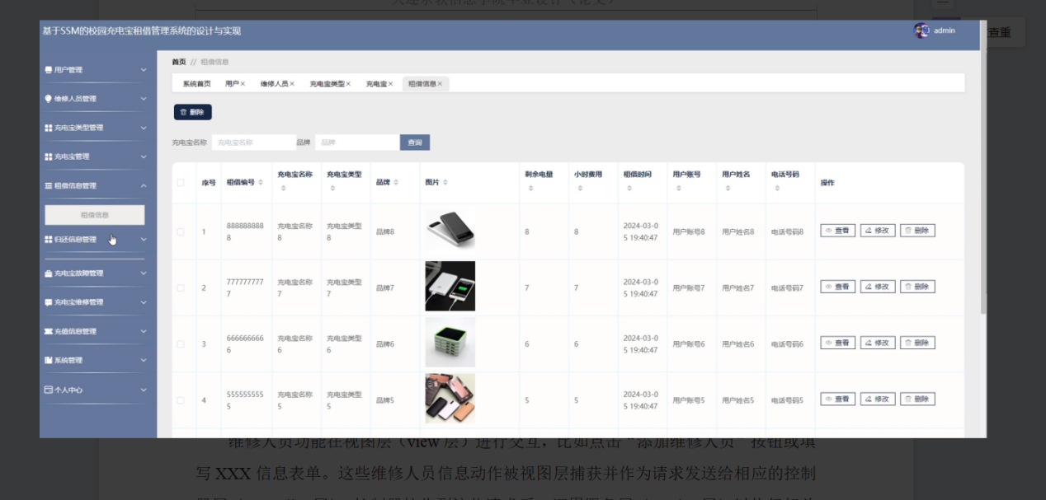
核心代码：
/**
* 后端列表
*/
@RequestMapping("/page")
public R page(@RequestParam Map<String, Object> params,ZujiexinxiEntity zujiexinxi,
HttpServletRequest request){
String tableName = request.getSession().getAttribute("tableName").toString();
if(tableName.equals("yonghu")) {
zujiexinxi.setYonghuzhanghao((String)request.getSession().getAttribute("username"));
}
EntityWrapper<ZujiexinxiEntity> ew = new EntityWrapper<ZujiexinxiEntity>();
PageUtils page = zujiexinxiService.queryPage(params, MPUtil.sort(MPUtil.between(MPUtil.likeOrEq(ew, zujiexinxi), params), params));
return R.ok().put("data", page);
}
/**
* 前端列表
*/
@IgnoreAuth
@RequestMapping("/list")
public R list(@RequestParam Map<String, Object> params,ZujiexinxiEntity zujiexinxi,
HttpServletRequest request){
EntityWrapper<ZujiexinxiEntity> ew = new EntityWrapper<ZujiexinxiEntity>();
PageUtils page = zujiexinxiService.queryPage(params, MPUtil.sort(MPUtil.between(MPUtil.likeOrEq(ew, zujiexinxi), params), params));
return R.ok().put("data", page);
}

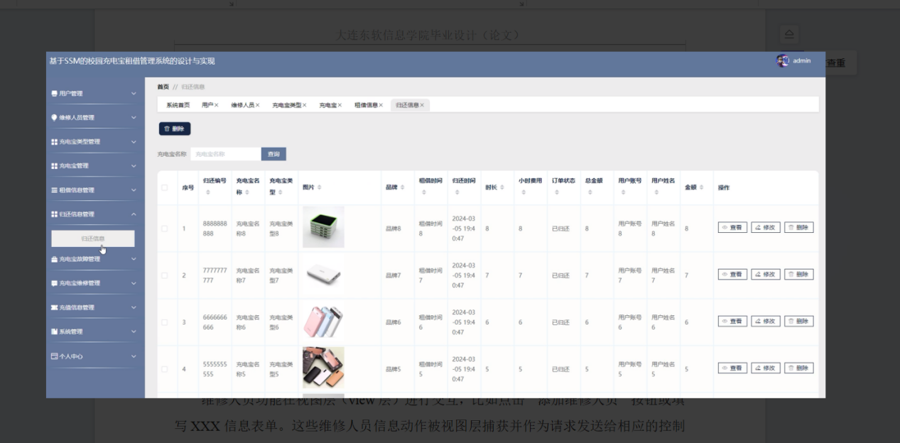
核心代码：
/**
* 后端列表
*/
@RequestMapping("/page")
public R page(@RequestParam Map<String, Object> params,GuihaixinxiEntity guihaixinxi,
HttpServletRequest request){
String tableName = request.getSession().getAttribute("tableName").toString();
if(tableName.equals("yonghu")) {
guihaixinxi.setYonghuzhanghao((String)request.getSession().getAttribute("username"));
}
EntityWrapper<GuihaixinxiEntity> ew = new EntityWrapper<GuihaixinxiEntity>();
PageUtils page = guihaixinxiService.queryPage(params, MPUtil.sort(MPUtil.between(MPUtil.likeOrEq(ew, guihaixinxi), params), params));
return R.ok().put("data", page);
}
/**
* 前端列表
*/
@IgnoreAuth
@RequestMapping("/list")
public R list(@RequestParam Map<String, Object> params,GuihaixinxiEntity guihaixinxi,
HttpServletRequest request){
EntityWrapper<GuihaixinxiEntity> ew = new EntityWrapper<GuihaixinxiEntity>();
PageUtils page = guihaixinxiService.queryPage(params, MPUtil.sort(MPUtil.between(MPUtil.likeOrEq(ew, guihaixinxi), params), params));
return R.ok().put("data", page);
}

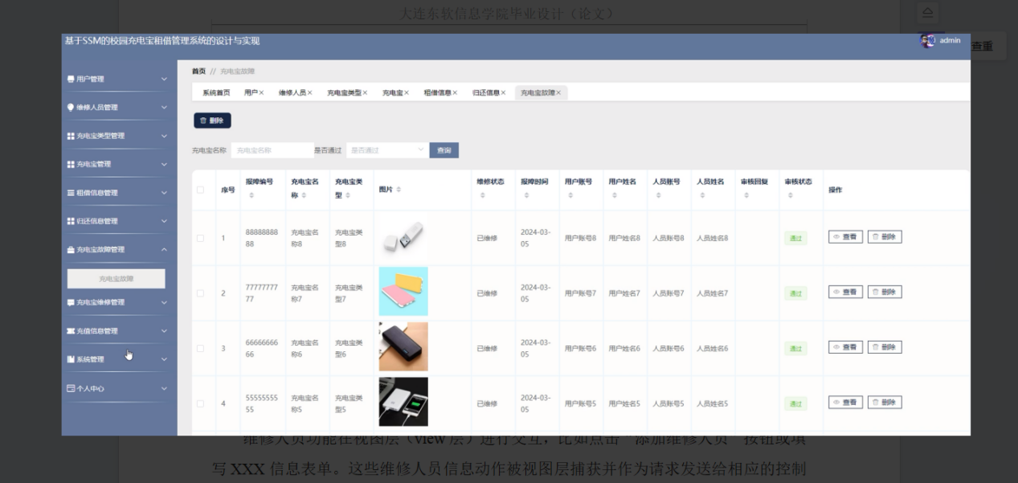
核心代码：
/**
* 后端列表
*/
@RequestMapping("/page")
public R page(@RequestParam Map<String, Object> params,ChongdianbaoguzhangEntity chongdianbaoguzhang,
HttpServletRequest request){
String tableName = request.getSession().getAttribute("tableName").toString();
if(tableName.equals("yonghu")) {
chongdianbaoguzhang.setYonghuzhanghao((String)request.getSession().getAttribute("username"));
}
if(tableName.equals("weixiurenyuan")) {
chongdianbaoguzhang.setRenyuanzhanghao((String)request.getSession().getAttribute("username"));
}
EntityWrapper<ChongdianbaoguzhangEntity> ew = new EntityWrapper<ChongdianbaoguzhangEntity>();
PageUtils page = chongdianbaoguzhangService.queryPage(params, MPUtil.sort(MPUtil.between(MPUtil.likeOrEq(ew, chongdianbaoguzhang), params), params));
return R.ok().put("data", page);
}
/**
* 前端列表
*/
@IgnoreAuth
@RequestMapping("/list")
public R list(@RequestParam Map<String, Object> params,ChongdianbaoguzhangEntity chongdianbaoguzhang,
HttpServletRequest request){
EntityWrapper<ChongdianbaoguzhangEntity> ew = new EntityWrapper<ChongdianbaoguzhangEntity>();
PageUtils page = chongdianbaoguzhangService.queryPage(params, MPUtil.sort(MPUtil.between(MPUtil.likeOrEq(ew, chongdianbaoguzhang), params), params));
return R.ok().put("data", page);
}

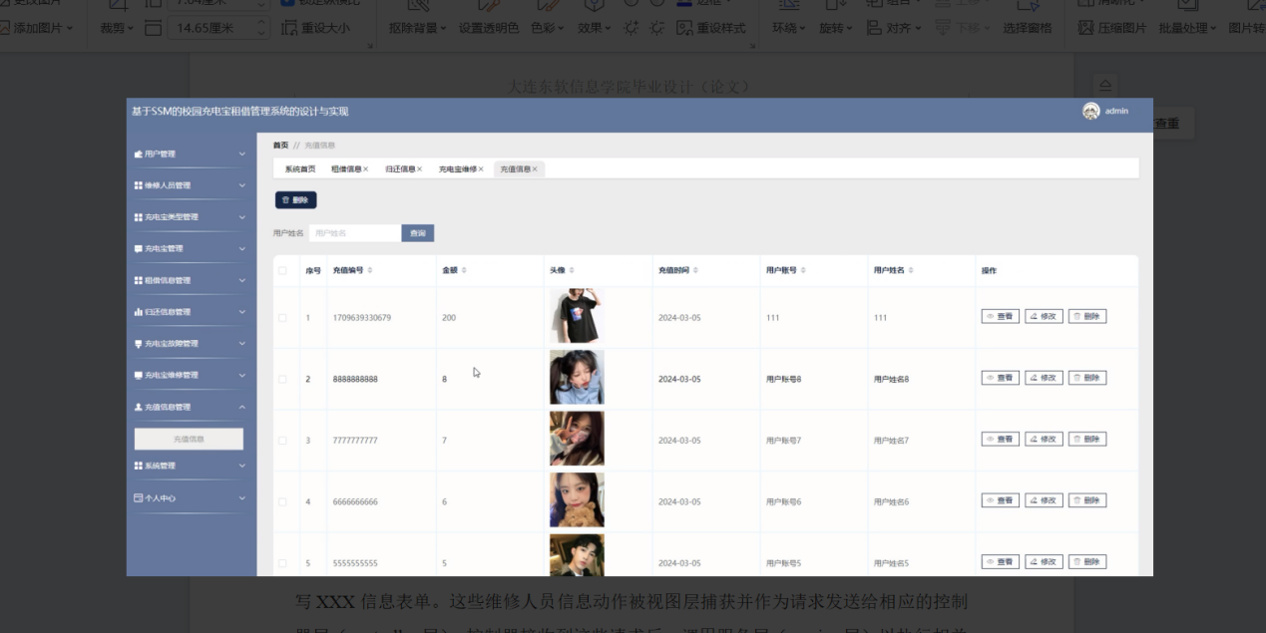
核心代码：
/**
* 后端列表
*/
@RequestMapping("/page")
public R page(@RequestParam Map<String, Object> params,ChongzhixinxiEntity chongzhixinxi,
HttpServletRequest request){
String tableName = request.getSession().getAttribute("tableName").toString();
if(tableName.equals("yonghu")) {
chongzhixinxi.setYonghuzhanghao((String)request.getSession().getAttribute("username"));
}
EntityWrapper<ChongzhixinxiEntity> ew = new EntityWrapper<ChongzhixinxiEntity>();
PageUtils page = chongzhixinxiService.queryPage(params, MPUtil.sort(MPUtil.between(MPUtil.likeOrEq(ew, chongzhixinxi), params), params));
return R.ok().put("data", page);
}
/**
* 前端列表
*/
@IgnoreAuth
@RequestMapping("/list")
public R list(@RequestParam Map<String, Object> params,ChongzhixinxiEntity chongzhixinxi,
HttpServletRequest request){
EntityWrapper<ChongzhixinxiEntity> ew = new EntityWrapper<ChongzhixinxiEntity>();
PageUtils page = chongzhixinxiService.queryPage(params, MPUtil.sort(MPUtil.between(MPUtil.likeOrEq(ew, chongzhixinxi), params), params));
return R.ok().put("data", page);
}

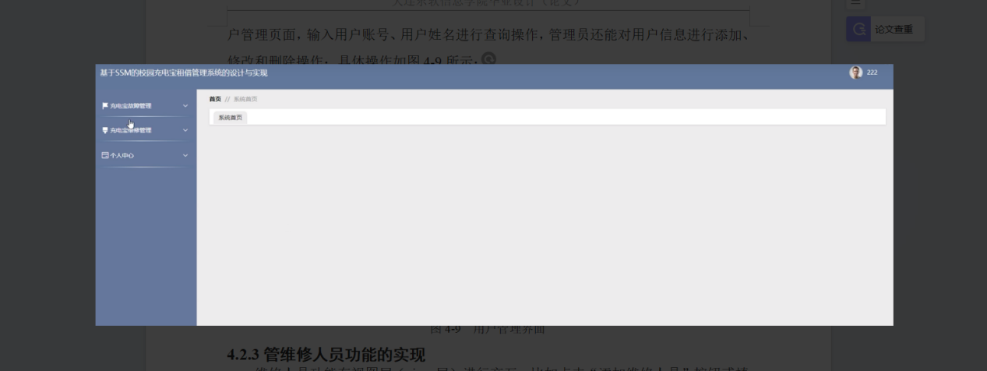
回复：这个首页是空的，无代码。

