1. In order to obtain insight on today’s (I assume it is 30-03-2015 instead of 24-03-2015) work status, I defined a class DayOverview to evaluate the performance. The class has following attributes,

* TillDateTime, last submission time that will be included in the dayoverview. So we can compare today’s data with other days’ data under same timeframe (till 11:30).
* NumberOfSubmission, to see how active the group is submitting answers.
* SumofProgress, sum value of progress, higher value means the group is making bigger progress.
* NumberOfProgressedPupil, how many pupils are making progress.
* NumberOfWorkedPupil, how many pupils working on the day.
* Subject, which can be used (not active now) if we want to have overview on each subject.

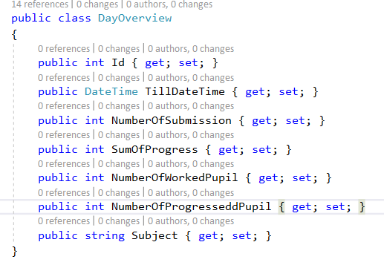

1. There is a C# API (WorkOverviewAPI) project created.

* The API is following Controller-Service-Repository architecture.
* Dapper is user to interact with backend SQL database.
* Stored procedure is used for complex data retrieval.

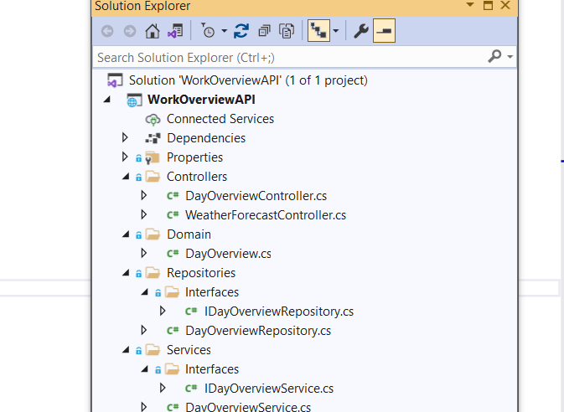

Postman is used to call the API and retrieve data.

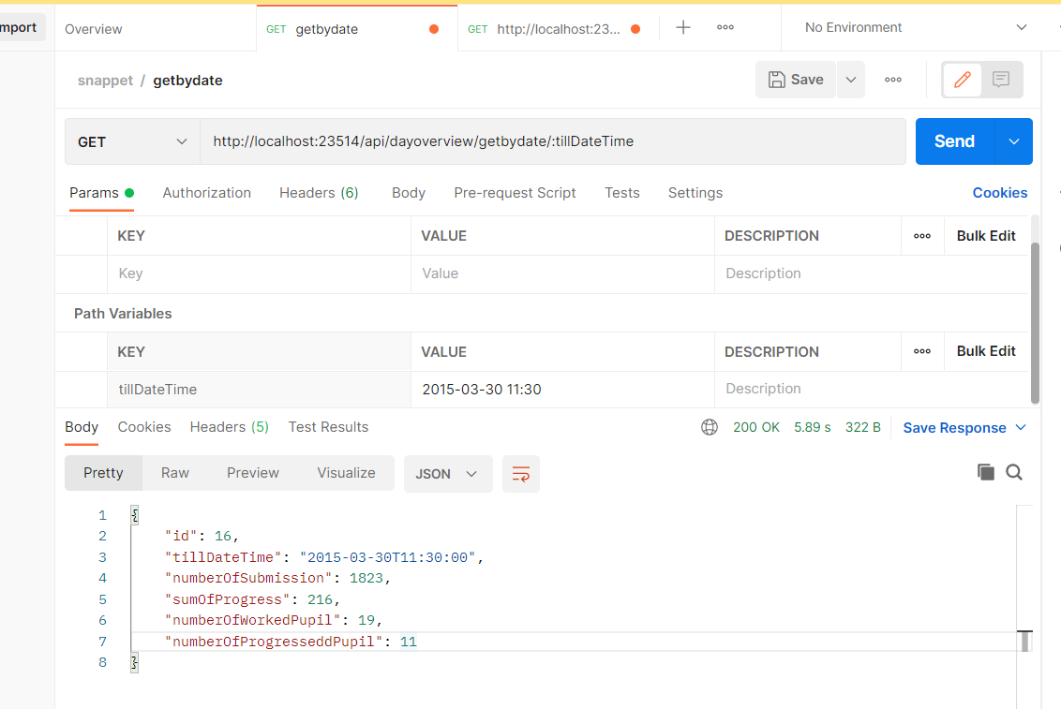

1. There is a database project (Work.DB) created. Data file work.csv is imported to newly created table Work. Table DayOverview is filled when API is called.

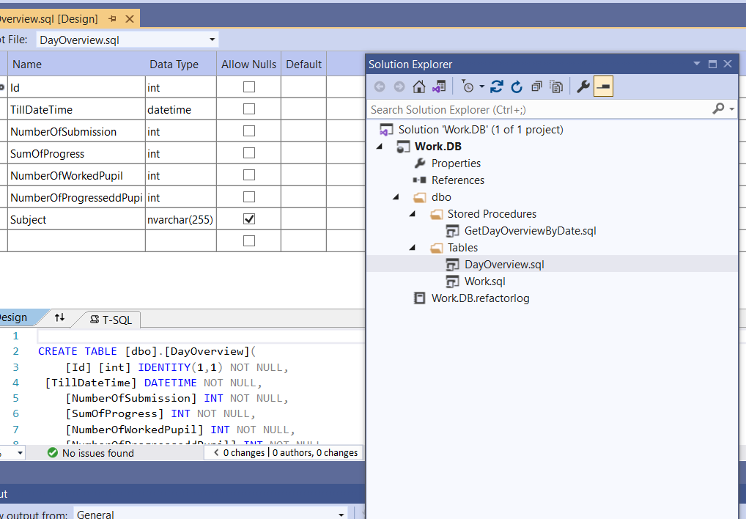

I used Python as graphic tool to visualize different measurement criteria.

