Hallo!!

I have created my solution using Asp.NET MVC, AngularJS, Bootstrap, Google Charts, and Pikaday inside of Visual Studio 2017. You will need Visual Studio 2017 to run the solution.

The backend code for the app is located inside of the **Controllers** and **Models** folders:

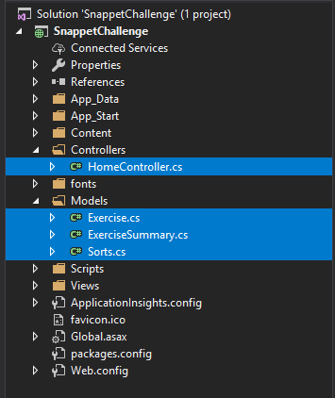

The client-side app files (**AngularJS**) are located under the **Scripts\App** folder:

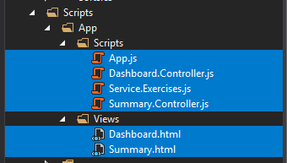

You will first need to build the app, which will require the restoration of some NuGet files. Please make sure that you are setup for this:

* Inside of Visual Studio type ctrl + q (at least that is what it is here in the states), and type in **nuget package manager** in the top right of the screen:  
  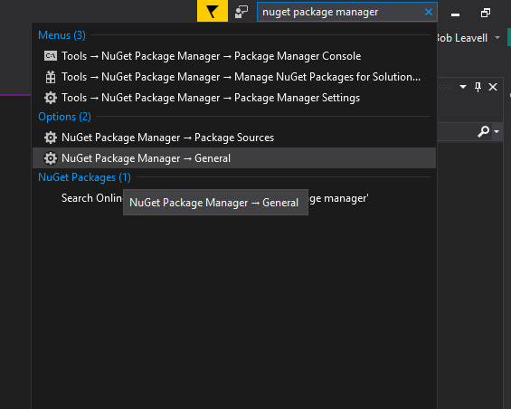
* Select NuGet Package Manager -> General
* Select the following settings:  
  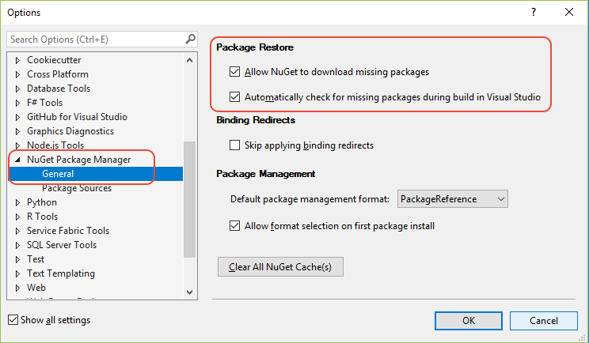

After building and running the project, you should be presented with the following summary screen:

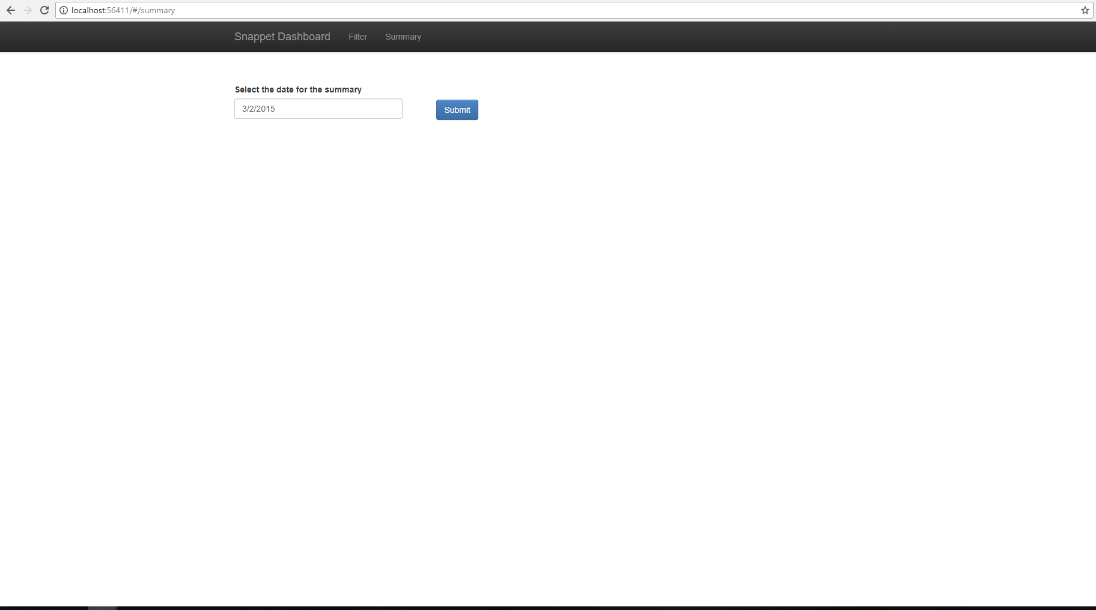

From here, you can select the date that you would like to see using the date picker. I have restricted the date picker to the month of March, to make searching simpler:

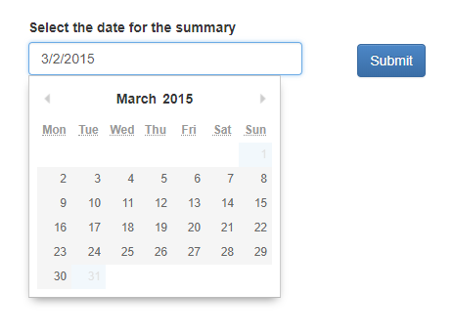

After submitting a date, you will be presented with a summary of the exercises for that date:

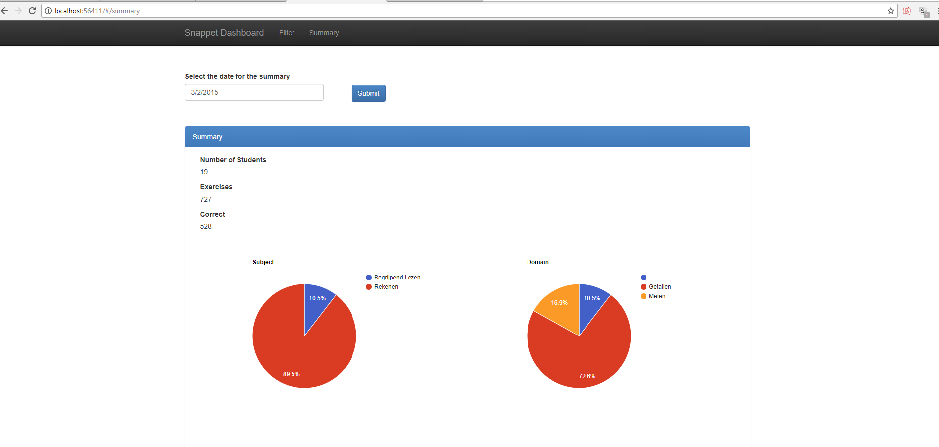

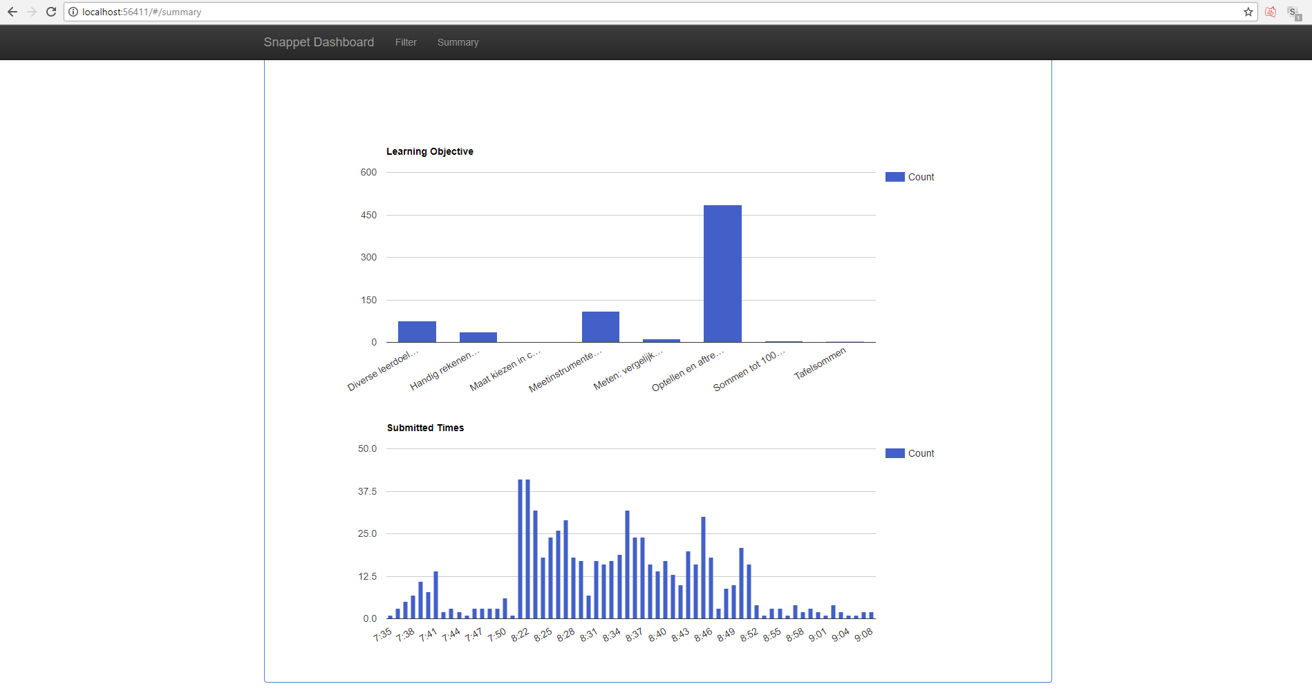

You will be notified if there are no results on that day:

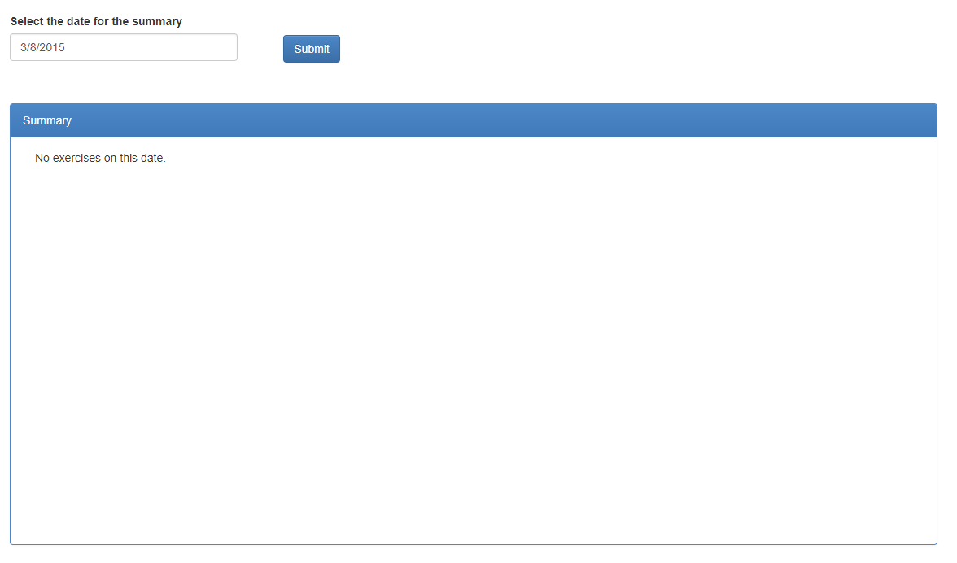

In addition to the summary, if you click the Filter link:

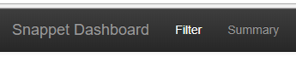

You will be able to filter through all the results:

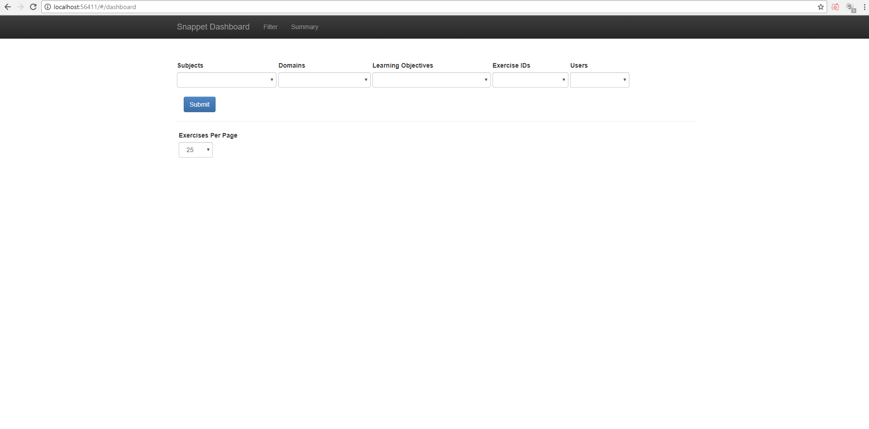

Once you have selected the item(s) to filter on, and have submitted it, you can then page through the returned results:

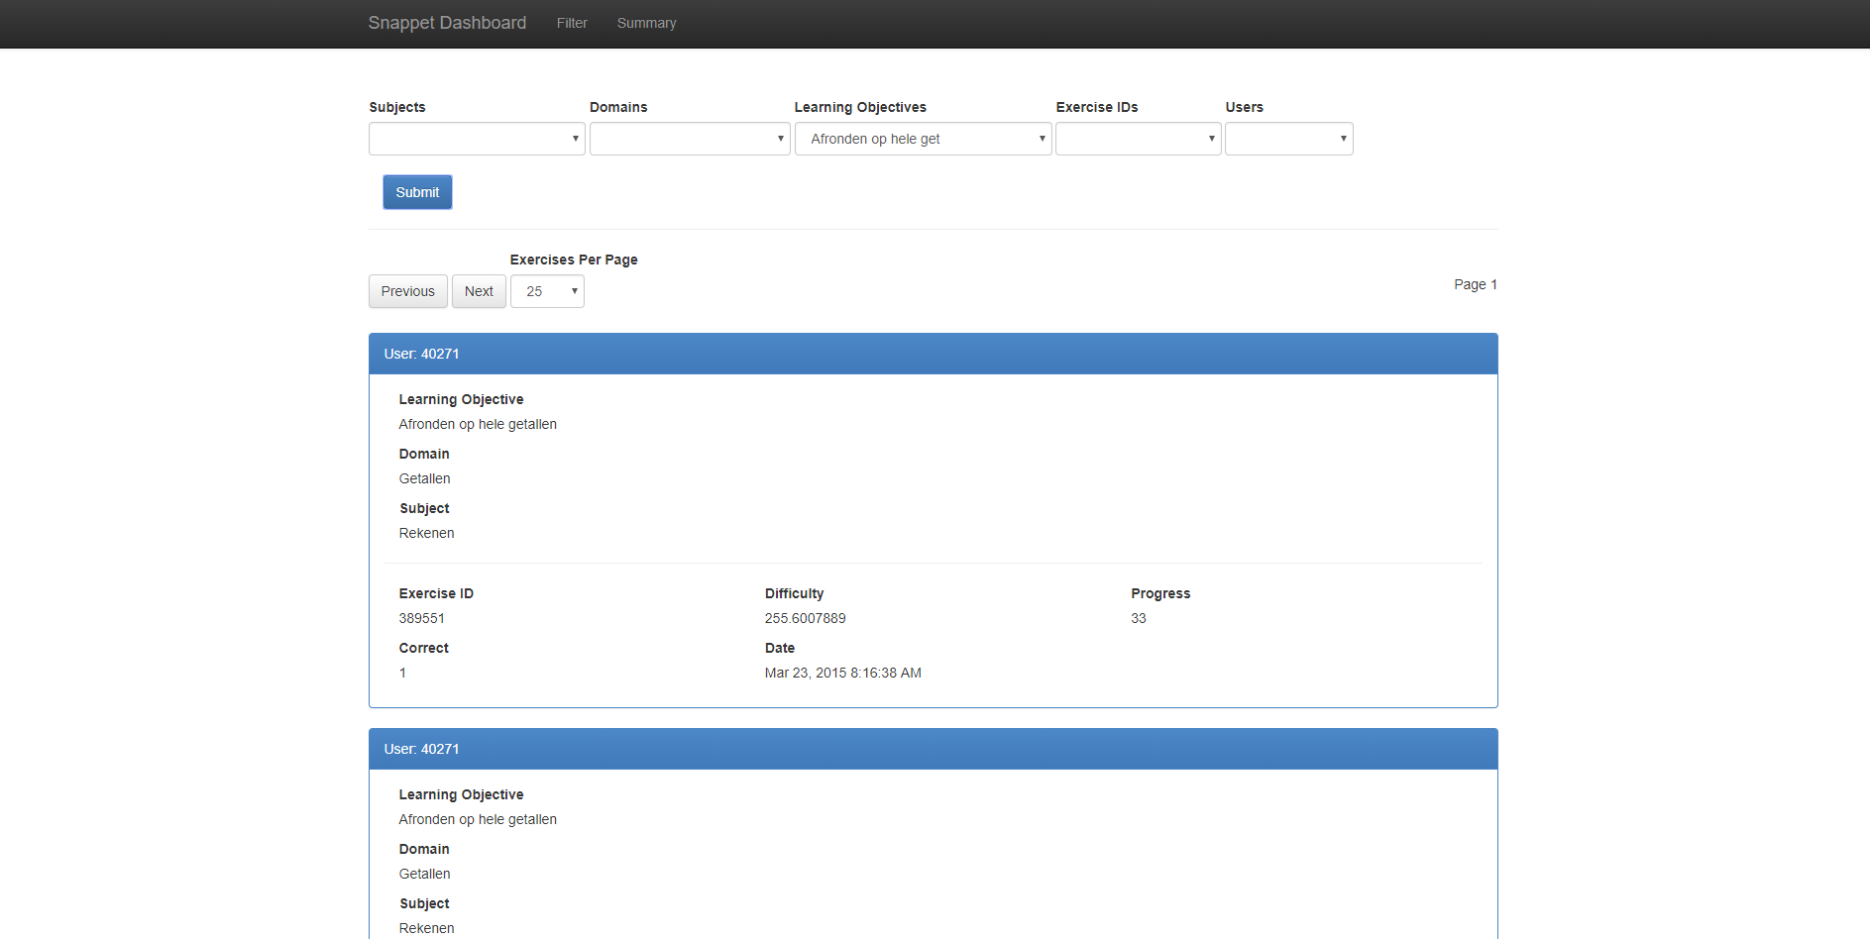

Exercises with a negative progress are red:

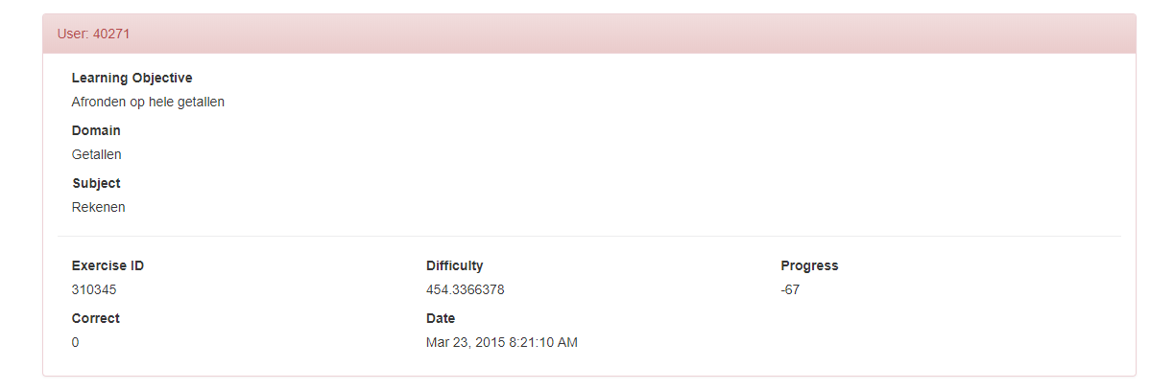

Please let me know if you have any questions! Bedankt!!