PHILIPPINE WOMEN'S COLLEGE
Information Technology Department
DAVAO BANK
A Mobile Banking System Rooted in Davao City Culture
Capstone System Documentation
A Capstone Project Presented to the Faculty of
the Information Technology Department, Philippine Women's College
In Partial Fulfillment of the Requirements for the Subject
COMPLEX SYSTEMS
Bachelor of Information Technology
Prepared by
Ron Albert Ancheta
Justin Arcete
Adviser: Iluminado Canoy
November 2026
Version 1.0 · documents the system as of 4 November 2026

Abstract
Davao Bank is a simulated mobile banking system developed as an undergraduate capstone project. It consists of a customer mobile application built with React Native and Expo, a staff administration console built with Next.js, and a shared Supabase backend that provides authentication, a PostgreSQL database, Row Level Security and server-side database functions. The system takes its name and visual identity from Davao City and its Kadayawan Festival.
The project addresses a problem that general-purpose application tutorials rarely confront: a banking application is only useful if its balances are always correct, its transfers can never be half-completed or duplicated, and each customer can see only his or her own data. Davao Bank therefore keeps all money logic on the server. Balances are never stored as an editable number; they are calculated from an append-only ledger. Every money operation runs inside a single database transaction, locks the affected accounts, carries an idempotency key that prevents duplicate submissions, and writes an audit record.
As of 4 November 2026 the system supports registration and email verification, balance viewing, internal transfers, simulated cash-in and cash-out, simulated bill payment, one-time and recurring scheduled payments, QR-based payment and money requests, transaction history, PDF and CSV statements, in-app notifications, and a view-only foreign exchange reference chart. Staff can manage users and accounts, adjust balances with a recorded reason, reverse transfers, monitor schedules and billers, and review the audit log.
Testing combined an offline database harness (63 of 63 checks passing on 4 November 2026), unit tests (50 of 50 passing), scripted tests against the hosted database, and observation of the running application on an iOS simulator. The first live run on 3 November 2026 passed 165 of 174 checks; all nine failures were traced to errors in the test scripts rather than in the system, and the concurrency checks for parallel withdrawals, double reversal and the scheduler all passed. Several user-interface defects and verification gaps remain and are documented in Chapter 5. All money in Davao Bank is play money: the system performs no real settlement and is not a licensed bank.
Keywords: mobile banking, double-entry ledger, Row Level Security, idempotency, React Native, Supabase, Kadayawan
Table of Contents

List of Figures

List of Tables

Chapter 1. Introduction

1.1 Project Background
Mobile banking is now the main way many Filipinos check balances, send money and pay bills. Behind every one of those simple screens is a set of guarantees that users take for granted: the balance shown is correct, money sent is either fully delivered or not sent at all, pressing a button twice does not send the money twice, and no other customer can read one's account. When any of these guarantees fails, the application has failed at its core purpose, regardless of how attractive its screens are.
Davao Bank was conceived as a capstone project that would take those guarantees seriously while remaining an academic prototype. It is a complete, demonstrable banking system with two front ends and one shared backend: a mobile application for customers and a web console for bank staff, both connected to a Supabase project that hosts the database, authentication and server-side logic.
The project also carries a cultural intent. Its name and appearance draw on Davao City and the Kadayawan Festival, the city's annual thanksgiving for a bountiful harvest. The 2026 festival theme, "We Are One, KadayawOne," celebrates the unity of Davao's eleven ethnolinguistic tribes, settlers and guests. The project adopts this idea of many threads woven into one fabric as its guiding metaphor: many individual customers brought together in one trusted system. The interface uses the Kadayawan 2026 color palette, with Mt. Apo green as the primary action color.
From the beginning the team treated Davao Bank as a simulation. Balances represent play money, no real funds are settled, and the system makes no claim to be a licensed financial institution. Within that boundary, the project applies the engineering practices a real bank would require: secure authentication, role-based access, atomic and idempotent money movement, an auditable ledger and layered testing.

1.2 Statement of the Problem
Any team building a banking application, even a prototype, faces a recurring set of problems that ordinary applications can usually ignore. The project proposal identified six, and they remained the problems the implementation was designed around:
- Data integrity. A customer's balance must always equal the sum of his or her transactions. If balances are stored as a field the application edits directly, a single missed update, race condition or crash leaves the data permanently wrong.
- Transaction reliability. Money must move atomically. The sender is debited and the receiver credited together, or neither happens.
- Duplicate operations. A user who taps "Send" twice, or a network retry, must not create two transfers.
- Unauthorized access. Each customer must see and act on only his or her own accounts and transactions. A weak access rule can expose every customer's data at once.
- Auditability. Every money movement and administrative action must be recorded in a way that clients cannot alter, so that history can be reviewed and reconciled.
- Confusing a prototype with a production bank. A managed backend such as Supabase provides authentication, a database and hosting. It does not provide a banking licence, payment rails, identity verification (KYC/AML) or payment-card compliance. Treating the two as equivalent leads to unsafe assumptions.
Stated as research questions, the project sought to answer the following: How can a mobile banking prototype guarantee correct balances, atomic transfers and duplicate-free submissions when clients may retry, crash or act concurrently? How can access be restricted so that customers reach only their own records while staff can administer the whole system? And how can these guarantees be demonstrated and verified, rather than merely asserted?

1.3 Objectives of the Project

1.3.1 General Objective
To design, develop and evaluate Davao Bank, a simulated mobile banking system rooted in Davao City culture, consisting of a customer mobile application, a staff administration console and a shared Supabase backend, in which balances are correct by construction, every money movement is atomic, idempotent and auditable, and every user can access only the data his or her role permits.

1.3.2 Specific Objectives
The proposal defined seven specific objectives, each with a measure. Chapter 6 reports how far each was achieved.
Table 1. Specific objectives and measures
ID | Objective | Measure (from the proposal)
O1 | Provide secure authentication and session management for customers and staff | 100% of data access requires a valid session; email verification required; no unauthenticated data endpoints
O2 | Enforce role-based access so users reach only permitted data | Customers access only their own records; all cross-user and unauthorized-write attempts blocked in tests
O3 | Guarantee atomic, correct money movement | 0 balance inconsistencies in reconciliation tests; every transfer is all-or-nothing
O4 | Prevent duplicate transactions | A repeated submission produces exactly one transaction
O5 | Record a complete, tamper-evident audit trail | 100% of money movements and admin actions recorded in an append-only log
O6 | Deliver a reliable, responsive user experience | Key screens load in under 2 seconds on the test device; all flows handle errors gracefully
O7 | Deliver a complete, demonstrable prototype | 100% of in-scope features working end to end across mobile, admin and backend

1.4 Significance of the Project
For the developers, the project is an exercise in building software where correctness matters more than features. It required designing a database before screens, writing server-side functions that hold up under concurrent use, and verifying claims with tests against a real database.
For the capstone adviser and panel, the system and this document provide a concrete case study of how integrity, access control and auditability can be enforced in a modern serverless architecture, and of where a prototype stops short of a production bank.
For future developers, the documentation describes the actual implementation in enough detail to maintain or extend it. The database design, money engine and security model are reusable patterns for any application that moves value between users.
For the Davao community, the project shows how local culture can shape the identity of a digital product. The Kadayawan palette, the Bisaya greeting "Maayong adlaw" on the Home screen, and the planned characters Kada (a Philippine eagle) and Duri (a durian) give the application a recognisably Davaoeño character.

1.5 Scope and Limitations

1.5.1 Scope
The delivered system covers three components. The customer mobile application provides registration, email verification, sign-in and password-reset requests; a Home dashboard with balances; internal transfers by account number, saved recipient or own account; simulated cash-in and cash-out; simulated bill payment to demonstration billers; one-time and recurring scheduled payments; a QR hub for showing and scanning payment codes and requesting money; transaction history with receipts; PDF and CSV statements; in-app notifications; profile management; biometric or password confirmation before money moves; and a view-only foreign-exchange reference chart.
The staff administration console provides staff-only sign-in, a dashboard of key figures, user management (suspend and reactivate, open accounts), account management (freeze, unfreeze, close, and adjust balances with a mandatory reason), transaction monitoring and reversal, oversight of scheduled payments and payment requests, biller management, a CSV export of transactions, and an audit-log viewer.
The Supabase backend provides email and password authentication; a PostgreSQL database of 15 tables with Row Level Security on every table; 39 database functions, including a single money engine; scheduled jobs (pg_cron) that run due payments, expire old payment requests and refresh exchange rates; and one Edge Function that fetches reference rates from the European Central Bank through the Frankfurter API.

1.5.2 Limitations
The following limitations are deliberate and follow from the project's status as an academic prototype:
- All money is simulated. Cash-in and cash-out create and remove play money; no bank, e-wallet, card network, InstaPay, PESONet or other payment rail is connected.
- Bill payments go only to fictional demonstration billers (for example "Mindanao Power Co. (demo)"). No real utility is paid.
- The system operates in a single currency, Philippine pesos. Foreign exchange rates are shown for reference only; the system cannot convert or hold other currencies.
- Identity is limited to email and password with email verification. There is no know-your-customer (KYC) or anti-money-laundering (AML) screening.
- The system has not been deployed to production hosting or published to an app store. During development the mobile app runs in Expo Go and the admin console runs on a local development server, both connected to a hosted Supabase project.
- The prototype has been exercised mainly on an iOS simulator. Android devices, physical phones and accessibility settings such as large text and screen readers have not yet been fully tested (see Section 5.7).
Table 2 summarizes the difference between this prototype and a production banking system. It is carried over from the proposal because it still describes the boundary accurately.
Table 2. Prototype compared with a production banking system
Dimension | Davao Bank (prototype) | Production banking system
Money | Simulated play-money balances; no settlement | Real funds settled through regulated payment rails
Regulation | None; academic use only | Banking licence, consumer-protection and reporting obligations
Identity | Email and password; email verification | Full KYC/AML verification and screening
Payment card data | None stored | PCI-DSS scope, tokenization, strict controls
Core ledger | Ledger in PostgreSQL; balances derived from entries | Dedicated, reconciled core-banking ledger with external audit
Availability | Best effort on free or low-cost managed tiers | High availability, disaster recovery, 24/7 operations
Fraud and risk | Input validation, limits, admin review | Real-time fraud detection, sanctions screening

1.6 Definition of Terms
The following terms are used throughout this document in the sense given here.
Table 3. Definition of terms
Term | Meaning in this document
Account number | A 10-digit identifier beginning with "10", generated by the database for every account.
Audit log | The audit_logs table. An append-only record of sensitive actions written only by server-side functions.
Centavo | One hundredth of a peso. All amounts are stored as whole centavos to avoid rounding errors (₱1.00 = 100).
Edge Function | A small server-side program hosted by Supabase. Davao Bank has one, fx-sync, which fetches exchange rates.
Expo Go | A mobile app that runs Expo projects during development without building a separate installable app.
Idempotency key | A unique string sent with each money request. If the same key arrives twice, the server returns the first result instead of moving money again.
JWT | JSON Web Token. The signed session token Supabase Auth issues after sign-in; the database reads the user's identity from it.
Ledger entry | One line in ledger_entries: a positive amount, a direction (debit or credit) and an account. Balances are sums of these lines.
pg_cron | A PostgreSQL extension that runs SQL on a timetable, used for scheduled payments, request expiry and exchange-rate refresh.
Row Level Security (RLS) | A PostgreSQL feature that filters every query by rules (policies) attached to a table, so each user sees only permitted rows.
RPC | Remote procedure call. In Supabase, a database function the app calls over HTTPS, for example rpc("transfer", ...).
SECURITY DEFINER | A PostgreSQL function that runs with its owner's privileges. Money functions use it so that they, and only they, can write to protected tables.
Simulated | Behaving like a banking operation inside the system, without any real money or external institution involved.

Chapter 2. Project Requirements and System Analysis

2.1 Intended Users and Stakeholders
Davao Bank has two kinds of human users and one automated actor. Table 4 lists them together with the project's other stakeholders.
Table 4. Users and stakeholders
User or stakeholder | Where they interact | Role and permissions
Customer | Mobile app | Registers, signs in and manages only his or her own profile, accounts, transactions, schedules, saved recipients, requests and notifications.
Administrator (staff) | Admin web console | Views all users, accounts and transactions; suspends users; opens, freezes and closes accounts; adjusts balances; reverses transactions; manages billers and schedules; reads the audit log. Must have role = admin and status = active.
System (automated) | Database jobs | pg_cron runs due scheduled payments every 5 minutes, expires payment requests daily and requests fresh exchange rates daily. A system profile owns the settlement accounts of the demonstration billers and cannot sign in.
Project owner | Development process | Makes product decisions and approvals and runs the implementing coding agent.
Project manager and technical lead | Development process | Writes phase specifications, reviews each phase against the code and database, and issues fixes.
Capstone adviser and panel | Evaluation | Provide academic oversight and final acceptance.

An Auditor role with read-only access to transactions and the audit log was described in the proposal as a future addition. It was not built.

2.2 The Existing Problem and Process
Davao Bank does not replace an existing institutional system; it is a new prototype. The "existing process" it responds to is the common way small or student banking applications are built: the application reads a balance, subtracts an amount on the phone or in a web page, and writes the new number back. That approach is simple but fails in exactly the situations described in Section 1.2. Two requests that arrive at the same moment both read the old balance and both succeed. A crash between debiting one account and crediting another leaves money missing. A slow network causes the user to tap again and the transfer happens twice. Access rules placed only in the user interface can be bypassed by calling the database directly.
The analysis therefore concluded that the client applications must never be trusted with money. They may display data and submit requests, but the database itself must validate and perform every money movement and enforce who may see what.

2.3 The Proposed System
The system is built around one principle stated in the proposal: the server is the only authority on money. Clients never compute or write balances. Every money movement is validated and executed by a database function inside one transaction, and every balance is derived from ledger entries. Access control is enforced in the database with Row Level Security, so it applies equally to the mobile app, the admin console and any other client. Administrative actions also run as database functions that check the caller's role and write an audit record.
The two client applications share a TypeScript package, @davao-bank/shared, which contains the Supabase client wrappers, data types, design tokens and utilities for currency, QR codes and idempotency keys. This keeps the rules for formatting money and building requests identical on both clients.

2.4 Functional Requirements
Table 5 lists the functional requirements, combining those in the proposal with those added by the approved scope change of 23 October 2026 (Scope Change 01). The status column reflects the repository on 4 November 2026. "Implemented" means the function exists end to end; "Partial" means part of the requirement is missing; known defects in implemented functions are listed in Section 5.6.
Table 5. Functional requirements and implementation status
ID | Requirement | Source | Status
FR-01 | Customers can register with email and password; a profile and a savings account are created automatically | Proposal | Implemented
FR-02 | Email verification is required before the app can be used | Proposal | Implemented
FR-03 | Customers can request a password reset | Proposal | Partial: reset email is sent, but the reset cannot be completed inside the app
FR-04 | Customers see their accounts and a ledger-derived balance, and can hide the balance | Proposal; Scope Change 01 | Implemented
FR-05 | Customers can transfer to another account by account number with a confirmation step and idempotent submission | Proposal | Implemented
FR-06 | Customers can save recipients and transfer between their own accounts | Scope Change 01 | Implemented
FR-07 | Simulated deposit (cash-in) and withdrawal (cash-out) | Proposal | Implemented
FR-08 | Biometric or password confirmation before money moves | Scope Change 01 | Implemented
FR-09 | Transaction history with filter and detail view | Proposal | Implemented (filter by type; no text search)
FR-10 | Simulated bill payment with reference validation | Scope Change 01 | Implemented
FR-11 | One-time and recurring scheduled transfers and bill payments, executed automatically | Scope Change 01 | Implemented
FR-12 | Show and scan a Davao Bank QR code to pay; request money from another customer | Scope Change 01 | Implemented
FR-13 | Account statement export as PDF and CSV | Proposal (optional) | Implemented
FR-14 | In-app notifications for money events and account changes | Proposal | Implemented
FR-15 | Profile view and edit | Proposal | Implemented (name and phone)
FR-16 | View-only foreign exchange reference chart | Scope Change 01 | Implemented
FR-17 | Staff-only sign-in with role-based access | Proposal | Implemented
FR-18 | Dashboard with users, accounts, balances and transaction volume | Proposal | Implemented (two figures have known defects)
FR-19 | User management: list, search, view, activate and suspend | Proposal | Implemented
FR-20 | Lightweight identity-verification flag for users | Proposal | Not implemented
FR-21 | Account management: open, freeze, unfreeze and close | Proposal | Implemented
FR-22 | Transaction monitoring and reversal within defined rules | Proposal | Implemented (reversal exposed for transfers only)
FR-23 | Flag suspicious transactions | Proposal | Not implemented
FR-24 | Manual balance adjustment with a mandatory reason, audit-logged | Proposal | Implemented
FR-25 | Audit log viewer and basic report export | Proposal | Partial: viewer implemented; export covers transactions only
FR-26 | Staff management of billers and scheduled payments | Scope Change 01 | Partial: create biller and schedule tools work; biller activate/deactivate has a defect

2.5 Nonfunctional Requirements
Table 6. Nonfunctional requirements
ID | Requirement | How the design addresses it | Status
NFR-01 Integrity | Balances always equal the ledger | No balance column; balances are sums of ledger entries; writes only through database functions | Met in tests
NFR-02 Atomicity | A transfer completes fully or not at all | Each money function runs in one database transaction | Met in tests
NFR-03 Idempotency | A repeated request produces one transaction | Unique idempotency_key; replay returns the original result | Met in tests
NFR-04 Concurrency | Parallel requests cannot overdraw or double-reverse | Row locks in a fixed order; unique index on reversals; run-once keys for schedules | Met in live tests (3 Nov 2026)
NFR-05 Access control | Each role reaches only permitted data | RLS on all 15 tables; is_admin() checks; function execute grants | Met in tests
NFR-06 Auditability | Money and admin actions recorded | write_audit called inside each function; no client write access | Met, with gaps listed in Section 4.5.7
NFR-07 Security of secrets | No privileged key in client bundles | Clients ship only the public anon key; service key used by scripts and the Edge Function | Met; gitleaks scan in CI
NFR-08 Performance | Key screens load in under 2 seconds | Small queries, indexed foreign keys | Not yet measured
NFR-09 Usability and accessibility | Clear flows, readable text, screen-reader support | Shared design system, confirmation steps, mapped error messages | Partial; see Section 3.7.5
NFR-10 Maintainability | One language and shared code | TypeScript throughout; shared package; append-only migrations; CI checks | Met

2.6 Feasibility and Constraints
Technical feasibility. Every component uses mature, documented technology. Supabase provides a managed PostgreSQL database with Row Level Security and authentication, which removed the need to build and host a custom API server. Expo allowed the mobile application to be developed and demonstrated on simulators and phones through Expo Go without native build tooling.
Economic feasibility. The proposal estimated typical running costs of USD 0 to 50 per month, relying on free tiers. The project has run on a Supabase project and free development tools; no paid services were required during development. Optional costs such as app-store accounts and a custom domain were not incurred.
Operational feasibility. The system is intended for demonstration and evaluation. Customers need only a phone with Expo Go; staff need a web browser. Database jobs run automatically once pg_cron and pg_net are enabled and the job registration function has been executed (Appendix F).
Schedule. The proposal planned 10 weeks in seven phases. The approved scope change added eight features and revised the estimate to about 14 to 15 weeks. Development began on 20 October 2026; Phases 1 to 5 were completed by 3 November 2026, and Phase 6 (testing and hardening) was in progress when this document was written.
Constraints. The project depends on the availability of Supabase and of the Frankfurter API for exchange rates, on the implementing AI coding agent, and on review capacity at each phase gate. Real-money functions are excluded by design.

2.7 Differences Between the Proposal and the Implementation
The proposal (version 1.1, 20 October 2026) describes what the team intended to build. The repository establishes what was actually built. Table 7 lists every significant difference so that no proposed feature is mistaken for completed functionality.
Table 7. Proposal compared with the implementation
Area | Proposal v1.1 | Implementation (4 Nov 2026)
Visual identity | Waling-waling purple primary color, with Mt. Apo green, gold, cacao brown and eagle slate | Replaced on 23 Oct 2026 by the Kadayawan 2026 palette with Mt. Apo green (#0C6D38) as primary; Plus Jakarta Sans typeface. The official logo files have not been supplied, so a "LOGO" placeholder is shown
Bill payment | Out of scope | Added by Scope Change 01 as simulated payments to demonstration billers
Foreign exchange | Out of scope (single currency) | Added as a view-only reference chart; the system remains single-currency PHP
Additional features | Not planned | Saved recipients, statements, hide balance, biometric confirmation, scheduled payments, QR send and request money (Scope Change 01)
Biometrics | Optional biometric unlock of the app | Biometric (or password) confirmation before each money movement instead of app unlock
Storage | Supabase Storage for avatars and exported statements | Not used. Avatars show initials; statements are generated on the phone and shared
Ledger | Every transaction's entries net to zero | Transfers, bill payments and request payments are balanced. Deposits, withdrawals and adjustments write a single entry because there is no cash or suspense account (Section 4.5.2)
Roles | Customer and administrator; auditor in future | Customer, administrator and a non-login system role for biller settlement accounts; auditor not built
Admin features | Includes a verification flag and flagging suspicious transactions | Neither implemented; audit export not implemented (transaction CSV only)
Transaction search | Search and filter | Filter by type on mobile; text search in the admin console only
Testing tools | Jest, RN Testing Library, pgTAP, Detox and Playwright | Jest and Testing Library; an offline PGlite database harness instead of pgTAP; scripted live suites; Maestro flows instead of Detox; Playwright
Deployment | Admin on Vercel, mobile build with EAS | Not yet done (planned final phase)
Phases | 7 phases over 10 weeks | Expanded after the scope change; Phase 6 in progress; UI refinement, workflow, savings and deployment phases planned

Chapter 3. Development Methodology and System Design

3.1 Development Methodology
Davao Bank was developed with an iterative, phase-gated methodology. The work was divided into phases with clear objectives and completion criteria, and no phase could begin until the previous one had been reviewed and approved. This resembles an incremental model with formal review gates rather than a single waterfall pass or open-ended agile sprints. It was chosen because correctness of money handling had to be proven before features were built on top of it.
Implementation was carried out by an AI coding agent working from a detailed written specification (a "phase prompt") for each phase. Each phase followed the same governed cycle:
- Specify. The technical lead wrote the phase prompt: scope, required behaviour, verification steps and an explicit list of things not to change.
- Implement. The coding agent built the phase on its own branch, with one commit and one new database migration per stage.
- Review. The reviewer inspected the actual code, migrations and test output, and from Phase 5 onward also applied the migrations to an independent database harness and ran the app. Reports were never accepted on the agent's summary alone.
- Decide. The phase was marked Approved, Needs Fixes or Requires Further Verification. Fixes were issued as a follow-up prompt.
- Proceed. Only an approved phase unlocked the next one. New requirements were checked against earlier decisions before being accepted.
The review step proved necessary. In Phase 5 the agent's reports claimed passing tests that had in fact run against an empty database in a fallback "contract mode" that only searched source files. The reviewer then built an offline database harness (Section 5.1) and required every later test run to show that it had connected to the live database. Three dedicated fix passes (after Phases 1, 4 and 5) and two carry-over steps resulted from reviews.
Table 8. Development phases and timeline
Phase | Objective and main deliverables | Completed
1 Project setup | Monorepo with mobile, admin and shared packages; Supabase connectivity check; coding standards. Fix pass for workspace and tooling issues | 23 Oct 2026 (committed with Phases 2 to 4)
2 Database and authentication | Full schema, RLS on every table, is_admin(), sign-up trigger, audit infrastructure, ledger-derived balance view, sign-up and sign-in flows | 23 Oct 2026
3 Core banking | Server-authoritative transfer, deposit and withdraw functions with centavo amounts, idempotency keys and row locking; transaction history | 23 Oct 2026
4 Admin management | Staff console: dashboard, users, accounts, reversal, adjustments, audit viewer, CSV export. Fix pass for a double-reversal race, unenforced suspension, a forgeable audit function and form idempotency | 23 Oct 2026
5 Redesign and feature expansion | Stage A Kadayawan design system; B saved recipients, statements, hide balance, biometric confirmation; C scheduled payments and bill pay on one money engine; D QR and payment requests; E FX reference chart | 23 to 27 Oct 2026
5 Fixes | Removed false-pass test mode; fixed seeding, cron registration, request linking, confirmation on devices without biometrics, and recipient tampering | 3 Nov 2026
6 Testing and hardening | Stage 0 carry-overs and critical flow fixes; Stage A unit tests, end-to-end flows and CI; Stage B security hardening; Stage C device checks | In progress (Stage 0 and A committed 4 Nov 2026)

On 23 October 2026 the project owner approved Scope Change 01, which added the eight features listed in Table 7 after comparing the design with a major Philippine bank's online banking features. The same record rejected adopting that bank's visual style or a five-tab layout, excluded all real payment networks and real currency conversion, and recorded the expected effect on the timeline.

3.2 Technology Stack
Table 9 lists the technologies actually present in the repository, with the versions declared in its package files. Versions prefixed with a caret (^) or tilde (~) allow compatible minor updates.
Table 9. Technology stack
Layer | Technology and version | Purpose
Language | TypeScript ~5.8.2 | Typed code across both clients and the shared package
Mobile framework | React Native 0.88.0, React 19.3.1, Expo SDK ~58.0.16 | Cross-platform customer app, run in Expo Go during development
Mobile navigation | @react-navigation/native ^7.0.14, bottom-tabs ^7.21.0 | Four-tab navigation
Mobile device APIs | expo-local-authentication, expo-camera, expo-print, expo-sharing, expo-file-system, expo-haptics | Biometrics, QR scanning, PDF generation, sharing, files, haptic feedback
Mobile UI | react-native-svg, react-native-qrcode-svg, lucide-react-native, Plus Jakarta Sans | Charts, QR codes, icons, typeface
Mobile storage | @react-native-async-storage/async-storage 2.2.0 | Session and preference storage (encrypted session storage is being added in Phase 6 Stage B)
Admin framework | Next.js 16.4.2 (App Router), React 19.3.1 | Server-rendered staff console with server actions
Admin data access | @supabase/ssr ^0.5.2 | Cookie-based Supabase sessions in Next.js
Admin UI | CSS Modules, lucide-react ^1.61.0 | Styling and icons
Backend | Supabase: Auth, PostgreSQL, PostgREST, Edge Functions (Deno), Vault | Authentication, database, API and server logic
Database extensions | pg_cron, pg_net | Scheduled jobs and outbound HTTP from the database
Client library | @supabase/supabase-js ^2.49.1 | Database and auth calls from both clients
External data | Frankfurter API (European Central Bank reference rates) | Exchange-rate history for the FX chart
Testing | Jest ^30.5.2, Testing Library, @electric-sql/pglite ^0.5.12, tsx scripts, Playwright ^1.64.1, Maestro | Unit, offline database, live database and end-to-end tests
Quality tools | ESLint 9, Prettier 3, GitHub Actions, gitleaks | Linting, formatting, continuous integration, secret scanning
Runtime | Node.js >= 20 (24.12.0 used) | Tooling and scripts

These technologies suit the project for three reasons. First, one language, TypeScript, runs on both clients and in the shared package, so money formatting and request rules are written once. Second, Supabase places the business rules next to the data in PostgreSQL, where transactions, row locks and Row Level Security are native features rather than application code that could be bypassed. Third, Expo and Next.js allowed a two-person team to deliver both a mobile app and a web console within the timeline.

3.3 System Architecture
Figure 1 shows the overall architecture. Both clients talk directly to Supabase over HTTPS; there is no separate application server. Reads go through PostgREST, which applies Row Level Security to every query. All writes to money tables go through database functions that run as SECURITY DEFINER, so clients have no direct write access to those tables.
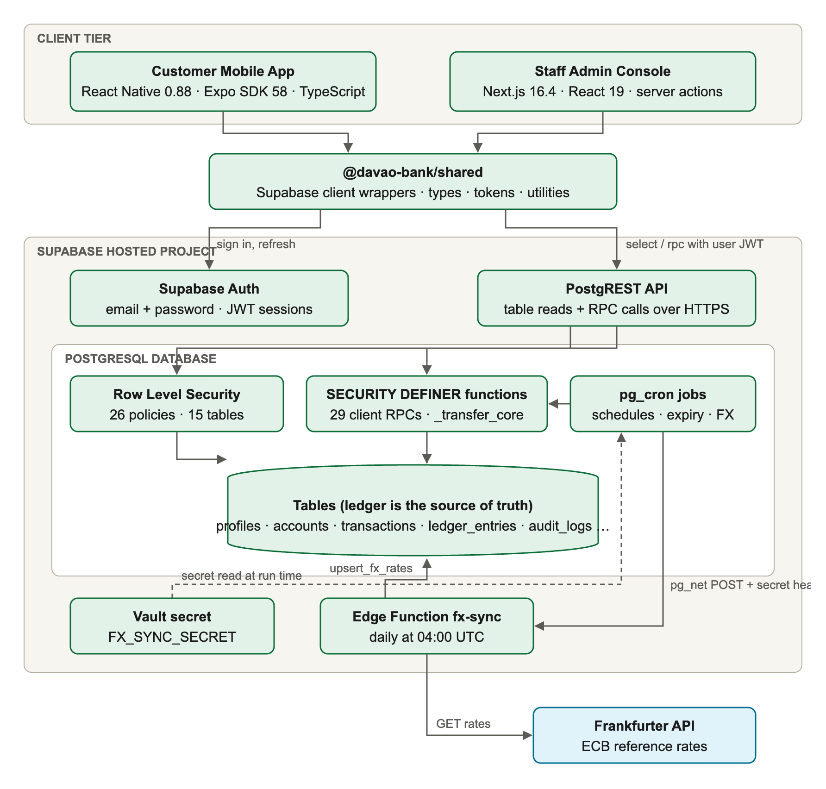
Figure 1. System architecture of Davao Bank
The architecture has four layers. The client tier consists of the mobile app and the admin console. The shared package gives both clients the same Supabase client wrappers, types and utilities. The API layer is provided by Supabase Auth, which issues JSON Web Tokens, and PostgREST, which exposes tables and functions over HTTPS. The database layer holds the 15 tables, the Row Level Security policies, the 39 functions and the scheduled jobs. A small FX synchronisation path lets a scheduled job call the fx-sync Edge Function, which fetches reference rates from the Frankfurter API and stores them through a database function.
Table 10. Key architectural decisions
Decision | Reason
No custom application server | Supabase exposes the database safely through RLS and functions, so a separate API would add code and failure points without adding protection
All money logic in PostgreSQL functions | Functions run atomically next to the data and cannot be bypassed by a modified client
One money engine (_transfer_core) | Transfers, bill payments, request payments and scheduled runs share one tested code path for locking, limits and ledger writes
Balances derived from the ledger | There is no balance field that could drift from the transaction history
Integer centavos | Avoids floating-point rounding errors
Idempotency key on every money request | Retries and double taps return the first result instead of moving money twice
Row Level Security on every table | Access rules apply to every client, including ones that call the API directly
Only the public anon key in clients | The privileged service-role key never reaches a phone or browser

3.4 Use Case Diagrams
The use case diagrams identify what each actor can do. Figure 2 covers the customer. Transfers, bill payments and paying a money request all include a confirmation step with biometrics or the account password. Figure 3 covers the administrator and the automated scheduler.
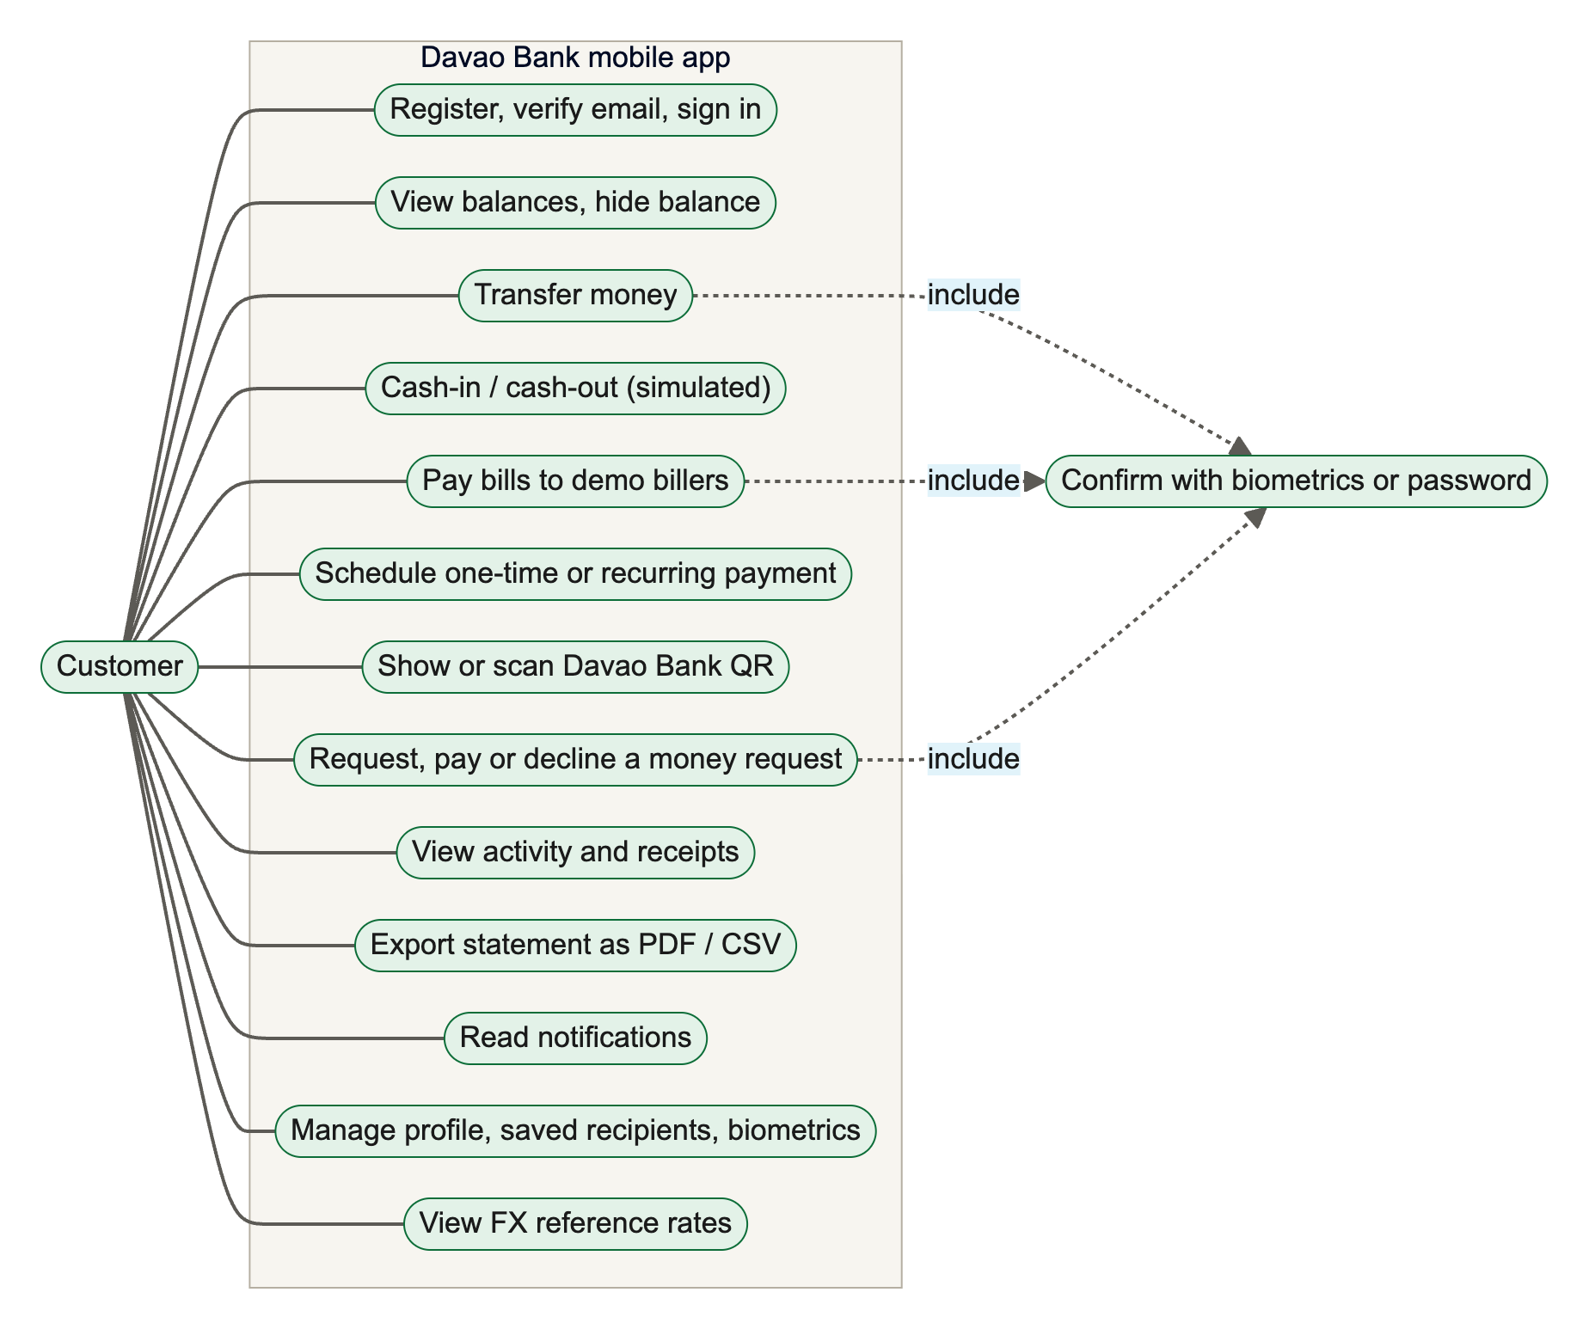
Figure 2. Use case diagram: customer
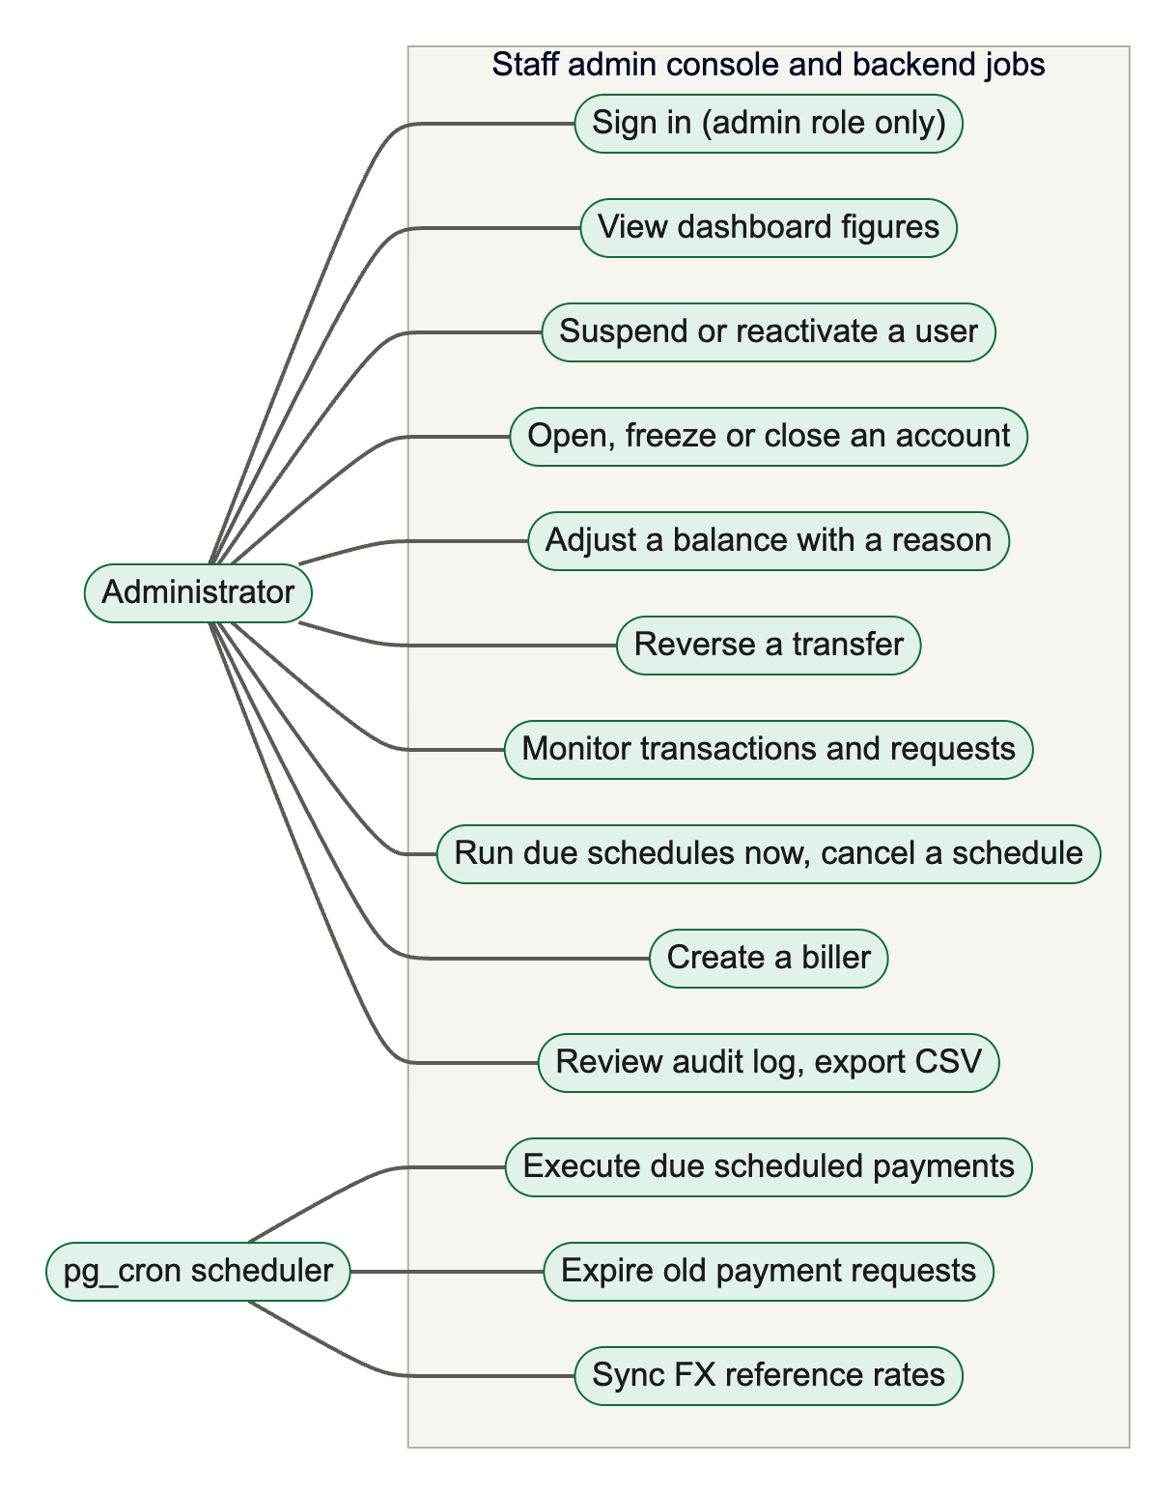
Figure 3. Use case diagram: administrator and scheduled jobs

3.5 Data Flow Diagrams
Figure 4 is the context diagram (level 0). It treats Davao Bank as a single process and shows the data exchanged with its external entities: customers, administrators, the Frankfurter exchange-rate service and the pg_cron scheduler.
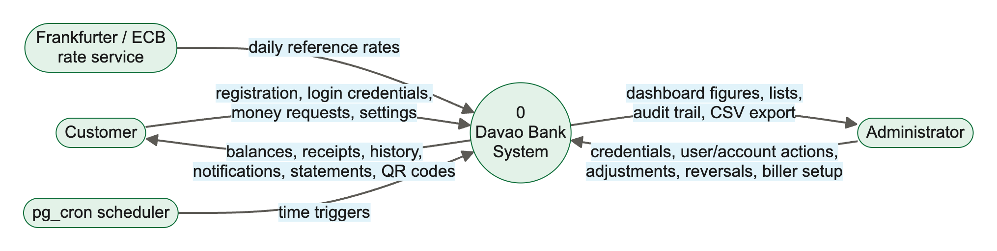
Figure 4. Context diagram (DFD level 0)
Figure 5 decomposes the system into seven processes and nine data stores. Process 2.0, "Process money movements", is the money engine; processes 3.0 (scheduling) and 4.0 (payment requests) do not move money themselves but call the engine. Process 6.0, "Administer", writes to the audit log and reads from it for the audit viewer.
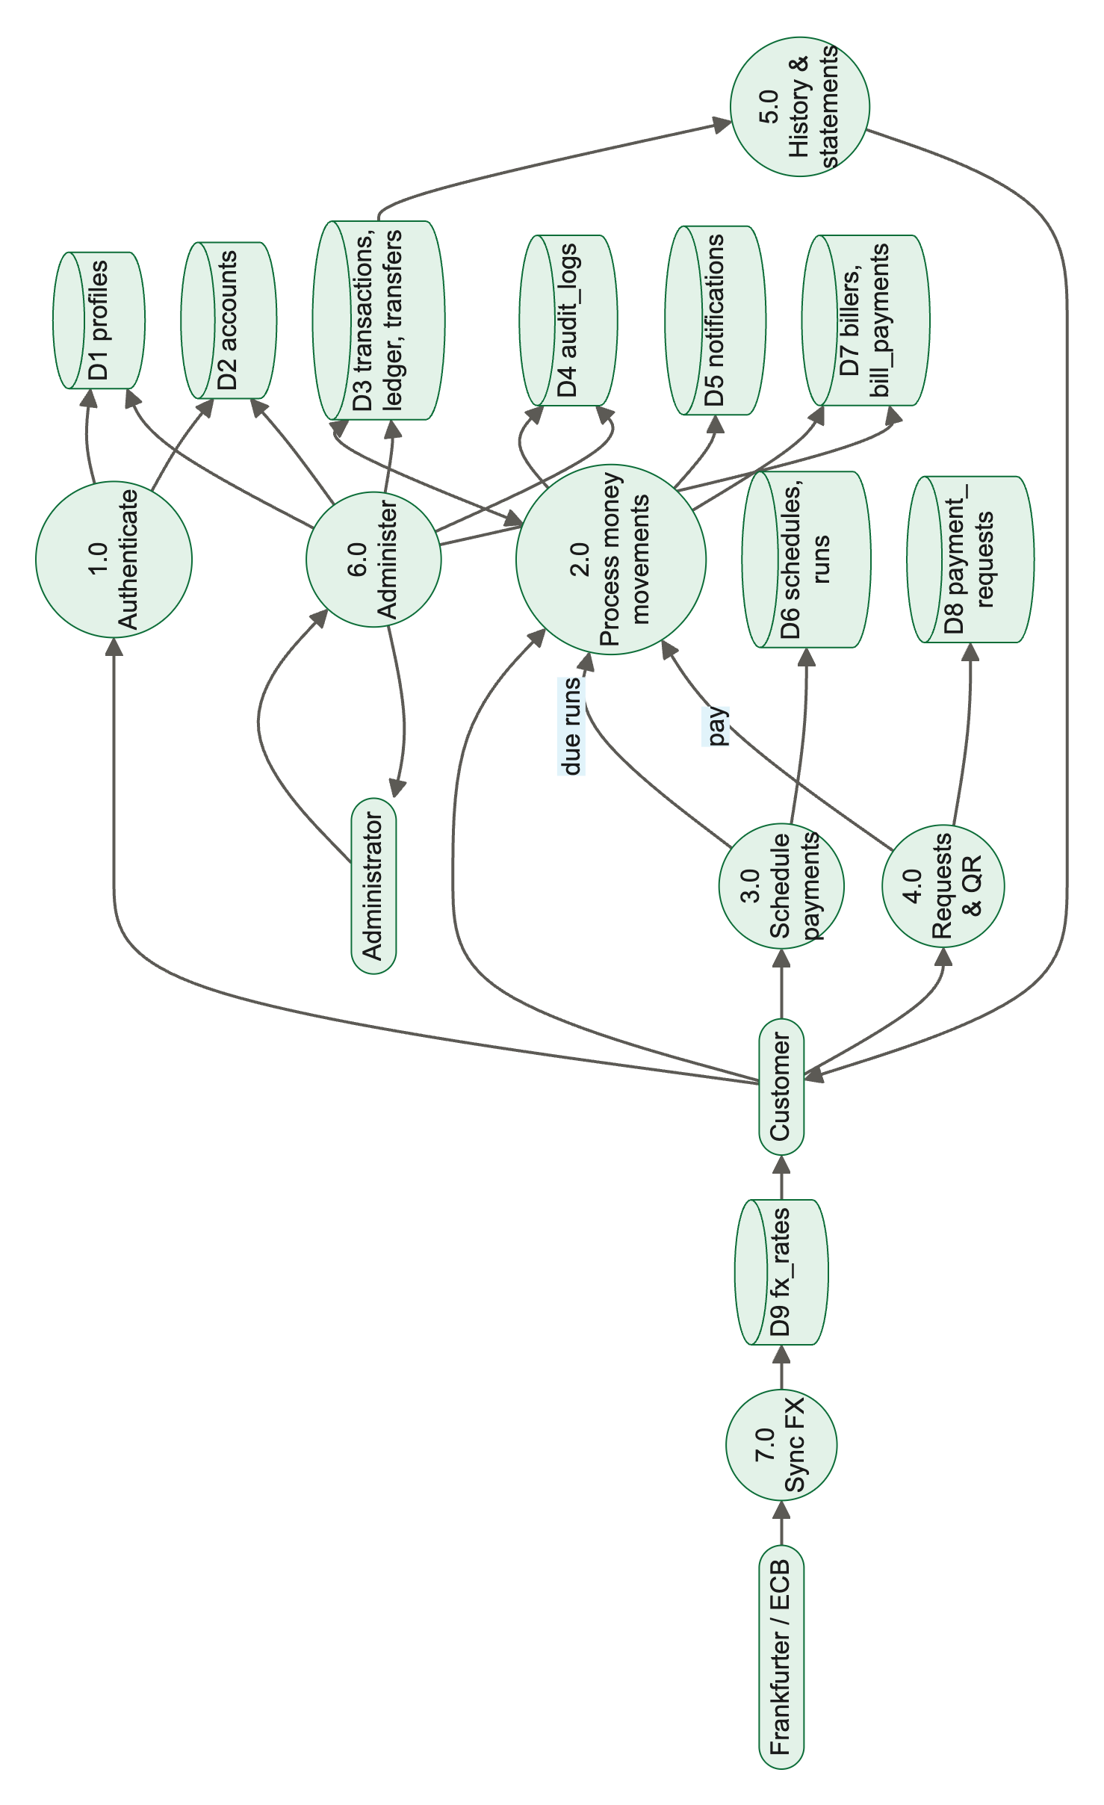
Figure 5. Data flow diagram level 1 (rotated to fit the page)

3.6 Database Design and Entity Relationship Diagrams
The database was designed first and the screens second. It has 15 tables in the public schema, two views and 39 functions. Figure 6 shows the core banking entities and Figure 7 the entities added in Phase 5 for recipients, billers, schedules, payment requests and exchange rates. Appendix A gives the full data dictionary.
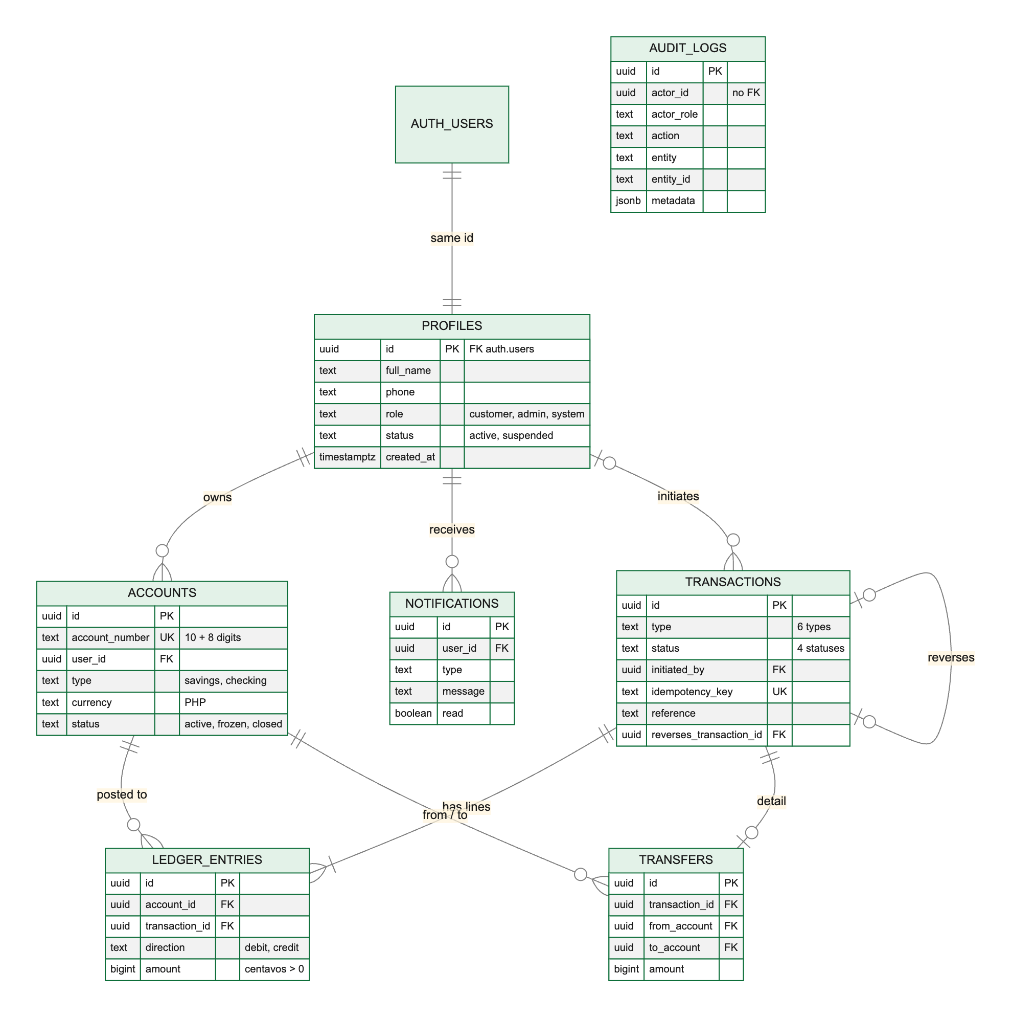
Figure 6. Entity relationship diagram: core banking entities
Every user who signs up has one row in profiles, keyed by the same identifier as the Supabase auth.users record, and one or more rows in accounts. A money event is recorded as one row in transactions (the envelope) and one or more rows in ledger_entries (the lines). Each ledger entry carries a positive amount in centavos and a direction, debit or credit. For transfers, a transfers row records the source and destination accounts. A reversal is a new transaction that points to the transaction it reverses; a unique index ensures that a transaction can be reversed only once.
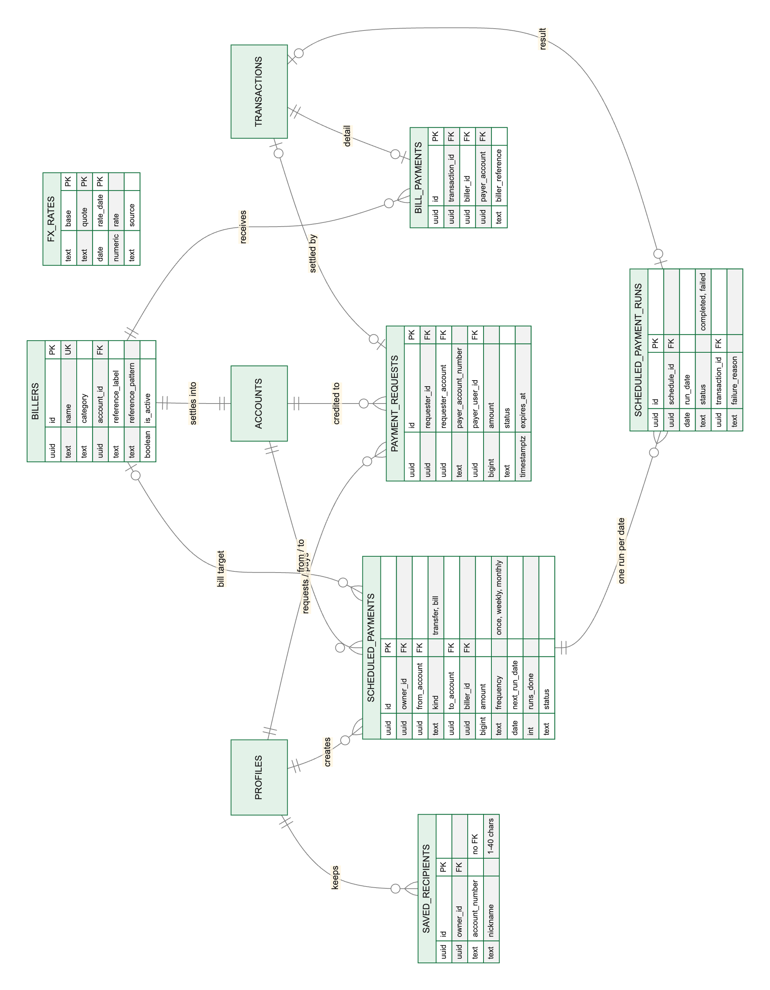
Figure 7. Entity relationship diagram: features added in Phase 5 (rotated to fit the page)
Each demonstration biller has its own settlement account, owned by the non-login system profile, so a bill payment is an ordinary balanced transfer from the customer to that account plus a bill_payments detail row. Scheduled payments are instructions; each execution is recorded once per date in scheduled_payment_runs. Payment requests record who asked whom for how much, and link to the transaction that paid them. The fx_rates table stands alone and is used only for display.
Table 11. Summary of database tables
Table | Purpose
profiles | One row per user: name, phone, role (customer, admin, system) and status (active, suspended)
accounts | Customer and biller settlement accounts: 10-digit number, type, currency, status
transactions | Envelope of every money event: type, status, initiator, idempotency key, reference
ledger_entries | Debit and credit lines; the source of truth for balances
transfers | Source and destination accounts of a transfer-type transaction
audit_logs | Append-only record of sensitive actions
notifications | In-app messages to users
saved_recipients | A customer's saved destination accounts and nicknames
billers | Demonstration billers with reference format rules
bill_payments | Biller and reference for each bill-payment transaction
scheduled_payments | One-time and recurring transfer or bill instructions
scheduled_payment_runs | One execution record per schedule per date
payment_requests | Money requests between customers
fx_rates | Daily ECB reference rates for USD, EUR and JPY against PHP
health_check | Connectivity probe used by tests and development diagnostics

3.7 User Interface Design

3.7.1 Design Principles
The interface design follows three principles. Clarity over decoration: money amounts, accounts and primary actions must be easy to find. Confirmation before commitment: every outgoing money movement passes through a review screen and an authorization step. Local identity: the palette, greeting and planned illustrations reflect Davao City without imitating any existing bank.

3.7.2 The Kadayawan Visual Identity
The color palette was sampled from the Kadayawan 2026 festival identity and approved on 23 October 2026. Mt. Apo green is the single primary action color; the other festival colors are used as accents for action tiles, icons and charts. The tokens are defined once in the shared package and used by both clients, and a check script confirms that the admin console's CSS variables match them.
Table 12. Core color tokens
Token | Value | Use
primary | #0C6D38 | Primary buttons, balance card, active tab, links
green | #03AA56 | Accent; Cash-in tile
blue | #0099C8 | Accent; Transfer tile
orange | #FD4B12 | Accent; Pay Bills and Cash-out tiles
yellow | #FEAD0B | Accent; Scheduled tile
red / redText | #EF2D23 / #C8102E | Destructive actions and error text
ink | #1A1A1A | Primary text
canvas | #F7F5F0 | Screen background

The typeface is Plus Jakarta Sans, loaded in four weights. Spacing follows a 4-point scale (4, 8, 12, 16, 20, 24, 32, 40, 48), and corner radii are 10, 16, 24 and 32 points. Icons come from the Lucide set on both clients.

3.7.3 Navigation Structure
Figure 8 shows how a user moves through the mobile app. On launch the app restores the saved session and applies three gates in order: signed in, email verified and not suspended. A user who passes all three reaches the four tabs: Home, Activity, Inbox and Profile. Feature flows such as Transfer and Pay Bills open as bottom sheets over the current tab, so the user never loses his or her place.
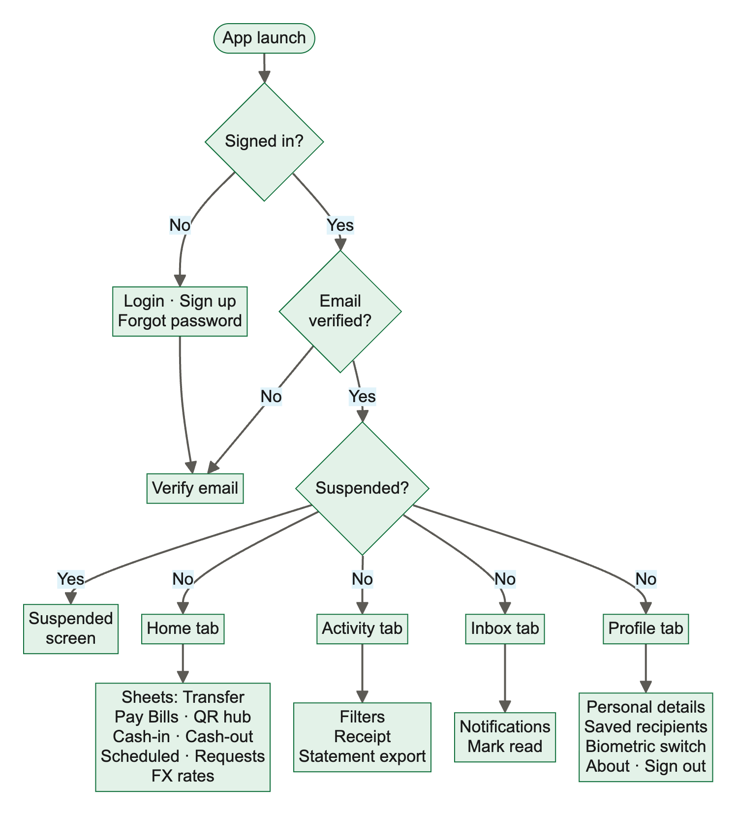
Figure 8. Mobile app navigation and screen flow

3.7.4 Principal Screens
Figure 9 shows the sign-in screen and the Home screen as they appeared on the iOS simulator on 3 November 2026. The Home screen places the balance card first, followed by six action tiles, a currency watch card, upcoming payments and recent activity. The blue gear button visible at the top right of mobile screenshots belongs to the Expo Go developer menu, not to the application.
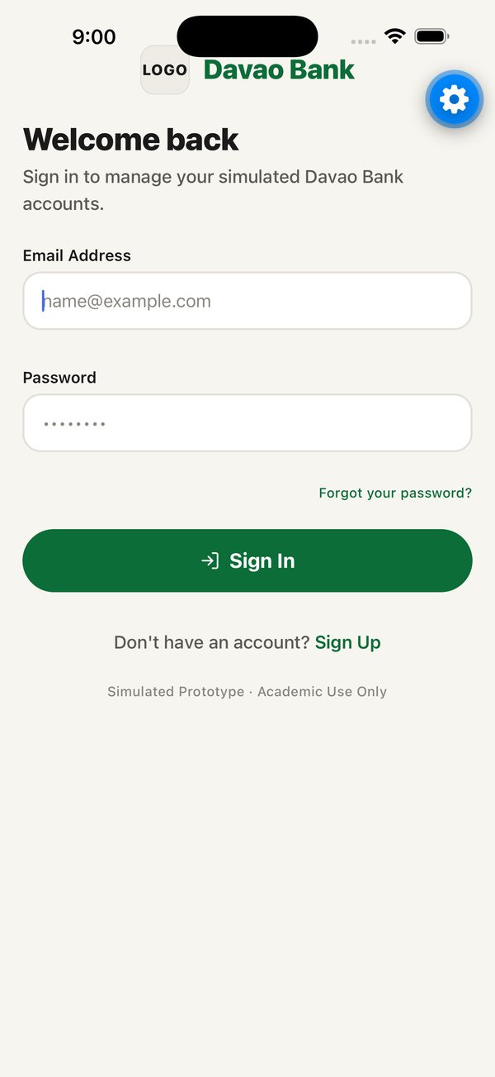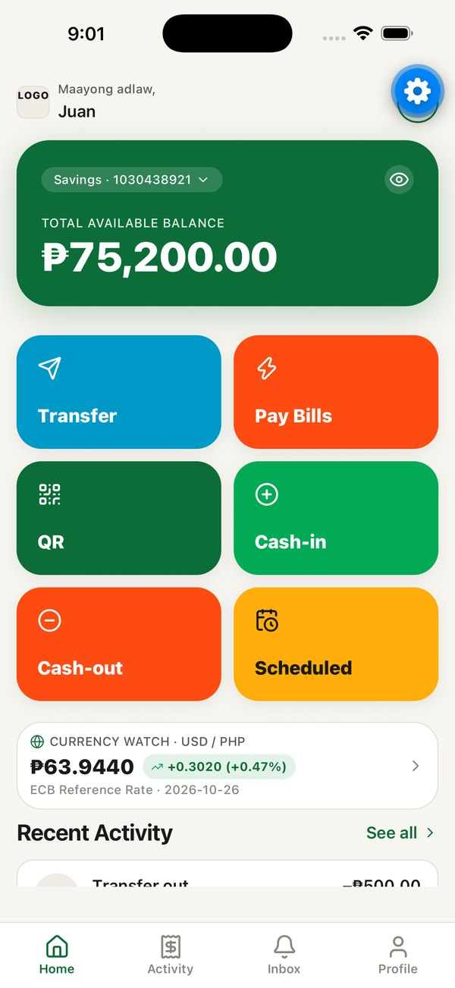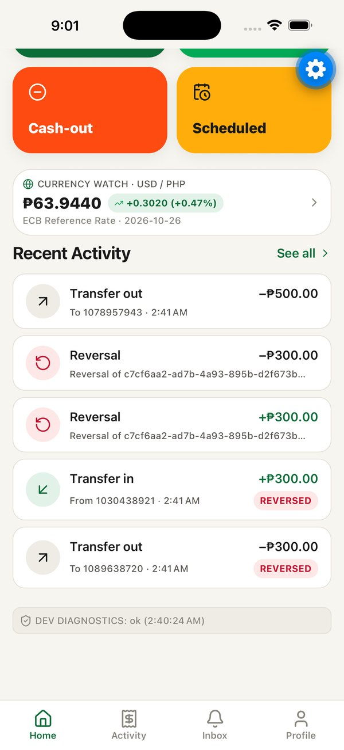
Figure 9. Sign-in screen, Home screen, and Home screen scrolled to recent activity (iOS simulator, 3 Nov 2026)

3.7.5 Accessibility Considerations and Known Gaps
Several accessibility measures are in place: balance hiding with screen-reader labels, haptic feedback on money results, Reduce Motion support in skeleton loaders and sheets, and an accessible summary for the exchange-rate chart. A user-interface audit on 3 November 2026 also found gaps that remain open and are scheduled for the next phase:
- The Plus Jakarta Sans font files load, but the text style refers to a font name that is not registered, so most text renders in the system font.
- White labels on the blue, green and orange action tiles have a contrast ratio of about 3.0 to 3.4 to 1, below the 4.5 to 1 required by WCAG AA for text of that size. The muted grey text color is also below 4.5 to 1.
- Several touch targets are smaller than 44 points, and some buttons lack screen-reader roles and labels.

Chapter 4. System Implementation
This chapter documents the system as it exists in the repository on 4 November 2026 (branch phase-6-hardening, commit f5f3086). Where Phase 6 Stage B security work was still uncommitted, it is identified as in progress. Line-level references to source files were verified during the review that produced this document.

4.1 Application Structure
The code is organised as an npm workspaces monorepo. Each client is a workspace, the shared code is a third workspace, and the database is defined entirely by SQL migration files that are applied in order and never edited after the fact.
davao-bank/
├── apps/
│ ├── mobile/ Customer app (Expo, React Native)
│ │ ├── App.tsx Session restore, gates, tab navigator
│ │ ├── assets/ App icons, illustrations, biller icons
│ │ └── src/
│ │ ├── components/ Button, Card, BottomSheet, TextField, AmountInput, ...
│ │ ├── context/ SettingsContext (hide balance, biometrics, confirmation)
│ │ ├── lib/ Supabase client configuration
│ │ └── screens/ Tabs and feature sheets (Transfer, PayBills, QR, ...)
│ └── admin/ Staff console (Next.js App Router)
│ └── src/
│ ├── middleware.ts Session refresh and admin gate
│ ├── app/ One folder per page; actions.ts (server actions)
│ ├── components/ui/ Table, Drawer, ConfirmDialog, StatTile, ...
│ └── lib/ Server and browser Supabase clients
├── packages/shared/ Supabase wrappers, types, tokens, currency/QR/error utils
├── supabase/
│ ├── migrations/ 12 SQL migrations (schema, policies, functions, jobs)
│ ├── functions/fx-sync/ Edge Function for exchange rates
│ └── seed.sql Local seed data
├── scripts/ Seed script, live test suites, PGlite review harness
└── e2e/ Maestro (mobile) and Playwright (admin) flows

4.2 Customer Mobile Application

4.2.1 Navigation and Screen Organisation
App.tsx decides what to render without a navigator: a splash screen while fonts and the session load, the authentication screens when signed out, the email verification screen when the email is unconfirmed, the suspended screen when the profile is suspended, and otherwise the main app. The main app is a bottom tab navigator with four tabs: Home, Activity, Inbox (with an unread badge) and Profile. Every feature flow is a React Native modal presented as a bottom sheet by the shared BottomSheet component and opened by a state flag in its parent screen. The exchange-rate screen is the exception; it is a full page sheet.

4.2.2 State Management
The app does not use a global store. Each screen holds its own state with React hooks and loads the data it needs. One React context, SettingsContext, provides settings that several screens share: whether balances are hidden, whether biometric confirmation is enabled, what kind of biometrics the device supports, and the confirmation function used before money moves. These preferences are stored on the device in AsyncStorage under the keys @davao_bank_hide_balance and @davao_bank_biometric_enabled. The Supabase session is also stored on the device; Phase 6 Stage B is replacing plain storage with an encrypted store whose key is kept in the device keychain through expo-secure-store.

4.2.3 Connection to Supabase
The mobile client is created by a factory in the shared package and configured with AsyncStorage for the session, automatic token refresh and no URL-based session detection. It is given only the public anon key, read from the environment variables EXPO_PUBLIC_SUPABASE_URL and EXPO_PUBLIC_SUPABASE_ANON_KEY. Every request also carries the signed-in user's token, so the database knows who is calling and applies Row Level Security accordingly.

4.2.4 Confirmation Before Money Moves
Every outgoing money movement except cash-in calls confirmMoneyAction from SettingsContext before contacting the server. If biometrics are enabled and available, it asks for Face ID or a fingerprint; the device passcode is accepted as a fallback by the operating system. If biometrics are off, unavailable or fail, it shows a password dialog and checks the password by signing in again with the user's own email. The function never returns success unless one of these checks passes, a rule added after the Phase 5 review found that devices without biometrics skipped confirmation entirely. Cancelling returns a "cancelled" result, and the flow shows that nothing was sent.

4.2.5 Error Handling
Money operations pass server errors through toUserMessage, a shared function that converts database messages into plain language. For example, "Insufficient funds" becomes "Not enough balance. You have ₱X available." and any unrecognised error becomes "Something went wrong. No money was sent. Try again." The original message is logged in development builds only. Errors appear in an inline red card on the relevant step. Some secondary screens, including sign-in and statement export, still show the raw message; this is listed in Section 5.6.
Bottom sheets protect money flows from accidental dismissal. While a request is being processed the sheet cannot be closed. On later steps, tapping outside the sheet goes back one step; on the first step with input it asks "Discard this transfer? Your details will be lost." before closing. Non-money sheets still close immediately on an outside tap.

4.3 Detailed Feature Documentation: Mobile Application
Each function below is described with the same ten fields: purpose, user, entry point, process, inputs, validation, system processing, database interaction, output and exceptions. Amounts are entered in pesos and converted to integer centavos before they are sent. Limits quoted are those enforced by the database.

4.3.1 App Launch and Session Restore
Purpose | Restore a saved session and route the user to the correct screen.
User | Anyone opening the app.
Entry point | Starting the app.
Process | The app loads the Plus Jakarta Sans fonts and shows a splash screen, reads the stored session with getSession, and subscribes to authentication changes. If a user is signed in, it loads the profile; if no profile exists, it calls ensure_my_profile to create one and reloads. It then applies the gates: not signed in leads to Login, unverified email to Verify Email, suspended profile to the Suspended screen, otherwise the tabs.
Inputs | None.
Validation | None on the client; the gates depend on the session and profile.
System processing | supabase-js restores and refreshes the token. ensure_my_profile (SECURITY DEFINER) creates a customer profile and a savings account for the caller only if they are missing.
Database interaction | Reads profiles; may insert into profiles and accounts.
Output | The appropriate screen.
Exceptions | Profile load errors are logged and the tabs show placeholder names. Suspension is re-checked on sign-in events and Home reloads, not continuously.

4.3.2 Registration (Sign Up)
Purpose | Create a customer login and a first account.
User | A new customer.
Entry point | Login screen, "Sign Up" link.
Process | The user completes the form and taps "Create Account". After client validation the app calls supabase.auth.signUp with the name and phone as metadata, then shows the Verify Email screen.
Inputs | Full legal name; mobile number (optional); email address; password; password confirmation.
Validation | Client: name and email required, password at least 6 characters, passwords match. Server: Supabase Auth checks email format and uniqueness.
System processing | The trigger on_auth_user_created runs handle_new_user, which inserts a customer profile and a PHP savings account with a generated 10-digit number beginning with "10".
Database interaction | Inserts into auth.users, profiles and accounts.
Output | The Verify Email screen.
Exceptions | Supabase errors are shown as returned. The phone format is not validated. Phase 6 Stage B raises the password minimum to 10 characters.

4.3.3 Email Verification
Purpose | Ensure the email belongs to the user before the app can be used.
User | A newly registered or unverified customer.
Entry point | Automatically after sign-up, after a sign-in rejected with "email not confirmed", or the launch gate.
Process | The screen shows the email address. "Resend Verification Email" calls supabase.auth.resend; "Back to Sign In" returns to Login, signing out first if needed. After confirming through the email link, the user signs in again.
Inputs | None; the email is passed in.
Validation | Resend is ignored if no email is known.
System processing | Supabase Auth sends the email and records confirmation.
Database interaction | auth.users (managed by Supabase).
Output | A confirmation message, or the error returned.
Exceptions | The email link does not open the app; the user must return and sign in.

4.3.4 Sign In, Password Reset and Sign Out
Purpose | Authenticate a customer, request a password reset, and end the session.
User | A registered customer.
Entry point | Login screen; "Forgot your password?" link; Profile, "Sign Out".
Process | Sign in calls signInWithPassword. If the email is unconfirmed, the app routes to Verify Email. Forgot password calls resetPasswordForEmail. Sign out asks for confirmation, calls signOut and returns to Login.
Inputs | Email and password; email only for reset.
Validation | Both fields required for sign in; email required for reset. Supabase Auth checks the credentials.
System processing | Supabase Auth issues or revokes the session. On success the authentication listener re-applies the launch gates.
Database interaction | auth.users; profiles after sign-in.
Output | Home, Verify Email or Suspended screen; a "reset instructions sent" message; the Login screen after sign out.
Exceptions | The reset link opens Supabase's default site because no in-app reset screen exists, so the reset cannot be completed in the app. Device preferences are not cleared at sign out.

4.3.5 Home Dashboard and Balance
Purpose | Show balances, shortcuts and recent activity at a glance.
User | A verified, active customer.
Entry point | Home tab.
Process | On load and on pull-to-refresh the screen loads, in parallel, the profile, account balances and transaction history, then counts pending payment requests and the next three active schedules. It shows a greeting ("Maayong adlaw,"), the balance card with an account selector and an eye button that hides amounts, a banner for pending requests, six action tiles (Transfer, Pay Bills, QR, Cash-in, Cash-out, Scheduled), the USD/PHP currency watch card, upcoming payments and the five most recent transactions.
Inputs | None; taps on tiles and cards.
Validation | None.
System processing | Balances come from the account_balances view, which sums ledger credits minus debits under the caller's RLS. History comes from the get_account_transactions function.
Database interaction | Reads profiles, account_balances, get_account_transactions, payment_requests, scheduled_payments and fx_rates.
Output | The dashboard (Figure 9).
Exceptions | Load failures are logged silently. The balance card label reads "Total Available Balance" and showed the total of all accounts while naming one account (observed 3 Nov 2026; corrected in Phase 6 Stage 0). If no exchange-rate data loads, the currency card shows built-in placeholder values.

4.3.6 Transfer
Transfer is the central money function. Figure 10 shows its three input steps, and Figure 27 in Section 4.7 shows the request it sends.
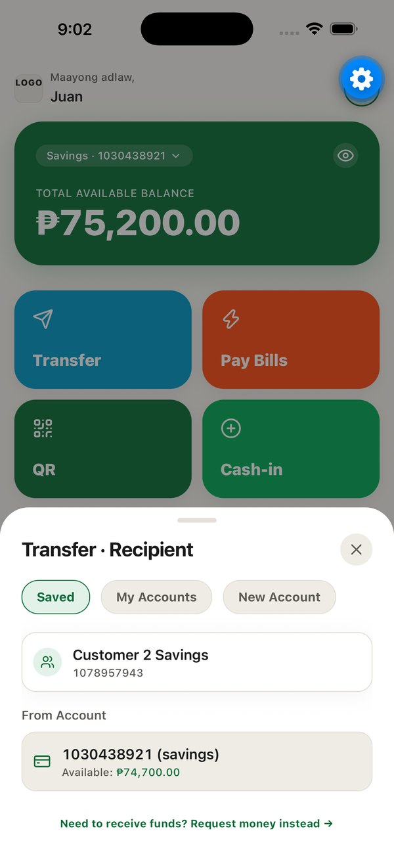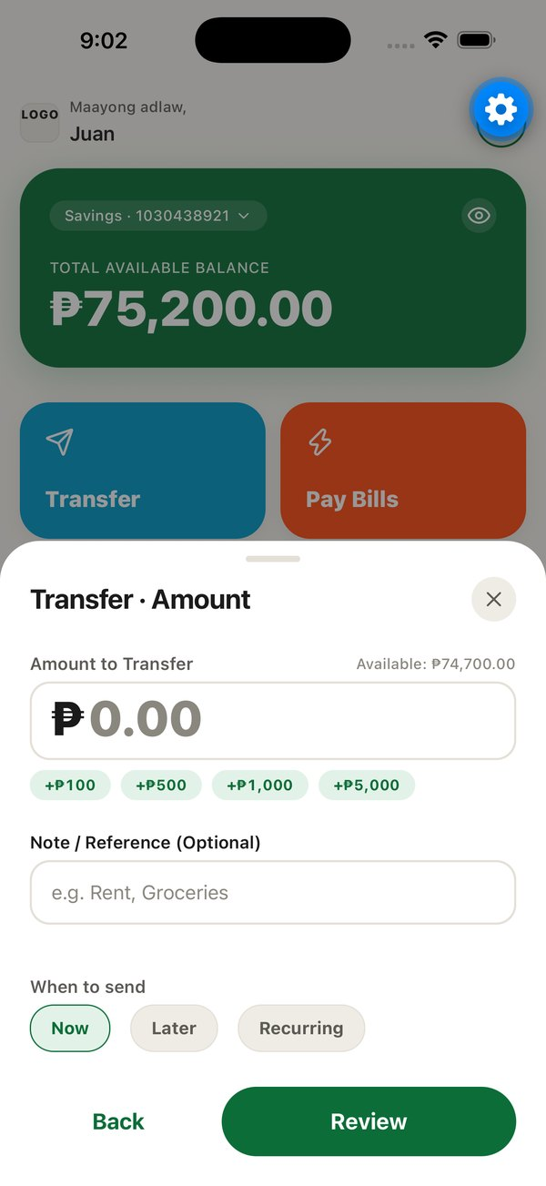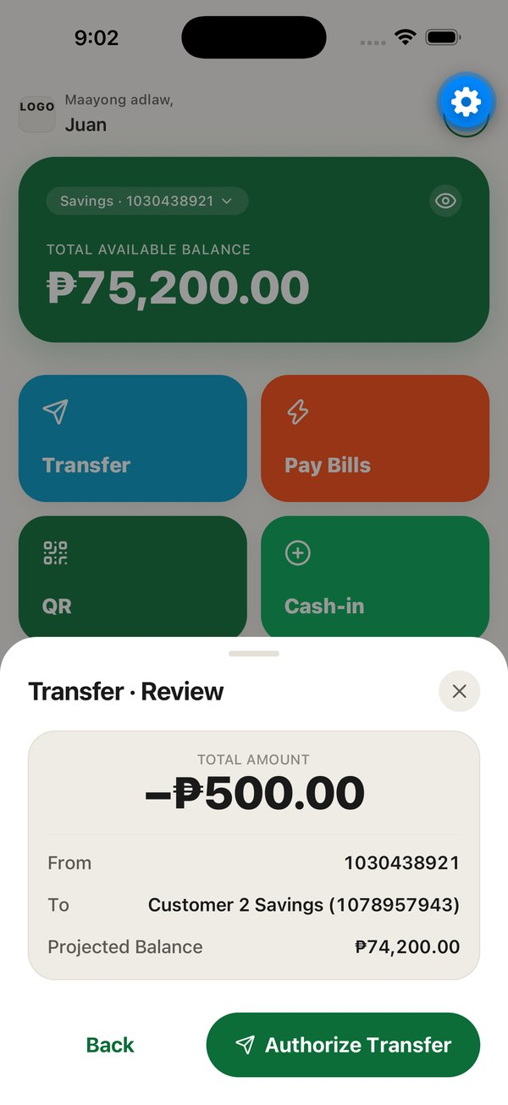
Figure 10. Transfer: recipient, amount and review steps (iOS simulator, 3 Nov 2026)
Purpose | Move pesos to another Davao Bank account, now, once later, or on a recurring schedule.
User | An active customer.
Entry point | Home, "Transfer" tile; also opened pre-filled after scanning a QR code.
Process | 1) Recipient step: choose a saved recipient, one of the user's own accounts, or enter a new 10-digit number (optionally saving it with a nickname). 2) Amount step: amount with preset chips, optional note, and timing (Now, Later or Recurring with weekly or monthly frequency and an optional number of runs). 3) Review step showing amount, from, to, note, timing and projected balance. 4) Authorize with biometrics or password. 5) Submit. 6) Result screen.
Inputs | Recipient account number or selection; amount; note (up to 60 characters); timing; start date (YYYY-MM-DD); frequency; maximum runs.
Validation | Client: recipient required, not the same account, amount greater than zero and not above the available balance. Server: authenticated and not suspended; amount at most ₱5,000,000; source owned by the caller and active; destination exists and is active; same currency; sufficient funds. For schedules: start date not in the past (Asia/Manila), at most 20 active schedules.
System processing | An idempotency key (prefix transfer_) is created when the sheet opens and regenerated whenever the recipient, amount, note or source changes. "Now" calls transfer_by_account_number, which resolves the number and calls transfer, which calls the engine _transfer_core (Section 4.5.1). "Later" and "Recurring" call create_scheduled_transfer_to_number, which resolves the number on the server and calls create_scheduled_payment. If "save recipient" was ticked, add_saved_recipient is called afterwards.
Database interaction | Now: inserts one transactions row, one transfers row, a debit and a credit in ledger_entries, an audit entry and two notifications. Scheduled: inserts a scheduled_payments row and an audit entry.
Output | "Transfer Sent" with recipient and transaction ID, or "Transfer Scheduled"; a replayed request shows "This payment was already processed".
Exceptions | Cancelled authorization shows that nothing was sent. Server errors are mapped to plain language. Known defects found on 4 Nov 2026: refreshing Home after success re-runs the sheet's reset logic, which replaces the result screen after about a second and, on the QR path, returns to the review step with a new key so that a second tap would send a second transfer. The "Updated Balance" on the receipt falls back to the pre-transfer value. These are listed in Section 5.6.

4.3.7 Cash-in (Simulated Deposit)
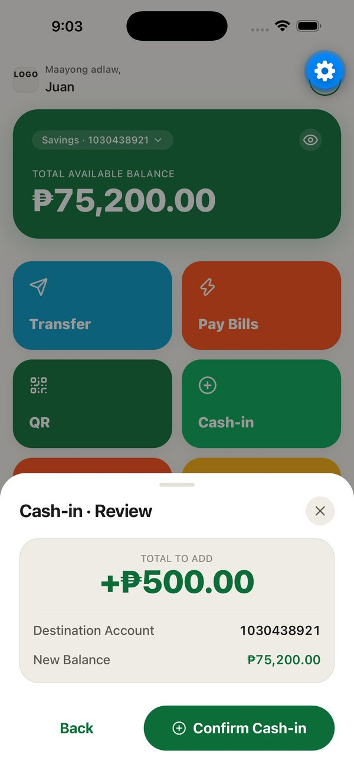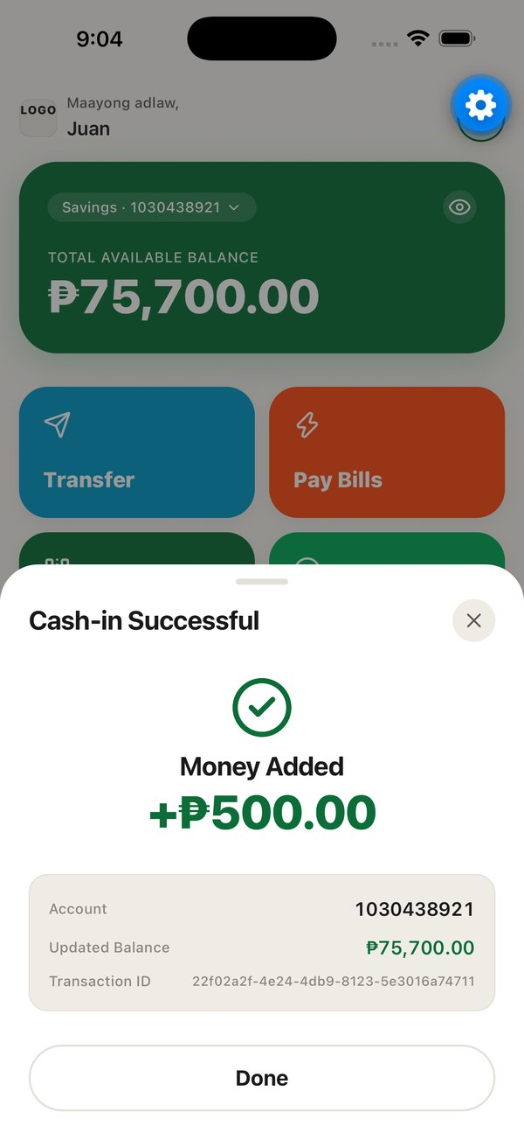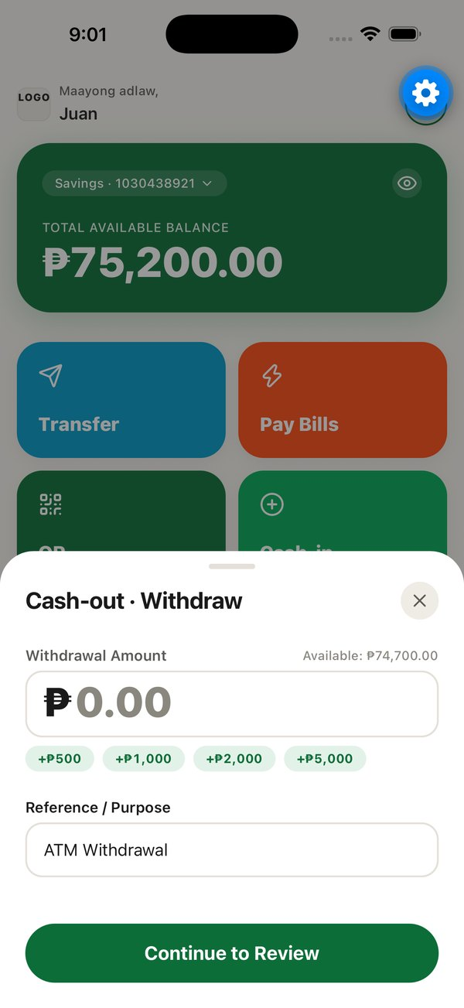
Figure 11. Cash-in review and result screens, and the Cash-out input step
Purpose | Add play money to an account for demonstration.
User | An active customer.
Entry point | Home, "Cash-in" tile.
Process | Enter an amount (presets ₱500 to ₱5,000) and a reference, review, tap "Confirm Cash-in", and see the result.
Inputs | Amount; reference (pre-filled "Online Top-up").
Validation | Client: amount greater than zero. Server: idempotency key required; authenticated and not suspended; amount at most ₱5,000,000; account owned by the caller and active.
System processing | deposit locks the account row, inserts the transaction and one credit entry, and writes the audit entry and notification. No biometric confirmation is required because no money leaves the user.
Database interaction | Inserts into transactions (type deposit), ledger_entries (one credit), audit_logs and notifications.
Output | "Money Added" with account, updated balance, date and transaction ID.
Exceptions | The deposit is single-sided: no contra account is debited (Section 4.5.2).

4.3.8 Cash-out (Simulated Withdrawal)
Purpose | Remove play money from an account for demonstration.
User | An active customer.
Entry point | Home, "Cash-out" tile.
Process | Enter an amount and a reference, review, authorize with biometrics or password, and see the result.
Inputs | Amount; reference (pre-filled "ATM Withdrawal").
Validation | Client: amount greater than zero and not above the balance. Server: as for cash-in, plus "Insufficient funds" when the locked balance is too low.
System processing | withdraw locks the account, computes the balance under the lock, and inserts the transaction and one debit entry.
Database interaction | Inserts into transactions (type withdrawal), ledger_entries (one debit), audit_logs and notifications.
Output | The result screen titled "Cash-out Prepared".
Exceptions | The title "Prepared" suggests the operation is pending although it is complete; Phase 7 replaces it with "Cash-out complete".

4.3.9 Pay Bills
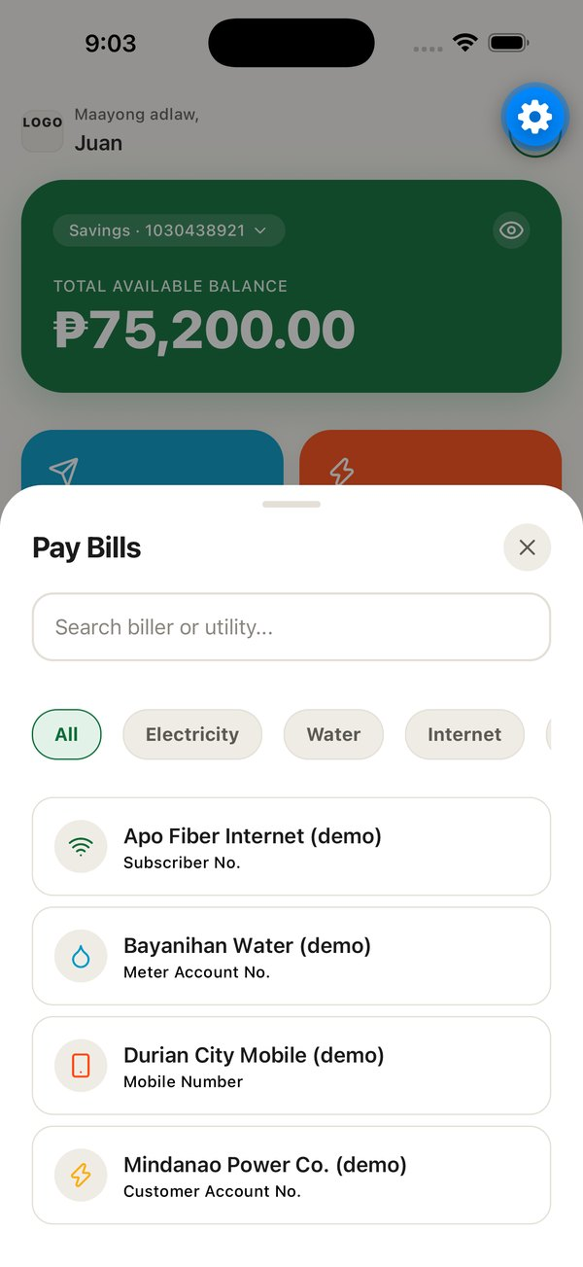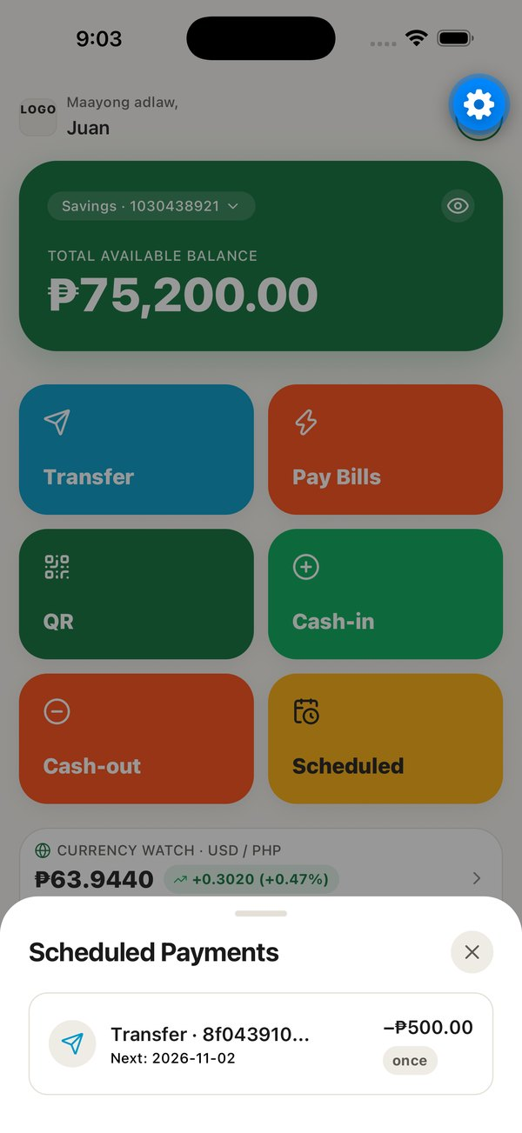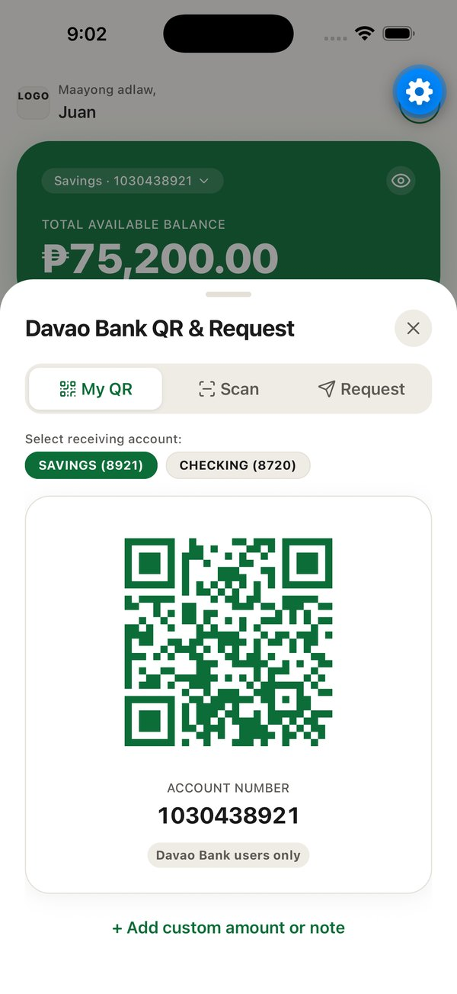
Figure 12. Pay Bills biller list, Scheduled Payments list, and the QR hub
Purpose | Pay a demonstration biller now, once later, or on a schedule.
User | An active customer.
Entry point | Home, "Pay Bills" tile.
Process | Six steps: choose a biller (search and category chips), enter the biller reference, enter the amount, choose timing, review, then authorize and pay. A result screen follows.
Inputs | Biller; reference (labelled by the biller, for example "Meter Account No."); amount; timing and date; frequency and maximum runs for recurring payments.
Validation | Client: reference required and matching the biller's pattern; amount above zero and within the balance. Server: biller exists and is active; reference matches the biller's regular expression; then all engine checks.
System processing | Now: pay_bill calls _transfer_core with type bill_payment to the biller's settlement account and inserts a bill_payments row. Scheduled: create_scheduled_payment with kind bill.
Database interaction | transactions, transfers, two ledger_entries, bill_payments, audit_logs, notifications; or scheduled_payments.
Output | "Payment Completed" with the first eight characters of the reference ID, or "Scheduled for" a date.
Exceptions | The reference helper text shows the raw pattern (for example ^[0-9]{10}$). Billers are fictional and marked "(demo)".

4.3.10 Scheduled Payments
Purpose | List, inspect and cancel scheduled transfers and bill payments.
User | An active customer.
Entry point | Home, "Scheduled" tile or "See all" on upcoming payments; Profile, "Scheduled Payments".
Process | The list shows each schedule's recipient or biller, next date, amount and frequency. Tapping one shows details and the execution history. "Cancel Schedule" asks for confirmation, then for biometrics or password.
Inputs | Selection; confirmation.
Validation | Server: the caller owns the schedule (or is an administrator).
System processing | list_my_scheduled_payments returns the caller's schedules with account numbers and biller names; runs are read from scheduled_payment_runs; cancel_scheduled_payment sets the status to cancelled. Execution is described in Section 4.5.4.
Database interaction | Reads scheduled_payments, accounts, billers, scheduled_payment_runs; updates scheduled_payments; writes audit_logs.
Output | Updated list.
Exceptions | There is no edit screen although an update function exists. Errors appear in a system alert.

4.3.11 QR Hub: My QR, Scan and Request Money
Purpose | Receive money by QR code, pay by scanning, and request money from another customer.
User | An active customer.
Entry point | Home, "QR" tile; Transfer, "Request money instead".
Process | My QR shows a QR code for the selected account, optionally with an amount and note. Scan opens the camera, reads a code and opens Transfer pre-filled; it never sends money by itself. Request asks for the payer's account number, amount and note.
Inputs | Account selection, optional amount and note (QR); camera permission (Scan); payer account number, amount, note (Request).
Validation | QR payload: format davaobank://pay?v=1&acct=<10 digits>[&amt=<centavos>][&note=<text>], amount at most ₱500,000, note at most 60 characters; foreign or malformed codes show "This isn't a Davao Bank QR code". Request (server): amount at most ₱500,000; payer account exists, is active and is not the requester's; at most 10 requests per day.
System processing | QR payloads are built and parsed by shared functions. Requests call create_payment_request, which stores the request with a seven-day expiry and notifies the payer.
Database interaction | Request: inserts into payment_requests, audit_logs, notifications.
Output | A QR code; a pre-filled transfer; "Request Sent!"
Exceptions | Typing a QR amount above ₱500,000 causes an error during rendering. The request form clears if the sheet is closed by an outside tap.

4.3.12 Payment Requests
Purpose | Pay or decline incoming requests and track or cancel outgoing ones.
User | An active customer.
Entry point | Home pending-request banner; Profile, "Payment Requests".
Process | Incoming and Outgoing tabs. Pay Now authorizes with biometrics or password and pays; Decline and Cancel ask for confirmation first.
Inputs | Selection; confirmation.
Validation | Server: only the payer may pay or decline and only the requester (or an administrator) may cancel; the request must be pending and not expired; the source account must be the caller's and active.
System processing | pay_payment_request locks the request row, pays through _transfer_core, marks the request paid and links the transaction. A repeat with the same key returns the original result. decline_payment_request and cancel_payment_request change the status. A daily job expires requests older than seven days.
Database interaction | Updates payment_requests; on payment also transactions, transfers, ledger_entries, audit_logs, notifications.
Output | Updated lists and a status banner.
Exceptions | The source account is chosen automatically. The authorization prompt shows the requester's internal account identifier instead of a masked account number.

4.3.13 Activity and Transaction Receipt
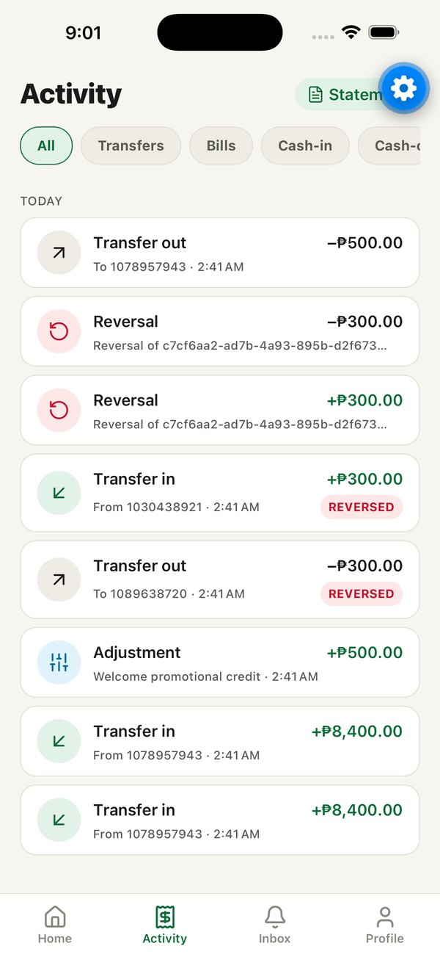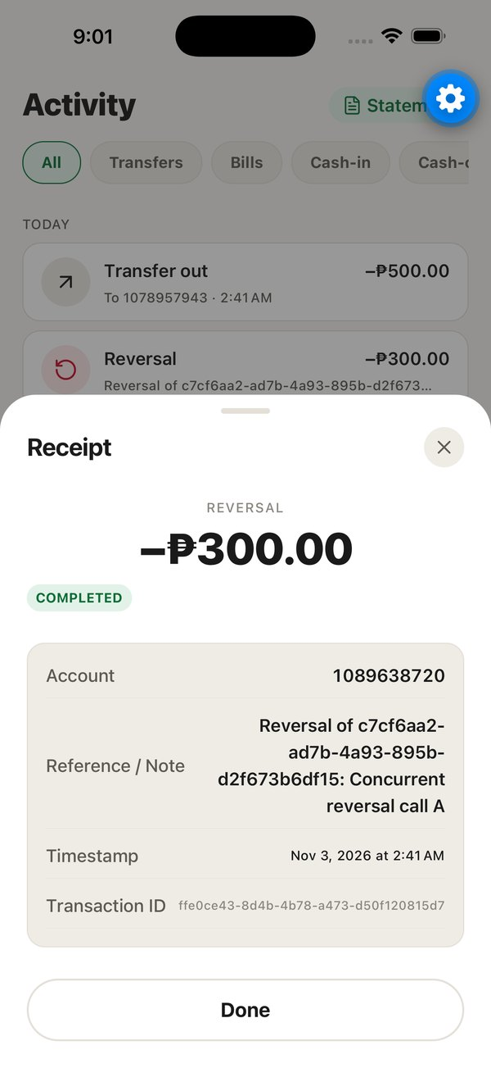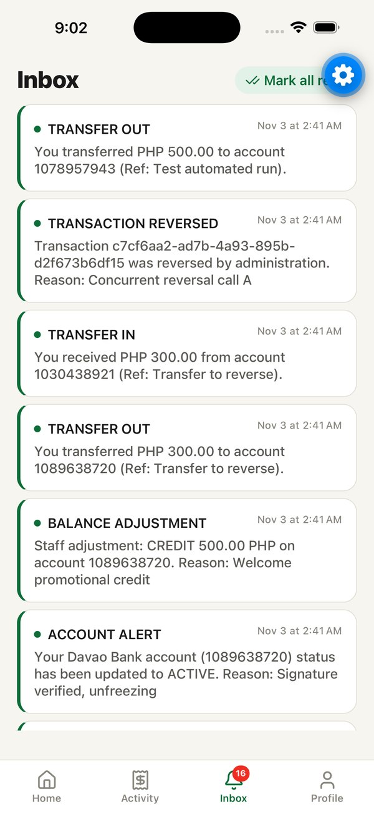
Figure 13. Activity tab, transaction receipt, and Inbox tab (iOS simulator, 3 Nov 2026)
Purpose | Show the full transaction history and a receipt for each item.
User | An active customer.
Entry point | Activity tab; Home, "See all".
Process | History is grouped by day ("TODAY", "YESTERDAY", then dates) and can be filtered by type: Transfers, Bills, Cash-in, Cash-out, Adjustments or Reversals. Tapping a row opens the receipt with type, amount, status, account, counterparty, reference, timestamp and transaction ID.
Inputs | Filter selection; row tap.
Validation | None.
System processing | get_account_transactions returns the caller's ledger lines with signed amounts and the counterparty account number.
Database interaction | Reads transactions, ledger_entries, accounts, transfers through the function, and account_balances.
Output | The history list and receipt (Figure 13).
Exceptions | Amounts in Activity are not masked when "hide balance" is on. Reversal rows show the internal identifier of the reversed transaction. There is no pagination.

4.3.14 Statement Export
Purpose | Produce a reconciled account statement as PDF or CSV.
User | An active customer.
Entry point | Activity, "Statement".
Process | Choose the account and a period (this month, last month, last three months or a custom range), then "Download PDF Statement" or "Export CSV Spreadsheet". The phone's share sheet opens with the file.
Inputs | Account; period or start and end dates.
Validation | Server: the caller owns the account; start date not after end date; period at most 366 days.
System processing | get_account_statement returns the opening balance, the period's transactions and the closing balance, so that opening plus movements equals closing. The PDF is built from HTML with expo-print; the CSV is written with expo-file-system; both are shared with expo-sharing. The PDF footer states that the bank is simulated.
Database interaction | Read only.
Output | A PDF or CSV file in the share sheet.
Exceptions | Errors are shown as returned. Dates must be typed in YYYY-MM-DD form.

4.3.15 Inbox Notifications
Purpose | Show in-app notices about money events and account changes.
User | An active customer.
Entry point | Inbox tab.
Process | Lists notifications newest first with type, time and message. Tapping an unread notice marks it read; "Mark all read" marks every notice read. The tab badge shows the unread count.
Inputs | Taps.
Validation | RLS allows users to read and update only their own notifications.
System processing | Notifications are created by database functions (Section 4.5.6); the app reads and updates them.
Database interaction | Reads and updates notifications.
Output | The list and badge (Figure 13).
Exceptions | The badge is empty until Inbox has been opened once. Message text is written by the database and uses "PHP 500.00" style amounts and administrator wording.

4.3.16 Profile, Saved Recipients and Settings
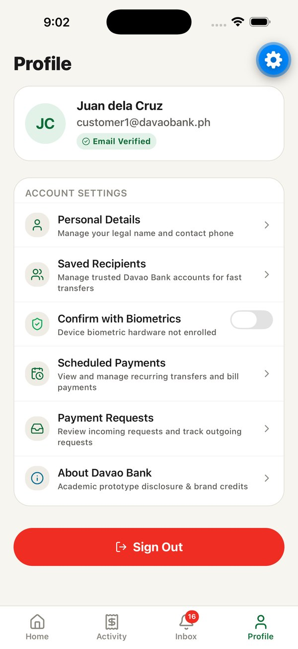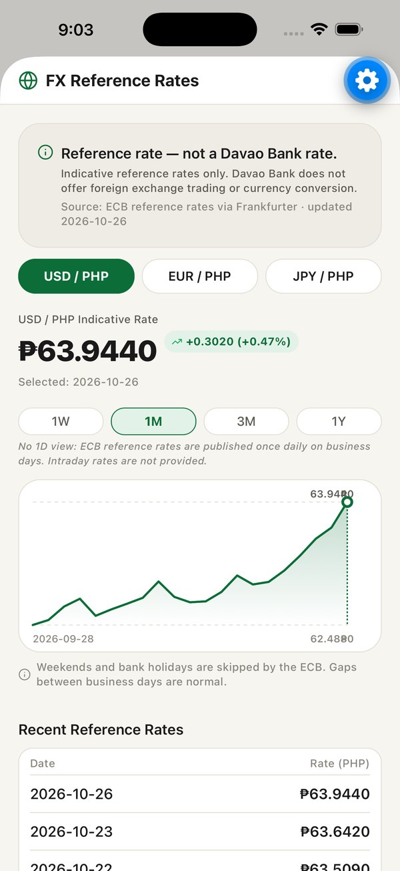
Figure 14. Profile tab and FX reference rates screen
Purpose | Manage personal details, saved recipients, biometric confirmation and other shortcuts.
User | An active customer.
Entry point | Profile tab; Home avatar.
Process | Personal Details edits name and phone. Saved Recipients lists, adds (through add_saved_recipient), renames and deletes recipients. The biometric switch turns confirmation on or off; turning it off requires a successful biometric check. About shows the prototype disclosure and brand credits. Sign Out ends the session.
Inputs | Name, phone; recipient number and nickname; switch state.
Validation | Name required. Recipients (server): nickname 1 to 40 characters; at most 50 recipients and 20 additions per day; account exists, is active and is not the user's own; no duplicates. RLS and a column grant allow customers to change only a recipient's nickname. A trigger blocks customers from changing their own role or status.
System processing | Profile update is a direct update under RLS; recipient additions use a SECURITY DEFINER function.
Database interaction | profiles, saved_recipients, audit_logs.
Output | Updated profile and lists.
Exceptions | Renaming a recipient uses an iOS-only dialog, so it does nothing on Android. The About screen still says "Phase 5 Build".

4.3.17 FX Reference Rates
Purpose | Show indicative ECB reference rates for context. Davao Bank does not exchange currency.
User | An active customer.
Entry point | Home, currency watch card.
Process | Choose USD, EUR or JPY against PHP and a range of one week, one month, three months or one year. The screen shows the latest rate with its change, a line chart that can be scrubbed, a disclaimer and a table of recent rates.
Inputs | Pair and range.
Validation | None.
System processing | Rates are read from fx_rates. The fx-sync Edge Function refreshes them daily (Section 4.5.5).
Database interaction | Reads fx_rates.
Output | The chart screen (Figure 14), with the disclaimer "Reference rate — not a Davao Bank rate."
Exceptions | When the daily sync is not running the latest date shown becomes stale; on 3 Nov 2026 the latest rate was dated 26 Oct 2026.

4.3.18 Suspended Account
Purpose | Block a customer whom staff have suspended.
User | A customer whose profile status is suspended.
Entry point | Automatic, through the launch gate or the Home screen.
Process | The screen explains that access to money operations is restricted and offers "Check Status Again" and "Sign Out".
Inputs | None.
Validation | None on the client.
System processing | Every money function independently rejects a suspended caller with "Your profile is suspended", so the block holds even if a client ignores the screen.
Database interaction | Reads profiles.
Output | The suspended screen.
Exceptions | When the suspension is detected from Home the tab bar remains visible, but money functions still refuse.

4.4 Staff Administration System

4.4.1 Architecture of the Console
The staff console is a Next.js 16 application using the App Router. Each page is a server component that creates a Supabase client bound to the staff member's session cookie, loads its data, and passes it to a client component that handles searching, filtering and dialogs in the browser. Every change is made through a server action in app/actions.ts, which calls a database function with the staff member's own token and then refreshes the affected pages. Because the token belongs to the staff member, the database records the real person in the audit log.
Access is controlled at three layers. Middleware (middleware.ts) refreshes the session on every request, sends signed-out visitors to /login, and sends signed-in users whose profile role is not admin to /unauthorized. Database functions used by the console each begin by calling is_admin(), which returns true only for an active administrator, and raise "Admin privilege required" otherwise. Row Level Security lets administrators read all rows only through policies that call is_admin(). The console never uses the privileged service-role key; a server-only module for it exists but is not imported anywhere.
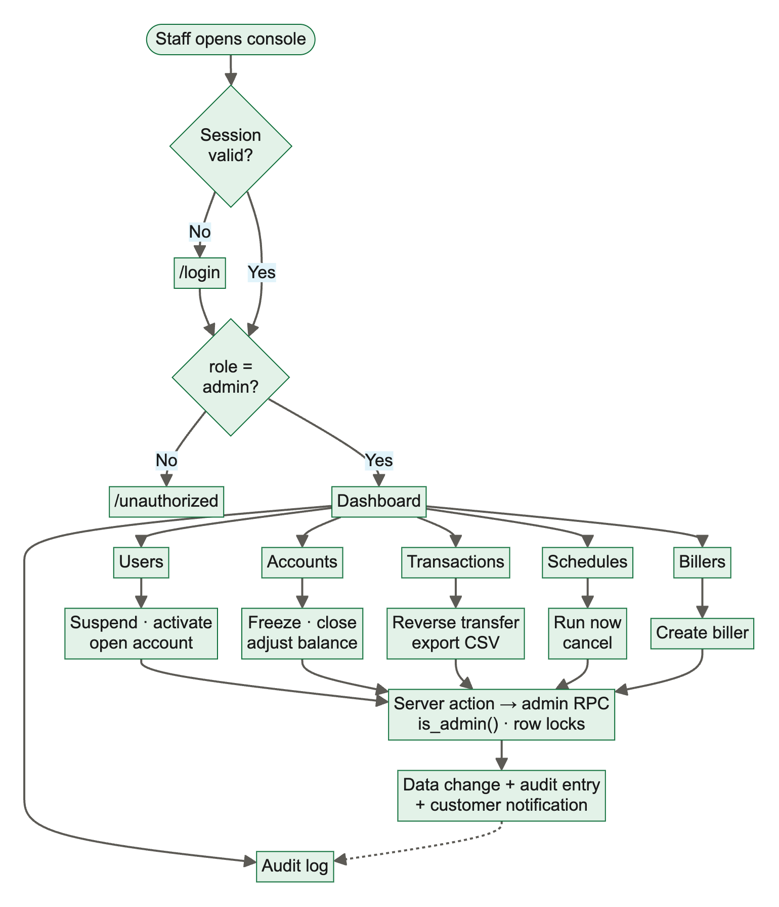
Figure 15. Administrative workflow in the staff console
Table 13. Admin console routes
Route | Page | Main data source
/login | Staff sign-in | Supabase Auth; profiles.role
/ | Dashboard | admin_get_dashboard_stats and recent rows
/users | User and customer directory | admin_get_users, account_balances
/accounts | Deposit and ledger accounts | account_balances, admin_get_users
/transactions | Transaction oversight and reversals; payment requests | transactions, ledger_entries, accounts, payment_requests
/schedules | Scheduled and recurring payments | scheduled_payments, scheduled_payment_runs
/billers | Biller directory and settlement | billers, accounts
/audit | Audit trail | audit_logs (latest 100)
/api/export/transactions | CSV download | transactions, ledger_entries
/unauthorized | Access denied | None

4.4.2 Staff Sign-in
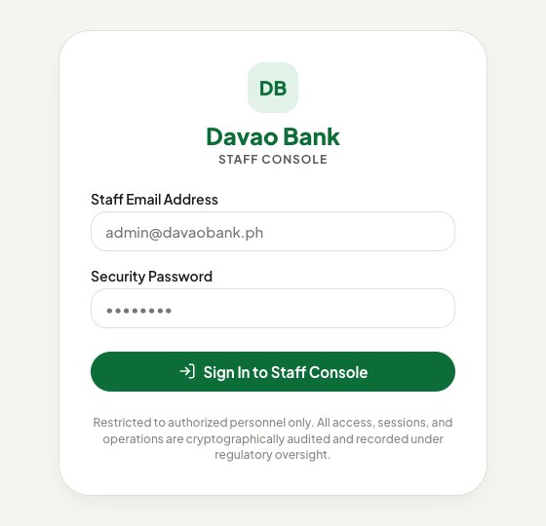
Figure 16. Staff console sign-in page
Purpose | Admit only active administrators to the console.
User | Bank staff with the administrator role.
Entry point | Any console address; unauthenticated visitors are redirected to /login.
Process | The staff member enters email and password and taps "Sign In to Staff Console". The page signs in with Supabase Auth, reads the profile role, and either opens the dashboard or signs out with "Access Denied".
Inputs | Staff email address; password.
Validation | Both fields required. Supabase Auth checks the credentials; the page and the middleware check role = admin.
System processing | The browser client stores the session in cookies so the middleware and server components can read it.
Database interaction | auth.users; reads profiles.role.
Output | The dashboard, or an error banner.
Exceptions | The middleware checks the role but not the status, so a suspended administrator can open pages, but every database function and RLS policy refuses him or her and the pages show empty data. The footer text claims activity is "cryptographically audited", which overstates the audit log.

4.4.3 Dashboard
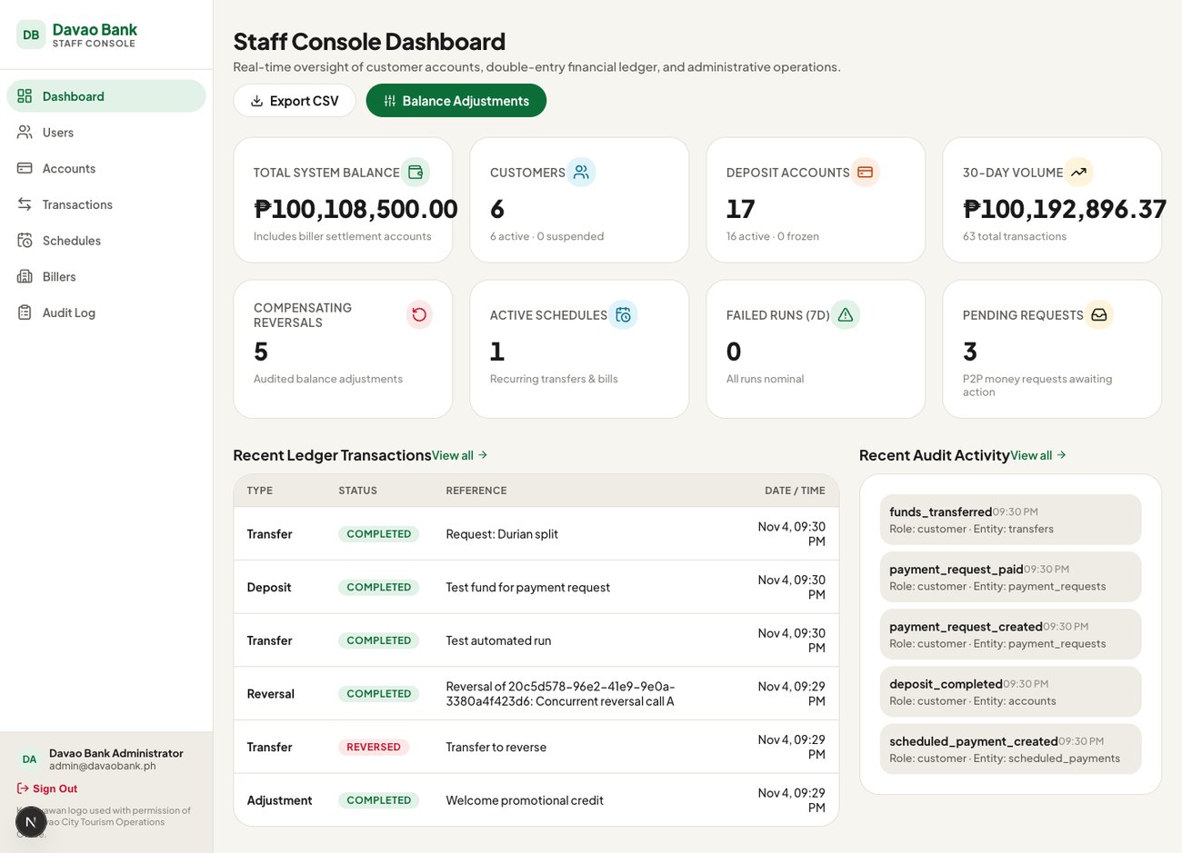
Figure 17. Staff console dashboard (local development server, 4 Nov 2026)
Purpose | Give staff an overview of the system.
User | Administrator.
Entry point | / or "Dashboard" in the sidebar.
Process | The page calls admin_get_dashboard_stats and three counting queries, then shows eight figures (total system balance, customers, deposit accounts, volume, compensating reversals, active schedules, failed runs in the last seven days, pending requests), the six most recent transactions and the five most recent audit entries. Buttons link to the CSV export and to account adjustments.
Inputs | None.
Validation | The function requires is_admin().
System processing | The function counts profiles and accounts by status, sums all balances, counts transactions by status, sums all credit entries as volume and counts the last 30 days of transactions.
Database interaction | Reads profiles, accounts, account_balances, transactions, ledger_entries, scheduled_payments, scheduled_payment_runs, payment_requests, audit_logs.
Output | Figure 17.
Exceptions | Three known issues: the "30-day volume" figure actually shows all-time credits; the "failed runs" figure queries a column that does not exist and therefore always shows zero; and the "customers" count includes staff and the system profile.

4.4.4 User Management
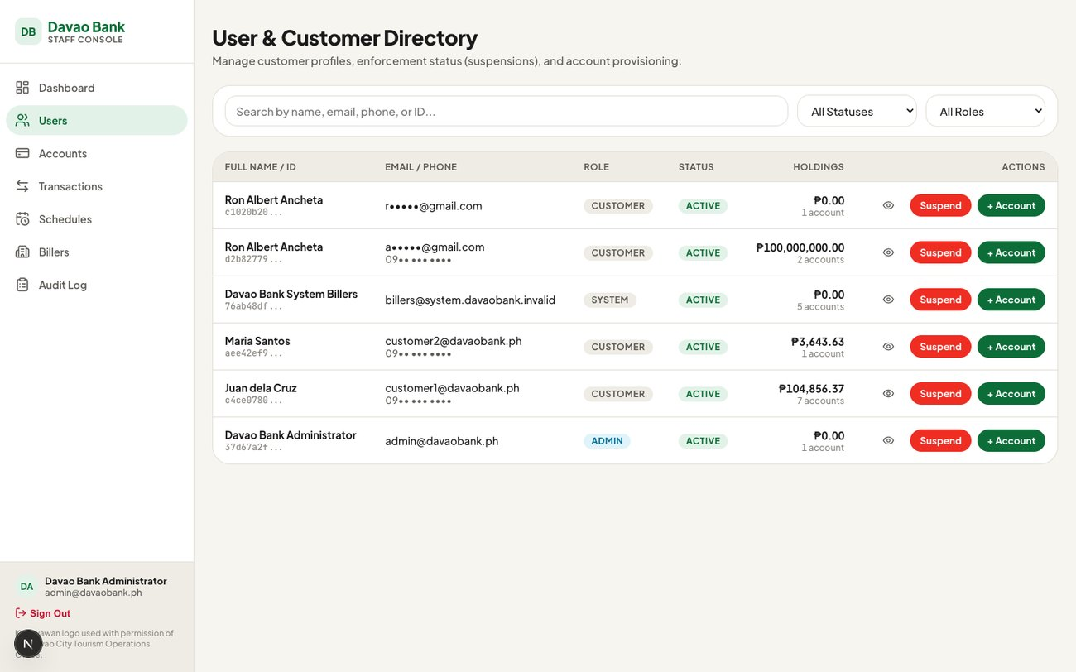
Figure 18. User and customer directory. Personal email addresses and phone numbers have been masked for this document.
Purpose | Find customers, view their accounts, suspend or reactivate them, and open additional accounts.
User | Administrator.
Entry point | Sidebar, "Users".
Process | Search by name, email, phone or identifier and filter by status (including "Needs attention" for logins without a profile) and role. The eye button opens a drawer with the user's accounts. "Suspend" or "Activate" opens a confirmation dialog that requires a reason. "+ Account" opens a drawer to choose savings or checking.
Inputs | Search text, filters, reason, account type.
Validation | Client: the reason cannot be empty. Server: admin_set_user_status requires an administrator, a valid status and a reason; admin_open_account requires an existing profile and a valid type.
System processing | admin_set_user_status updates the profile status (the profile guard trigger permits it because the caller is an administrator), writes admin_user_status_changed to the audit log and notifies the user. admin_open_account generates a unique account number, creates the account, audits and notifies.
Database interaction | Reads auth.users (through admin_get_users), profiles, account_balances; updates profiles; inserts accounts, audit_logs, notifications.
Output | Refreshed table; suspended customers are blocked on their next request (Figure 18).
Exceptions | There is no guard against suspending oneself or other administrators. Roles cannot be changed from the console.

4.4.5 Account Management and Balance Adjustment
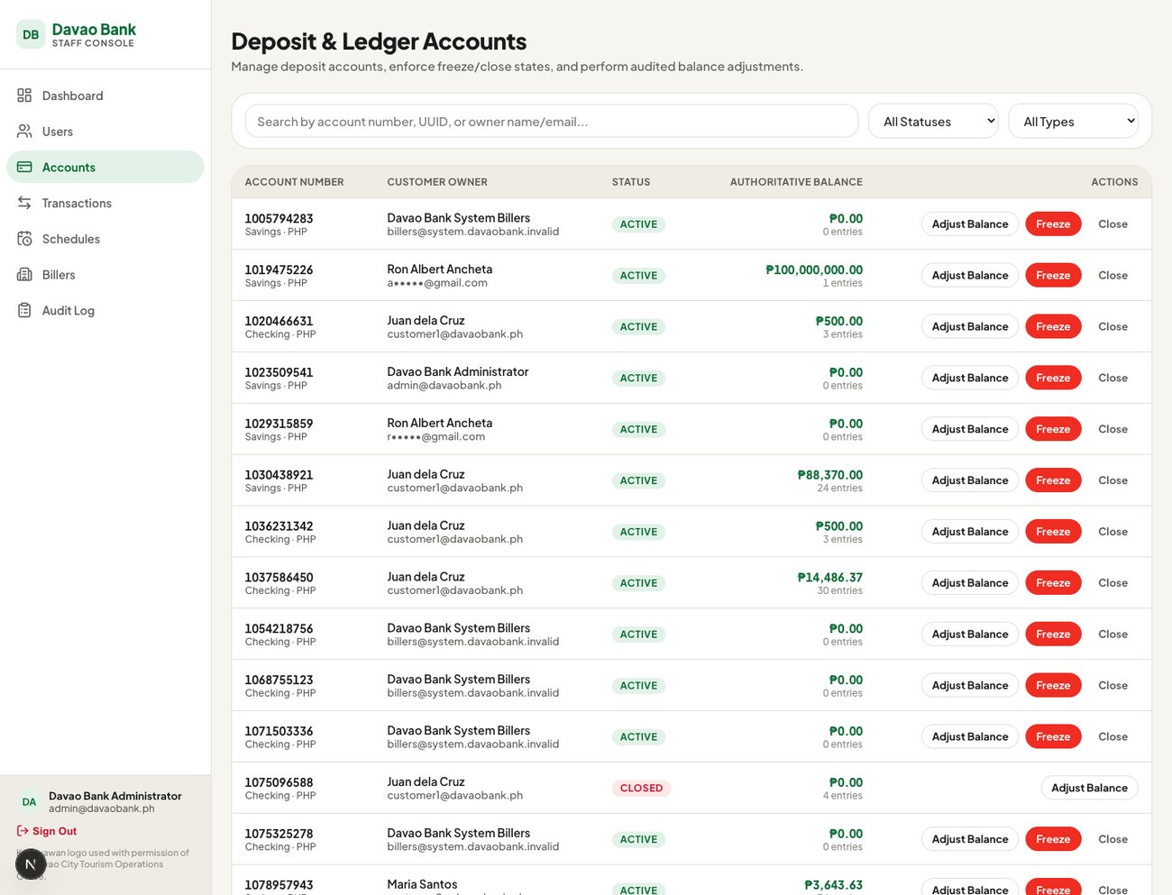
Figure 19. Deposit and ledger accounts. Personal email addresses have been masked.
Purpose | Freeze, unfreeze or close accounts, and correct balances with an audited adjustment.
User | Administrator.
Entry point | Sidebar, "Accounts"; dashboard, "Balance Adjustments".
Process | Search and filter accounts by number, owner, status and type. Freeze, Unfreeze and Close open a confirmation dialog with a mandatory reason. "Adjust Balance" opens a drawer showing the current balance, a credit or debit choice, an amount and a live preview of the resulting balance, then asks for a reason.
Inputs | Status action and reason; direction, amount and reason for adjustments.
Validation | Server, status: valid status; reason required; no change to the same status; closed accounts cannot change; an account can be closed only with a zero balance. Server, adjustment: idempotency key required; amount above zero; reason required; account not closed; a debit cannot make the balance negative.
System processing | Both functions lock the account row. admin_adjust_balance inserts an adjustment transaction whose reference is the reason and one ledger entry, records the balance before and after in the audit metadata, and notifies the owner. The idempotency key is generated when the drawer opens, so a double click cannot apply the adjustment twice.
Database interaction | Updates accounts; inserts transactions, ledger_entries, audit_logs, notifications.
Output | Refreshed balances (Figure 19).
Exceptions | There is no upper limit on adjustment amounts. The confirmation dialog for "Close" is mislabelled "Unfreeze Account". The adjustment notification truncates centavos.

4.4.6 Transaction Monitoring, Reversal and Export
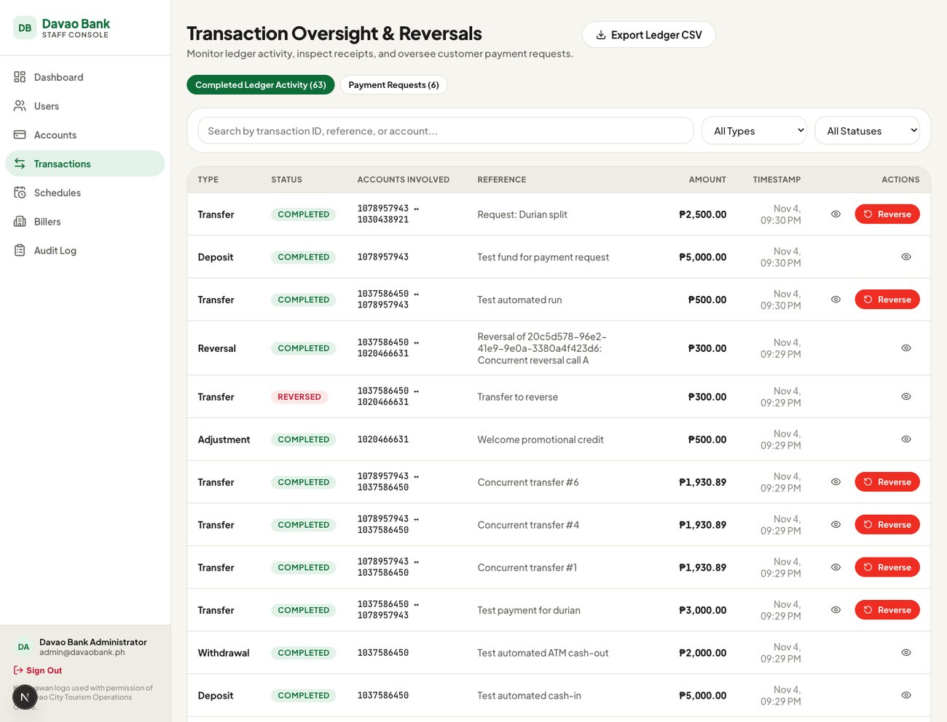
Figure 20. Transaction oversight and reversals
Purpose | Monitor all money movement, inspect receipts, reverse transfers, review payment requests and export data.
User | Administrator.
Entry point | Sidebar, "Transactions"; dashboard "View all"; "Export Ledger CSV".
Process | Two tabs list completed ledger activity and payment requests, with search and filters by type and status. A row opens a drawer with the transaction's amount, status, identifier, idempotency key and accounts. "Reverse" appears on completed transfers and opens a dialog requiring a reason. "Export Ledger CSV" downloads all transactions.
Inputs | Search text, filters, reason.
Validation | Server, reversal: administrator; idempotency key; reason; original must be completed, not already reversed and not itself a reversal; no affected account may go negative.
System processing | admin_reverse_transaction locks the original transaction first, then the affected accounts in a fixed order, inserts a reversal transaction pointing to the original, writes mirror-image ledger entries, marks the original "reversed", audits and notifies the owners (Figure 28). A unique index on the reversal reference makes a second reversal impossible even under concurrent attempts. The export route checks the administrator role and returns a CSV file.
Database interaction | Reads transactions, ledger_entries, accounts, payment_requests; on reversal inserts transactions, ledger_entries, transfers, audit_logs, notifications and updates the original transaction.
Output | Refreshed table (Figure 20) or a CSV download.
Exceptions | The type filter lacks "bill payment". The page and the export read whole tables without pagination, so results would be truncated beyond 1,000 rows. Exports are not audited.

4.4.7 Scheduled Payments, Billers and Audit Log
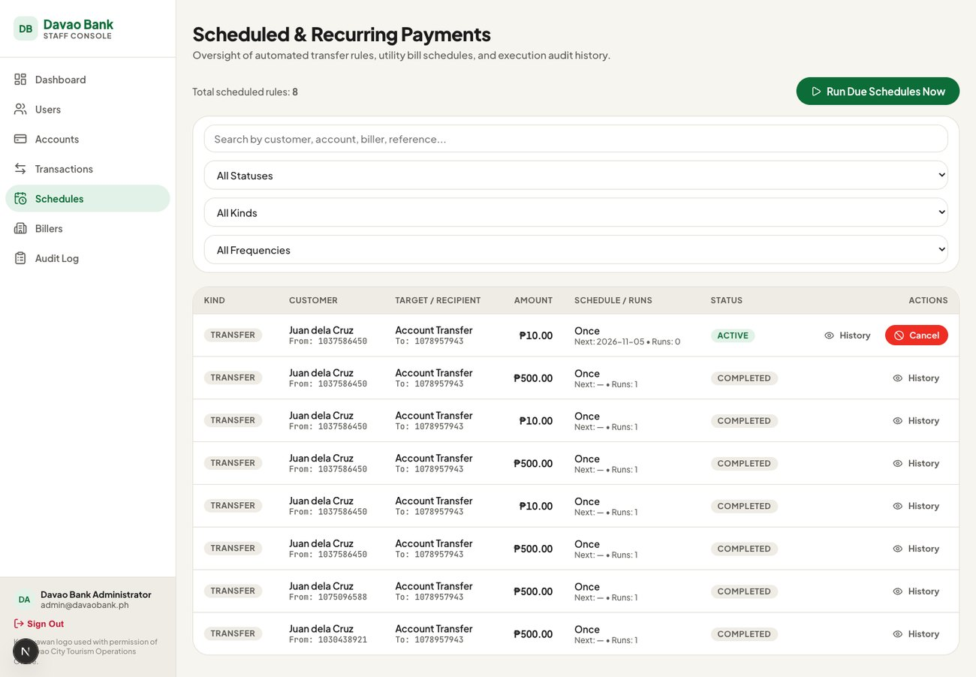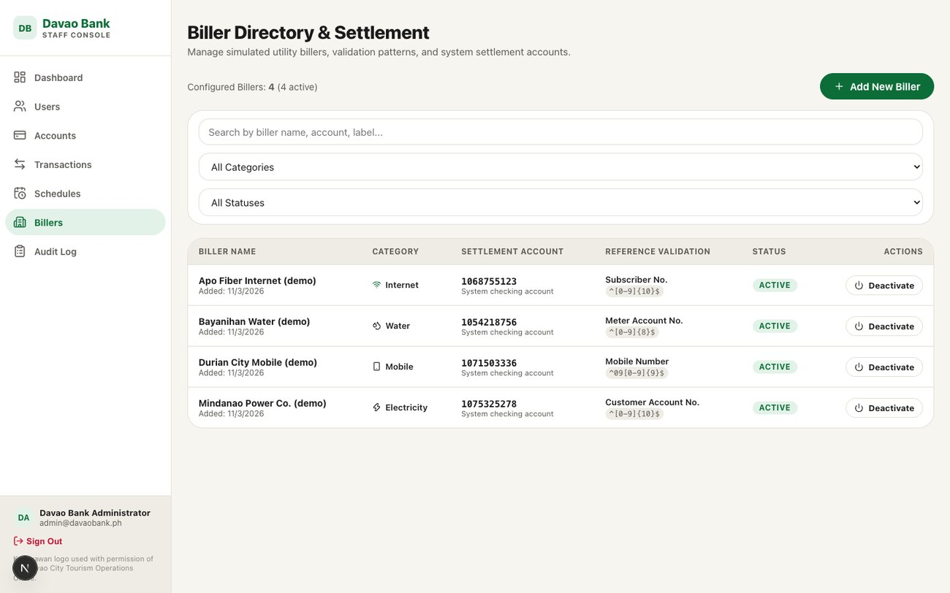
Figure 21. Scheduled payment oversight (left) and biller directory (right)
Purpose | Oversee customers' schedules, manage billers, and review the audit trail.
User | Administrator.
Entry point | Sidebar, "Schedules", "Billers" and "Audit Log".
Process | Schedules: search and filter all schedules, view run history, "Run Due Schedules Now", and cancel a schedule with a reason. Billers: list billers with their settlement account and reference rule, and "Add New Biller". Audit Log: the 100 most recent entries, filterable by action and role, with a drawer showing the full metadata.
Inputs | Filters; cancellation reason; biller name, category, reference label and pattern.
Validation | Server: each function requires an administrator. New billers need a unique name and a valid category; the client checks that the pattern is a valid regular expression.
System processing | admin_run_due_schedules_now audits the trigger and runs the scheduler immediately. cancel_scheduled_payment cancels and notifies the owner. admin_create_biller creates a checking settlement account owned by the system profile, then the biller, then an audit entry.
Database interaction | scheduled_payments, scheduled_payment_runs, billers, accounts, audit_logs, notifications.
Output | Figure 21 and Figure 22.
Exceptions | The biller Activate/Deactivate button updates the table directly instead of calling admin_set_biller_active; because billers have no update policy it silently changes nothing and writes no audit entry. A failed manual run is displayed in the success color. The audit view cannot reach entries older than the latest 100.

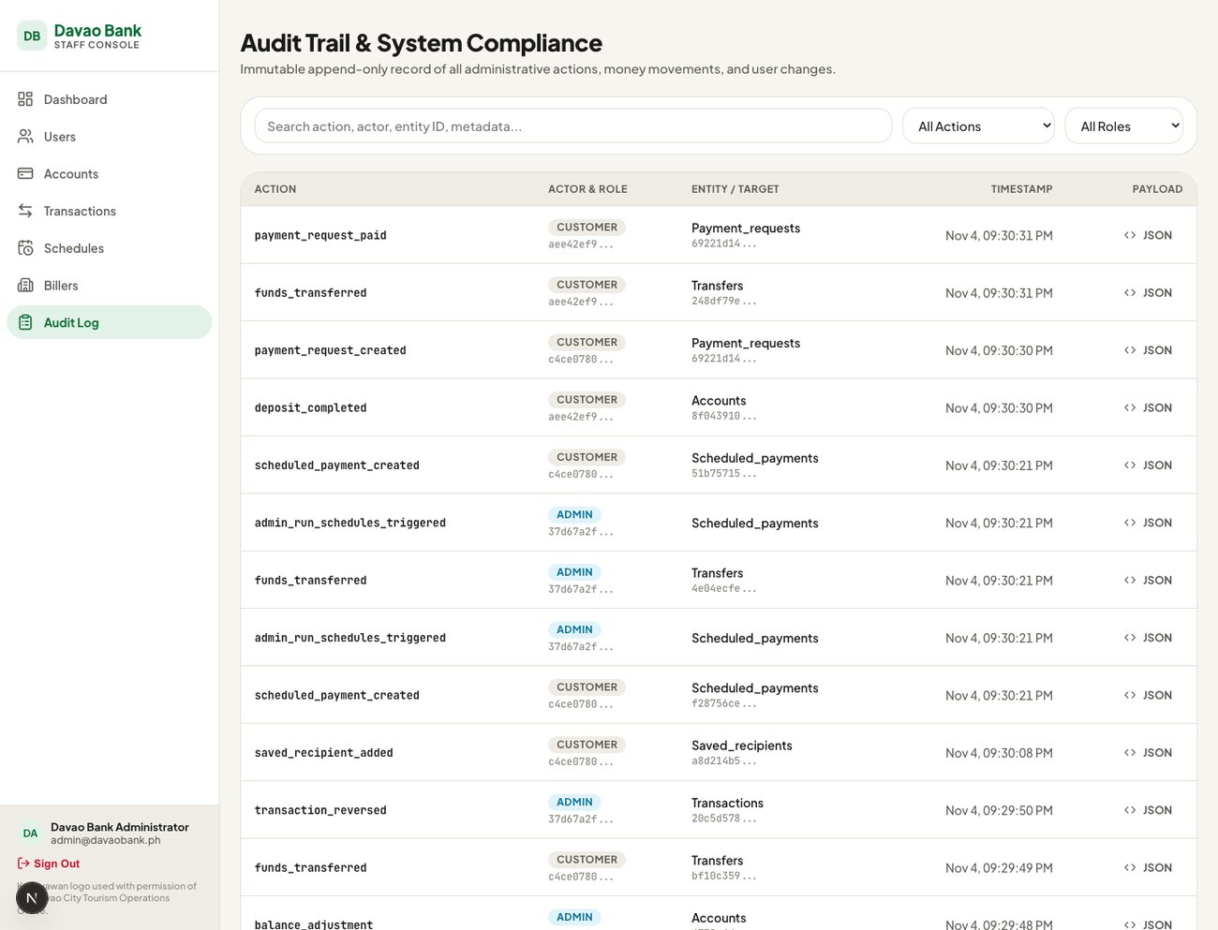
Figure 22. Audit trail

4.5 Backend and Database Operations

4.5.1 The Money Engine
All transfers, bill payments, payment-request payments and scheduled executions go through one internal function, _transfer_core. Clients cannot call it directly; they call thin wrappers that pass the caller's identity. Figure 23 shows the customer's path through a transfer, and the numbered steps below describe what the engine does inside one database transaction.
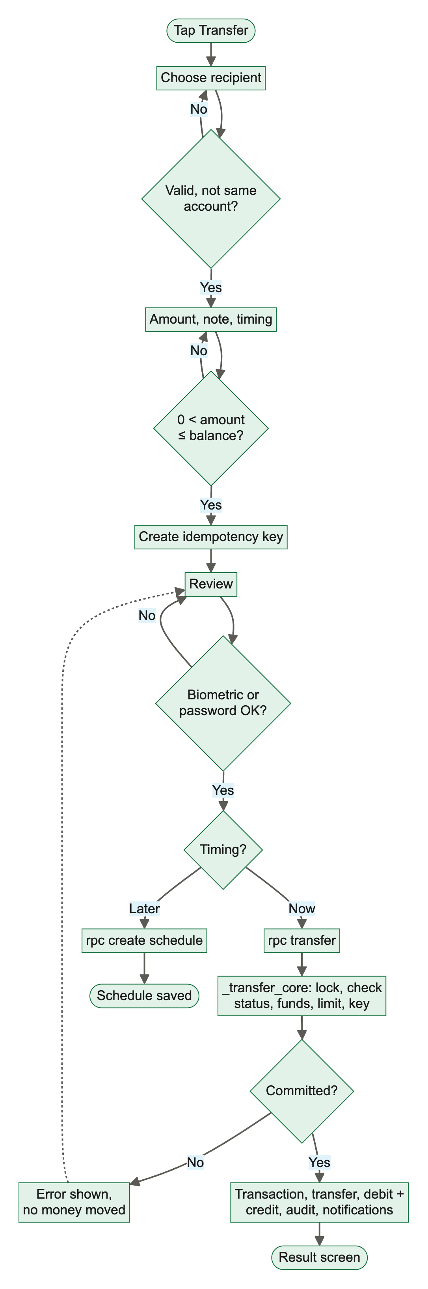
Figure 23. Activity diagram: transfer from the mobile app
- Look up the idempotency key. If a transaction with this key exists, return it marked as a replay.
- Check that the caller is signed in and the profile is active, the amount is above zero and at most ₱5,000,000, and the two accounts differ.
- Lock both account rows with SELECT ... FOR UPDATE, always in the same order (lower identifier first) so that two opposite transfers cannot deadlock.
- Confirm the source belongs to the caller and both accounts are active and in the same currency.
- Compute the source balance from the ledger while holding the lock, and reject the request with "Insufficient funds" if it is too low.
- Insert the transaction, the transfer row, a debit on the source and a credit on the destination.
- Write the audit entry and the notifications, and return the transaction.
If any step fails, PostgreSQL rolls back everything, so no partial transfer can exist. If two requests with the same key race, the unique constraint on idempotency_key lets only one insert succeed; the other catches the violation and returns the winner's result.

4.5.2 Ledger Model
There is no balance column anywhere in the database. An account's balance is always the sum of its credit entries minus the sum of its debit entries, computed by the account_balances view or, under lock, inside the money functions. Table 14 shows what each operation writes.
Table 14. Ledger effect of each operation
Operation | Transaction type | Ledger entries | Other rows
Transfer | transfer | Debit source, credit destination | transfers
Bill payment | bill_payment | Debit payer, credit biller settlement account | transfers, bill_payments
Pay a request | transfer | Debit payer, credit requester | transfers; request marked paid
Scheduled run | transfer or bill_payment | As above | scheduled_payment_runs
Cash-in | deposit | One credit | —
Cash-out | withdrawal | One debit | —
Adjustment | adjustment | One credit or one debit | —
Reversal | reversal | Mirror of every original line | transfers (swapped); original marked reversed

Transfers, bill payments and request payments are balanced: their debits equal their credits. Cash-in, cash-out and adjustments are single-sided because the prototype has no internal "cash" or "suspense" account to take the other side. As a result the system as a whole does not net to zero; the difference equals the play money created by cash-in and credit adjustments minus that removed by cash-out and debit adjustments. This differs from the proposal's statement that every transaction nets to zero. The reconciliation tests therefore check two narrower invariants: every account's balance equals its ledger sum, and every transfer, bill payment and reversal nets to zero.
Transactions use four statuses. Functions only ever write completed, and a reversal changes the original to reversed. The statuses pending and failed are allowed by the table constraint but never written, because a failed request is rolled back entirely (Figure 24).
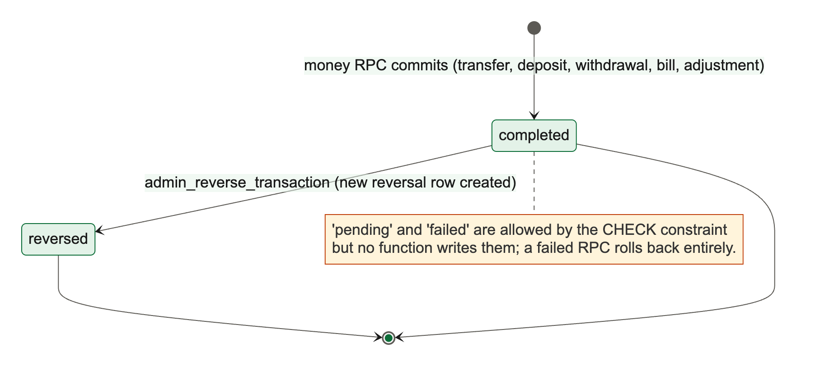
Figure 24. State diagram: transaction status

4.5.3 Limits and Business Rules
Table 15. Limits enforced by the database
Rule | Limit | Enforced by
Maximum single transfer, deposit, withdrawal, bill or scheduled amount | ₱5,000,000 | Money functions
Maximum payment request or QR amount | ₱500,000 | create_payment_request; QR utilities
Payment requests per day | 10 | create_payment_request
Payment request lifetime | 7 days | Default expires_at; daily expiry job
Saved recipients | 50 total; 20 additions per 24 hours | add_saved_recipient
Active scheduled payments | 20 per user | create_scheduled_payment
Statement period | 366 days | get_account_statement
Note or nickname length | 60 / 40 characters | Table constraints and functions
Account closure | Balance must be zero | admin_set_account_status

4.5.4 Scheduled Payment Execution
A pg_cron job named davao-run-schedules runs every five minutes and calls run_due_scheduled_payments. Figure 25 shows its logic. The job first records a run row for the schedule and date; a unique constraint on that pair guarantees each schedule runs at most once per date even if two executions overlap. It then pays through the money engine as if the owner had initiated it, using the key sched:<schedule id>:<date>. A failure is recorded with its reason and the owner is notified, without affecting other schedules. Monthly schedules are calculated from the start date (start date plus n months), so a schedule starting on 31 January runs on 28 February and 31 March rather than drifting.
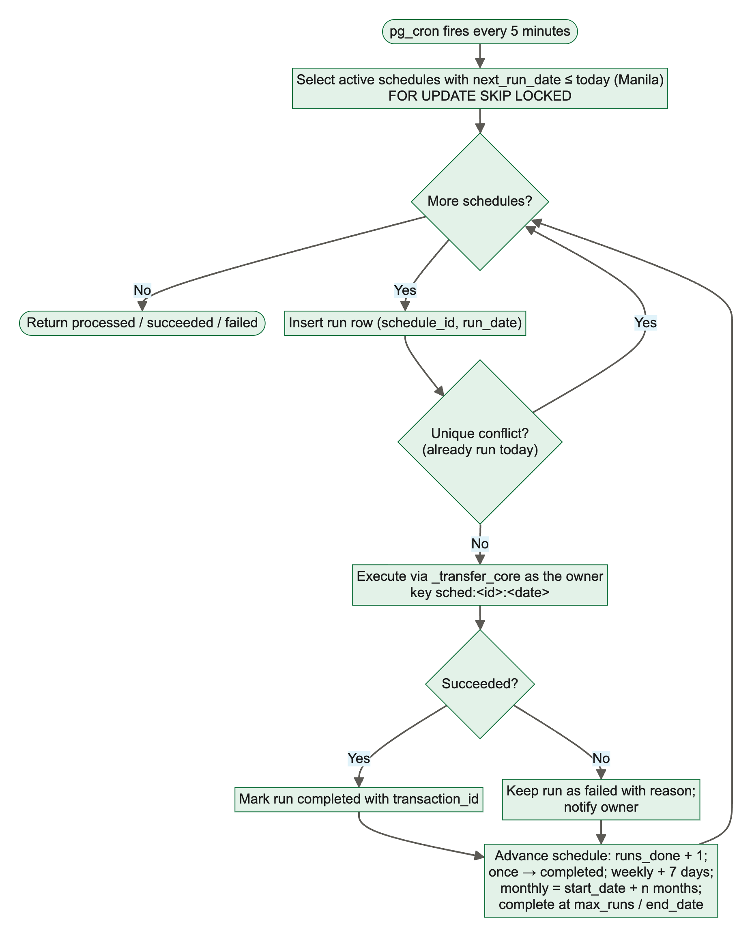
Figure 25. Activity diagram: scheduled payment executor
A failed run still advances the schedule and counts toward its maximum number of runs. This is a design choice that may surprise customers and is noted in Section 5.6.

4.5.5 Exchange-Rate Synchronisation
The fx_rates table was seeded with 768 European Central Bank reference rates (256 business days each for USD, EUR and JPY against PHP, from 24 October 2025 to 26 October 2026). The daily job davao-daily-fx-sync uses pg_net to call the fx-sync Edge Function at 04:00 UTC. The function accepts only requests carrying a header that matches the FX_SYNC_SECRET value; the job reads this secret from Supabase Vault at run time, so it never appears in the job definition. The function fetches the latest rates from the Frankfurter API and stores them through upsert_fx_rates. Rates are for display only and play no part in any money operation.

4.5.6 Notifications
Database functions insert notifications in the same transaction as the event they describe, so a notification exists only if the event committed. Table 16 lists them.
Table 16. Notification events
Event | Recipient | Type
Transfer, request payment or scheduled transfer | Sender and receiver | transfer_out, transfer_in
Bill payment | Payer | bill_payment
Cash-in / cash-out | Owner | deposit / withdrawal
Profile suspended or reactivated | User | account_alert
Account frozen, unfrozen or closed | Owner | account_alert
Account opened by staff | User | account_opened
Balance adjustment | Owner | balance_adjustment
Transaction reversed | Each affected owner | transaction_reversed
Schedule cancelled by staff | Owner | scheduled_payment_cancelled
Scheduled run failed | Owner | scheduled_payment_failed
Payment request received / paid / declined | Payer / requester / requester | payment_request_received, _paid, _declined

4.5.7 Audit Trail
All audit entries are written by the internal function write_audit, which records the caller's identifier and role, an action name, the affected entity and a JSON metadata object. Clients cannot execute it; this was closed after the Phase 4 review found that customers could forge entries. The table has a read policy for administrators and no update or delete policy, so no client can alter the trail. It is append-only with respect to the application, but not cryptographically protected: a database superuser could still change it.
Table 17. Audited actions
Action | Written by
funds_transferred, bill_payment_completed | Money engine
deposit_completed, withdrawal_completed | Cash-in and cash-out functions
admin_user_status_changed, profile_role_changed | User status function; role-change trigger
admin_account_opened, admin_account_status_changed | Account functions
balance_adjustment, transaction_reversed | Adjustment and reversal functions
saved_recipient_added | Saved recipient function
scheduled_payment_created, _updated, _cancelled, admin_run_schedules_triggered | Schedule functions
biller_created, biller_status_changed | Biller functions
payment_request_created, _paid, _declined, _cancelled | Request functions

Some events are not audited: sign-in and sign-out, CSV exports, payment-request expiry, notification reads, exchange-rate updates and direct edits or deletions of saved recipients. Objective O5 is therefore met for money movements and administrative changes but not for every action in the system.

4.5.8 Payment Request Lifecycle
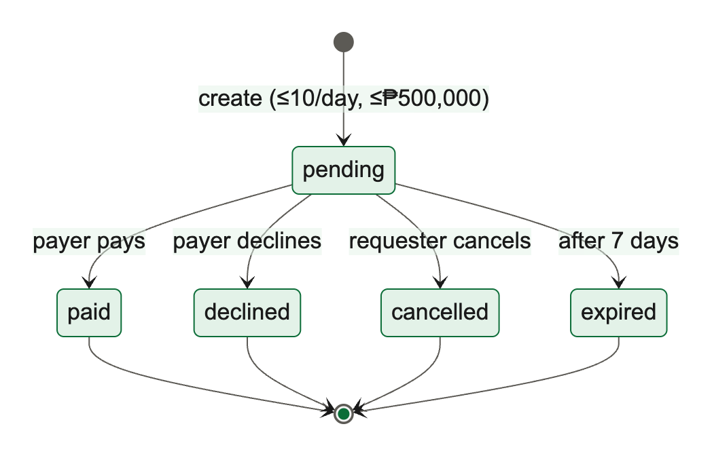
Figure 26. State diagram: payment request lifecycle
Figure 26 shows the five states of a payment request. Only a pending request can change, and paying it is idempotent: retrying with the same key after a timeout returns the original payment instead of an error, while any other attempt to pay a request that is no longer pending is refused. The linked transaction_id is unique, so one transaction can settle only one request.

4.6 Authentication, Security and Validation

4.6.1 Authentication
Customers and staff authenticate with email and password through Supabase Auth. Customers must confirm their email before the app can be used. Sessions are JSON Web Tokens that the clients refresh automatically: the mobile app stores them on the device, and the console stores them in cookies that the middleware refreshes on every request. The database identifies the caller from the token through auth.uid().

4.6.2 Authorization
- Row Level Security is enabled on all 15 tables with 26 policies. Customers can read their own profile, accounts, ledger entries, transfers, notifications, saved recipients, schedules, bill payments and payment requests in which they are a party. Administrators can read all rows through policies that call is_admin().
- No client write access to money or audit tables. There are no insert, update or delete policies on transactions, ledger_entries, transfers or audit_logs. Writes happen only inside SECURITY DEFINER functions with a fixed search_path.
- Function permissions. Phase 6 Stage B (in progress) revokes execute permission on every function from the public and anonymous roles by default and grants it to signed-in users only for the 29 functions the apps call. Internal functions such as _transfer_core and write_audit are executable by no client role.
- Profile guard. A trigger blocks anyone except an administrator or the trusted backend from changing a profile's role or status, so a customer cannot promote or unsuspend himself or herself.
- Suspension. is_admin() requires an active status, and every money function rejects a suspended caller, so suspension takes effect on the next request.

4.6.3 Validation Layers
Input is validated twice. The clients check formats and obvious errors to give fast feedback, but the database functions repeat every rule that matters for safety: ownership, status, limits, funds, reference formats and idempotency. A modified client therefore cannot bypass any rule. Table constraints provide a third layer, for example positive amounts, valid status values and unique account numbers.

4.6.4 Secrets and Configuration
Only the public anon key and project URL are shipped in the clients, through EXPO_PUBLIC_ and NEXT_PUBLIC_ environment variables. The service-role key is used only by the seed and test scripts and by the Edge Function. Environment files are excluded from version control, and the continuous-integration workflow runs a gitleaks scan for leaked secrets. The exchange-rate secret is kept in Supabase Vault and in the Edge Function's secret settings.

4.6.5 Security Work in Progress
At the time of writing, Phase 6 Stage B is adding: default revocation of function permissions from anonymous users; removal of anonymous read access to billers and exchange rates; an automated audit that every table has RLS enabled; encrypted session storage on the phone; hiding the app's contents in the app switcher; stronger password rules; and a written security review. These are not yet reviewed and are described here as planned or in progress.

4.7 Integration of System Components
The three components interact only through Supabase. Figure 27 traces an immediate transfer from the customer's tap to the database and back. The app collects and validates input, generates the idempotency key, obtains confirmation, and calls the transfer function over HTTPS with the user's token. PostgREST runs the function, which performs the steps in Section 4.5.1 and returns the new transaction.
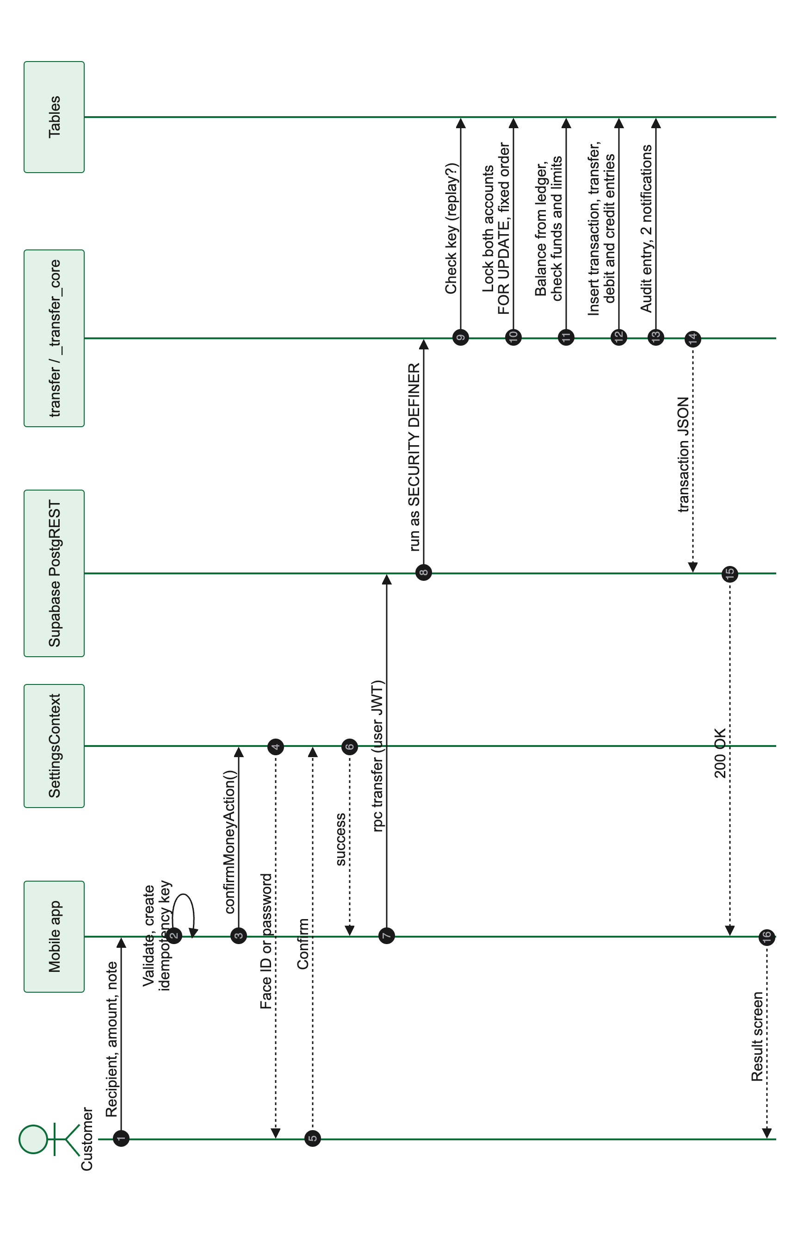
Figure 27. Sequence diagram: immediate transfer (rotated to fit the page)
Figure 28 traces a reversal from the staff console. The middleware confirms the administrator, the server action calls the reversal function with the administrator's token, and the function locks, validates, writes the compensating entries, audits and notifies. The affected customer sees the reversal in Activity and a notification in Inbox the next time the app loads, which shows how the console and the mobile app stay consistent through the shared database rather than through direct communication.
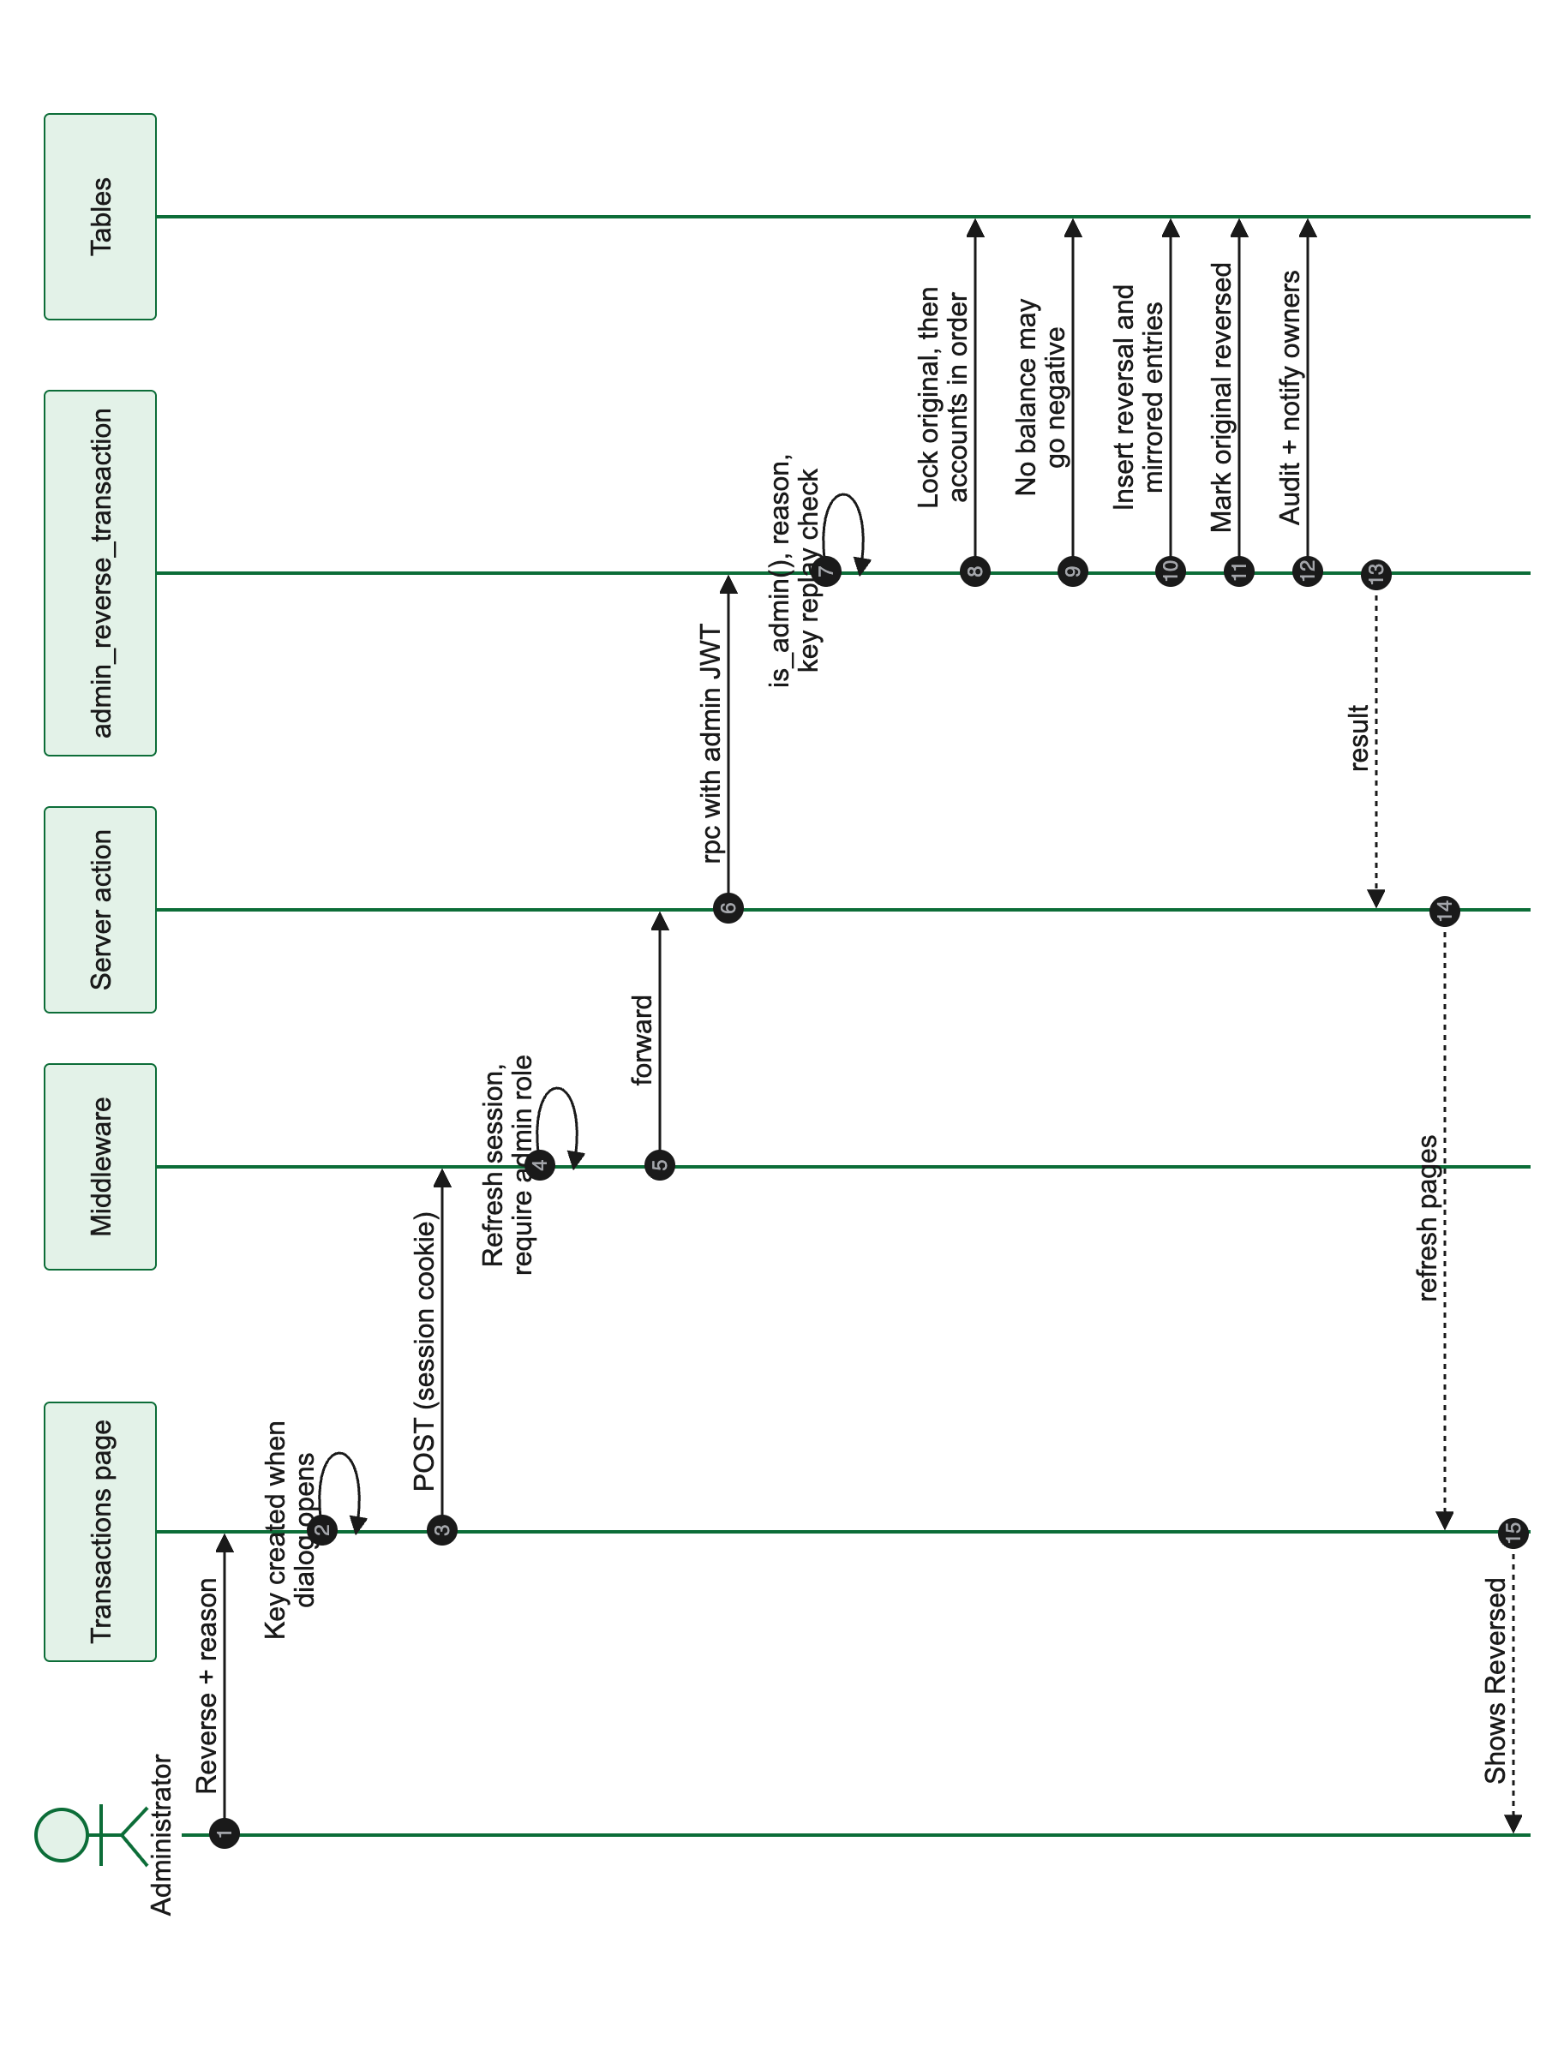
Figure 28. Sequence diagram: administrator reverses a transfer (rotated to fit the page)

Chapter 5. Testing and Evaluation

5.1 Testing Approach
Testing was organised in layers, from fast offline checks to observation of the running application. Because the implementing agent's early reports included results that had not touched a real database, this chapter distinguishes carefully between kinds of evidence. Every result is labelled with one of the codes in Table 18, and no result is reported as passing unless a recorded run supports it.
Table 18. Evidence types used in this chapter
Code | Evidence | Date and scope
H | Offline database harness (npm run test:db): applies all migrations to an in-process PostgreSQL (PGlite) with Supabase stand-ins, then runs each check as the relevant user | Run on 4 Nov 2026 against the working tree: 63 passed, 0 failed
L | Live suites (npm run test:rls, test:money, test:admin, test:extras, test:schedules, test:qr, test:fx) against the hosted Supabase project, observed by the reviewer | Run on 3 Nov 2026: 165 of 174 checks passed; all 9 failures were errors in the test scripts (Section 5.4)
U | Unit tests (npm run test:unit, Jest) for shared utilities, mobile components and admin components | Run on 4 Nov 2026: 50 of 50 tests in 7 suites passed
S | Observation of the running app on an iPhone 17 Pro Max simulator (Expo Go) and of the admin console in a browser | Mobile on 3 Nov 2026 (Phase 5 build); admin on 4 Nov 2026
C | Inspection of source code and migrations | 4 Nov 2026
A | Reported by the implementing agent and not yet independently re-run | PHASE6_REPORT.md, 4 Nov 2026

The offline harness cannot test true concurrency because it has a single database connection, and it does not run pg_cron, pg_net or the Edge Function. Concurrency was therefore tested only against the live database. End-to-end flows exist for Maestro (mobile) and Playwright (admin) but no recorded run of them was available, so they are not counted as evidence.

5.2 Test Environment
- Database: hosted Supabase project with all migrations applied up to Phase 6 Stage 0; seeded with one administrator, two customers, the system profile and four demonstration billers.
- Mobile: Expo Go on an iPhone 17 Pro Max simulator (iOS 26.4, 440-point width), signed in as the seeded customer customer1.
- Admin: Next.js development server on a local machine, signed in as the seeded administrator, viewed in Chrome at 1,440 pixels wide.
- Tooling: Node.js 24.12.0; TypeScript type checking passed for all three workspaces and ESLint reported 0 errors and 95 warnings on 4 Nov 2026.

5.3 Test Cases
The tables below list representative test cases by category. The full list of 63 harness checks is in Appendix E. "Pass" means the observed result matched the expected result in the run cited.

5.3.1 Authentication and Authorization
Table 19. Test cases: authentication and authorization
ID | Objective and input | Expected result | Observed result | Ev.
TC-01 | Sign up a new user | Profile and one savings account created automatically | Created for each test user. Pass | H
TC-02 | Customer A reads Customer B's accounts | No rows returned | No rows. Pass | H, L
TC-03 | Customer changes own role, then own status | Both rejected by the guard trigger | Rejected. Pass | H
TC-04 | Anonymous caller changes a role; calls transfer and deposit | Rejected | Rejected with permission denied. Pass | H
TC-05 | Customer inserts directly into ledger_entries or audit_logs | Rejected | Rejected. Pass | H, L
TC-06 | Customer calls _transfer_core or write_audit directly | Permission denied | Denied. Pass | H, L
TC-07 | Customer calls each admin function | "Admin privilege required" | Rejected. Pass | H, L
TC-08 | Suspended customer transfers, deposits or withdraws | Rejected | Rejected. Pass | H, L
TC-09 | Suspended administrator uses admin functions | Loses admin powers | Rejected. Pass | L
TC-10 | Every public table has RLS enabled; no permissive "using (true)" policies except the health check | Audit passes | Passes (in-progress Stage B check). Pass | H
TC-11 | Non-admin opens admin console routes | Redirected to /unauthorized | Playwright test written; no recorded run. Not run | —

5.3.2 Transaction Logic and Integrity
Table 20. Test cases: transaction logic and integrity
ID | Objective and input | Expected result | Observed result | Ev.
TC-12 | Deposit, then repeat with the same idempotency key | One credit only; second call returns the original | One credit. Pass | H, L
TC-13 | Transfer A to B, then repeat with the same key | Exact debit and credit once; replay returns original | Pass | H, L
TC-14 | Transfer more than the available balance | "Insufficient funds"; no rows written | Rejected. Pass | H, L
TC-15 | Spend from another customer's account | Rejected | Rejected. Pass | H
TC-16 | Parallel withdrawals totalling more than the balance | Balance never below zero; rejections say insufficient funds | Balance stayed non-negative. Pass | L
TC-17 | Two administrators reverse the same transfer at once | Exactly one reversal succeeds | One succeeded. Pass | L
TC-18 | Reverse a transfer, then attempt a second reversal with a new key | Second attempt rejected | Rejected. Pass | H
TC-19 | Run the scheduler twice for the same due date | Exactly one run and one debit | One run. Pass | H, L
TC-20 | Scheduled run with insufficient funds | Run recorded as failed; no ledger rows | Pass | H
TC-21 | Monthly schedule starting 31 January | Runs 28 Feb, 31 Mar, 30 Apr | Pass | H
TC-22 | Pay a request, retry with same key, then pay again with a new key | Paid once; retry succeeds; new key rejected | Pass | H
TC-23 | Reconciliation: each account balance against its ledger sum; each transfer, bill and reversal nets to zero | 0 mismatches | 0 mismatches (live: 9 accounts, 19 entries on 3 Nov; harness on 4 Nov). Pass | H, L

5.3.3 Input Validation and Business Rules
Table 21. Test cases: validation
ID | Objective and input | Expected result | Observed result | Ev.
TC-24 | Pay a bill with a malformed reference | Rejected with the biller's format | Rejected. Pass | H, L
TC-25 | Save own account or a non-existent account as a recipient | Both rejected | Pass | H, L
TC-26 | Change a saved recipient's account number directly | Rejected; only nickname may change | Rejected. Pass | H
TC-27 | Requester pays own payment request | Rejected | Pass | H, L
TC-28 | Statement period over one year; non-owner fetches statement | Both rejected; owner's statement reconciles | Pass | H, L
TC-29 | Parse QR codes with a foreign scheme, version 2, invalid account, invalid amount, or a note over 60 characters | Each rejected | Pass | U
TC-30 | Map server errors to user messages | Plain-language messages for each known error | Pass | U
TC-31 | Confirmation helper with biometrics disabled, unsupported or failed, and with a wrong password | Password required; never succeeds without a check | Pass | U

5.3.4 Administrative Functions
Table 22. Test cases: administrative functions
ID | Objective and input | Expected result | Observed result | Ev.
TC-32 | Administrator suspends and reactivates a customer | Status changes; audit entry written | Pass | H, L
TC-33 | Close an account with a non-zero balance | Rejected | Pass | L
TC-34 | Credit adjustment with reason | Adjustment transaction, ledger credit and balance increase | Test script expected a field the function does not return and failed on 3 Nov; the adjustment itself succeeded. Test corrected in Phase 6 | L, A
TC-35 | Create a biller | Biller and settlement account created | Pass | H
TC-36 | Open each admin page while signed in as administrator | Pages render with data | All eight pages rendered (Figures 17 to 22). Pass | S
TC-37 | Deactivate a biller from the Billers page | Biller becomes inactive; audit entry written | Code inspection: update is silently ignored. Fail | C

5.3.5 User Interface Behaviour
The following cases were observed on the iOS simulator on 3 November 2026, before the Phase 6 fixes. Where the code has since changed, the change has not yet been re-verified on a device.
Table 23. Test cases: user interface (iOS simulator)
ID | Objective and input | Expected result | Observed result | Ev.
TC-38 | Sign in as the seeded customer | Home screen with balances | Pass | S
TC-39 | Cash-in ₱500 | Balance increases; result screen shown | Balance increased by ₱500, but the sheet closed before the result could be read. Fail (fixed in code in Phase 6; not re-verified) | S, C
TC-40 | Tap outside the sheet on the Transfer review step | Input preserved or confirmation asked | Transfer discarded with no warning. Fail (fixed in code in Phase 6; not re-verified) | S, C
TC-41 | Open QR hub, Pay Bills, Scheduled and FX screens | Screens load with data | Pass; FX latest date was 26 Oct 2026 because the daily sync was not yet running | S
TC-42 | Inbox badge on first launch | Unread count visible | Badge appeared only after Inbox was opened. Fail | S
TC-43 | Hide balance, then open Activity | Amounts masked | Amounts remain visible. Fail | C

5.4 Actual Results
Table 24 summarises all recorded runs.
Table 24. Summary of recorded test runs
Run | Date | Result | Ev.
Offline database harness | 4 Nov 2026 | 63 passed, 0 failed (56 committed checks plus 7 in-progress Stage B checks) | H
Unit tests | 4 Nov 2026 | 50 passed in 7 suites | U
Type checking (3 workspaces) | 4 Nov 2026 | Passed | C
Lint | 4 Nov 2026 | 0 errors, 95 warnings (mostly use of any) | C
Live suites, first real run | 3 Nov 2026 | 165 of 174 checks passed | L
Live concurrency checks | 3 Nov 2026 | Parallel overdraft, double reversal and scheduler run-once all passed | L
Live suites after test fixes | 4 Nov 2026 | 179 of 179 reported | A
Maestro and Playwright flows | — | Written; no recorded run | —

The nine failures in the first live run were investigated individually. Each was an error in the test script, not in the system: the payment-request test used wrong parameter names; the exchange-rate test checked source text for an outdated column type; the adjustment test expected a new_balance field the function does not return; the audit-delete test expected an error, whereas Row Level Security silently matches no rows (which is the correct protection); the withdrawal test used an amount above the ₱5,000,000 limit, so it hit the limit rule instead of the funds rule; and the schedule test asserted that system-wide credits equal debits, which is not true in this ledger model (Section 4.5.2). The scripts were corrected in Phase 6 Stage 0; the corrected run of 179 of 179 is reported by the implementing agent and is awaiting independent re-run.

5.5 System Evaluation
Table 25 evaluates the system against the success metrics defined in the proposal.
Table 25. Evaluation against the proposal's success metrics
Metric | Target | Result | Assessment
Balance integrity | 0 inconsistencies in reconciliation | 0 mismatches live (3 Nov) and in the harness (4 Nov) | Met
Transfer atomicity | 100% all-or-nothing | Single-transaction functions; failed runs write no ledger rows | Met
Idempotency | Duplicate submission gives exactly one transaction | Replays return the original for every money function | Met in tests; one client-side path can issue a new key after success (Section 5.6)
Access control | 100% of unauthorized attempts blocked | All cross-user, anonymous and privilege tests blocked | Met in tests
Audit coverage | 100% of money movements and admin actions | All money movements and admin changes audited; some secondary events are not | Largely met
Feature completeness | 100% of in-scope features end to end | 21 of 26 functional requirements implemented; 3 partial; 2 not implemented (Table 5) | Partially met
Performance | Key screens under 2 s | Not measured | Not yet evaluated
Phase discipline | Every phase reviewed before the next | All phases reviewed; three fix passes issued | Met

5.6 Known Issues and Limitations
Table 26 lists open defects known on 4 November 2026. Severity reflects the effect on a user or on data integrity in the prototype.
Table 26. Known issues
ID | Area | Issue | Severity
KI-01 | Mobile, Transfer | After a QR-prefilled transfer succeeds, the refreshed Home data re-runs the sheet's reset logic, which returns to the review step with a new idempotency key; tapping again would send a second transfer | High
KI-02 | Mobile, Transfer | The result screen is replaced by the first step about a second after success; the receipt shows the pre-transfer balance | Medium
KI-03 | Mobile, privacy | Hide balance is not applied in Activity | Medium
KI-04 | Mobile, design | Brand font not applied; several text colors below WCAG AA contrast; touch targets under 44 points | Medium
KI-05 | Mobile, auth | Password reset cannot be completed inside the app | Medium
KI-06 | Mobile, QR | Entering a QR amount above ₱500,000 causes a rendering error | Medium
KI-07 | Admin, billers | Activate/Deactivate silently changes nothing and is not audited; the in-progress Stage B migration also hides inactive billers from administrators | Medium
KI-08 | Admin, dashboard | "Failed runs" always shows zero; "30-day volume" shows all-time volume | Medium
KI-09 | Backend, FX sync | It has not been confirmed whether the Edge Function was deployed with JWT verification disabled, which the scheduled call requires | Medium (unverified)
KI-10 | Mobile | Inbox badge empty until Inbox is opened; data not refreshed on tab focus | Low
KI-11 | Mobile, Android | Renaming a saved recipient uses an iOS-only dialog | Low
KI-12 | Mobile, requests | Authorization prompt shows an internal account identifier; source account chosen automatically | Low
KI-13 | Mobile, wording | Raw identifiers and enum values appear in some rows; database-written notifications use "PHP 500.00" and administrator wording | Low
KI-14 | Admin | Close-account dialog labelled "Unfreeze"; a failed manual schedule run is shown in success style; audit view limited to 100 entries; tables unpaginated beyond 1,000 rows | Low
KI-15 | Admin | Middleware and export check the role but not the status (the database still refuses suspended administrators) | Low
KI-16 | Backend | Adjustment notifications truncate centavos; the daily payment-request limit resets at 08:00 Manila time rather than midnight; failed scheduled runs count toward the maximum | Low
KI-17 | Design limitation | Cash-in, cash-out and adjustments are single-sided ledger entries (Section 4.5.2) | Design

Several defects observed on 3 November were addressed in code by Phase 6 Stage 0 and are not repeated above: result screens closing early, unguarded dismissal of sheets during a transfer, missing idempotency key on QR payments, failure of scheduled transfers to other customers, the admin "Add New Biller" error, unmapped server errors, and the balance card showing the total under one account's name. They still require confirmation on a device.

5.7 Outstanding Verification
- Independent re-run of the corrected live suites and of the Maestro and Playwright flows.
- Device testing on Android and on physical phones, including QR scanning with a real camera.
- Accessibility testing with VoiceOver and TalkBack and at large text sizes.
- Measurement of screen load times against the two-second target.
- A dropped-connection test proving that a retried transfer creates exactly one transaction (planned in Phase 6 Stage C).
- Confirmation that the scheduled exchange-rate sync and the five-minute scheduler run successfully on the hosted project.
- Review of the Phase 6 Stage B security changes once committed.

Chapter 6. Summary, Conclusions and Recommendations

6.1 Summary of Accomplishments
In about two weeks of phased development, from 20 October to 4 November 2026, the team delivered a working banking prototype with a customer mobile app, a staff console and a shared database. The core of the system, its money engine, ledger and access rules, was designed first, reviewed at every phase gate, and tested both offline and against the live database. On top of that core, the system supports the full set of everyday functions planned in the proposal and the eight features added by Scope Change 01, presented in an interface built on Davao City's Kadayawan identity.

6.2 Alignment With the Original Objectives
Table 27. Achievement of the specific objectives
ID | Objective | Status | Evidence
O1 | Secure authentication and session management | Achieved | Supabase Auth; email verification gate; no unauthenticated data access (TC-02, TC-04)
O2 | Role-based access | Achieved in tests | RLS on all tables; admin checks in functions and middleware (TC-02 to TC-10)
O3 | Atomic, correct money movement | Achieved in tests | Single-transaction functions, row locks, zero reconciliation mismatches (TC-12 to TC-23)
O4 | Prevent duplicate transactions | Achieved on the server; one client defect open | Idempotency keys and unique constraints (TC-12, TC-13, TC-22); KI-01
O5 | Complete, tamper-evident audit trail | Largely achieved | All money and admin changes audited; client cannot write; some events not audited; not cryptographically sealed
O6 | Reliable, responsive experience | Partially achieved | Errors mapped and flows guarded; load time not measured; UI defects open
O7 | Complete, demonstrable prototype | Largely achieved | 21 of 26 functional requirements implemented; deployment pending

6.3 Conclusions
The evidence supports four conclusions. First, placing all money logic in database functions that lock accounts and run in one transaction prevented the integrity failures the project set out to avoid: concurrent withdrawals could not overdraw an account, a transfer could not be reversed twice, the scheduler could not pay the same instruction twice, and reconciliation found no mismatches.
Second, enforcing access in the database rather than in the user interface made the rules hold for every client. Customers could not read other customers' data, write to money or audit tables, or call internal or administrative functions, even when calling the API directly.
Third, idempotency keys checked by the server make retries safe, but the client must also handle keys correctly. The open defect KI-01 shows that the server's guarantee can be undermined if a client generates a fresh key for the same intended payment.
Fourth, the review process was essential. Several serious issues, including a forgeable audit function, a double-reversal race, unenforced suspension and test reports that had not touched a database, were found only because each phase was checked against the real code and database rather than the implementer's summary.

6.4 Current Limitations
Davao Bank remains a simulation. It moves no real money, connects to no payment network, performs no identity verification and has not been deployed beyond development tooling. Its ledger is single-sided for cash-in, cash-out and adjustments. Testing has concentrated on the database and on an iOS simulator; Android, physical devices, accessibility tools and performance have not yet been evaluated. The known issues in Section 5.6 remain open.

6.5 Recommendations

6.5.1 Immediate
- Fix KI-01 and KI-02 by keeping the result screen until the user taps Done and by resetting the transfer sheet only when it opens, never in response to data refreshes.
- Route the biller Activate/Deactivate button through admin_set_biller_active, and restore administrator visibility of inactive billers in the Stage B migration.
- Correct the dashboard figures and apply "hide balance" throughout the app.
- Complete Phase 6 Stages B and C and independently re-run every live suite and end-to-end flow.

6.5.2 Next Phases
- Phase 7 (approved): refine the interface, apply the brand typeface and accessible contrast, unify flows, add a consistent motion system, and introduce the Kada and Duri illustrations for empty and error states.
- Add a system "cash" account so that cash-in, cash-out and adjustments become balanced double entries, which would allow a system-wide zero-sum check.
- Add pagination to admin tables and to the audit log, an audit-log export, and the read-only auditor role described in the proposal.
- Deploy the admin console and build installable mobile apps, then measure performance against the two-second target.

6.5.3 Toward Production (Outside the Capstone Scope)
A production bank would additionally require a banking or e-money licence, identity verification and anti-money-laundering screening, integration with regulated payment rails, fraud monitoring, high-availability infrastructure, and an independently audited core ledger. These are recorded so that the prototype is not mistaken for a production system.

Appendix A. Data Dictionary
This appendix describes every table in the public schema in its final state after all migrations. Money amounts are bigint centavos. Unless stated, foreign keys take no action on delete. "NN" means NOT NULL.

profiles
One row per authenticated user, created by the sign-up trigger.
Table 28. Data dictionary: profiles
Column | Type | Constraints and notes
id | uuid | PK; FK to auth.users.id, cascade on delete
full_name | text | Nullable
phone | text | Nullable
role | text | NN, default customer; one of customer, admin, system
status | text | NN, default active; one of active, suspended
created_at | timestamptz | NN, default now()

RLS: users read and update their own row (role must remain customer); administrators read and update all rows. Triggers: guard against role or status changes by non-administrators; audit of role changes.

accounts
Customer deposit accounts and biller settlement accounts. There is no balance column.
Table 29. Data dictionary: accounts
Column | Type | Constraints and notes
id | uuid | PK, default gen_random_uuid()
account_number | text | NN, unique; "10" followed by 8 random digits
user_id | uuid | NN; FK to profiles.id, cascade
type | text | NN, default savings; savings or checking
currency | text | NN, default PHP
status | text | NN, default active; active, frozen or closed
created_at | timestamptz | NN, default now()

Indexes: user_id; account_number. RLS: owners and administrators may read.

transactions
The envelope of every money event.
Table 30. Data dictionary: transactions
Column | Type | Constraints and notes
id | uuid | PK
type | text | NN; transfer, deposit, withdrawal, adjustment, reversal, bill_payment
status | text | NN, default completed; pending, completed, failed, reversed
initiated_by | uuid | FK to profiles.id; nullable
idempotency_key | text | Unique
reference | text | Human-readable description
created_at | timestamptz | NN, default now()
reverses_transaction_id | uuid | FK to transactions.id; partial unique index ensures one reversal per transaction

RLS: a customer may read a transaction that has a ledger entry on one of his or her accounts; administrators read all.

ledger_entries
Debit and credit lines; the source of truth for balances.
Table 31. Data dictionary: ledger_entries
Column | Type | Constraints and notes
id | uuid | PK
account_id | uuid | NN; FK to accounts.id
transaction_id | uuid | NN; FK to transactions.id, cascade
direction | text | NN; debit or credit
amount | bigint | NN; check amount > 0 (centavos)
created_at | timestamptz | NN, default now()

Indexes: account_id; transaction_id. RLS: entries on own accounts; administrators read all. No client insert, update or delete.

transfers
Source and destination of transfer-type transactions, bill payments, request payments and their reversals.
Table 32. Data dictionary: transfers
Column | Type | Constraints and notes
id | uuid | PK
transaction_id | uuid | NN; FK to transactions.id, cascade
from_account | uuid | NN; FK to accounts.id
to_account | uuid | NN; FK to accounts.id; check from_account <> to_account
amount | bigint | NN; check amount > 0

audit_logs
Append-only record of sensitive actions, written only through write_audit.
Table 33. Data dictionary: audit_logs
Column | Type | Constraints and notes
id | uuid | PK
actor_id | uuid | Caller identifier (no foreign key; null for scheduled jobs)
actor_role | text | Caller role, or system
action | text | NN; for example funds_transferred
entity, entity_id | text | Affected table and row
metadata | jsonb | Details such as amounts, reasons and balances before and after
created_at | timestamptz | NN, default now()

RLS: administrators read; no client writes.

notifications
In-app messages.
Table 34. Data dictionary: notifications
Column | Type | Constraints and notes
id | uuid | PK
user_id | uuid | NN; FK to profiles.id, cascade
type | text | Event type (Table 16)
message | text | NN
read | boolean | NN, default false
created_at | timestamptz | NN, default now()

RLS: users read and update their own; administrators read all.

saved_recipients
A customer's saved destination accounts.
Table 35. Data dictionary: saved_recipients
Column | Type | Constraints and notes
id | uuid | PK
owner_id | uuid | NN; FK to profiles.id, cascade
account_number | text | NN; validated when added (no foreign key); unique per owner
nickname | text | NN; 1 to 40 characters
created_at | timestamptz | NN

RLS: owners read, delete and update; a column grant limits updates to nickname. Inserts only through add_saved_recipient.

billers
Demonstration billers.
Table 36. Data dictionary: billers
Column | Type | Constraints and notes
id | uuid | PK
name | text | NN, unique
category | text | NN; electricity, water, internet, mobile, other
account_id | uuid | NN, unique; FK to accounts.id (settlement account)
reference_label | text | NN; label shown to the customer
reference_pattern | text | NN; regular expression the reference must match
is_active | boolean | NN, default true
created_at | timestamptz | NN

RLS: signed-in users read active billers.

bill_payments
Biller and reference for each bill-payment transaction.
Table 37. Data dictionary: bill_payments
Column | Type | Constraints and notes
id | uuid | PK
transaction_id | uuid | NN, unique; FK to transactions.id, cascade
biller_id | uuid | NN; FK to billers.id
payer_account | uuid | NN; FK to accounts.id
biller_reference | text | NN
created_at | timestamptz | NN

scheduled_payments
One-time and recurring instructions.
Table 38. Data dictionary: scheduled_payments
Column | Type | Constraints and notes
id | uuid | PK
owner_id | uuid | NN; FK to profiles.id, cascade
from_account | uuid | NN; FK to accounts.id
kind | text | NN; transfer or bill (with matching target columns)
to_account / biller_id / biller_reference | uuid / uuid / text | Target, depending on kind
amount | bigint | NN; > 0
note | text | Optional
frequency | text | NN; once, weekly, monthly
start_date, end_date | date | end_date null or not before start_date
max_runs, runs_done | int | max_runs > 0 if set; runs_done default 0
next_run_date | date | NN
status | text | NN; active, completed, cancelled
created_at, updated_at | timestamptz | NN

scheduled_payment_runs
One execution record per schedule per date.
Table 39. Data dictionary: scheduled_payment_runs
Column | Type | Constraints and notes
id | uuid | PK
schedule_id | uuid | NN; FK to scheduled_payments.id, cascade; unique with run_date
run_date | date | NN
status | text | NN; completed or failed
transaction_id | uuid | FK to transactions.id; null when failed
failure_reason | text | Error message when failed
created_at | timestamptz | NN

payment_requests
Money requests between customers.
Table 40. Data dictionary: payment_requests
Column | Type | Constraints and notes
id | uuid | PK
requester_id | uuid | NN; FK to profiles.id, cascade
requester_account | uuid | NN; FK to accounts.id (account to credit)
payer_account_number | text | NN
payer_user_id | uuid | NN; FK to profiles.id
amount | bigint | NN; > 0
note | text | Up to 60 characters
status | text | NN, default pending; pending, paid, declined, cancelled, expired
transaction_id | uuid | Unique; FK to transactions.id
expires_at | timestamptz | NN, default now() + 7 days
created_at, responded_at | timestamptz | Creation and response times

RLS: requester, payer and administrators read. No client writes.

fx_rates
Daily ECB reference rates for display.
Table 41. Data dictionary: fx_rates
Column | Type | Constraints and notes
base, quote, rate_date | text, text, date | Composite PK
rate | numeric(18,8) | NN; > 0
source | text | NN, default "Frankfurter / European Central Bank"
fetched_at | timestamptz | NN

RLS: signed-in users read. Writes only through upsert_fx_rates by the service role.

health_check
Connectivity probe.
Table 42. Data dictionary: health_check
Column | Type | Constraints and notes
id | integer | PK, identity
status | text | NN; seeded "ok"
checked_at | timestamptz | NN

Views: account_balances (one row per account with balance, ledger entry count and last activity) and account_transactions (one row per ledger line with signed amount). Both run with the caller's permissions, so Row Level Security applies.

Appendix B. Database Function Reference
Table 43. Customer-callable functions
Function | Purpose
is_admin() | True if the caller is an active administrator
ensure_my_profile() | Create the caller's profile and account if missing
transfer(...), transfer_by_account_number(...) | Immediate transfer by account identifier or number
deposit(...), withdraw(...) | Simulated cash-in and cash-out
get_account_transactions(...) | History with signed amounts and counterparties
get_account_statement(...) | Opening balance, period transactions, closing balance
add_saved_recipient(...) | Validated recipient save
pay_bill(...) | Bill payment through the engine
create_scheduled_payment(...), create_scheduled_transfer_to_number(...) | Create a schedule
list_my_scheduled_payments(), update_scheduled_payment(...), cancel_scheduled_payment(...) | Manage schedules
create_payment_request(...), pay_payment_request(...), decline_payment_request(...), cancel_payment_request(...) | Payment request lifecycle

Table 44. Administrator functions
Function | Purpose
admin_get_users() | All users including logins without a profile
admin_get_dashboard_stats() | Dashboard figures
admin_set_user_status(...) | Suspend or reactivate with reason
admin_open_account(...) | Open an account for a user
admin_set_account_status(...) | Freeze, unfreeze or close with reason
admin_adjust_balance(...) | Audited credit or debit
admin_reverse_transaction(...) | Compensating reversal
admin_create_biller(...), admin_set_biller_active(...) | Biller management
admin_run_due_schedules_now() | Run the scheduler immediately

Table 45. Internal and trigger functions (not callable by clients)
Function | Purpose
_transfer_core(...) | The single money engine
write_audit(...) | Insert an audit entry
run_due_scheduled_payments() | Scheduled executor
expire_due_payment_requests() | Expire requests past seven days
upsert_fx_rates(...) | Store exchange rates (service role)
register_cron_jobs() | (Re)register the three scheduled jobs
handle_new_user() | Sign-up trigger: profile and account
guard_profile_self_update() | Block role and status changes by non-administrators
audit_profile_changes() | Audit role changes
audit_account_changes() | Legacy; its trigger was removed in Phase 4

Appendix C. Row Level Security Policies
Table 46. Row Level Security policies by table
Table | Policies
profiles | Read own; update own (role stays customer); admins read all; admins update all
accounts | Read own; admins read all
transactions | Read those touching own accounts; admins read all
ledger_entries | Read entries on own accounts; admins read all
transfers | Read those involving own accounts; admins read all
audit_logs | Admins read
notifications | Read own; update own; admins read all
saved_recipients | Read own; delete own; update own (nickname only by column grant)
billers | Signed-in users read active billers
bill_payments | Payer or admin reads
scheduled_payments | Owner or admin reads
scheduled_payment_runs | Owner of the schedule or admin reads
payment_requests | Requester, payer or admin reads
fx_rates | Signed-in users read
health_check | Anyone reads

Appendix D. Diagram Sources
All diagrams in this document were produced from Mermaid text definitions that describe the implemented system. The definitions are supplied with this document in the folder diagram-sources/, one .mmd file per diagram (the architecture diagram is a hand-drawn .svg), so they can be edited and regenerated with any Mermaid-compatible tool. Table 47 maps each file to its figure.
Table 47. Diagram source files
File | Figure
architecture.svg | Figure 1
use-case-customer.mmd | Figure 2
use-case-staff.mmd | Figure 3
context-dfd.mmd | Figure 4
dfd-level1.mmd | Figure 5
erd-core.mmd | Figure 6
erd-features.mmd | Figure 7
mobile-navigation.mmd | Figure 8
admin-workflow.mmd | Figure 15
activity-transfer.mmd | Figure 23
state-transaction.mmd | Figure 24
activity-scheduler.mmd | Figure 25
state-payment-request.mmd | Figure 26
sequence-transfer.mmd | Figure 27
sequence-reversal.mmd | Figure 28

Appendix E. Offline Database Test Inventory
The 63 checks run by npm run test:db on 4 November 2026, all of which passed. Checks 55 to 61 belong to the in-progress Phase 6 Stage B work.
Table 48. Offline harness checks
No. | Check
1 | Signup trigger provisions profile and account for each user
2 | Service role can promote a profile to admin (seed path)
3 | Customer changing own role is rejected
4 | Customer changing own status is rejected
5 | Anonymous role change is rejected
6 | Admin can suspend a customer
7 | Database superuser can update profile status
8 | Customer deposit works
9 | Deposit idempotent replay (same key, no second credit)
10 | Transfer A to B
11 | Transfer idempotent replay
12 | Insufficient funds rejected
13 | Cannot spend from someone else's account
14 | Customer cannot call _transfer_core
15 | Customer cannot forge audit log
16 | Customer cannot write ledger directly
17 | RLS: B cannot see A's accounts
18 | Suspended customer cannot transfer
19 | Suspended customer cannot un-suspend self
20 | Admin reversal works
21 | Second reversal (new key) rejected
22 | Customer cannot call admin functions
23 | Cannot save own account as recipient
24 | Cannot save nonexistent account
25 | Save valid recipient
26 | add_saved_recipient does not return holder name
27 | Direct insert into saved_recipients denied
28 | Owner cannot change a saved recipient's account number
29 | Statement returns opening, closing and rows
30 | Non-owner cannot fetch statement
31 | Admin creates biller and settlement account
32 | Bill pay rejects malformed reference
33 | Bill pay with valid reference
34 | bill_payments row linked to its transaction
35 | Create weekly schedule starting today
36 | Executor called twice gives exactly one run and one debit
37 | next_run_date advanced by 7 days
38 | Unfunded scheduled run recorded as failed, no ledger writes
39 | Monthly from 31 Jan gives 28 Feb, 31 Mar, 30 Apr
40 | Customer cannot run the executor
41 | Customer schedules to another customer by account number
42 | Scheduling to a nonexistent number returns not-found
43 | Scheduling from someone else's account is rejected
44 | list_my_scheduled_payments returns only caller rows with last four digits
45 | Create payment request
46 | Request response has no names
47 | Requester cannot pay own request
48 | Payer pays request (requester credited)
49 | Request marked paid and linked to transaction
50 | Paid request same-key retry returns success
51 | Second payment (new key) rejected, no extra money moved
52 | Direct insert into payment_requests denied
53 | Customers can read fx_rates (768 rows)
54 | Customers cannot write fx_rates
55 | Anonymous transfer call rejected
56 | Anonymous deposit call rejected
57 | Anonymous users cannot read billers
58 | Anonymous users cannot read fx_rates
59 | RLS audit: all public tables enable row-level security
60 | RLS audit: no "using (true)" policies outside health_check
61 | RLS audit: neither billers nor fx_rates allow anonymous reads
62 | Reconciliation: every transfer, reversal and bill nets to zero
63 | Reconciliation: account balance equals ledger sum for every account

Appendix F. Installation and Configuration Guide
These steps set up a development copy. Secret values are never written in this document; they are obtained from the Supabase dashboard of the project.
- Install Node.js 20 or later (24.12.0 was used) and run npm install in the repository root.
- Copy .env.example to .env (root), apps/admin/.env.local and apps/mobile/.env, and fill in SUPABASE_URL, SUPABASE_ANON_KEY, EXPO_PUBLIC_SUPABASE_URL, EXPO_PUBLIC_SUPABASE_ANON_KEY, NEXT_PUBLIC_SUPABASE_URL, NEXT_PUBLIC_SUPABASE_ANON_KEY and, for scripts only, SUPABASE_SERVICE_ROLE_KEY. Optionally set SEED_PASSWORD.
- Link the hosted project and apply migrations: npx supabase login, npx supabase link --project-ref <project-ref>, then npx supabase db push --remote. For a local database use npx supabase db reset.
- Seed demonstration data: npm run seed. This creates an administrator, two customers, the system profile and four demonstration billers.
- Enable the pg_cron and pg_net extensions in the Supabase dashboard, deploy the Edge Function with npx supabase functions deploy fx-sync, store the sync secret with npx supabase secrets set FX_SYNC_SECRET=<value> and in Vault under the same name, and run select public.register_cron_jobs(); in the SQL editor.
- Run the admin console with npm run dev:admin (http://localhost:3000) and the mobile app with npm run dev:mobile, then open it in Expo Go.
- Verify with npm run typecheck, npm run lint, npm run test:unit and npm run test:db; the live suites (npm run test:rls and others) require the hosted database.
# Common commands
npm install
npm run seed
npm run dev:admin
npm run dev:mobile
npm run test:db
npm run test:unit

Appendix G. User Guide (Customer)

Getting started
- Open the app in Expo Go and tap Sign Up. Enter your name, email and a password, then confirm your email from the link you receive.
- Return to the app and Sign In. Your savings account is created automatically.
- Use Cash-in to add play money for testing. All money in Davao Bank is simulated.

Sending money
- On Home, tap Transfer. Choose a saved recipient, one of your accounts, or enter a 10-digit account number.
- Enter the amount and an optional note. Choose Now, Later or Recurring.
- Check the review screen, tap the confirm button, and approve with Face ID, fingerprint or your password.

Other tasks
- Pay a bill: Home, Pay Bills, choose a demo biller, enter the reference from your bill and the amount.
- Receive money: Home, QR, My QR, and let the payer scan it. To ask for money, use the Request tab.
- Pay a request: tap the pending-request banner on Home, then Pay Now.
- See history and receipts: Activity tab; tap any row. Tap Statement to export a PDF or CSV.
- Hide your balance: tap the eye icon on the balance card.
- Manage scheduled payments, saved recipients and biometrics: Profile tab.

Appendix H. Administrator Guide
- Open the console and sign in with an administrator account. Non-administrators are refused.
- Dashboard: review system figures and the latest transactions and audit entries.
- Users: search for a customer; use Suspend or Activate (a reason is required); use + Account to open another account.
- Accounts: use Freeze, Unfreeze or Close (reason required; closing needs a zero balance). Use Adjust Balance to credit or debit with a reason.
- Transactions: inspect any transaction; use Reverse on a completed transfer (reason required); use Export Ledger CSV for a download.
- Schedules: view run history, Run Due Schedules Now, or cancel a schedule with a reason.
- Billers: add a demo biller with a reference label and pattern.
- Audit Log: filter recent actions and open any entry to see its details.
Every action that changes data is recorded in the audit log under the signed-in administrator's identity.

Appendix I. References
- Ancheta, R. A., & Arcete, J. (2026). Davao Bank: A mobile banking system rooted in Davao City culture (Project proposal, version 1.1).
- Davao Bank project team. (2026). Scope Change 01: Feature additions; phase implementation prompts (Phases 1 to 7); PHASE5_REPORT.md and PHASE6_REPORT.md. Project repository.
- European Central Bank. Euro foreign exchange reference rates. https://www.ecb.europa.eu/stats/policy_and_exchange_rates/euro_reference_exchange_rates/html/index.en.html
- Expo. Expo documentation. https://docs.expo.dev/
- Frankfurter. Frankfurter exchange rates API. https://frankfurter.dev/
- Meta Platforms. React Native documentation. https://reactnative.dev/
- Republic of the Philippines. (2000). Republic Act No. 8791, The General Banking Law of 2000.
- PostgreSQL Global Development Group. Explicit locking. https://www.postgresql.org/docs/current/explicit-locking.html
- PostgreSQL Global Development Group. CREATE FUNCTION. https://www.postgresql.org/docs/current/sql-createfunction.html
- React Navigation. React Navigation documentation. https://reactnavigation.org/
- Supabase. Row Level Security. https://supabase.com/docs/guides/database/postgres/row-level-security
- Supabase. Database functions. https://supabase.com/docs/guides/database/functions
- Supabase. pg_cron extension. https://supabase.com/docs/guides/database/extensions/pg_cron
- Supabase. Edge Functions. https://supabase.com/docs/guides/functions
- Vercel. Next.js documentation. https://nextjs.org/docs
- World Wide Web Consortium. (2023). Web Content Accessibility Guidelines (WCAG) 2.2. https://www.w3.org/TR/WCAG22/

