**ESCAPE-19**

(**E**ssential **S**tores **C**ollaboration **A**nd **P**andemic **E**-tracking)

**Project Aim:** To track the contacts of a given covid-19 positive patient who visits one or more of the registered stores.

**Project Description:** This project provides the ability to any storekeeper to register with the portal to start with. A registered storekeeper will be able to capture the contact number of his customers and timing of their visit. This system will be able to help local authorities to track all possible contacts of a given covid-19 positive patient if he/she had visited one or more of the registered stores during a given timeframe.

**System Architecture:**

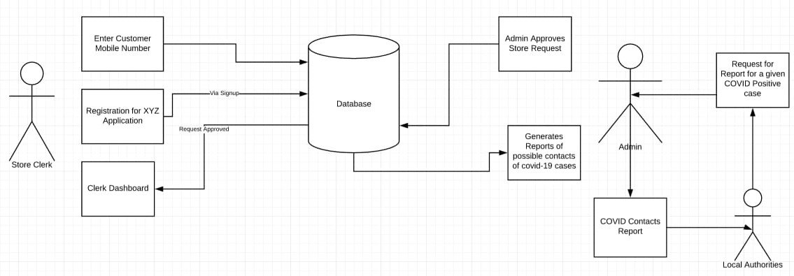

**Modules**

1. **Store Module:**
2. **Registration:** Store-clerk uses the portal to signup the shop for be included as a part of the scheme.
3. **Dashboard:** Using the dashboard, the storekeeper can perform various functions the portal has to offer.
4. **Capture Customer Contact Details:** Storekeeper can use this provision to enter details of the visiting customers.
5. **Generate Reports:** Storekeeper can use this provision to generate information on based on the details entered.
6. **Admin Module:**
7. **Provisioning of User Access:** Approving access for stores to use the portal and provide information on the of a given covid-19 positive patient who visits one or more of the registered stores.
8. **Governmental Authorities Module:**
9. Provides an ability to the local authorities to get all possible contacts of a given covid-19 patient. The authorities will also be able to find any iterative contacts of such first contacts, should such first contacts visit other stores in subsequent time.