import cv2  
from pvlib import pvsystem, singlediode  
import pandas as pd  
import numpy as np  
from scipy.interpolate import interp1d  
import matplotlib.pyplot as plt  
import math  
  
from scipy.constants import e as qe, k as kB

# Für alle Berechungungen wurden 25°C Zelltemperatur angenommen  
# kB ist J/K, qe ist C=J/V  
# kB * T / qe -> V  
Vth = kB * (273.15+25) / qe  
  
cell_parameters = {  
 'I_L_ref': 18,  
 'I_o_ref': 5.16e-9,  
 'R_sh_ref': 1000,  
 'a_ref': 1.3*Vth,  
 'R_s': 0.00181,  
 'alpha_sc': 0.0042,  
 'breakdown_factor': 2e-3,  
 'breakdown_exp': 3,  
 'breakdown_voltage': -15,  
}

def plot_curves_current(dfs, labels, title):  
 """plot the forward- and reverse-bias portions of an IV curve"""  
 fig, axes = plt.subplots(figsize=(5, 5))  
 for df, label in zip(dfs, labels):  
 df.plot('v', 'i', label=label, ax=axes)  
 axes.set_xlim([0, df['v'].max()*1.5])  
 axes.set_ylim([0, 20])  
 axes.set_ylabel('Strom [A]')  
 axes.set_xlabel('Spannung [V]')  
 fig.suptitle(title)  
 fig.tight_layout()  
 return axes

def plot_curves_power(dfs, labels, title):  
 """plot the forward- and reverse-bias portions of an PV curve"""  
 fig, axes = plt.subplots(figsize=(5, 5))  
 for df, label in zip(dfs, labels):  
 df.plot('v', 'p', label=label, ax=axes)  
 axes.set_xlim([0, df['v'].max()*1.5])  
 axes.set_ylim([0, 750])  
 axes.set_ylabel('Leistung [W]')  
 axes.set_xlabel('Spannung [V]')  
 fig.suptitle(title)  
 fig.tight_layout()  
 return axes

def simulate_full_curves(parameters, Geffs, Tcell, ivcurve_pnts=1000):  
 """  
 Use De Soto and Bishop to simulate a full IV curve with both  
 forward and reverse bias regions.  
 """  
 # adjust the reference parameters according to the operating  
 # conditions using the De Soto model:  
 curves = []  
 for Geff in Geffs:  
 sde_args = pvsystem.calcparams_desoto(  
 Geff,  
 Tcell,  
 alpha_sc=parameters['alpha_sc'],  
 a_ref=parameters['a_ref'],  
 I_L_ref=parameters['I_L_ref'],  
 I_o_ref=parameters['I_o_ref'],  
 R_sh_ref=parameters['R_sh_ref'],  
 R_s=parameters['R_s'],  
 )  
 # sde_args has values:  
 # (photocurrent, saturation_current, resistance_series,  
 # resistance_shunt, nNsVth)  
  
 # Use Bishop's method to calculate points on the IV curve with V ranging  
 # from the reverse breakdown voltage to open circuit  
 kwargs = {  
 'breakdown_factor': parameters['breakdown_factor'],  
 'breakdown_exp': parameters['breakdown_exp'],  
 'breakdown_voltage': parameters['breakdown_voltage'],  
 }  
 v_oc = singlediode.bishop88_v_from_i(  
 0.0, *sde_args, **kwargs  
 )  
 # ideally would use some intelligent log-spacing to concentrate points  
 # around the forward- and reverse-bias knees, but this is good enough:  
 vd = np.linspace(0.99*kwargs['breakdown_voltage'], v_oc, ivcurve_pnts)  
  
 ivcurve_i, ivcurve_v, _ = singlediode.bishop88(vd, *sde_args, **kwargs)  
 curves.append(pd.DataFrame({  
 'i': ivcurve_i,  
 'v': ivcurve_v,  
 }))  
   
 return curves

# https://www.microsemi.com/document-portal/doc_view/125066-rf01055-datasheet  
  
def bypass_diode():  
 i_s = 0.00012  
 t = 273.15 + 25  
 v = np.linspace(0,1,1000)  
  
 n = 1.446554  
  
 v_t = kB * t / qe  
  
 i = i_s * (np.exp(v/(v_t * n)) - 1)  
 return pd.DataFrame({'i': i, 'v': -v})

def interpolate_v(df, i):  
 """convenience wrapper around scipy.interpolate.interp1d"""  
 f_interp = interp1d(np.flipud(df['i']), np.flipud(df['v']), kind='linear',  
 fill_value='extrapolate')  
 return f_interp(i)

def interpolate_i(df, v):  
 """convenience wrapper around scipy.interpolate.interp1d"""  
 f_interp = interp1d(np.flipud(df['v']), np.flipud(df['i']), kind='linear',  
 fill_value='extrapolate')  
 return f_interp(v)

def assemble_serial(curves):  
 i_min = 0  
 i_max = 0  
  
 for curve in curves:  
 i_min = min(i_min, curve['i'].min())  
 i_max = max(i_min, curve['i'].max())  
  
 i_max = min(i_max, 50)  
  
 i = np.linspace(i_min, i_max, 1000)  
  
 v = 0  
   
 for curve in curves:  
 v_diode = interpolate_v(curve, i)  
 v += v_diode  
 return pd.DataFrame({'i': i, 'v': v})

def assemble_parallel(curves):  
 v_min = 0  
 v_max = 0  
  
 for curve in curves:  
 v_min = min(v_min, curve['v'].min())  
 v_max = max(v_max, curve['v'].max())  
  
 v = np.linspace(v_min, v_max, 1000)  
  
 i = 0  
   
 for curve in curves:  
 i_diode = interpolate_i(curve, v)  
 i += i_diode  
   
 return pd.DataFrame({'i': i, 'v': v})

def arr_to_module(arr):  
 rotated = np.flip(np.rot90(arr), axis=0)  
 combined = np.concatenate((arr[::2], np.flip(arr[1::2], axis=1)), axis=1)  
 return combined

def addPower(iv):  
 i = iv['i']  
 v = iv['v']  
 p = v * i  
 return pd.DataFrame({'i': i, 'v': v, 'p': p})

def simulate_module_shaded(shadow_arr, poa_direct=800, poa_diffuse=200, Tcell=25, diode_every_cell=False):  
   
 shadow_module = arr_to_module(shadow_arr)  
  
 iv_strings = []  
 if diode_every_cell:  
 for string in shadow_module:  
 cell_curves = []  
 for curve in simulate_full_curves(cell_parameters, string * poa_direct + poa_diffuse, Tcell):  
 cell_curves.append(assemble_parallel([curve, bypass_diode()]))  
 iv_strings.append(assemble_serial(cell_curves))  
  
 else:  
 for string in shadow_module:  
 iv_strings.append(assemble_parallel([assemble_serial(simulate_full_curves(cell_parameters, string * poa_direct + poa_diffuse, Tcell)), bypass_diode()]))  
  
 iv_module = assemble_serial(iv_strings)  
 return addPower(iv_module)

def partial_shadow(sun_radius):  
 arr = np.linspace(0, 2, sun_radius * 2 + 1)  
 arr = np.delete(arr + (arr[1] - arr[0]) / 2, -1)  
 shadow_arr = (np.arccos(1 - arr) - (1 - arr) * np.sqrt(2 * arr - arr ** 2)) / np.pi  
  
 return shadow_arr

def solar_cell_mask(cell_size, distance, pix_deg, sun_radius):  
 cell_x = cell_size[0]  
 cell_y = cell_size[1]  
  
 projection_x = int(2 * math.degrees(math.atan(cell_x / distance / 2)) * pix_deg)  
 projection_y = int(2 * math.degrees(math.atan(cell_y / distance / 2)) * pix_deg)  
 projection = [projection_x, projection_y]  
   
 size_x = projection_x + 2 * sun_radius  
 size_y = projection_y + 2 * sun_radius  
  
 mask = np.ones((size_x, size_y))  
  
 shadow_arr = partial_shadow(sun_radius)  
  
 mask[0:sun_radius * 2, :] *= shadow_arr[:, None] # top  
 mask[-sun_radius * 2:,:] *= np.flip(shadow_arr)[:, None] # bottom  
 mask[:, 0:sun_radius * 2] *= shadow_arr[None, :] # left  
 mask[:,-sun_radius * 2:] *= np.flip(shadow_arr)[None, :] # right  
  
 return projection, mask

def get_slices_from_coords(mask, mask_coords):  
 res_masks = []  
 for row in mask_coords:  
 res_row = []  
 for cell in row:  
 res_row.append(mask[cell[0]:cell[2], cell[1]:cell[3]])  
 res_masks.append(res_row)  
 return np.array(res_masks)

def solar_module_masks(cell_size, shape, spacing, pos, mask, distance, pix_deg, sun_radius):  
  
 cell_projection, cell_mask = solar_cell_mask(cell_size, distance, pix_deg, sun_radius)  
 spacing_projection = np.int_(np.multiply(cell_projection, int(spacing * 1000000)) / cell_size / 1000000)  
 unit_projection = cell_projection + spacing_projection  
  
 size = shape * (unit_projection)  
 start_pos = pos - size / 2  
 cell_mask_size = np.array(cell_mask.shape)  
  
 pos_arr = np.array(np.meshgrid(np.arange(0.5, shape[0] + 0.5), np.arange(0.5, shape[1] + 0.5)))  
 pos_arr = pos_arr.T.reshape(shape[0],shape[1],2) * unit_projection + start_pos  
  
 mask_coords = np.int_(np.concatenate((pos_arr - cell_mask_size / 2, pos_arr + cell_mask_size / 2), axis=2))  
  
 tree_mask_slices = get_slices_from_coords(mask, mask_coords) / 255  
  
 combined_masks = tree_mask_slices * cell_mask  
  
 radiation_on_cells = (np.apply_over_axes(np.sum, combined_masks, [2,3]) / np.sum(cell_mask)).reshape(len(combined_masks),-1)  
  
 return radiation_on_cells, combined_masks, cell_mask, mask_coords

def visualize(mask, cell_mask, mask_coords, alpha):  
 beta = 1 - alpha  
  
 overlay = np.zeros_like(mask, dtype=float)  
 for row in mask_coords:  
 for coord in row:  
 overlay[coord[0]:coord[2], coord[1]:coord[3]] += cell_mask  
   
 vis = cv2.addWeighted(np.float64(mask), alpha, (overlay * 255), beta, 0.0)  
   
 return vis

filename = input("Filename: ")  
tree_img = cv2.imread('measuredTrees/' + filename)  
plt.imshow(tree_img)

<matplotlib.image.AxesImage at 0x285edbc1060>

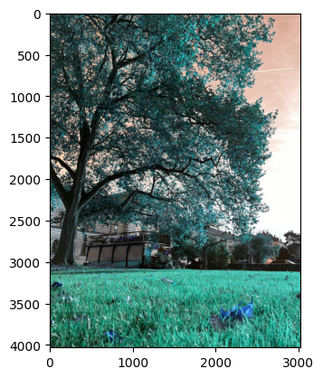

distance = 5  
pos_az = 10  
  
variation = 200  
  
sun_radius_deg = 0.533  
  
res_x = tree_img.shape[1]  
res_y = tree_img.shape[0]  
pix_deg = res_x / 65  
  
sun_radius = int(sun_radius_deg * pix_deg) // 2

lower_bound = np.array([170, 0, 0])  
upper_bound = np.array([360, 255, 255])  
  
mask = cv2.inRange(tree_img, lower_bound, upper_bound)  
  
#cv2.imshow('treemask', imagemask)  
plt.imshow(mask, cmap='gray')

<matplotlib.image.AxesImage at 0x285f448e710>

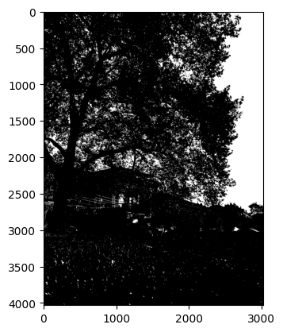

radiation_on_cells1, cells_transmission1, cell_mask1, mask_coords1 = solar_module_masks([0.21, 0.21], [12,6], 0.04, [1550, 900], mask, 14, pix_deg, sun_radius)  
radiation_on_cells2, cells_transmission2, cell_mask2, mask_coords2 = solar_module_masks([0.21, 0.21], [12,6], 0.04, [800, 2000], mask, 14, pix_deg, sun_radius)  
radiation_on_cells3, cells_transmission3, cell_mask3, mask_coords3 = solar_module_masks([0.21, 0.21], [12,6], 0.04, [750, 900], mask, 14, pix_deg, sun_radius)  
  
radiation_on_cells = radiation_on_cells2  
  
averaged = np.ones_like(radiation_on_cells) * np.average(radiation_on_cells)  
  
iv_module1 = simulate_module_shaded(radiation_on_cells, poa_diffuse=100, diode_every_cell=True)  
iv_module2 = simulate_module_shaded(radiation_on_cells, poa_diffuse=100)  
iv_module3 = simulate_module_shaded(np.ones_like(radiation_on_cells), poa_diffuse=100)  
iv_module4 = simulate_module_shaded(np.zeros_like(radiation_on_cells), poa_diffuse=100)  
iv_module5 = simulate_module_shaded(averaged, poa_diffuse=100)  
  
p_max1 = iv_module1['p'].max()  
p_max2 = iv_module2['p'].max()  
p_max3 = iv_module3['p'].max()  
p_max4 = iv_module4['p'].max()  
p_max5 = iv_module5['p'].max()  
  
  
curves = [iv_module3, iv_module5, iv_module1, iv_module2, iv_module4]  
labels_p = ['kein Schatten (' + str(int(p_max3)) + 'W)', 'theoretisch (' + str(int(p_max5)) + 'W)', 'jede Zelle (' + str(int(p_max1)) + 'W)', 'jeder String (' + str(int(p_max2)) + 'W)', 'voller Schatten (' + str(int(p_max4)) + 'W)']  
labels_i = ['kein Schatten', 'theoretisch', 'jede Zelle', 'jeder String', 'voller Schatten']  
  
ax = plot_curves_power(curves, labels=labels_p, title='Leistung-Spannungsdiagram Solarmodul (72 Zellen)')  
ax = plot_curves_test(curves, labels_i, 'Strom-Spannungdiagramm Solarmodul (72 Zellen)')

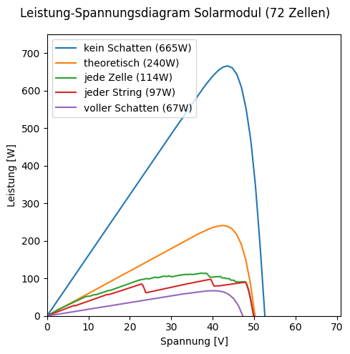

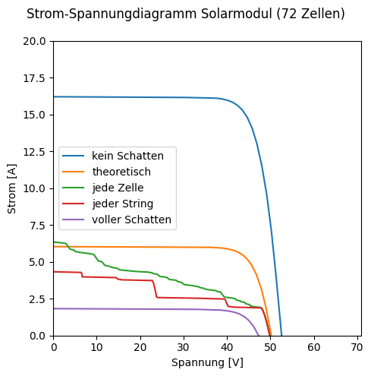

radiation_on_cells = radiation_on_cells3  
  
res_table = [["Diffuse Einstahlung [W/m^2]", "voller Schatten [W/m^2]", "Diode für jeden String [W/m^2]", "Diode für jede Zelle [W/m^2]", "direkte Einstahlung jeder String [W/m^2]", "direkte Einstahlung jede Zelle [W/m^2]", "Leistungsanstieg bei jede Zelle"]]  
for i, diffuse in enumerate(range(0, 225, 25)): #0-200  
 res_row = [diffuse]  
 full_shadow = simulate_module_shaded(np.zeros_like(radiation_on_cells), poa_diffuse=diffuse)['p'].max()  
 every_string = simulate_module_shaded(radiation_on_cells, poa_diffuse=diffuse)['p'].max()  
 every_cell = simulate_module_shaded(radiation_on_cells, poa_diffuse=diffuse, diode_every_cell=True)['p'].max()  
   
 direct_every_string = every_string - full_shadow  
 direct_every_cell = every_cell - full_shadow  
  
 direct_power_increase = direct_every_cell / direct_every_string - 1  
  
 res_table.append([diffuse, full_shadow, every_string, every_cell, direct_every_string, direct_every_cell, direct_power_increase])

df_table = pd.DataFrame(res_table)  
  
writer = pd.ExcelWriter('test.xlsx')  
  
df_table.to_excel(writer, sheet_name='2', index=False)  
  
writer.save()

C:\Users\patri\AppData\Local\Temp\ipykernel_31192\1808722512.py:7: FutureWarning: save is not part of the public API, usage can give unexpected results and will be removed in a future version  
 writer.save()

#vis_filename = input('visualisation filename')  
#mask_coords = [*mask_coords1, *mask_coords2, *mask_coords3]  
vis = visualize(mask, cell_mask2, mask_coords2, 0.4)  
plt.imshow(vis, cmap='gray')  
#cv2.imwrite('doc_pictures/' + vis_filename + 'png', vis)  
cv2.imwrite('test.png', vis)

True

