Name: Aaron Rodriguez

SQL SELECT, WHERE, DISTINCT practice

1. Write a select statement to return all columns and rows from the customer table.

Command: select*from customer;

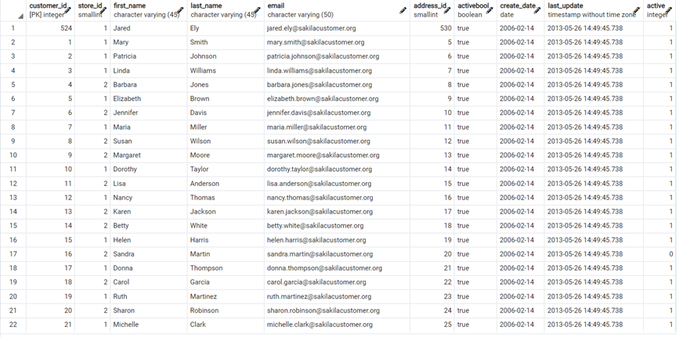

1. Write a query to select first name, last name, and email from the customer table.

Command: Select first_name, last_name, email from customer;

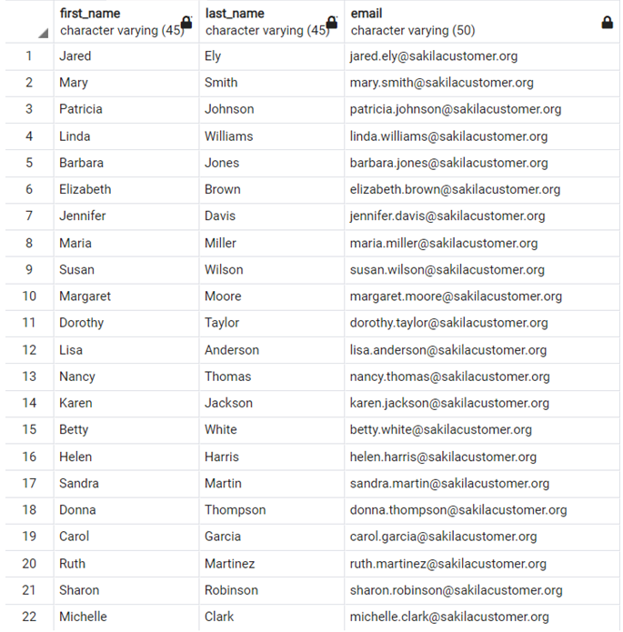

1. Write a query to return all rows and columns from the film table.

Command: SELECT*FROM film

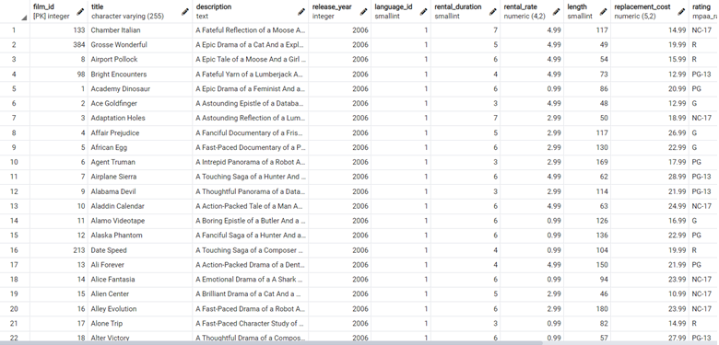

1. Write a query to return unique rows from the release_year column in the film table.

Command: SELECT release_year FROM film

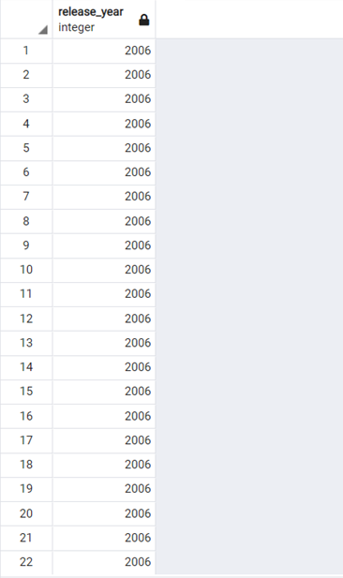

1. Write a query to return unique rows from the rental_rate column in the film table.

Command: SELECT DISTINCT rental_rate from film



1. A customer left us some feedback about our store. Write a query to find her email address – for Nancy Thomas.

Command: SELECT*FROM customer WHERE first_name = 'Nancy' AND last_name = 'Thomas'





1. We’re trying to find a customer located at a certain address ‘259 Ipoh Drive’ – can you find their phone number?

Command: SELECT*FROM address where address='259 Ipoh Drive'





1. Write a query from the customer table, where store id is 1 and address id is greater than 150.

Command: SELECT*FROM customer WHERE store_id=1 AND address_id >150

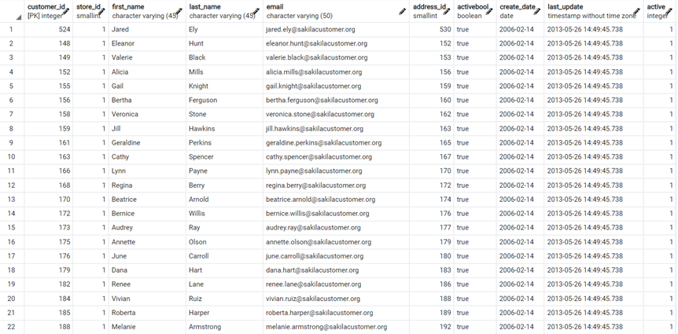



1. Write a query from the payment table where the amount is either 4.99 or 1.99.

Command: SELECT*FROM payment WHERE amount=1.99 OR amount= 4.99

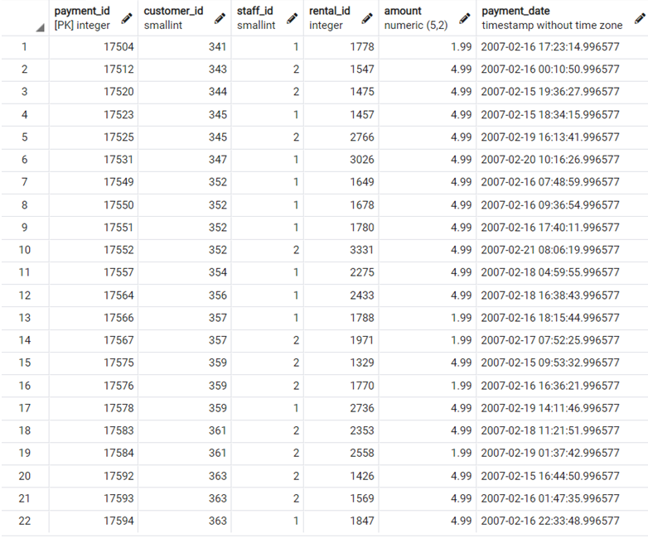



1. Write a query to return a list of transactions from the payment table where the amount is greater than 5.

Command: SELECT*FROM payment WHERE amount>5

