Web Application and Development

Term Project Proposal

**___**

By Snedden Gonsalves

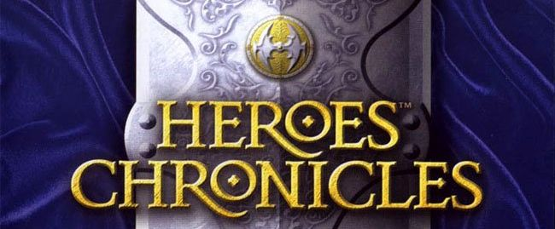

# 

# 

# INTRODUCTION

The Goal of this project is to developed a multiplayer turn based game played on the web platform. The game would be have all the standard security measured as required by the course.Also the game would consist of a inbuilt chat module where players can chat with each other once authenticated.All the chats would be archived.

## About

The game is based on a turn based strategy game called ‘Heroes Chronicles’ developed by new world . The game would be much scaled-down version of the original game.The game would try to recreate the turn based fights of the original game where different players fight each other in a chess like environment. The game would require each player to be registered and authenticated using a valid email address.

## The Game

### Authentication

The login screen would be first window the user sees when he hits the game URL,here he can log-in if he already registered or register using a valid email ID.

### Chat /Challenge room

Once the user has successfully logged in he would access the chat room where he can chat with other online players(privately or common chat window) or challenge another online chat

### Pre Game

After a challenge has been issued and accepted both players will come to the pre-game screen. Here they are given fix amount of resources (gold) which they would have to used to their units(would talk more on units in the later section).Each player has 5 slots for units. They can distribute their gold to buy up till 5 different types of units out of 7 available.Also they can choose one of the 3 spells available.

There are 7 types of units as mentioned below, each unit differs from the other in terms of ‘attributes’.The attributes a unit can have and the unit types are discussed below;  
  
**Attributes**

•Attack :A ranged number , it says the amount the damage the unit deals in an attack

•Defense: A number, its says the amount of damage a unit would block from an incoming attack (if he unit is blocking an attack)

•Range: The minimum number of blocks from the target the unit must be in to be able to attack

•Mobility: The number of blocks an unit can travel in a single turn.

•Hitpoints: A number , the amount of damage a unit can take before it is killed.

•Cost: The amount of gold necessary to buy the unit

**UNITS:**

Pikeman [Pikeman](http://heroes.thelazy.net/wiki/Pikeman)  Attack:1-4 Defence:5 range:1 Hit Points:10 Mobility:4 Cost:60Gold

Archer [Archer](http://heroes.thelazy.net/wiki/Archer) Attack:1-3 Defence:3 range:20 Hit Points:8 Mobility:2 Cost:90Gold

Griffin [Griffin](http://heroes.thelazy.net/wiki/Griffin) Attack:3-6 Defence:5 range:1 Hit Points:20 Mobility:6 Cost:200Gold

Swordsman [Swordsman](http://heroes.thelazy.net/wiki/Swordsman) Attack:6-9 Defence:7 range:1 Hit Points:30 Mobility:5 Cost:300Gold

Monk [Monk](http://heroes.thelazy.net/wiki/Monk) Attack:10-12 Defence:2 range:15 Hit Points:10 Mobility:5 Cost:400Gold

Cavalier [Cavalier](http://heroes.thelazy.net/wiki/Cavalier) Attack:15-25 Defence:8 range:1 Hit Points:50 Mobility:7 Cost:550Gold

Angel [Angel](http://heroes.thelazy.net/wiki/Angel) Attack 30-35 Defence:10 range:1 Hit Points:100 Mobility:12 Cost:1000Gold

**Slots:**  
•Each player is given 1000 gold to buy units ,he has 5 empty slots to accommodate each unit he buys .  
•Each slot can hold any number of units of the same type.

Once the player has decided on the slots he can press the ready button.

### 4.In game

Once both players press the ready button the game can start. The game starts as players and their units facing each other .(Below is a the screenshot from the original game for illustration)

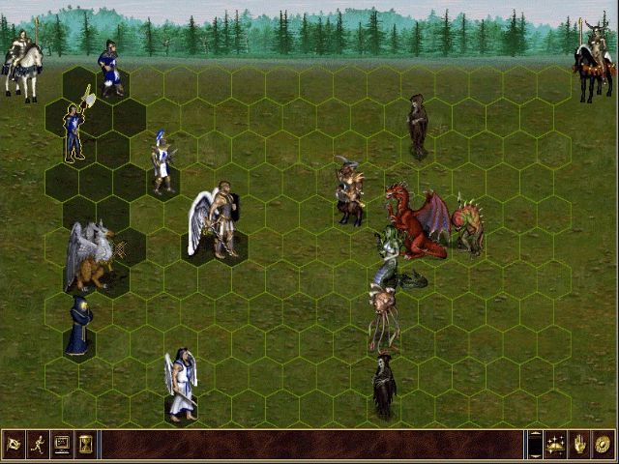

Player one starts first ,each of his slotted-units gets a turn. Where they can perform one the following **actions** :  
•Move: Moves the unit to a specified block(is limited by unit’s mobility)

•Attack:Attack enemy unit(is limited by unit’s range)

•Block: This makes the unit block the attack inflicted on him if a enemy unit(s) attacks him in the next turn (is limited by the unit’s defense)

Beside the unit ,the player himself gets to cast a spell each turn.

**Spells:**

The player can choose on the following three spells in the pre game phase

1.Lighting bolt: Inflicts 10 damage on the target enemy unit

2.Slow:Decreses mobility by 3 of the targeted enemy unit.

3 Shield:Grants a shield to a friendly unit which blocks 5 damage in that turn .

A unit dies when its Hit Points are drained by incoming attacks.The game ends when one of the player loses all his/hers units.

### Server Side

The back-end or server end will be developed in PHP. MySQL database will serve as a data storage. The database would consist of data such as user information,chat logs,game information(attributes,units,spells etc) . The PHP application will run inside the Apache server .

### Client Side

Would use modern browsers such as Chrome, Firefox, Safari, Opera and Internet Explorer for the user interface.The game graphics element would be created using SVG using CSS for animations effects. And javascript to take care of the front end logic. The in game communication would emphasis on to and fro AJAX calls and setting up an heartbeat to set up response listeners at both end of the communication

### Database Design :

**Tables:-**

**User Table:**Consists of basic user information exg Firstname,email ,hashpassword,status(online,offline,in game...) etc

**Profile:**Each user can have more than one profile, A user must have a profile to enter the game. Consist of username, victories,loses,gold etc

**Chat:**Each chat text spend is logged here.

**ChatReceipents:** The receipients of the chat, uses userTable ID as the primary key

**Slot:**Gives the status of a particular slot , each profile has 5 slots associated with.

**Unit**: Unit table consisting of unit name and unit ‘attributes’.

**Actions:**Actions such as move ,attack,block

**Spells:**Spells such as Lightnin blot,slow,shield.

Below is the ER diagram of the proposed database design:

