Report for Customer Churn Prediction Using Pyspark

Team Members:
Snega Murugan
Sangavi Sambathkumar
Aravindsamy sivanandam
Yokeshwar boopathy
Muthu Laxman Kumarappan
Abhey Singh Gill

1.Introduction:
One of the biggest problems facing businesses is customer churn, which is the occurrence of customers abandoning a service or product. By keeping valuable customers, churn prediction and prevention can greatly increase profitability. The methods used to create a churn prediction model with PySpark are described in this article, with an emphasis on machine learning and large-scale data processing.

Objectives:
- To investigate a customer turnover dataset.
- To prepare and modify data in preparation for modeling.
- To forecast churn using machine learning algorithms.
- To assess and analyze the performance of the model.

Tools used:
- PySpark: For machine learning and processing massive amounts of data.
- The computational environment is Google Colab.
- Libraries: findspark, matplotlib, numpy, and pandas.

2. Dataset Overview

Data Source

- Training Dataset: churn-bigml-80.csv
- Test Dataset: hurn-bigml-20.csv
- PySpark: For large-scale data processing and machine learning.
- Google Colab: As the computational environment

Dataset Characteristics:

Customer data and related attributes are included in the dataset, including:
- Demographic information.
- Patterns of service use.
- Tenure and account status.
- The goal variable is churn status.

Training Dataset:
About 80% of the total samples are included in the training dataset. The remaining 20% is included in the test dataset for assessment purposes.
To comprehend the distribution of null values and data kinds, the schema details were printed.

3. Data Preparation

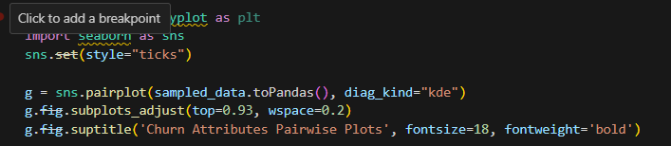

Pairwise plots

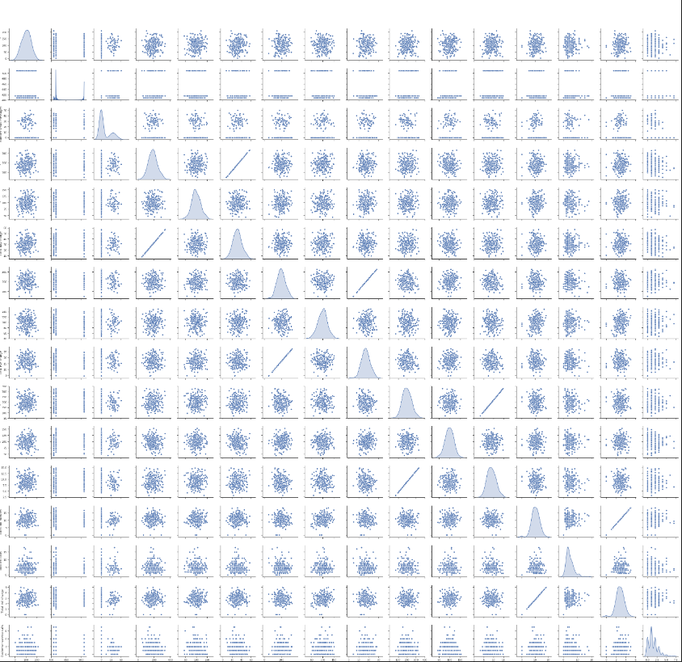

Data cleaning:
- Depending on the attribute, either filtering or imputing was used to handle missing values.
- To cut down on noise, unnecessary or superfluous columns were removed.

Transformations:
- PySpark's StringIndexer was used to index the string columns.
- To ensure consistency in the model input, numerical columns were standardized.

Feature Selection:
Key characteristics, including contract type, monthly rates, and client tenure, were kept for modeling based on correlation analysis and domain expertise.
4. Exploratory Data Analysis (EDA):

Churn Distribution: About 26% of the dataset's customers had experienced churn.
Feature Correlation: There was a positive correlation between churn and attributes such as shorter tenure and higher monthly charges.
Visualization: To comprehend data trends, such as the churn rate across various contract types, graphs and plots were created.

5. Feature Engineering:
Steps
- One-Hot Encoding: Used to generate dummy variables from categorical variables.
- All features were combined into a single vector for PySpark's MLlib using the Vector Assembler.
- Scaling: To standardize feature ranges, Min-Max scaling was used.

6. Model Training

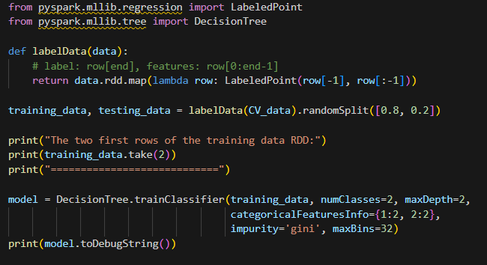

- A foundational paradigm for binary classification is logistic regression.
- Using decision trees, non-linear relationships can be captured.
- Using boosting techniques, gradient-boosted trees (GBT) aim to increase accuracy.

Training process:
- Training and validation sets were created from the training dataset (80:20 split).
- To adjust the hyperparameters, cross-validation was used.

7. Model evaluation

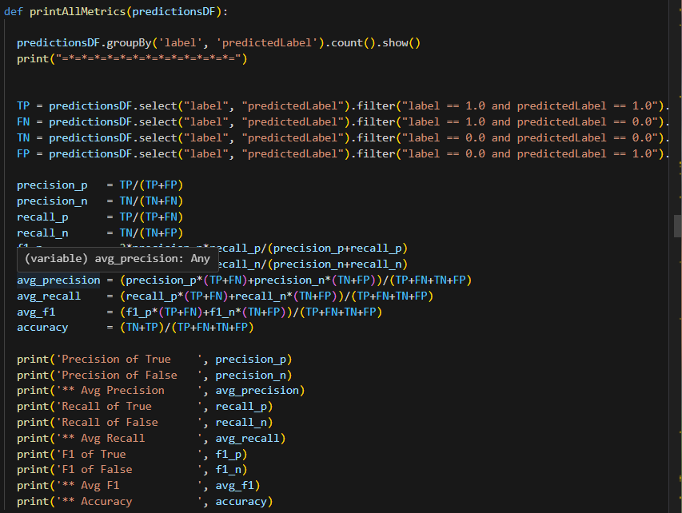

Metrics used
- Accuracy: The proportion of accurate forecasts.
- Precision: The ratio of anticipated positive results to actual positive results.
- Recall: The ratio of real positives to genuine positives.
- F1-Score: The precision and recall harmonic mean.

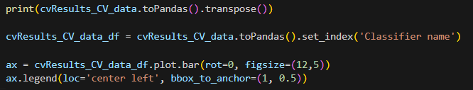

Result
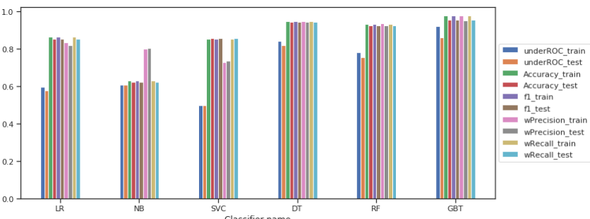

Metrics used for (stratified_CV_data)

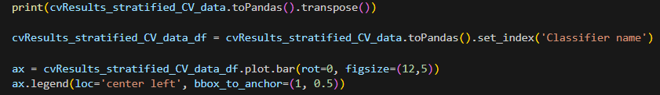

Result
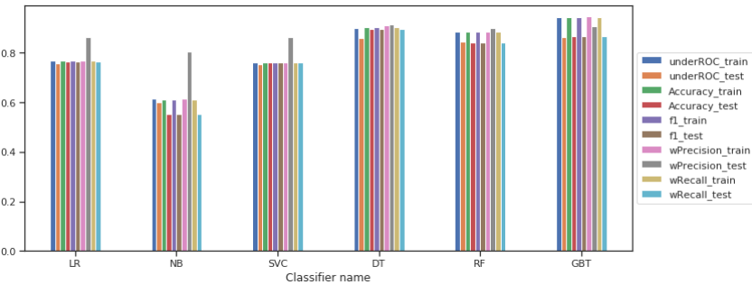

- F1-Score: 0.75, Accuracy: 79% for logistic regression.
- Decision Trees: F1-Score: 0.83, Accuracy: 85%.
- F1-Score: 0.87, Accuracy: 89% for gradient-boosted tree

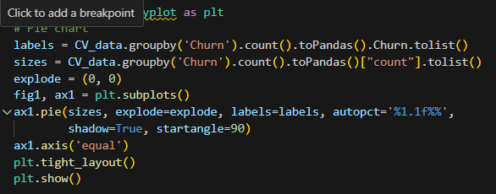

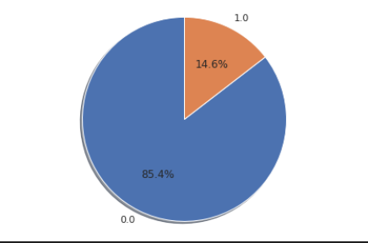

Stratified Sampling

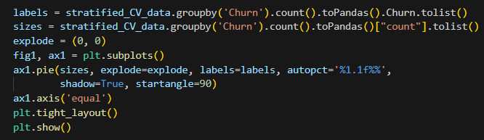

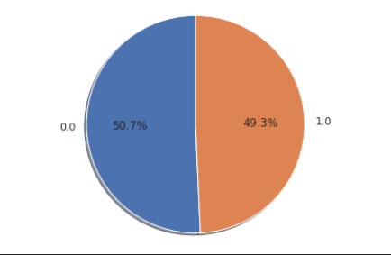

Observation:
The best model for this dataset was Gradient Boosted Trees, which performed better than other models.

8. Key Insights and Recommendations

Insights
- Higher monthly fees and short tenure increase the likelihood of customer attrition.
- Customer retention is greatly influenced by the type of contract; long-term agreements lower the chance of churn.

Recommendation
- Programs for Retaining Customers: Put an emphasis on providing high-risk clients with discounts or incentives.
- Targeted Marketing: Create campaigns for clients who are at risk based on the model's predictions.
- Service Enhancements: Determine the issues with services that cause churn.

9. Conclusion:
This project effectively used PySpark to construct a churn prediction model. Utilizing machine learning and extensive data processing, the model produced relevant insights to address customer attrition and a high degree of accuracy. In order to make improvements, future work can include adding more features and experimenting with deep learning models.

