**APPLICATION DEVELOPMENT TO LIST THE NOBEL PRICE WINNER FOR LAST 100 YEARS**

1. Created HTTP response (URL) using Mocky.



2. Validated the Json using JavaLint .

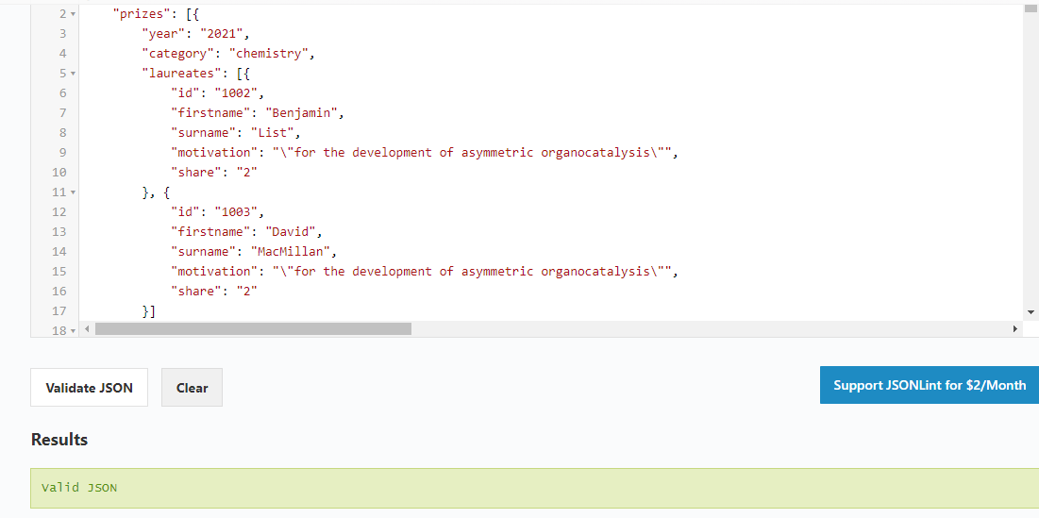

3. Created three Java files to create the application