**Q-1. Create a web page using PHP which accept item information like item name, item type, and quantity from the customer which gives the facility of placing the order. Also give facility of displaying order according to order no.**

<?php

include "connection.php";

?>

<html>

<head>

<title>ITEM</title>

</head>

<body>

<?php

if(isset($_REQUEST['submit']))

{

$Item_name=$_REQUEST['txtname'];

$Item_type=$_REQUEST['txttype'];

$quantity=$_REQUEST['txtqty'];

$query="insert into item(Item_name,Item_type,Quantity) values('$Item_name ','$Item_type ',' $quantity')";

$cnt=mysqli_query($conn,$query);

if($cnt>0)

echo "<font color='green'>Record insetred.......</font>";

else

echo "<font color='red'>Record not insetred......</font>";

}

?>

<form name= "form" method="post">

<table>

<tr>

<td>Item_name:</td>

<td><input type="text" name="txtname"/></td>

</tr>

<tr>

<td>Item_type:</td>

<td><input type="text" name="txttype"/></td>

</tr>

<tr>

<td>Quantity:</td>

<td><input type="text" name="txtqty"/></td>

</tr>

<tr>

<td><input type="submit" name="submit" value="submit"/></td>

</tr>

</table>

</form>

<table border="2">

<tr>

<th> order_number</th>

<th> Item_name</th>

<th> Item_type</th>

<th> Quantity</th>

</tr>

<?php

$query="select * from item";

$res=mysqli_query($conn,$query);

$cnt=mysqli_num_rows($res);

if($cnt>0)

{

$i=1;

while($ans=mysqli_fetch_array($res))

{

$item_name=$ans['Item_name'];

$item_type=$ans['Item_type'];

$quantity=$ans['Quantity'];

echo "<tr>";

echo"<td>".$i++."</td>";

echo"<td>".$item_name."</td>";

echo"<td>".$item_type."</td>";

echo"<td>".$quantity."</td>";

}

}

else{

echo "<tr><td> record not</td></tr>";

}

?>

</table>

</body>

</html>

**Output:**

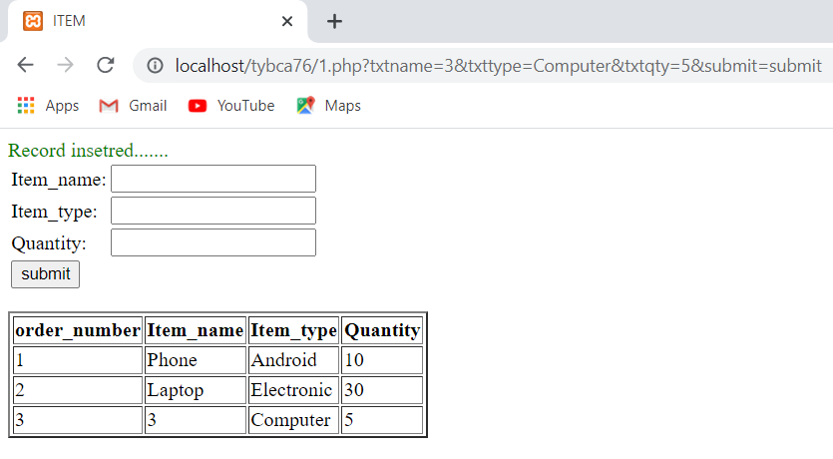

**Q-2. Create a web page using PHP which accept ticket booking information like client_name, source, destination, address, nos. Of passenger travelling, travelling date and train number. Store these records using mySQL database. Provide insert and navigation options.**

**Ass3q2.php code:**

<?php

include "connection.php";

if(isset($_REQUEST['submit']))

{

$clientname=$_REQUEST['cname'];

$source=$_REQUEST['source'];

$destination=$_REQUEST['desti'];

$address=$_REQUEST['add'];

$noofpassenger=$_REQUEST['passenger'];

$travellingdate=$_REQUEST['tdate'];

$trainno=$_REQUEST['tno'];

$query="insert into ticket('Client_name',' Source','Destination','Address','No_of_passenger','Travelling_date','Train_no') values

('$clientname ',' $source',' $destination',' $address', $noofpassenger,'$travellingdate ','$trainno')";

$cnt=mysqli_query($conn,$query);

if($cnt>0)

header("Location:ass3q2.php?msg=Book");

else

header("Location:ass3q2.php?msg= Not Book");

}

?>

<html>

<head>

<title>Question-2</title>

</head>

<body>

<h1>Ticket Book</h1>

<a href="ass3q2.php">Home</a>

<a href="ticket.php">Your Ticket</a>

<form>

<table>

<tr>

<td>Client Name:</td>

<td><input type="text" name="cname" /></td>

</tr>

<tr>

<td>Source:</td>

<td><input type="text" name="source" /></td>

</tr>

<tr>

<td>Destination:</td>

<td><input type="text" name="desti" /></td>

</tr>

<tr>

<td>Address:</td>

<td><input type="text" name="add" /></td>

</tr>

<tr>

<td>NoOfPassenger:</td>

<td><input type="number" name="passenger" /></td>

</tr>

<tr>

<td>Travelling Date:</td>

<td><input type="date" name="tdate" /></td>

</tr>

<tr>

<td>Train No:</td>

<td><input type="number" name="tno" /></td>

</tr>

<tr>

<td><input type="submit" name="submit" /></td>

</tr>

</table>

</form>

</body>

</html>

**Ticket.php code:**

<?php

include "connection.php";

?>

<html>

<head>

<title>ticket</title>

</head>

<body>

<h1> Ticket Booking</h1>

<a href="ass3q2.php">Home</a>

<a href="ticket.php">Your Ticket</a>

<h3>VIEW YOUR DETAIL</h3>

<table border="2">

<tr>

<th> Name</th>

<th> Sorce</th>

<th> Destination</th>

<th> Travelling Date</th>

<th>Train Number</th>

</tr>

<?php

$query="select *from ticket";

$res=mysqli_query($conn,$query);

$cnt=mysqli_num_rows($res);

if($cnt>0)

{

while($ans=mysqli_fetch_array($res))

{

$tno=$ans['Train_no'];

$name=$ans['Client_name'];

$tdate=$ans['Travelling_date'];

$source=$ans['Source'];

$destination=$ans['Destination'];

echo "<tr>";

echo "<td>$name</td>";

echo "<td>$source</td>";

echo "<td>$destination</td>";

echo "<td>$tdate</td>";

echo "<td>$tno</td>";

}

}

else

{

echo "<tr><td>no record</td></tr>";

}

?>

</table>

</body>

</html>

**Output:**

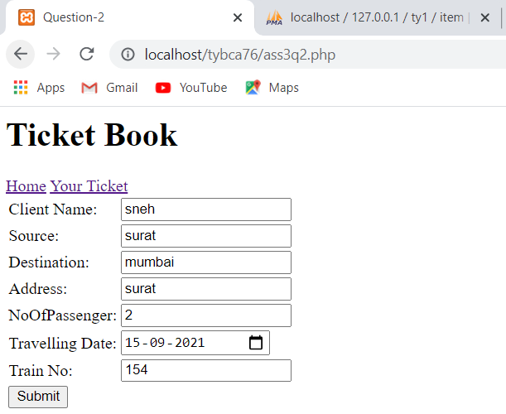 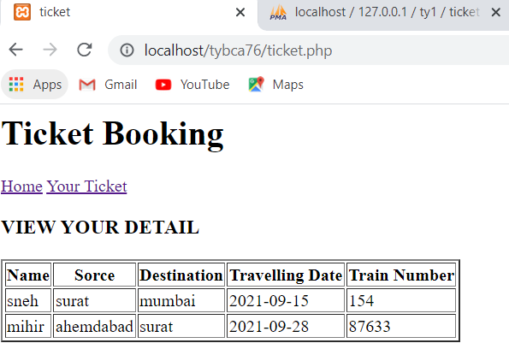

**Q-3. Create a web page using PHP which accepts student information like roll no, name, age, city and phone_number. Store these records in mySQL database. Provide insert, update by roll no. & view options.**

<?php

include "connection.php";

if(isset($_REQUEST['editid']))

{

$editid=$_REQUEST['editid'];

$query="select *from student where rollno=$editid";

$res=mysqli_query($conn,$query);

$ans=mysqli_fetch_array($res);

$rollno=$ans['rollno'];

$name=$ans['name'];

$age=$ans['age'];

$city=$ans['city'];

$phone=$ans['phone'];

}

else

{

$rollno="";

$name="";

$age="";

$city="";

$phone="";

}

**//insert record//**

if(isset($_REQUEST['btninsert']))

{

$rollno=$_REQUEST['rollno'];

$name=$_REQUEST['name'];

$age=$_REQUEST['age'];

$city=$_REQUEST['city'];

$phone=$_REQUEST['phone'];

$query= "insert into student(rollno,name,age,city,phone) values($rollno,'$name','$age','$city','$phone')";

$cnt=mysqli_query($conn,$query);

if($cnt>0)

{

header("Location:ass3q3.php?msg=insert");

}

else

{

header("Location:ass3q3.php?msg= not insert");

}

}

**//Update Record//**

if(isset($_REQUEST['btnupdate']))

{

$rollno=$_REQUEST['rollno'];

$name=$_REQUEST['name'];

$age=$_REQUEST['age'];

$city=$_REQUEST['city'];

$phone=$_REQUEST['phone'];

$query= "update student set name='$name',age=$'$age',city='$city',phone='$phone' where rollno=$rollno";

$cnt=mysqli_query($conn,$query);

if($cnt>0)

{

header("Location:ass3q3.php?edit=ok");

}

else

{

header("Location:ass3q3.php?edit= not ok");

}

}

?>

<html>

<head>

<title>Student Details</title>

</head>

<body>

<h1>Student Information</h1>

<form>

<table>

<tr>

<td>RollNo:</td>

<td><input type="text" name="rollno" value="<?php echo $rollno?>"/></td>

</tr>

<tr>

<td>Name:</td>

<td><input type="text" name="name" value="<?php echo $name ?>"> </td>

</tr>

<tr>

<td>Age:</td>

<td><input type="text" name="age" value="<?php echo $age ?>"></td>

</tr>

<tr>

<td>City:</td>

<td><input type="text" name="city" value="<?php echo $city ?>"></td>

</tr>

<tr>

<td>Phone_no:</td>

<td><input type="text" name="phone" value="<?php echo $phone ?>"></td>

</tr>

<tr>

<?php

if(isset($_REQUEST['editid'])){

?>

<td><input type="submit" name="btnupdate" value= "Update" /></td>

<?php

}

else{

?>

<td><input type="submit" name="btninsert" value= "Insert" /></td>

<?php

}

?>

</tr>

</table>

</form>

<table border="2">

<tr>

<th>RollNo</th>

<th>Name</th>

<th>Age</th>

<th>City</th>

<th>Phone_no</th>

<th>Update</th>

</tr>

<?php

$query="select *from student";

$res=mysqli_query($conn,$query);

$cnt=mysqli_num_rows($res);

if($cnt>0)

{

while($ans=mysqli_fetch_array($res))

{

$rollno=$ans['rollno'];

$name=$ans['name'];

$age=$ans['age'];

$city=$ans['city'];

$phone=$ans['phone'];

echo "<tr>";

echo "<td>$rollno</td>";

echo "<td>$name</td>";

echo "<td>$age</td>";

echo "<td>$city</td>";

echo "<td>$phone</td>";

echo "<td><a href=\"ass3q3.php?editid=$rollno\">Update</a><td>";

echo "</tr>";

}

}

else{

echo "<tr><td>Record not display</td></tr>";

}

?>

</table>

</body>

</html>

**Output:**

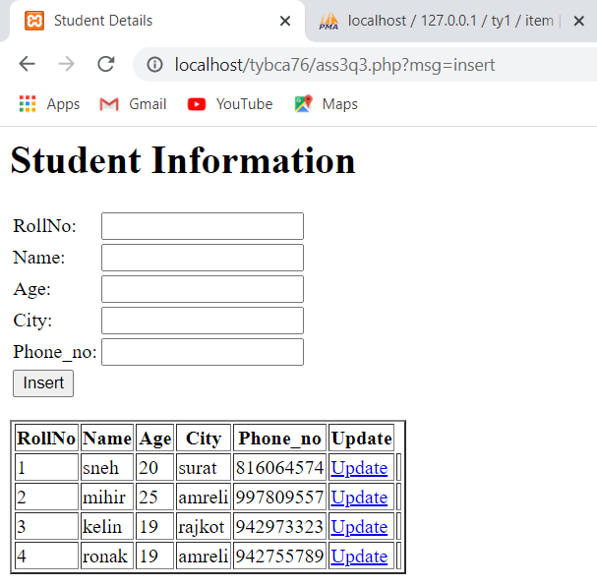 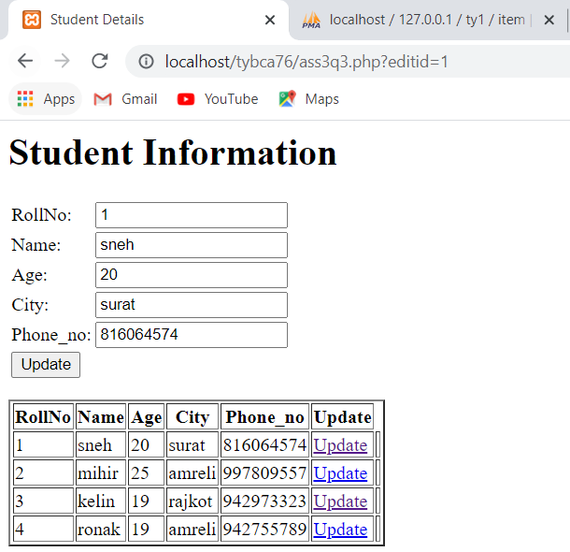

**Q-4. Create web pages which accept book details like book_code, book_name, author_name, cost, ISBN_No. Create database and provide facility to updating book by book_code and searching by book_name and author_name.**

**Book.php**

<?php

include "connection.php";

$editid="";

$bookcode="";

$bookname="";

$authorname="";

$cost="";

$isbnno="";

//Insert Record//

if(isset($_REQUEST['btnsubmit']))

{

$bookcode=$_REQUEST['bcode'];

$bookname=$_REQUEST['bname'];

$authorname=$_REQUEST['aname'];

$cost=$_REQUEST['cost'];

$isbnno=$_REQUEST['isbn'];

$query="insert into book(book_code,book_name,author_name,cost,isbn_no) values('$bookcode','$bookname','$authorname','$cost','$isbnno')";

$cnt=mysqli_query($conn,$query);

if($cnt>0)

echo "<font color='green'>Record insetred.......</font>";

else

echo "<font color='red'>Record not insetred......</font>";

}

//Update Record//

if(isset($_REQUEST['btnupdate']))

{

$bookcode=$_REQUEST['bcode'];

$bookname=$_REQUEST['bname'];

$authorname=$_REQUEST['aname'];

$cost=$_REQUEST['cost'];

$isbnno=$_REQUEST['isbn'];

$query="update book set book_name='$bookname', author_name='$authorname',cost='$cost',isbn_no='$isbnno' where book_code='$bookcode'";

$cnt=mysqli_query($conn,$query);

if($cnt>0)

echo "<font color='green'>Record Updated.......</font>";

else

echo "<font color='red'>Record not Updated......</font>";

}

if(isset($_REQUEST['editid']))

{

$editid=$_REQUEST['editid'];

$query="select * from book where book_code=$editid";

$res=mysqli_query($conn,$query);

$ans=mysqli_fetch_array($res);

$bookname=$ans['book_name'];

$authorname=$ans['author_name'];

$cost=$ans['cost'];

$isbnno=$ans['isbn_no'];

}

?>

<html>

<head>

<title>Untitled Document</title>

</head>

<body>

<form>

<h1>Book Information Insert</h1>

<a href="search.php">Search</a>

<table>

<tr>

<td>Book Code :</td>

<td><input type="text" name="bcode" value="<?php echo $editid;?>" /></td>

</tr>

<tr>

<td>Book name :</td>

<td><input type="text" name="bname" value="<?php echo $bookname;?>" /></td>

</tr>

<tr>

<td>Author Name :</td>

<td><input type="text" name="aname" value="<?php echo $authorname;?>"/></td>

</tr>

<tr>

<td>Cost :</td>

<td><input type="text" name="cost" value="<?php echo $cost;?>" /></td>

</tr>

<tr>

<td>ISBN No. :</td>

<td><input type="text" name="isbn" value="<?php echo $isbnno;?>" /></td>

</tr>

<tr><td colspan="2" align="center">

<?php

if(isset($_REQUEST['editid']))

{

?>

<input type="submit" name="btnupdate" value="Update" />

<?php

}

else

{

?>

<input type="submit" name="btnsubmit" />

<?php

}

?>

</td>

</tr>

</table>

</form>

<table border="2">

<tr>

<td>Book code</td>

<td>Book Name</td>

<td>Author Name</td>

<td>Cost</td>

<td>ISBN No</td>

<td>Update</td>

</tr>

<?php

$res=mysqli_query($conn,"select * from book");

while($ans=mysqli_fetch_array($res))

{

echo "<tr>";

echo "<td>";echo $ans['book_code']; echo "</td>";

echo "<td>";echo $ans['book_name']; echo "</td>";

echo "<td>";echo $ans['author_name']; echo "</td>";

echo "<td>";echo $ans['cost']; echo "</td>";

echo "<td>";echo $ans['isbn_no']; echo "</td>";

?>

<td><a href="index.php?editid=<?php echo $ans['book_code']; ?>">Update</a></td>

</tr>

<?php

}

?>

</table>

</div>

</body>

</html>

Serachbook.php

<?php

include "connection.php";

?>

<html>

<head>

<title>Search Book</title>

</head>

<body>

<form method="post">

<table>

<tr>

<td>Enter Book Name:</td>

<td><input type="text" name="bname" /></td>

</tr>

<tr>

<td>Enter Author Name : </td>

<td><input type="text" name="aname" /></td>

</tr>

<tr>

<td><input type="submit" name="search" value="search" /></td>

</tr>

</form>

<?php

if(isset($_POST['search']))

{

?>

<table border="2">

<tr>

<td>Book code</td>

<td>Book Name</td>

<td>Author Name</td>

<td>Cost</td>

<td>ISBN No</td>

</tr>

<?php

$bookname=$_REQUEST['bname'];

$authorname=$_REQUEST['aname'];

$query="select * from book where bname='$bookname' and aname='$authorname'";

$res=mysqli_query($conn,$query);

$cnt=mysqli_num_rows($res);

if($cnt>0)

{

while($ans=mysqli_fetch_array($res))

{

echo "<tr>";

echo "<td>";echo $ans['book_code']; echo "</td>";

echo "<td>";echo $ans['book_name']; echo "</td>";

echo "<td>";echo $ans['author_name']; echo "</td>";

echo "<td>";echo $ans['cost']; echo "</td>";

echo "<td>";echo $ans['isbn_no']; echo "</td>";

}

?>

</tr>

<?php

}

else

{

echo "record not display";

}

}

?>

</table>

</body>

</html>

**Output:**

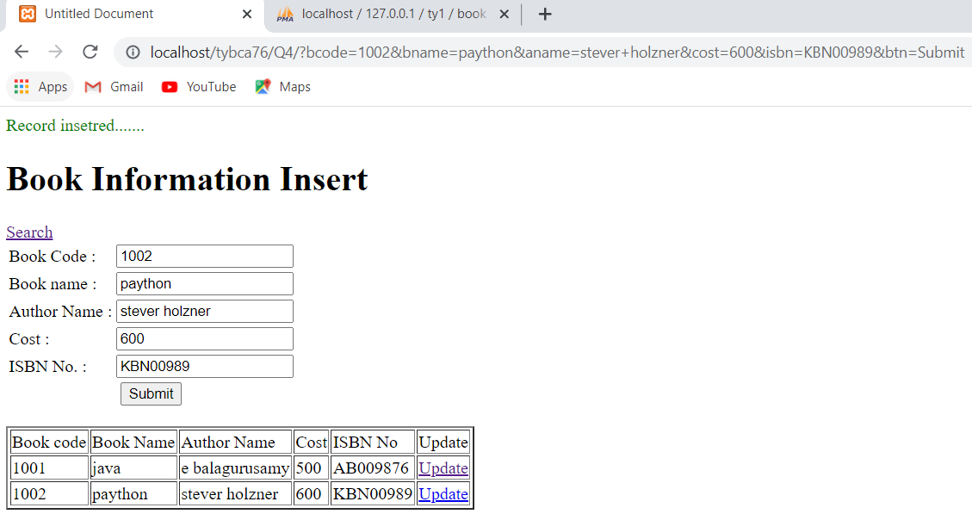

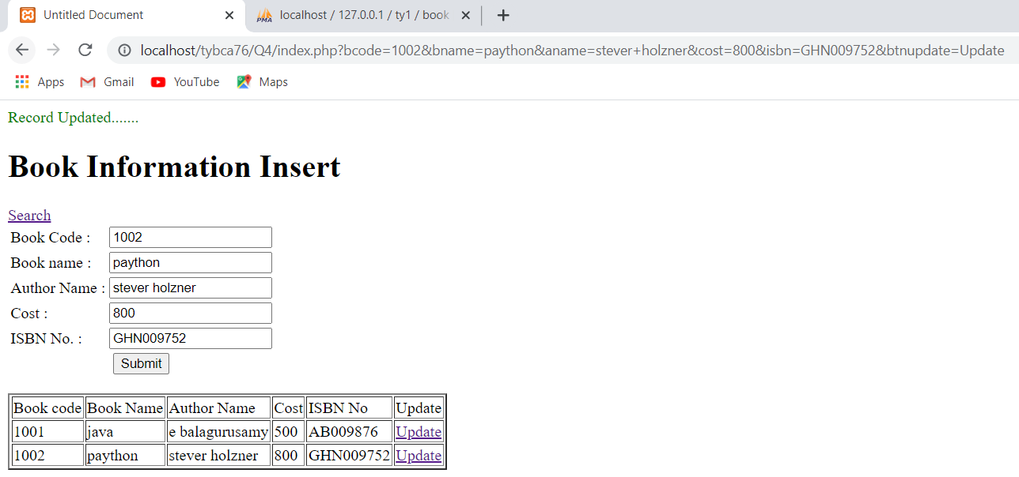

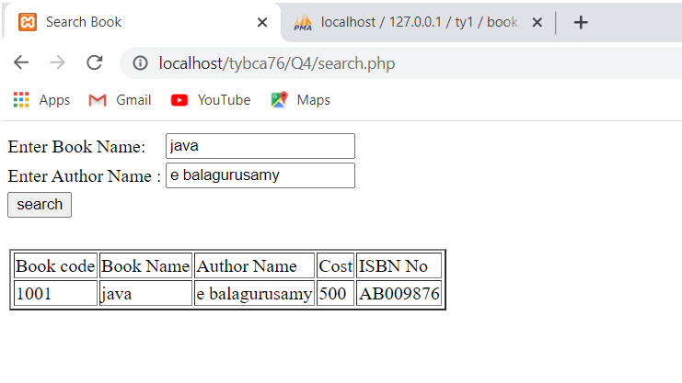

**Q-5. Create a website for online mobile shopping of different companies. This website displays different mobiles with their prices. (Company, Model Name, price, etc.) Admin can add or remove mobiles. Customer can search mobile according to price. Also provide proper validations.**

<?php

include "connection.php";

?>

<html>

<head>

<title>Questio-5</title>

<script language="javascript">

function chech()

{

var tmp=confirm('are you sure want to delete record??');

if(tmp)

return true;

else

return false;

}

</script>

</head>

<body>

<?php

if(isset($_REQUEST['submit']))

{

$id=$_REQUEST['txtid'];

$Mobile_CompanyName=$_REQUEST['txtcname'];

$Mobile_Name=$_REQUEST['txtname'];

$Mobile_Price=$_REQUEST['txtprice'];

$Mobile_Storage=$_REQUEST['txtstorage'];

$query="insert into mobile(id,Mobile_CompanyName,Mobile_Name,Mobile_Price,Mobile_Storage) values('$id','$Mobile_CompanyName','$Mobile_Name','$Mobile_Price','$Mobile_Storage')";

$cnt=mysqli_query($conn,$query);

if($cnt>0)

{

echo "record insert";

}

else

{

echo "record not insert";

}

}

?>

<form>

<h2>Mobile Information</h2>

<table>

<tr>

<td>Mobile Id:</td>

<td><input type="text" name="txtid"/></td>

</tr>

<tr>

<td>Mobile Company Name:</td>

<td><input type="text" name="txtcname"/></td>

</tr>

<tr>

<td>Mobile Name:</td>

<td><input type="text" name="txtname"/></td>

</tr>

<tr>

<td>Mobile Price:</td>

<td><input type="text" name="txtprice"/></td>

</tr>

<tr>

<td>Mobile Storage:</td>

<td><input type="text" name="txtstorage"/></td>

</tr>

<tr>

<td><input type="submit" name="submit"/></td>

</tr>

</table>

</form>

<h2>Display Data</h2>

<table border="2">

<tr>

<th> ID</th>

<th> Mobile_CompanyName</th>

<th> Mobile_Name</th>

<th> Mobile_Price</th>

<th> Mobile_Storage</th>

<th> Delete</th>

</tr>

<?php

$query="select * from mobile order by id";

$res=mysqli_query($conn,$query);

$cnt=mysqli_num_rows($res);

if($cnt>0)

{

while($ans=mysqli_fetch_array($res))

{

$id=$ans['id'];

$Mobile_CompanyName=$ans['Mobile_CompanyName'];

$Mobile_Name=$ans['Mobile_Name'];

$Mobile_Price=$ans['Mobile_Price'];

$Mobile_Storage=$ans['Mobile_Storage'];

echo "<tr>";

echo "<td>$id</td>";

echo "<td>$Mobile_CompanyName</td>";

echo "<td>$Mobile_Name</td>";

echo "<td>$Mobile_Price</td>";

echo "<td>$Mobile_Storage</td>";

echo "<td><a href=\"delete1.php?delid=$id\" onclick= \"return check();\">Delete</a></td>";

echo "</tr>";

}

}

else{

echo "<tr><td>record not display</td></tr>";

}

?>

</table>

</body>

</html>

**customer.php**

<?php

include "connection.php";

?>

<html>

<head>

<title>Customer </title>

</head>

<body>

<form method="post">

Mobile Price:<input type="text" name="txtmp"/>

<br>

<input type="submit" name="search">

</form>

<h2>Display Data</h2>

<table border="2">

<tr>

<th>id </th>

<th>Mobile_CompanyName </th>

<th>Mobile_Name </th>

<th>Mobile_Price</th>

<th>Mobile_Storage </th>

</tr>

<?php

if(isset($_REQUEST['search']))

{

$Mobile_Price=$_REQUEST['txtmp'];

$query="select * from mobile where Mobile_Price <=$_REQUEST[txtmp]";

$res=mysqli_query($conn,$query);

$cnt=mysqli_num_rows($res);

if($cnt>0)

{

while($ans=mysqli_fetch_array($res))

{

$id=$ans['id'];

$Mobile_CompanyName=$ans['Mobile_CompanyName'];

$Mobile_Name=$ans['Mobile_Name'];

$Mobile_Price=$ans['Mobile_Price'];

$Mobile_Storage=$ans['Mobile_Storage'];

echo "<tr>";

echo "<td>$id</td>";

echo "<td>$Mobile_CompanyName</td>";

echo "<td>$Mobile_Name</td>";

echo "<td>$Mobile_Price</td>";

echo "<td>$Mobile_Storage</td>";

echo "</tr>";

}

}

else{

echo "<tr><td>record not display</td></tr>";

}

}

?>

</table>

</body>

</html>

**delete1.php**

<?php

include "connection.php";

$id=$_REQUEST['delid'];

$query="delete from mobile where id=$id";

$cnt=mysqli_query($conn,$query);

if($cnt == 0)

{

header("Location:ass3q5.php?delmsg=notok");

}

else

{

header("Location:ass3q5.php?delmsg=ok");

}

?>

**Output:**

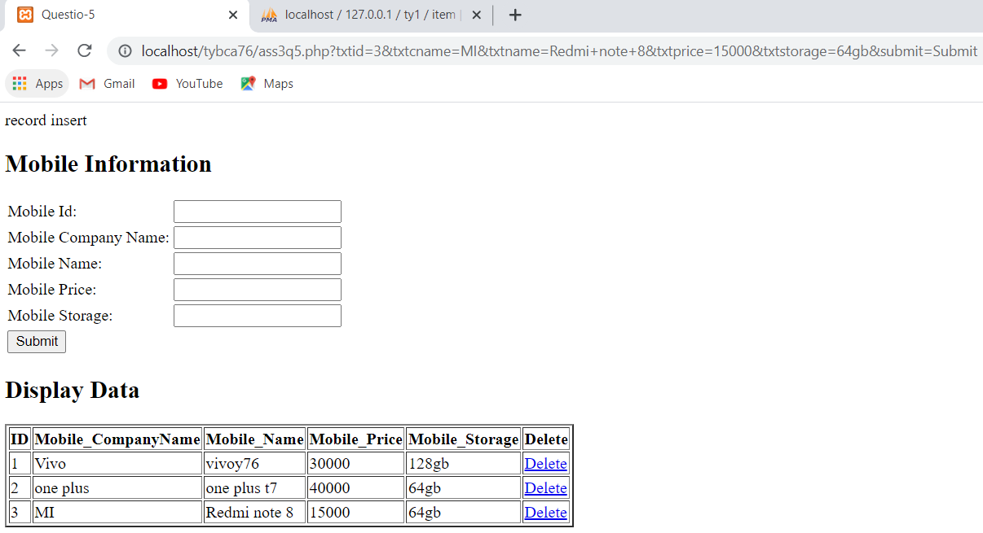

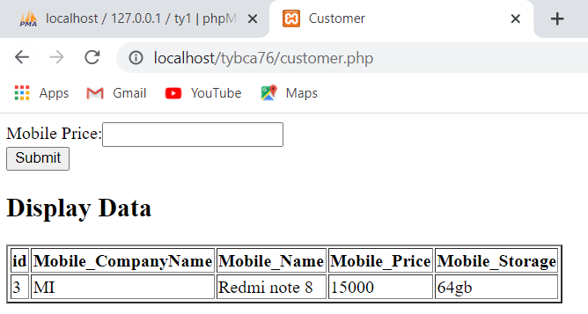

**Q-6. Create a web page for AMAZON that gives order details and status of order according to the order no. given by customer. Give appropriate validations. Also give facility for viewing past orders by date. (Tables : cust_mast, item_mast, order_mast, order_detail).**

<?php

include "connection.php";

?>

<html>

<head>

<title>Question-6</title>

</head>

<body>

<h1>Amazon</h1>

<h3>Track your order with order id</h3>

<form>

<input type="text" name="search" />

<input type="submit" name="btnsearch" value="Track Order"/>

</form>

<table border="2">

<tr>

<th>Order No</th>

<th>Product Name</th>

<th>Product Type</th>

<th>Product Price</th>

<th>Order Status</th>

</tr>

<?php

if(isset($_REQUEST['btnsearch']))

{

$ono=$_REQUEST['search'];

$query="select * from order_mast o,order_details od, item_mast i where od.o_id=o.id and o.i_id=i.id and od.o_id=$ono";

$res=mysqli_query($conn,$query);

$cnt=mysqli_num_rows($res);

if($cnt>0)

{

while($ans=mysqli_fetch_array($res))

{

$oid=$ans['o_id'];

$name=$ans['name'];

$type=$ans['type'];

$price=$ans['price'];

$status=$ans['status'];

echo "<tr>";

echo "<td>$oid</td>";

echo "<td>$name</td>";

echo "<td>$type</td>";

echo "<td>$price</td>";

echo "<td>$status</td>";

echo "</tr>";

}

}

else

{

echo "<tr><td>record not</td></tr>";

}

}

?>

</table>

<br><br>

<h3> Track Your Order With Date</h3>

<form>

<input type="date" name="searchdate" />

<input type="submit" name="btndatesearch" value="Track Order"/>

</form>

<table border="2">

<tr>

<th>Order No</th>

<th>Product Name</th>

<th>Product Type</th>

<th>Product Price</th>

<th>Order Status</th>

</tr>

<?php

if(isset($_REQUEST['btndatesearch']))

{

$date=$_REQUEST['searchdate'];

$query="select * from order_mast o,order_details od, item_mast i where od.o_id=o.id and o.i_id=i.id and o.time=$date";

$res=mysqli_query($conn,$query);

$cnt=mysqli_num_rows($res);

if($cnt>0)

{

while($ans=mysqli_fetch_array($res))

{

$oid=$ans['o_id'];

$name=$ans['name'];

$type=$ans['type'];

$price=$ans['price'];

$status=$ans['status'];

echo "<tr>";

echo "<td>$oid</td>";

echo "<td>$name</td>";

echo "<td>$type</td>";

echo "<td>$price</td>";

echo "<td>$status</td>";

echo "</tr>";

}

}

else

{

echo "<tr><td>record not</td></tr>";

}

}

?>

</table>

</body>

</html>

**Output:**

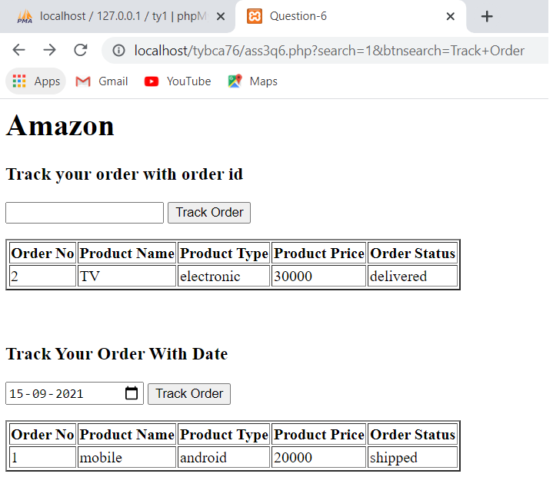

**Q-7. Create a registration page for matrimony website with all required validations. Fields are like person_name, city, mobno, cast, subcast, gender, qualification, etc. Also give facility of searching records by city and cast. Use concept of session.**

**person.php**

<?php

include "connection.php";

session_start();

if(isset($_REQUEST['submit']))

{

$pname=$_REQUEST['pname'];

$city=$_REQUEST['city'];

$mo=$_REQUEST['mo'];

$cast=$_REQUEST['cast'];

$subcast=$_REQUEST['subcast'];

$gender=$_REQUEST['gender'];

$quali=$_REQUEST['quali'];

$query="insert into person (pname,city,mobile,cast,subcast,gender,qualification) values('$pname','$city','$mo','$cast','$subcast','$gender','$quali')";

$cnt=mysqli_query($conn,$query);

}

?>

<html>

<head>

</head>

<body>

<h1>Matrimony</h1>

<a href="show.php">Show</a>

<form>

<table>

<tr>

<td>Person name</td>

<td><input type="text" name="pname"></td>

</tr>

<tr>

<td>City</td>

<td><input type="text" name="city"></td>

</tr>

<tr>

<td>Mobile no</td>

<td><input type="text" name="mo"></td>

</tr>

<tr>

<td>Cast</td>

<td><input type="text" name="cast"></td>

</tr>

<tr>

<td>Subcast</td>

<td><input type="text" name="subcast"></td>

</tr>

<tr>

<td>Gender</td>

<td><input type="radio" name="gender" value="Male">Male

<input type="radio" name="gender" value="Female">Female</td>

</tr>

<tr>

<td>Qualification</td>

<td><input type="text" name="quali"></td>

</tr>

<tr>

<td><input type="submit" name="submit" value="submit"></td>

</tr>

</table>

</form>

<table border="2">

<tr>

<th> Person Name</th>

<th> City</th>

<th> Mobile No</th>

<th> Cast</th>

<th> SubCast</th>

<th> Gender</th>

<th> Qualification</th>

</tr>

<?php

$query="select * from person";

$res=mysqli_query($conn,$query);

$cnt=mysqli_num_rows($res);

if($cnt>0)

{

while($ans=mysqli_fetch_array($res))

{

$pname=$ans['pname'];

$city=$ans['city'];

$mobileno=$ans['mobile'];

$cast=$ans['cast'];

$subcast=$ans['subcast'];

$gender=$ans['gender'];

$qualification=$ans['quali'];

echo "<tr>";

echo"<td>".$pname."</td>";

echo"<td>".$city."</td>";

echo"<td>".$mobileno."</td>";

echo"<td>".$cast."</td>";

echo"<td>".$subcast."</td>";

echo"<td>".$gender."</td>";

echo"<td>".$qualification."</td>";

}

}

else

{

echo "<tr><td> record not</td></tr>";

}

?>

</table>

</body>

</html>

**Show.php**

<?php

include "connection.php";

session_start();

?>

<html>

<head>

<title>Show</title>

</head>

<body>

<form method="post">

<table>

<tr>

<td>Enter city:</td>

<td><input type="text" name="city" /></td>

</tr>

<tr>

<td>Enter cast : </td>

<td><input type="text" name="cast" /></td>

</tr>

<tr>

<td><input type="submit" name="search" value="search" /></td>

</tr>

</form>

<?php

if(isset($_POST['search']))

{

?>

<table border="2">

<tr>

<td>Person Name</td>

<td>City</td>

<td>Mobile no</td>

<td>Cast</td>

<td>Subcast</td>

<td>Gender</td>

<td>Qualification</td>

</tr>

<?php

$city=$_REQUEST['city'];

$cast=$_REQUEST['cast'];

$query="select * from book where city='$city' and cast='$cast'";

$res=mysqli_query($conn,$query);

$cnt=mysqli_num_rows($res);

if($cnt>0)

{

while($ans=mysqli_fetch_array($res))

{

echo "<tr>";

echo "<td>";echo $ans['pname']; echo "</td>";

echo "<td>";echo $ans['city']; echo "</td>";

echo "<td>";echo $ans['mobile']; echo "</td>";

echo "<td>";echo $ans['subcast']; echo "</td>";

echo "<td>";echo $ans['gender']; echo "</td>";

echo "<td>";echo $ans['quali']; echo "</td>";

}

?>

</tr>

<?php

}

else

{

echo "record not display";

}

}

?>

</table>

</body>

</html>

**Output:**

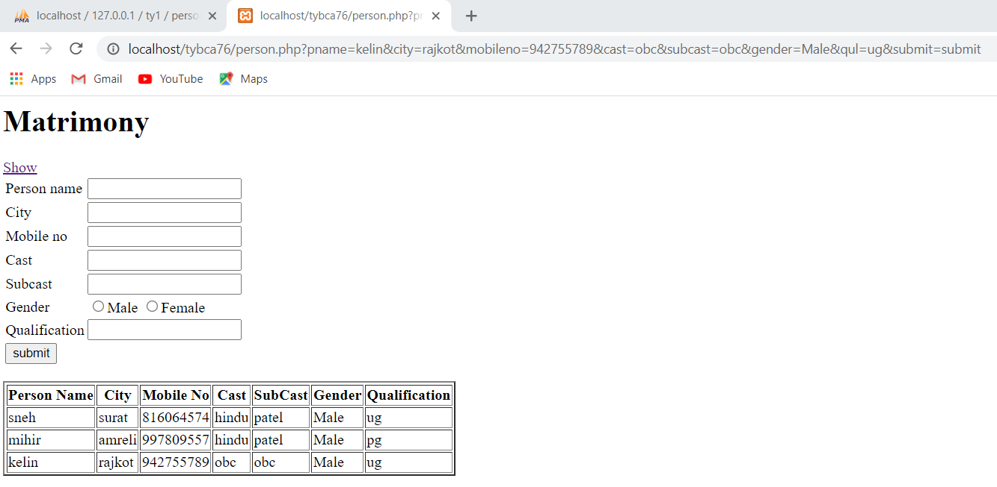

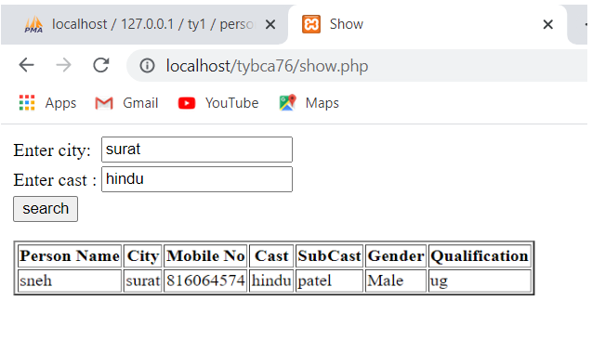

**Q-8. Create a website for particular hotel. Customer can book rooms using this website and also view status of available rooms. Admin can** add **room detail in this website. (Tables: Room_Mast, Booking, Cust_Mast).**

**Admin.php:**

<?php

include "connection.php";

if(isset($_REQUEST['editid']))

{

$editid=$_REQUEST['editid'];

$query="select * from room_mast where id=$editid";

$res=mysqli_query($conn,$query);

$ans=mysqli_fetch_array($res);

$id=$ans['id'];

$name=$ans['name'];

$type=$ans['type'];

$cost=$ans['cost'];

$status=$ans['status'];

}

else

{

$id="";

$name="";

$type="";

$cost="";

$status="";

}

//insert//

if(isset($_REQUEST['btnsubmit']))

{

$id=$_REQUEST['id'];

$name=$_REQUEST['name'];

$type=$_REQUEST['type'];

$cost=$_REQUEST['cost'];

$status=$_REQUEST['status'];

$query="insert into room_mast(id,name,type,cost,status) values($id,'$name','$type','$cost','$status')";

$cnt=mysqli_query($conn,$query);

if($cnt>0)

header("Location:q8.php?msg=record inserted....");

else

header("Location:q8.php?msg= not record inserted....");

}

//update//

if(isset($_REQUEST['btnupdate']))

{

$id=$_REQUEST['id'];

$name=$_REQUEST['name'];

$type=$_REQUEST['type'];

$cost=$_REQUEST['cost'];

$status=$_REQUEST['status'];

$query="update room_mast set name='$name',type='$type',cost='$cost',status='$status' where id=$id";

$cnt=mysqli_query($conn,$query);

if($cnt>0)

header("Location:q8.php?msg=record update....");

else

header("Location:q8.php?msg= not record update....");

}

?>

<html>

<head>

<title>Hotel</title>

</head>

<body>

<h1>Room Booking Information</h1>

<a href="cust.php">customer</a>

<form>

<table>

<tr>

<td>Room No:</td>

<td><input type="text" name="id" value="<?php echo $id?>"></td>

</tr>

<tr>

<td>Room Name:</td>

<td><input type="text" name="name" value="<?php echo $name?>"></td>

</tr>

<tr>

<td>Room Type:</td>

<td><input type="text" name="type" value="<?php echo $type?>"></td>

</tr>

<tr>

<td>Cost:</td>

<td><input type="text" name="cost" value="<?php echo $cost?>"></td>

</tr>

<tr>

<td>Status:</td>

<td><input type="text" name="status" value="<?php echo $status?>"></td>

</tr>

<tr>

<?php

if(isset($_REQUEST['editid']))

{

?>

<td><input type="submit" name="btnupdate" value="Update"/></td>

<?php

}

else

{

?>

<td><input type="submit" name="btnsubmit" value="Insert"/></td>

<?php

}

?>

</table>

</form>

<table border="2">

<tr>

<th>Room NO</th>

<th>Room Name</th>

<th>Room Type</th>

<th>Cost</th>

<th>Status</th>

<th>Update</th>

</tr>

<?php

$query="select * from room_mast";

$res=mysqli_query($conn,$query);

$cnt=mysqli_num_rows($res);

if($cnt>0)

{

while($ans=mysqli_fetch_array($res))

{

$id=$ans['id'];

$name=$ans['name'];

$type=$ans['type'];

$cost=$ans['cost'];

$status=$ans['status'];

echo "<tr>";

echo "<td>$id</td>";

echo "<td>$name</td>";

echo "<td>$type</td>";

echo "<td>$cost</td>";

echo "<td>$status</td>";

echo "<td><a href=\"q8.php?editid=$id\">Update</a></td>";

echo "</tr>";

}

}

else{

echo "<tr><td>record not</td></tr>";

}

?>

</table>

</body>

</html>

**Cust.php:**

<?php

include "connection.php";

if(isset($_REQUEST['submit']))

{

$cid=$_REQUEST['cid'];

$cname=$_REQUEST['cname'];

$id=$_REQUEST['id'];

$name=$_REQUEST['name'];

$type=$_REQUEST['type'];

$cost=$_REQUEST['cost'];

$status=$_REQUEST['status'];

$query="insert into cust_mast1 (cid,cname,id,rname,rtype,cost,status) values('$cid','$cname','$id','$name','$type','$cost','$status')";

$cnt=mysqli_query($conn,$query);

if($cnt>0)

header("Location:customerbooking.php?msg=record inserted....");

else

header("Location:customerbooking.php?msg= not record inserted....");

}

?>

<html>

<head>

<title>Document</title>

</head>

<body>

<form action="">

<table>

<tr>

<td>cid</td>

<td><input type="text" name="cid"></td>

</tr>

<tr>

<td>cname</td>

<td><input type="text" name="cname"></td>

</tr>

<tr>

<td>Room No:</td>

<td><input type="text" name="id" ></td>

</tr>

<tr>

<td>Room Name:</td>

<td><input type="text" name="name" ></td>

</tr>

<tr>

<td>Room Type:</td>

<td><input type="text" name="type" ></td>

</tr>

<tr>

<td>Cost:</td>

<td><input type="text" name="cost" ></td>

</tr>

<tr>

<td>Status:</td>

<td><input type="text" name="status"/></td>

</tr>

<tr>

<td>

<input type="submit" name="submit" value="insert">

</td>

</tr>

</table>

</form>

<table border="2">

<tr>

<th> Cid</th>

<th> Cname</th>

<th> RoomNo</th>

<th> RoomName</th>

<th>Type</th>

<th>Cost</th>

<th>Status</th>

</tr>

<?php

$query="select * from cust_mast1";

$res=mysqli_query($conn,$query);

$cnt=mysqli_num_rows($res);

if($cnt>0)

{

while($ans=mysqli_fetch_array($res))

{

$cid=$ans['cid'];

$cname=$ans['cname'];

$id=$ans['id'];

$name=$ans['name'];

$type=$ans['type'];

$cost=$ans['cost'];

$status=$ans['status'];

echo "<tr>";

echo"<td>".$cid."</td>";

echo"<td>".$cname."</td>";

echo"<td>".$id."</td>";

echo "<td>".$name."</td>";

echo "<td>".$type."</td>";

echo "<td>".$cost."</td>";

echo "<td>".$status."</td>";

echo "</tr>";

}

}

else{

echo "<tr><td> record not</td></tr>";

}

?>

</table>

</body>

</html>

**Output:**

