Assignment 2: Flowchart Creation - Design a

Flow chart that outlines the logic for a user login process. It should include

conditional paths for successful and unsuccessful login attempts, and a loop

that allows a user three attempts before locking the account.

**Flowchart:**

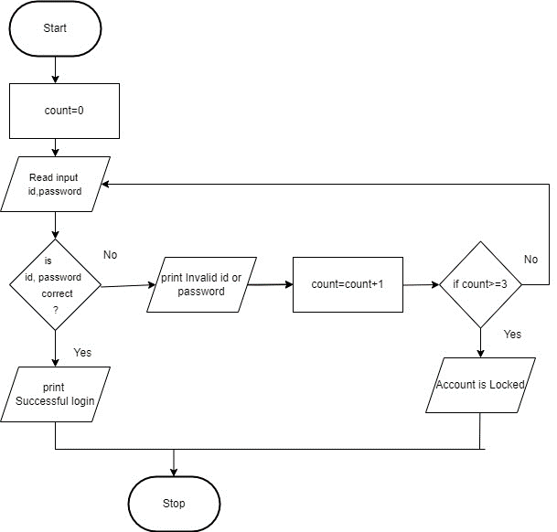

Assignment 3:

Function Design and Modularization - Create a document that describes the design of two modular functions: one that returns the factorial of a number, and another that calculates the nth Fibonacci number. Include pseudo code and a brief explanation of how modularity in programming helps with code reuse and organization.

**Fibonacci:**

Begin

if n <= 1 then

return n

else

return fibonacci(n-1) + fibonacci(n-2)

end if

End

**Factorial:**

Start

if n == 0 then

return 1

else

return n * factorial(n-1)

end if

End