Document on the Queries

This Document contains queries and their results related to EDA and Advance Data Analytics

Step 1. DATABASE EXPLORATION

1. Explore All Objects in the Database

SELECT * FROM INFORMATION_SCHEMA.TABLES

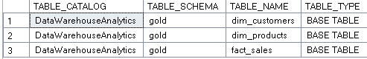

1. Explore All Columns in Database

SELECT * FROM INFORMATION_SCHEMA.COLUMNS

WHERE TABLE_NAME = 'dim_customers'

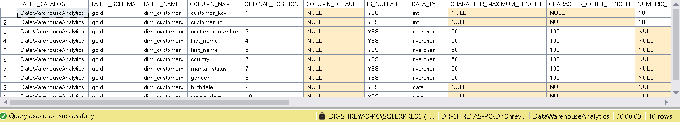

Step 2. DIMENSIONS EXPLORATIO

Identifying the unique values (or categories) in each dimensions &

Recognizing how data might be grouped or segmented. Which is useful for later analysis

1. Explore All Countries our Customers come from

SELECT DISTINCT country from gold.dim_customers;

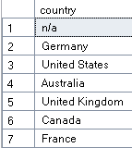

1. Explore All Categories "The major Divisions", Subcategories & Products

SELECT DISTINCT category, subcategory, product_name FROM gold.dim_products

ORDER BY 1,2,3

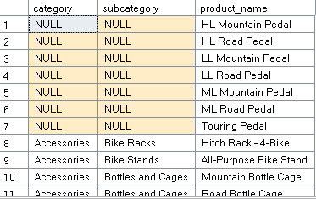

In Total we have 295 different Products

Step 3. DATE EXPLORATION

Identify the earliest and latest dates (boundaries). Understand the scope of data and the timespan

1. Find the date of the first and last order

SELECT

MIN(order_date) first_order_date,

MAX(order_date) last_order_date

FROM gold.fact_sales;



1. How many years of sales are available

SELECT

MIN(order_date) first_order_date,

MAX(order_date) last_order_date,

DATEDIFF(year, MIN(order_date), MAX(order_date)) AS order_range_years

FROM gold.fact_sales;



1. --Find the youngest and oldest customer

SELECT

MIN(birthdate) oldest_birthdate,

DATEDIFF(year, MIN(birthdate), GETDATE()) AS youngest_age,

MAX(birthdate) youngest_birthdate,

DATEDIFF(year, MAX(birthdate), GETDATE()) AS youngest_age

FROM gold.dim_customers;



Step 4. MEASURES EXPLORATION

Calculate the key metric of the business (Big Numbers)

-Highest Level of Aggregation

1. --Find the Total Sales

SELECT SUM(sales_amount) AS total_sales FROM gold.fact_sales



1. --Find how many items are sold

SELECT SUM(quantity) FROM gold.fact_sales



1. --Find the average selling price

SELECT AVG(price) AS avg_selling_price FROM gold.fact_sales



1. --Find the total number of orders

SELECT COUNT(DISTINCT order_number) as total_orders from gold.fact_sales



1. --Find the total number of products

SELECT COUNT(product_name) AS total_products FROM gold.dim_products



1. --Find the total number of customers

SELECT COUNT(customer_key) AS total_customers FROM gold.dim_customers



1. --Find the total number of customers that has placed an order

SELECT COUNT(DISTINCT customer_key) AS total_customers FROM gold.fact_sales



1. --Generate a Report that shows all key metrics of the business

SELECT 'Total Sales' AS meaure_name, SUM(sales_amount) AS measure_value FROM gold.fact_sales

UNION ALL

SELECT 'Total Quantity', SUM(quantity) FROM gold.fact_sales

UNION ALL

SELECT 'Average Price', AVG(price) AS avg_selling_price FROM gold.fact_sales

UNION ALL

SELECT 'Total Nr. orders', COUNT(DISTINCT order_number) as total_orders from gold.fact_sales

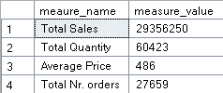

Step 5. Magnitude

Compare the measure values by categories

It helps us understand the importance of different categories

1. --Find total customers by countries

SELECT country, COUNT(customer_id) AS Total_Customers FROM gold.dim_customers

GROUP BY country

ORDER BY Total_Customers DESC

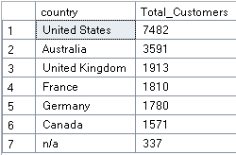

1. --Find total customers by gender

SELECT gender, COUNT(customer_id) AS Total_Customers FROM gold.dim_customers

GROUP BY gender

ORDER BY Total_Customers DESC

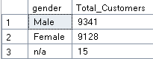

1. --Find total products by category

SELECT Category, COUNT(DISTINCT product_key) AS Total_Product FROM gold.dim_products

GROUP BY category

ORDER BY Total_Product DESC

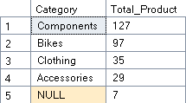

1. --What is the average cost in each category

SELECT category, AVG(cost) AS AVG_Cost From gold.dim_products

GROUP BY category

ORDER BY AVG_Cost DESC

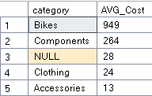

1. --What is the total revenue generated for each category

SELECT

p.category,

SUM(f.sales_amount) total_revenue

FROM gold.fact_sales f

LEFT JOIN gold.dim_products p

ON p.product_key = f.product_key

GROUP BY p.category

ORDER BY total_revenue DESC

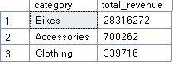

1. --What is the total revenue generated by each customer

SELECT DISTINCT

c.customer_key,

c.first_name,

c.last_name,

SUM(s.sales_amount) AS Total_Revenue

FROM gold.dim_customers c

LEFT JOIN gold.fact_sales s

ON c.customer_key = s.customer_key

GROUP BY

c.customer_key,

c.first_name,

c.last_name

ORDER BY Total_Revenue DESC

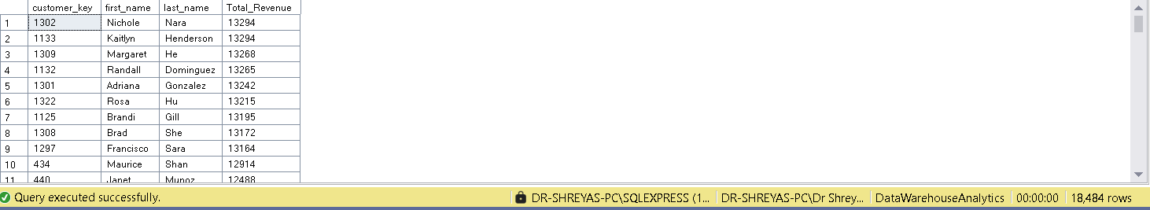

1. --What is the distribution of items sold across countries

SELECT DISTINCT

c.country,

SUM(s.quantity) AS Total_sold_items

FROM gold.dim_customers c

LEFT JOIN gold.fact_sales s

ON c.customer_key = s.customer_key

GROUP BY

c.country

ORDER BY Total_sold_items DESC

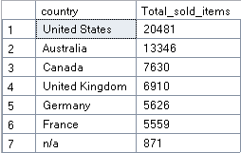

Step 6. Ranking (Top N – Bottom N)

Order the values of dimensions by measure

1. --Which 5 Products generate the highest revenue

SELECT Top 5

p.product_name,

SUM(f.sales_amount) total_revenue,

ROW_NUMBER() OVER (ORDER BY SUM(f.sales_amount) DESC) AS rank_products

FROM gold.fact_sales f

LEFT JOIN gold.dim_products p

ON p.product_key = f.product_key

GROUP BY p.product_name

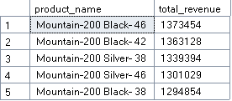

1. --What are the 5 worst-performing products in terms of sales

SELECT Top 5

p.product_name,

SUM(f.sales_amount) total_revenue

FROM gold.fact_sales f

LEFT JOIN gold.dim_products p

ON p.product_key = f.product_key

GROUP BY p.product_name

ORDER BY total_revenue DESC

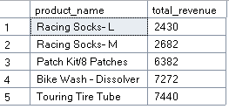

1. --Find the top 10 customers who have generated the highest revenue

SELECT TOP 10

c.customer_key,

c.first_name,

c.last_name,

SUM(f.sales_amount) AS total_revenue

FROM gold.fact_sales f

LEFT JOIN gold.dim_customers c

ON c.customer_key = f.customer_key

GROUP BY

c.customer_key,

c.first_name,

c.last_name

ORDER BY total_revenue DESC

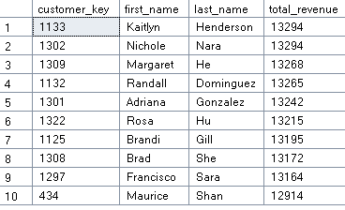

1. --The 3 customers with the fewest orders placed

SELECT TOP 3

c.customer_key,

c.first_name,

c.last_name,

COUNT(DISTINCT order_number) AS total_orders

FROM gold.fact_sales f

LEFT JOIN gold.dim_customers c

ON c.customer_key = f.customer_key

GROUP BY

c.customer_key,

c.first_name,

c.last_name

ORDER BY total_orders

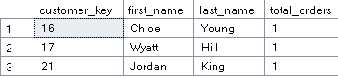

Step 7 – Change Over Time

Analyze how a measure evolves over time.

Helps track trends and identify seasonality in your data.

1. --Analyze Sales Performance Change Over Time

SELECT

DATETRUNC(month,order_date) AS order_year,

SUM(sales_amount) AS total_sales,

COUNT(DISTINCT customer_key) AS total_customers,

SUM(quantity) as total_quantity

From gold.fact_sales

WHERE order_date IS NOT NULL

GROUP BY DATETRUNC(month,order_date)

ORDER BY DATETRUNC(month,order_date)

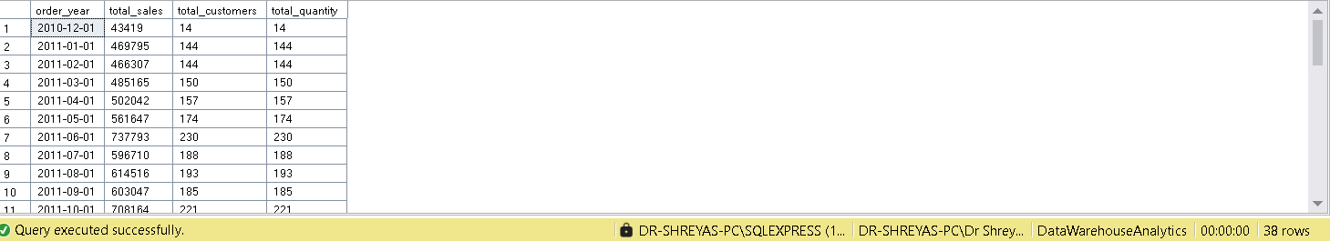

Step 8 – Cumulative Analysis

Aggregate the data progressively over time

Helps to understand whether our business is growing or declining.

1. --Calculate the total sales per year

SELECT

order_date,

total_sales,

SUM(total_sales) OVER (ORDER BY order_date) AS running_total_sales,

SUM(avg_price) OVER (ORDER BY order_date) AS moving_average_price

FROM

(

SELECT

DATETRUNC(year, order_date) AS order_date,

SUM(sales_amount) AS total_sales,

AVG(price) AS avg_price

FROM gold.fact_sales

WHERE order_date IS NOT NULL

Group BY DATETRUNC(year,order_date)

) t

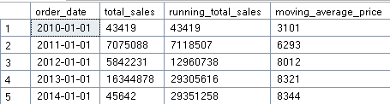

Step 9. Performance Analysis

Comparing the current value to the target value.

Help measure success and compare performance.

1. --Analyze the yearly performance of products by comparing each product's sale to both its average sales performance and the previous year's sales.

WITH yearly_product_sales AS (

SELECT

YEAR(f.order_date) AS order_year,

p.product_name,

SUM(f.sales_amount) AS current_sales

FROM gold.fact_sales f

LEFT JOIN gold.dim_products p

ON f.product_key = p.product_key

WHERE f.order_date IS NOT NULL

GROUP BY

YEAR(f.order_date),

p.product_name

)

SELECT

order_year,

product_name,

current_sales,

AVG(current_sales) OVER (PARTITION BY product_name) avg_sales,

current_sales - AVG(current_sales) OVER (PARTITION BY product_name) AS diff_avg,

CASE WHEN current_sales - AVG(current_sales) OVER (PARTITION BY product_name) > 0 THEN 'Above Avg'

WHEN current_sales - AVG(current_sales) OVER (PARTITION BY product_name) < 0 THEN 'Below Avg'

ELSE 'Avg'

END avg_change,

LAG(current_sales) OVER (PARTITION BY product_name ORDER BY order_year) py_sales,

current_sales - LAG(current_sales) OVER (PARTITION BY product_name ORDER BY order_year) AS diff_py,

CASE WHEN current_sales - LAG(current_sales) OVER (PARTITION BY product_name ORDER BY order_year) > 0 THEN 'Increase'

WHEN current_sales - LAG(current_sales) OVER (PARTITION BY product_name ORDER BY order_year) < 0 THEN 'Decrease'

ELSE 'No change'

END py_change

FROM yearly_product_sales

ORDER BY product_name, order_year

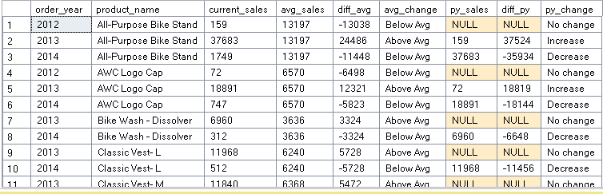

Step 10 – Part To Whole Analysis

Anlayze how an individual part is performing compared to the overall.

Allowing us to understand which category has the greatest impact on the business

1. Which categories contribute the most to overall sales

WITH category_sales AS (

SELECT

category,

SUM(sales_amount) total_sales

FROM gold.fact_sales f

LEFT JOIN gold.dim_products p

ON

p.product_key = f.product_key

GROUP BY category)

SELECT

category,

total_sales,

SUM(total_sales) OVER() overall_sales,

CONCAT(ROUND((CAST (total_sales AS float)/ SUM(total_sales) OVER())*100,2), '%') AS percentage_of_total

FROM category_sales

ORDER BY total_sales DESC

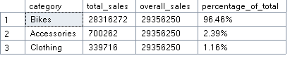

Step 11. Data Segmentation

Group the data base don a specific range.

Helps understand the correlation between two measures.

1. /*Segment products into cost ranges and count how many products fall into each segment*/

WITH product_segments AS(

SELECT

product_key,

product_name,

cost,

CASE WHEN cost < 100 THEN 'Below 100'

WHEN cost BETWEEN 100 AND 500 THEN '100-500'

WHEN cost BETWEEN 500 AND 1000 THEN '500-1000'

ELSE 'Above 1000'

END cost_range

FROM gold.dim_products)

SELECT

cost_range,

COUNT(product_key) AS total_products

FROM product_segments

GROUP BY cost_range

ORDER BY total_products DESC

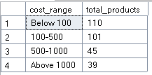

Step 5: Reporting

CREATE VIEW gold.report_customers AS

WITH base_query AS (

/*-------------------------------------------------

1) Base Query: Retrieves core columns from tables

---------------------------------------------------*/

SELECT

f.order_number,

f.product_key,

f.order_date,

f.sales_amount,

f.quantity,

c.customer_key,

c.customer_number,

CONCAT(c.first_name, ' ', c.last_name) AS customer_name,

DATEDIFF(year, c.birthdate, GETDATE()) age

FROM gold.fact_sales f

LEFT JOIN gold.dim_customers c

ON c.customer_key = f.customer_key

WHERE order_date IS NOT NULL

)

, customer_aggregation AS (

/*-------------------------------------------------------------

2) Customer Aggregations: Summarizes key metrics at the customer level

*/

SELECT

customer_key,

customer_number,

customer_name,

age,

COUNT(DISTINCT order_number) AS total_orders,

SUM(sales_amount) AS total_sales,

SUM(quantity) AS total_quantity,

COUNT(DISTINCT product_key) AS total_products,

MAX(order_date) AS last_order_date,

DATEDIFF(month, MIN(order_date), MAX(order_date)) AS lifespan

FROM base_query

GROUP BY

customer_key,

customer_number,

customer_name,

age

)

SELECT

customer_key,

customer_number,

customer_name,

age,

CASE

WHEN age < 20 THEN 'Under 20'

WHEN age BETWEEN 20 AND 29 THEN '20-29'

WHEN age BETWEEN 30 AND 39 THEN '30-39'

WHEN age BETWEEN 40 AND 49 THEN '40-49'

ELSE '50 and above'

END AS age_group,

CASE

WHEN lifespan >= 12 AND total_sales > 5000 THEN 'VIP'

WHEN lifespan >= 12 AND total_sales <= 5000 THEN 'Regular'

ELSE 'New'

END AS customer_segment,

last_order_date,

DATEDIFF(month, last_order_date, GETDATE()) AS recency,

total_orders,

total_sales,

total_quantity,

total_products,

lifespan,

--Compuate average order value (AVO)

CASE WHEN total_orders = 0 THEN 0

ELSE total_sales / total_orders

END AS avg_order_value,

--Compuate average monthly spend

CASE WHEN lifespan = 0 THEN total_sales

ELSE total_sales / lifespan

END AS avg_monthly_spend

FROM customer_aggregation

/* Product Report */

CREATE VIEW gold.report_products AS

WITH base_query AS (

SELECT

f.order_number,

f.order_date,

f.customer_key,

f.sales_amount,

f.quantity,

p.product_key,

p.product_name,

p.category,

p.subcategory,

p.cost

FROM gold.fact_sales f

LEFT JOIN gold.dim_products p

ON f.product_key = p.product_key

WHERE order_date IS NOT NULL

),

product_aggregations AS (

SELECT

product_key,

product_name,

category,

subcategory,

cost,

DATEDIFF(MONTH, MIN(order_date), MAX(order_date)) AS lifespan,

MAX(order_date) AS last_sale_date,

COUNT(DISTINCT order_number) AS total_orders,

COUNT(DISTINCT customer_key) AS total_customers,

SUM(sales_amount) AS total_sales,

SUM(quantity) AS total_quantity,

ROUND(AVG(CAST(Sales_amount AS FLOAT) / NULLIF(quantity, 0)), 1) AS avg_selling_price

FROM base_query

GROUP BY

product_key,

product_name,

category,

subcategory,

cost

)

SELECT

product_key,

product_name,

category,

subcategory,

cost,

last_sale_date,

DATEDIFF(MONTH, last_sale_date, GETDATE()) AS recency_in_months,

CASE

WHEN total_sales > 50000 THEN 'High-Performance'

WHEN total_sales >= 10000 THEN 'Mid-Range'

ELSE 'Low-Performance'

END AS product_segment,

lifespan,

total_orders,

total_sales,

total_quantity,

total_customers,

avg_selling_price,

CASE

WHEN total_orders = 0 THEN 0

ELSE total_sales / lifespan

END AS avg_monthly_revenue

FROM product_aggregations