Software Design Document
(SDD)
For
BusMate

20th September, 2025

Department of Computer Science Engineering (AIML/DS/CYS)
Jodhpur Institute of Engineering and Technology
Session 2025-26

Software Design Document (SDD)

APPROVAL and Compulsory Review LIST
Role | Name | Date
Mentor | Ms. Khushboo Parashar | 20 September 2025

Version Tracking
Date | Version | Comments | Author
20 September 2025 | 1.0 | Initial draft | Sneha Dadhich  Noorun Fatima Khan

Table of Contents
1.0 Introduction 4
2.0 Functional Description 5
3.0 Functional Partitions 7
4.0 Data Description 9
4.1 E R Diagram 9
4.2 Data Flow Diagram 10
5.0 Module Description 12
6.0 Definitions and Acronyms 14
7.0 References 14

1.0 Introduction
Transportation plays a crucial role in the daily life of students, particularly in institutions where buses are the primary mode of commuting. For many students, these buses are the only means of reaching college on time and safely. However, managing institutional transport systems is not without challenges. In our college, one of the major difficulties faced by students is the frequent change in bus allotments for different stops. Due to operational reasons such as driver availability, bus maintenance, or reallocation of routes, the bus assigned to a particular stop often changes on a day-to-day basis.
Currently, students must manually call or contact the transport coordinator each morning to confirm which bus has been assigned to their stop. This manual communication not only causes inconvenience and delays but also places an unnecessary burden on the transport coordinators, who must handle multiple calls from students simultaneously. Moreover, this system lacks transparency and efficiency, leaving students uncertain about their daily commute until the last moment.
To overcome these challenges, the proposed project introduces a BusMate —a digital platform designed to provide students with real-time and reliable information about their buses. The system is developed using Flask (for backend services), MySQL (for database management), and HTML, CSS, and JavaScript (for frontend development). It is structured into two distinct interfaces:
Student Interface
- Displays the bus allocated to the student’s stop for the day.
- Provides live geo-location of the bus, enabling students to track whether it has passed their stop.
- Includes a fee verification feature using QR-code scanning, ensuring only students who have paid transport fees are authorized to travel.

Admin Interface
- Allows administrators to perform Bus Management (add, update, or delete bus details).
- Facilitates Route Management, where buses can be assigned dynamically to stops based on daily requirements.
- Provides Driver Management, enabling efficient record-keeping of driver information and assignments.
2.0 Functional Description

The BusMate provides the following key features:
- Student Interface:
  - Display the bus allocated to the student's stop for the day.
  - Provide live geo-location tracking of the bus.
  - Implement a QR-code based fee verification feature.
- Admin Interface:
  - Allow administrators to perform Bus Management (add, update, or delete bus details).
  - Facilitate Route Management to dynamically assign buses to stops.
  - Enable Driver Management for efficient record-keeping.

System Functional Block Diagram
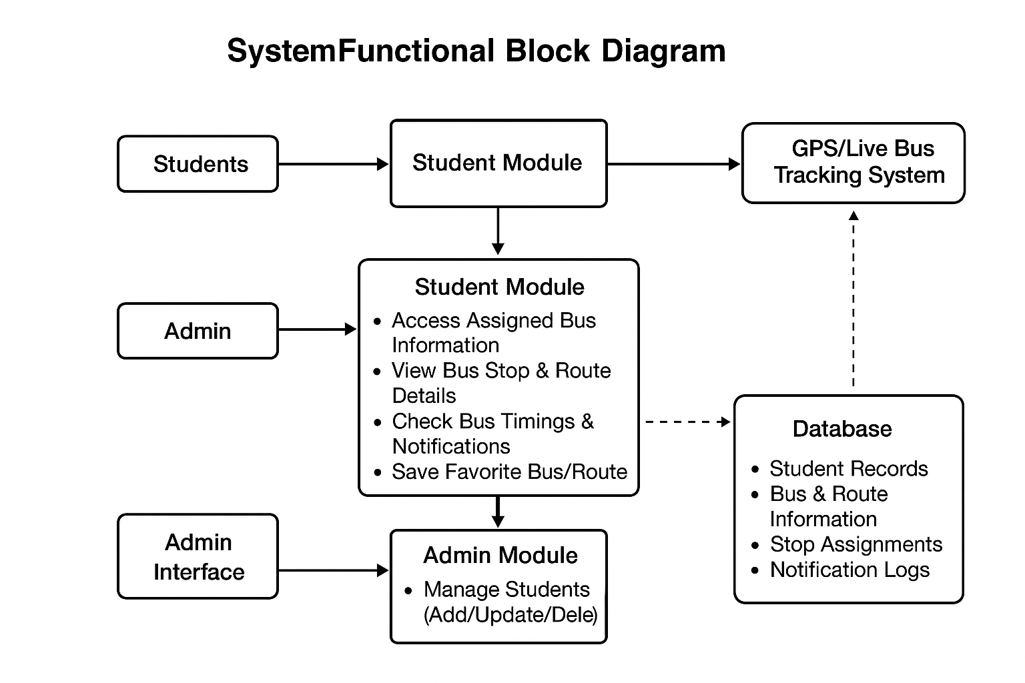
Main Components:
- Users
  - Students
  - Admin
- Frontend (User Interface)
  - Student Login / Registration
  - Admin Login
- Student Module
  - Access Assigned Bus Information
  - View Bus Stop & Route Details
  - Check Bus Timings & Notifications
  - Save Favorite Bus/Route
- Admin Module
  - Manage Students (Add/Update/Delete)
  - Assign Bus to Stops
  - Update Bus Routes, Timings, Notifications
  - Monitor Bus Usage
- Database
  - Student Records
  - Bus & Route Information
  - Stop Assignments
  - Notification Logs
- External System (Optional Integration)
  - GPS/Live Bus Tracking System
Block Description:
- Students → [Login/Registration] → Student Module → Database
- Admin → [Login] → Admin Module → Database
- Database ↔ Both Modules (Student & Admin)
- Optional GPS → Admin & Student Module (for real-time updates)

3.0 Functional Partitioning
The BusMate system is divided into two primary user perspectives: Student Functions and Admin Functions, each with distinct roles and operations. These are further supported by common backend services such as authentication, database management, and API handling.

1. Student Functions
- Bus Allocation Lookup - Students can check which bus is assigned to their stop on any given day.
- Live Bus Tracking - Integration with geo-location services to display the real-time movement of buses.
- Fee Verification - A QR-based mechanism verifies whether a student has paid the transport fee before boarding.
- User Authentication - Secure login for students to access their personalized transport details.

2. Admin Functions
- Bus Management - Add, update, or delete bus details such as bus number, capacity, and assigned driver.
- Driver Management - Maintain driver records including personal details, contact information, and assignment history.
- Route Management - Assign buses dynamically to stops on a daily basis.
- Fee Monitoring - Check and update transport fee status of students.
- User Access Control - Ensure role-based access to the system, limiting admin privileges to authorized personnel only.

3. Common/Supporting Functions
- Database Management - MySQL database to store student, bus, driver, and route records securely.
- API Services - Flask-based APIs for communication between the frontend and backend.
- Notification Services (Future Enhancement) - Automated alerts for students about bus arrival or emergencies.
- Security and Compliance - Prevent unauthorized bus usage through QR verification and secured login systems.

4.0 Data Description
ER Diagram
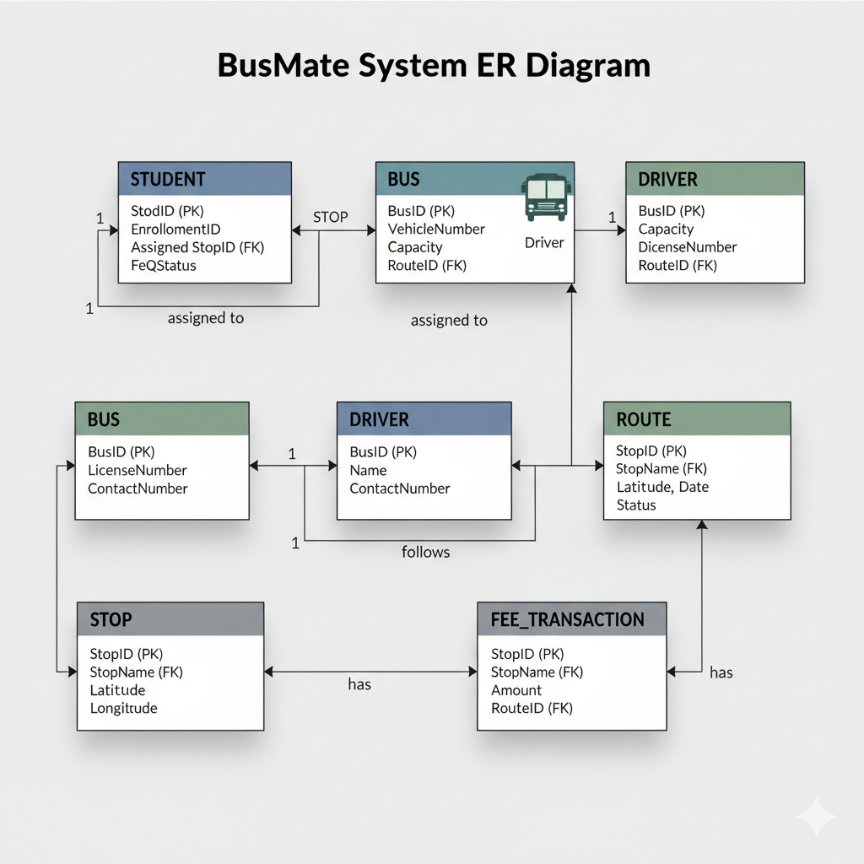

Data Flow Diagram
Level 0 DFD :
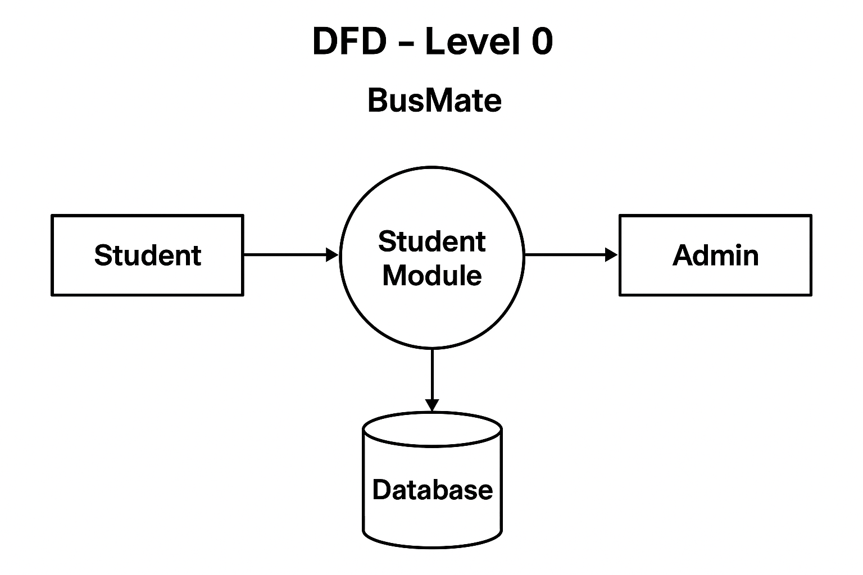:
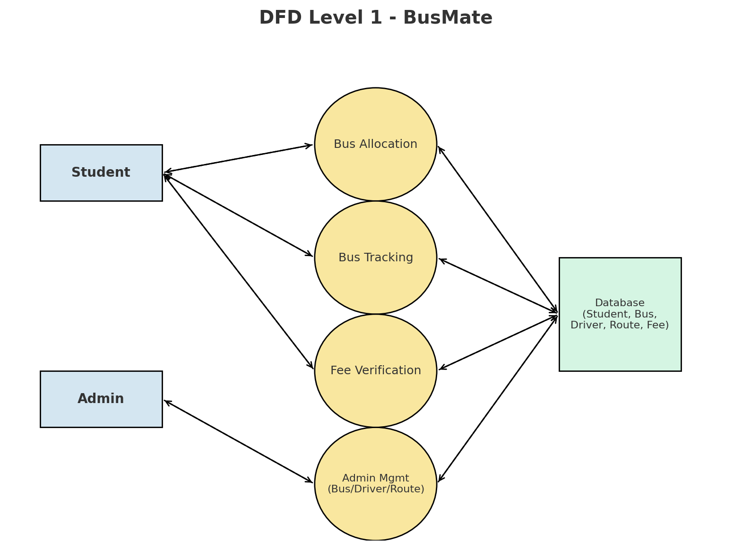
Level 1 DFD :

Brief Description:
- Students interact with the system for bus allocation, live tracking, and fee verification.
- Admin uses the system for bus, driver, and route management.
- Processes (Bus Allocation, Tracking, Fee Verification, and Admin Management) handle the logic.
- Database (Student, Bus, Driver, Route, Fee) stores and retrieves required data for all modules.
Module Description

1. Student Module
This module is designed for end-users (students) who need to access bus-related information.
Key Features:
- Access Assigned Bus Information → Students can log in and instantly see which bus is assigned to their bus stop for the day.
- View Bus Stop & Route Details → Complete information about stops, pickup points, and bus routes is available.
- Check Bus Timings & Notifications → Students get real-time or scheduled updates about bus arrival, delays, or changes in route.
- Save Favorite Bus/Route → Students can mark frequently used routes or buses for quick access.
- User-Friendly Dashboard → Intuitive interface for checking all details at one place.
Purpose: Enhances convenience by removing confusion about routes and timings, improving punctuality and reliability.

2. Admin Module
This module is for system administrators who manage and update the bus system.
Key Features:
- Manage Students → Add, update, or remove student records.
- Assign Bus to Stops → Allocate buses to routes and specific stops based on demand.
- Update Bus Routes & Timings → Modify routes, add new stops, and update schedules.
- Send Notifications → Alert students about emergencies, route changes, or delays.
- Monitor Usage → Track how many students are using each bus or route.
Purpose: Ensures smooth operation by managing all backend logistics of buses, routes, and notifications.

3. Authentication & User Management Module
This supports both students and admins by controlling secure access.
Key Features:
- Registration/Login → Students and admins log in with credentials.
- Role-Based Access → Students get limited features (viewing info), admins get management features.
- Password Management → Forgot password/reset functionality.
Purpose: Keeps the system secure and personalized.

4. Database Module
Central storage system for all information.
Contents:
- Student Records → Student ID, stop allocation, bus assignment.
- Bus & Route Information → List of buses, routes, stops, timings.
- Stop Assignments → Which student belongs to which stop.
- Notification Logs → Past and current alerts sent to users.
Purpose: Provides a single source of truth to both admin and student modules.

5. Notification & Alert Module
Keeps users updated about important events.
Key Features:
- Bus Arrival Alerts → Students can receive alerts about upcoming arrivals.
- Delay Notifications → If a bus is late or rescheduled, students are notified immediately.
- Route Change Alerts → Updates about diversions, temporary closures, etc.
Purpose: Improves communication and reliability.

6. GPS/Live Tracking Module (Optional Integration)
This is an advanced feature that can be integrated with GPS systems.
Key Features:
- Real-Time Bus Location → Students can see where their bus is currently located.
- Route Tracking → Displays the movement of the bus along its assigned route.
- Admin Monitoring → Helps admins manage buses in real-time and optimize routes.

Definitions and Acronyms

Abbreviation | Description
SDD | Software Design Document
DFD | Data Flow Diagram
ERD | Entity Relationship Diagram
API | Application Programming Interface
DBMS | Database Management System
RDBMS | Relational Database Management System
UI | User Interface
UX | User Experience
GPS | Global Positioning System
CRUD | Create, Read, Update, Delete
SQL | Structured Query Language
OTP | One Time Password (if you plan login authentication)
HTTP | HyperText Transfer Protocol
CSS | Cascading Style Sheets
HTML | HyperText Markup Language

References

In this section list out all the references while used for developing this document and project.
- Flask Documentation – https://flask.palletsprojects.com/
- MySQL Documentation – https://dev.mysql.com/doc/

