Software Requirements Specification
(SRS)
For
BusMate
20th September 2025


Department of Computer Science Engineering (AIML/DS/CYS)
Jodhpur Institute of Engineering and Technology
Session 2025-26

APPROVAL and Compulsory Review LIST
Role | Name | Date
Lab Faculty/ Supervisor | Ms. Khushboo Parashar | 20th September 2025

Version Tracking
Date | Version | Comments | Author
20th September 2025 | 1.0 | Completed Initial Draft | Sneha Dadhich  Noorun Fatima Khan

Table of Contents

1.0 INTRODUCTION 3
1.1 Scope 3
1.2 Technologies to be used 3
2.0 GENERAL REQUIREMENTS 6
2.1 Functionalities 6
2.2 Use Case Model Diagrams 6
2.3 General Constraints 7
2.4 Supplementary requirements 8
3.0 DEFINITION, ACRONYMS, AND ABBREVIATIONS 8
4.0 REFERENCES 9

- INTRODUCTION

  - Scope
The BusMate system is designed to address the specific needs of educational institutions and has the following scope:
- Institution-Specific Application: Customized for colleges, schools, or universities where buses are the primary mode of student transport.
- Dynamic Bus Allocation: Capable of handling daily changes in bus assignments due to driver availability or maintenance issues.
- Student-Focused Interface: Provides a simple, mobile-friendly interface for students to access bus information and track locations in real time.
- Admin-Focused Interface: Facilitates bus management, route planning, driver assignment, and transport fee monitoring.
- Scalability: Can be expanded to include multiple campuses, additional transport modes, and integration with smart campus systems.
- Security and Compliance: Ensures secure access and fee compliance through QR-code scanning and optional AI-driven monitoring features.

  - Technologies to be used

Frontend
- HTML / CSS → Basic structure and styling of the web pages.
- Jinja2 Templates → Dynamically render student/admin dashboards with Python backend data.
- JavaScript / AJAX → Interactive elements, form validations, and real-time updates (e.g., bus status, geolocation tracking).

Backend
- Python → Core programming language.
- Flask / FastAPI → Web framework to serve Jinja templates and handle API endpoints.
- Werkzeug → For secure request handling and authentication.
Database & Storage
- SQLite / MySQL / PostgreSQL → Store user data, bus schedules, geolocation logs, QR codes.
- SQLAlchemy → ORM for easy database interactions.
- Pandas → Optional for data handling and reporting.

Authentication & Security
- Flask-Login / Flask-Security → Manage student/admin login sessions.
- bcrypt / hashlib → Secure password hashing.
- JWT Tokens (optional) → For API authentication.

QR Code Verification
- qrcode → Generate QR codes for student tickets or bus passes.
- pyzbar → Scan and decode QR codes using images or webcam.
- OpenCV → Capture QR codes from webcam or uploaded images.

Geolocation & Mapping
- geopy → Convert addresses to coordinates and vice versa.
- geocoder → Get current user location via IP or GPS.
- Google Maps API / OpenStreetMap API → Fetch routes, calculate distance, or display maps.
- folium / leaflet.js → Display bus locations and routes interactively on a map.
- pynmea2 / GPS modules → Read GPS device data if bus hardware is used.

Other Tools
- Requests → For making API calls (e.g., Google Maps API).
- Base64 → Encode/decode images or QR codes.
- Docker (optional) → Containerize the application for deployment.

- GENERAL REQUIREMENTS
  - Functionalities
Student Module
- View assigned bus details (bus number, route, timing).
- Check real-time bus location on map (geolocation feature).
- Scan and verify QR codes for boarding verification.
- Receive notifications about delays or changes in schedule.
- Submit feedback or complaints regarding bus service.
Admin Module
- Manage bus schedules, routes, and stops.
- Assign buses to students or groups.
- Track buses in real-time using geolocation data.
- Generate reports on bus occupancy, student usage, and feedback.
- Validate QR codes scanned by students for verification.
System Features
- Secure login and authentication for students and admins.
- Data storage and retrieval for schedules, QR codes, and geolocation.
- API integration with Google Maps / OpenStreetMap for route mapping.
- Dashboard visualizations for bus tracking and reporting.

  - Use Case Model Diagrams
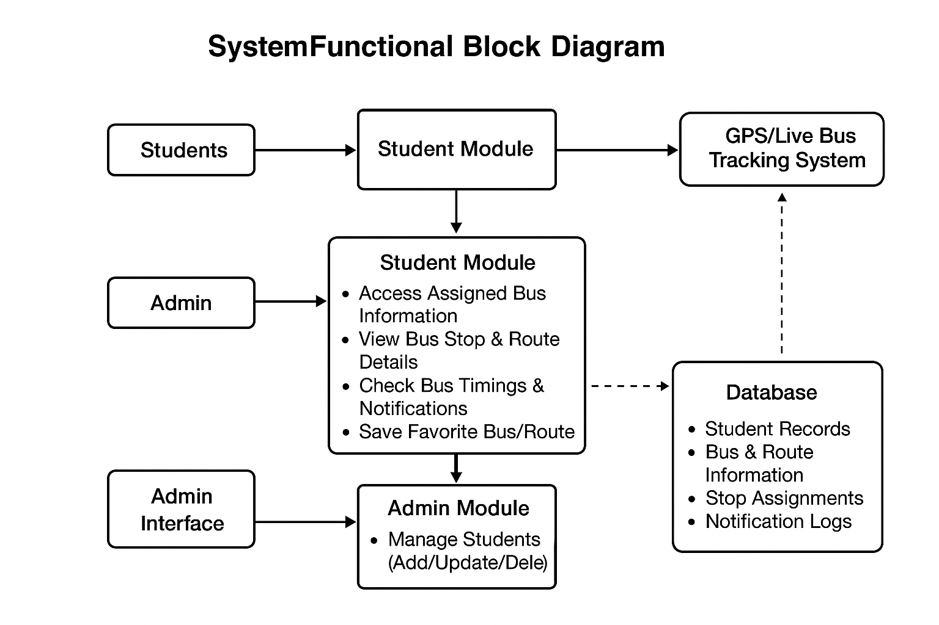

  - General Constraints
- The system must be accessible on desktop and mobile browsers.
- Only authorized users (students/admins) can access respective modules.
- QR verification must work under low-light or low-resolution conditions.
- Geolocation tracking must be accurate within ±50 meters.
- The system should handle concurrent access by multiple students and buses without performance degradation.
- Database operations must ensure data consistency and avoid loss.

  - Supplementary requirements
- Performance: Real-time tracking updates should have minimal latency (< 5 seconds).
- Reliability: System should be available 99% of the time with backup mechanisms for server downtime.
- Usability: User-friendly dashboards and easy navigation for both students and admins.
- Security:
- Passwords must be hashed and stored securely.
- QR codes should have time-based or unique identifiers to prevent misuse.
- API keys for maps or GPS services must be securely stored.
- Maintainability: System should allow easy updates of bus schedules, routes, and modules.
- Portability: Application should run on any OS that supports Python, Flask/FastAPI, and required libraries.

- Definition, Acronyms, and Abbreviations

Acronym | Definition
GPS | Global Positioning System – used for tracking bus locations.
QR | Quick Response – a type of barcode used for student bus verification.
API | Application Programming Interface – allows communication between BusMate and external services like Google Maps.
DBMS | Database Management System – manages storage and retrieval of system data.
HTML | HyperText Markup Language – used to structure frontend pages.
CSS | Cascading Style Sheets – used to style frontend pages.
JS | JavaScript – adds interactivity to web pages.
UML | Unified Modeling Language – used for system diagrams like use case models.

- References
- Flask Documentation – https://flask.palletsprojects.com/
- MySQL Documentation – https://dev.mysql.com/doc/
- Google Maps API – https://developers.google.com/maps

