Module 6:
1. In the PageRank algorithm, what does a hyperlink from one page to another represent? Explain
briefly how PageRank is used in search engines to rank web pages.

2. What is a recommendation system? Explain the design of a recommended system used to
recommend movies to users.

3. Explain collaborative filtering-based recommendation system.
Collaborative filtering is a type of recommendation system that is based on the principle of "users
like items that are similar to the ones they already like". In other words, collaborative filtering
algorithms analyze the behavior of a group of users to identify patterns and similarities in their
preferences and use this information to make personalized recommendations.
The collaborative filtering process involves three main steps:
1. Data collection: The system collects data on users' past behavior, such as their ratings,
reviews, and purchase history.
2. Similarity measurement: The system calculates the similarity between users based on
their past behavior. This is typically done using a similarity metric such as Pearson
correlation or cosine similarity.

3. Recommendation generation: The system generates personalized recommendations for
each user based on the behavior of similar users. This is typically done using one of two

methods: user-based filtering, which recommends items liked by similar users, or item-
based filtering, which recommends items similar to those that the user has already liked.

One of the benefits of collaborative filtering is that it does not rely on explicit knowledge of the
items being recommended, such as metadata or keywords. Instead, it is based on the implicit
preferences of users and the relationships between them. This makes it particularly effective in
situations where users have not explicitly stated their preferences or where the characteristics of
the items being recommended are difficult to define.
4. Define link spam and its relevance in the context of link analysis algorithms.
5. What is Clique Percolation Method (CPM). Write an algorithm on CPM. Also show how the
CPM finds clique for the following graph. Explain with steps.
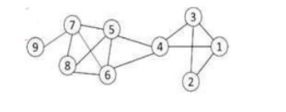

The Clique Percolation Method (CPM) is a popular technique for detecting overlapping
communities in complex networks. The procedure involves identifying cliques of size k and then
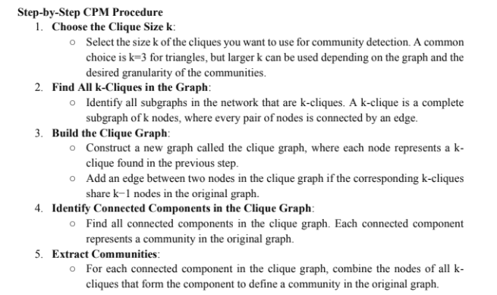
connecting these cliques if they share k−1k-1 nodes. Here is a detailed step-by-step procedure:

