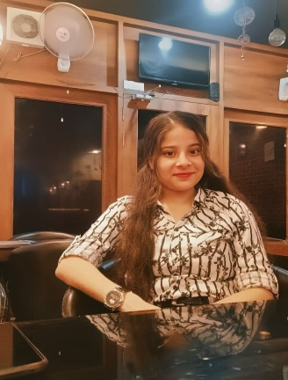

Sneha Gaur
Kanpur, Uttar Pradesh | +916393681502 | snehagaur1911@gmail.com | http://www.linkedin.com/in/sneha-gaur-28a106308 | https://github.com/roshni99679/JS-Course-Infosys-Springboard-

CAREER SUMMARY
I am a student at Pranveer Singh Institute of Technology, Kanpur, U.P., pursuing a B.Tech in Computer Science and Engineering. I am seeking an entry-level opportunity with an esteemed organization where I can utilize my skills and enhance my learning in the field. I am capable of mastering new technologies.

EDUCATION QUALIFICATION

- I completed my 10th from Ram Krishna education Centre (Naubasta), kanpur, in 2020.
- I completed my 12th from Ram Krishna education Centre (Naubasta), kanpur, in 2022.
- I am currently pursuing my B.Tech in Computer Science and Engineering from Pranveer Singh Institute of Technology, Kanpur, U.P., with an expected completion between 2024-2026.

Technical Skills
- Python
- HTML
- CSS
- JavaScript
- Next.js
- Node.js
- ReactJS

WORKSHOP AND CERTIFICATION
- Azure, Generative AI – Microsoft
- Kirit 4.0 – Unstop
- IoT Club – PSIT Kanpur
- Infosys Springboard – Python Part 1 and Part 2
- Infosys Springboard – HTML5, CSS3, JavaScript Essentials, Next.js, Node.js, React.js
- Career Essentials in Generative AI, Build Your Generative AI Productivity Skills – Microsoft and LinkedIn

Converted to HTML with WordToHTML.net

