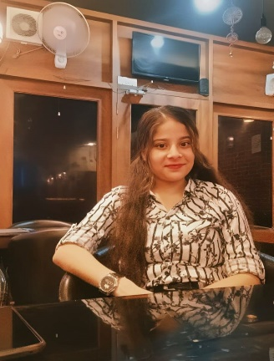

**Sneha Gaur**

Kanpur, Uttar Pradesh | +916393681502 | [snehagaur1911@gmail.com](mailto:snehagaur1911@gmail.com) | <http://www.linkedin.com/in/sneha-gaur-28a106308> | https://github.com/roshni99679/JS-Course-Infosys-Springboard-

# CAREER SUMMARY

I am a student at Pranveer Singh Institute of Technology, Kanpur, U.P., pursuing a B.Tech in Computer Science and Engineering. I am seeking an entry-level opportunity with an esteemed organization where I can utilize my skills and enhance my learning in the field. I am capable of mastering new technologies.

# EDUCATION QUALIFICATION

* I completed my 10th from Ram Krishna education Centre (Naubasta), kanpur, in 2020.
* I completed my 12th from Ram Krishna education Centre (Naubasta), kanpur, in 2022.
* I am currently pursuing my B.Tech in Computer Science and Engineering from Pranveer Singh Institute of Technology, Kanpur, U.P., with an expected completion between 2024-2026.

# Technical Skills

* Python
* HTML
* CSS
* JavaScript
* Next.js
* Node.js
* ReactJS

# WORKSHOP AND CERTIFICATION

* Azure, Generative AI – Microsoft
* Kirit 4.0 – Unstop
* IoT Club – PSIT Kanpur
* Infosys Springboard – Python Part 1 and Part 2
* Infosys Springboard – HTML5, CSS3, JavaScript Essentials, Next.js, Node.js, React.js
* Career Essentials in Generative AI, Build Your Generative AI Productivity Skills – Microsoft and LinkedIn

Converted to HTML with WordToHTML.net