🟦 1. Backend Screenshots Section
Heading:
Backend Screenshots (Spring Boot + Postman)
1.Create Issue (POST /issues)
Caption:
New Issue created successfully using POST request.
Description (below screenshot):
This screenshot shows the API call to create a new issue using Postman.
A valid JSON object was submitted and the backend returned 201 Created with the created issue details.
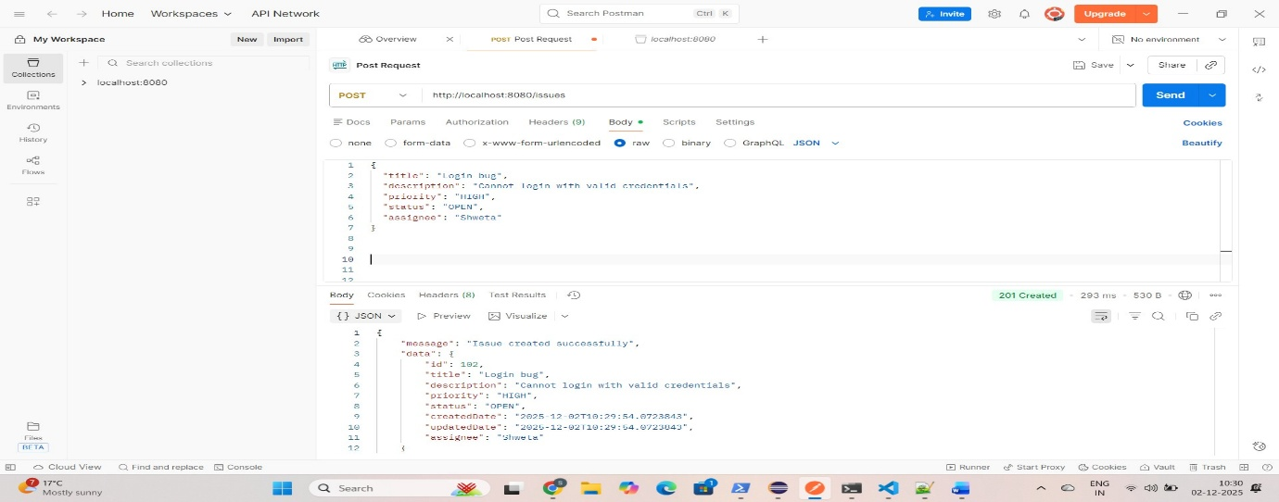
2 Get All Issues (GET /issues)
Caption:
Fetching list of all issues.
Description:
This screenshot shows the GET API returning the list of all issues from the database in JSON format.
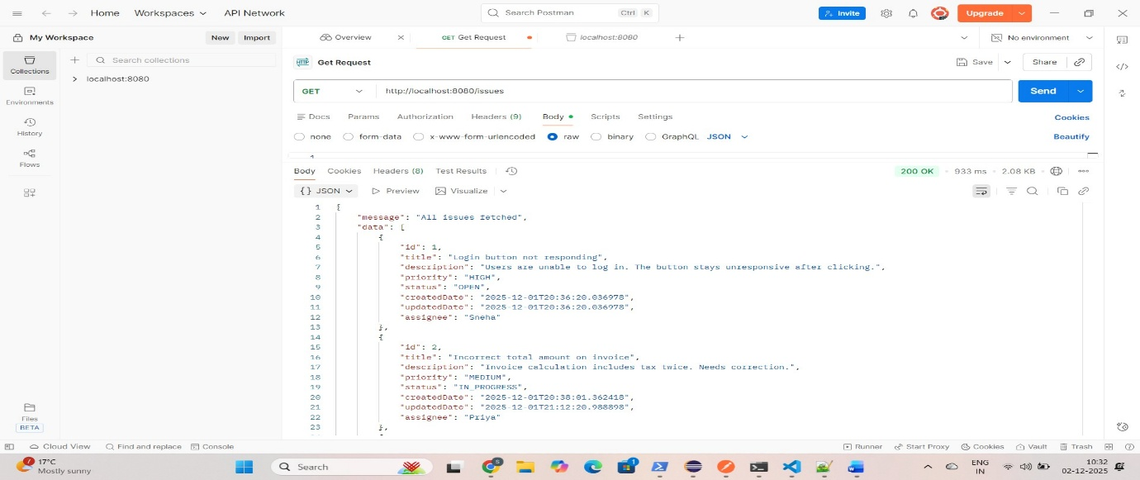

3. Get Issue By ID (GET /issues/{id})
Caption:
Getting a single issue by its ID.
Description:
This screenshot shows the API that fetches a specific issue using its unique ID.
Example:
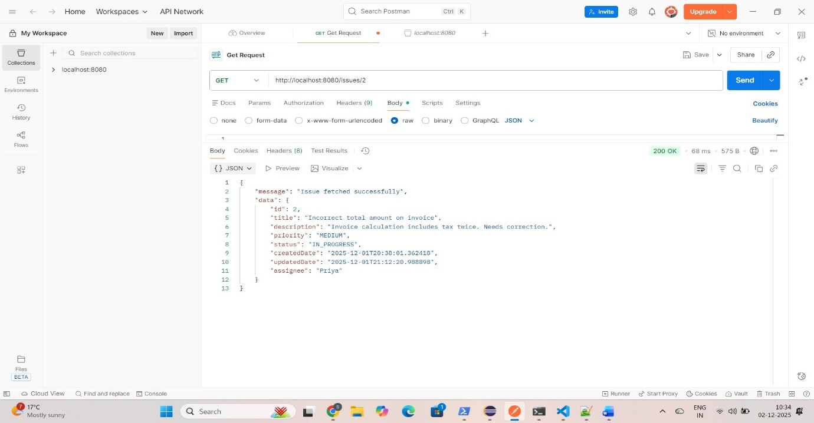
4. Update Issue (PUT /issues/{id})
Caption:
Updating issue details using PUT.
Description:
This screenshot demonstrates updating an existing issue and receiving a success response with updated data.
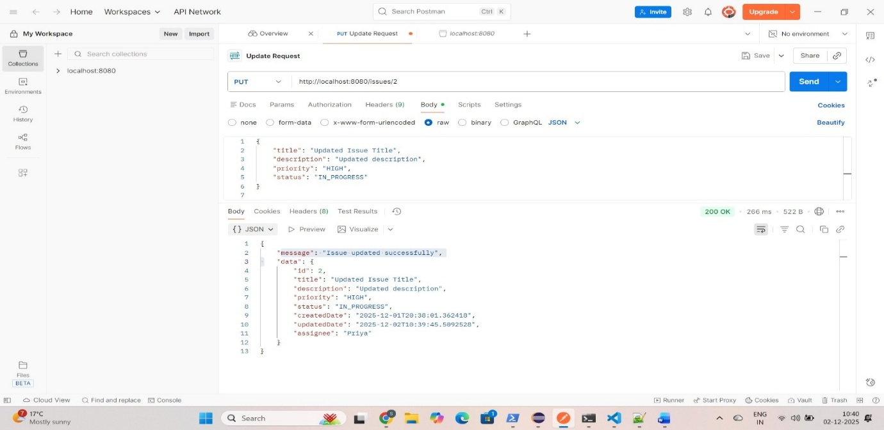
5. Update Status (PUT /issues/{id}/status)
Caption:
Updating only the status of an issue.
Description:
This test shows updating the issue status (e.g., OPEN → RESOLVED) using the dedicated status update API.
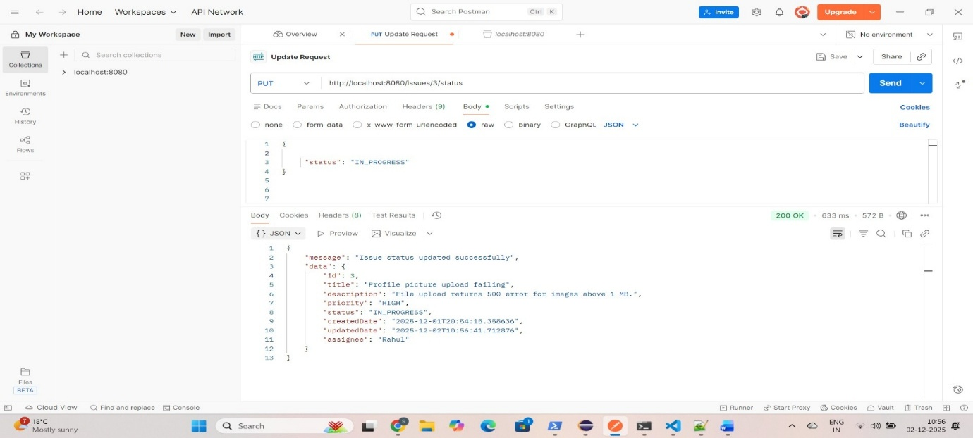
6. Update Full Issue (PUT /issues/{id}/full)
Caption:
Updating all fields of an issue using the full update API.
Description:
This screenshot shows the API call where every field of the issue is updated.
The request body includes full details like title, description, priority, status, and assignee.
Backend responds with an updated issue object, confirming the full update operation.
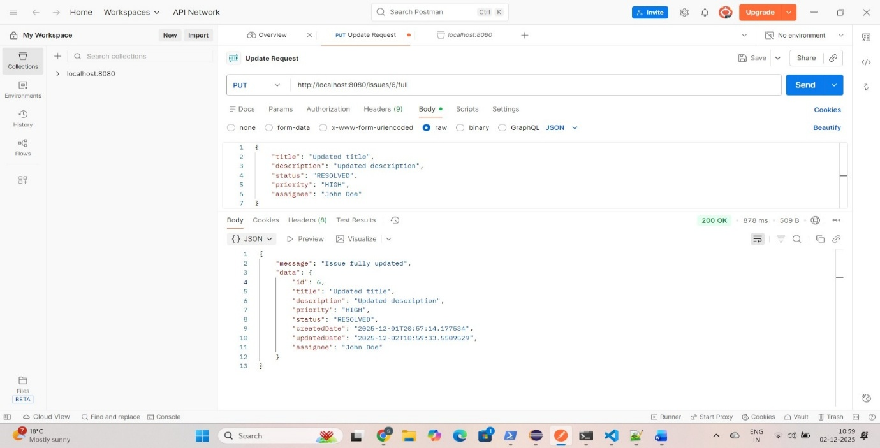
7. Delete Issue (DELETE /issues/{id})
Caption:
Deleting an issue.
Description:
This screenshot shows the DELETE request successfully removing an issue and returning a confirmation message.
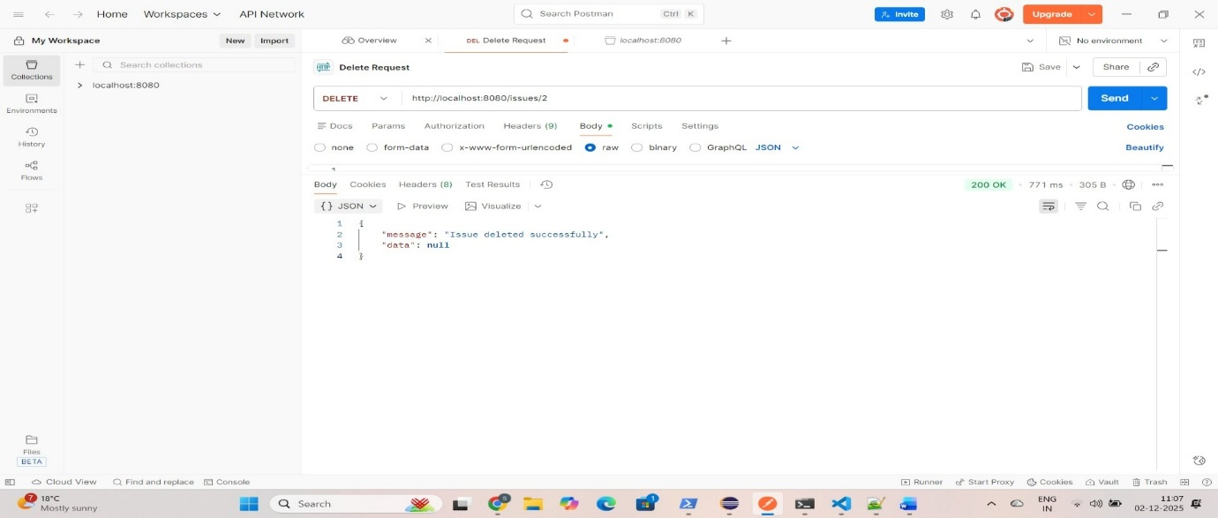
8. Filter Issue:
8.1: Filter Issue by Status (GET /issues/filter?status=OPEN)
Caption:
Filtering issues by status.
Description:
This screenshot shows the API returning all issues that match a specific status.
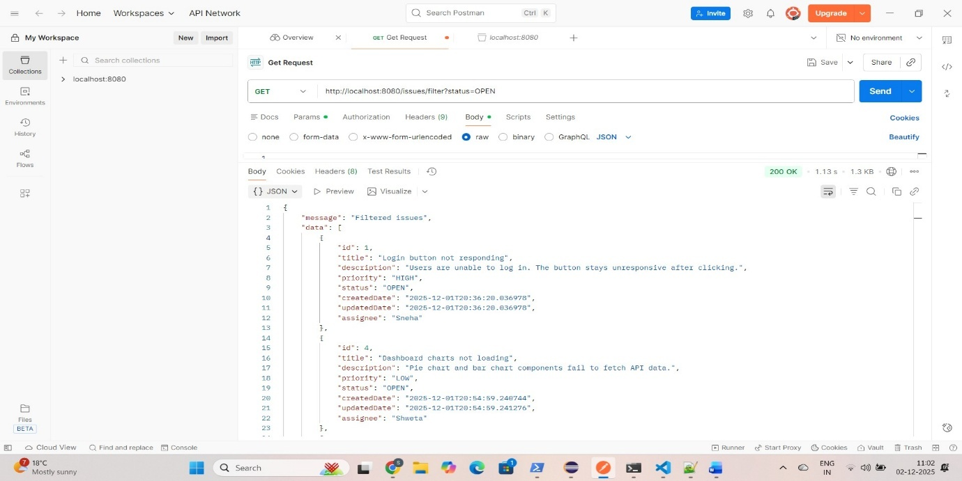

8.2 Filter by Priority (GET /issues/filter?priority=HIGH)
Caption:
Filtering issues by priority.
Description:
This screenshot demonstrates filtering issues based on priority.
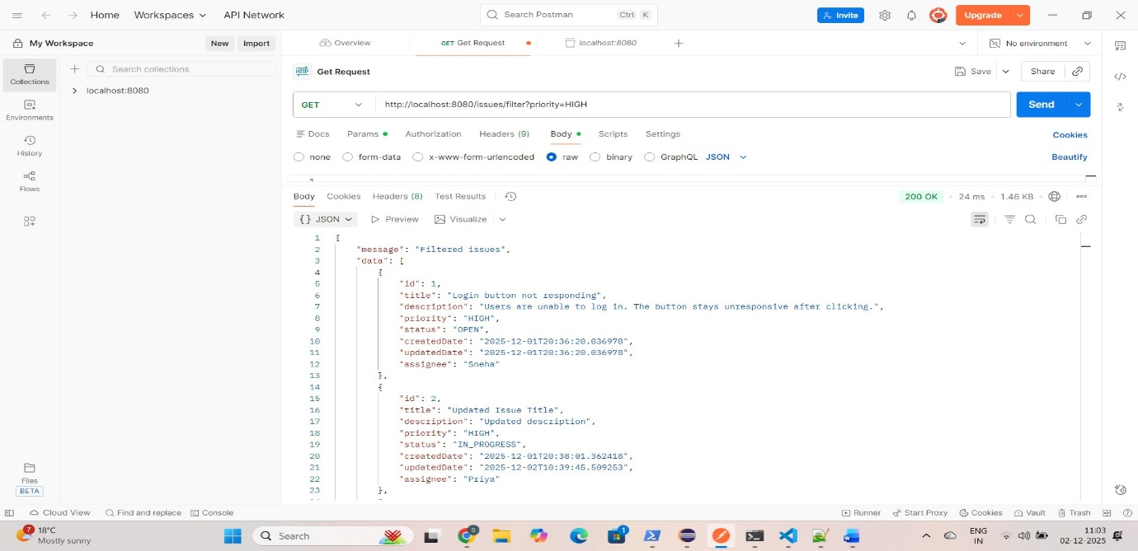

8.3 Filter by Priority and Status Together (GET /issues/filter?priority=LOW&status=OPEN)
Caption:
Filtering issues using both priority and status.
Description:
This screenshot shows applying multiple filters at the same time.
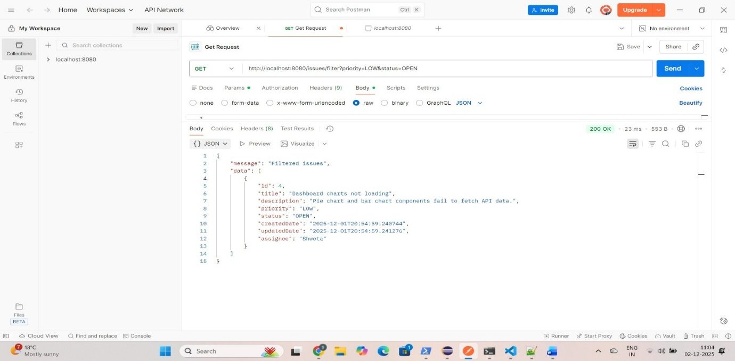

9. Search Issue by Assignee (GET /issues/search?assignee=John)
Caption:
Searching issues by assignee name.
Description:
This screenshot shows the API used to search issues assigned to a specific user.
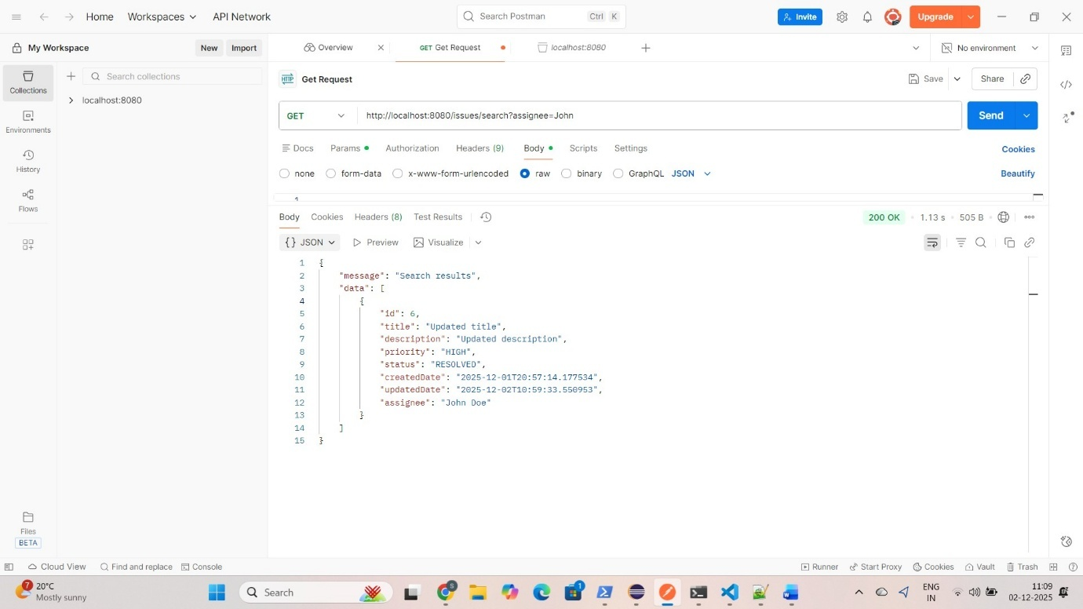
10. Count By Staus (GET/issues/count?status)
Caption:
Count of issues by status.
Description:
This screenshot displays the API returning issue counts grouped by different statuses.

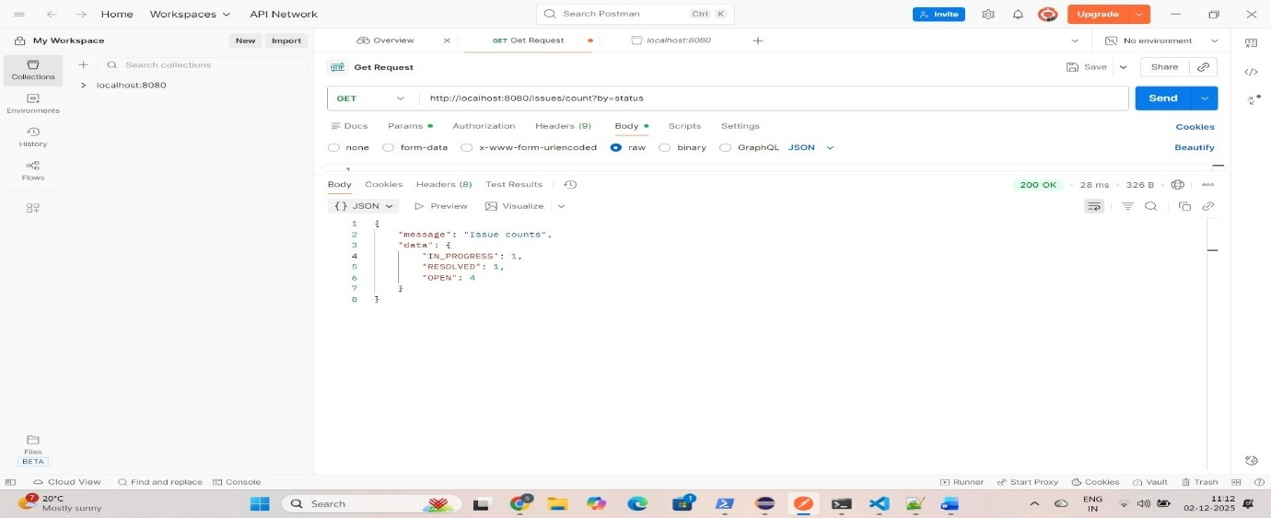

🟦 2. Frontend Screenshots Section
Heading:
Frontend Screenshots (Angular UI)
2.1 Issue List Page
Caption:
Main issue list displayed in a table.
Description:
Shows all issues with their fields like title, description, priority, status, and action buttons.
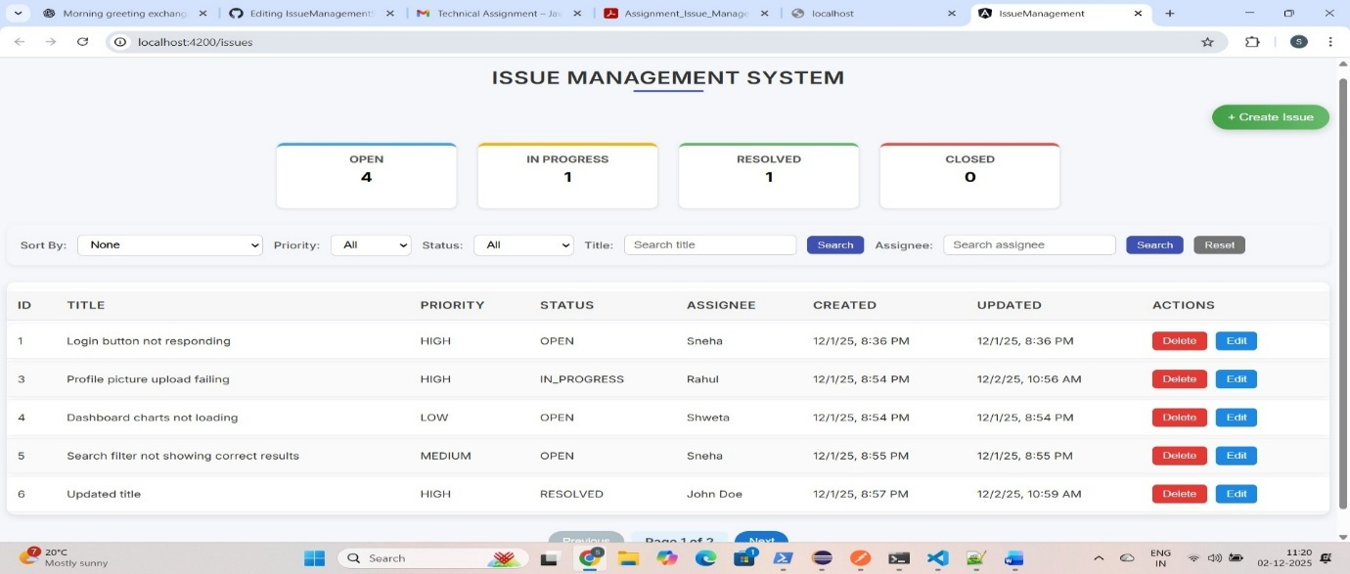
2.2 Create Issue Form
Caption:
Form for adding a new issue.
Description:
Includes form fields with validations (title required, priority required etc.) for creating a new issue.
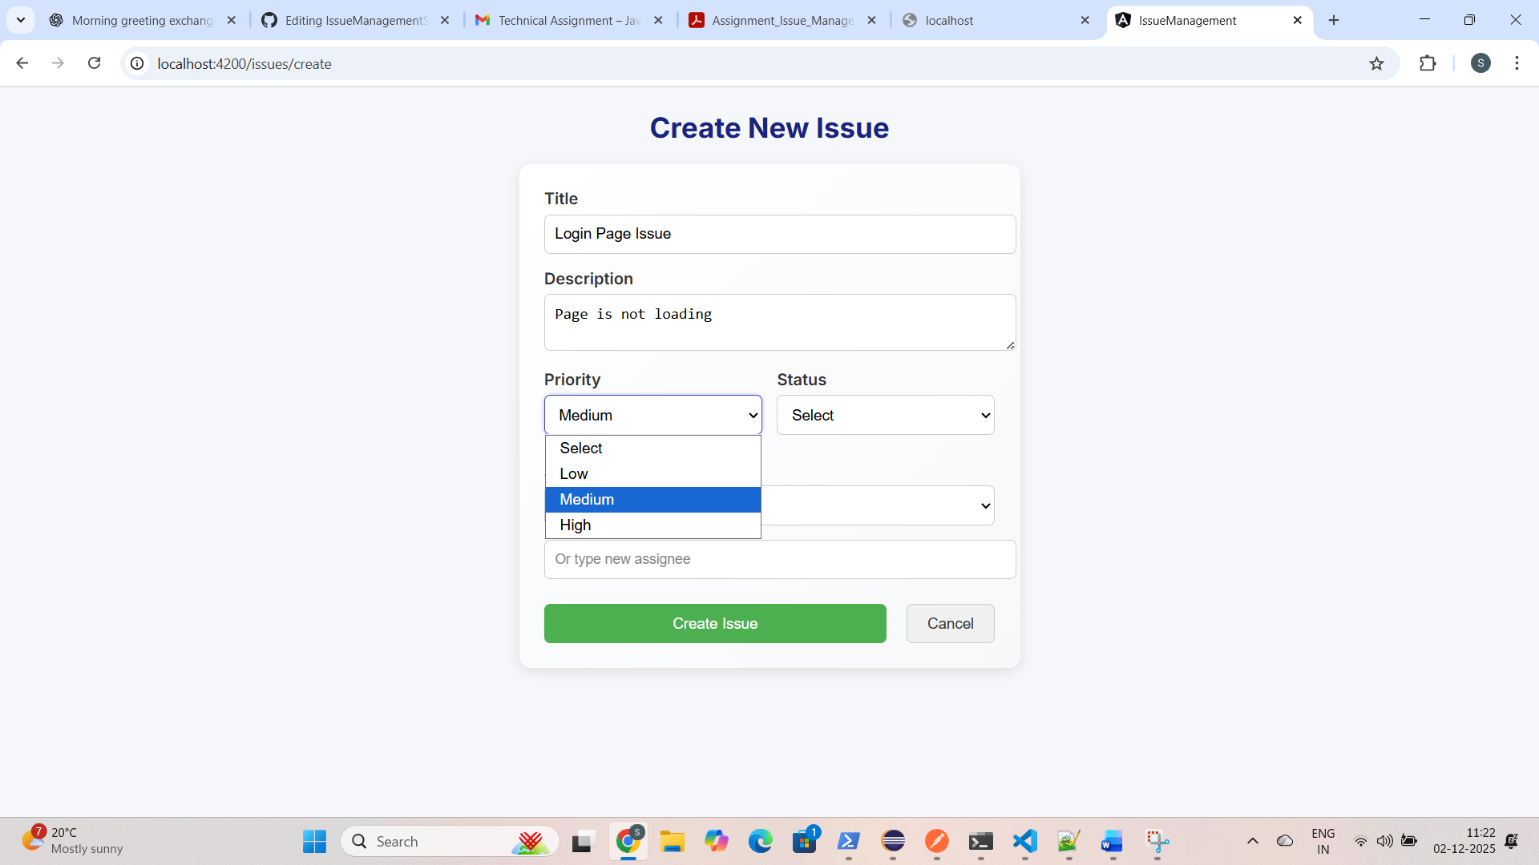
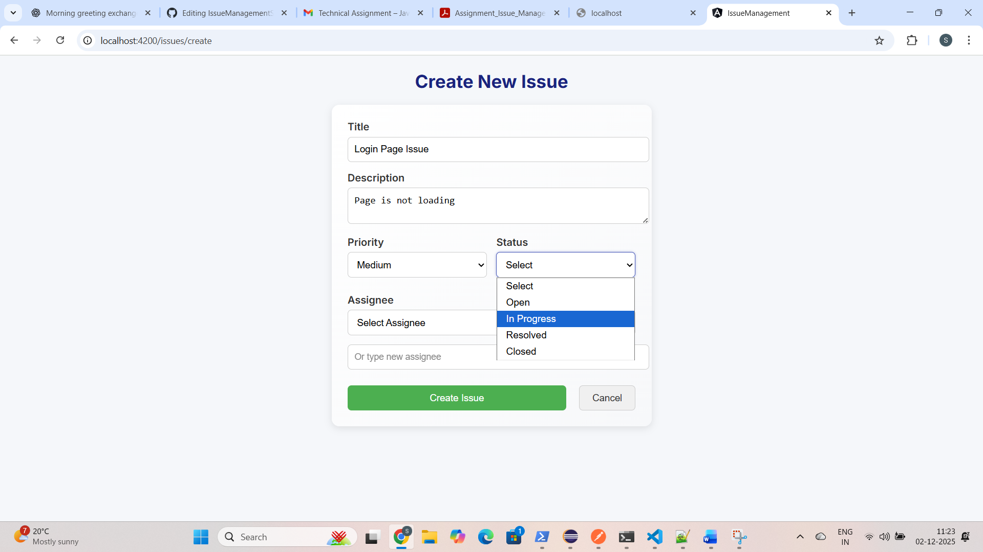

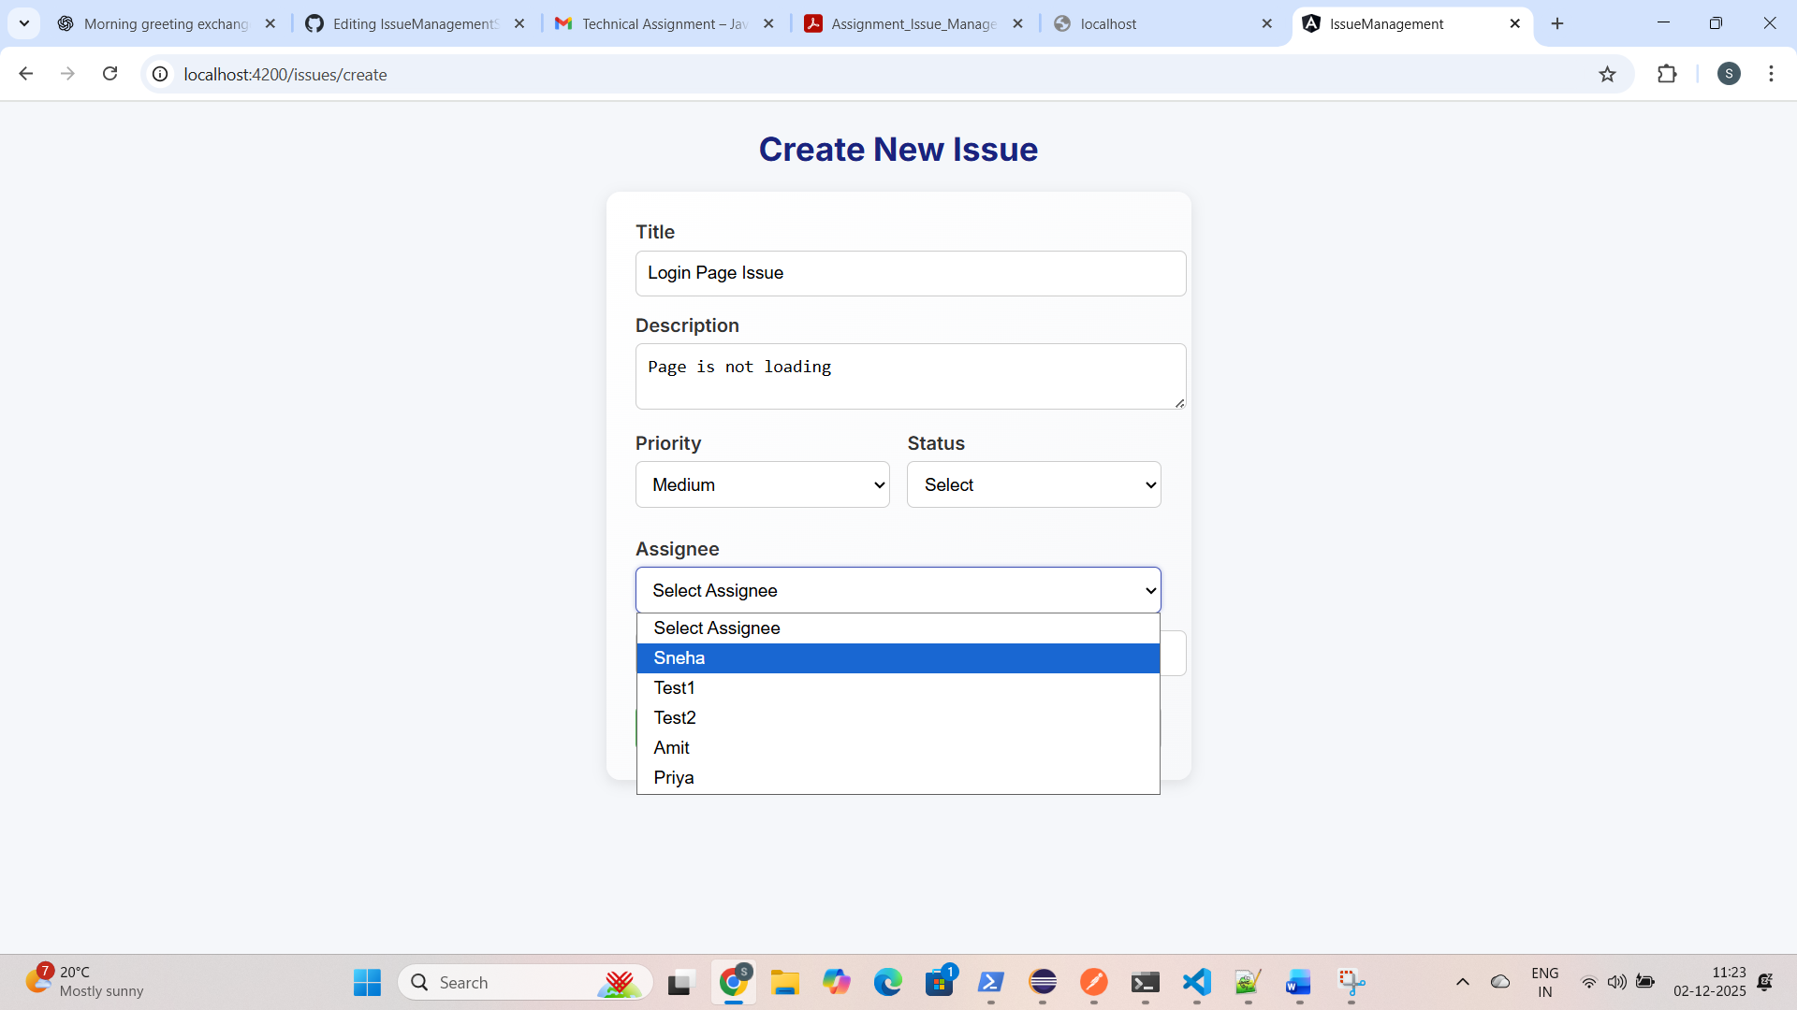

2.3 Edit Issue Page
Caption:
Edit existing issue details.
Description:
Shows editable form with existing values populated from backend.
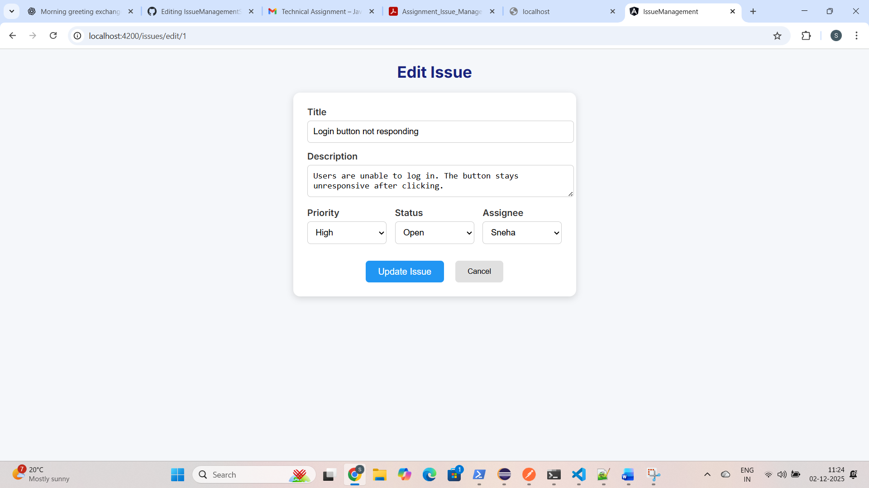

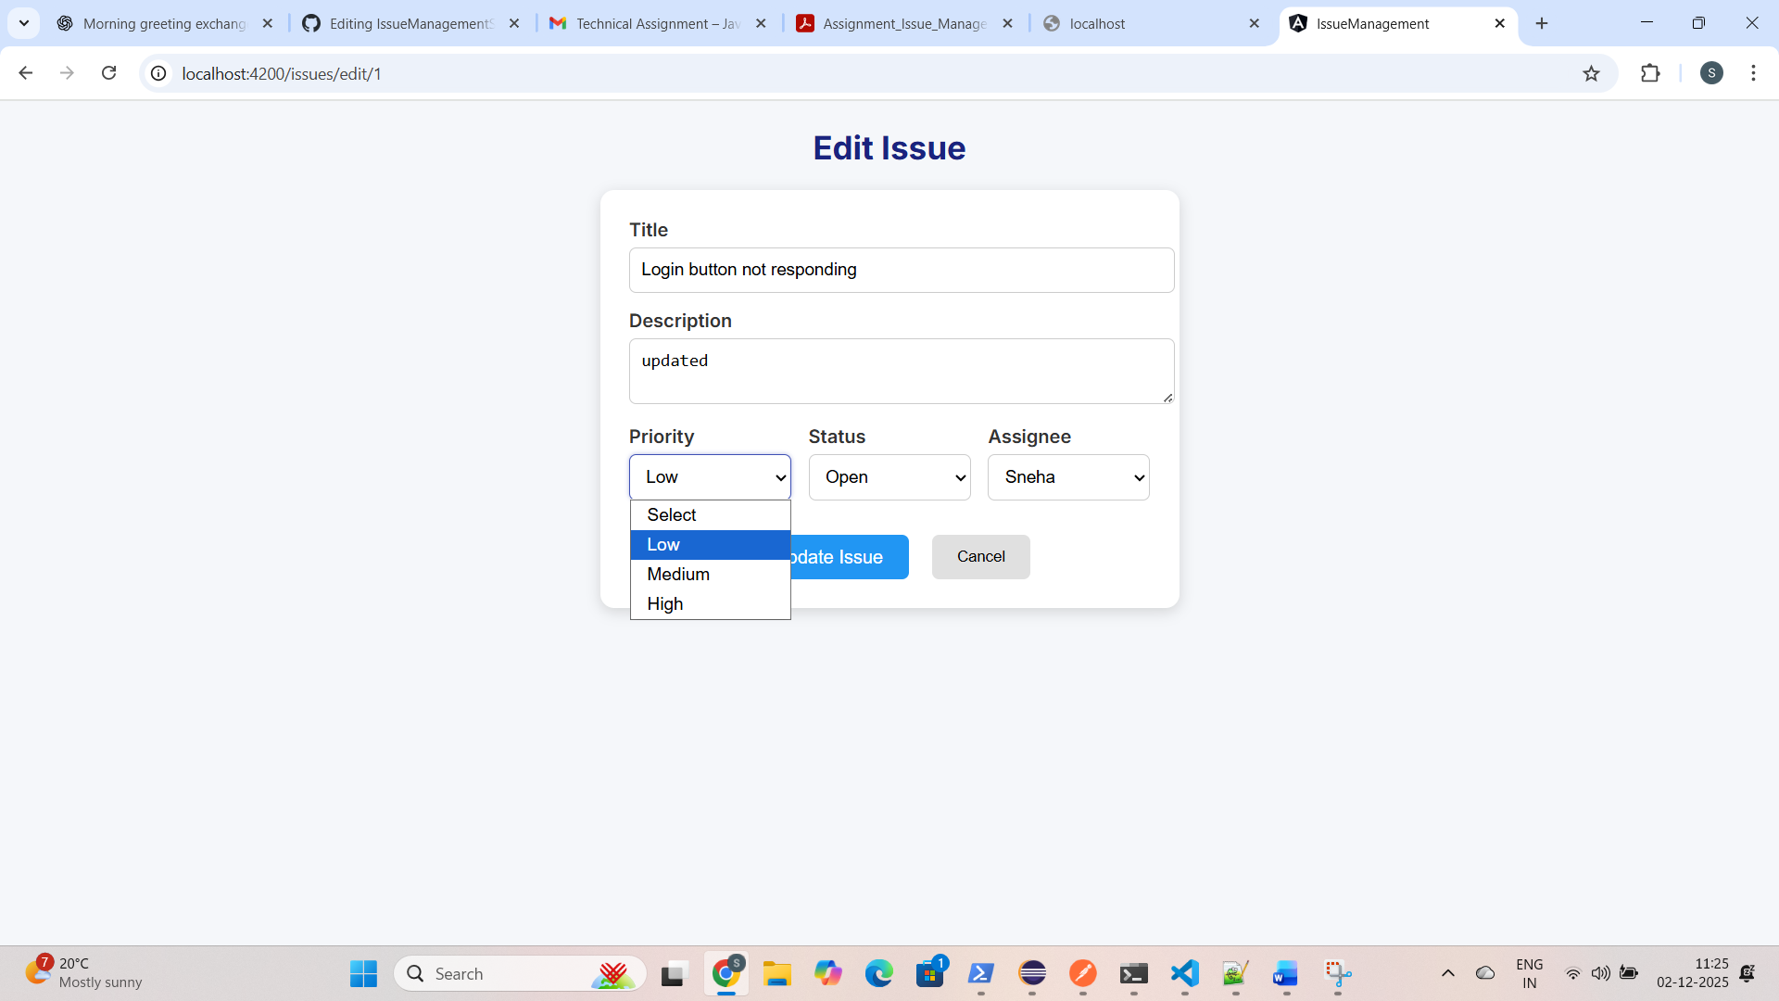
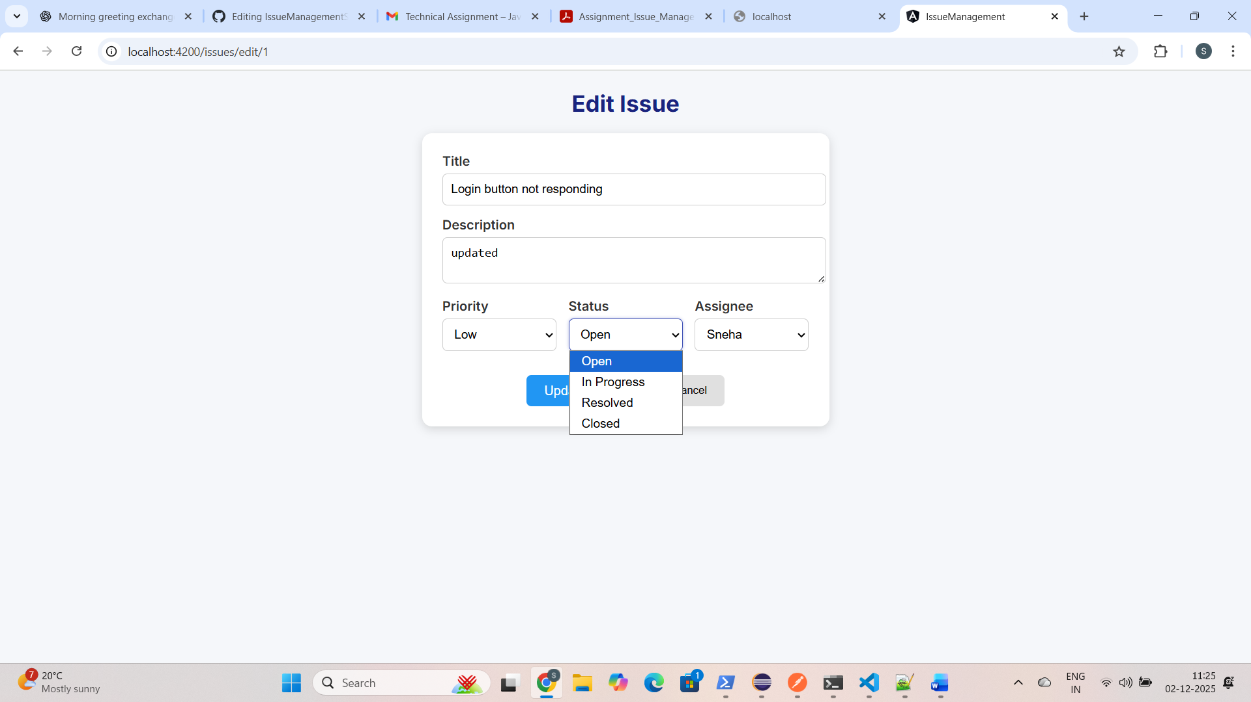

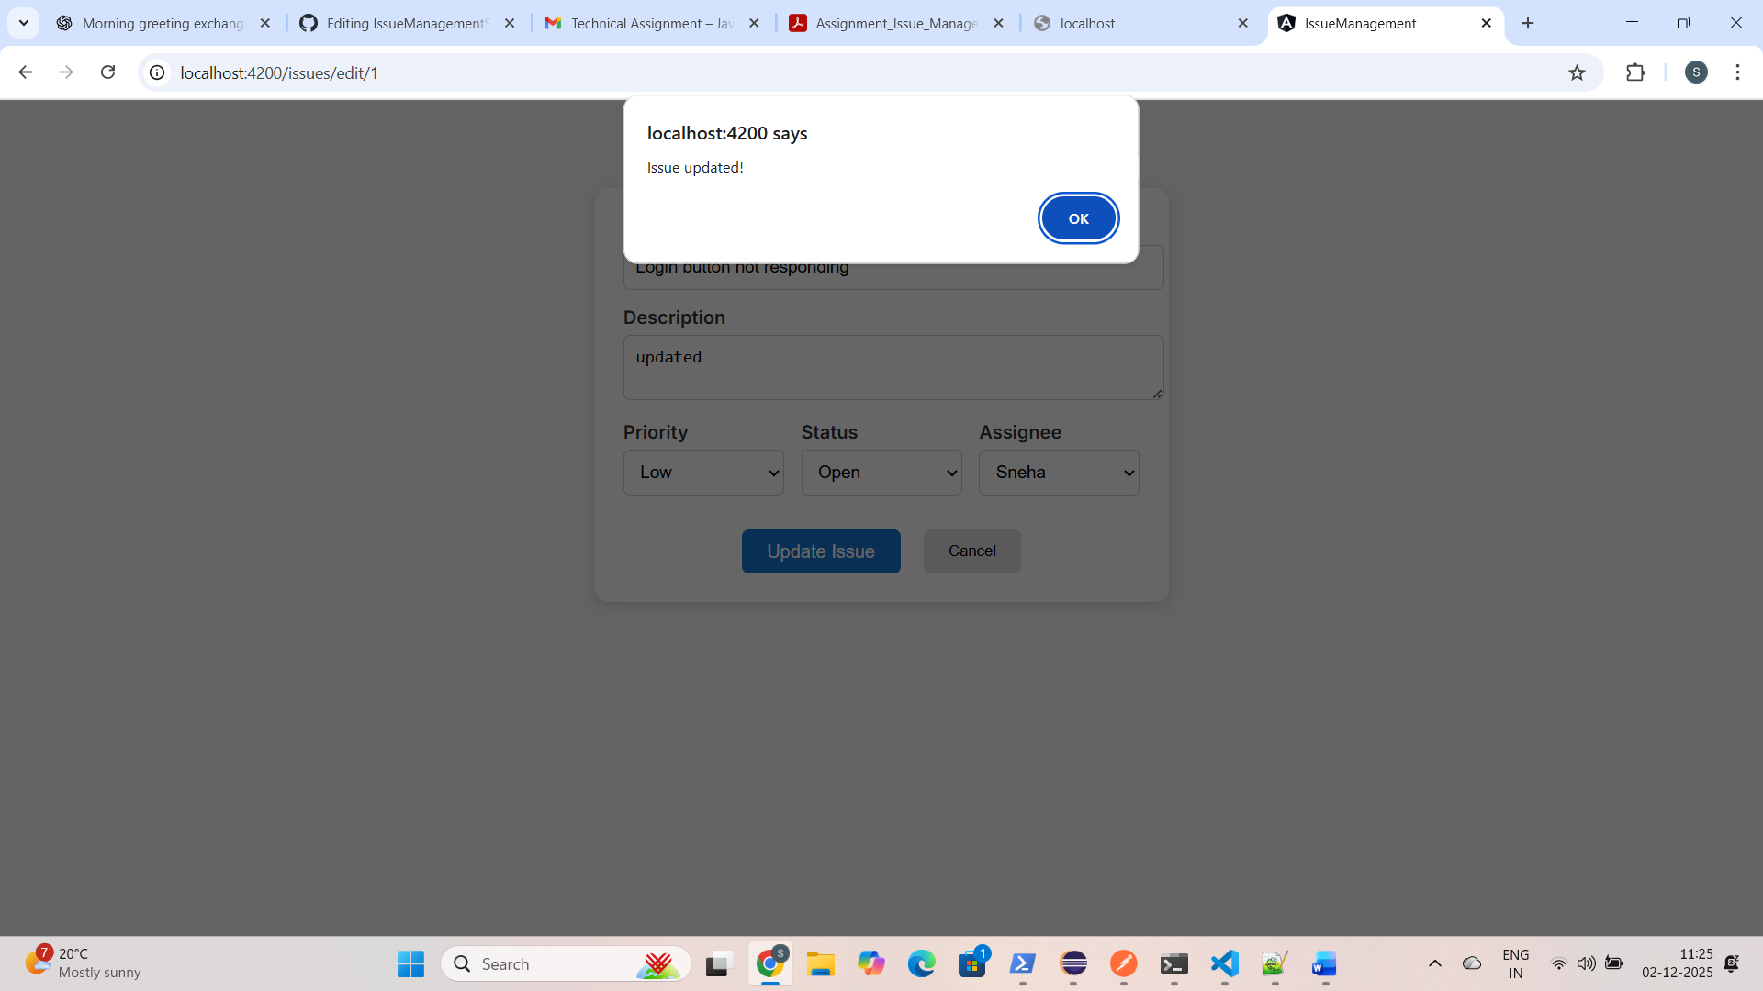

2.3 Delete Issue from UI
Caption:
Deleting an issue from the Angular UI.
Description:
This screenshot shows the delete action from the issue list page.
When the user clicks on the Delete button for a specific issue, a request is sent to the backend DELETE /issues/{id} API. After successful deletion, the issue is removed from the table and a success toast/message is shown on the screen.

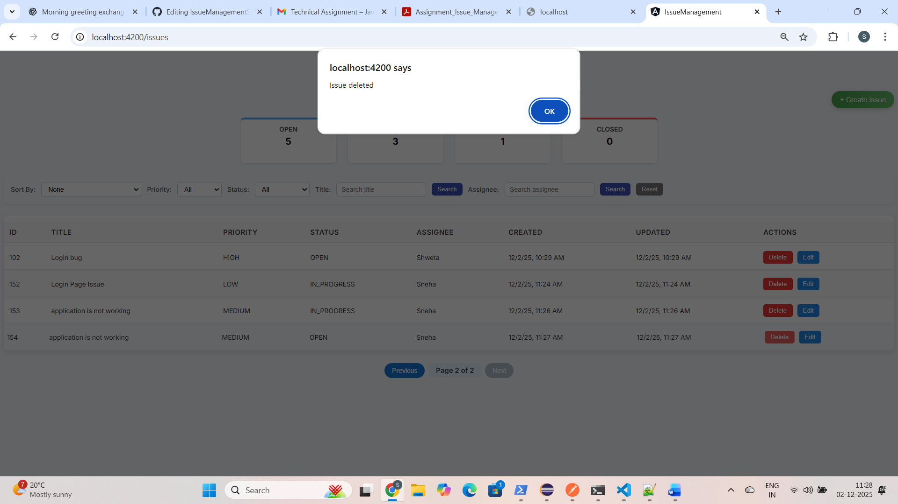
2.4 Dashboard Summary
Caption:
Dashboard counts of issues.
Description:
Shows total open, resolved, closed, etc., issues in cards (if implemented).
